Supplementary Figure S5. Breastfeeding Self-Efficacy Scores by Maternal Characteristics
Supplementary Figure S5 presents box plots comparing breastfeeding self-efficacy scores across subgroups defined by 14 maternal characteristics. Wilcoxon rank-sum tests were used for all comparisons. Variables approaching statistical significance (p < 0.1) included gravidity (p = 0.056), gestational age (p = 0.079), and pre-pregnancy BMI (p = 0.082).
Age groups (<30 vs. >=30 years)
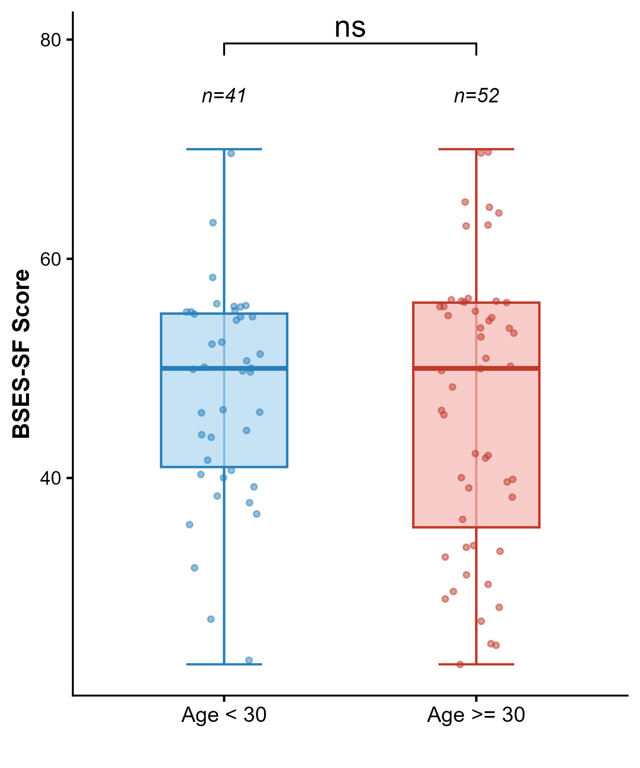

Education level
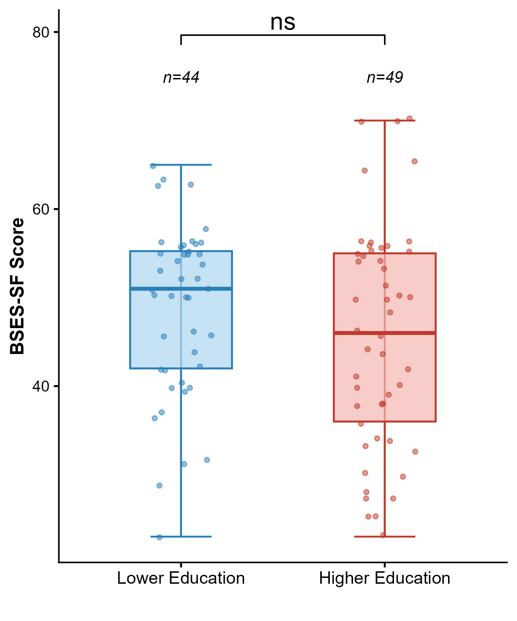

Work type
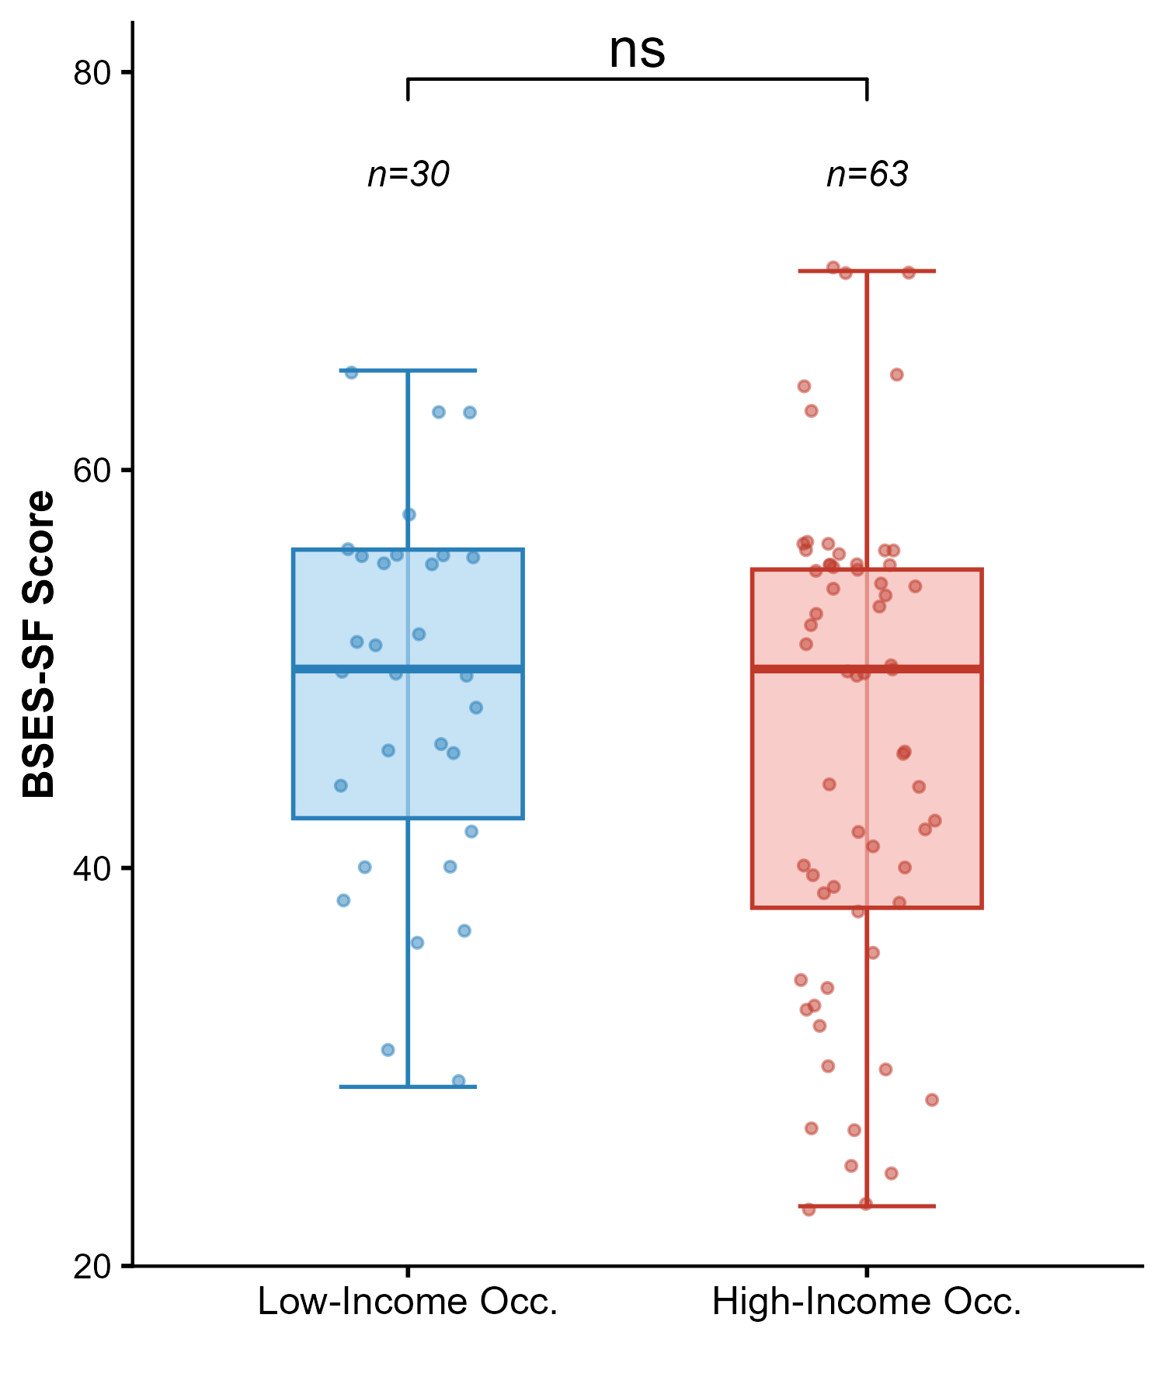

Family income
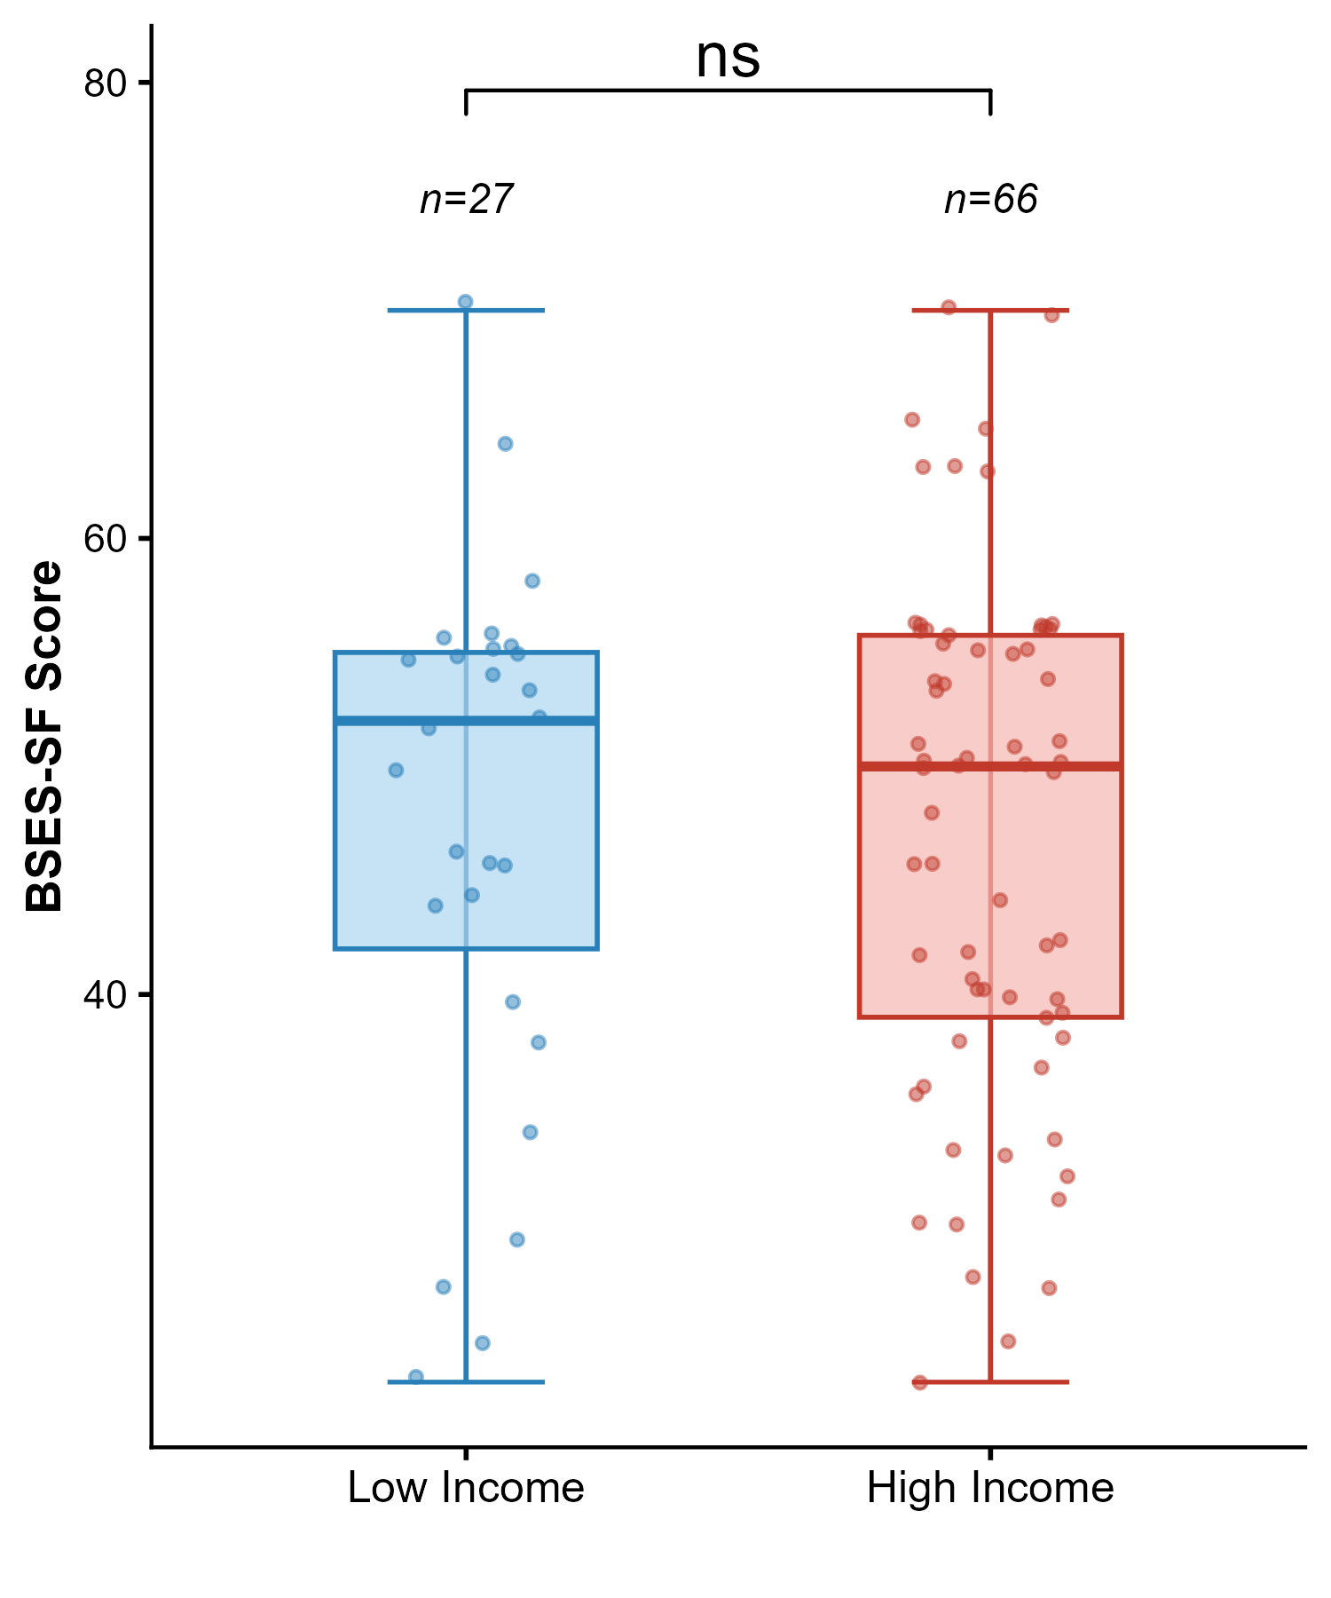

Gravidity
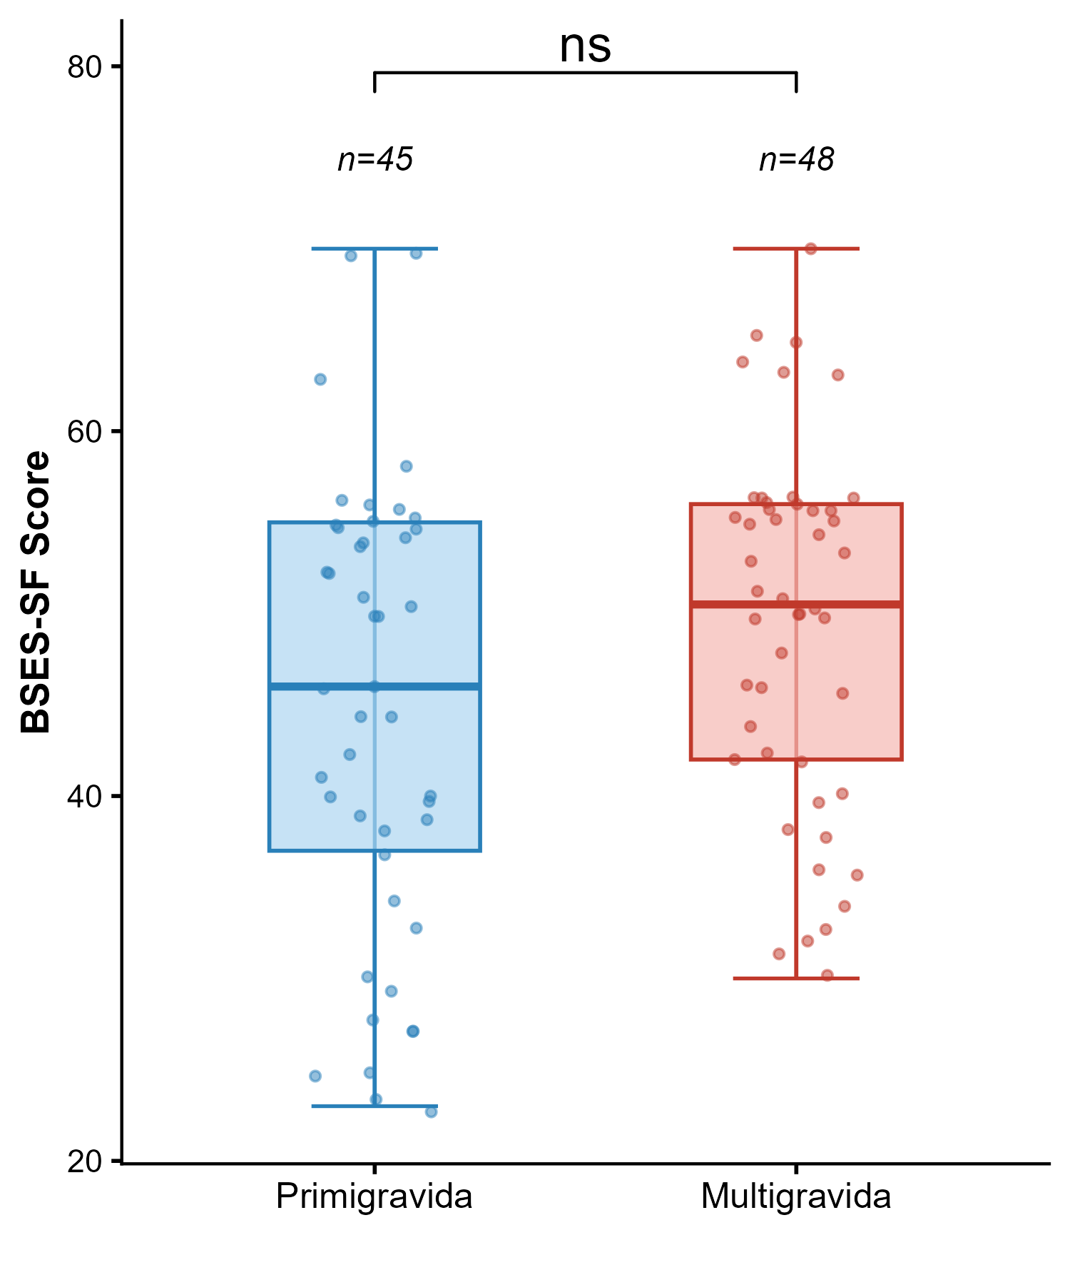

Parity status
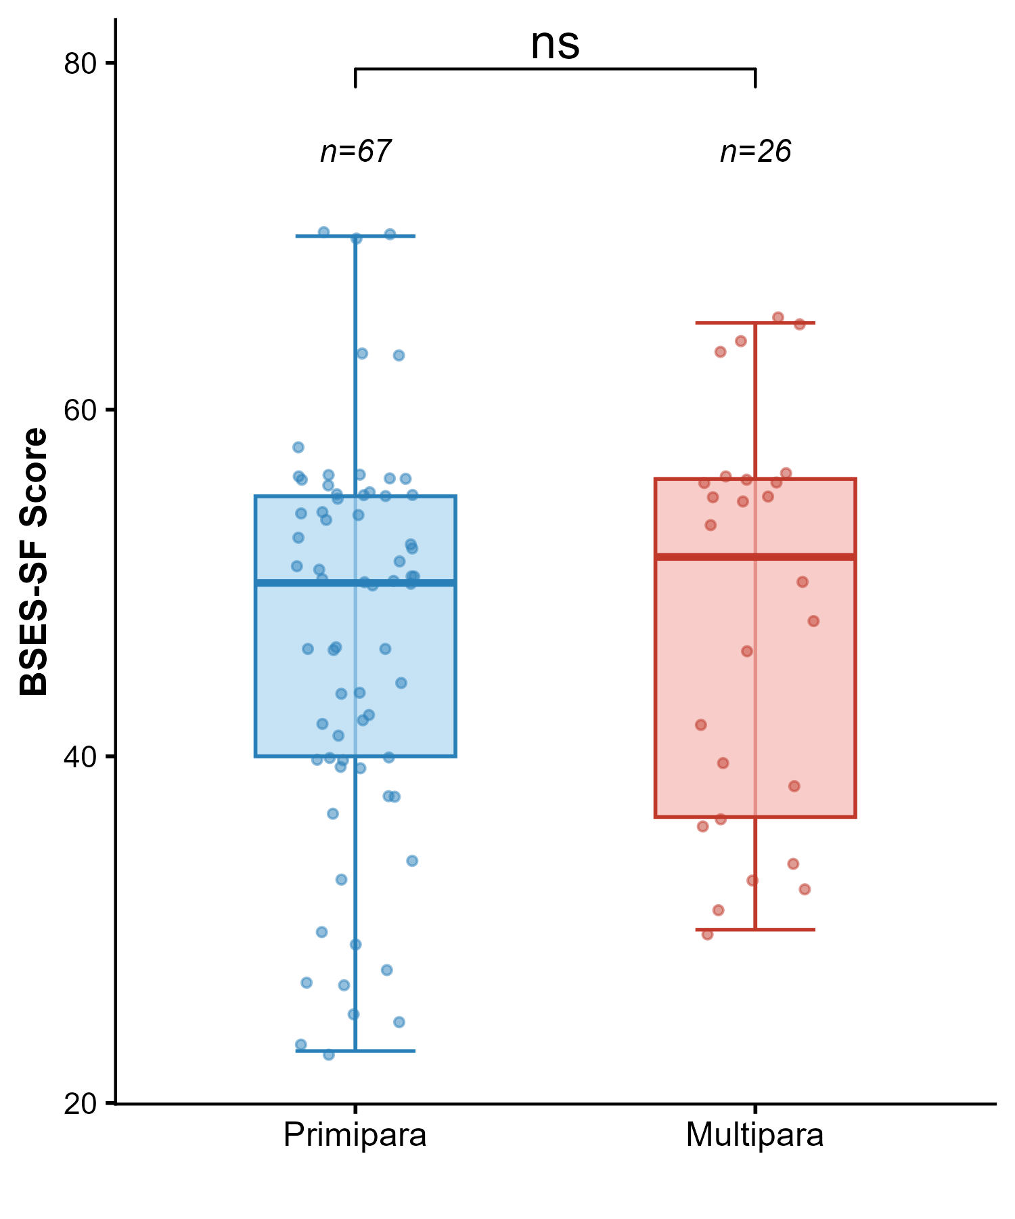

Gestational weeks
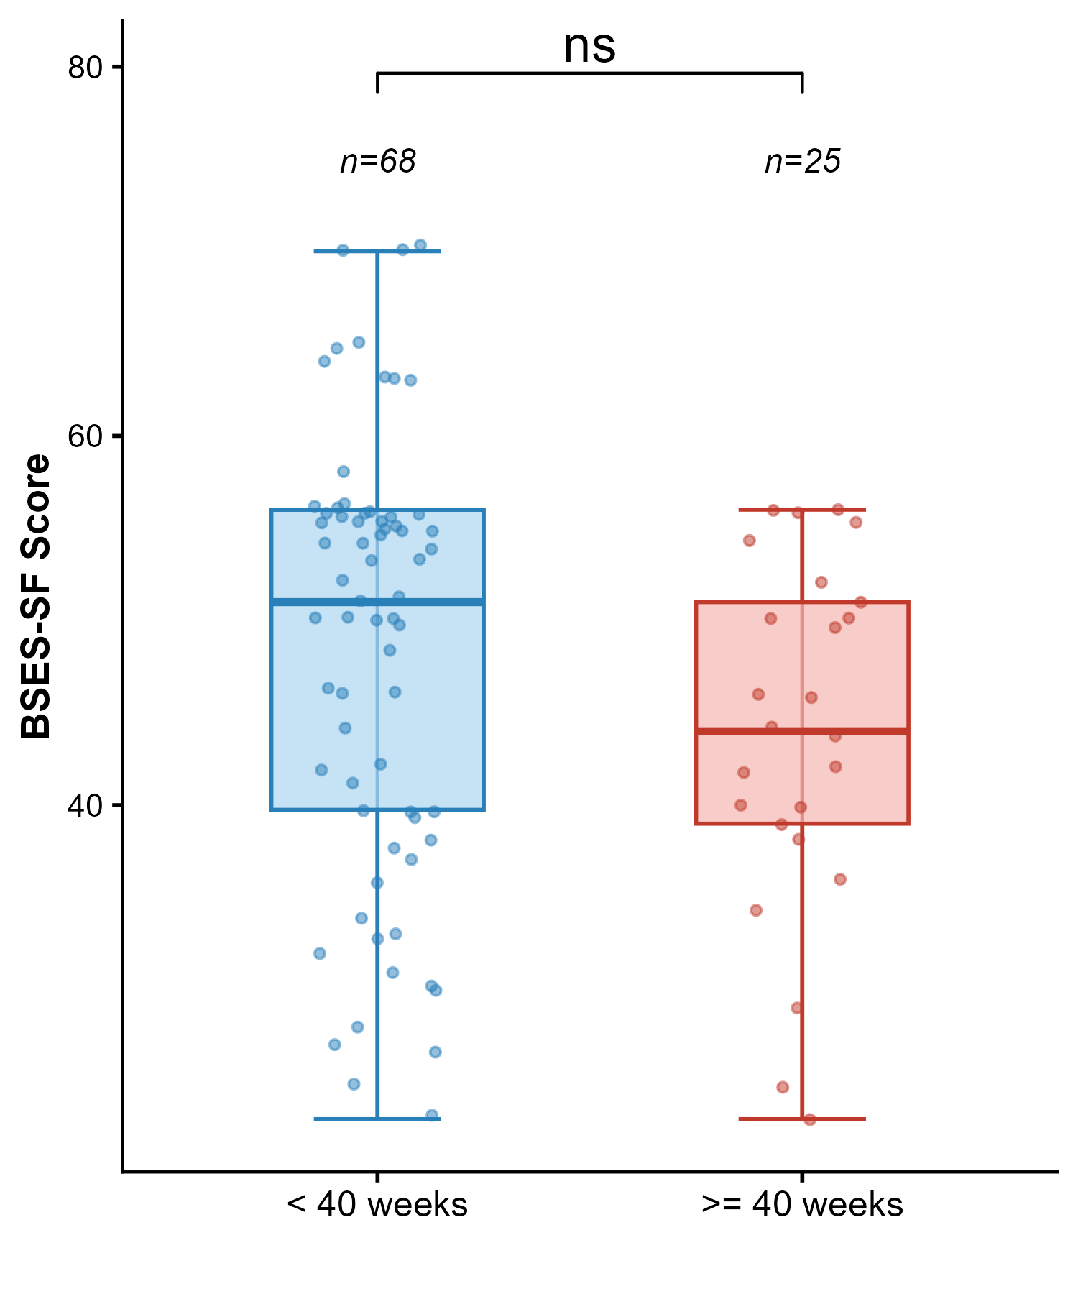

Type of delivery
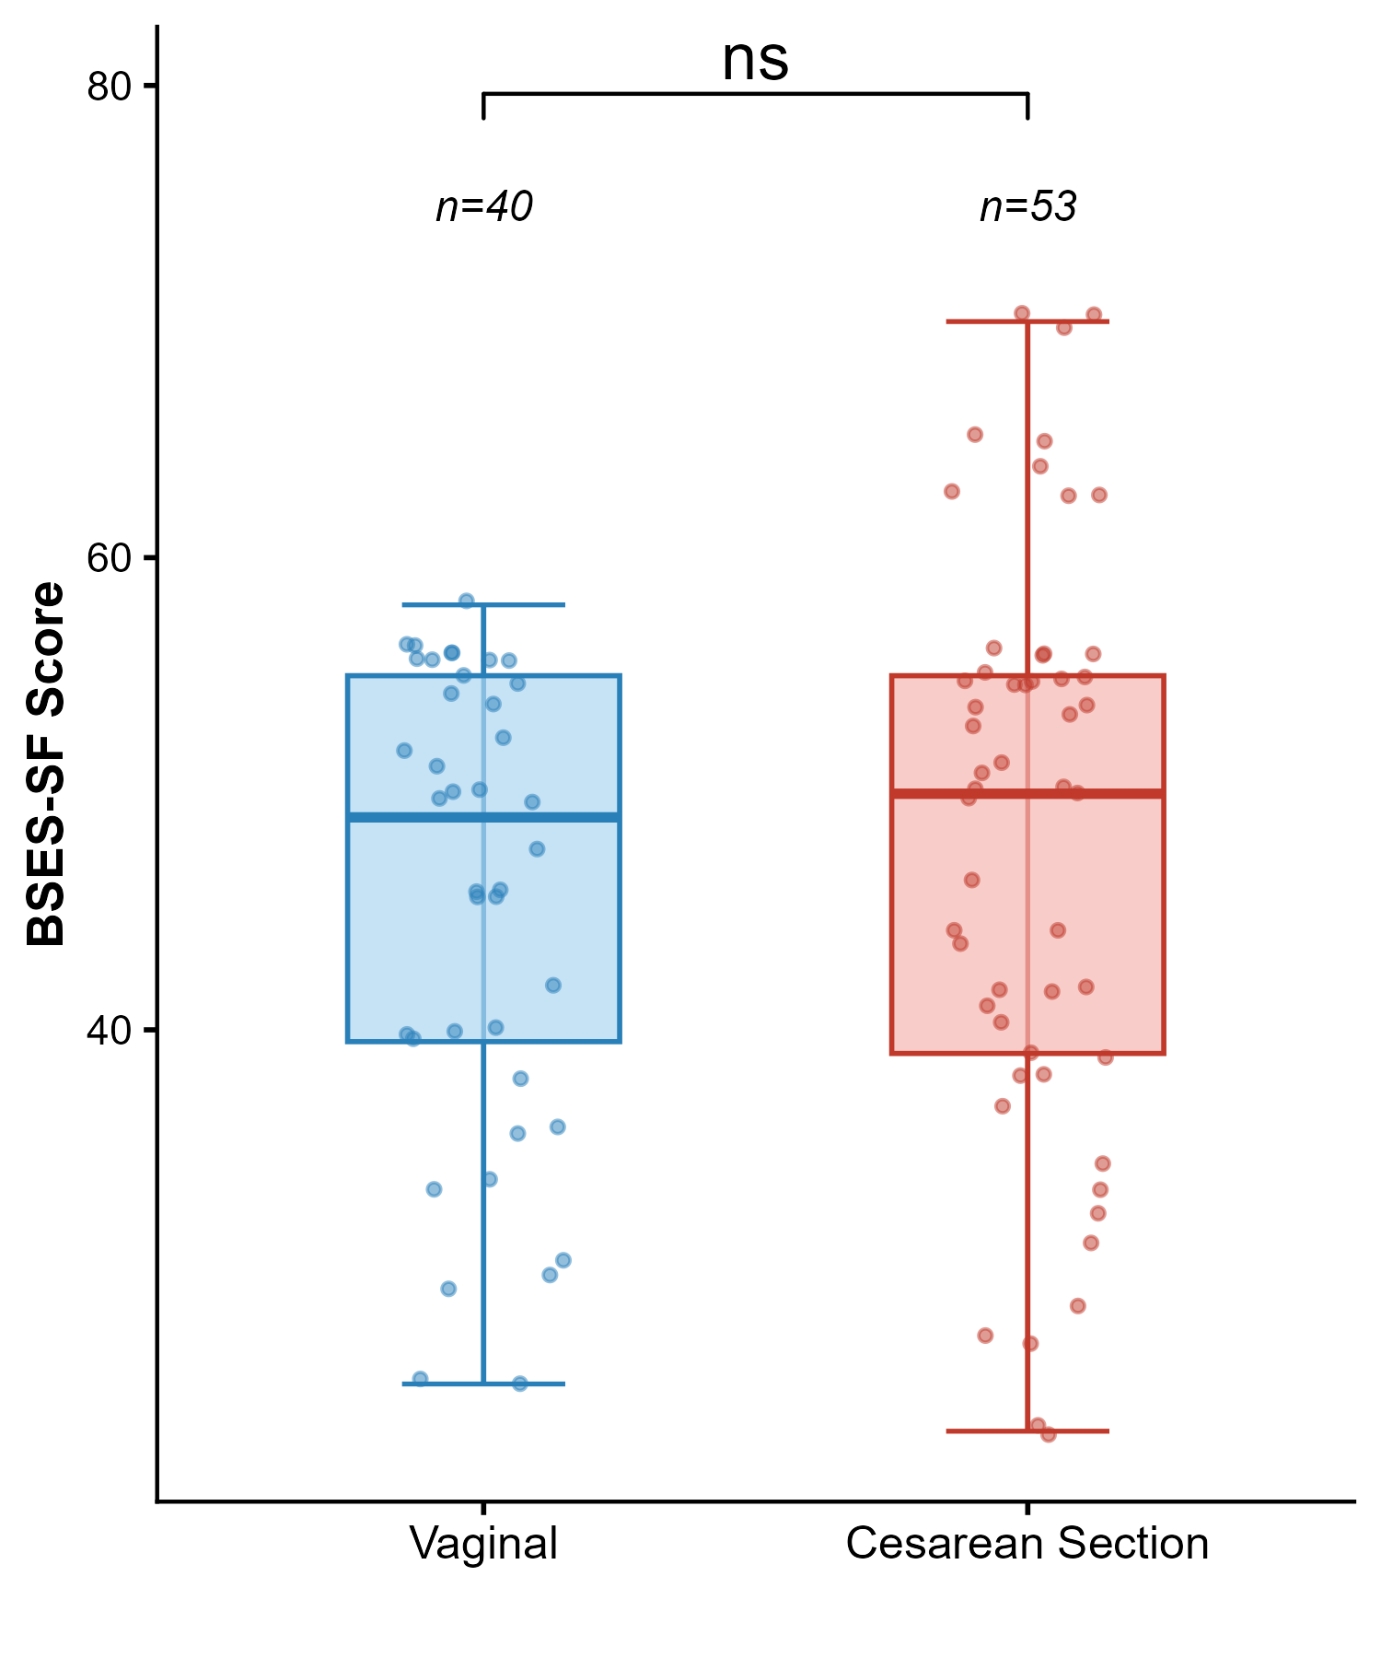

Pre-pregnancy BMI

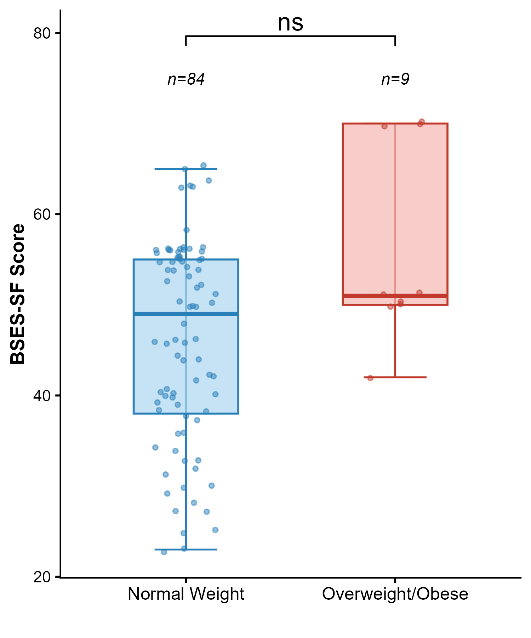

Postpartum BMI
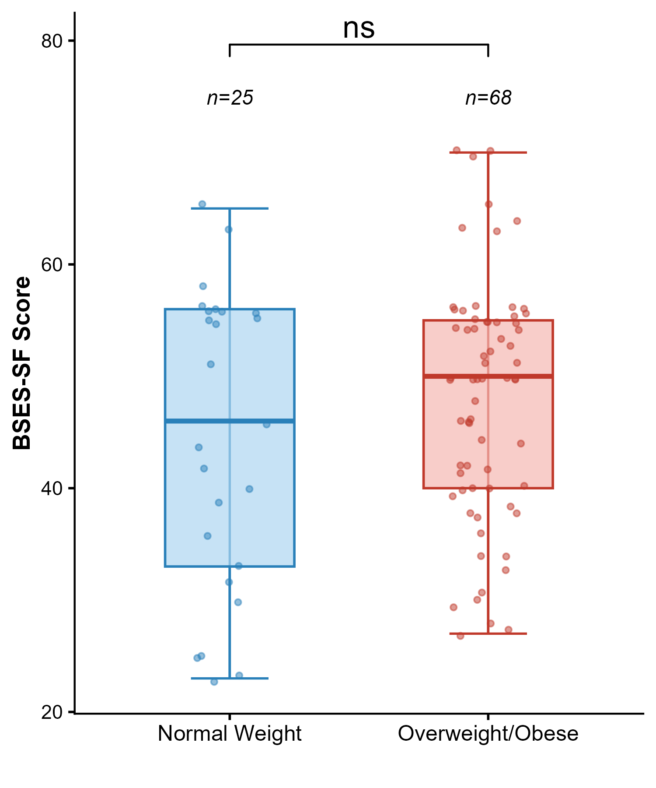

BMI gain
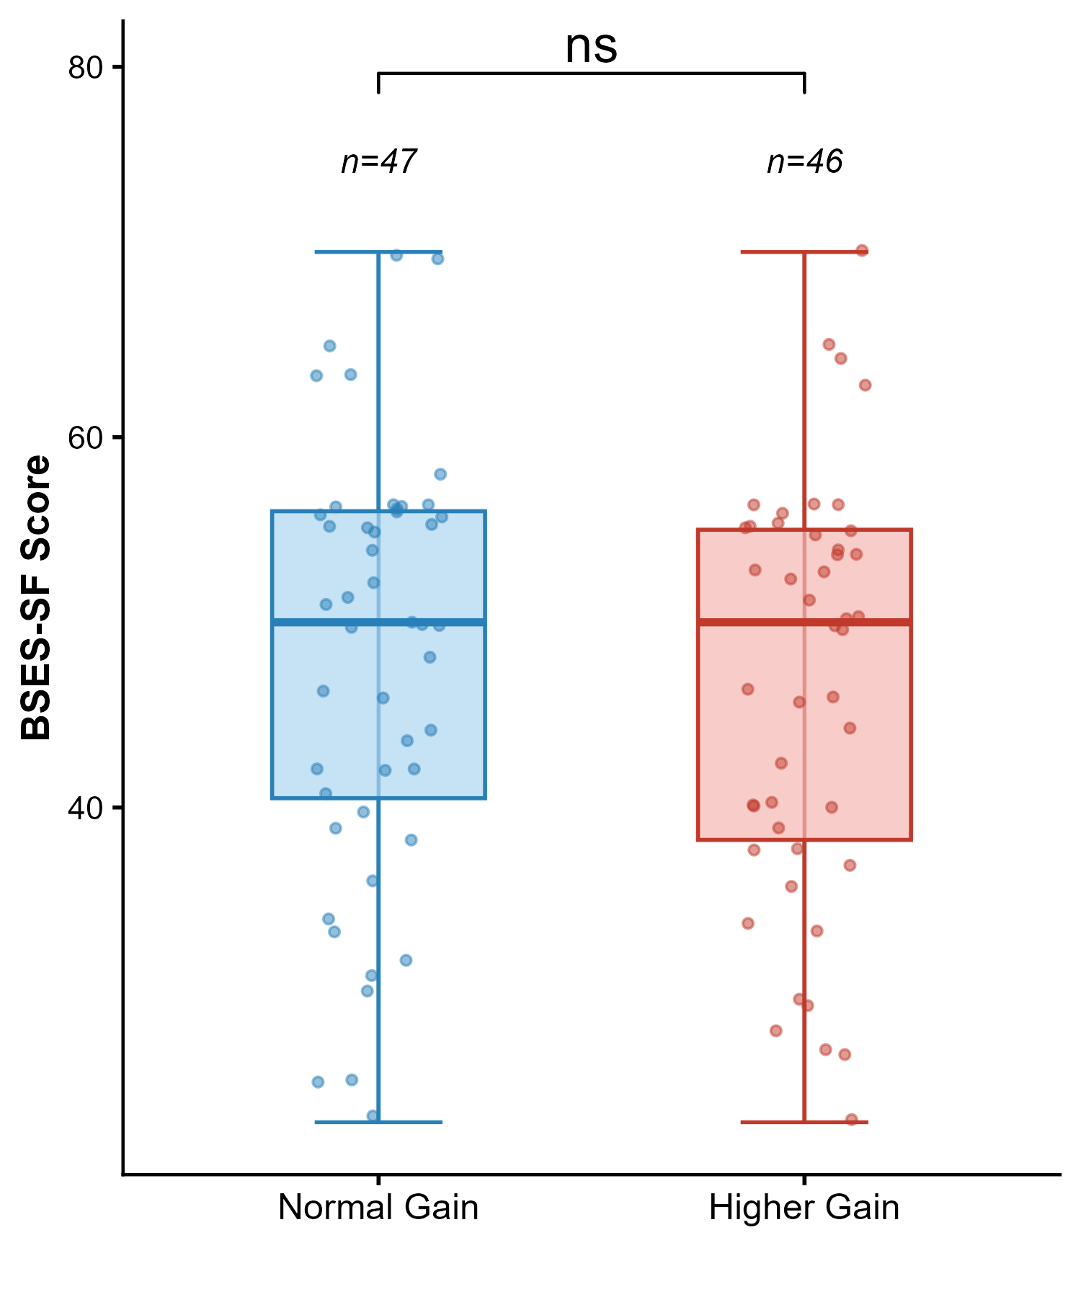

Postpartum hemorrhage
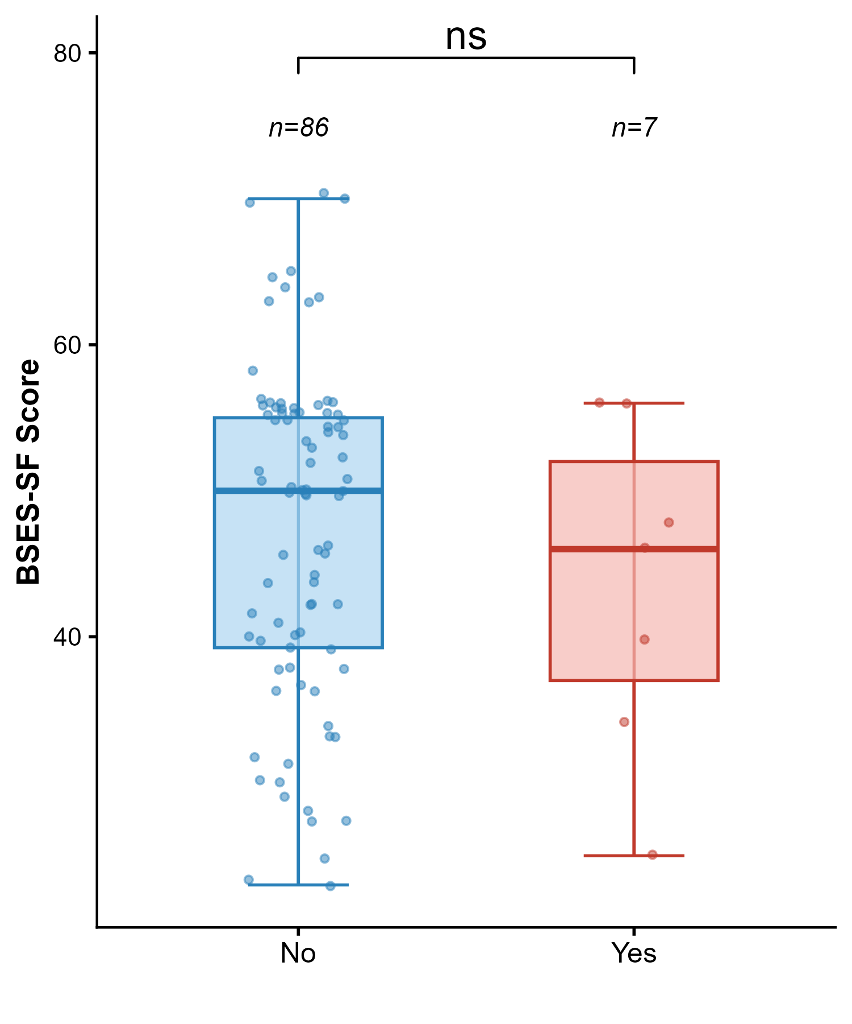

Rooming-in practice
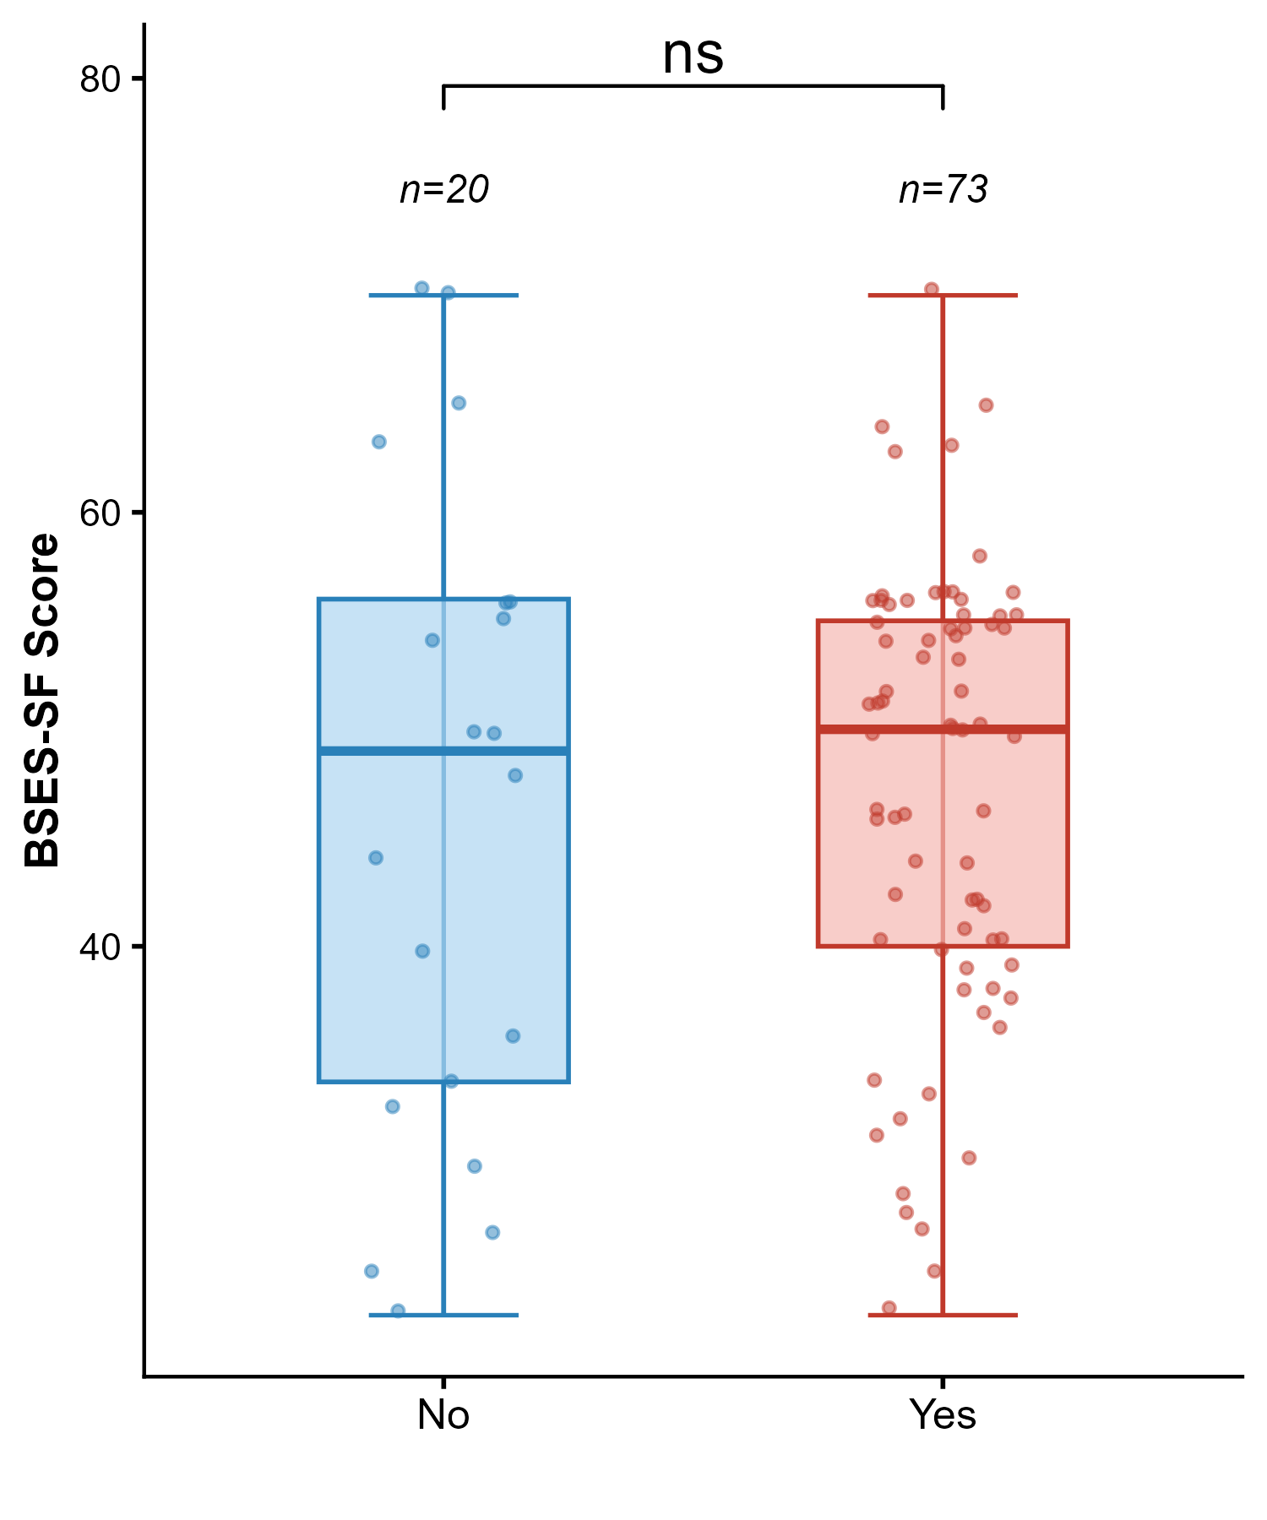

Other complications
