Supplementary Information
Quantifying Inside-Out acting: facial action units and silence duration as markers of interior performance

Supplementary Figure S1
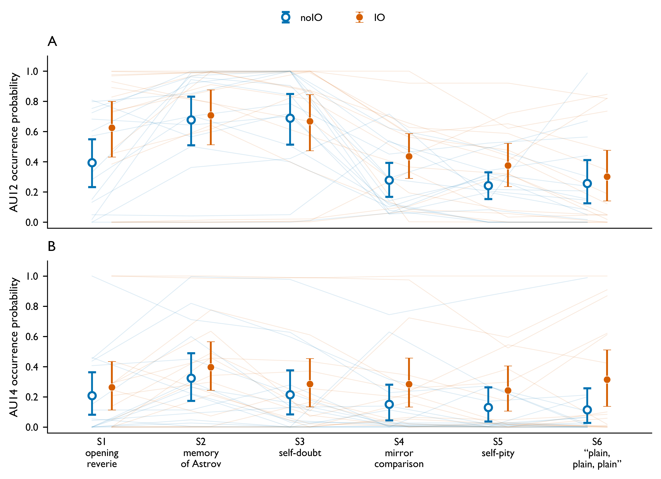
Supplementary Figure S1. AU12 and AU14 occurrence probability under the intention-to-treat sample (n = 15). Layout matches Figure 2 but with the three IO-inadequacy-excluded actors (20250123_3, 20250123_5, 20250123_11) re-included; per-actor segment boundaries for those three actors were transferred proportionally from the consensus representative boundaries of the retained 12. Group means with 95 % percentile bootstrap CIs over actors. Significance markers are not displayed in this descriptive figure. The pattern observed in Figure 2 (AU12 elevated under IO across most segments, AU14 elevated in segments S2–S6) is preserved.

Supplementary Table S1
Supplementary Table S1. Direction consistency of IO > noIO across AU occurrence thresholds (mean occurrence probability difference, IO minus noIO). Originally reported as Table 2 in the v3 manuscript; moved here as a robustness check supporting §3.6.
AU | Seg | Thr = 0.5 | Thr = 1.0 | Thr = 1.5 | Consistent
AU12 | 1 | +0.156 | +0.293 | +0.249 | Yes
AU12 | 2 | +0.023 | +0.070 | +0.080 | Yes
AU12 | 3 | +0.016 | +0.011 | +0.047 | Yes
AU12 | 4 | +0.193 | +0.264 | +0.173 | Yes
AU12 | 5 | +0.145 | +0.195 | +0.075 | Yes
AU12 | 6 | +0.134 | +0.169 | +0.051 | Yes
AU14 | 1 | +0.099 | +0.052 | +0.053 | Yes
AU14 | 2 | +0.104 | +0.097 | +0.032 | Yes
AU14 | 3 | +0.035 | +0.079 | +0.066 | Yes
AU14 | 4 | +0.218 | +0.196 | +0.182 | Yes
AU14 | 5 | +0.210 | +0.153 | +0.102 | Yes
AU14 | 6 | +0.302 | +0.263 | +0.153 | Yes
Note. The “Consistent” column reads “Yes” when all three thresholds (0.5, 1.0, 1.5) yield the same sign of the IO − noIO difference for that AU × segment cell.

