Supplementary Figure 1
Phylogenetic tree: salmon TRIM genes
General methodology
TRIM genes in Atlantic salmon were identified with OrthoFinder (v.2.5.4). Before analysis, proteomes of a considerably large list of fish species, including Salmo salar (Ssal_v3.1), and some outgroups, were downloaded from the Ensembl or NCBI databases (Supplementary table 1). Proteomes were filtered to leave only one transcript per gene (the largest one). OrthoFinder was then run with default options (diamond for sequence search and an inflation parameter of 1.5 for MCL clustering) to obtain the orthogroups. Among all orthogroups, those clustering TRIM proteins (four major groups, including btr, finTRIM, TRIM-like and TRIM25) were identified using the SMART analysis web service. Only Atlantic salmon sequences were kept.
To infer the phylogenetic tree, a multiple sequence alignment was performed using MAFFT, using the L-INS-i iterative refinement method with a maximum of 1,000 cycles. These two alignments were used to construct a Maximum-Likelihood tree with IQ-TREE using ModelFinder to determine the best-fit substitution model (JTT+F+R7 according to BIC), and 10,000 ultrafast bootstraps to assess branch supports. The option “-bnni” was also used to reduce the risk of overestimating branch supports in case of severe model violations.
Pairwise distance matrices for sequence similarity were calculated from the aligned sequences with the function dist.alignment() from the R package ‘seqinr’. This function outputs a root distance matrix that can be converted to a similarity matrix as follows: S = 1 - (root distance)².
Trees were illustrated using the R package ‘ggtree’. Tip labels include Ensembl information: gene name, chromosome number (genes located on unplaced-scaffolds are indicated by “-”), and accession code. Similarities are shown as heatmap columns due to the size of the figures.

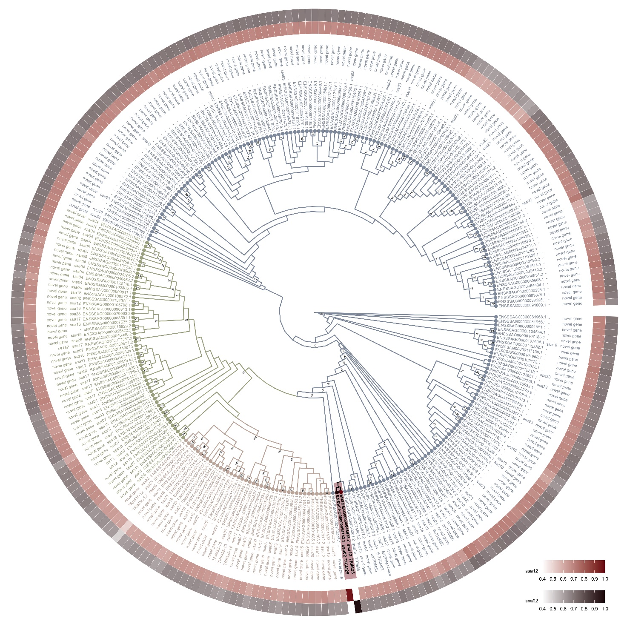
Figure 1- ML tree inferred from the MAFFT alignment. Colors indicate the orthogroups identified by OrthoFinder (blue: include finTRIMs; orange: TRIM35; green: btr; black highlighted in red: TRIM25).

Supplementary Figure 2 – Area under curve analysis for trim25 paralog expression
Area under curve analysis of trim25 paralog gene expression quantified and analysed via one-way ANOVA in GraphPad Prism. Error bars represent SEM.

Supplementary Figure 3 – Genome editing of trim25
- Guide targeting Ssa02 trim25
Ssa02 trim25 SHK-1 polyclonal cell pool – Day 0 pre-infection – 97% INDEL
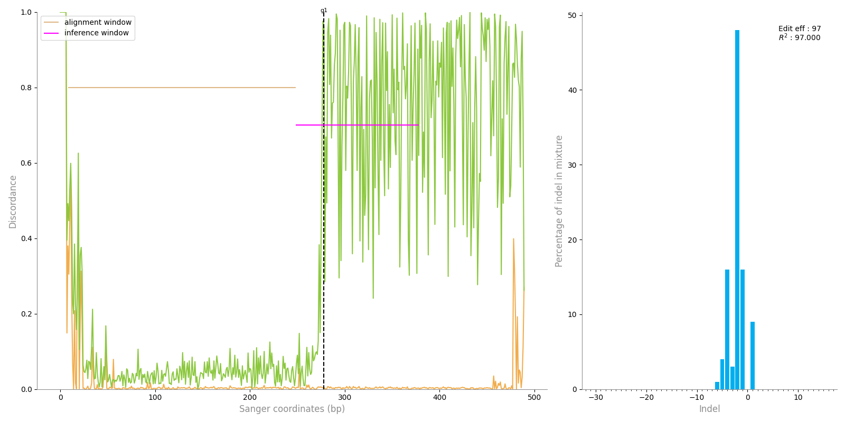
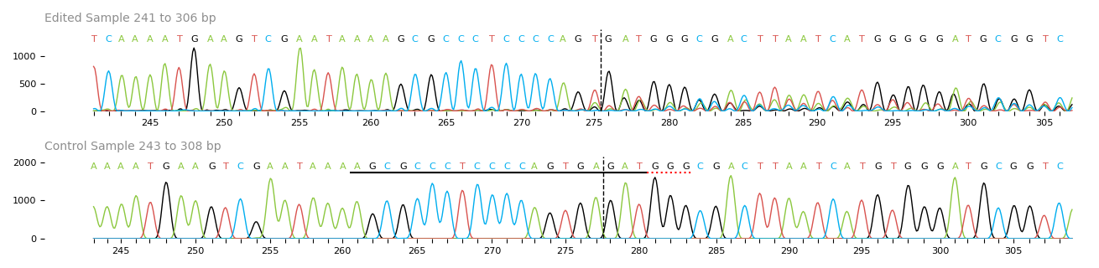
Ssa12 trim25 SHK-1 polyclonal cell pool – Day 0 pre-infection – 0% INDEL
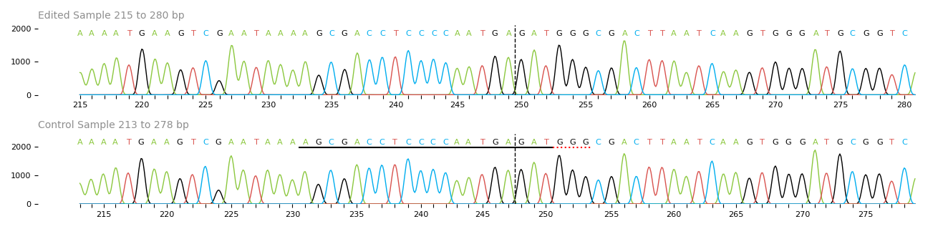
Figure 2A - Sequencing trace of Ssa02 trim25 and Ssa12 trim25 edited polyclonal cell pools. Cells edited with gRNA specific for Ssa02 trim25. Black line represents the gRNA sequence. Red line denotes PAM site. Vertical black dotted line represents DNA cut site.

- Guide targeting Ssa12 trim25
Ssa02 trim25 SHK-1 polyclonal cell pool – Day 0 pre-infection – 19% INDEL
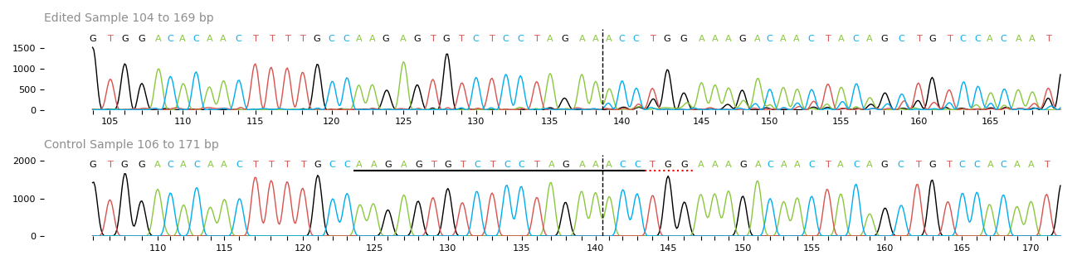
Ssa12 trim25 SHK-1 polyclonal cell pool – Day 0 pre-infection – 97% INDEL
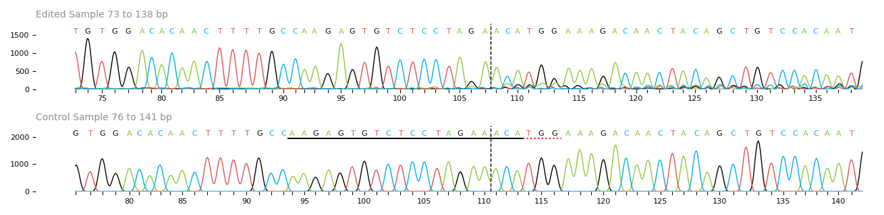
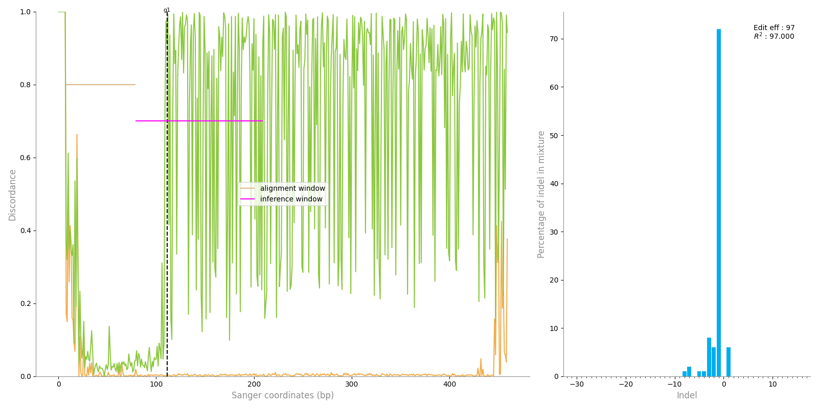
Figure 2B - Sequencing trace of Ssa02 trim25 and Ssa12 trim25 edited polyclonal cell pools. Cells edited with gRNA specific for Ssa12 trim25. Black line represents the gRNA sequence. Red line denotes PAM site. Vertical black dotted line represents DNA cut site.

- Guide targeting Ssa02 trim25 + Ssa12 trim25
Ssa02 trim25 SHK-1 polyclonal cell pool – Day 0 pre-infection – 19% INDEL
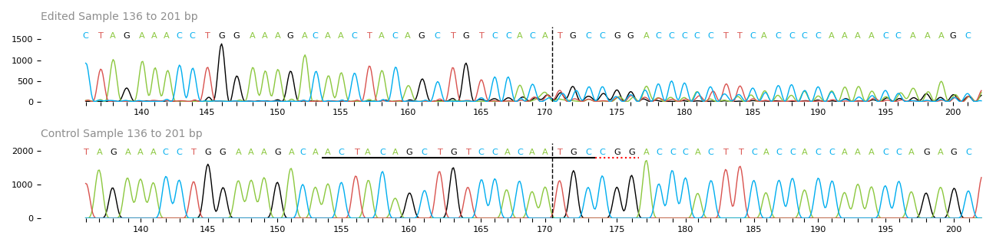
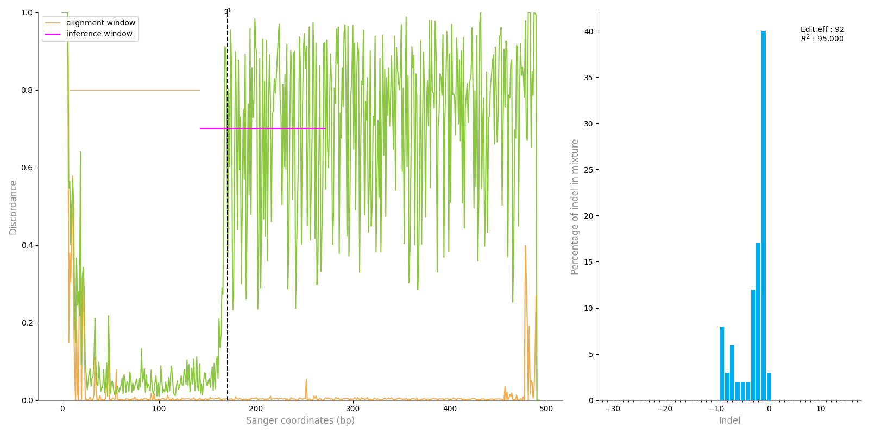
Ssa12 trim25 SHK-1 polyclonal cell pool – Day 0 pre-infection – 97% INDEL
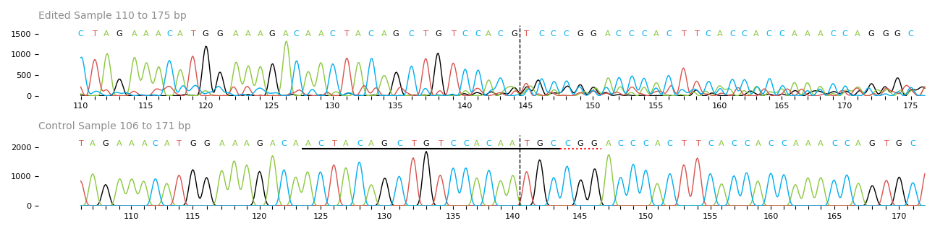

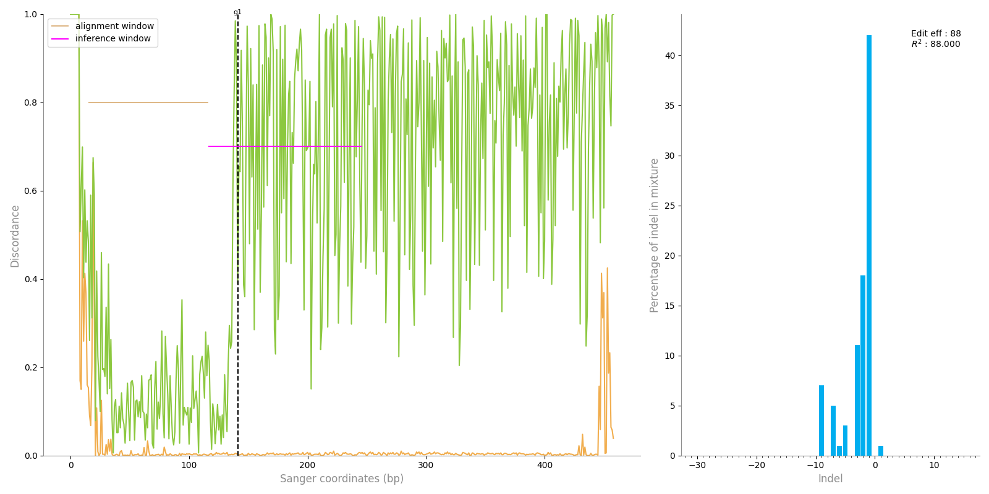

Figure 2C - Sequencing trace of Ssa02 trim25 and Ssa12 trim25 edited polyclonal cell pools. Cells edited with gRNA specific for both Ssa02 trim25 and Ssa12 trim25. Black line represents the gRNA sequence. Red line denotes PAM site. Vertical black dotted line represents DNA cut site.

Table 1. List of fish species and outgroups used for OrthoFinder analyses.
Order | Species | Database | Assembly
Petromyzontiformes | Petromyzon marinus | NCBI | kPetMar1.pri
Chimaeriformes | Scyliorhinus canicula | NCBI | sScyCan1.1
Primates | Homo sapiens | Ensembl | GRCh38.p14
Rodentia | Mus musculus | Ensembl | GRCm39
Galliformes | Gallus gallus | Ensembl | bGalGal1.mat.broiler.GRCg7b
Testudines | Gopherus evgoodei | Ensembl | rGopEvg1_v1.p
Anura | Xenopus tropicalis | Ensembl | UCB_Xtro_10.0
Ceratodontiformes | Protopterus annectens | NCBI | PAN1.0
Coelacanthiformes | Latimeria chalumnae | NCBI | fLatCha1.pri
Cyprinodontiformes | Xiphophorus maculatus | Ensembl | X_maculatus-5.0-male
Acipenseriformes | Polyodon spathula | Ensembl - RR | ASM1765450v1
Anabantiformes | Anabas testudineus | Ensembl | fAnaTes1.3
Anguilliformes | Anguilla anguilla | Ensembl - RR | fAngAng1.pri
Atheriniformes | Melanotaenia boesemani | Ensembl - RR | fMelBoe1.pri
Batrachoidiformes | Thalassophryne amazonica | Ensembl - RR | fThaAma1.1
Beloniformes | Oryzias javanicus | Ensembl | OJAV_1.1
Blenniiformes | Salarias fasciatus | Ensembl | fSalaFa1.1
Carangiformes | Echeneis naucrates | Ensembl | fEcheNa1.1
Centrarchiformes | Micropterus salmoides | Ensembl - RR | ASM2243578v1
Chaetodontiformes | Chelmon rostratus | Ensembl - RR | fCheRos1.pri
Characiformes | Astyanax mexicanus - mexican tetra | Ensembl - RR | AstMex3_surface
Characiformes | Pygocentrus nattereri | Ensembl | fPygNat1.pri
Cichliformes | Astatotilapia calliptera | Ensembl | fAstCal1.3
Cichliformes | Oreochromis niloticus | Ensembl | O_niloticus_UMD_NMBU
Clupeiformes | Denticeps clupeoides | Ensembl | fDenClu1.2
Cypriniformes | Cyprinus carpio carpio | Ensembl | Cypcar_WagV4.0
Cypriniformes | Danio rerio | Ensembl | GRCz11
Cypriniformes | Beaufortia kweichowensis | Ensembl - RR | ASM1915518v1
Elopiformes | Megalops atlanticus | Ensembl - RR | MATL_1.0
Esociformes | Esox lucius | Ensembl | fEsoLuc1.pri
Gadiformes | Gadus morhua - Atlantic cod | Ensembl | gadMor3.0
Gobiiformes | Neogobius melanostomus | Ensembl | RGoby_Basel_V2
Gobiiformes | Periophthalmus magnuspinnatus | NCBI | fPerMag1.2.pri
Gonorynchiformes | Chanos chanos | NCBI | fChaCha1.1
Gymnotiformes | Electrophorus electricus | Ensembl | fEleEle1.pri
Holocentriformes | Myripristis murdjan | Ensembl | fMyrMur1.1
Istiophoriformes | Xiphias gladius | NCBI | ASM1685928v1
Kurtiformes | Sphaeramia orbicularis | Ensembl | fSphaOr1.1
Labriformes | Labrus bergylta | NCBI | fLabBer1.1
Lampriformes | Lampris incognitus | Ensembl - RR | ASM2205924v1
Mugiliformes | Mugil cephalus | Ensembl - RR | CIBA_Mcephalus_1.1
Order-level incertae sedis | Lates calcarifer | NCBI | TLL_Latcal_v3
Order-level incertae sedis | Amphiprion percula | Ensembl | Nemo_v1
Order-level incertae sedis | Dicentrarchus labrax | Ensembl | dlabrax2021
Order-level incertae sedis | Parambassis ranga | Ensembl | fParRan2.2
Order-level incertae sedis | Larimichthys crocea | Ensembl | L_crocea_2.0
Order-level incertae sedis | Scatophagus argus | Ensembl - RR | fScaArg1.pri
Order-level incertae sedis | Toxotes jaculatrix | Ensembl - RR | fToxJac2.pri
Osmeriformes | Hypomesus transpacificus | NCBI | fHypTra1
Osteoglossiformes | Scleropages formosus | Ensembl | fSclFor1.1
Perciformes | Cottoperca gobio | Ensembl | fCotGob3.1
Perciformes | Cyclopterus lumpus | Ensembl | fCycLum1.pri
Perciformes | Sander lucioperca | NCBI | SLUC_FBN_1.2
Pleuronectiformes | Scophthalmus maximus | Ensembl | ASM1334776v1
Salmoniformes | Salmo salar | Ensembl | Ssal_v3.1
Scombriformes | Thunnus albacares | Ensembl - RR | fThuAlb1.1
Semionotiformes | Lepisosteus oculatus | Ensembl | LepOcu1
Siluriformes | Ictalurus punctatus | NCBI | Coco_2.0
Siluriformes | Silurus meridionalis | NCBI | ASM1480568v1
Spariformes | Sparus aurata | Ensembl | fSpaAur1.1
Synbranchiformes | Mastacembelus armatus | Ensembl | fMasArm1.2
Syngnathiformes | Synchiropus splendidus | NCBI | RoL_Sspl_1.0
Tetraodontiformes | Takifugu rubripes | Ensembl | fTakRub1.2
Uranoscopiformes | Ammodytes marinus | Ensembl - RR | fAmmMar1.1
Polypteriformes | Erpetoichthys calabaricus | NCBI | fErpCal1.3

