Supplementary information

Silicon/MAPbI₃ Heterostructure Field Effect Transistor
Farhad Assareh Pour ª, Ghafar Darvishª and Rahim Faez ^{b}

- Department of Electrical Engineering, SR.C., Islamic Azad University, Tehran, Iran.
- Electrical Engineering Department, Sharif University of Technology, Tehran 14395515 Iran.

Supplementary simulation results for the small-scale structure of Silicon/MAPbI₃ heterostructure
In the following, the wavefunctions, potential, electric field, and energy levels in the simulated structure are examined in order to investigate more precisely the effects of the selected parameters and models. Fig. S1 shows the wavefunctions corresponding to the conduction-band and valence-band edge states for the simulated structure under zero-bias conditions. As observed in Fig. S1, due to the close alignment of the conduction-band edges in silicon and MAPbI₃, the conduction-band-edge wavefunction is spread throughout the entire structure (including the substrate and perovskite) ($E_{C_{MAPbI3}}- E_{C_{Si}}= 0.12 eV$ ). In contrast, owing to the valence-band offset between the two regions ($E_{V_{Si}}- E_{V_{MAPbI3}}= 0.24 eV$), the valence-band-edge wavefunction is localized within the silicon substrate.
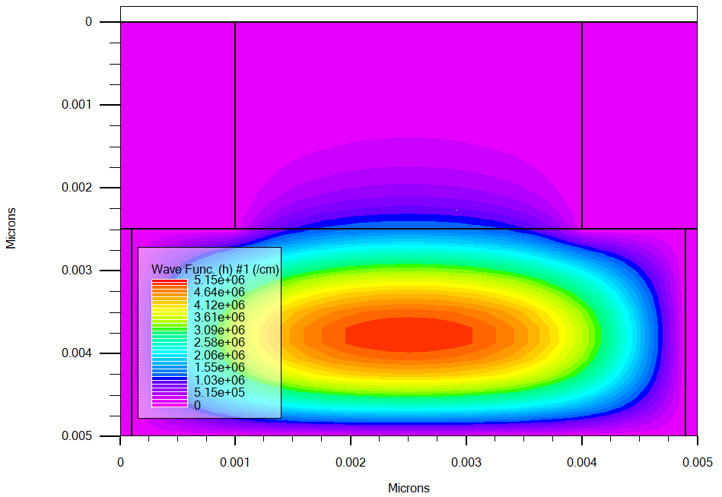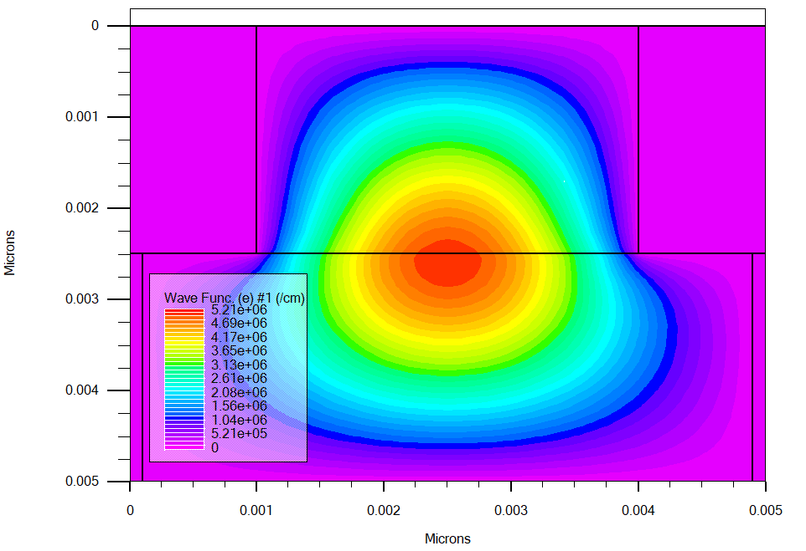
(a)
(b)
Fig. S1 (a) Conduction-band edge wavefunction and (b) valence-band edge wavefunction for the Si–MAPbI₃ structure.
Silicon
MAPbI₃
MAPbI₃
Silicon
Fig. S2 presents the potential and electric field in the simulated structure. For a more detailed analysis, Fig. S3 and Fig. S4 present the potential and electric field profiles along a vertical cross section as well as along the silicon surface. Part of the variations in the electric field and potential originate from the band-edge offsets, while another part arises from the impurity distribution and the zero-potential boundary conditions applied to the electrodes. As shown, although the electric field in the perovskite region is nonzero, its magnitude is small compared to that within the silicon substrate. The electric field in the perovskite region results from carrier transfer from the perovskite into the silicon substrate.
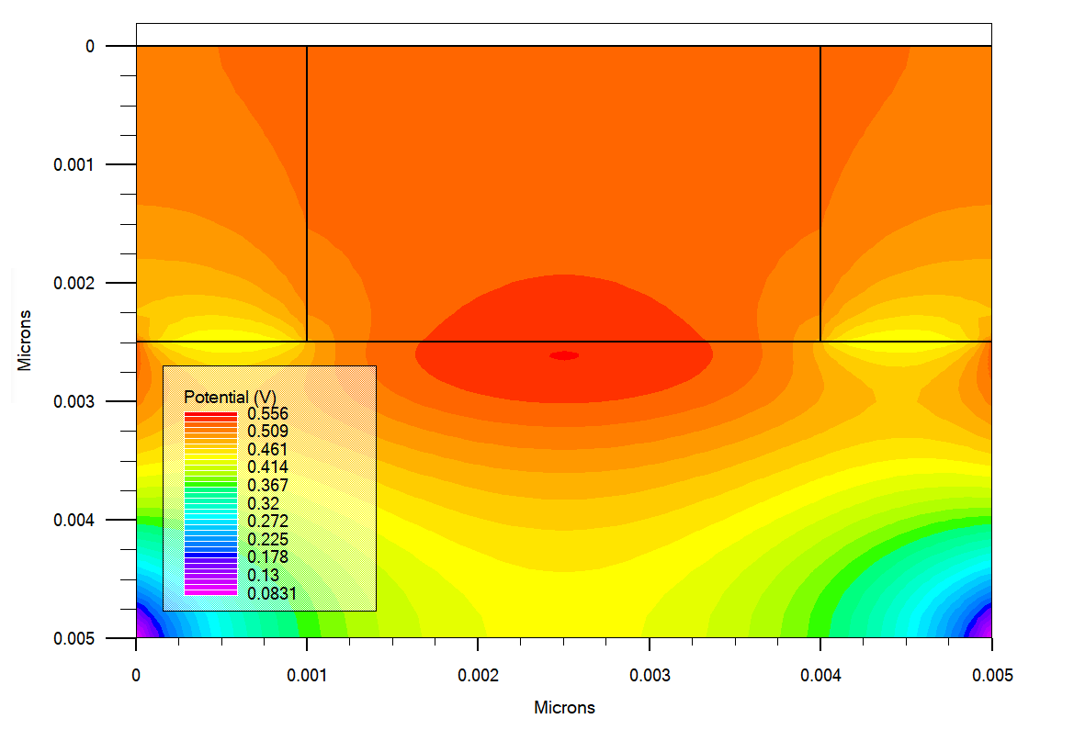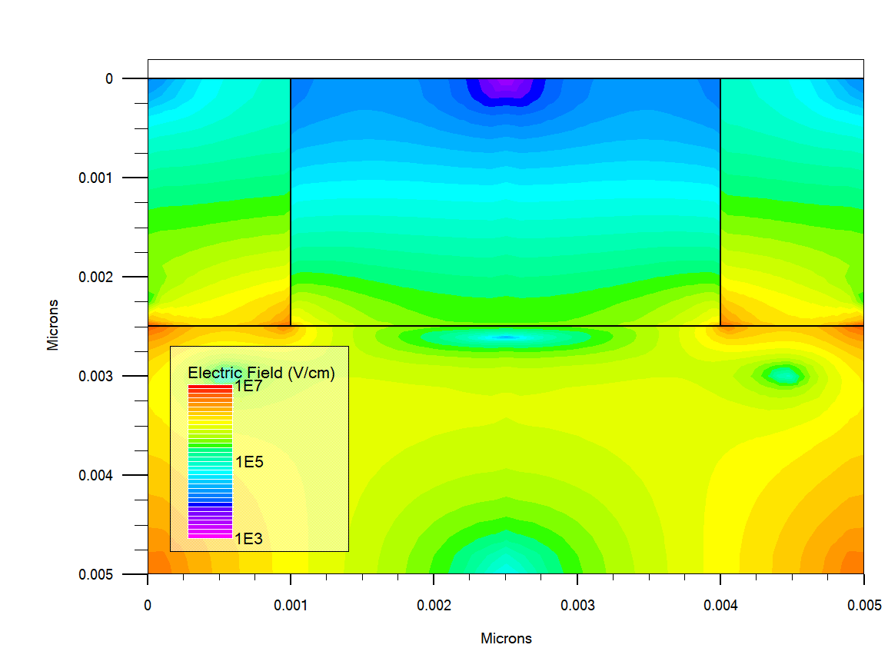
(a)
(b)
Silicon
Silicon
MAPbI₃

MAPbI₃

Fig. S2 (a) Potential and (b) electric field in the Si–MAPbI₃ structure, simulated using the ATLAS software.
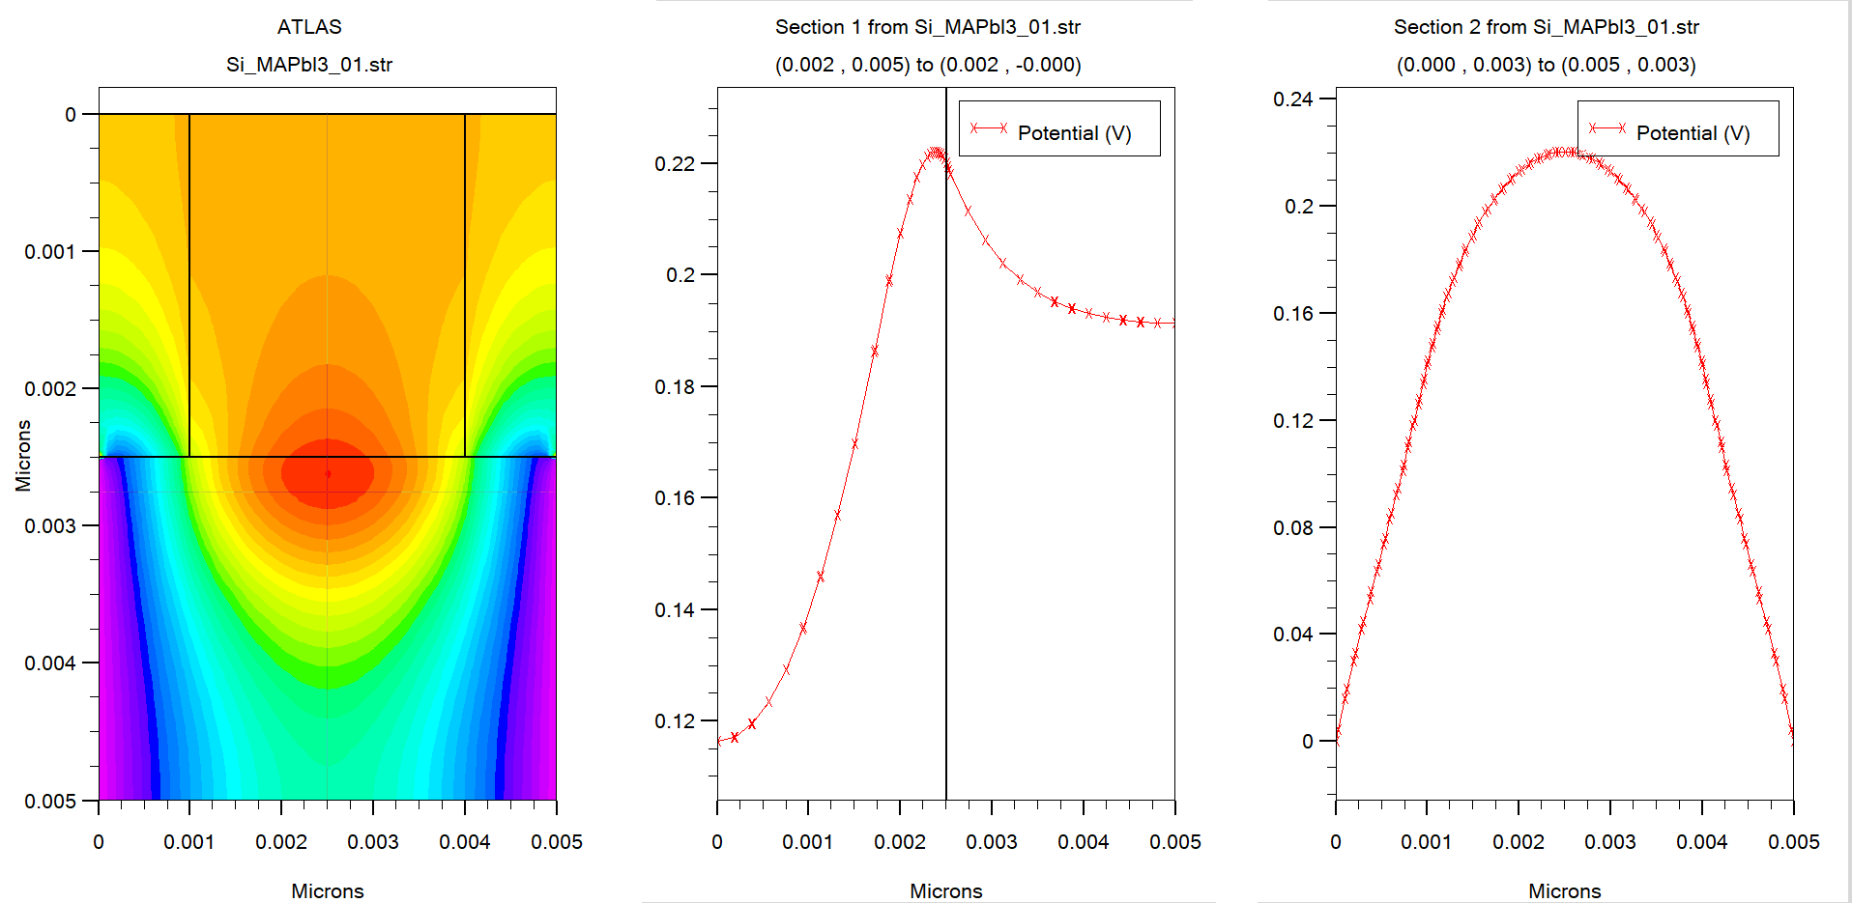
Section 2
Section 1
(a)
(b)
(c)
Fig. S3 (a) Potential in the HFET with a perovskite barrier, and (b) and (c) the potential along the vertical and horizontal cut lines (silicon surface).
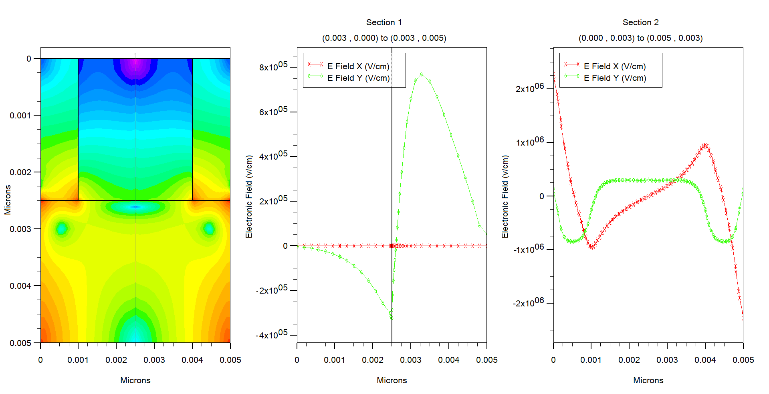
Section 2
Section 1
(a)
(b)
(c)
Fig. S4 (a) Electric field in the HFET with a perovskite barrier, and (b) and (c) the electric field along the vertical and horizontal cut lines (silicon surface).
Fig. S5 illustrates the energies corresponding to the conduction- and valence-band edges. In Fig. S5 (c), the energy levels across the mid-plane of the structure and along the direction perpendicular to the surface are also shown. These results have likewise been obtained under zero applied bias. As expected, the curvature of the energy levels within the perovskite (MAPbI₃) region is small, owing to the intrinsic treatment of this layer. The slight discrepancy between the bandgap values entered into the software and those displayed in Fig. S5 (c) arises from the use of a quantum model for this structure. In other words, the levels shown in Fig. S5 correspond to the lowest-energy states of the conduction band and the highest-energy states of the valence band, calculated using the Schrödinger equation.
An examination of the current density provides a useful perspective on carrier transport in the Si–MAPbI₃ structure. Fig. S6 presents the electron and hole current densities on a logarithmic scale. The simulations in this section were performed under an applied bias of 0.1 V between the two electrodes. As shown in Fig. S6, the current in this structure is predominantly carried by electrons and is generated primarily at the perovskite–substrate interface. However, the reduction in electron current density near the electrode held at positive potential (electrode 1) is due to the introduction of impurities beneath the perovskite layer (associated with the effect of the linker molecules). Consequently, carrier transport in this region occurs mainly via tunneling.
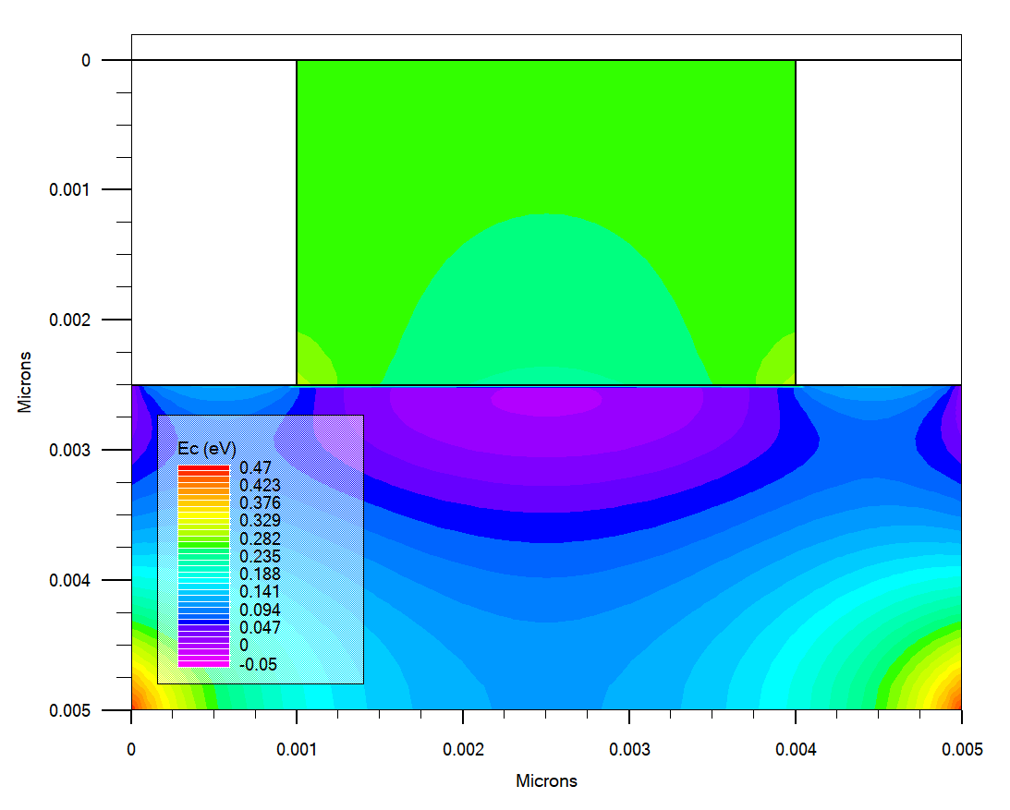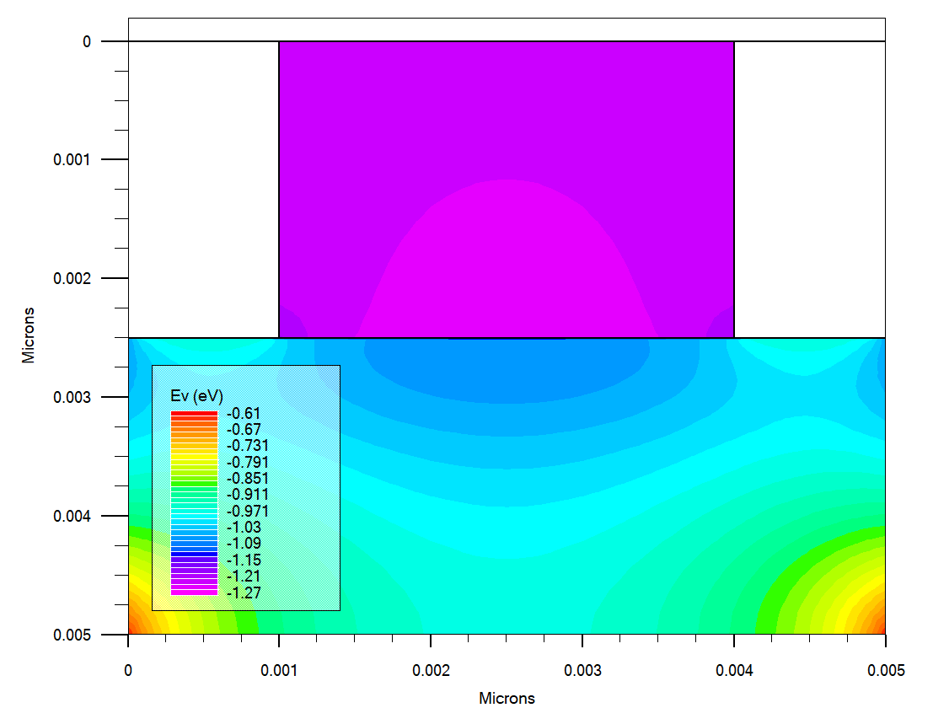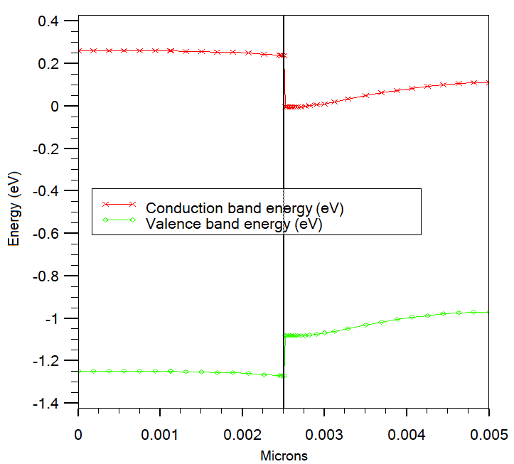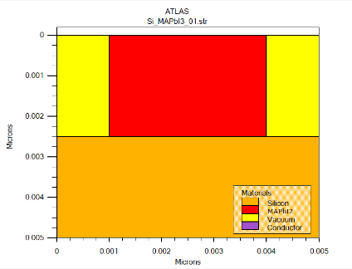
Cut Line
Silicon
Silicon
MAPbI₃
MAPbI₃
(a)I₃
(b)I₃
(c)
Fig. S5 (a) Conduction-band and (b) valence-band energy levels in the Si–MAPbI₃ structure, and (c) the conduction- and valence-band energy levels shown at the mid-plane of the structure along the direction perpendicular to the surface.
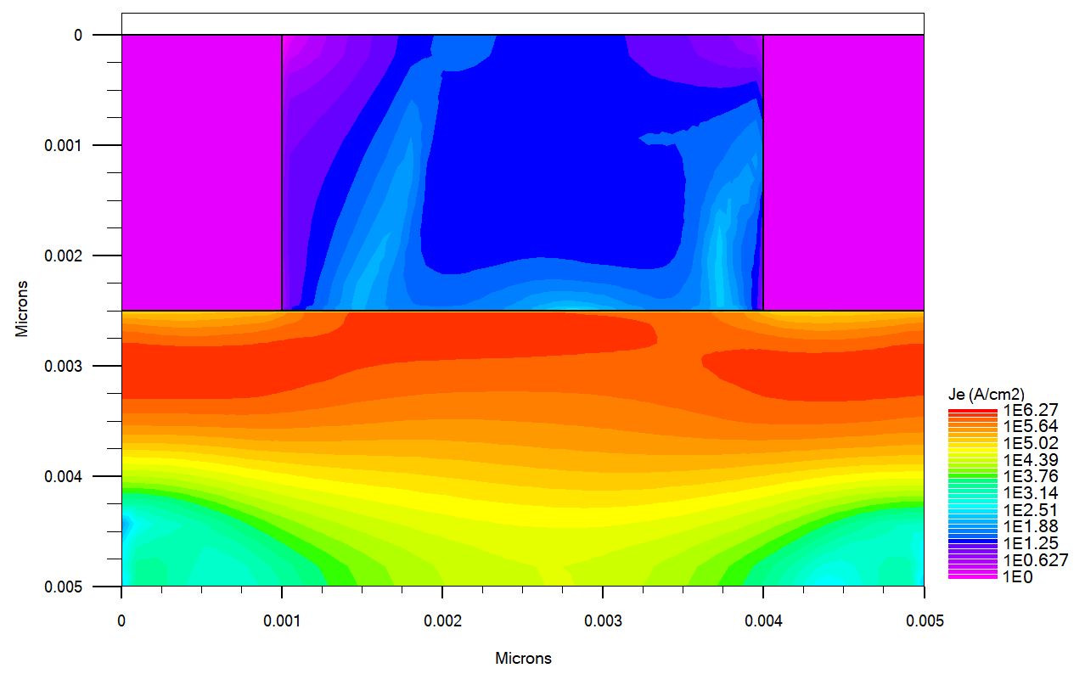
(a)
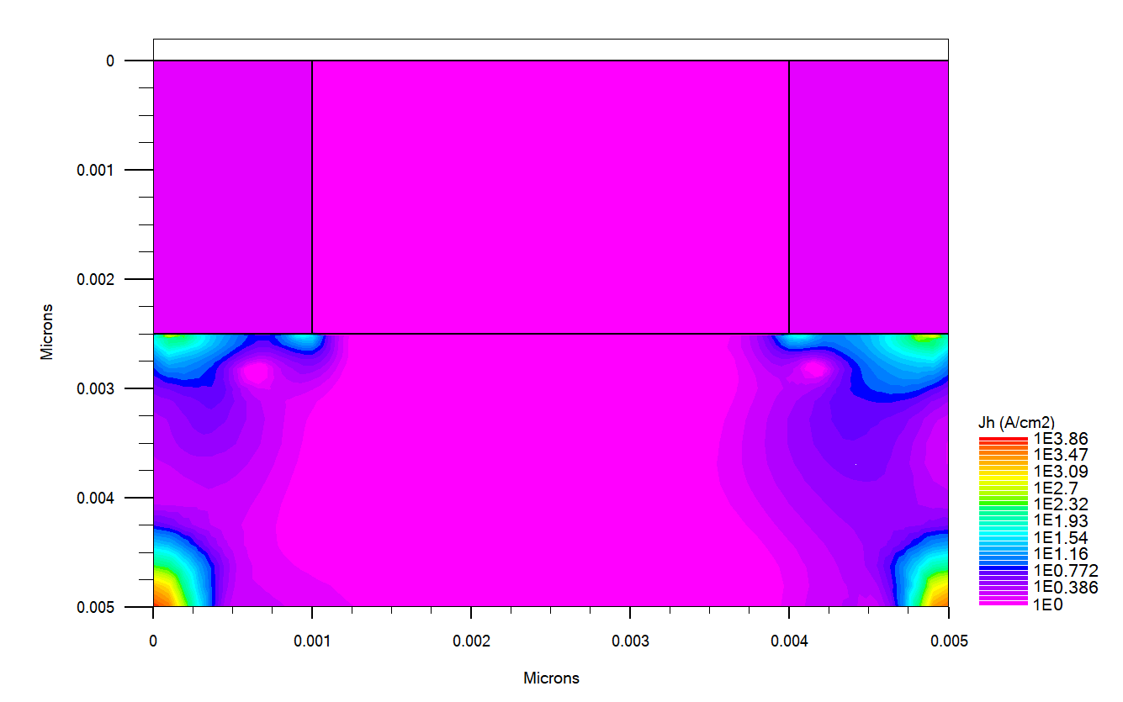
(b)
Fig. S6 Electron (a) and hole (b) current density (in logarithmic scale) in the Si–MAPbI₃ structure under an applied voltage of 0.1 V between the two electrodes.

Supplementary Simulation Parameters and Simulation Result
Table S1 Simulation parameters in the ATLAS software
Structure Parameters
25nm | Silicon thickness
30 nm – 5 nm | MAPbI₃ thickness
350 nm | Drain/Source doped length
50 nm | Gate-Source space
100 nm | Drain-Gate space
250 nm | Gate length
300nm | Drain/Source length
1100 nm | Total length
Contact Parameter
4.64 | Gate workfunction
Doping Parameters
10¹⁸ cm⁻³ | Drain/Source doping
Intrinsic | Channel doping
3.26×10¹² cm⁻³ | Barrier doping
2×10²⁰ cm⁻³ Gaussian Char=6 Å | Surface doping
Trap
2.1×10¹³ cm⁻³ | Density | Energy Level*= 0.1 | Donor
4.4×10¹³ cm⁻³ | Density | Energy Level*= 0.3 | Donor
6.5×10¹³ cm⁻³ | Density | Energy Level*= 0.1 | Acceptor
Material Parameters
23.3 F/m [1] | Permittivity | MAPbI₃
3.93 eV [2] | Electron affinity
1.56 eV [3] | Bandgap
0.76 [4] | Electron effective mass
0.35 [4] | Hole effective mass
1.66×10¹⁹ cm⁻³ [5] | N_{C}
5.41×10¹⁸ cm⁻³ [5] | N_{V}
0.7 cm²/V.s [6] | Electron mobility
0.4 cm²/V.s [6] | Hole mobility
11.8 F/m | Permittivity | Silicon
4.17 eV | Electron affinity
1.08 eV | Bandgap
2.8×10¹⁹ cm⁻³ | N_{C}
1.04×10¹⁹ cm⁻³ | N_{V}
1000 cm²/V.s | Electron mobility
* The energy distance between conductance band and trap level for acceptor trap, and the energy distance between trap level and valence band for donor trap [7].

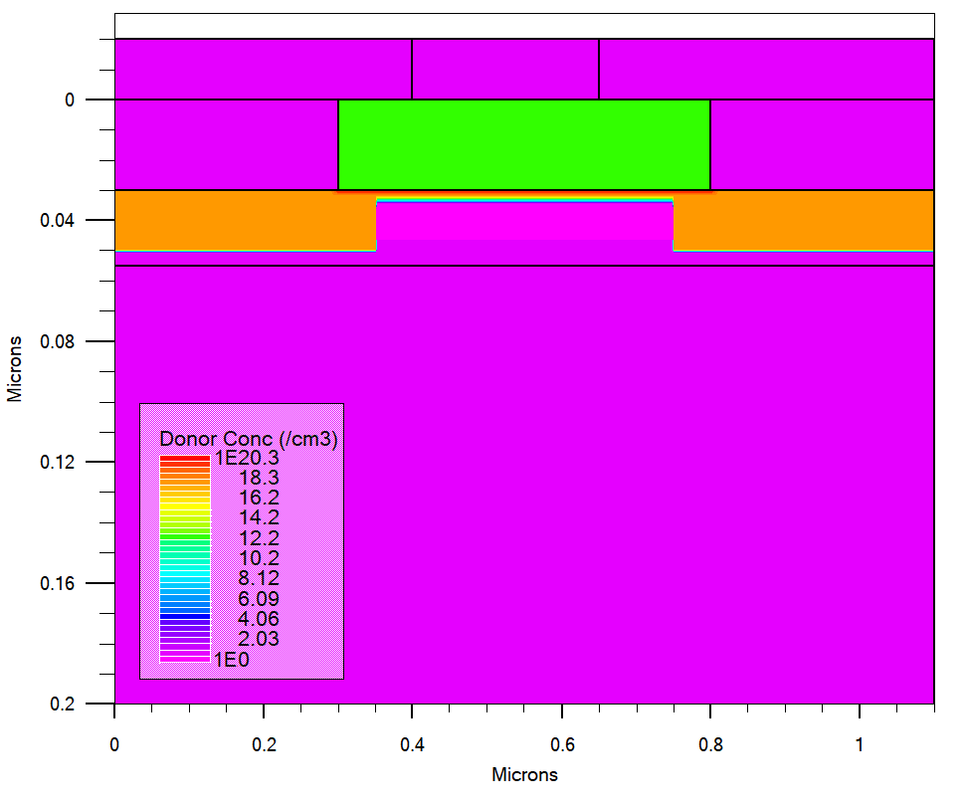

Fig. S7 Impurity distribution (on a logarithmic scale) in the HFET with a perovskite barrier.

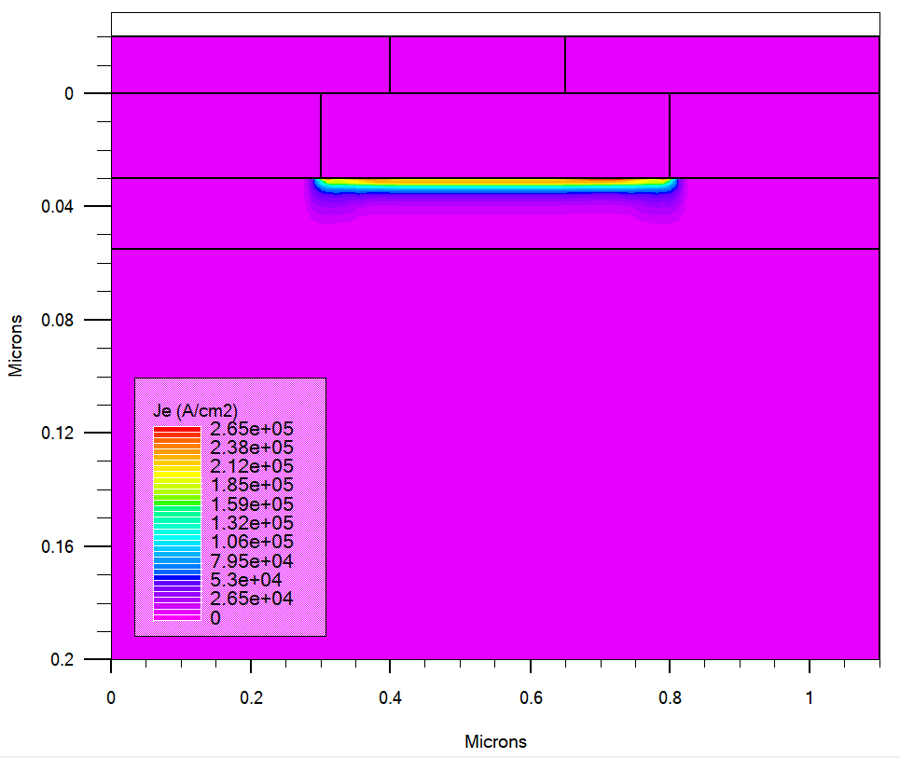
Fig. S8 Current density at the barrier–substrate interface for the HFET based on the Si–APS–MAPbI₃ structure with a 30 nm perovskite layer under equilibrium (V_{DS} = 0.05 V).

References:
[1] N. Onoda-Yamamuro, T. Matsuo, and H. Suga, “Dielectric study of CH3NH3PbX3 (X = Cl, Br, I),” J. Phys. Chem. Solids, vol. 53, no. 7, pp. 935–939, Jul. 1992, doi: 10.1016/0022-3697(92)90121-S.
[2] W. A. Laban and L. Etgar, “Depleted hole conductor-free lead halide iodide heterojunction solar cells,” Energy Environ. Sci., vol. 6, no. 11, p. 3249, 2013, doi: 10.1039/c3ee42282h.
[3] S. Chen et al., “Atomic-scale imaging of CH3NH3PbI3 structure and its decomposition pathway,” Nat. Commun., vol. 12, no. 1, p. 5516, Dec. 2021, doi: 10.1038/s41467-021-25832-9.
[4] J. Feng and B. Xiao, “Crystal Structures, Optical Properties, and Effective Mass Tensors of CH 3 NH 3 PbX 3 (X = I and Br) Phases Predicted from HSE06,” J. Phys. Chem. Lett., vol. 5, no. 7, pp. 1278–1282, Apr. 2014, doi: 10.1021/jz500480m.
[5] A. Zhang, Y. Chen, and J. Yan, “Optimal Design and Simulation of High-Performance Organic-Metal Halide Perovskite Solar Cells,” IEEE J. Quantum Electron., vol. 52, no. 6, pp. 1–6, Jun. 2016, doi: 10.1109/JQE.2016.2563783.
[6] L. M. Herz, “Charge-Carrier Mobilities in Metal Halide Perovskites: Fundamental Mechanisms and Limits,” ACS Energy Lett., vol. 2, no. 7, pp. 1539–1548, Jul. 2017, doi: 10.1021/acsenergylett.7b00276.
[7] Atlas User’s Manual. 2015.

Corresponding Author (E-mail: darvish_gh@iau.ir)

