Supplementary File for
Measuring atmospheric microplastic composition and concentration from an uncrewed aerial system

Supplemental Material S1: calculation of sampled volume of air
Step 1: from reading m from the differential pressure sensor to pressure $P_{PSI}$in PSI
$P_{PSI}=a_{P}×m+b_{P}$ (eq. S1)
With $a_{P}$= 0.000115 and $b_{P}$= 0.01113 from the differential pressure sensor calibration.
Step 2: from differential pressure $P_{PSI}$ to pressure $P_{H2O}$ in cm of H₂O
$P_{H2O}=P_{PSI}×C_{H2O}$ (eq. S2)
With $C_{H2O}$ = 70.307 cm of H₂O
Step 3: from differential pressure $P_{H2O}$ to flow rate Q in L min⁻¹
$Q = {\left(\frac{P_{H2O}}{a_{Q}}\right)}^{\frac{1}{b_{Q}}}$ (eq. S3)
With $a_{Q}$ = 0.005304 and $b_{Q}$ = 2.147355 provided by the cyclone constructor (Fig. 1b).
Step 4: from flow rate Q to volume V in m³
$V=T×Q$ (eq. S4)
With T the flight time when the air was sampled (Table 1)

Supplemental Material S2: uncertainty of sampled volume of air
Considering the propagation of error from the reading m and the associated standard deviation Δm obtained for the sUAS flight measurements, the error from the volume calculation is:
$ΔV= \frac{dV}{dm} Δm$ (eq. S5)
$ΔV= \left[\frac{a_{P}}{\left(b_{Q}\left(a_{P}.m+b_{P}\right)\right)}\right].V. Δm$ (eq. S6)
$ΔV$ is calculated for each sUAS flight measurements (Table 1)
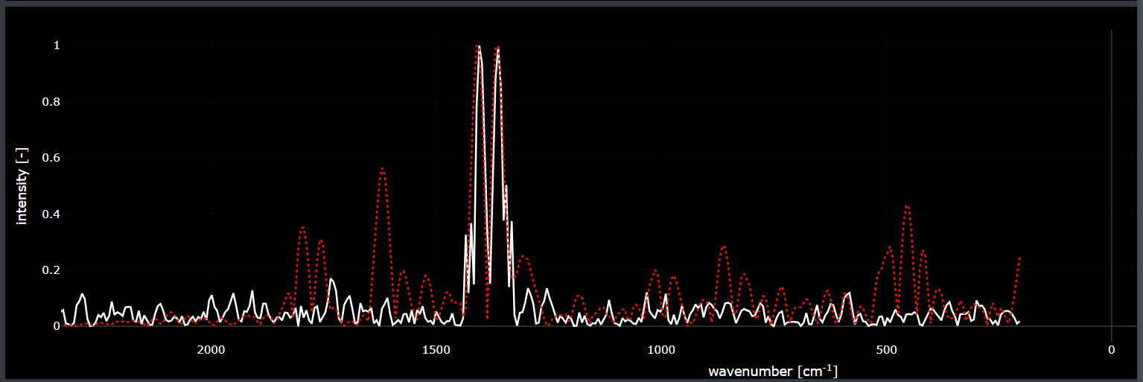
Figure S1. Example of an environmental sample spectrum successfully matching the OpenSpecy reference libraries. The red dotted line represents the most similar match found in the library spectra, while the white line represents a particle sample spectrum.

Table S1: Example of top OpenSpecy matches for selected particles. For each spectrum, the best-match material class, correlation-based match value, and signal-to-noise ratio are shown. Signal-to-noise scale (S/N) values: ≥10 is very good S/N, peaks are well resolved; values 5-10 is usable, but noise can still affect matching; values <5 is low S/N, matches become uncertain and often end up as “unknown” or ambiguous.
file_name | material_class | match_val | signal_to_noise
03 Spectrum--033--Spec.Data 1_OPENSPACY.csv | mineral | 0.716 | 12.871
05 Spectrum--040--Spec.Data 1_OPENSPACY.csv | polyimides | 0.612 | 12.062
13 Spectrum--063--Spec.Data 1_OPENSPACY.csv | poly(esters/ethers/diglycidylethers/  terephthalates)s | 0.551 | 6.0144
14 Spectrum--065--Spec.Data 1_OPENSPACY.csv | unknown | 0.492 | 6.441
12 Spectrum--060--Spec.Data 1_OPENSPACY.csv | unknown | 0.466 | 7.803
15 Spectrum--068--Spec.Data 1_OPENSPACY.csv | unknown | 0.419 | 4.138
07 Spectrum--046--Spec.Data 1_OPENSPACY.csv | unknown | 0.377 | 2.280
02 Spectrum--030--Spec.Data 1_OPENSPACY.csv | unknown | 0.369 | 1.728
11 Spectrum--057--Spec.Data 1_OPENSPACY.csv | unknown | 0.361 | 3.236
09 Spectrum--052--Spec.Data 1_OPENSPACY.csv | unknown | 0.360 | 2.696
06 Spectrum--043--Spec.Data 1_OPENSPACY.csv | unknown | 0.344 | 2.195
01 Spectrum--027--Spec.Data 1_OPENSPACY.csv | unknown | 0.332 | 5.171
10 Spectrum--054--Spec.Data 1_OPENSPACY.csv | unknown | 0.327 | 2.520
08 Spectrum--049--Spec.Data 1_OPENSPACY.csv | unknown | 0.304 | 3.917
04 Spectrum--038--Spec.Data 1_OPENSPACY.csv | unknown | 0.277 | 5.579

Table S2: Calculation of robustness based on limits of detection from Dawson et al. (2023) for fragment and filament plastic-like particles. LoD means limits-of-detection, LoQ means limits-of-quantification, Corr means samples corrected with blanks, SD means standard deviation.
Fragments
SampleID |  | Location | Counts | Corr_LoD | Volume (m³) | Concentration (m⁻³)
20240920 |  | Arvada | 28 | 9 | 2.16 | 4.17
20240902 |  | Arvada | 23 | 14 | 2.38 | 5.88
20240919 |  | Erie | 25 | 9 | 2.29 | 3.93
20241003 |  | Erie | 29 | 18 | 2.38 | 14.40
B_20240920 |  | Blank | 19
B_20240902 |  | Blank | 9
B_20240919 |  | Blank | 16
B_20241003 |  | Blank | 10
BL |  | Lab blank | 1
 |  |  | Mean Blank | SD blank | LoD | LoQ | LoD/LoQ
 |  |  | 11.50 | 7.94 | 35.31 | 90.87 | 0.39
Filaments
SampleID | Location |  | Counts | Corr_LoD | Volume (m³) | Concentration (m⁻³)
20240920 | Arvada |  | 4 | 3 | 2.16 | 1.39
20240902 | Arvada |  | 18 | 14 | 2.38 | 5.88
20240919 | Erie |  | 8 | 7 | 2.29 | 3.06
20241003 | Erie |  | 6 | 2 | 2.38 | 1.60
B_20240920 | Blank |  | 1
B_20240902 | Blank |  | 4
B_20240919 | Blank |  | 1
B_20241003 | Blank |  | 4
BL | Lab blank |  | 1
 |  |  | Mean Blank | SD blank | LoD | LoQ | LoD/LoQ
 |  |  | 1.75 | 1.50 | 6.25 | 16.75 | 0.37

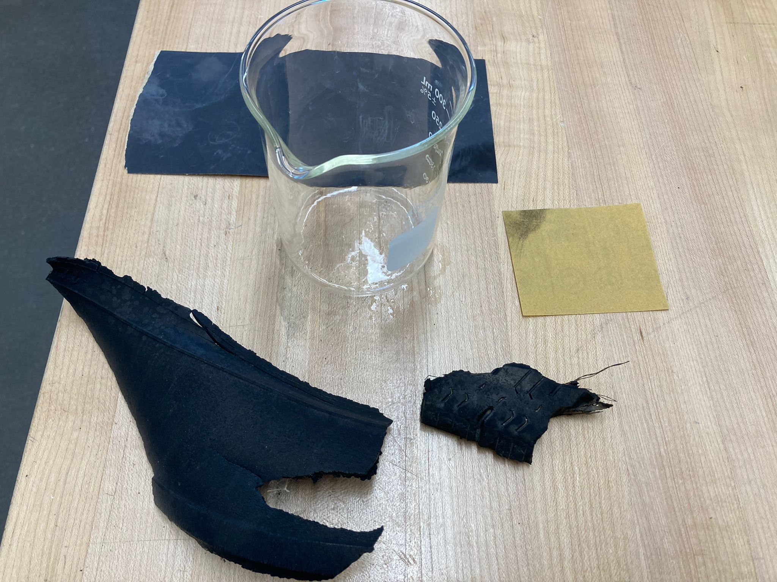
Figure S2. Old tire parts found on the road side at Erie, CO. Particles from the tires were grated with sandpaper to deionized water and transferred to a filter following the same analysis process as the flight samples.
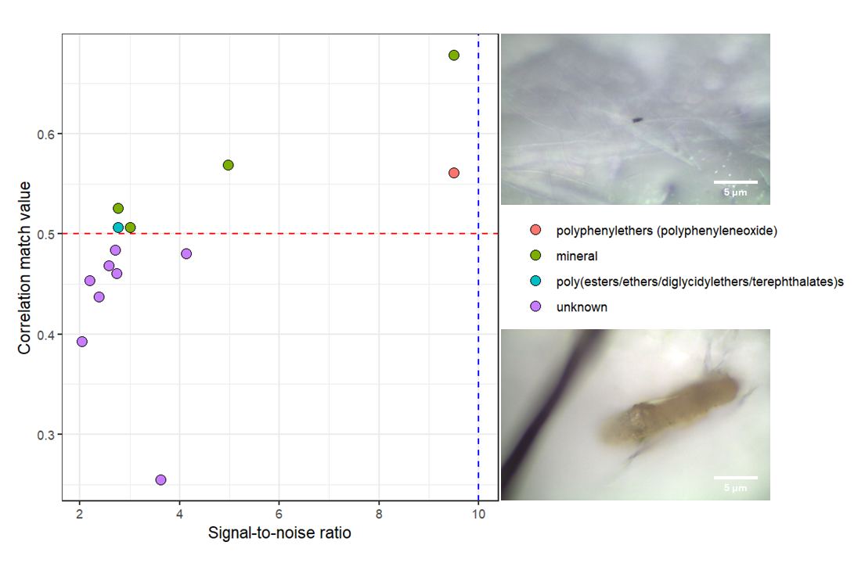
Figure S3: Relationship between Raman spectral signal-to-noise ratio and correlation match value for particles analyzed in tire-wear samples (N=14). Colors indicate the assigned material class from spectral matching. The dashed horizontal line indicates the correlation match threshold used for confident identification, and the dashed vertical line indicates the signal-to-noise threshold. Representative microscope images of the identified plastic particles are shown on the right, with scale bars of 5 µm.

