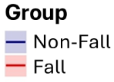
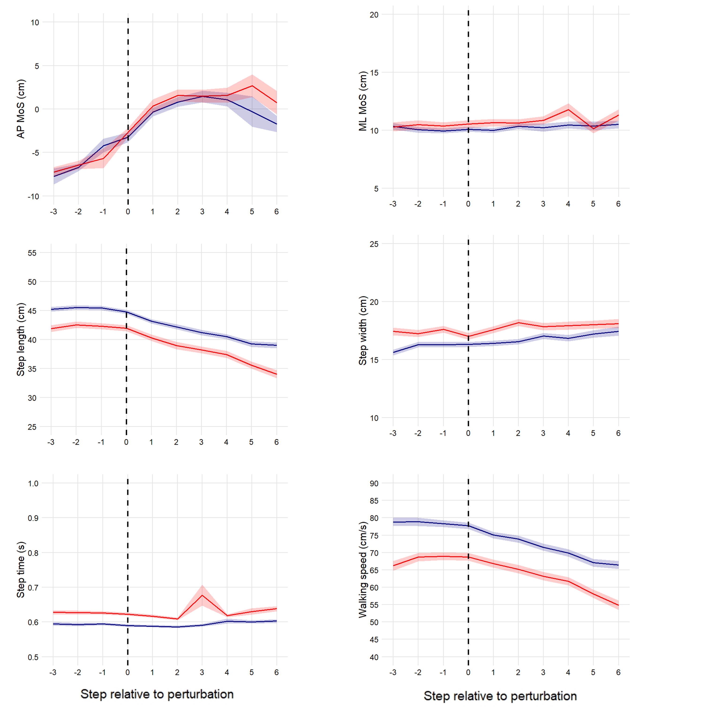

Supplementary 1: MoS and STPs within all head movement directions. The dotted line indicates the transition step upon which the head movements starts. All negative step numbers (-3 to 0) are prior and all positive step numbers (0 to 6) are during the head movement (x-axis). The blue line corresponds to the Control group and the red line to the Fall group. MoS, Step length, and Step width are in centimeter (cm), Walking speed is in centimeter per second (cm/s), Step time is in seconds (s).

