Supplementary figures
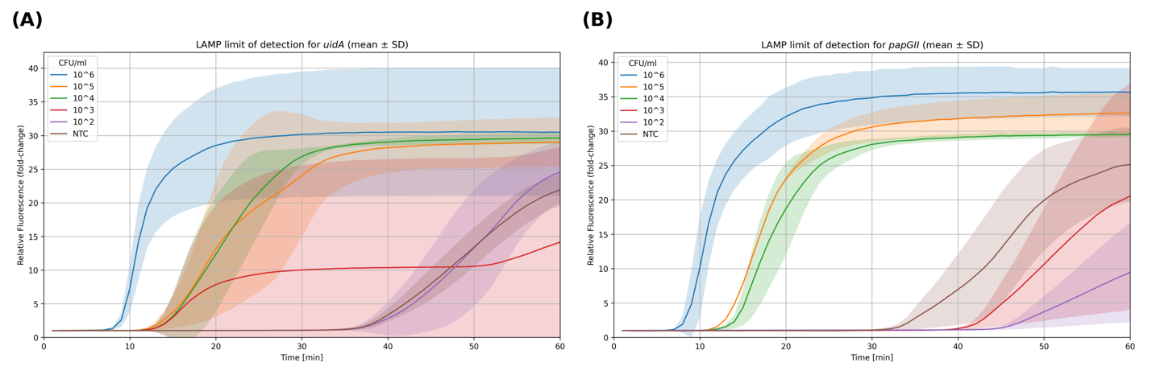
Supplementary Figure 1. Fluorescence LAMP amplification plots for a dilution series of papGII-positive E. coli with primers for (A) uidA and (B) papGII. Measurements were taken from three biological replicates. Fluorescence values were normalized to the first time point (fold-change) to reduce baseline differences. Curves are stratified by bacterial load. Solid lines indicate mean, shaded bands indicate ± standard deviation.
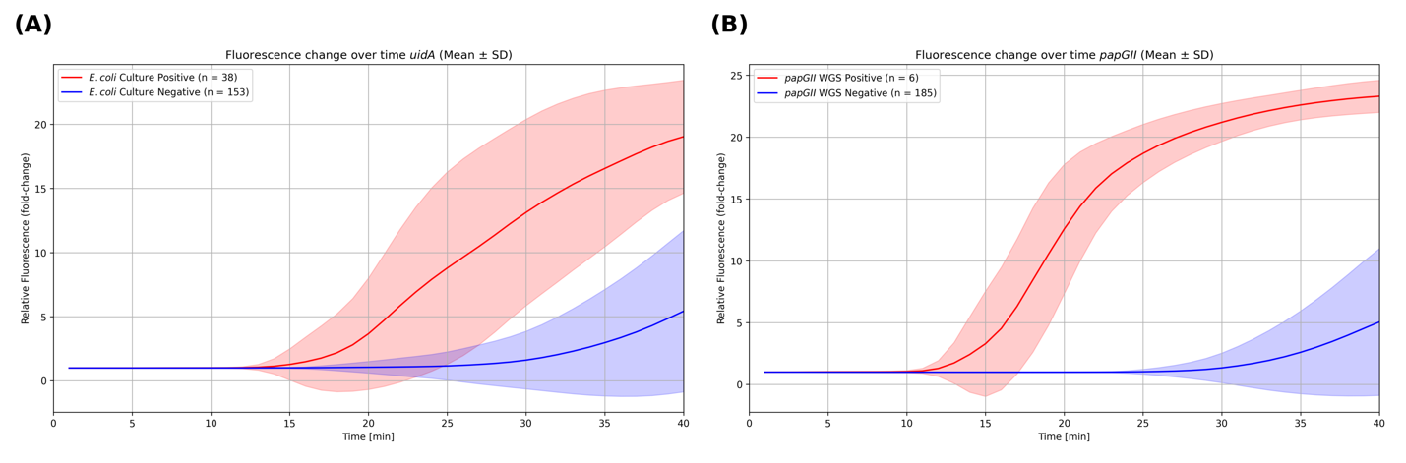
Supplementary Figure 2. Fluorescence kinetics of LAMP assays for the detection of (A) uidA (E. coli) and (B) papGII in clinical urine samples (n = 191). Fluorescence values were normalized to the first time point (fold-change). Curves are stratified based on the reference method (red = positive, blue = negative; culture for E. coli, WGS for papGII). Within each plot, solid lines indicate mean and shaded bands indicate variability (± standard deviation).

Supplementary tables
Time [min] | Fluorescence fold-change | Youden’s index score | Sensitivity | Specificity | PPV | NPV
39 | 11.40 | 0.82 | 0.95 | 0.87 | 0.64 | 0.99
30 | 2.88 – 3.25 | 0.82 | 0.87 | 0.95 | 0.80 | 0.97

Supplementary Table 2. Diagnostics metrics for the best 2 thresholds ranked by Youden’s index score for uidA (E. coli).

Time [min] | Fluorescence fold-change | Youden’s index score | Sensitivity | Specificity | PPV | NPV
30 (fixed) | 3.00 (fixed) | 0.95 | 1.00 | 0.95 | 0.38 | 1.00
30 (fixed) | 11.69 – 19.58 | 1.00 | 1.00 | 1.00 | 1.00 | 1.00
20 - 25 | 3.00 (fixed) | 1.00 | 1.00 | 1.00 | 1.00 | 1.00
Supplementary Table 3. Diagnostics metrics for papGII with different thresholds fixed.
Metric | Equation
Sensitivity | $$\frac{TP}{TP+FN}$$
Specificity | $$\frac{TN}{TN+FP}$$
Youden’s index score | $$Sensitivity+Specificity-1$$
Positive Predictive Value (PPV) | $$\frac{TP}{TP+FP}$$
Negative Predictive Value (NPV) | $$\frac{TN}{TN+FN}$$
Supplementary Table 4. Diagnostics metrics used in this study.

