Supplementary Material
Selective fragmentation of polyphthalamide via induced foaming assisted ball milling for multi-component recovery from LEDs
Mingfei Xing^{1*}, Ping Xu¹, Yun Zhao¹, Shuofei Fu¹, Mingshi Wang¹, Li Zhao¹, Fayang Guo¹, Fengcheng Jiang¹
¹Institute of Resource and Environment, Henan Polytechnic University, Jiaozuo, China
Supplementary Material Content：
7 pages (including the cover page),
6 Figures,
3 Tables.

Elemental composition of waste LED
The metal lead frame was digested using a microwave digestion system (Anton Paar Microwave PRO) with 1.5 mL of nitric acid and 4.5 mL of hydrochloric acid at 170 °C and 40 bar for 30 min. The digested solution was subsequently evaporated to near dryness, diluted, and analyzed for elemental composition using ICP-OES (Avio 500).
Table. S1. Elemental composition of the metal lead frame
element | Ag | Al | Cu | Fe | Ni | Zn
Content (%) | 0.015±0.002 | 0.021±0.0001 | 65.50±0.85 | 0.011±0.001 | 0.39±0.02 | 34.07±0.31

Experimental design
Table. S2. Subcritical water experimental parameters
 | Temperature (℃) | Holding time(min) | Liquid to solid ratio | Pressure（MPa）
1 | 255 | 20 | 40：1 | 3.7
2 | 270 | 20 | 40：1 | 4.6
3 | 285 | 20 | 40：1 | 5.5
4 | 300 | 20 | 40：1 | 6.4
5 | 315 | 20 | 40：1 | 9.3
6 | 285 | 25 | 40：1 | 5.5
7 | 285 | 15 | 40：1 | 5.5
8 | 285 | 10 | 40：1 | 5.5
9 | 285 | 5 | 40：1 | 5.5
10 | 255 | 10 | 40：1 | 3.7
11 | 270 | 10 | 40：1 | 4.6
12 | 300 | 10 | 40：1 | 6.4
13 | 315 | 10 | 40：1 | 9.3
14 | 285 | 10 | 20：1 | 4.6
15 | 285 | 10 | 10：1 | 4.6
16 | 285 | 10 | 5：1 | 4.6
17 | 285 | 10 | 1：1 | 4.6
EDS spectrum of virgin PPA cross-section
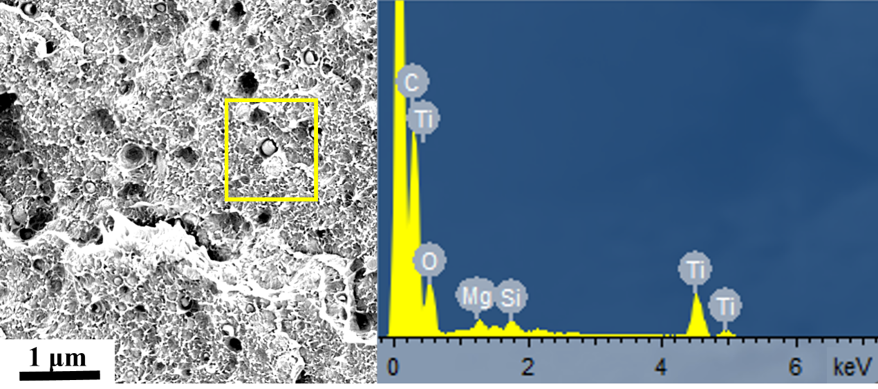
Fig. S1. EDS spectrum of virgin PPA cross-section
From Fig. S1, the presence of Ti in PPA indicates the incorporation of titanium dioxide, which serves as a whitening agent in the plastic. The detection of Si and Mg elements can be attributed to the additives contained in the PPA material.

FTIR spectra of PPA obtained at different SubCW treatment temperatures.
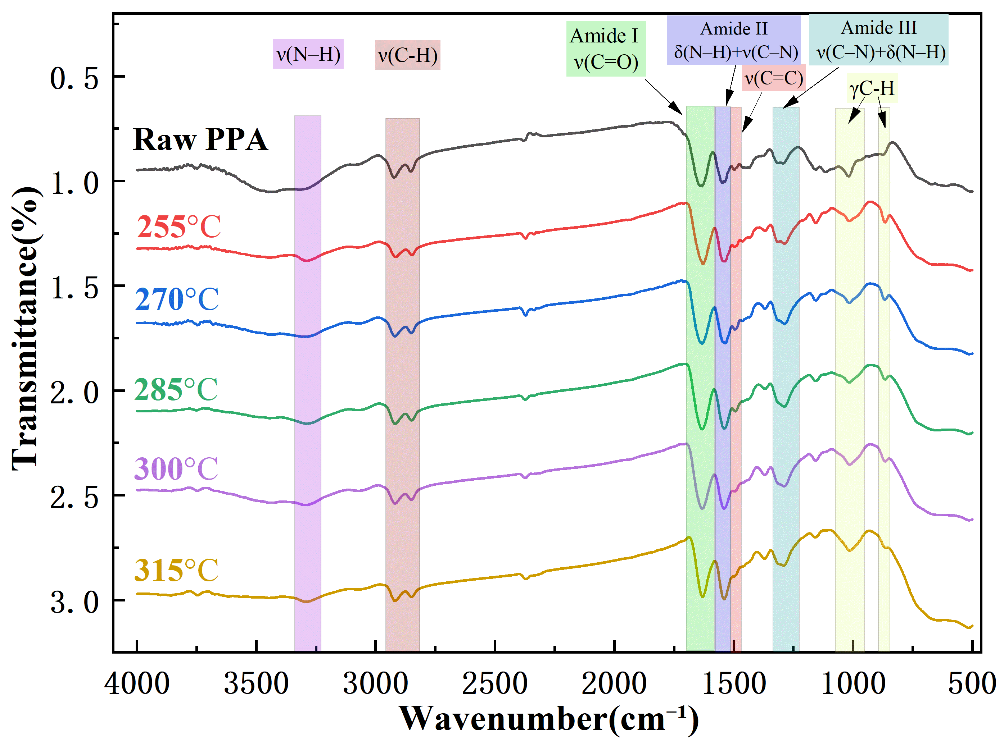
Fig. S2. FTIR spectra of PPA obtained at different SubCW treatment temperatures.
Analysis of oil-phase products after subcritical water treatment
The oil-phase products obtained from LEDs after subcritical water treatment were analyzed using gas chromatography–mass spectrometry (GC–MS, Agilent 7890A/5975C, USA). A DB-5 capillary column (60 m × 0.25 mm × 0.25 μm) was employed. The oven temperature program was set as follows: initial temperature of 50 °C (held for 5 min), ramped at 10 °C/min to 280 °C, and maintained for 20 min.
Table. S3. GC–MS results of the oil-phase products obtained at different temperatures.
Components | Chemical formulas | Area (%)  (255℃) | Area (%)  (270℃) | Area (%)  (285℃) | Area (%)  (300℃) | Area (%)  (315℃)
Benzoic acid | C₇H₆O₂ |  |  |  |  | 28.11
2,4-Di-tert-butylphenol | C₁₄H₂₂O | 3.74 | 6.39 | 2.12 | 5.73
Tributyl phosphate | C₁₂H₂₇O₄P | 1.73 | 0.95 |  |  | 1.41
2,4-bis(1-methyl-1-phenylethyl) | C₂₄H₂₆O | 4.00 |  |  | 4.17
n-Hexadecanoic acid | C₁₆H₃₂O₂ | 32.73 | 34.08 | 16.58 | 14.1 | 16.24
Bicyclo[3.3.1]nona-2,6-diene | C₁₄H₁₁N |  |  |  | 5.87
Eicosyl isobutyl ether | C₂₄H₅₀O | 1.19
Tetrazolo[1,5-a]pyrimidine, 5,7-dimethyl | C₆H₇N₅ |  |  |  | 12.70
Oleic Acid | C₁₈H₃₄O₂ | 8.10 | 4.69 | 12.13 | 11.6 | 15.78
9-Octadecenoic acid, (E)- | C₁₈H₃₄O₂ |  |  | 30.07
Octadecanoic acid | C₁₈H₃₆O₂ | 25.82 | 24.64 | 17.14 | 12.58 | 13.79
N-Acrylonitryl-2,2-dimethylaziridine | C₄H₉N |  |  |  | 17.26
Ethyl hexadecyl ether | C₁₈H₃₈O | 2.13
9-Octadecenamide | C₁₈H₃₅N |  |  |  | 4.08
2,4,6-Trimethylbenzoic acid | C₁₀H₁₂O₂ |  |  | 1.23
(9E,11E)-Octadecadienoic acid | C₁₈H₃₂O₂ | 1.99 | 7.54 | 8.73 | 1.59 | 2.69
10E,12Z-Octadecadienoic acid | C₁₈H₃₂O₂ | 1.79 | 1.14
Proposed degradation mechanism of PPA plastic in subcritical water
The removal of PPA from waste LEDs is a key step toward the complete recovery of all components. Therefore, based on bond energy theory and GC–MS analysis, the possible degradation pathways of organic compounds in PPA under subcritical water conditions were investigated. The proposed degradation pathways of organics in PPA are illustrated in Fig. S3.
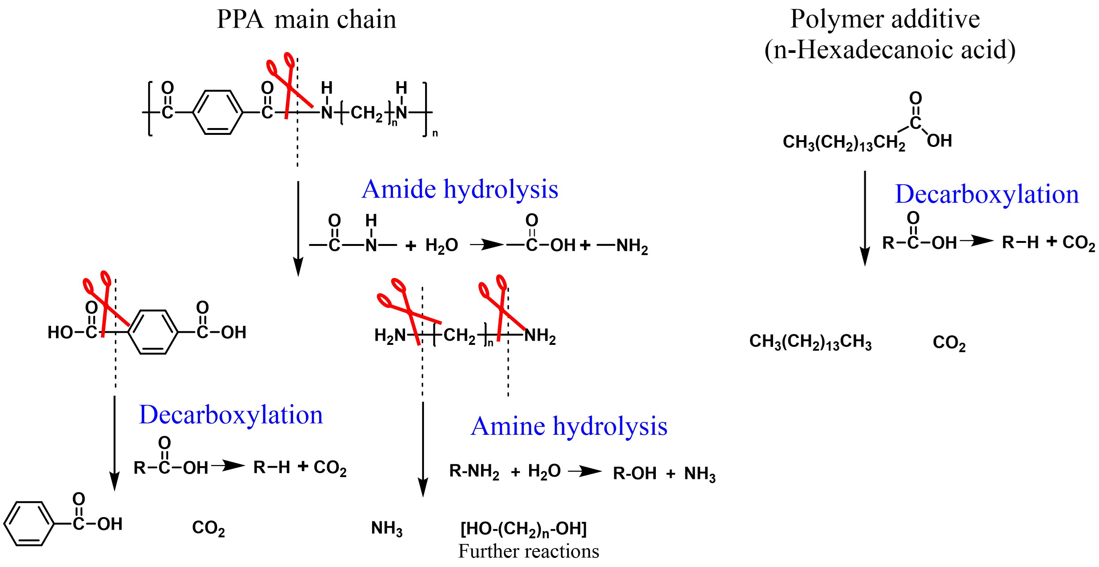
Fig. S3. Proposed bond cleavage and decomposition pathways of PPA and additives in SubCW.
Thermal performance analysis of virgin and recycled PPA
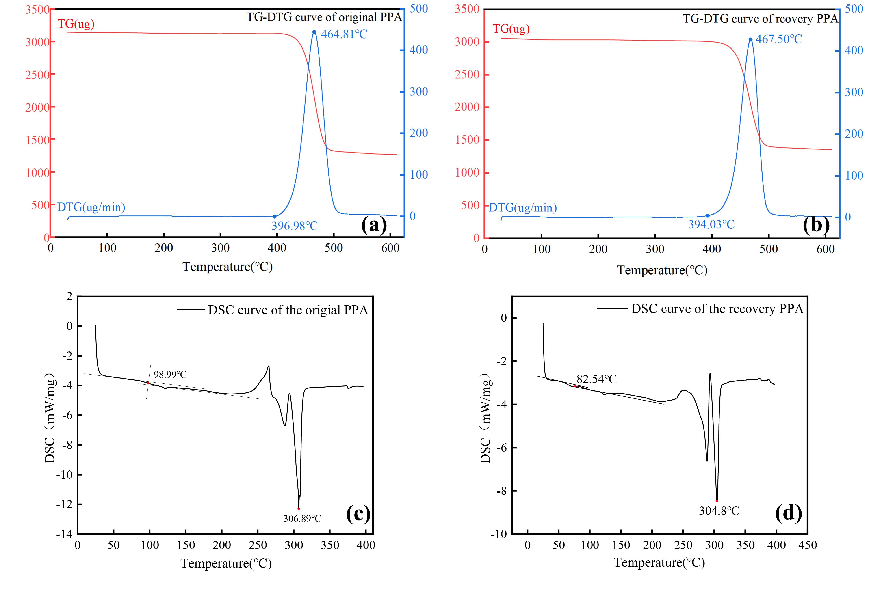
Fig. S4. TG–DTG curves (a, b) and DSC curves (c, d) of the virgin and recovered PPA.
SEM micrographs of the recycled products
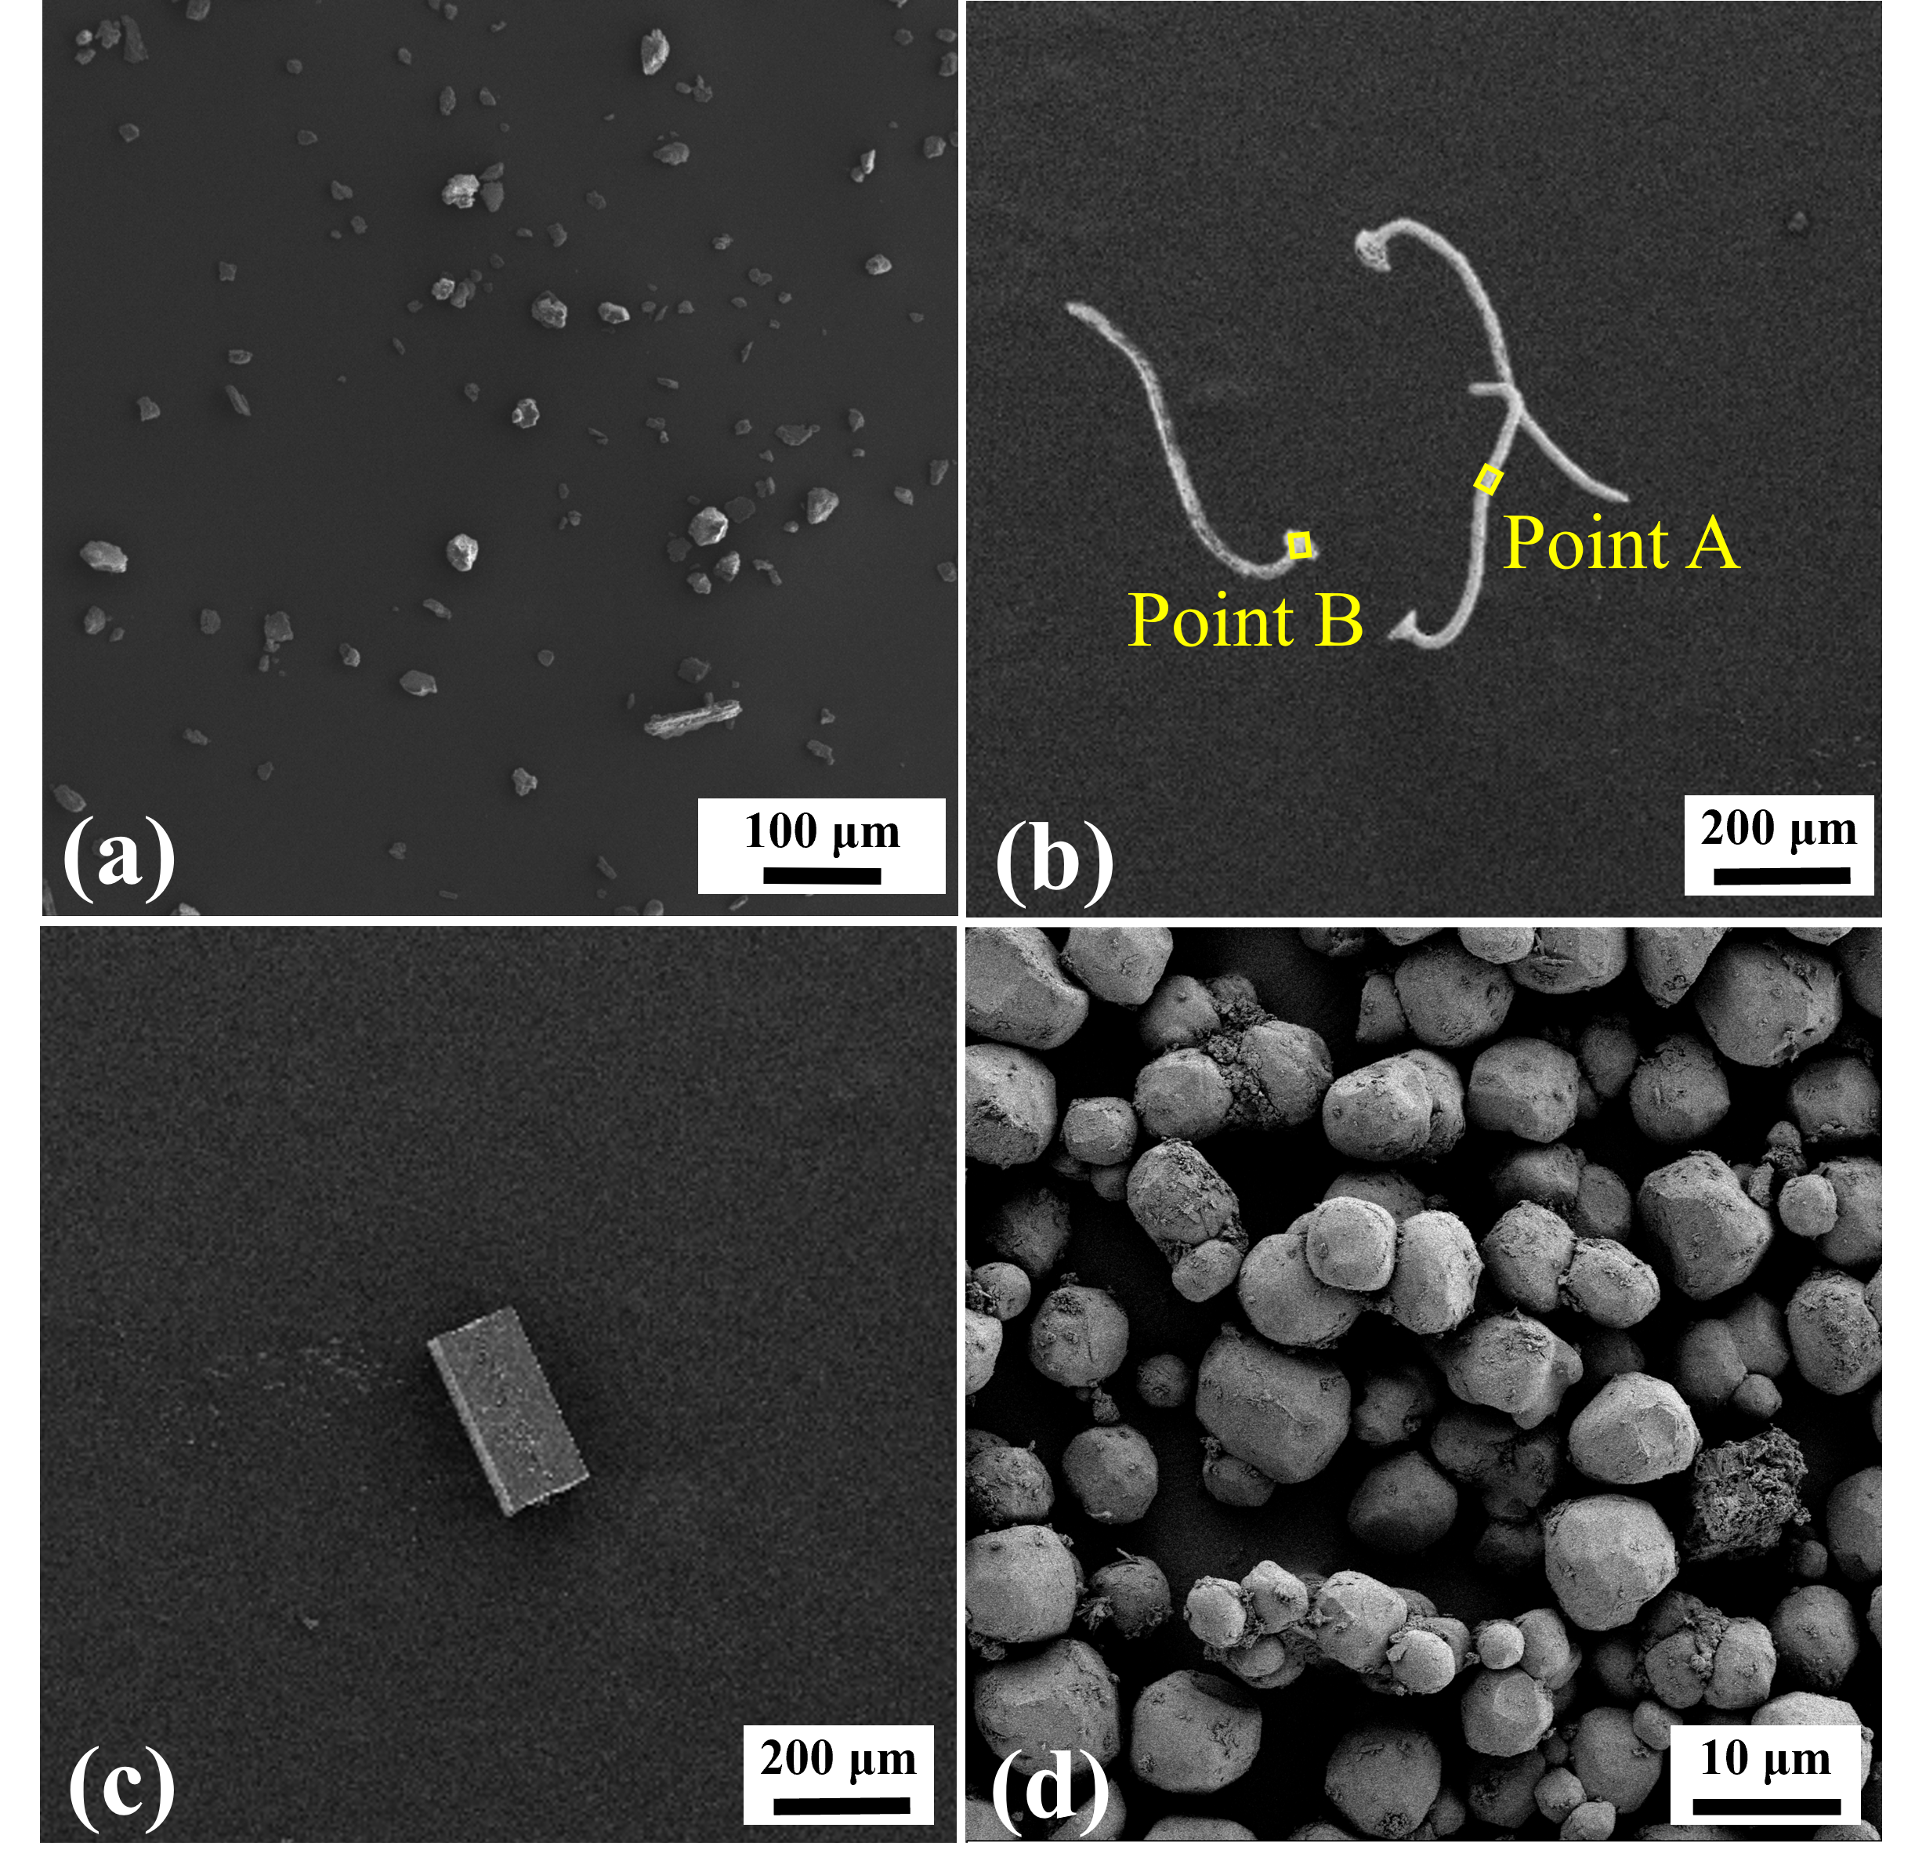
Fig. S5. SEM images of recovered products: PPA powder (a), silver wire(b), LED chip (c), and phosphor (d).

Glass fiber analysis in virgin and recycled PPA
To compare the morphology of glass fiber bundles in virgin and recycled PPA, 0.1g of each sample was accurately weighed and digested in 5mL of concentrated nitric acid using microwave-assisted digestion at 200°C for 30min. This treatment effectively removed the organic polymer matrix and exposed the embedded glass fibers. After digestion, the residues were thoroughly washed and dried, followed by microscopic examination to evaluate and compare the morphology of the glass fiber bundles.

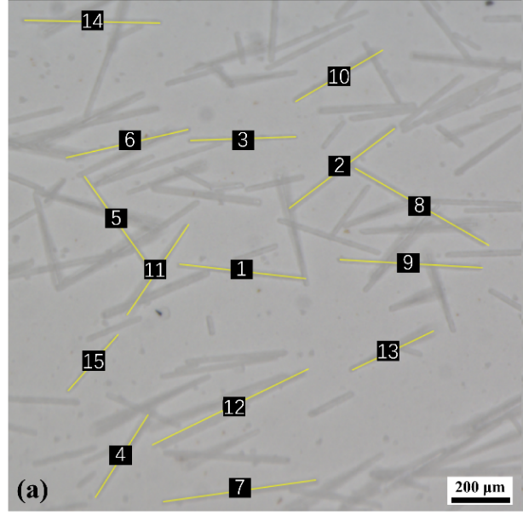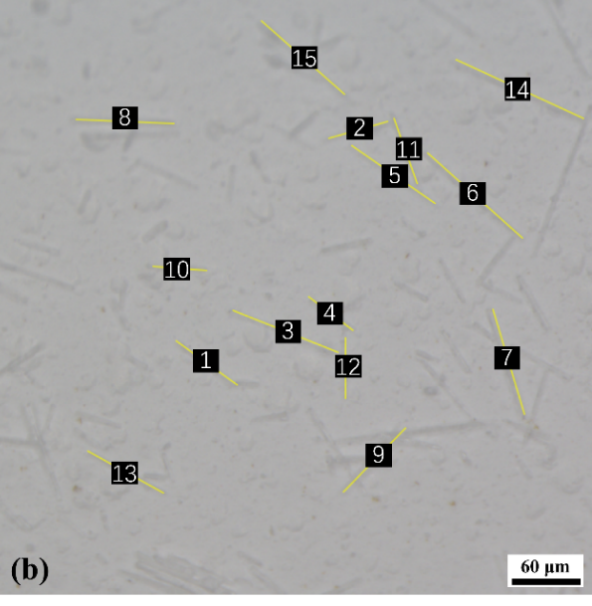
Fig. S6. Glass fibers in virgin PPA (a) and recycled PPA (b).

