Additional file 1. Supplementary Figures S1-S2
Supplementary material for: Association between a comprehensive governance strategy and the burden of urban non-traumatic multiple casualty incidents in China: a 14-year retrospective interrupted time-series study in Liuzhou, 2012-2025.
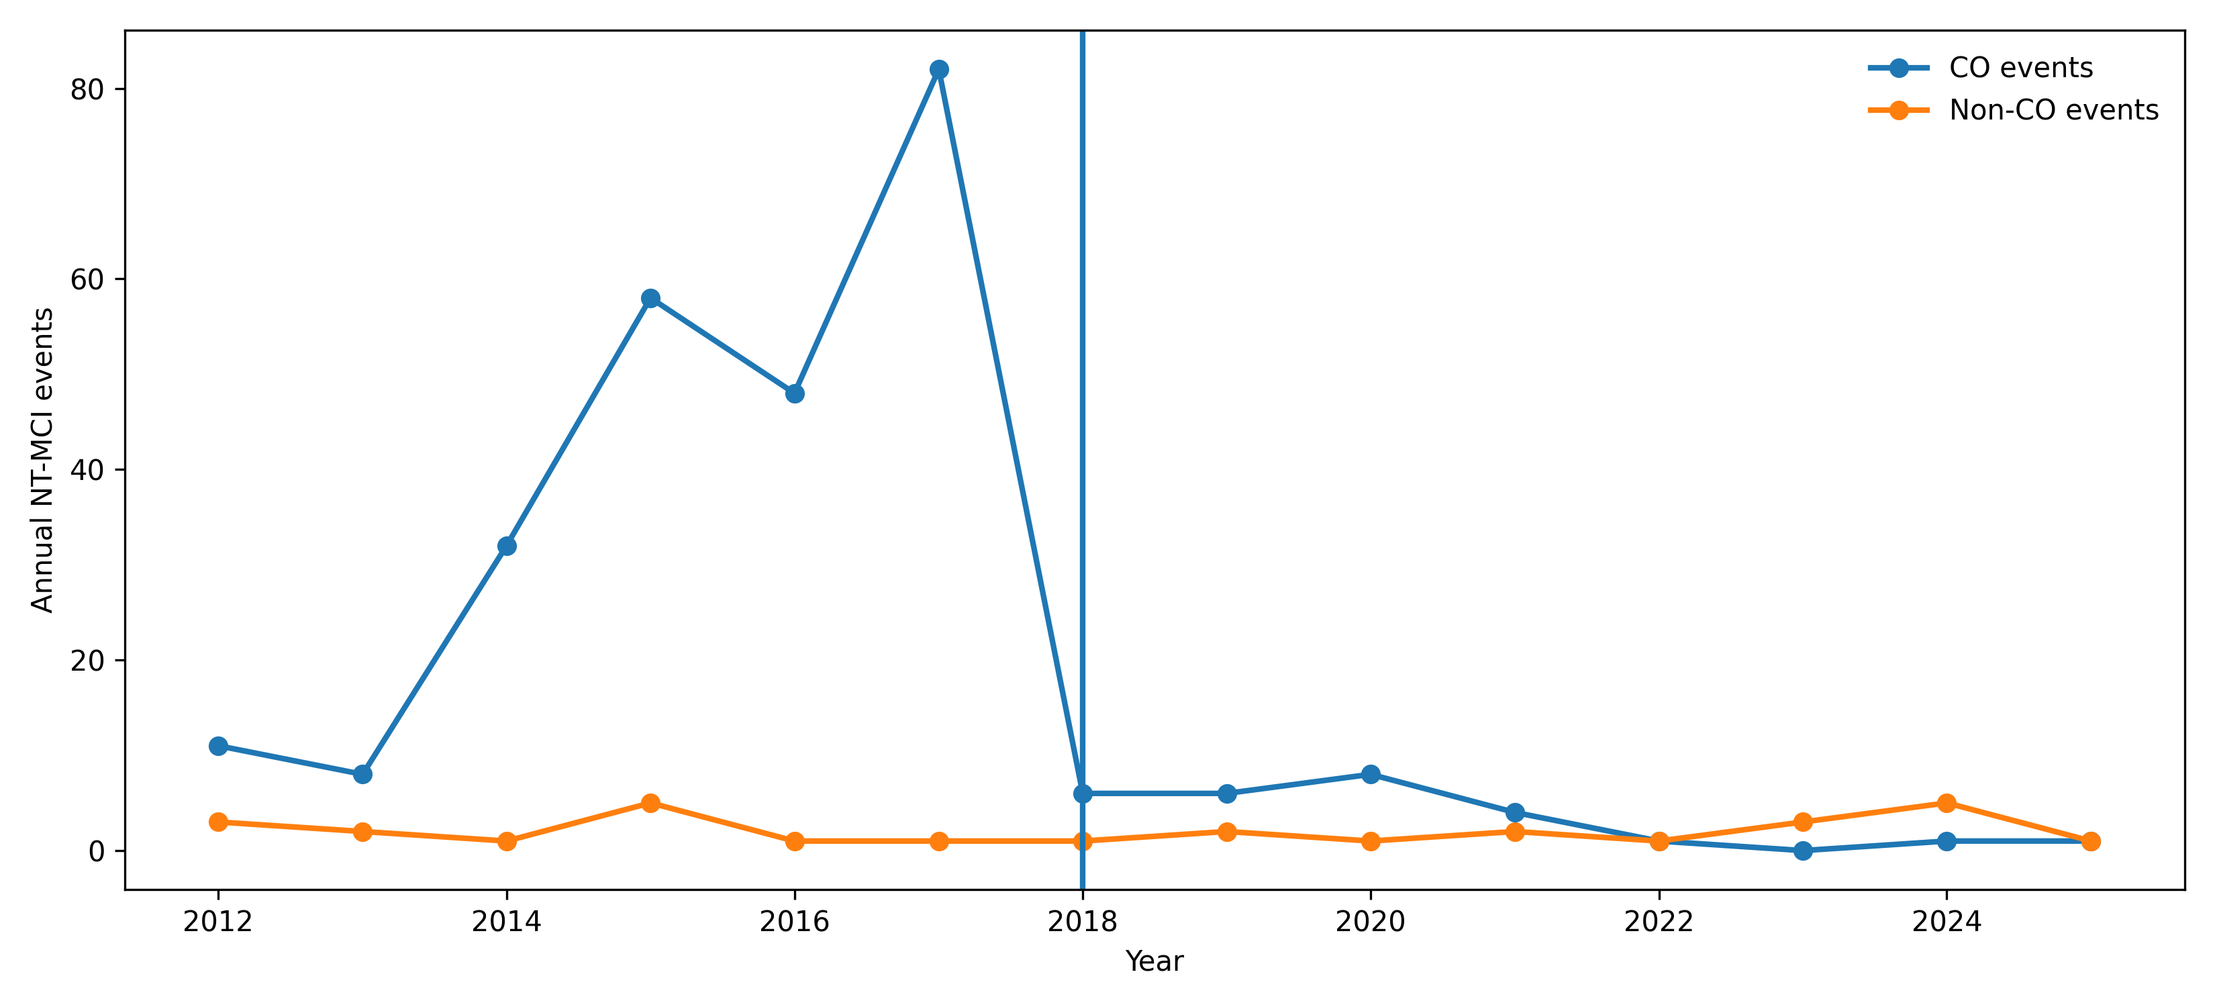
Supplementary Figure S1. Annual trends in CO and non-CO events, with the January 2018 policy start marked.
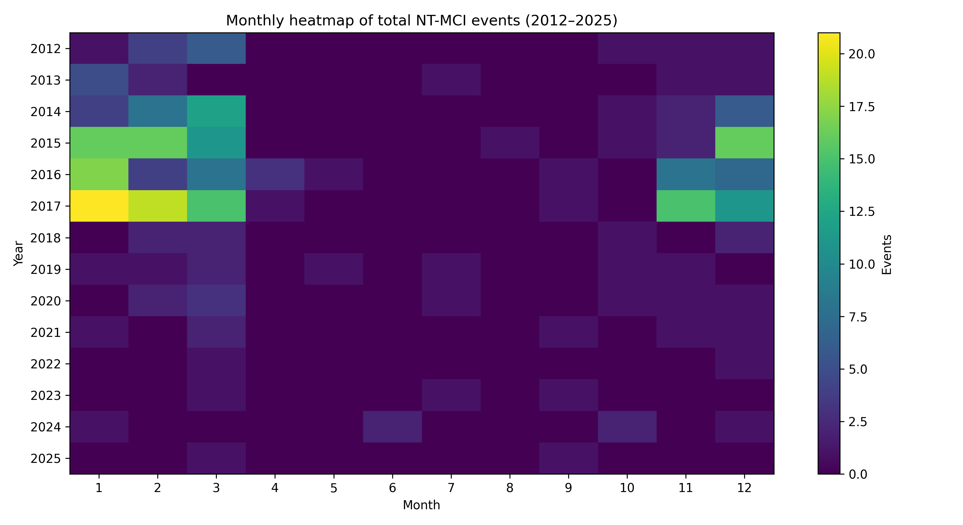
Supplementary Figure S2. Year-by-month heat map of monthly total event counts.

