Supplementary Materials
Tab.S1 Baseline characteristics and demographic data of study participants
Variable | Placebo | pAkk11 | p-value
Variable | (n=30, mean ± STD) | (n=31, mean ± STD) | p-value
Age (years) | 29.97 ± 9.73 | 32.52 ± 12.15 | 0.370
Sex (no. of subject (%))
Male | 16 (53.3%) | 15 (48.4%)
Female | 14 (46.7%) | 16 (51.6%)
Weight (kg) | 83.40 ± 11.65 | 80.69 ± 11.62 | 0.366
C | 1.69 ± 0.096 | 1.66 ± 0.092 | 0.123
BMI (kg/m²) | 28.86 ± 2.69 | 29.16 ± 2.73 | 0.671
Fat mass (kg) | 24.75 ± 5.82 | 24.94 ± 6.10 | 0.904
VFI | 11.59 ± 2.06 | 11.99 ± 2.21 | 0.464
BFP (%) | 30.07 ± 6.97 | 31.76 ± 6.75 | 0.339
Wrist (cm) | 17.96 ± 1.46 | 17.67 ± 1.14 | 0.390
Waist (cm) | 94.01 ± 8.14 | 90.05 ± 16.67 | 0.246
Hip (cm) | 106.65 ± 6.84 | 105.00 ± 7.00 | 0.355
Waist-hip ratio | 0.96 ± 0.05 | 0.96 ± 0.05 | 0.969
Glucose (mmol/L) | 5.15 ± 0.72 | 5.62 ± 1.08 | 0.054
TC (mmol/L) | 4.78 ± 0.80 | 5.23 ± 1.86 | 0.218
TG (mmol/L) | 1.61 ± 0.86 | 1.51 ± 0.69 | 0.621
HDL-C (mmol/L) | 1.50 ± 0.27 | 1.58 ± 0.25 | 0.270
LDL-C (mmol/L) | 2.22 ± 0.78 | 2.58 ± 0.83 | 0.087
ALT (U/L) | 35.23 ± 22.12 | 33.03 ± 24.84 | 0.716
AST (U/L) | 24.13 ± 8.95 | 25.42 ± 13.67 | 0.666
Total Bilirubin (µmol/L) | 12.45 ± 4.83 | 12.38 ± 5.56 | 0.959
GGT (U/L) | 32.27 ± 26.42 | 32.81 ± 36.38 | 0.948
Cr (µmol/L) | 66.23 ± 10.71 | 62.21 ± 10.08 | 0.136
BUN (mmol/L) | 5.79 ± 0.83 | 5.85 ± 0.99 | 0.793
UA (µmol/L) | 380.15 ± 86.93 | 371.39 ± 98.94 | 0.715
WBC (10⁹/L) | 6.19 ± 1.03 | 6.38 ± 1.67 | 0.601
BMI body-mass index, VFI visceral fat index, BFP body fat percentage; GGT gamma-glutamyl transferase, Cr creatinine; BUN blood urea nitrogen; UA uric acid; WBC white blood cell count; Data are n (%), mean (SD) or median (interquartile range).

Fig. S1
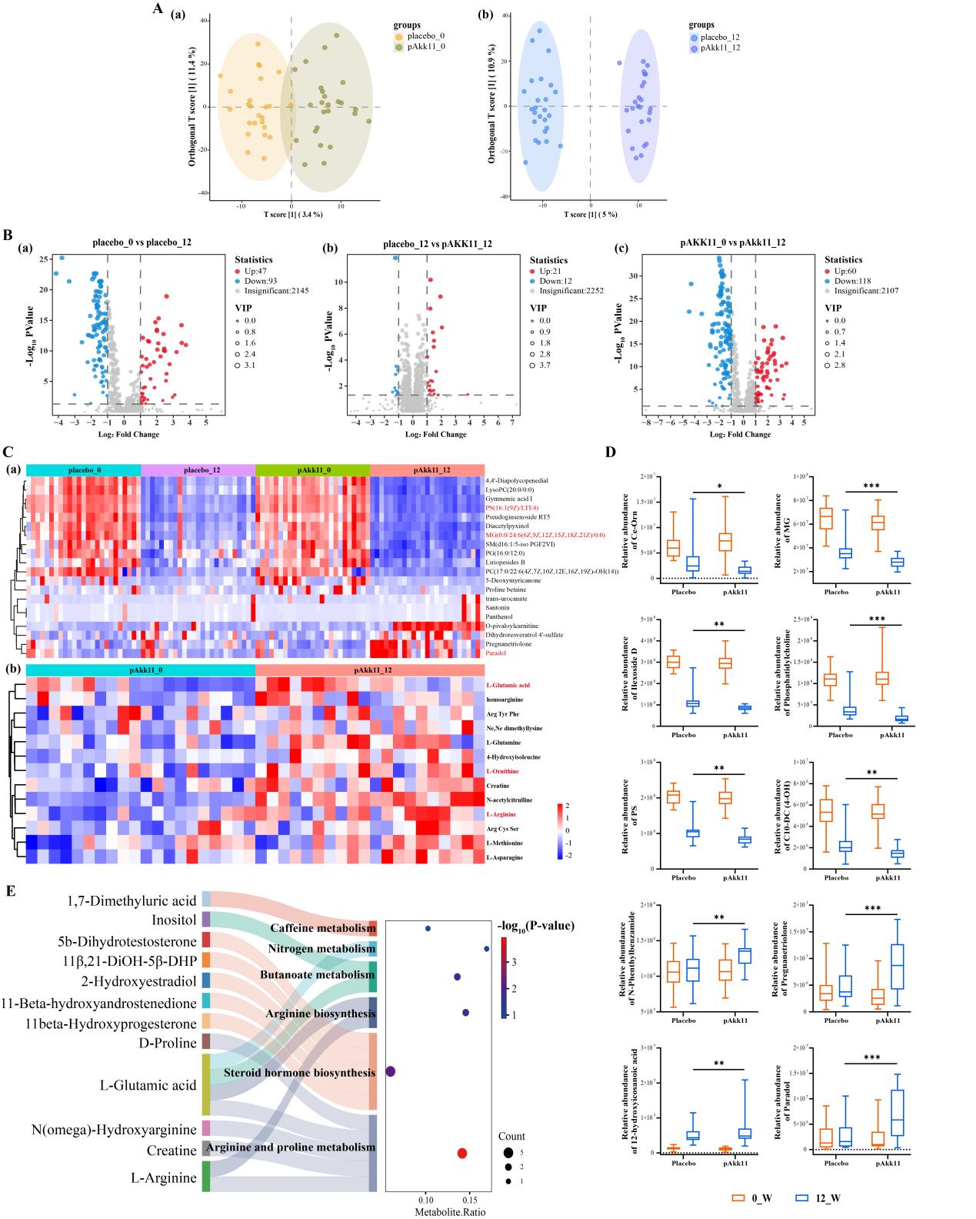
Fig. S1 Multivariate and differential analyses of metabolic profiles in placebo and pAkk11 groups at baseline (0_W) and after 12 weeks (12_W). (A) OPLS-DA score plots comparing the two groups: (a) Comparison between the placebo group (placebo_0) and the pAkk11 group (pAkk11_0) at baseline; (b) Comparison between the placebo group (placebo_12) and the pAkk11 group (pAkk11_12) after the 12-week intervention; (B)| Volcano plots depicting differential comparisons: (a) Placebo group before versus after the intervention (placebo_0 vs. placebo_12); (b) pAkk11 group before versus after the intervention (pAkk11_0 vs. pAkk11_12); (c) Between-group comparison after the 12-week intervention (placebo_12 vs. pAkk11_12); (C) Heatmap illustrating the abundance patterns of selected metabolites across groups, with hierarchical clustering demonstrating distinct profile changes; (D) Relative abundance plots for specific metabolites including (Creatine, Malonate, Xanthine, Inosine, Palmitate, Oleate, Linoleate, Stearate, Pentadecanoate, and Myristate); (E) KEGG enrichment analysis of serum metabolic pathways.

Fig. S2
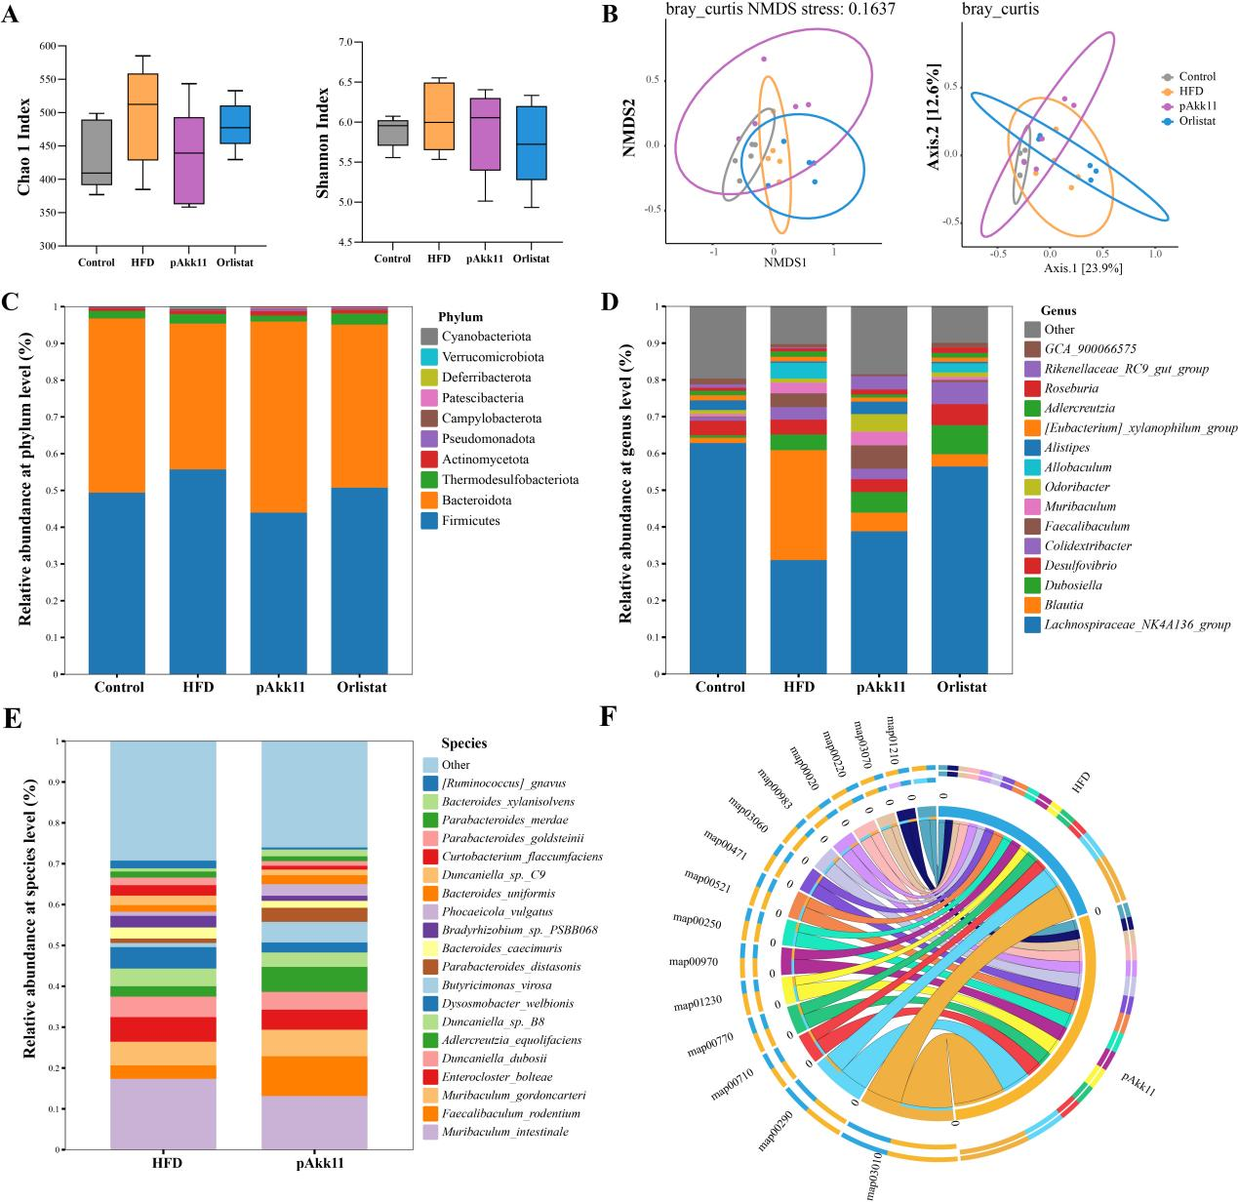
Fig. S2 Efficacy of pAkk11 on gut microbiota diversities and Metagenomic Analysis. (A) Chao1 index and Shannon index of gut microbiota diversity; (B) Beta diversity of intestinal microbiota assessed by PcoA and NMDS analyses based on Bray-Curtis distance; (C) Gut microbial composition at the phylum level; (D) Gut microbial composition at the genus level; (E) Relative abundance of gut microbial species; (F) KEGG functional pathway enrichment analysis and Species-source stratified bar chart plot of arginine biosynthesis pathway; (map03010-Ribosome; map00290-Valine leucine and isoleucine biosynthesis; map00710-Carbon fixation in photosythetic organisms; map00770-Pantotheate and CoA biosynthesis; map01230-Biosynthesis of amino acids; map00970-Aminoacyl-tRNA biosynthesis; map00250-Alanine, aspartate and glutamate metabolism; map00521-Streptomycin biosynthesis; map00471-D-Glutamine and D-glutamate metabolism; map03060-Proteinexport; map00983-Drug metabolism-other enzymes; map00020-Citrate cycle; map00220-Arginine biosynthesis; map03070-Bacterial secretion system; map01210-2-Oxocarboxylic acid metabolism).

