Supplementary File of
“Machine Learning for Predicting Traumatic Brain Injury Outcomes: Development and External Validation Using Real-World Data from Two Indonesian Tertiary Hospitals”

Supplementary File 1. TRIPOD-AI Checklist
Section/Topic Item Development Checklist item  / evaluation¹ |  |  |  | Reported on page
TITLE |  |  |  | Reported on page
Title | 1 | D;E | Identify the study as developing or evaluating the performance of a multivariable prediction model, the target population, and the outcome to be predicted | 1
ABSTRACT
Abstract | 2 | D;E | See TRIPOD+AI for Abstracts checklist | 2
INTRODUCTION
Background | 3a | D;E | Explain the healthcare context (including whether diagnostic or prognostic) and rationale for developing or evaluating the prediction model, including references to existing models | 4-5
Background | 3b | D;E | Describe the target population and the intended purpose of the prediction model in the context of the care pathway, including its intended users (e.g., healthcare professionals, patients, public) | 4-5
Background | 3c | D;E | Describe any known health inequalities between sociodemographic groups | 4-5
Objectives | 4 | D;E | Specify the study objectives, including whether the study describes the development or validation of a prediction model (or both) | 5
METHODS
Data | 5a | D;E | Describe the sources of data separately for the development and evaluation datasets (e.g., randomised trial, cohort, routine care or registry data), the rationale for using these data, and representativeness of the data | 6
Data | 5b | D;E | Specify the dates of the collected participant data, including start and end of participant accrual; and, if applicable, end of follow-up | 6
Participants | 6a | D;E | Specify key elements of the study setting (e.g., primary care, secondary care, general population)  including the number and location of centres | 6
Participants | 6b | D;E | Describe the eligibility criteria for study participants | 6
Participants | 6c | D;E | Give details of any treatments received, and how they were handled during model development or evaluation, if relevant | 6
Data preparation | 7 | D;E | Describe any data pre-processing and quality checking, including whether this was similar across  relevant sociodemographic groups | 7
Outcome | 8a | D;E | Clearly define the outcome that is being predicted and the time horizon, including how and when assessed, the rationale for choosing this outcome, and whether the method of outcome assessment is  consistent across sociodemographic groups | 7
Outcome | 8b | D;E | If outcome assessment requires subjective interpretation, describe the qualifications and demographic characteristics of the outcome assessors | 7
Outcome | 8c | D;E | Report any actions to blind assessment of the outcome to be predicted | 7
Predictors | 9a | D | Describe the choice of initial predictors (e.g., literature, previous models, all available predictors) and  any pre-selection of predictors before model building | 8
Predictors | 9b | D;E | Clearly define all predictors, including how and when they were measured (and any actions to blind assessment of predictors for the outcome and other predictors) | 8
Predictors | 9c | D;E | If predictor measurement requires subjective interpretation, describe the qualifications and demographic characteristics of the predictor assessors | 8
Sample size | 10 | D;E | Explain how the study size was arrived at (separately for development and evaluation), and justify that  the study size was sufficient to answer the research question. Include details of any sample size calculation | 6
Missing data | 11 | D;E | Describe how missing data were handled. Provide reasons for omitting any data | 8
Analytical methods | 12a | D | Describe how the data were used (e.g., for development and evaluation of model performance) in the analysis, including whether the data were partitioned, considering any sample size requirements | 7-10
Analytical methods | 12b | D | Depending on the type of model, describe how predictors were handled in the analyses (functional form,  rescaling, transformation, or any standardisation). | 7-10
Analytical methods | 12c | D | Specify the type of model, rationale², all model-building steps, including any hyperparameter tuning,  and method for internal validation | 7-10
Analytical methods | 12d | D;E | Describe if and how any heterogeneity in estimates of model parameter values and model performance was handled and quantified across clusters (e.g., hospitals, countries). See TRIPOD-Cluster for  additional considerations³ | 7-10
Analytical methods | 12e | D;E | Specify all measures and plots used (and their rationale) to evaluate model performance (e.g., discrimination, calibration, clinical utility) and, if relevant, to compare multiple models | 7-10
Analytical methods | 12f | E | Describe any model updating (e.g., recalibration) arising from the model evaluation, either overall or for particular sociodemographic groups or settings | 7-10
Analytical methods | 12g | E | For model evaluation, describe how the model predictions were calculated (e.g., formula, code, object, application programming interface) | 7-10
Class imbalance | 13 | D;E | If class imbalance methods were used, state why and how this was done, and any subsequent methods to  recalibrate the model or the model predictions | -
Fairness | 14 | D;E | Describe any approaches that were used to address model fairness and their rationale | 7-10
Model output | 15 | D | Specify the output of the prediction model (e.g., probabilities, classification). Provide details and  rationale for any classification and how the thresholds were identified | 7-10

Training versus  evaluation | 16 | D;E | Identify any differences between the development and evaluation data in healthcare setting, eligibility  criteria, outcome, and predictors | 7-10
Ethical approval | 17 | D;E | Name the institutional research board or ethics committee that approved the study and describe the participant-informed consent or the ethics committee waiver of informed consent | 7-10
OPEN SCIENCE
Funding | 18a | D;E | Give the source of funding and the role of the funders for the present study | 28
Conflicts of interest | 18b | D;E | Declare any conflicts of interest and financial disclosures for all authors | 28
Protocol | 18c | D;E | Indicate where the study protocol can be accessed or state that a protocol was not prepared | 28
Registration | 18d | D;E | Provide registration information for the study, including register name and registration number, or state  that the study was not registered | 28
Data sharing | 18e | D;E | Provide details of the availability of the study data | 28
Code sharing | 18f | D;E | Provide details of the availability of the analytical code⁴ | 28
PATIENT & PUBLIC INVOLVEMENT
Patient & Public Involvement | 19 | D;E | Provide details of any patient and public involvement during the design, conduct, reporting, interpretation, or dissemination of the study or state no involvement. | -
RESULTS
Participants | 20a | D;E | Describe the flow of participants through the study, including the number of participants with and without the outcome and, if applicable, a summary of the follow-up time. A diagram may be helpful. | 10-11
Participants | 20b | D;E | Report the characteristics overall and, where applicable, for each data source or setting, including the key dates, key predictors (including demographics), treatments received, sample size, number of outcome events, follow-up time, and amount of missing data. A table may be helpful. Report any  differences across key demographic groups. | 10-11
Participants | 20c | E | For model evaluation, show a comparison with the development data of the distribution of important predictors (demographics, predictors, and outcome). | 10-11
Model development | 21 | D;E | Specify the number of participants and outcome events in each analysis (e.g., for model development, hyperparameter tuning, model evaluation) | 11-15
Model specification | 22 | D | Provide details of the full prediction model (e.g., formula, code, object, application programming interface) to allow predictions in new individuals and to enable third-party evaluation and implementation, including any restrictions to access or re-use (e.g., freely available, proprietary)⁵ | 11-15
Model performance | 23a | D;E | Report model performance estimates with confidence intervals, including for any key subgroups (e.g., sociodemographic). Consider plots to aid presentation. | 11-15
Model performance | 23b | D;E | If examined, report results of any heterogeneity in model performance across clusters. See TRIPOD  Cluster for additional details³. | 11-15
Model updating | 24 | E | Report the results from any model updating, including the updated model and subsequent performance | -
DISCUSSION
Interpretation | 25 | D;E | Give an overall interpretation of the main results, including issues of fairness in the context of the  objectives and previous studies | 15-25
Limitations | 26 | D;E | Discuss any limitations of the study (such as a non-representative sample, sample size, overfitting, missing data) and their effects on any biases, statistical uncertainty, and generalizability | 25
Usability of the model in the context of current care | 27a | D | Describe how poor quality or unavailable input data (e.g., predictor values) should be assessed and handled when implementing the prediction model | 15-25
Usability of the model in the context of current care | 27b | D | Specify whether users will be required to interact in the handling of the input data or use of the model,  and what level of expertise is required of users | 15-25
Usability of the model in the context of current care | 27c | D;E | Discuss any next steps for future research, with a specific view to applicability and generalizability of  the model | 26-27
Training versus  evaluation | 16 | D;E | Identify any differences between the development and evaluation data in healthcare setting, eligibility  criteria, outcome, and predictors | 15-25
Ethical approval | 17 | D;E | Name the institutional research board or ethics committee that approved the study and describe the participant-informed consent or the ethics committee waiver of informed consent | 6

From: Collins GS, Moons KGM, Dhiman P, et al. BMJ 2024;385:e078378. doi:10.1136/bmj-2023-078378

Supplementary File 2. Distribution of Clinical Outcomes in Developmental and Validation Cohort (80/20 Split)

 | Development Cohort (Sardjito Train 80%)  n (%) | Internal Validation Cohort (SardjitoTest 20%)  n (%)
Good GOSE X Survive | 164 (80%) | 45 (86.5%)
Poor GOSE X Survive | 4 (2%) | 3 (5.8%)
Poor GOSE X Death | 37 (18%) | 4 (7.7%)
Good GOSE | 164 (80%) | 45 (86.5%)
Poor GOSE | 41 (20%) | 7 (13.5%)
Survive | 168 (82%) | 48 (92.3%)
Death | 37 (18%) | 4 (7.7%)

Supplementary File 3. Multicenter data collection form used in the study
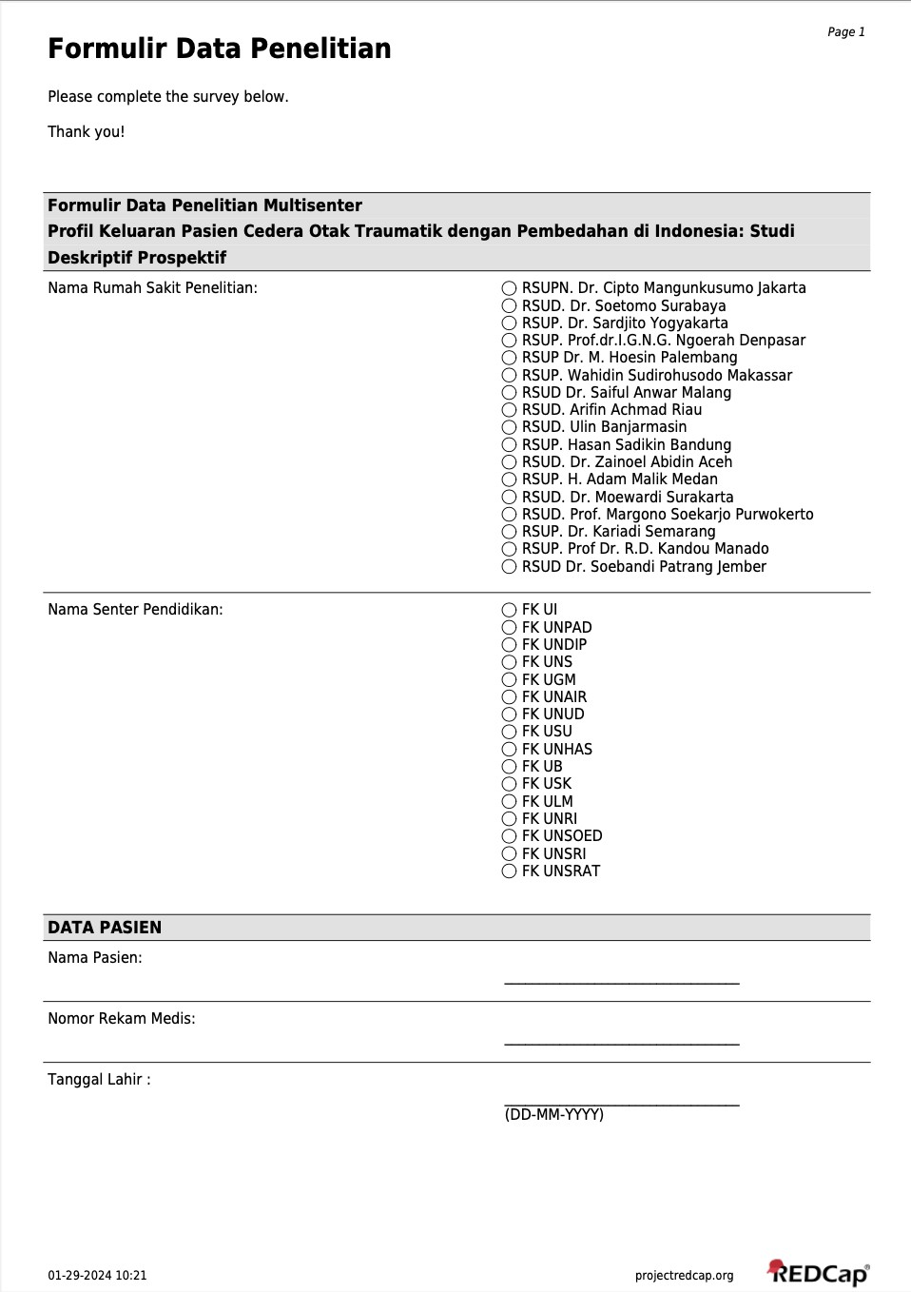

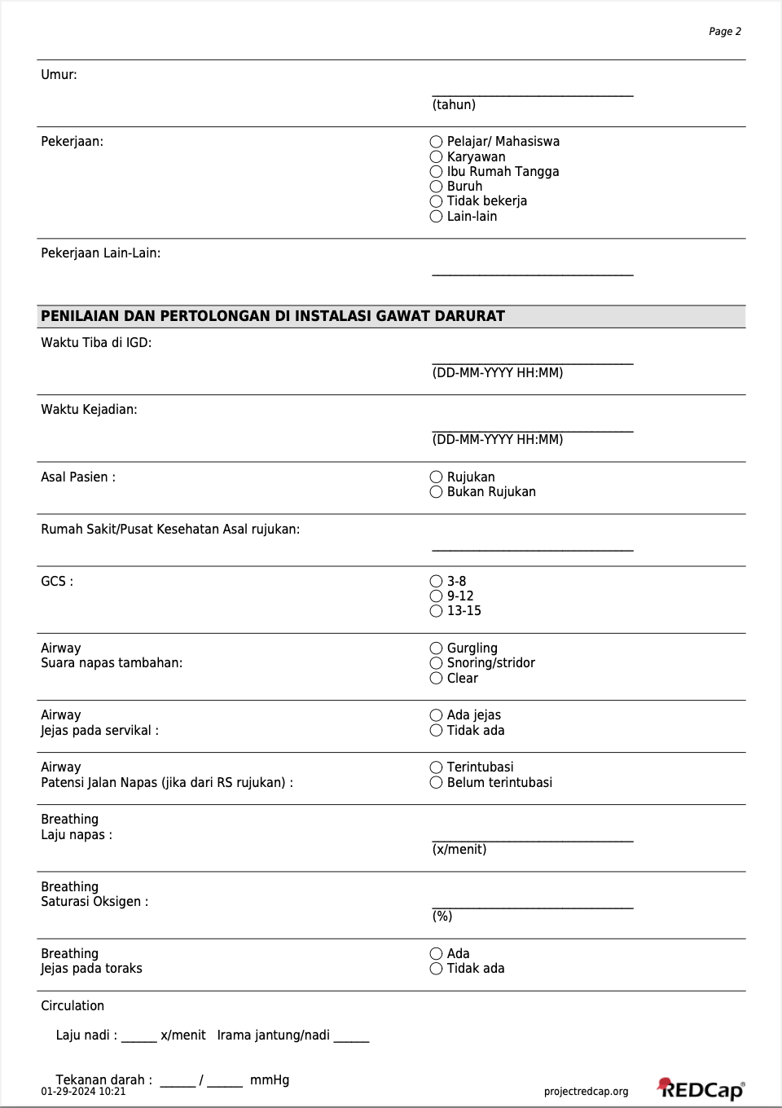
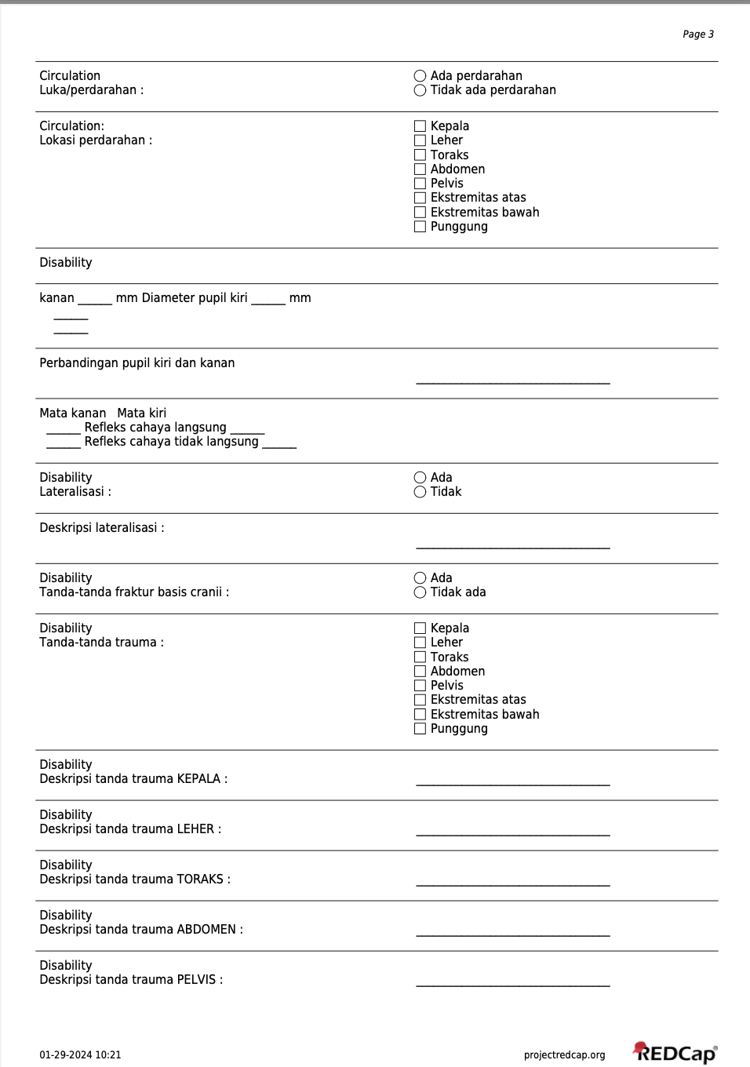
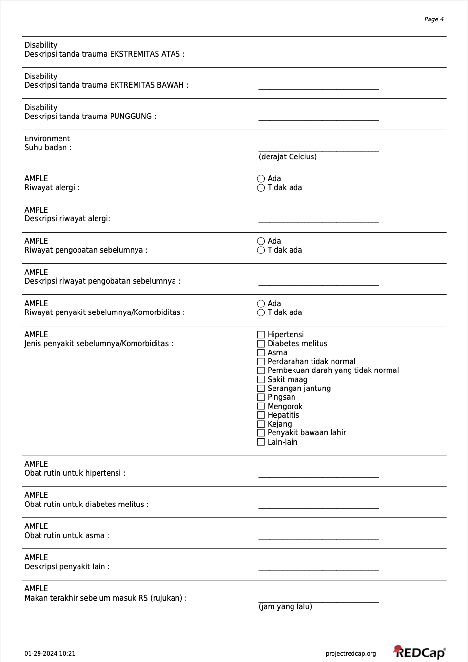
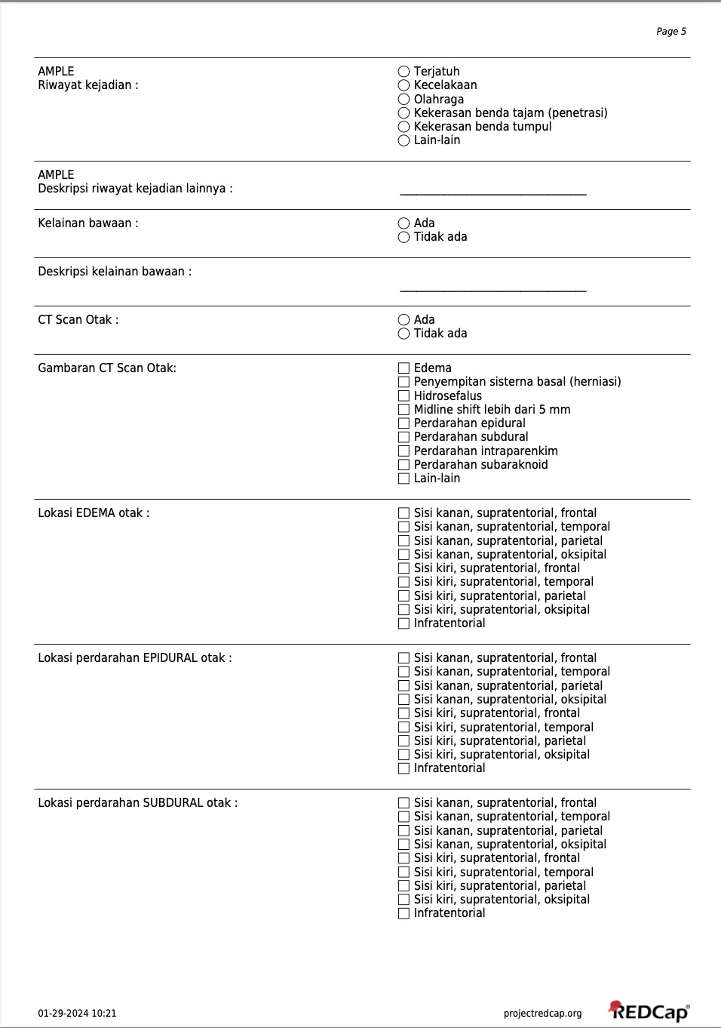
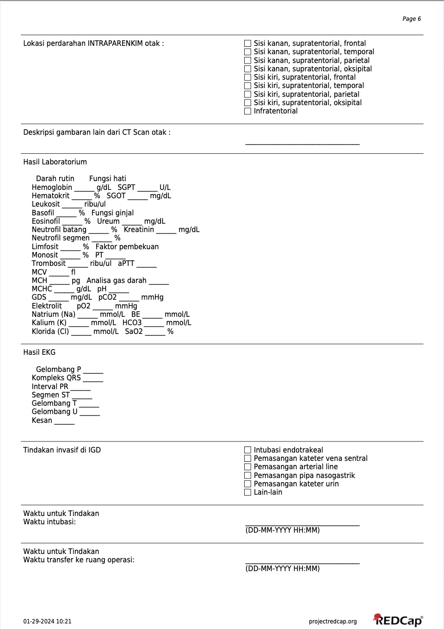
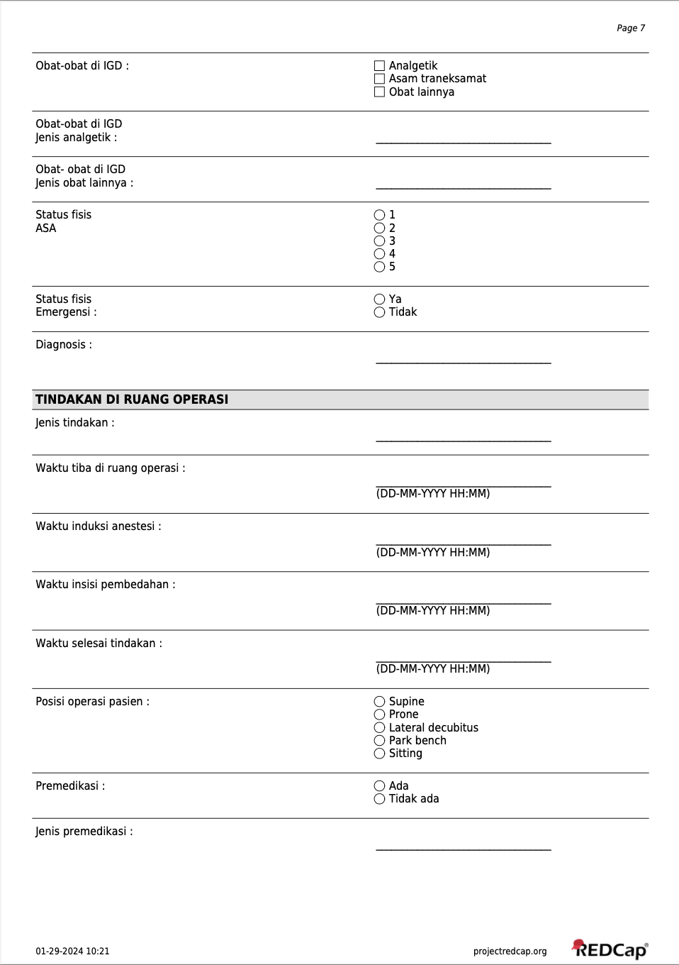
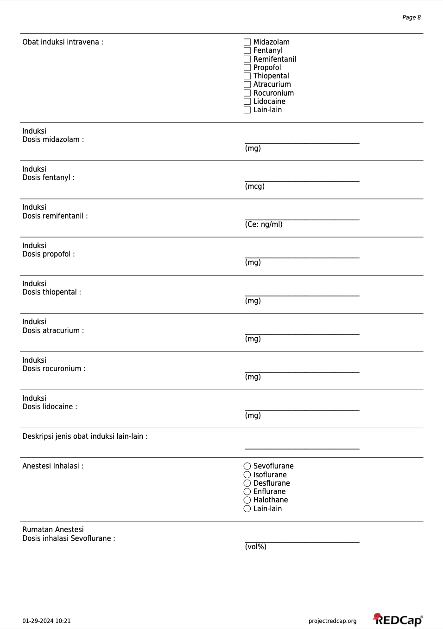
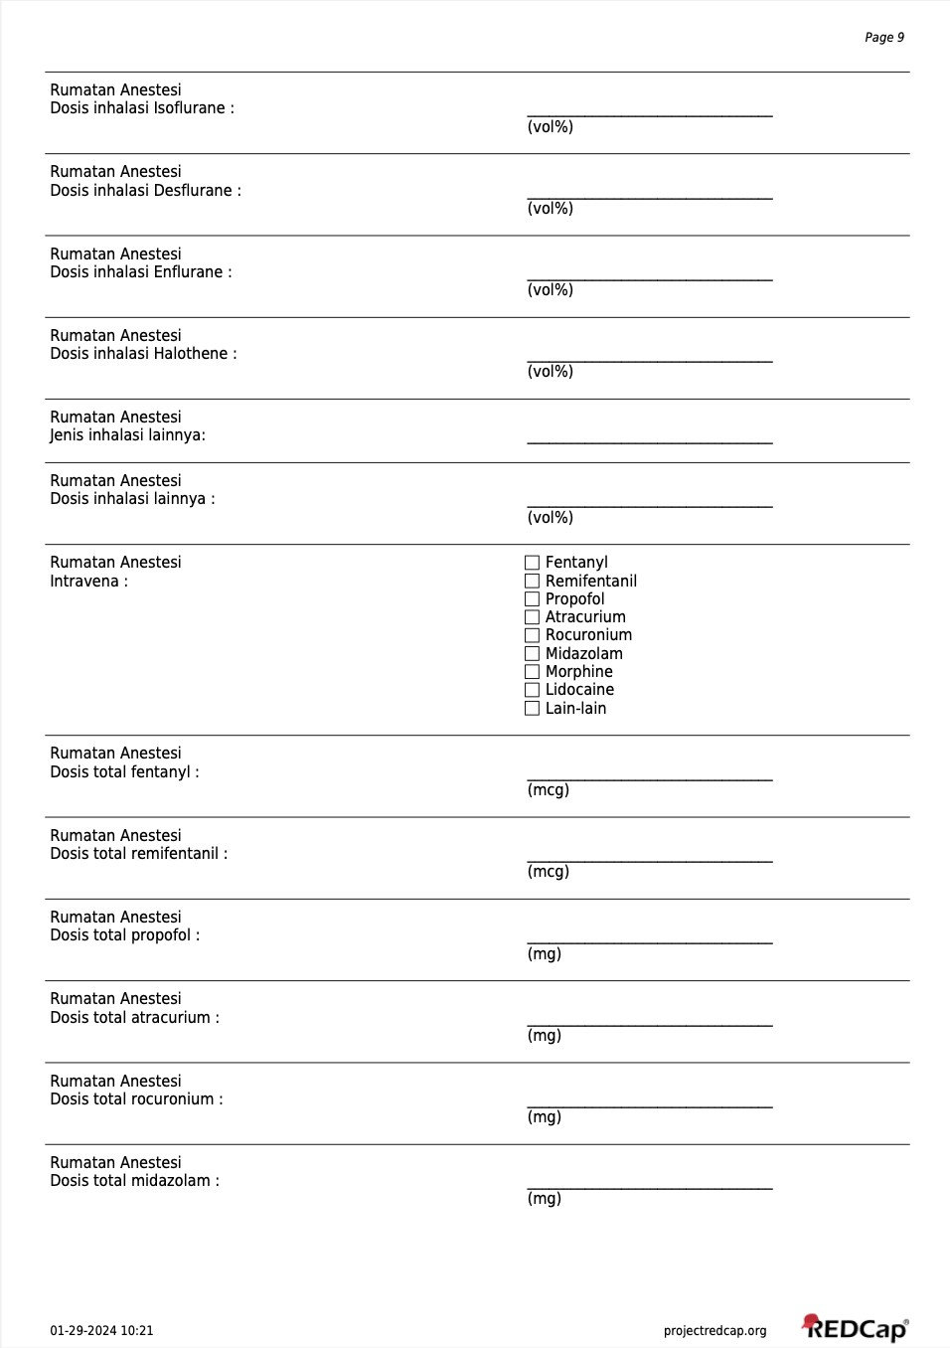
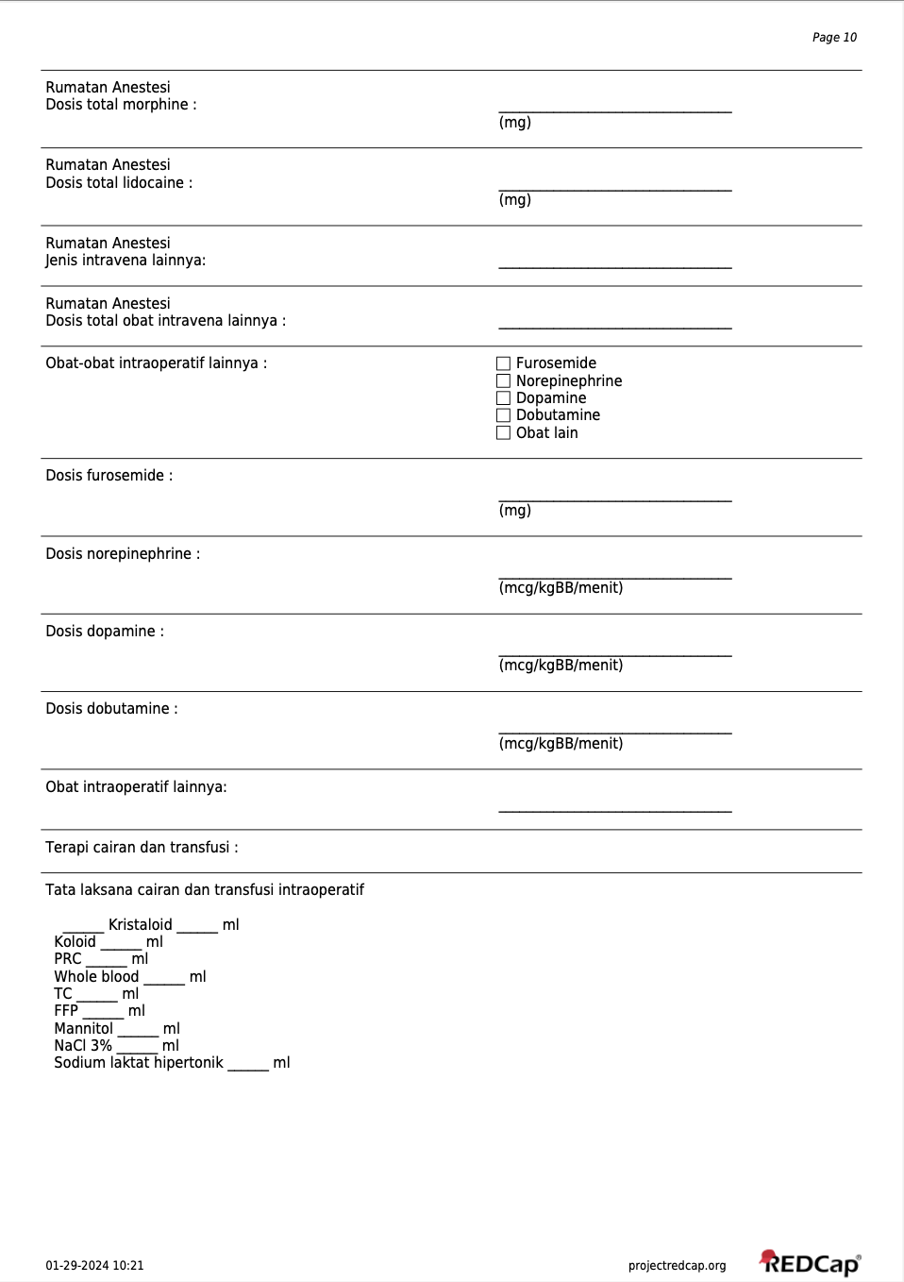
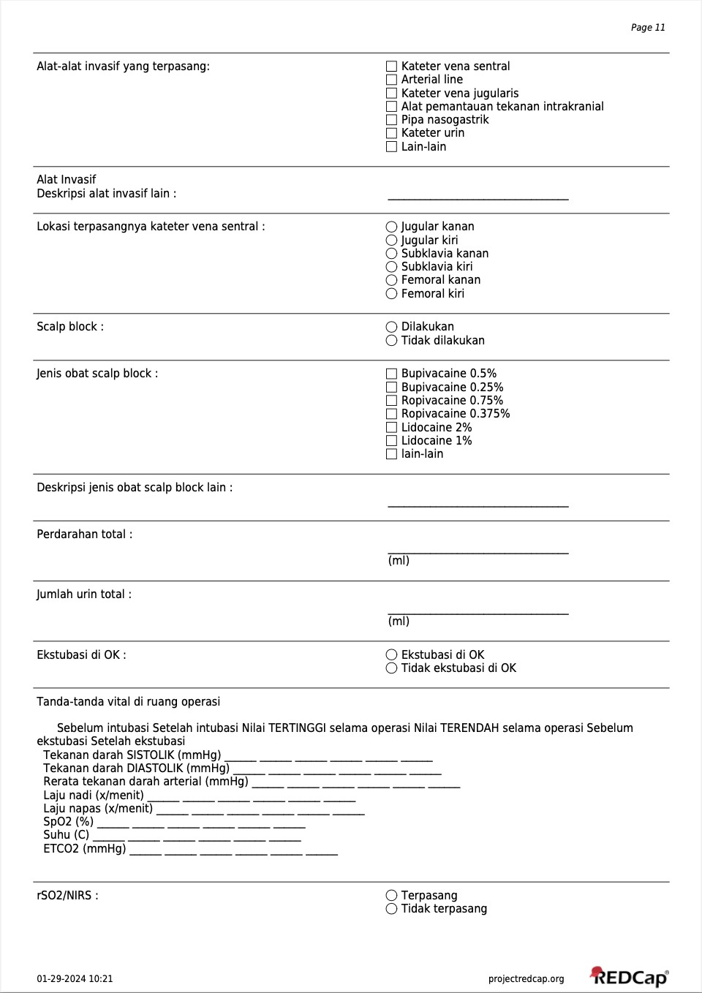
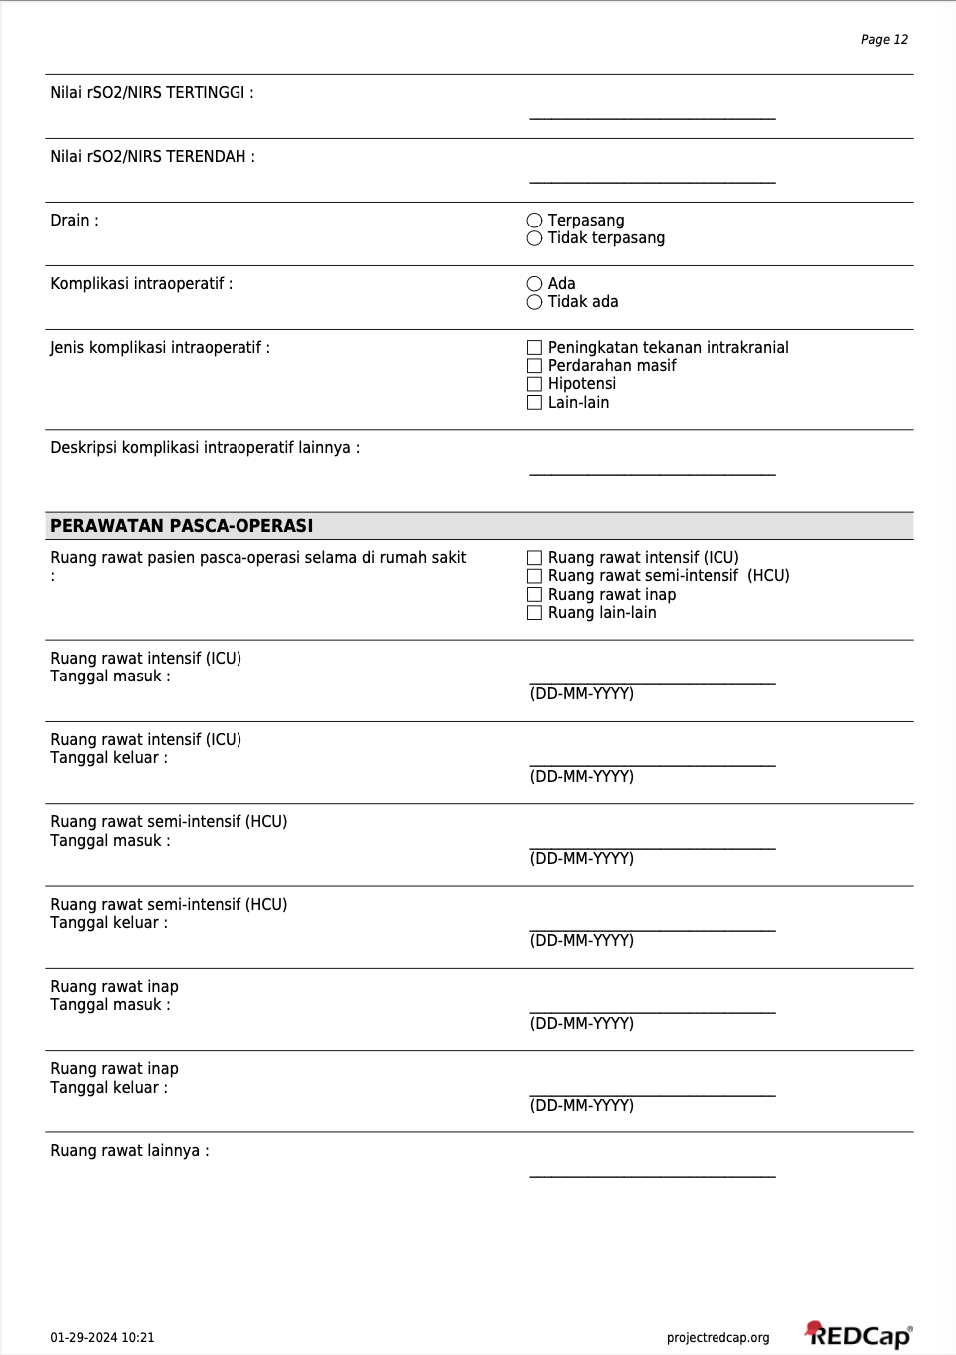
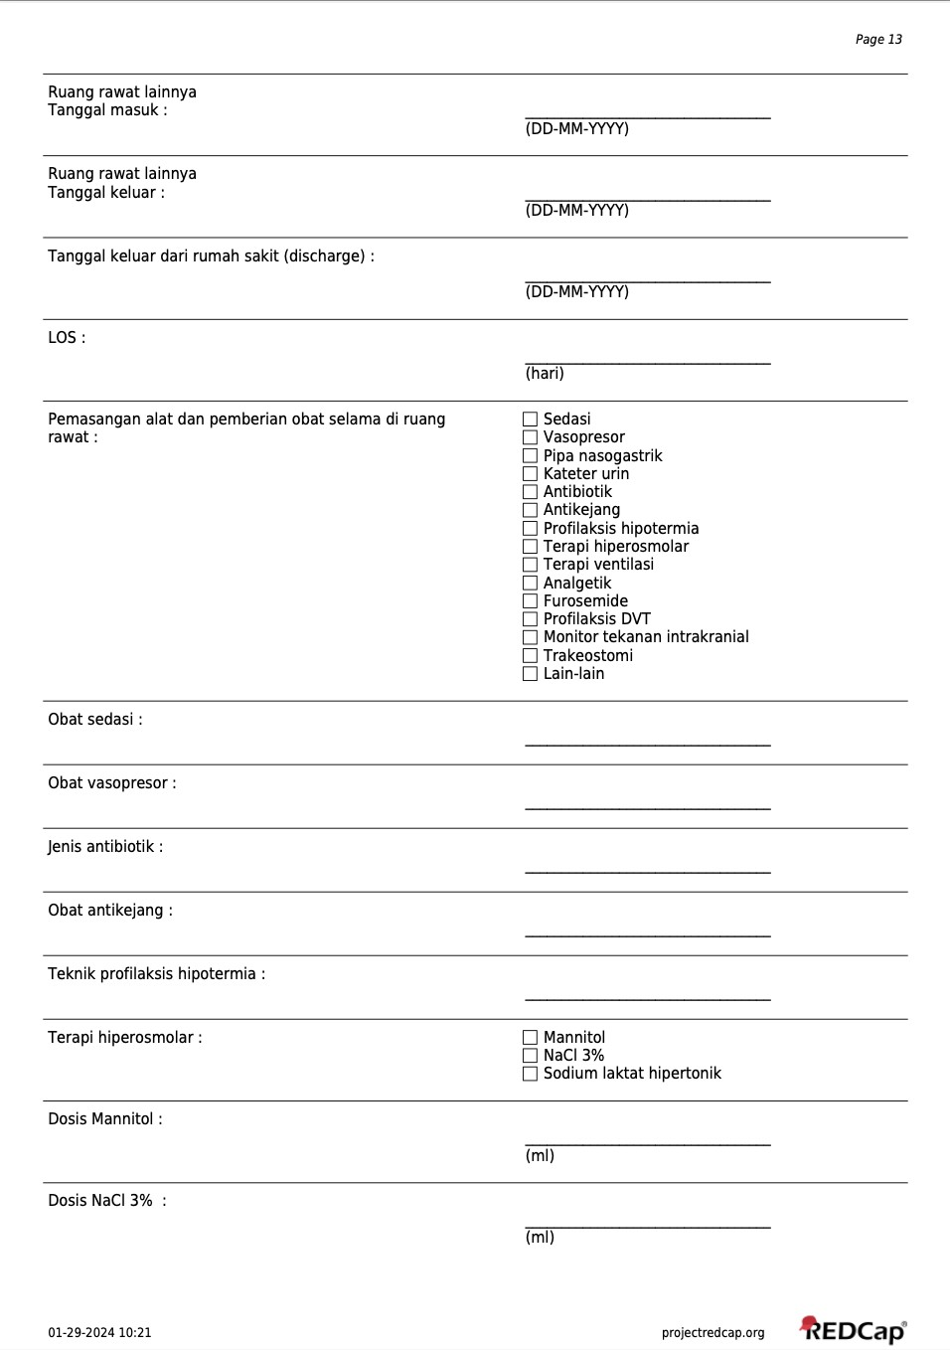
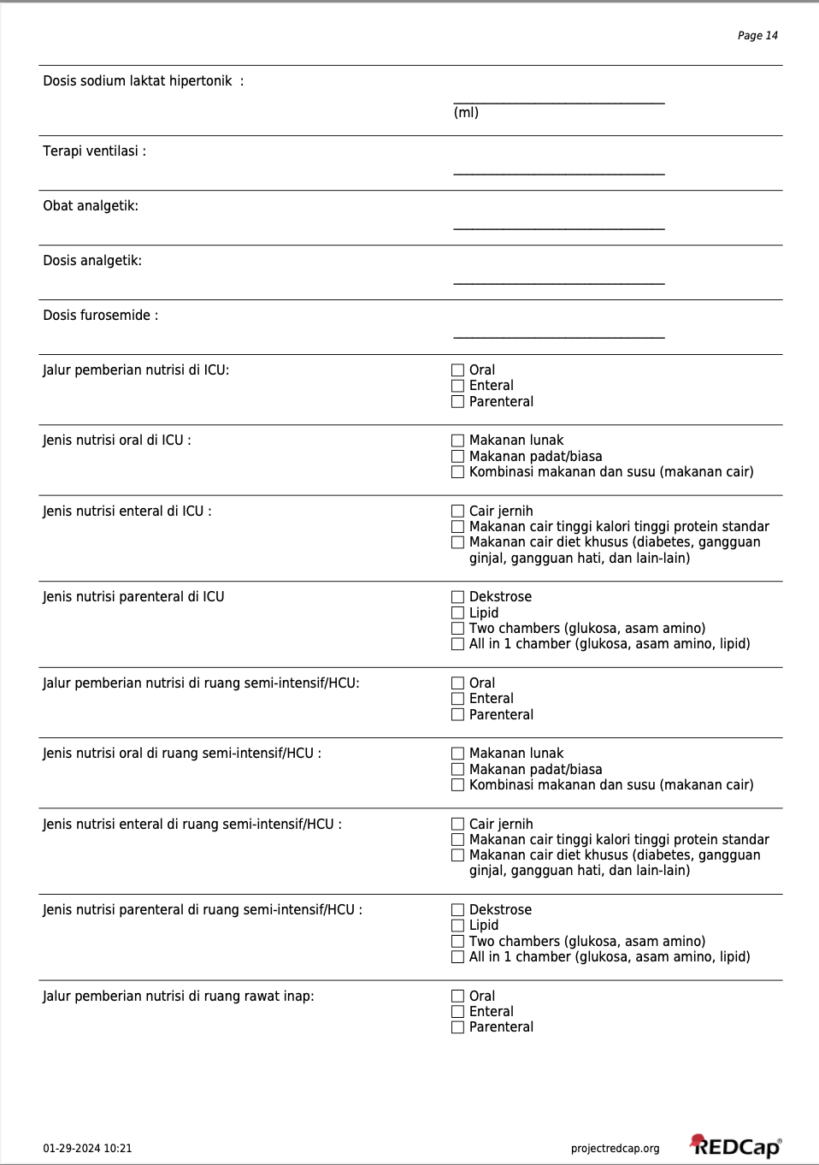
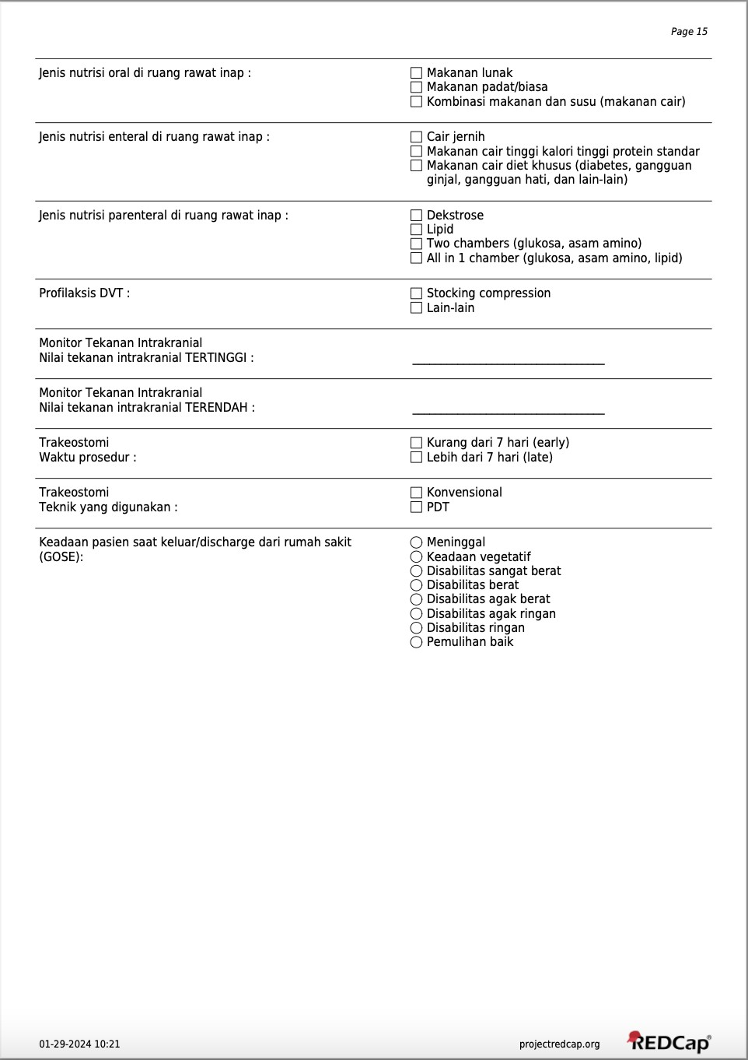
Supplementary File 4. Operational Definition
Variable | Encoding | Code definition
Prehospital/Preoperative
age | numeric | -
age (category) | ordinal | 0 = 0 - 4 years  1 = 5 - 9 years  2 = 10 -14 years  3 = 15 - 24 years  4 = 25 - 34 years  5 = 35 - 44 years  6 = 45 - 54 years  7 = 55 - 64 years  8 = 65 - 74 years  9 = >75 years
sex (category) | nominal | 0 = male  1 = female
occupation | nominal | 0 = employee  1 = homemaker  2 = laborer  3 = unemployed  4 = student  5 = others
cause of trauma | nominal | 0 = fall  1 = accident  2 = sport injury  3 = penetrating injury  4 = others
trauma severity | ordinal | 0 = mild  1 = moderate  2 = severe
gcs (category) | ordinal | 0 = mild  1 = moderate  2 = severe
breath sound | nominal | 0 = clear  1 = obstruction
cervical | nominal | 0 = clear  1 = injury present
airway patency | nominal | 0 = not intubated  1 = intubated
rr | numeric | -
hr | numeric | -
sbp | numeric | -
dbp | numeric | -
bleeding | nominal | 0 = no  1 = yes
head injury | nominal | 0 = no  1 = yes
thoracic injury | nominal | 0 = no  1 = yes
abdominal injury | nominal | 0 = no  1 = yes
back injury | nominal | 0 = no  1 = yes
pelvic injury | nominal | 0 = no  1 = yes
extremity injury | nominal | 0 = no  1 = yes
temperature | numeric | -
allergy | nominal | 0 = none  1 = drug  2 = food
pupil size | nominal | 0 = normal  1 = mydriasis (>3 mm)  2 = miosis (<2 mm)
pupil simetry | nominal | 0 = isokor  1 = anisokor
direct reflex | nominal | 0 = normal  1 = impaired
indirect reflex | nominal | 0 = normal  1 = impaired
lateralization | nominal | 0 = normal  1 = present
skull base fracture | nominal | 0 = no  1 = yes
medication history | nominal | 0 = none  1 = aspirin  2 = analgetics  3 = others
abnormal bleeding | nominal | 0 = no  1 = yes
abnormal clot | nominal | 0 = no  1 = yes
peptic ulcer | nominal | 0 = no  1 = yes
anemia | nominal | 0 = no  1 = yes
heart attack | nominal | 0 = no  1 = yes
asthma | nominal | 0 = no  1 = yes
dm | nominal | 0 = no  1 = yes
faint | nominal | 0 = no  1 = yes
snoring | nominal | 0 = no  1 = yes
hepatitis | nominal | 0 = no  1 = yes
seizure | nominal | 0 = no  1 = yes
hypertension | nominal | 0 = no  1 = yes
congenital | nominal | 0 = no  1 = yes
others | nominal | 0 = no  1 = yes
last meal | ordinal | 0 = 1 – 3 hours  1 = 3 – 6 hours  2 = 6 – 8 hours  3 = >8 hours
imaging herniation | nominal | 0 = no  1 = yes  3 = no ct scan
imaging edema | nominal | 0 = no  1 = yes  3 = no ct scan
imaging hydrocephalus | nominal | 0 = no  1 = yes  3 = no ct scan
imaging midline shift | nominal | 0 = no  1 = yes  3 = no ct scan
imaging SDH | nominal | 0 = no  1 = yes  3 = no ct scan
imaging SAH | nominal | 0 = no  1 = yes  3 = no ct scan
imaging EDH | nominal | 0 = no  1 = yes  3 = no ct scan
imaging IVH | nominal | 0 = no  1 = yes  3 = no ct scan
imaging ICH | nominal | 0 = no  1 = yes  3 = no ct scan
imaging mixed hemorrhage | nominal | 0 = no  1 = yes  3 = no ct scan
imaging fracture | nominal | 0 = no  1 = yes  3 = no ct scan
imaging others | nominal | 0 = no  1 = yes  3 = no ct scan
hb | numeric | -
hb (category) | nominal | 0 = normal  1 = anemia (<10 g/dL)
leucocyte | numeric | -
leucocyte (category) | ordinal | 0 = normal (4000-10000)  1 = leucopenia (<4000)  2 = leucocytosis (>10000)
hematocrite | numeric | -
hematocrite (category) | ordinal | 0 = normal (30-45)  1 = hemodilution (<30)  2 = hemoconcentration (>45)
thrombocyte | numeric | -
thrombocyte (category) | ordinal | 0 = normal (150000-450000)  1 = thrombocytopenia (<150000)  2 = thrombocytosis (>450000)
natrium | numeric | -
natrium (category) | ordinal | 0 = normal (135-145)  1 = hyponatremia (<135)  2 = hypernatremia (>145)
potassium | numeric | -
potassium (category) | ordinal | 0 = normal (3.5-5.0)  1 = hypokalemia (<3.5)  2 = hyperkalemia (>5.0)
sgot | numeric | -
sgpt | numeric | -
liver function | nominal | 0 = normal  1 = impaired (sgot >= 40 or sgpt >= 40)
creatinine | numeric | -
renal function | nominal | 0 = normal  1 = impaired (creatinine >= 1.5)
random blood glucose | numeric | -
random blood glucose (category) | ordinal | 0 = normal (70 – 199)  1 = hypoglycemia (<70)  2 = hyperglycemia (>= 200)
abg time | ordinal | 0 = not performed  1 = before intubation  2 = after intubation
ph | numeric | -
pCO2 | numeric | -
pO2 | numeric | -
BE | numeric | -
HCO3 | numeric | -
SaO2 | numeric | -
abg interpretation (category) | nominal | 0 = normal  1 = metabolic acidosis  2 = metabolic alkalosis  3 = respiratory acidosis  4 = respiratory alkalosis  5 = mixed acidosis  6 = abg not performed
Intraoperative
emergency surgery | nominal | 0 = no  1 = yes
surgery or not | nominal | 0 = no  1 = yes
asa | nominal | 0 = no  1 = yes  2 = no surgical procedure
surgical procedure | nominal | 1 = hematome evacuation/craniotomy  2 = vp shunt  3 = others  4 = no surgical procedure
premedication | nominal | 0 = no  1 = yes  2 = no surgical procedure
induction | nominal | 0 = no  1 = yes  2 = no surgical procedure
patient position | nominal | 0 = prone  1 = supine  2 = lateral decubitus  3 = others  4 = no surgical procedure
drain | nominal | 0 = no  1 = yes  2 = no surgical procedure
intraoperative complication | nominal | 0 = no  1 = yes  2 = no surgical procedure
extubation location | nominal | 0 = no  1 = yes  2 = no surgical procedure
total fluid intake | numeric | -
total bloos loss | numeric | -
urine output | numeric | -
postoperative room | ordinal | 0 = ward  1 = hcu  2 = hcu  3 = no surgical procedure
Critical Care
icu only (non postoperative) | nominal | 0 = no  1 = yes
icu or not | nominal | 0 = no  1 = yes
ngt icu | nominal | 0 = no  1 = yes  2 = no ICU admission
catheter icu | nominal | 0 = no  1 = yes  2 = no ICU admission
ventilation icu | nominal | 0 = no  1 = yes  2 = no ICU admission
sedation icu | nominal | 0 = no  1 = propofol  2 = morphine  3 = midazolam  4 = dexmedetomidine  5 = others  6 = no ICU admission
icp icu | nominal | 0 = no  1 = yes  2 = no ICU admission
antibiotic icu | nominal | 0 = no  1 = yes  2 = no ICU admission
vasopressor icu | nominal | 0 = no  1 = yes  2 = no ICU admission
anticonvulsan icu | nominal | 0 = no  1 = yes  2 = no ICU admission
hyperosmolar icu | nominal | 0 = no  1 = yes  2 = no ICU admission
analgetic icu | nominal | 0 = no  1 = yes  2 = no ICU admission
nutrition icu | nominal | 0 = oral  1 = enteral  2 = parenteral  3 = mixed  4 = no ICU admission
dvt prophylaxis icu | nominal | 0 = no  1 = yes  2 = no ICU admission
Time
admission to incision | numeric | -
injury to incision | numeric | -
admission to intubation (ed) | numeric | -
injury to intubation ed | numeric | -
admission to induction | numeric | -
injury to induction | numeric | -
admission to ok | numeric | -
injury to ok | numeric | -
admission to_icu | numeric | -
injury to icu | numeric | -
admission to decission | numeric | -
injury to decission | numeric | -
decision to incision | numeric | -
surgical time | numeric | -
los icu | numeric | -
los hospital | numeric | -
Outcome
outcome gose | ordinal | 0 = GOSE 1 (dead)  1 = GOSE 2 (vegetative state)  2 = GOSE 3 (lower severe disability)  3 = GOSE 4 (upper severe disability)  4 = GOSE 5 (lower moderate disability)  5 = GOSE 6 (upper moderate disability)  6 = GOSE 7 (lower good recovery)  7 = GOSE 8 (upper good recovery)
outcome gose binary | nominal | 0 = good GOSE (GOSE 5-8)  1 = poor GOSE (GOSE 1-4)
outcome mortality | nominal | 0 = survive  1 = death
Supplementary File 5. Mathematical formulation and corresponding script implementation for each step
Analysis Step | Mathematical Formulation | Key Implementation in Script
MICE Imputation
Missing data identification | $$X_{\text{mis}}=\{x_{ij}∣x_{ij}=\text{NA}\}$$ | is.na(df)
Variable type specification | $$X_{j}∈\{0,1\}, \{1,…,K\}, R$$ | as.factor()  as.numeric()
Binary imputation | $$P\left(X_{j}=1 | X_{-j}\right)$$  $$=1/\left(1+\exp\left(-\left(β_{0}+β^{T}X_{-j}\right)\right)\right)$$ | method="logreg"
Multiclass imputation | $$P\left(X_{j}=c | X_{-j}\right)$$  $$=\exp\left(β_{c}^{T}X_{-j}\right)/\sum_{k=1}^{K}{\exp\left(β_{k}^{T}X_{-j}\right)}$$ | method="polyreg"
Continous imputation | $$X_{j}^{imp}=X_{k}, k=\arg{\min_{l}\left|\hat{x_{j}}-\hat{x_{l}}\right|}$$ | method="pmm"
Conditional imputation model | $$X_{j}^{mis}∼P\left(X_{j} ∣ X_{-j}\right)$$ | make.method(df)
Chained equations update | $$X_{j}^{\left(t\right)}∼P!\left(X_{j} ∣ X_{-j}^{\left(t-1\right)}\right)$$ | mice(..., maxit=20)
Multiple imputation dataset | $$D^{\left(1\right)},…,D^{\left(m\right)}$$ | m = 20
Completed dataset extration | $$X^{imp}=\text{complete}!\left(D^{\left(k\right)}\right)$$ | complete(imp,1)
LASSO Regression
Removal of constant predictors | Var(Xj​)>0 | length(unique(x)) > 1
Construction of predictor matrix | $$X∈R^{n×p}$$ | model.matrix(~ ., data = predictor_data)
LASSO regularization | $$\hat{β}=\arg{\min_{β}\left(L\left(β\right)+λ\sum_{j=1}^{p}{\left|β_{j}\right|}\right)}$$ | cv.glmnet(x, y, family = "binomial", alpha = 1)
Cross-validation for tuning parameter | $$λ_{min}=\arg{\min_{λ∈Λ}{C}}V\left(λ\right)$$ | cv.glmnet()
Feature selection rule | $$S_{λ}=\{j:\hat{β_{j}}\left(λmin\right)≠0\}$$ | coef(lasso_fit, s = "lambda.min")
Initial Training for Development Cohort
Binary outcome definition | $$y ∈\{0,1\}$$ | factor(..., levels = c(0,1), labels = c("good","poor"))
Ordinal outcome encoding | $$y ∈\{0,1,…,7\}$$ | outcome_gose_multiclass  trained as numeric
Outer cross-validation | $$D=\bigcup_{k=1}^{5}{D_{k}}$$ | createFolds(..., k = 5)
Inner cross-validation for hyperparameter | $$θ^{*}=\arg{\max_{θ∈Θ}{\text{AU}{\text{C}}_{\text{CV}}}}\left(θ\right)$$ | trainControl(method = "cv", number = 3, classProbs = TRUE, summaryFunction = twoClassSummary)
Logistic regression model (binary data) | $$\text{logit}\left(P\left(Y=1 ∣ X\right)\right)=β_{0}+\sum_{j=1}^{p}{β_{j}X_{j}}$$ | train(..., method = "glm", family = "binomial")
Random forest model | $$\hat{f}\left(X\right)=\frac{1}{B}\sum_{b=1}^{B}{T_{b}\left(X\right)}$$ | train(..., method = "rf", ntree = 500)
Support vector machine | $$f\left(X\right)=\text{sign}\left(\sum_{i=1}^{n}{α_{i}y_{i}K\left(x_{i},x\right)}+b\right)$$ | train(..., method = "svmRadial", preProcess = c("center","scale"))
Naive Bayes classifier (binary data) | $$P\left(Y | X\right)=\frac{P\left(Y\right)\prod_{j=1}^{p}{P\left(X_{j} | Y\right)}}{P\left(X\right)}$$ | train(..., method = "naive_bayes", preProcess = c("center","scale"))
XGBoost classifier | $$\hat{y_{i}}=\sum_{t=1}^{T}{f_{t}\left(x_{i}\right)}, f_{t}∈F$$ | xgb.cv(...)  xgb.train(...)
Ordinal-regression-style prediction | $$\hat{y_{raw}}=\hat{f_{m}}\left(X\right)$$ | method = "rf"  method = "svmRadial"  objective = "reg:squarederror"
Prediction clipping and rounding for ordinal data | $$\hat{y}=\text{clip}\left(\text{round}\left(\hat{y_{raw}}\right),0,7\right)$$ | round_class_goseordinal(...)
Probability estimation (binary data) | $$\hat{p}=P\left(Y=1 ∣ X\right)$$ | predict(model, newdata, type="prob")
Probability estimation for regression output (ordinal data) | $$P\left(Y=c ∣ X\right)$$  $$=Φ\left(\frac{u_{c}-\hat{y_{raw}}}{σ}\right)-Φ\left(\frac{l_{c}-\hat{y_{raw}}}{σ}\right)$$ | make_prob_from_  regression_goseordinal(...)
Threshold rule (binary data) | $$\hat{y}=1\text{ if }\hat{p}≥0.5, 0\text{ otherwise}$$ | ifelse(prob >= threshold, positive_label, negative_label)
Model discrimination | $$\text{AUC}=P\left(\hat{p_{+}}>\hat{p_{-}}\right)$$ | roc(...)  auc(...)
Classification metrics (binary data) | $$\text{Accuracy}=\frac{TP+TN}{TP+TN+FP+FN}$$  $$\text{Precision}=\frac{TP}{TP+FP}$$  $$\text{Recall}=\frac{TP}{TP+FN}$$  $$\text{Specificity}=\frac{TN}{TN+FP}$$  $$F1=\frac{2×\text{Precision}×\text{Recall}}{\text{Precision}+\text{Recall}}$$ | get_binary_metrics(...)
Macro-averaged multiclass evaluation (ordinal data) | Macro-AUC,Macro-Precision,Macro-Recall,Macro-Specificity,Macro-F1 | get_multiclass_metrics_  from_ordinal_goseordinal(...)
Ordinal error evaluation | $$\text{MAE}=\frac{1}{n}\sum_{i=1}^{n}{\left|\hat{y_{i}}-y_{i}\right|}$$  $$\text{RMSE}=\sqrt{\frac{1}{n}\sum_{i=1}^{n}{{\left(\hat{y_{raw,i}}-y_{i}\right)}^{2}}}$$ | mean(abs(pred_class - actual_class))  mean(abs(pred_raw - actual_class))  sqrt(mean((pred_raw - actual_class)^2))
Final Training for Development Cohort
Final hyperparameter selection | $$θ^{*}=\text{median}\left(θ_{CV}\right)\text{ or mode}\left(θ_{CV}\right)$$ | median(...)  mode_value(...)
Model training | Binary data =  $$\hat{f_{m}}:X→\hat{p},$$  $$m∈\{LR,RF,SVM,NB,XGB\}$$  Ordinal data =  $$\hat{f_{m}}:X→\hat{y_{raw}}$$  $$m ∈\{RF, SVM, XGB\}$$ | train(...)  xgb.train(...)
Threshold rule (binary data) | $$\hat{y}=1\text{ if }\hat{p}≥0.5, 0\text{ otherwise}$$ | ifelse(prob >= threshold, ...)
Validation
Data alignment with training template | $$X_{val}∼X_{train}$$ | preprocess_validation_data(...)  prepare_validation_  data_goseordinal(...)
Probability prediction | Binary =  $$\hat{p_{i}}=\hat{f_{m}}\left(x_{i}\right),$$  $$m∈\{LR,RF,SVM,NB,XGB\}$$  Ordinal =  $$\hat{y_{raw,i}}=f_{m}\left(X_{i}\right),$$  $$m∈\{RF,SVM,XGB\}$$ | predict(..., type="prob")
Internal validation | $$\hat{p_{int}}=\hat{f_{m}}\left(X_{int}\right)$$ | prob_*_internal
External validation | $$\hat{p_{ext}}=\hat{f_{m}}\left(X_{ext}\right)$$ | prob_*_external
Model discrimination | Binary =  $$AUC, Accuracy, Precision,$$  $$Recall, Specificity, F_{1}$$  Ordinal =  Macro-AUC, Macro-Precision, Macro-Recall, Macro-Specificity, Macro-F1, MAE, RMSE, κw | get_binary_metrics(...)  get_multiclass_metrics_  from_ordinal_validation(...)  quadratic_weighted_  kappa_goseordinal(...)
Classification metrics
Calibration
Observed outcome encoding | Binary =  $$y_{i}∈\{0,1\}$$  Ordinal =  $$y_{i}∈\{0,1,…,7\}$$ | ifelse(... == positive_label, 1, 0)
Calibration assessment | Binary =  $$y_{i}∼\hat{p_{i}}$$  Ordinal =  $$y_{i}∼\hat{y_{raw,i}}$$ | calc_calibration_stats(...)
Brier score | Binary =  $$\text{Brier}=\frac{1}{n}\sum_{i=1}^{n}{{\left(\hat{p_{i}}-y_{i}\right)}^{2}}$$  Ordinal (classwise) =  $$BS_{c}=\frac{1}{n}\sum_{i=1}^{n}{{\left(p_{ic}-y_{ic}\right)}^{2}}$$  Macro Brier =  $$BS_{macro}=\frac{1}{K}\sum_{c=1}^{K}{BS_{c}}$$ | calc_brier(...)  get_classwise_brier_scores(...)
Calibration intercept | Binary =  $$\text{logit}\left(y_{i}\right)=α+\text{offset}\left(\text{logit}\left(\hat{p_{i}}\right)\right)$$  Ordinal =  $$y_{i}-\hat{y_{raw,i}}=α+ϵ_{i}$$ | glm(obs ~ offset(logit_prob), family = binomial())  lm(I(Actual_Num - Pred_Raw) ~ 1)
Calibration slope | Binary =  $$\text{logit}\left(y_{i}\right)=α+β \text{logit}\left(\hat{p_{i}}\right)$$  Ordinal =  $$y_{i}=α+β\hat{y_{raw,i}}+ϵ_{i}$$ | glm(obs ~ logit_prob, family = binomial())  lm(Actual_Num ~ Pred_Raw)
Calibration plot binning | Binary =  $$\overline{p_{b}}, \overline{y_{b}}, b=1,…,B$$  Ordinal =  $$\overline{y_{pred,b}},\overline{y_{obs,b}}$$ | make_calibration_df(..., n_bins=10)  get_raw_calibration_table(...)
Internal calibration | $$\hat{p_{int}}=\hat{f_{m}}\left(X_{int}\right)$$ | *_internal
External calibration | $$\hat{p_{ext}}=\hat{f_{m}}\left(X_{ext}\right)$$ | *_external
Decision Curve Analysis
Observed outcome encoding | $$y_{i}∈\{0,1\}$$ | ifelse(... == positive_label, 1, 0)
Ordinal outcome dichotomization | $$y_{i}=1\left(GOSE_{i}∈\{0,1,2,3\}\right)$$ | actual_poor = ifelse(Actual_Class %in% {g0,g1,g2,g3},1,0)
Probability prediction | Binary =  $$\hat{p_{i}}=\hat{f_{m}}\left(X_{i}\right),$$  $$m∈\{LR,RF,SVM,NB,XGB\}$$  Ordinal =  $$\hat{p_{i}}=\sum_{c=0}^{3}{p_{ic}}$$  $$m∈\{RF,SVM,XGB\}$$ | prob <- predict(model, type="prob")[,positive_class]  prob_poor = rowSums(g0 + g1 + g2 + g3)
Threshold range definition | $$p_{t}∈\left[0.01,0.60\right]$$ | seq(0.01, 0.60, by = 0.01)
Net benefit calculation | $$NB\left(p_{t}\right)=\frac{TP}{n}-\frac{FP}{n}\frac{p_{t}}{1-p_{t}}$$ | calculate_net_benefit(...)
Treat-all strategy | $$NB_{all}\left(p_{t}\right)=π-\left(1-π\right)\frac{p_{t}}{1-p_{t}}$$ | calc_treat_all(...)
Treat-none strategy | $$NB_{none}\left(p_{t}\right)=0$$ | calc_treat_none(...)
Internal DCA | $$NB_{int}\left(p_{t}\right)$$ | *_internal
External DCA | $$NB_{ext}\left(p_{t}\right)$$ | *_external
SHAP
Data alignment with training template | $$X_{exp}∼X_{train}$$ | preprocess_validation_data(...)
SHAP value estimation | $$ϕ_{ij}$$ | fastshap::explain(...)
Prediction decomposition | $$\hat{f}\left(x_{i}\right)=ϕ_{0}+\sum_{j=1}^{p}{ϕ_{ij}},$$  $$\hat{f}\left(x_{i}\right)∈\{\hat{p_{i}},\hat{y_{raw,i}}\}$$ | adjust = TRUE
Global feature importance | $$I_{j}=\frac{1}{n}\sum_{i=1}^{n}{\left|ϕ_{ij}\right|}$$ | sv_importance(..., kind = "bar")
Top-10 feature ranking | $$\text{rank}\left(I_{j}\right)$$ | arrange(desc(Importance)) %>% slice(1:10)
Categorical effect summary | $$\overline{ϕ_{jc}}=\frac{1}{n_{c}}\sum_{i∈c}{ϕ_{ij}}$$ | calc_category_effects(...)
Continuous effect summary | $$\overline{ϕ_{jb}}=\frac{1}{n_{b}}\sum_{i∈b}{ϕ_{ij}}$$ | calc_continuous_effects(...)
High- and low-risk local explanation | $$ϕ_{i}=\left(ϕ_{i1},…,ϕ_{ip}\right)$$ | sv_waterfall(...)

Supplementary File 6. Missing Value and Handling Technique
RS Sardjito Dataset
Variable | Total | Missing (n) | Missing (%) | Handling
Prehospital/Preoperative
age | 272 | 0 | 0 | Not required
age (category) | 272 | 0 | 0 | Not required
sex (category) | 272 | 0 | 0 | Not required
occupation | 272 | 181 | 66.54 | Drop
cause of trauma | 272 | 1 | 0.37 | Simple imputation
trauma severity | 272 | 1 | 0.37 | Simple imputation
gcs (category) | 272 | 1 | 0.37 | Simple imputation
breath sound | 272 | 0 | 0 | Not required
cervical | 272 | 0 | 0 | Not required
airway patency | 272 | 3 | 1.1 | Simple imputation
rr | 272 | 0 | 0 | Not required
hr | 272 | 1 | 0.37 | Simple imputation
sbp | 272 | 10 | 3.68 | Simple imputation
dbp | 272 | 10 | 3.68 | Simple imputation
bleeding | 272 | 2 | 0.73 | Simple imputation
head injury | 272 | 0 | 0 | Not required
thoracic injury | 272 | 0 | 0 | Not required
abdominal injury | 272 | 0 | 0 | Not required
back injury | 272 | 0 | 0 | Not required
pelvic injury | 272 | 0 | 0 | Not required
extremity injury | 272 | 0 | 0 | Not required
temperature | 272 | 3 | 1.1 | Simple imputation
allergy | 272 | 0 | 0 | Not required
pupil size | 272 | 0 | 0 | Not required
pupil simetry | 272 | 0 | 0 | Not required
direct reflex | 272 | 0 | 0 | Not required
indirect reflex | 272 | 0 | 0 | Not required
lateralization | 272 | 0 | 0 | Not required
skull base fracture | 272 | 0 | 0 | Not required
medication history | 272 | 0 | 0 | Not required
abnormal bleeding | 272 | 0 | 0 | Not required
abnormal clot | 272 | 0 | 0 | Not required
peptic ulcer | 272 | 0 | 0 | Not required
anemia | 272 | 0 | 0 | Not required
heart attack | 272 | 0 | 0 | Not required
asthma | 272 | 0 | 0 | Not required
dm | 272 | 0 | 0 | Not required
faint | 272 | 0 | 0 | Not required
snoring | 272 | 0 | 0 | Not required
hepatitis | 272 | 0 | 0 | Not required
seizure | 272 | 0 | 0 | Not required
hypertension | 272 | 0 | 0 | Not required
congenital | 272 | 0 | 0 | Not required
others | 272 | 0 | 0 | Not required
last meal | 272 | 262 | 96.32 | Drop
imaging herniation | 272 | 40 | 14.71 | MICE
imaging edema | 272 | 40 | 14.71 | MICE
imaging hydrocephalus | 272 | 40 | 14.71 | MICE
imaging midline shift | 272 | 40 | 14.71 | MICE
imaging SDH | 272 | 40 | 14.71 | MICE
imaging SAH | 272 | 40 | 14.71 | MICE
imaging EDH | 272 | 40 | 14.71 | MICE
imaging IVH | 272 | 40 | 14.71 | MICE
imaging ICH | 272 | 40 | 14.71 | MICE
imaging mixed hemorrhage | 272 | 40 | 14.71 | MICE
imaging fracture | 272 | 40 | 14.71 | MICE
imaging others | 272 | 40 | 14.71 | MICE
hb | 272 | 5 | 1.84 | Simple imputation
hb (category) | 272 | 5 | 1.84 | Simple imputation
leucocyte | 272 | 7 | 2.57 | Simple imputation
leucocyte (category) | 272 | 7 | 2.57 | Simple imputation
hematocrite | 272 | 6 | 2.21 | Simple imputation
hematocrite (category) | 272 | 6 | 2.21 | Simple imputation
thrombocyte | 272 | 8 | 2.94 | Simple imputation
thrombocyte (category) | 272 | 8 | 2.94 | Simple imputation
natrium | 272 | 15 | 5.51 | Simple imputation
natrium (category) | 272 | 15 | 5.51 | Simple imputation
potassium | 272 | 16 | 5.89 | Simple imputation
potassium (category) | 272 | 16 | 5.89 | Simple imputation
sgot | 272 | 21 | 7.72 | Simple imputation
sgpt | 272 | 21 | 7.72 | Simple imputation
liver function | 272 | 21 | 7.72 | Simple imputation
creatinine | 272 | 20 | 7.35 | Simple imputation
renal function | 272 | 20 | 7.35 | Simple imputation
random blood glucose | 272 | 24 | 8.82 | Simple imputation
random blood glucose (category) | 272 | 24 | 8.82 | Simple imputation
abg time | 272 | 0 | 0 | Not required
ph | 143 | 0 | 0 | Not required
pCO2 | 143 | 0 | 0 | Not required
pO2 | 143 | 0 | 0 | Not required
BE | 143 | 0 | 0 | Not required
HCO3 | 143 | 0 | 0 | Not required
SaO2 | 143 | 0 | 0 | Not required
abg interpretation (category) | 143 | 0 | 0 | Not required
Intraoperative
emergency surgery | 272 | 0 | 0 | Not required
surgery or not | 272 | 0 | 0 | Not required
asa | 83 | 46 | 55.42 | Drop
surgical procedure | 83 | 0 | 0 | Not required
premedication | 83 | 16 | 19.28 | MICE
induction | 83 | 8 | 9.64 | Simple imputation
patient position | 83 | 10 | 12.05 | MICE
drain | 83 | 13 | 15.66 | MICE
intraoperative complication | 83 | 13 | 15.66 | MICE
extubation location | 83 | 5 | 6.02 | Simple imputation
total fluid intake | 83 | 50 | 60.24 | Drop
total bloos loss | 83 | 25 | 30.12 | MICE
urine output | 83 | 51 | 61.44 | Drop
postoperative room | 83 | 2 | 2.41 | Simple imputation
Critical Care
icu only (non postoperative) | 272 | 0 | 0 | Not required
icu or not | 272 | 0 | 0 | Not required
ngt icu | 194 | 65 | 33.5 | MICE
catheter icu | 194 | 67 | 34.54 | MICE
ventilation icu | 194 | 67 | 34.54 | MICE
sedation icu | 194 | 66 | 34.02 | MICE
icp icu | 194 | 67 | 34.54 | MICE
antibiotic icu | 194 | 66 | 34.02 | MICE
vasopressor icu | 194 | 67 | 34.54 | MICE
anticonvulsan icu | 194 | 66 | 34.02 | MICE
hyperosmolar icu | 194 | 66 | 34.02 | MICE
analgetic icu | 194 | 66 | 34.02 | MICE
nutrition icu | 194 | 66 | 34.02 | MICE
dvt prophylaxis icu | 194 | 67 | 34.54 | MICE
Time
admission to incision | 76 | 2 | 2.63 | Simple imputation
injury to incision | 76 | 4 | 5.26 | Simple imputation
admission to intubation (ed) | 272 | 238 | 87.5 | Drop
injury to intubation (ed) | 272 | 238 | 87.5 | Drop
admission to induction | 76 | 1 | 1.31 | Simple imputation
injury to induction | 76 | 1 | 1.31 | Simple imputation
admission to ok | 76 | 1 | 1.31 | Simple imputation
injury to ok | 76 | 1 | 1.31 | Simple imputation
admission to_icu | 140 | 43 | 32.33 | MICE
injury to icu | 140 | 43 | 32.33 | MICE
admission to decission | 272 | 195 | 71.43 | Drop
injury to decission | 272 | 195 | 71.43 | Drop
decision to incision | 76 | 9 | 11.84 | MICE
surgical time | 83 | 9 | 10.84 | MICE
los icu | 194 | 58 | 29.9 | MICE
los hospital | 272 | 2 | 0.73 | Simple imputation
Outcome
outcome gose | 272 | 0 | 0 | Not required
outcome gose binary | 272 | 0 | 0 | Not required
outcome mortality | 272 | 0 | 0 | Not required

RSCM Dataset

Variable | Total N | Missing (n) | Missing (%) | Handling
Prehospital/Preoperative
age | 133 | 0 | 0 | Not required
age (category) | 133 | 0 | 0 | Not required
sex (category) | 133 | 0 | 0 | Not required
occupation | 133 | 0 | 0 | Not required
cause of trauma | 133 | 0 | 0 | Not required
trauma severity | 133 | 0 | 0 | Not required
gcs (category) | 133 | 0 | 0 | Not required
breath sound | 133 | 0 | 0 | Not required
cervical | 133 | 0 | 0 | Not required
airway patency | 133 | 0 | 0 | Not required
rr | 133 | 0 | 0 | Not required
hr | 133 | 0 | 0 | Not required
sbp | 133 | 0 | 0 | Not required
dbp | 133 | 0 | 0 | Not required
bleeding | NA | NA | NA | Drop
head injury | 133 | 0 | 0 | Not required
thoracic injury | 133 | 0 | 0 | Not required
abdominal injury | 133 | 0 | 0 | Not required
back injury | 133 | 0 | 0 | Not required
pelvic injury | 133 | 0 | 0 | Not required
extremity injury | 133 | 0 | 0 | Not required
temperature | 133 | 0 | 0 | Not required
allergy | 133 | 0 | 0 | Not required
pupil size | 133 | 0 | 0 | Not required
pupil simetry | 133 | 0 | 0 | Not required
direct reflex | 133 | 0 | 0 | Not required
indirect reflex | 133 | 0 | 0 | Not required
lateralization | 133 | 0 | 0 | Not required
skull base fracture | 133 | 0 | 0 | Not required
medication history | NA | NA | NA | Drop
abnormal bleeding | 133 | 0 | 0 | Not required
abnormal clot | 133 | 0 | 0 | Not required
peptic ulcer | NA | NA | NA | Drop
anemia | NA | NA | NA | Drop
heart attack | 133 | 0 | 0 | Not required
asthma | 133 | 0 | 0 | Not required
dm | 133 | 0 | 0 | Not required
faint | NA | NA | NA | Drop
snoring | NA | NA | NA | Drop
hepatitis | NA | NA | NA | Drop
seizure | NA | NA | NA | Drop
hypertension | 133 | 0 | 0 | Not required
congenital | NA | NA | NA | Drop
others | 133 | 0 | 0 | Not required
last meal | 133 | 0 | 0 | Not required
imaging herniation | 133 | 0 | 0 | Not required
imaging edema | 133 | 0 | 0 | Not required
imaging hydrocephalus | 133 | 0 | 0 | Not required
imaging midline shift | 133 | 0 | 0 | Not required
imaging SDH | 133 | 0 | 0 | Not required
imaging SAH | 133 | 0 | 0 | Not required
imaging EDH | 133 | 0 | 0 | Not required
imaging IVH | NA | NA | NA | Drop
imaging ICH | 133 | 0 | 0 | Not required
imaging mixed hemorrhage | 133 | 0 | 0 | Not required
imaging fracture | 133 | 0 | 0 | Not required
imaging others | 133 | 0 | 0 | Not required
hb | 133 | 37 | 27.82 | MICE
hb (category) | 133 | 37 | 27.82 | MICE
leucocyte | 133 | 37 | 27.82 | MICE
leucocyte (category) | 133 | 37 | 27.82 | MICE
hematocrite | 133 | 37 | 27.82 | MICE
hematocrite (category) | 133 | 37 | 27.82 | MICE
thrombocyte | 133 | 37 | 27.82 | MICE
thrombocyte (category) | 133 | 37 | 27.82 | MICE
natrium | 133 | 37 | 27.82 | MICE
natrium (category) | 133 | 37 | 27.82 | MICE
potassium | 133 | 37 | 27.82 | MICE
potassium (category) | 133 | 37 | 27.82 | MICE
sgot | 133 | 37 | 27.82 | MICE
sgpt | 133 | 37 | 27.82 | MICE
liver function | 133 | 37 | 27.82 | MICE
creatinine | 133 | 37 | 27.82 | MICE
renal function | 133 | 37 | 27.82 | MICE
random blood glucose | 133 | 37 | 27.82 | MICE
random blood glucose (category) | 133 | 37 | 27.82 | MICE
abg time | 133 | 0 | 0 | Not required
ph | 16 | 0 | 0 | Not required
pCO2 | 16 | 0 | 0 | Not required
pO2 | 16 | 0 | 0 | Not required
BE | 16 | 0 | 0 | Not required
HCO3 | 16 | 0 | 0 | Not required
SaO2 | 16 | 0 | 0 | Not required
abg interpretation (category) | 16 | 0 | 0 | Not required
Intraoperative
emergency surgery | 133 | 0 | 0 | Not required
surgery or not | 133 | 0 | 0 | Not required
asa | 11 | 0 | 0 | Not required
surgical procedure | 11 | 0 | 0 | Not required
premedication | 11 | 0 | 0 | Not required
induction | 11 | 0 | 0 | Not required
patient position | 11 | 0 | 0 | Not required
drain | 11 | 0 | 0 | Not required
intraoperative complication | 11 | 0 | 0 | Not required
extubation location | NA | NA | NA | Drop
total fluid intake | NA | NA | NA | Drop
total bloos loss | 11 | 0 | 0 | Not required
urine output | 11 | 0 | 0 | Not required
postoperative room | 11 | 0 | 0 | Not required
Critical Care
icu only (non postoperative) | 12 | 0 | 0 | Not required
icu or not | 12 | 0 | 0 | Not required
ngt icu | 12 | 0 | 0 | Not required
catheter icu | 12 | 0 | 0 | Not required
ventilation icu | 12 | 0 | 0 | Not required
sedation icu | 12 | 0 | 0 | Not required
icp icu | 12 | 0 | 0 | Not required
antibiotic icu | 12 | 0 | 0 | Not required
vasopressor icu | 12 | 0 | 0 | Not required
anticonvulsan icu | 12 | 0 | 0 | Not required
hyperosmolar icu | 12 | 0 | 0 | Not required
analgetic icu | 12 | 0 | 0 | Not required
nutrition icu | 12 | 0 | 0 | Not required
dvt prophylaxis icu | 12 | 0 | 0 | Not required
Time
admission to incision | 11 | 0 | 0 | Not required
injury to incision | 11 | 0 | 0 | Not required
admission to intubation (ed) | NA | NA | NA | Drop
injury to intubation (ed) | NA | NA | NA | Drop
admission to induction | NA | NA | NA | Drop
injury to induction | NA | NA | NA | Drop
admission to ok | NA | NA | NA | Drop
injury to ok | NA | NA | NA | Drop
admission to_icu | 12 | 0 | 0 | Not required
injury to icu | 12 | 0 | 0 | Not required
admission to decission | NA | NA | NA | Drop
injury to decission | NA | NA | NA | Drop
decision to incision | NA | NA | NA | Drop
surgical time | 11 | 0 | 0 | Not required
los icu | 12 | 0 | 0 | Not required
los hospital | 133 | 0 | 0 | Not required
Outcome
outcome gose | 133 | 0 | 0 | Not required
outcome gose binary | 133 | 0 | 0 | Not required
outcome mortality | 133 | 0 | 0 | Not required

Supplementary File 7. Confusion Matrix
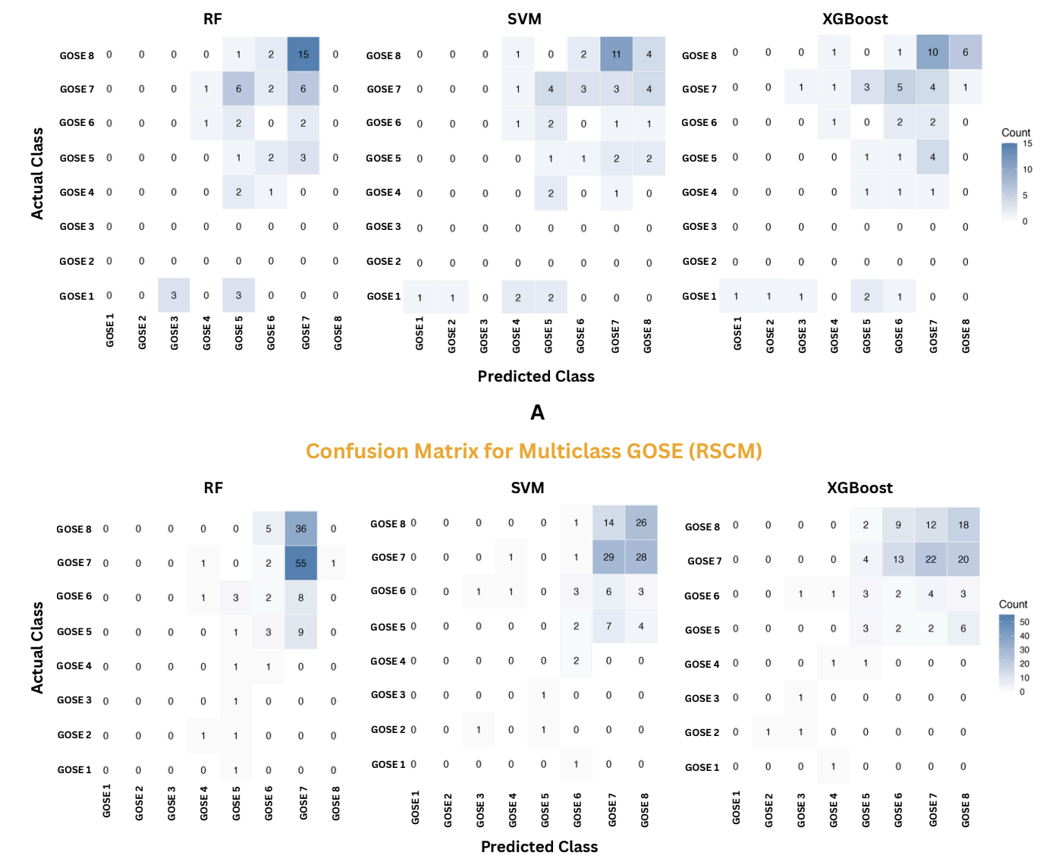

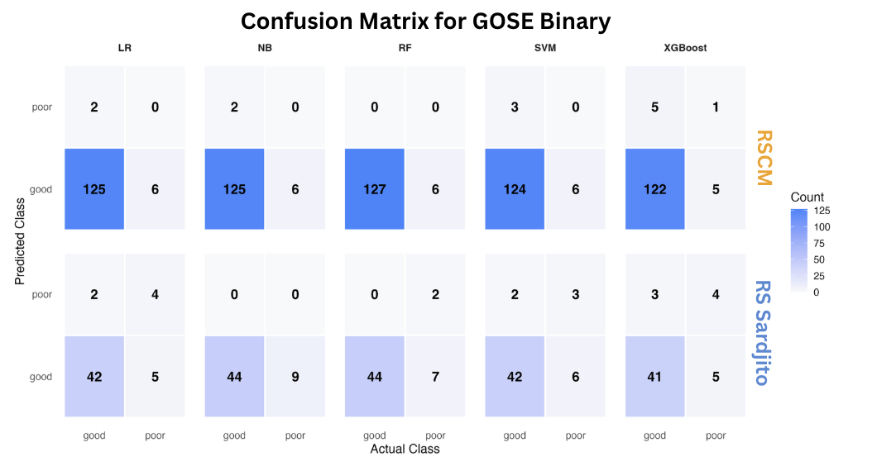
Supplementary File 8. SHAP summary plots for model explainability in the external internal validation cohort for XGBoost
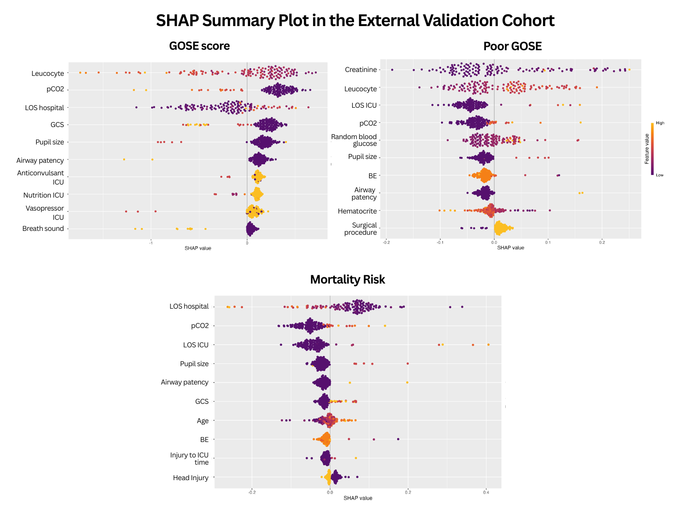
Supplementary File 9. Top 10 Key Predictors of Lower and Higher GOSE Outcomes Identified by SHAP Analysis of the XGBoost Model

No | Feature | Mean Absolute SHAP Global | Risk-associated  Value Range | Mean Absolute SHAP | Direction
RS Sardjito
1 | pCO2 | 0.358 | 32.8 (0 – 32.8) | 0.168 | ↑ higher GOSE class
1 | pCO2 | 0.358 | 35.98 (32.8 – 38.7) | -0.078 | ↑ lower GOSE class
1 | pCO2 | 0.358 | 45.79 (38.7 – 54.4) | -0.216 | ↑ lower GOSE class
2 | Airway patency | 0.289 | 0 (not intubated) | 0.124 | ↑ higher GOSE class
2 | Airway patency | 0.289 | 1 (intubated) | -0.921 | ↑ lower GOSE class
3 | Leucocyte | 0.288 | 7930/uL  (5300 – 9870) | 0.334 | ↑ higher GOSE class
3 | Leucocyte | 0.288 | 11760/uL  (9870 – 13300) | 0.166 | ↑ higher GOSE class
3 | Leucocyte | 0.288 | 14530/uL  (13300 – 15800) | 0.102 | ↑ higher GOSE class
3 | Leucocyte | 0.288 | 23700/uL  (15800 – 45200) | -0.445 | ↑ lower GOSE class
4 | LOS hospital | 0.259 | 3.28 days (1 – 5) | -0.164 | ↑ lower GOSE class
4 | LOS hospital | 0.259 | 6.60 days (5 – 7) | -0.245 | ↑ lower GOSE class
4 | LOS hospital | 0.259 | 11.17 days (7 – 14) | 0.219 | ↑ higher GOSE class
4 | LOS hospital | 0.259 | 22.00 days (14 – 37) | 0.367 | ↑ higher GOSE class
5 | Pupil size | 0.254 | 0 (normal) | 0.179 | ↑ higher GOSE class
5 | Pupil size | 0.254 | 1 (mydriasis) | -0.810 | ↑ lower GOSE class
6 | GCS (category) | 0.252 | 0 (13-15) | 0.171 | ↑ higher GOSE class
6 | GCS (category) | 0.252 | 1 (9-12) | -0.076 | ↑ lower GOSE class
6 | GCS (category) | 0.252 | 2 (3-8) | -0.487 | ↑ lower GOSE class
7 | Vasopressor ICU | 0.175 | 0 (no) | 0.094 | ↑ higher GOSE class
7 | Vasopressor ICU | 0.175 | 1 (yes) | -1.264 | ↑ lower GOSE class
7 | Vasopressor ICU | 0.175 | 2 (no ICU admission) | 0.069 | ↑ higher GOSE class
8 | Anticonvulsant ICU | 0.144 | 0 (no) | 0.115 | ↑ higher GOSE class
8 | Anticonvulsant ICU | 0.144 | 1 (yes) | -0.214 | ↑ lower GOSE class
8 | Anticonvulsant ICU | 0.144 | 2 (no ICU admission) | 0.105 | ↑ higher GOSE class
9 | Nutrition ICU | 0.135 | 0 (oral) | 0.105 | ↑ higher GOSE class
9 | Nutrition ICU | 0.135 | 1 (enteral) | -0.147 | ↑ lower GOSE class
9 | Nutrition ICU | 0.135 | 2 (parenteral) | -0.318 | ↑ lower GOSE class
9 | Nutrition ICU | 0.135 | 3 (mixed) | 0.104 | ↑ higher GOSE class
9 | Nutrition ICU | 0.135 | 4 (no ICU admission) | 0.102 | ↑ higher GOSE class
10 | Patient position | 0.120 | 1 (supine) | 0.204 | ↑ higher GOSE class
10 | Patient position | 0.120 | 4 (no surgical procedure | -0.080 | ↑ lower GOSE class
RSCM
1 | Leucocyte | 0.389 | 8760/uL (1960 – 11000) | 0.383 | ↑ higher GOSE class
1 | Leucocyte | 0.389 | 12760/uL (11000 – 14450) | 0.176 | ↑ higher GOSE class
1 | Leucocyte | 0.389 | 16850/uL (14450 – 18490) | 0.062 | ↑ higher GOSE class
1 | Leucocyte | 0.389 | 22120/uL (18490 – 36130) | -0.756 | ↑ lower GOSE class
2 | pCO2 | 0.353 | 10 (0-10) | 0.351 | ↑ higher GOSE class
2 | pCO2 | 0.353 | 28.15 (20 – 30) | -0.22 | ↑ lower GOSE class
2 | pCO2 | 0.353 | 35.53 (30 – 40) | -0.322 | ↑ lower GOSE class
2 | pCO2 | 0.353 | 48.7 (40 – 50) | -1.179 | ↑ lower GOSE class
2 | pCO2 | 0.353 | 52 (50 – 52) | -1.052 | ↑ lower GOSE class
3 | LOS hospital | 0.310 | 0.95 days (0 – 1) | -0.353 | ↑ lower GOSE class
3 | LOS hospital | 0.310 | 4.28 days (1 – 6) | -0.231 | ↑ lower GOSE class
3 | LOS hospital | 0.310 | 16.76 days (6 – 36) | 0.181 | ↑ higher GOSE class
4 | GCS (category) | 0.250 | 0 (13 – 15) | 0.227 | ↑ higher GOSE class
4 | GCS (category) | 0.250 | 1 (9 – 12) | -0.243 | ↑ lower GOSE class
4 | GCS (category) | 0.250 | 2 (3 – 8) | -0.518 | ↑ lower GOSE class
5 | Pupil size | 0.203 | 0 (normal) | 0.177 | ↑ higher GOSE class
5 | Pupil size | 0.203 | 1 (mydriasis) | -0.832 | ↑ lower GOSE class
6 | Airway patency | 0.143 | 0 (not intubated) | 0.127 | ↑ higher GOSE class
6 | Airway patency | 0.143 | 1 (intubated) | -1.134 | ↑ lower GOSE class
7 | Anticonvulsant ICU | 0.116 | 0 (no) | 0.111 | ↑ higher GOSE class
7 | Anticonvulsant ICU | 0.116 | 1 (yes) | -0.210 | ↑ lower GOSE class
7 | Anticonvulsant ICU | 0.116 | 2 (no ICU admission) | 0.113 | ↑ higher GOSE class
8 | Nutrition ICU | 0.108 | 0 (oral) | 0.046 | ↑ higher GOSE class
8 | Nutrition ICU | 0.108 | 1 (enteral) | -0.132 | ↑ lower GOSE class
8 | Nutrition ICU | 0.108 | 2 (parenteral) | -0.331 | ↑ lower GOSE class
8 | Nutrition ICU | 0.108 | 3 (mixed) | 0.040 | ↑ higher GOSE class
8 | Nutrition ICU | 0.108 | 4 (no ICU admission) | 0.104 | ↑ higher GOSE class
9 | Vasopressor ICU | 0.095 | 0 (no) | 0.070 | ↑ higher GOSE class
9 | Vasopressor ICU | 0.095 | 1 (yes) | -1.117 | ↑ lower GOSE class
9 | Vasopressor ICU | 0.095 | 2 (no ICU admission) | 0.071 | ↑ higher GOSE class
10 | Breath sound | 0.090 | 0 (clear) | 0.039 | ↑ higher GOSE class
10 | Breath sound | 0.090 | 1 (obstruction) | -0.713 | ↑ lower GOSE class

Supplementary File 10. Top 10 Key Predictors of Poor GOSE (Binary GOSE) Outcomes Identified by SHAP Analysis of the XGBoost Model
No | Feature | Mean Absolute SHAP Global | Risk-associated  Value Range | Mean Absolute SHAP | Direction
RS Sardjito
1 | Creatinine | 0.064 | 0.51 mg/dL  (0.33 – 0.64) | -0.070 | ↓ poor GOSE
1 | Creatinine | 0.064 | 0.78 mg/dL  (0.64 – 0.82) | -0.033 | ↓ poor GOSE
1 | Creatinine | 0.064 | 0.91 mg/dL  (0.82 – 0.96) | 0.048 | ↑ poor GOSE
1 | Creatinine | 0.064 | 1.20 mg/dL  (0.96 – 1.67) | 0.094 | ↑ poor GOSE
2 | Random blood glucose | 0.059 | 99.78 g/dL  (76 – 115) | -0.045 | ↓ poor GOSE
2 | Random blood glucose | 0.059 | 121.54 g/dL  (115 – 129) | -0.035 | ↓ poor GOSE
2 | Random blood glucose | 0.059 | 140.38 g/dL  (129 – 154) | 0.062 | ↑ poor GOSE
2 | Random blood glucose | 0.059 | 227.31g/dL  (154 – 355) | 0.074 | ↑ poor GOSE
3 | LOS ICU | 0.056 | 0.69 days  (0 – 2.65) | -0.039 | ↓ poor GOSE
3 | LOS ICU | 0.056 | 3.50 days  (2.65 – 4.56) | 0.003 | ↑ poor GOSE
3 | LOS ICU | 0.056 | 7.25 days  (4.56 – 19.33) | 0.122 | ↑ poor GOSE
4 | Leucocyte | 0.044 | 7933/uL  (5300 – 9870) | -0.056 | ↓ poor GOSE
4 | Leucocyte | 0.044 | 11761/uL  (9870 – 13300) | -0.043 | ↓ poor GOSE
4 | Leucocyte | 0.044 | 14531/uL  (13300 – 15800) | -0.004 | ↓ poor GOSE
4 | Leucocyte | 0.044 | 23700/uL  (15800 – 45200) | 0.053 | ↑ poor GOSE
5 | pCO2 | 0.038 | 35.98 (32.8 – 38.7) | 0.025 | ↑ poor GOSE
5 | pCO2 | 0.038 | 45.79 (38.7 – 54.4) | 0.059 | ↑ poor GOSE
6 | Airway patency | 0.036 | 0 (not intubated) | -0.018 | ↓ poor GOSE
6 | Airway patency | 0.036 | 1 (intubated) | 0.105 | ↑ poor GOSE
7 | Hematocrite | 0.034 | 25.32 (21.5 – 27.4) | 0.051 | ↑ poor GOSE
7 | Hematocrite | 0.034 | 30.88 (27.4 – 33.4) | 0.025 | ↑ poor GOSE
7 | Hematocrite | 0.034 | 36.90 (33.4 – 40.7) | -0.017 | ↓ poor GOSE
7 | Hematocrite | 0.034 | 44.06 (40.7 – 53.4) | -0.039 | ↓ poor GOSE
8 | Pupil size | 0.027 | 0 (normal) | -0.021 | ↓ poor GOSE
8 | Pupil size | 0.027 | 1 (mydriasis) | 0.078 | ↑ poor GOSE
9 | BE | 0.026 | -5.5 (-12 – -2.75) | 0.046 | ↑ poor GOSE
9 | BE | 0.026 | -0.16 (-2.75 – 0) | -0.020 | ↓ poor GOSE
9 | BE | 0.026 | 0.22 (0 – 0.22) | -0.012 | ↓ poor GOSE
9 | BE | 0.026 | 9.24 (0.22 – 9.6) | -0.008 | ↓ poor GOSE
10 | Surgical procedure | 0.023 | 1 (hematome evacuation/craniotomy) | -0.043 | ↓ poor GOSE
10 | Surgical procedure | 0.023 | 3 (others) | -0.031 | ↓ poor GOSE
10 | Surgical procedure | 0.023 | 4 (no surgical procedure) | 0.016 | ↑ poor GOSE
RSCM
1 | Creatinine | 0.076 | 0.52 mg/dL  (0.3 – 0.65) | -0.070 | ↓ poor GOSE
1 | Creatinine | 0.076 | 0.82 mg/dL  (0.65 – 0.90) | -0.033 | ↓ poor GOSE
1 | Creatinine | 0.076 | 1.06 mg/dL  (0.9 – 1.1) | 0.150 | ↑ poor GOSE
1 | Creatinine | 0.076 | 3.14 mg/dL  (1.1 – 14.6) | 0.091 | ↑ poor GOSE
2 | Leucocyte | 0.056 | 8760/uL  (1960 – 11000) | -0.061 | ↓ poor GOSE
2 | Leucocyte | 0.056 | 12760/uL  (11000 – 14450) | -0.030 | ↓ poor GOSE
2 | Leucocyte | 0.056 | 16850/uL  (14450 – 18490) | 0.054 | ↑ poor GOSE
2 | Leucocyte | 0.056 | 22120/uL  (18490 – 36130) | 0.080 | ↑ poor GOSE
3 | LOS ICU | 0.049 | 0.08 days  (0 – 5) | -0.045 | ↓ poor GOSE
3 | LOS ICU | 0.049 | 8.5 days  (5 – 10) | 0.104 | ↑ poor GOSE
3 | LOS ICU | 0.049 | 14 days  (10 – 15) | 0.118 | ↑ poor GOSE
3 | LOS ICU | 0.049 | 17 days  (15 – 20) | 0.067 | ↑ poor GOSE
3 | LOS ICU | 0.049 | 23 days  (20 – 25) | 0.159 | ↑ poor GOSE
3 | LOS ICU | 0.049 | 26 days  (25 – 26) | 0.128 | ↑ poor GOSE
4 | pCO2 | 0.036 | 28.15  (20 – 30) | 0.006 | ↑ poor GOSE
4 | pCO2 | 0.036 | 35.53  (30 – 40) | 0.011 | ↑ poor GOSE
4 | pCO2 | 0.036 | 48.7  (40 – 50) | 0.033 | ↑ poor GOSE
4 | pCO2 | 0.036 | 52  (50 – 52) | 0.16 | ↑ poor GOSE
5 | Random blood glucose | 0.028 | 93.63 (29 – 111) | -0.033 | ↓ poor GOSE
5 | Random blood glucose | 0.028 | 121.05 (111 – 128) | -0.018 | ↓ poor GOSE
5 | Random blood glucose | 0.028 | 132.85 (128 – 137) | 0.003 | ↑ poor GOSE
5 | Random blood glucose | 0.028 | 215.42 (137 – 413) | 0.042 | ↑ poor GOSE
6 | Pupil size | 0.023 | 0 (normal) | -0.021 | ↓ poor GOSE
6 | Pupil size | 0.023 | 1 (mydriasis) | 0.076 | ↑ poor GOSE
7 | BE | 0.021 | -0.33 (-13.2 – 0) | -0.016 | ↓ poor GOSE
7 | BE | 0.021 | 2.56 (0 – 3.7) | -0.022 | ↓ poor GOSE
8 | Airway patency | 0.021 | 0 (not intubated) | -0.018 | ↓ poor GOSE
8 | Airway patency | 0.021 | 1 (intubated) | 0.161 | ↑ poor GOSE
9 | Hematocrite | 0.018 | 30.07 (19.2 – 34.6) | 0.022 | ↑ poor GOSE
9 | Hematocrite | 0.018 | 37.24 (34.6 – 39.1) | -0.007 | ↓ poor GOSE
9 | Hematocrite | 0.018 | 40.65 (39.1 – 42) | -0.014 | ↓ poor GOSE
9 | Hematocrite | 0.018 | 45.55 (42 – 56.9) | -0.026 | ↓ poor GOSE
10 | Surgical procedure | 0.014 | 1 (hematome evacuation/craniotomy) | -0.033 | ↓ poor GOSE
10 | Surgical procedure | 0.014 | 4 (no surgical procedure) | 0.013 | ↑ poor GOSE

Supplementary File 11. Top 10 Key Predictors of Mortality Identified by SHAP Analysis of the XGBoost Model
No | Feature | Mean Absolute SHAP Global | Risk-associated  Value Range | Mean Absolute SHAP | Direction
RS Sardjito
1 | LOS hospital | 0.103 | 3.28 days  (1 – 5) | 0.090 | ↑ mortality
1 | LOS hospital | 0.103 | 6.60 days  (5 – 7) | 0.030 | ↑ mortality
1 | LOS hospital | 0.103 | 11.17 days  (7 – 14) | -0.050 | ↓ mortality
1 | LOS hospital | 0.103 | 22.00 days  (14 – 37) | -0.210 | ↓ mortality
2 | LOS ICU | 0.063 | 0.69 days  (0 – 2.65) | -0.049 | ↓ mortality
2 | LOS ICU | 0.063 | 3.51 days  (2.65 – 4.56) | -0.006 | ↓ mortality
2 | LOS ICU | 0.063 | 7.25 days (  4.56 – 19.33) | 0.101 | ↑ mortality
3 | pCO2 | 0.042 | 35.98 (32.8 – 38.7) | 0.022 | ↑ mortality
3 | pCO2 | 0.042 | 45.79 (38.7 – 54.4) | 0.064 | ↑ mortality
4 | Airway patency | 0.038 | 0 (not intubated) | -0.017 | ↓ mortality
4 | Airway patency | 0.038 | 1 (intubated) | 0.121 | ↑ mortality
5 | Pupil size | 0.032 | 0 (normal) | -0.022 | ↓ mortality
5 | Pupil size | 0.032 | 1 (mydriasis) | 0.093 | ↑ mortality
6 | Age | 0.027 | 10.51 years  (0.67 – 17) | -0.036 | ↓ mortality
6 | Age | 0.027 | 20.83 years  (17 – 25) | -0.023 | ↓ mortality
6 | Age | 0.027 | 32.69 years  (25 – 43) | 0.009 | ↑ mortality
6 | Age | 0.027 | 62.08 years  (43 – 91) | 0.034 | ↑ mortality
7 | BE | 0.019 | -5.51  (-12 – -2.75) | 0.029 | ↑ mortality
7 | BE | 0.019 | -0.16  (-2.75 – 0) | -0.013 | ↓ mortality
7 | BE | 0.019 | 0.22  (0 – 0.22) | -0.020 | ↓ mortality
7 | BE | 0.019 | 9.24  (0.22 – 9.6) | -0.010 | ↓ mortality
8 | GCS (category) | 0.019 | 0 (13-15) | -0.015 | ↓ mortality
8 | GCS (category) | 0.019 | 1 (9-12) | 0.038 | ↑ mortality
8 | GCS (category) | 0.019 | 2 (3-8) | 0.019 | ↑ mortality
9 | Injury to ICU time | 0.018 | 7.37 days  (0 – 29.64) | -0.009 | ↓ mortality
9 | Injury to ICU time | 0.018 | 231.42 days (29.64 – 1223.5) | 0.025 | ↑ mortality
10 | Imaging SDH | 0.014 | 0 (no) | -0.009 | ↓ mortality
10 | Imaging SDH | 0.014 | 1 (yes) | 0.041 | ↑ mortality
10 | Imaging SDH | 0.014 | 3 (no ct scan) | -0.008 | ↓ mortality
RSCM
1 | LOS hospital | 0.077 | 0.95 days  (0 – 1) | 0.086 | ↑ mortality
1 | LOS hospital | 0.077 | 4.28 days  (1 – 6) | 0.053 | ↑ mortality
1 | LOS hospital | 0.077 | 16.76 days  (16 – 76) | -0.076 | ↓ mortality
2 | pCO2 | 0.054 | 28.15 (20 – 30) | 0.009 | ↑ mortality
2 | pCO2 | 0.054 | 35.53 (30 – 40) | 0.031 | ↑ mortality
2 | pCO2 | 0.054 | 48.7 (40 – 50) | 0.021 | ↑ mortality
2 | pCO2 | 0.054 | 52 (50 – 52) | 0.141 | ↑ mortality
3 | LOS ICU | 0.054 | 0.08 days (0 – 5) | -0.045 | ↓ mortality
3 | LOS ICU | 0.054 | 8.5 days (5 – 10) | 0.057 | ↑ mortality
3 | LOS ICU | 0.054 | 14 days (10 – 15) | 0.279 | ↑ mortality
3 | LOS ICU | 0.054 | 17 days (15 – 20) | 0.366 | ↑ mortality
3 | LOS ICU | 0.054 | 23 days (20 – 25) | 0.406 | ↑ mortality
3 | LOS ICU | 0.054 | 26 days (25 – 26) | 0.289 | ↑ mortality
4 | Pupil size | 0.027 | 0 (normal) | -0.024 | ↓ mortality
4 | Pupil size | 0.027 | 1 (mydriasis) | 0.105 | ↑ mortality
5 | Airway patency | 0.020 | 0 (not intubated | -0.018 | ↓ mortality
5 | Airway patency | 0.020 | 1 (intubated) | 0.124 | ↑ mortality
6 | GCS (category) | 0.018 | 0 (13-15) | -0.016 | ↓ mortality
6 | GCS (category) | 0.018 | 1 (9-12) | 0.038 | ↑ mortality
6 | GCS (category) | 0.018 | 2 (3-8) | 0.023 | ↑ mortality
7 | Age | 0.017 | 7.89 years (0 – 18) | -0.032 | ↓ mortality
7 | Age | 0.017 | 23.72 (18 – 29) | -0.007 | ↓ mortality
7 | Age | 0.017 | 38.06 (29 – 47) | -0.001 | ↓ mortality
7 | Age | 0.017 | 57.56 (47 – 84) | 0.017 | ↑ mortality
8 | BE | 0.014 | -0.33 (-13.2 – 0) | -0.009 | ↓ mortality
8 | BE | 0.014 | 2.56 (0 – 3.7) | -0.008 | ↓ mortality
9 | Injury to ICU time | 0.012 | 0.12 hours (0 – 20) | -0.011 | ↓ mortality
9 | Injury to ICU time | 0.012 | 28.5 hours (20 – 40) | 0.008 | ↑ mortality
9 | Injury to ICU time | 0.012 | 67.5 hours (60 – 67.5) | 0.066 | ↑ mortality
10 | Head injury | 0.011 | 0 (no) | 0.016 | ↑ mortality
10 | Head injury | 0.011 | 1 (yes) | -0.004 | ↓ mortality

