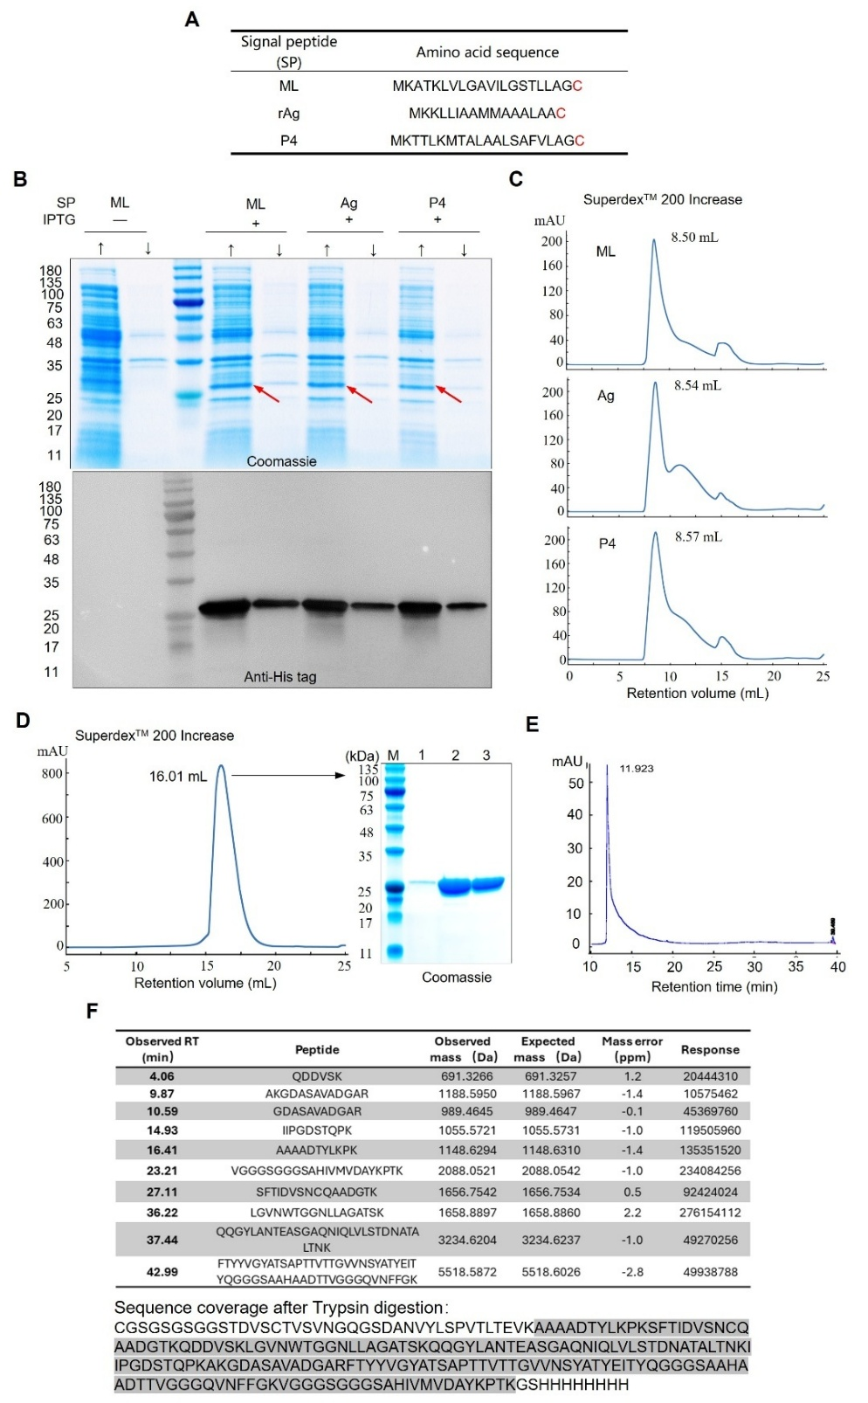
Supplementary Figure 1. Expression and identification of recombinant MrkAaST bearing different signal peptides. A, Signal peptides (SP) and the amino acid sequences used in this study. B, Expression of the recombinant MrkAaST, bearing various lipoprotein signal peptides (ML, rAg, and P4), was assessed in the supernatant and debris of the host strain using Coomassie blue staining and immunoblotting, with detection by an anti-His tag antibody. The symbol "↑" denotes the supernatant of bacterial cell lysis, while "↓" indicates the debris. C, Retention volume of recombinant MrkAaST proteins was determined using size exclusion chromatography (SuperdexTM 200 Increase, total volume of 24 mL) with a surfactant-free mobile phase. D, The secreted recombinant MrkAaST (PelB-MrkAaST) was isolated by size exclusion chromatography (SuperdexTM 200 Increase, total volume of 24 mL) and subsequently analyzed by Coomassie blue staining. E, The secreted recombinant MrkAaST (PelB-MrkAaST) underwent analysis via reverse-phase high-performance liquid chromatography (RP-HPLC) using a SinoChrom C4 column (300 Å, 4.6 × 250 mm, 5 μm). F, Protein identification was performed by peptide mass fingerprinting (PMF). ML-MrkAaST was digested with trypsin and separated using RP-HPLC (ACQUITY UPLC Peptide BEH C18 column, 130 Å, 1.7 µm, 2.1 mm × 150 mm) at 55°C, with peptide masses evaluated by tandem mass spectrometry (MS/MS) using the Xevo G2-XS QTof.
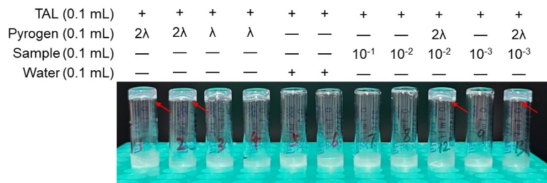
Supplementary Figure 2. Limulus Amebocyte Lysate (LAL) gel-clot assay quantified endotoxin content. The sensitivity of the Limulus lysate reagent (λ) was 0.125 EU/mL, and the assay was executed in accordance with the Pharmacopoeia of the People's Republic of China (2020, Vol. 4, p. 180).

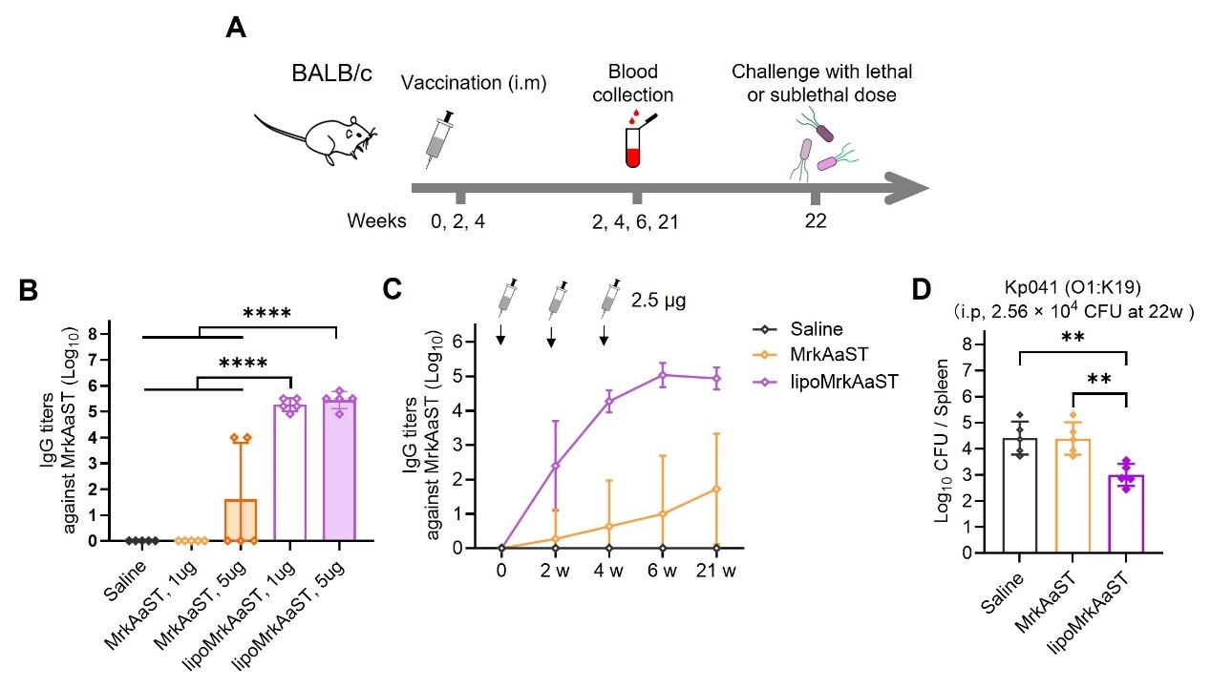
Supplementary Figure 3. lipoMrkAaST is a highly immunogenic and potentially protective antigen. A, Immunization schedule for evaluating the immunogenicity of lipoMrkAaST. Mice (n = 10 in each group) were intramuscularly immunized 3 times with different doses of MrkAaST or lipoMrkAaST at 2-week intervals. Sera were harvested at the indicated time points and analyzed by ELISA. B, Measurement of MrkAaST-specific IgG titers in the serum 14 days after three doses of saline, 1 or 5 μg MrkAaST, 1 or 5 μg lipoMrkAaST (n = 10). C, MrkAaST-specific IgG profile of mice immunized with 2.5 μg MrkAaST or lipoMrkAaST. D, Bacterial load in the spleen 36 h post sublethal-dose challenge (2.56 × 10⁴ CFU Kp041 per mouse) at week 22 (n = 5).

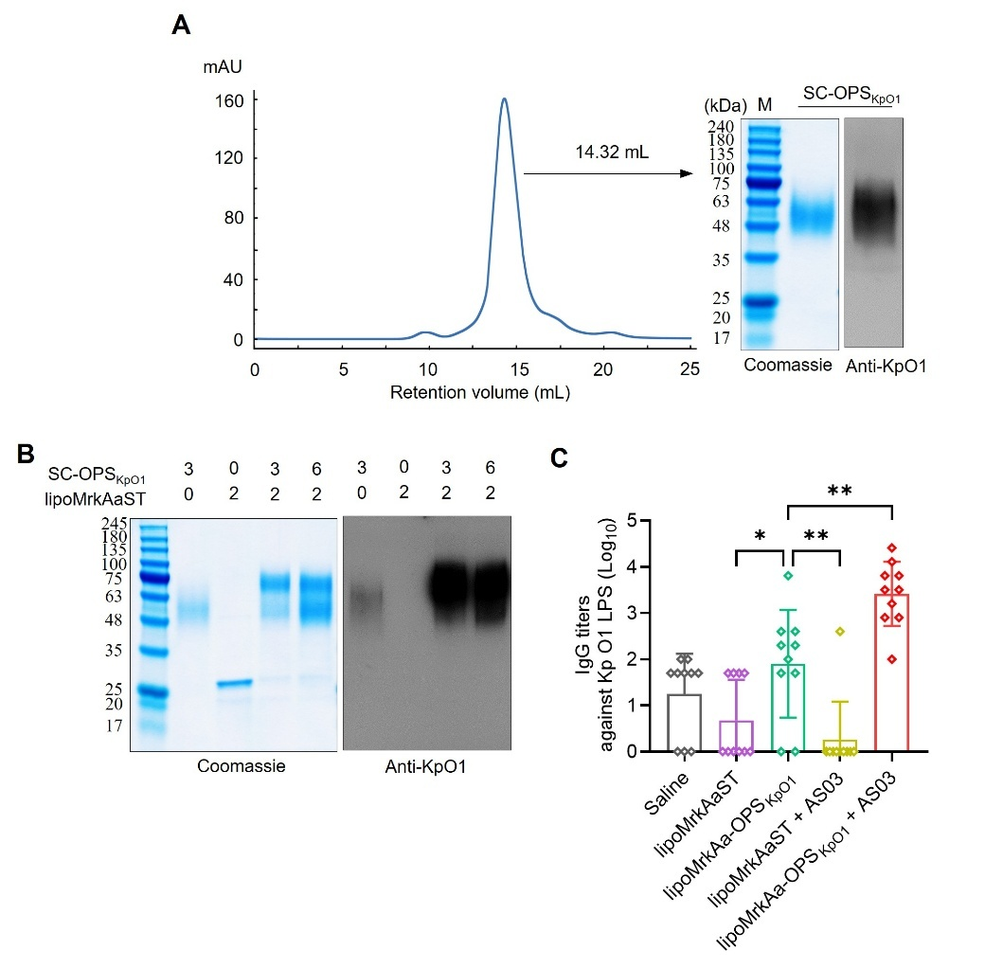
Supplementary Figure 4. A, B, Coomassie blue staining and western blotting (probed with an anti-KpO1 polyclonal antibody) showing covalent complex formation between SC-OPS_{KpO1} and lipoMrkAaST at 4°C for 12 h. C, IgG titers against K. pneumoniae serotype O1 OPS following a 3-dose regimen of AS03 adjuvanted or unadjuvanted-lipoMrkAaST and lipoMrkAa-OPS_{KpO1} (n = 10).

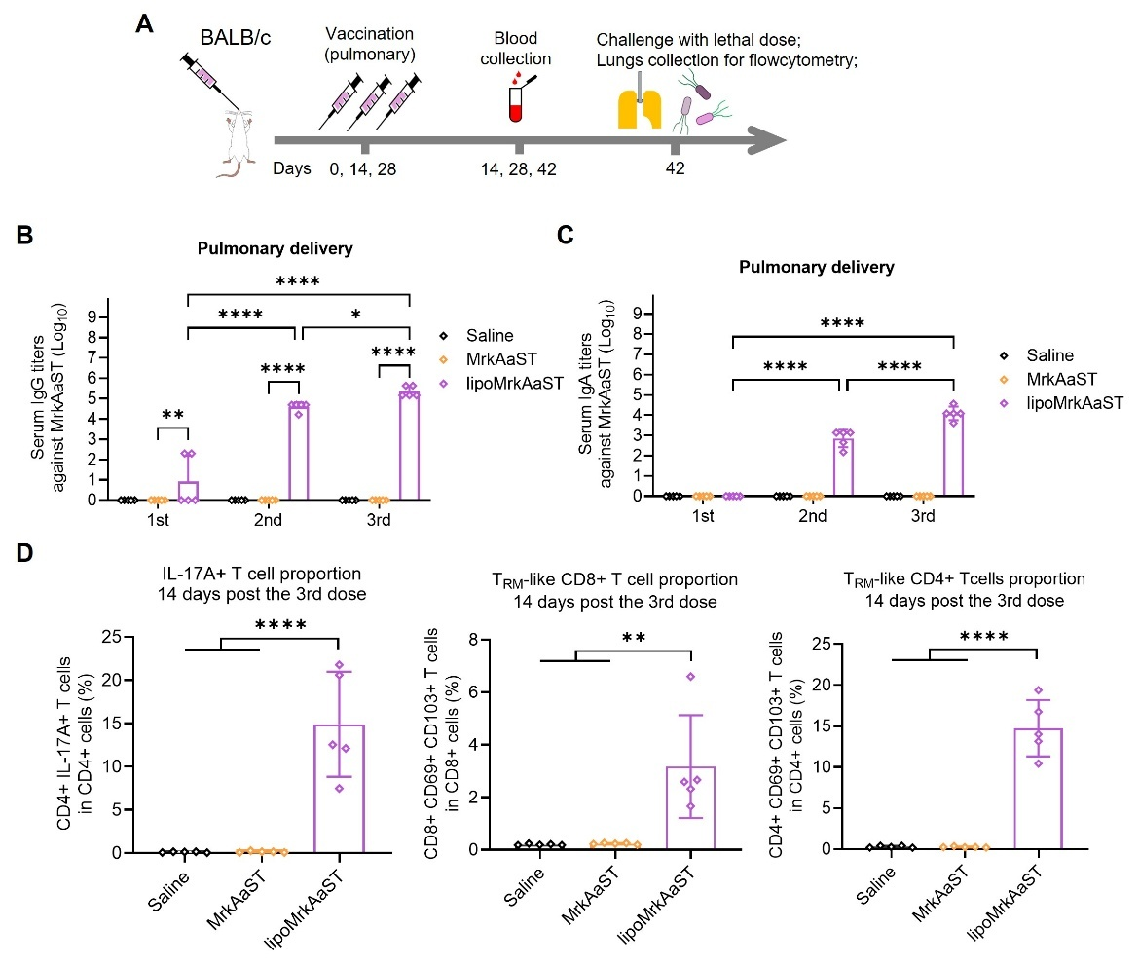
Supplementary Figure 5. Immune responses elicited by intratracheal immunization of lipoMrkAaST in mice. A, Intratracheal administration schedule for assessing the mucosal immune responses of lipoMrkAaST. B and C, Measurement of MrkAaST-specific IgG (B) and IgA (C) titers in the serum 14 days after intratracheal immunization (n = 5). D, Lung-localized IL-17-producing MrkAaST-specific CD4⁺ T-cells (defined as CD3⁺ CD4⁺ IL-17A⁺), T_{RM}-like CD4⁺ T-cells (defined as CD3⁺ CD4⁺ CD69⁺ CD103⁺), and T_{RM}-like CD8⁺ T-cells (defined as CD3⁺ CD8⁺ CD69⁺ CD103⁺) in the lungs were identified by flow cytometry (n = 5). Each group was compared for antibody titers via one-way ANOVA with Dunnett’s multiple comparison test, and survival rates were compared via Log-rank (Mantel-Cox) test: **** P < 0.0001, *** P < 0.001, ** P < 0.01, and * P < 0.05.

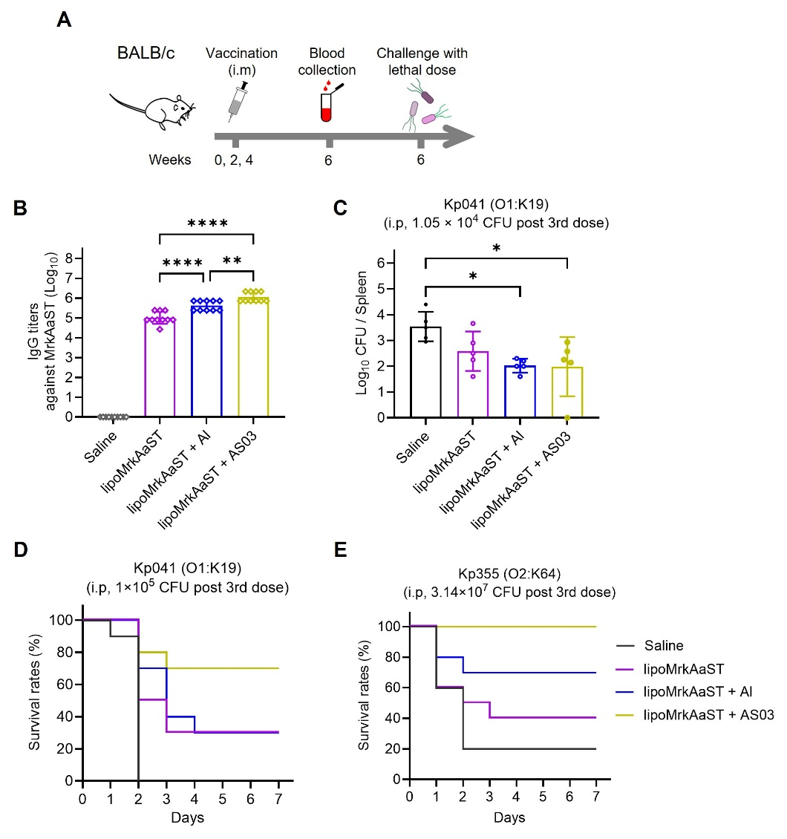
Supplementary Figure 6. Adjuvanted lipoMrkAaST induces variable protection against clinical isolates in mice. A, Administration schedule for assessing the antibody responses and prophylactic performance of adjuvanted lipoMrkAaST. B, Measurement of MrkAaST-specific IgG titers in the serum 14 days after three doses of saline, lipoMrkAaST, lipoMrkAaST + AS(OH)₃, and lipoMrkAaST + AS03 (n = 10). C, Bacterial loads in the spleen 36 h after sublethal dose challenge (1.05 × 10⁴ CFU of Kp041 (O1:K19) per mouse) 14 days after the third immunization (n = 5). D and E, Survival rate was monitored for a total of 7 days when the mice were challenged with 1 × 10⁵ CFU of Kp041 (O1:K19) (D) or 3.14 × 10⁷ CFU of Kp355 (O2:K64) (E) 14 days after the third injection (n = 10). Each group was compared for antibody titers and bacterial loads via one-way ANOVA with Dunnett’s multiple comparison test, and survival rates were compared via Log-rank (Mantel-Cox) test: **** P < 0.0001, *** P < 0.001, ** P < 0.01, and * P < 0.05.

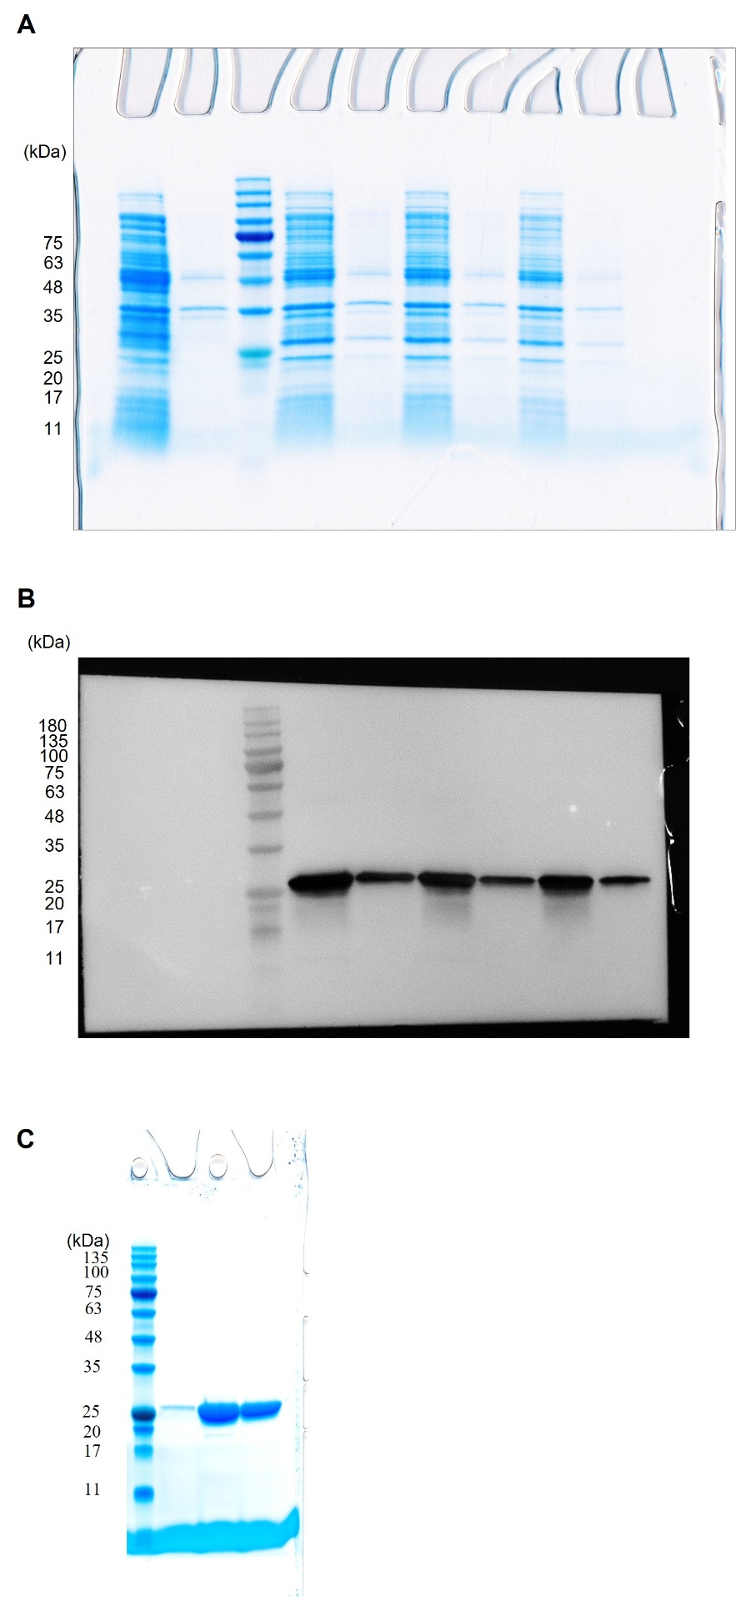
Supplementary Figure 7. Uncropped Coomassie-stained gel and immunoblotting images used in Supplementary Figure 1. A and B, uncropped images used in Supplementary Figure 1B. C, uncropped Coomassie-stained gel image used in Supplementary Figure 1D.

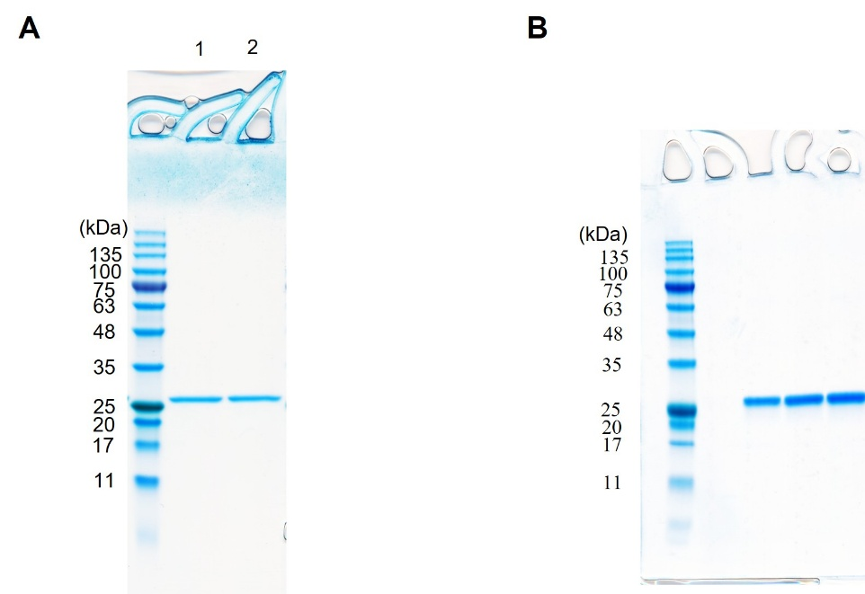
Supplementary Figure 8. Uncropped Coomassie-stained gel images used in Figure 2. A, Lane 1 used in Figure 2B. B, Uncropped Coomassie-stained gel image used in Figure 2E.

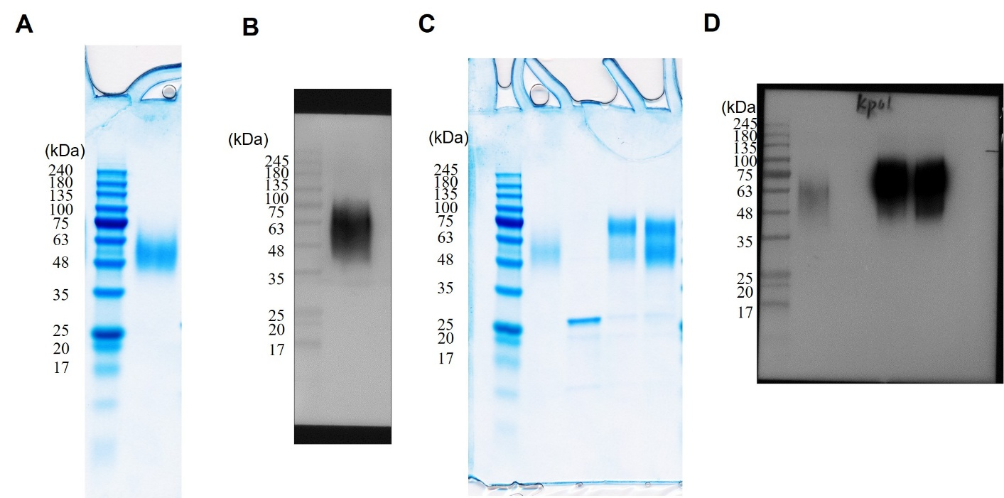
Supplementary Figure 9. Uncropped Coomassie-stained gel and immunoblotting images used in Supplementary Figure 4. A and B, uncropped images used in Supplementary Figure 4A. C and D, uncropped images used in Supplementary Figure 4B.

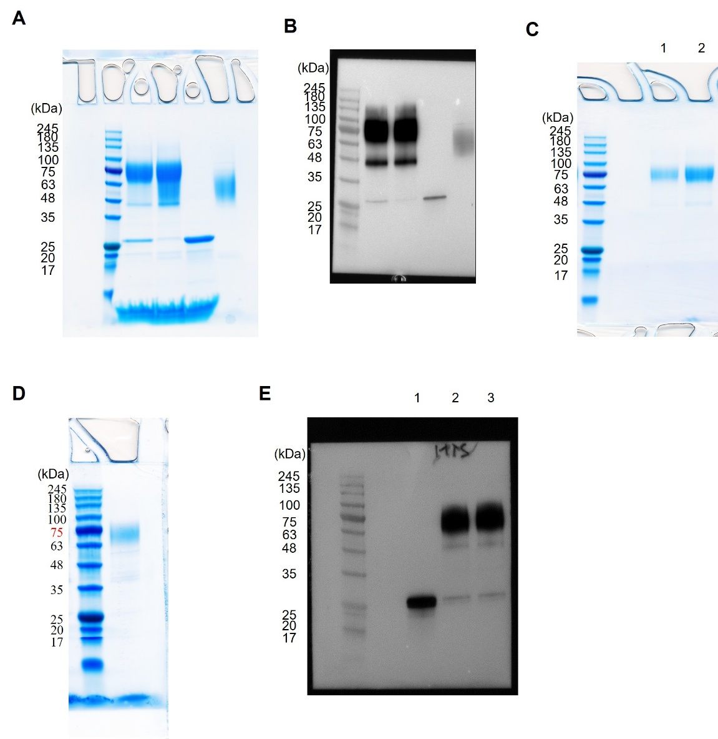
Supplementary Figure 10. Uncropped Coomassie-stained gel and immunoblotting images used in Figure 6. A and B, uncropped images used in Figure 6A. C, Lane 2 used in Figure 6B. D, uncropped Coomassie-stained gel image used in Figure 6G. E, Lane 2 used in Figure 6G.

