Electronic Supplementary Material
“It’s now or never: mating is highly synchronised in a monestrous ungulate”
Agathe Culioli, L. Monica Trondrud, Nadège C. Bonnot, Jean-Michel Gaillard, Benjamin Rey, Jean-François Lemaître, A. J. Mark Hewison

Online resource 1: Scanned observation sheet

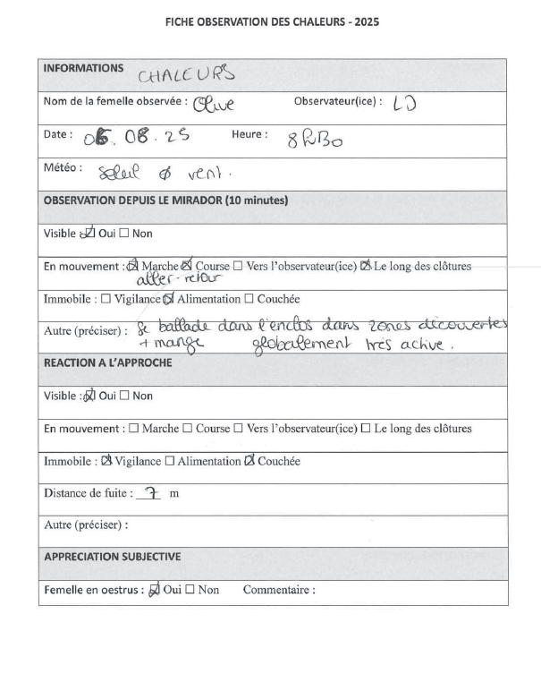

Online resource 2
Table S1: Concentration in progesterone metabolite with associated coefficient of variation (CV) between duplicates and percentage of dry matter of faecal samples in captive roe deer females with known oestrus date.
Subject name | Date of sample | CV | % Dry matter | Concentration (ng/g of fresh matter) | Identified oestrus date from behavioural observations
Olive | 2025-07-16 | 7.1 | 43.7 | 25.5 | 2025-08-05
Olive | 2025-07-18 | 16 | 42,4 | 40 | 2025-08-05
Olive | 2025-07-22 | 10.1 | 42.8 | 145.2 | 2025-08-05
Olive | 2025-07-30 | 1.8 | 55.9 | 217.6 | 2025-08-05
Olive | 2025-08-01 | 4.8 | 54.9 | 160.1 | 2025-08-05
Olive | 2025-08-05 | 13.7 | 45.4 | 50.7 | 2025-08-05
Olive | 2025-08-08 | 4.7 | 48.1 | 59 | 2025-08-05
Olive | 2025-08-10 | 4.8 | 37.1 | 232.1 | 2025-08-05
Olive | 2025-08-12 | 3.2 | 51 | 360.2 | 2025-08-05
Olive | 2025-08-14 | 7.7 | 49.4 | 185.5 | 2025-08-05
Olive | 2025-08-20 | 0.3 | 40.1 | 261.2 | 2025-08-05
Ninon | 2025-07-16 | 4 | 32.8 | 67.5 | 2025-08-11
Ninon | 2025-07-18 | 7.1 | 45.2 | 37.6 | 2025-08-11
Ninon | 2025-07-22 | 21.4 | 47.2 | 83.9 | 2025-08-11
Ninon | 2025-07-31 | 1.9 | 47.4 | 71.9 | 2025-08-11
Ninon | 2025-08-04 | 2.6 | 39.7 | 214.3 | 2025-08-11
Ninon | 2025-08-06 | 6.3 | 49.2 | 266.9 | 2025-08-11
Ninon | 2025-08-08 | 10.8 | 48 | 125.2 | 2025-08-11
Ninon | 2025-08-10 | 14.9 | 51.7 | 219.6 | 2025-08-11
Ninon | 2025-08-11 | 16.5 | 52.6 | 54.1 | 2025-08-11
Ninon | 2025-08-12 | 20.3 | 48.8 | 64.6 | 2025-08-11
Ninon | 2025-08-14 | 2.3 | 45.5 | 374.4 | 2025-08-11
Ninon | 2025-08-20 | 5.5 | 41.2 | 447.5 | 2025-08-11
Quorine | 2025-07-22 | 2.6 | 52.7 | 366.3 | 2025-08-06
Quorine | 2025-07-28 | 19.4 | 46.2 | 79.9 | 2025-08-06
Quorine | 2025-07-30 | 1.3 | 45 | 94.1 | 2025-08-06
Quorine | 2025-08-01 | 1 | 46.2 | 316.9 | 2025-08-06
Quorine | 2025-08-02 | 9.2 | 47.6 | 127.6 | 2025-08-06
Quorine | 2025-08-04 | 6.6 | 42.9 | 176.7 | 2025-08-06
Quorine | 2025-08-06 | 10.3 | 48 | 127.6 | 2025-08-06
Quorine | 2025-08-10 | 5.8 | 41.4 | 178.8 | 2025-08-06
Quorine | 2025-08-12 | 2.1 | 56.7 | 403.8 | 2025-08-06
Quorine | 2025-08-14 | 7.2 | 54.8 | 295 | 2025-08-06
Quorine | 2025-08-20 | 3.7 | 48.3 | 336.5 | 2025-08-06

Online resource 3
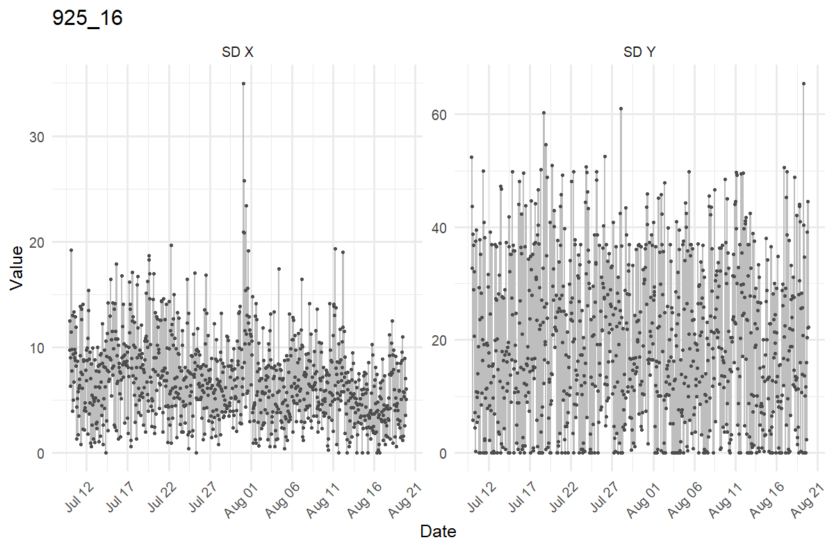
Figure S1: Example of activity data from a female equipped with a mercury tip switch sensor (Lotek GPS 3300). The hourly means of the standard deviation of activity values on the X axis (SD X) and the Y axis (SD Y) are represented. While a clear peak is visible for the SD X, the SD Y appears relatively monotonous over the rutting season.
Online resource 4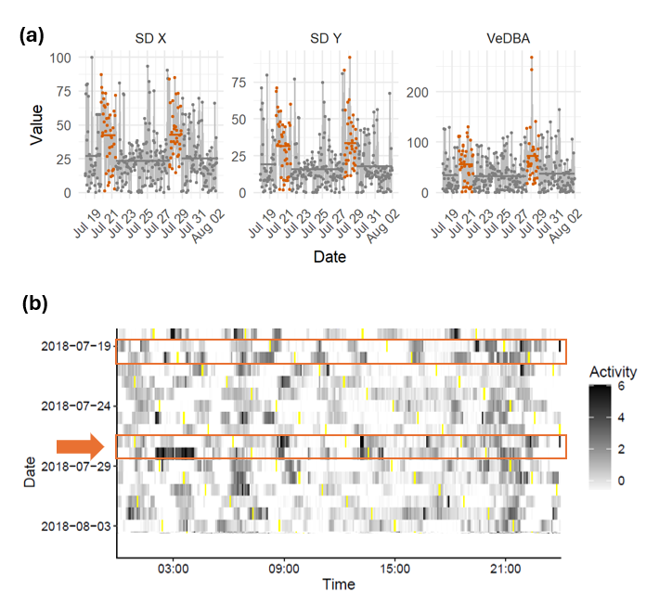
Figure S2: Example of manual cluster selection using an actogram from a given captive roe deer female equipped with an activity sensor embedded in a GPS collar. (a) Clustered time series of three activity-derived metrics. A clustering algorithm was run on the hourly means of the standard deviation (SD) on the X Y axes separately, and the vectorial dynamic body acceleration (VeDBA). The horizontal line represents the mean value of the metric for each cluster. Orange points denote the two candidate clusters identified as the possible oestrus. (b) Individual actogram along the rutting period. The raw activity was scaled over the rutting period. The time periods corresponding to the two identified clusters are highlighted in orange. The cluster that was visually selected is identified with an arrow. This cluster corresponds to an unusual activity pattern, with several activity peaks throughout the day.

Online resource 5: Results of the analyses using the clusters automatically selected from variable maximization instead of a manual selection with the actograms
When more than one potential oestrus cluster was identified during the rutting season, we repeated the analysis using an alternative approach to assess the robustness of our method. For each activity metric, we identified the candidate cluster in which it attained its maximum value. We then selected the cluster that maximized the greatest number of variables. In the event of a tie, we retained the cluster with the highest VeDBA (for accelerometer-based sensor, as only sdX was used for mercury tip switch sensors). Note that the results using this variable maximization approach to select the oestrus cluster give very similar results than with the manual selection approach (see the main text): a similar distribution of oestrus dates (i.e. Gaussian-like distribution, mean oestrus date = 31st of July, sd = 6.4 days days; see Fig S3).

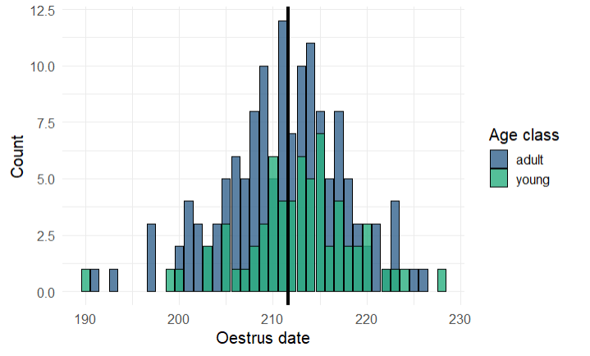
Figure S3: Distribution of oestrus dates in free-ranging female roe deer using the clusters selected from variable maximization. Oestrus dates were determined based on activity data for 203 individual-years equipped with activity sensors between 2003 and 2024. Colours correspond to different age classes. The vertical line represents the mean oestrus date (julian day 212; calendar day July 31st)
Table S2: Test results for the model assessing oestrus date using the clusters selected from variable maximization. We fitted a GLMM with the oestrus date as Gaussian response with age class, habitat, and body mass as fixed effects, as well as the two-way interaction between body mass and age class. We included the individual’s identity and the monitoring year as random effects. We then tested the significance of the fixed effects using Likelihood Ratio test (LRT) by comparing the full model with reduced models lacking the effect of interest. Statistically significant effects (p<0.05) are shown in bold.
Variable | Chi-square | df | p-value (LRT)
Age class | 2.27 | 1 | 0.132
Habitat | 0.44 | 2 | 0.804
Body mass | 5.97 | 1 | 0.024
Body mass: age class | 0.93 | 1 | 0.335

Online resource 6: Analysis of the factors that influence the probability of successfully detecting oestrus using change-point analysis on GPS collar activity data
Methods
Since in 33% of cases, our approach did not allow to identify a potential activity cluster encompassing oestrus, we aimed to characterize whether some individual or environmental factors influenced the oestrus detection rate. To do so, we fitted a GLMM with oestrus detection as a binomial response, that indicated whether oestrus (ie an activity peak identified from the clustering) was detected (1) or not (0) in a given individual. We included several variables that could affect the activity patterns of the females and/or the behavioural expression of oestrus as fixed effects. First, we included the age class of the individual at the time of capture, a 3-level categorical variable (young, adult and old). We also included body mass as a continuous variable, as oestrus is possibly condition dependent (Hewison & Gaillard, 2001; Kamieniarz et al., 2024). For the juveniles, we corrected the body mass by standardizing it to the median capture date (27 January). We also corrected the body mass for age by centring the body mass around 0 for each age class. We included the age class- body mass interaction in the model, as we expected the relationship between body mass and oestrus expression or detection to be age-dependant (Flajšman et al., 2017). We included habitat type as a 3-level categorical variable: open, mixed or closed, depending on the sector where the female was captured (See Brunot et al., 2025 for the precise description of the different sectors). The juveniles that underwent natal dispersal between capture and the rutting season were assigned a sector depending on the proportion of woodland of their actual rutting home range, estimated from GPS data. Indeed, it seems that the mating tactics of females vary depending on habitat, as it was shown that females with less woodland in their home range perform further excursions during the rut (Culioli et al., 2026), which could affect activity levels. The last fixed-effect that was included was the type of activity sensor in the collar (“switch” or “accelerometer”). We included the life-long identifier of the individuals as a random effect. We also included the year of monitoring as a random effect to account for possible cohort effects. The significance of fixed effects was assessed using Likelihood Ratio Tests (LRT) by comparing the full model with reduced models lacking the effect of interest.
Results and discussion
We detected oestrus in about two third of females (203 out of 305). We found that age class influenced oestrus detection (LRT: χ² = 5.16, df = 1, p = 0.023), as detection was less likely for juveniles than adults (β = -0.64 ± 0.29, p = 0.024). Oestrus detection rate was 62.1 % (64/103) in juveniles and 68.8 % (139/202) in adults. The type of sensor also influenced the detection rate (LRT: χ² = 17.03, df = 1, p <0.001). Indeed, oestrus detection was more likely for females equipped with an accelerometer-based collar than for females with mercury tip switches (β = -1.14 ± 0.32, p < 0.001). Oestrus detection rate was 74.9 % (134/179) in « accelerometer » type collars vs. 54.8 % (69/126) in « switch » type collars. We did not find any effect of the habitat (LRT: χ² = 0.13, df = 2, p = 0.839), of female body mass (LRT: χ² = 0.01, df = 1, p = 0.928), nor any support for a two-way interaction of body mass and age class (LRT: χ² = 0.04, df = 1, p = 0.939) on the probability of detecting the oestrus.
In roe deer, it has been shown that 1 year-old individuals (at time of rutting) have a lower ovulation rate than adults, although the proportion of individuals failing to ovulate completely is consistently low regardless of the age class (<10%, Flajšman et al., 2017; Hewison & Gaillard, 2001). Overall, the percentage of females without identifiable activity peaks (33.4%) is likely mostly due to a failure of detecting oestrus through activity rather than the actual absence of ovulation. We speculate that this could be due to the variation in how females behave during their receptivity period. Indeed around half the females do not perform reproductive excursions during the summer (Debeffe et al., 2014), making their heat harder to detect. Then, it is also possible that females that already exhibit high levels of activity in general tend to display lesser changes during the rut.

Online resource 7: Method used to assign a habitat type to juveniles
While we characterized a female environmental context based on the sector of capture (classified as open, mixed or closed/forest based on the local woodland density), this information is unavailable for some juvenile females that undergo natal dispersal and settle out of the study site. Indeed, around a third of the juvenile females disperse from their natal site to their breeding site during spring (Debeffe et al, 2012). To identify the dispersers, we followed an approach adapted from Ducros et al. (2020) using a Lavielle segmentation based on the GPS data (6-hour fixes) collected between the winter capture and the end of the rutting season (Lavielle, 1999; Patin et al., 2020). This approach allowed us, for each individual, to distinguish their rutting home range from their natal home range. We estimated both home ranges with the 90% fixed-kernel density estimate (Worton, 1989). Individuals were characterized as dispersers when their two seasonal home ranges did not overlap and were separated by at least 500m. We then calculated the percentage of woodland in each disperser’s rutting home range based on parcel data and used it to assigned each disperser’s rutting range to a sector modality: closed (>40%), mixed (]20%; 40%]) or open (<=20%)

Online resource 8
Table S3: Comparison of oestrus dates identified from the clustering algorithm on activity data versus behavioural observations in the captive females
Subject | Year of monitoring | Date of oestrus from behavioural observations | Date of oestrus from activity clustering | Interval between oestrus detection methods (in days)
Quorine | 2024 | 5 August | 4 August | 1
Quorine | 2025 | 6 August | 5 August | 1
Quachou | 2024 | 9 August | 9 August | 0
Olive | 2025 | 5 August | NA | NA
Ninon | 2025 | 9 August | 8 August | 1

Online resource 9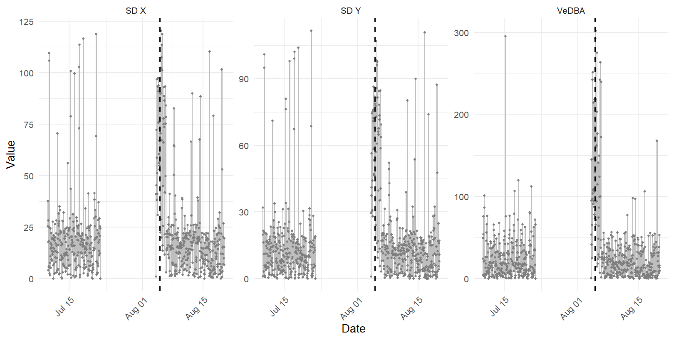
Figure S4: Absence of detection of oestrus from activity in a captive female (Olive) equipped with a GPS collar embedding an activity sensor, which malfunctioned between 22 June and 04 August. The dashed line indicates the date of the behavioural oestrus identified from daily observations. Note that although the collar malfunctioned, an activity peak is still visible around the time of the behavioural oestrus.

Online resource 10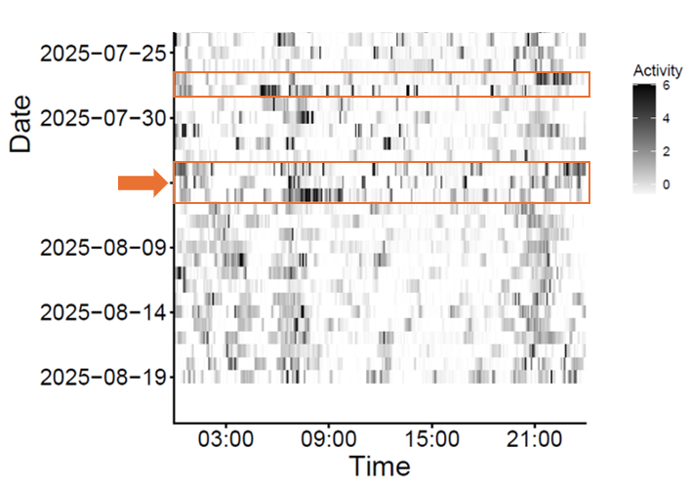
Figure S5: Actogram for a free-ranging female (F2) observed in oestrus in the wild. Using activity data collected during Summer 2025, two candidate oestrus clusters were identified with the clustering algorithm. The corresponding time periods on the actogram are highlighted in orange. The cluster that was visually selected (corresponding to an unusual activity pattern, with several activity peaks throughout the day) is identified with an arrow. This cluster also corresponds to the oestrus date detected from the behavioural observations (date).

References
Brunot, M., Morellet, N., Balandier, M., Marchand, P., Gaillard, J. ‐M., Cargnelutti, B., Bonnet, A., Chaval, Y., Pellerin, M., & Mark Hewison, A. J. (2025). Born in heterogenous landscapes: Birth timing, body mass and early development of roe deer fawns in contrasting habitats. Journal of Zoology. https://doi.org/10.1111/jzo.70025
Culioli, A., Lemaitre, J.-F., Morellet, N., Gaillard, J.-M., Pellerin, M., Bonnet, A., Chaval, Y., & Hewison, A. J. M. (2026). Natal versus breeding dispersal : Behavioural tactics in first-time breeder roe deer females during mating. Animal Behaviour, 235, 123554. https://doi.org/10.1016/j.anbehav.2026.123554
Debeffe, L., Morellet, N., Cargnelutti, B., Lourtet, B., Bon, R., Gaillard, J.-M., & Mark Hewison, A. J. (2012). Condition-dependent natal dispersal in a large herbivore : Heavier animals show a greater propensity to disperse and travel further. Journal of Animal Ecology, 81(6), 1327-1327. https://doi.org/10.1111/j.1365-2656.2012.02014.x
Debeffe, L., Focardi, S., Bonenfant, C., Hewison, A. J. M., Morellet, N., Vanpé, C., Heurich, M., Kjellander, P., Linnell, J. D. C., Mysterud, A., Pellerin, M., Sustr, P., Urbano, F., & Cagnacci, F. (2014). A one night stand? Reproductive excursions of female roe deer as a breeding dispersal tactic. Oecologia, 176(2), 431–443. https://doi.org/10.1007/s00442-014-3021-8
Ducros, D., Morellet, N., Patin, R., Atmeh, K., Debeffe, L., Cargnelutti, B., Chaval, Y., Lourtet, B., Coulon, A., & Hewison, A. J. M. (2020). Beyond dispersal versus philopatry? Alternative behavioural tactics of juvenile roe deer in a heterogeneous landscape. Oikos, 129(1), 81–92. https://doi.org/10.1111/oik.06793
Flajšman, K., Jerina, K., & Pokorny, B. (2017). Age-related effects of body mass on fertility and litter size in roe deer. PLOS ONE, 12(4), e0175579. https://doi.org/10.1371/journal.pone.0175579
Hewison, A. J. M., & Gaillard, J. M. (2001). Phenotypic quality and senescence affect different components of reproductive output in roe deer. Journal of Animal Ecology, 70(4), 600–608. https://doi.org/10.1046/j.1365-2656.2001.00528.x
Kamieniarz, R., Szymański, M., Woźna-Wysocka, M., Jaśkowski, B. M., Dyderski, M. K., Pers-Kamczyc, E., & Skorupski, M. (2024). Roe Deer Reproduction in Western Poland: The Late Autumn Rut Phenomenon. Animals, 14(21), 3078. https://doi.org/10.3390/ani14213078

Lavielle, M. (1999). Detection of multiple changes in a sequence of dependent variables. Stochastic Processes and Their Applications, 83(1), 79–102. https://doi.org/10.1016/S0304-4149(99)00023-X
Patin, R., Etienne, M., Lebarbier, E., Chamaillé‐Jammes, S., & Benhamou, S. (2020). Identifying stationary phases in multivariate time series for highlighting behavioural modes and home range settlements. Journal of Animal Ecology, 89(1), 44–56. https://doi.org/10.1111/1365-2656.13105
Worton, B. J. (1989). Kernel Methods for Estimating the Utilization Distribution in Home-Range Studies. Ecology, 70(1), 164–168. https://doi.org/10.2307/1938423

