Table 1. OSATS Global Rating Scale (GRS) domains applied for the assessment of suturing performance.
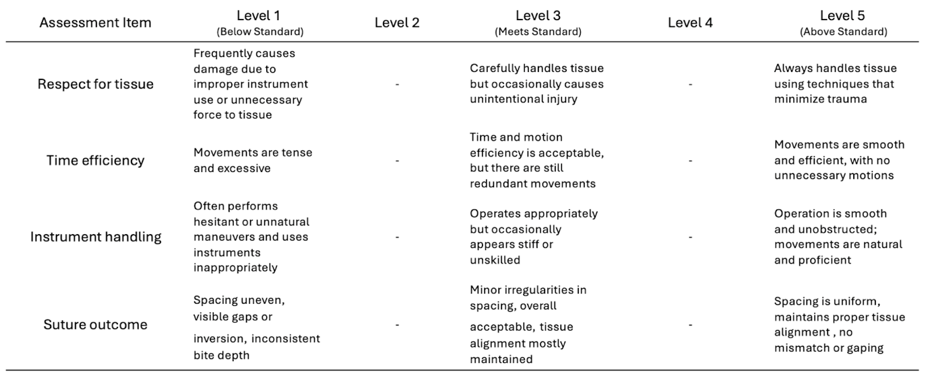
Table 2a. Comparison of suturing performance scores by surgical specialty across videos.
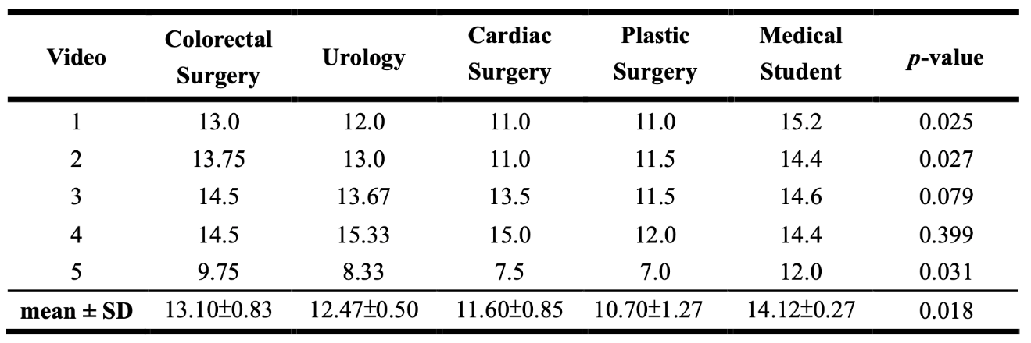

Table 2b. Post-hoc pairwise comparisons of mean suturing performance scores across surgical specialties.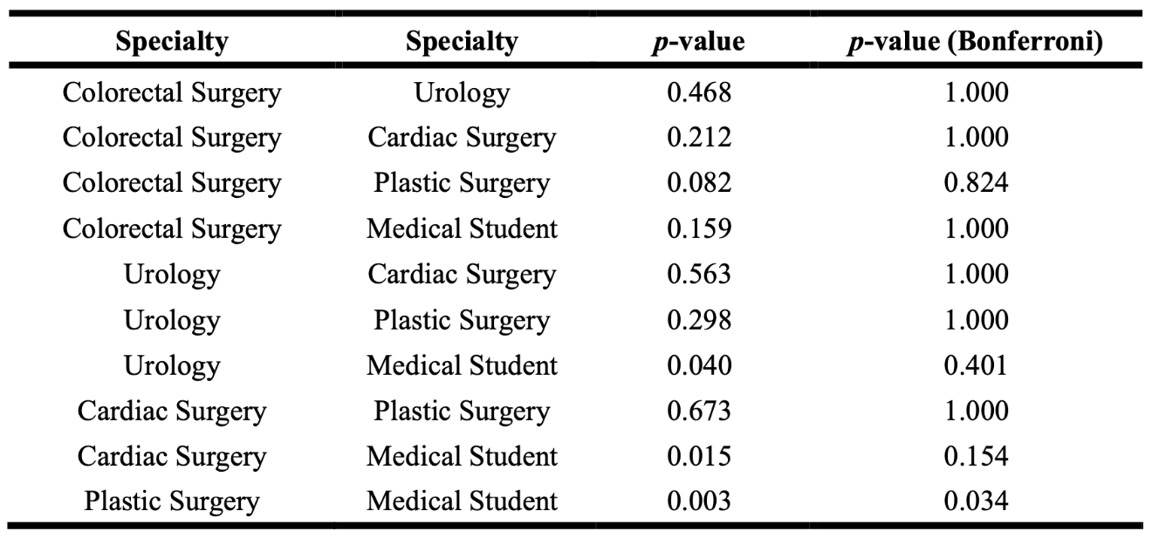
Table 3a. Comparison of suturing performance scores by clinical role across videos.
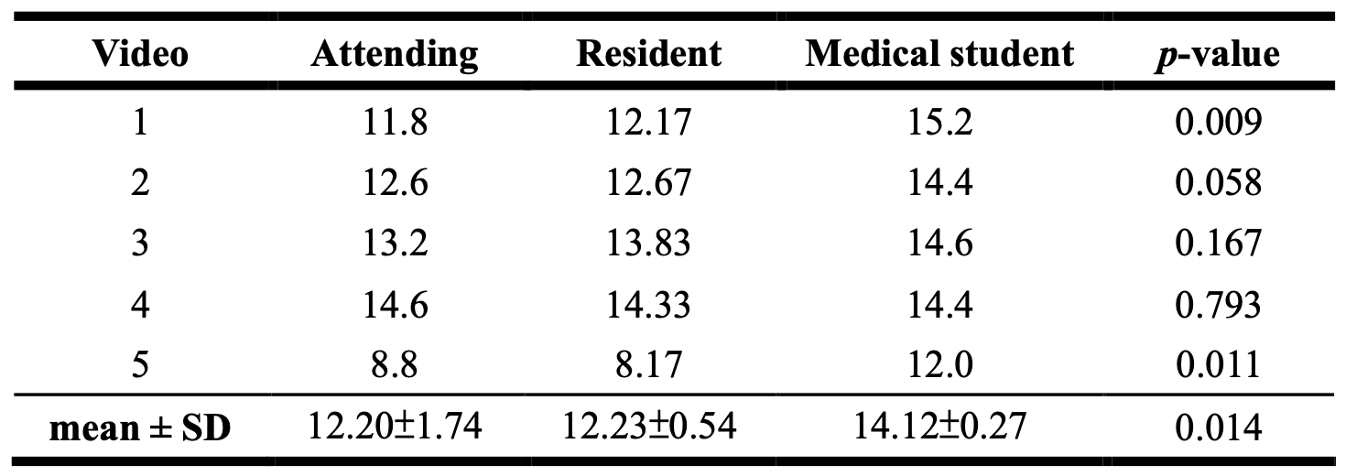

Table 3b. Post-hoc pairwise comparisons of mean suturing performance scores across clinical roles.
