
Standards for Reporting Implementation Studies: the StaRI checklist for completion

This paper aims to review the implementation strategy fidelity for the implementation of a chest injury care bundle. Patient, costing, and uptake and adherence to the care bundle are to be evaluated separately (Figure 1). Therefore, some items on the STaRI are not applicable.
Checklist item |  | Reported on page # | Implementation Strategy | Reported on page # | Intervention
 |  |  | “Implementation strategy” refers to how the intervention was implemented |  | “Intervention” refers to the healthcare or public health intervention that is being implemented.
Title and abstract
Title | 1 | 1 | Identification as an implementation study, and description of the methodology in the title and/or keywords
Abstract | 2 | 2 | Identification as an implementation study, including a description of the implementation strategy to be tested, the evidence-based intervention being implemented, and defining the key implementation and health outcomes.
Introduction
Introduction | 3 | 4-5 | Description of the problem, challenge or deficiency in healthcare or public health that the intervention being implemented aims to address.
Rationale | 4 | 4,6 | The scientific background and rationale for the implementation strategy (including any underpinning theory/framework/model, how it is expected to achieve its effects and any pilot work). | 5 | The scientific background and rationale for the intervention being implemented (including evidence about its effectiveness and how it is expected to achieve its effects).
Aims and objectives | 5 | 5 | The aims of the study, differentiating between implementation objectives and any intervention objectives.
Methods: description
Design | 6 | 10 | The design and key features of the evaluation, (cross referencing to any appropriate methodology reporting standards) and any changes to study protocol, with reasons
Context | 7 | 11 | The context in which the intervention was implemented. (Consider social, economic, policy, healthcare, organisational barriers and facilitators that might influence implementation elsewhere).
Targeted ‘sites’ | 8 | 11 | The characteristics of the targeted ‘site(s)’ (e.g locations/personnel/resources etc.) for implementation and any eligibility criteria. | N/A  As focus on Strategy | The population targeted by the intervention and any eligibility criteria.
Description | 9 | 6-10 | A description of the implementation strategy | 5  (1, 2) | A description of the intervention
Sub-groups | 10 | Figure 1 | Any sub-groups recruited for additional research tasks, and/or nested studies are described
Methods: evaluation
Outcomes | 11 | 10-12 | Defined pre-specified primary and other outcome(s) of the implementation strategy, and how they were assessed. Document any pre-determined targets | N/A  (3) | Defined pre-specified primary and other outcome(s) of the intervention (if assessed), and how they were assessed. Document any pre-determined targets
Process evaluation | 12 | 10-12 | Process evaluation objectives and outcomes related to the mechanism by which the strategy is expected to work
Economic evaluation | 13 | N/A  (3) | Methods for resource use, costs, economic outcomes and analysis for the implementation strategy | N/A  Plans for this: (3) | Methods for resource use, costs, economic outcomes and analysis for the intervention
Sample size | 14 | N/A | Rationale for sample sizes (including sample size calculations, budgetary constraints, practical considerations, data saturation, as appropriate)
Analysis | 15 | 12 | Methods of analysis (with reasons for that choice)
Sub-group analyses | 16 | - | Any a priori sub-group analyses (e.g. between different sites in a multicentre study, different clinical or demographic populations), and sub-groups recruited to specific nested research tasks

Results
Characteristics | 17 | 12-13 | Proportion recruited and characteristics of the recipient population for the implementation strategy | - | Proportion recruited and characteristics (if appropriate) of the recipient population for the intervention
Outcomes | 18 | 12-13 | Primary and other outcome(s) of the implementation strategy | - | Primary and other outcome(s) of the Intervention (if assessed)
Process outcomes | 19 | 13-16 | Process data related to the implementation strategy mapped to the mechanism by which the strategy is expected to work
Economic evaluation | 20 | N/A  (3) | Resource use, costs, economic outcomes and analysis for the implementation strategy | 7-11 | Resource use, costs, economic outcomes and analysis for the intervention
Sub-group analyses | 21 | 12-15 | Representativeness and outcomes of subgroups including those recruited to specific research tasks
Fidelity/ adaptation | 22 | 12-15 | Fidelity to implementation strategy as planned and adaptation to suit context and preferences | Separate (see Figure 1) | Fidelity to delivering the core components of intervention (where measured)
Contextual changes | 23 | N/A | Contextual changes (if any) which may have affected outcomes
Harms | 24 | N/A | All important harms or unintended effects in each group
Discussion
Structured discussion | 25 | 15-16 | Summary of findings, strengths and limitations, comparisons with other studies, conclusions and implications
Implications | 26 | 16-17 | Discussion of policy, practice and/or research implications of the implementation strategy (specifically including scalability) | - | Discussion of policy, practice and/or research implications of the intervention (specifically including sustainability)
General
Statements | 27 | 12 | Include statement(s) on regulatory approvals (including, as appropriate, ethical approval, confidential use of routine data, governance approval), trial/study registration (availability of protocol), funding and conflicts of interest

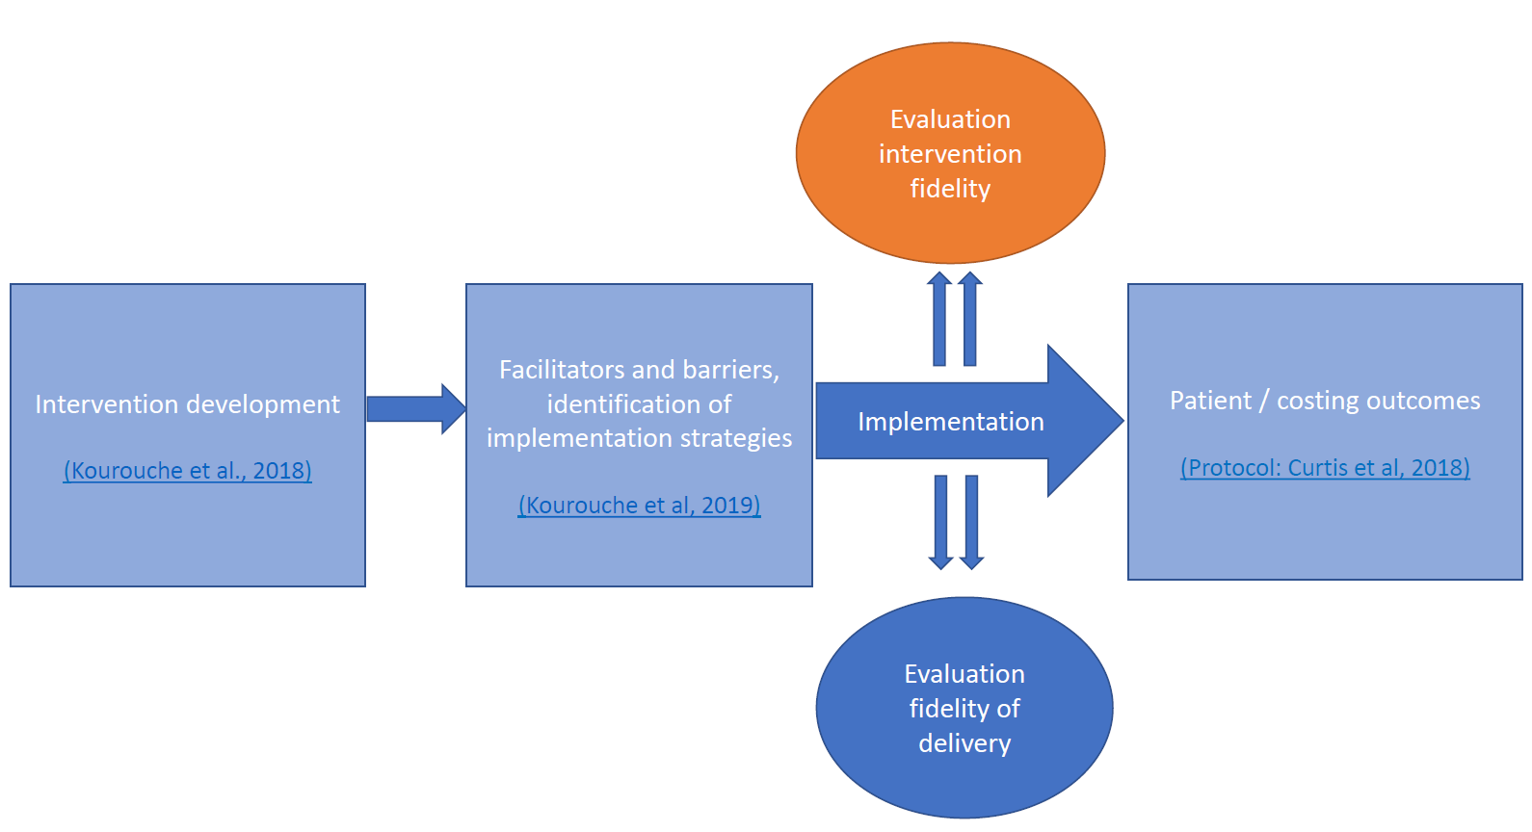 Figure 1. Overall study – this study highlighted in orange

1. Kourouche S, Buckley T, Munroe B, Curtis K. Development of a blunt chest injury care bundle: An integrative review. Injury. 2018;49:1008-23.
2. Kourouche S, Buckley T, Van C, Munroe B, Curtis K. Designing strategies to implement a blunt chest injury care bundle using the behaviour change wheel: a multi-site mixed methods study. BMC Health Serv Res. 2019;19:461.
3. Curtis K. Trial registration: Retrospective pre-post evaluation of the impact of an evidence-based protocol for management of patients with blunt chest injury under real-world conditions: Chest Injury bundle of care Protocol (ChIP). 2018.

