A Novel Simultaneous Reverse Phase High Performance Liquid Chromatography (RP-HPLC) Method for The Determination of Gentamicin and Amoxicillin in Milk Samples
Chemical Papers
Kavya B L¹, Rashmi Nelligare Gopala Krishna¹*
¹Department of Pharmaceutical Analysis and Chemistry, Sri Adichunchanagiri College of Pharmacy, Adichunchanagiri University, B.G. Nagara, Mandya, Karnataka, India– 571448

Author,

Kavya B L

M Pharmacy

Department of Pharmaceutical Analysis and Chemistry,
Sri Adichunchanagiri College of Pharmacy,

Email ID: kavyabl200@gmail.com
ORCID No: 0009-0007-0654-2950

Corresponding author,
Dr Rashmi Nelligare Gopala Krishna
Associate Professor

Department of Pharmaceutical Analysis and Chemistry,
Sri Adichunchanagiri College of Pharmacy,
E-mail ID: ngrashmi@accp.co.in
ORCID No: 0000-0002-8363-7597
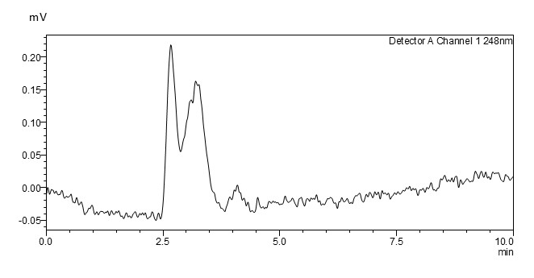
E
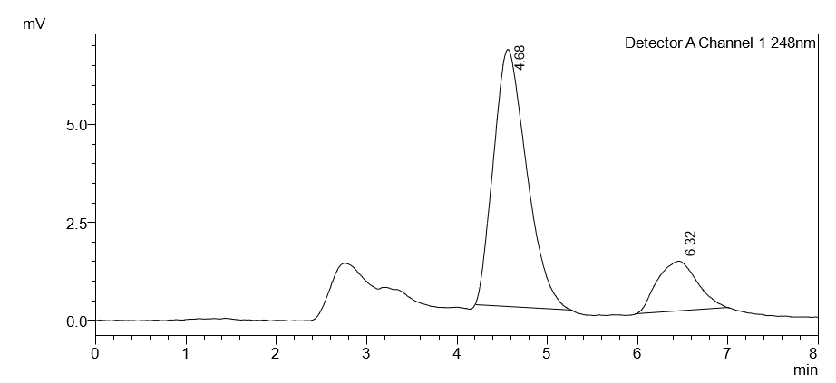
F
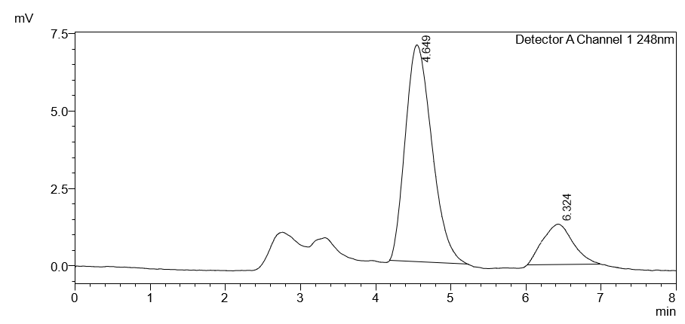
G
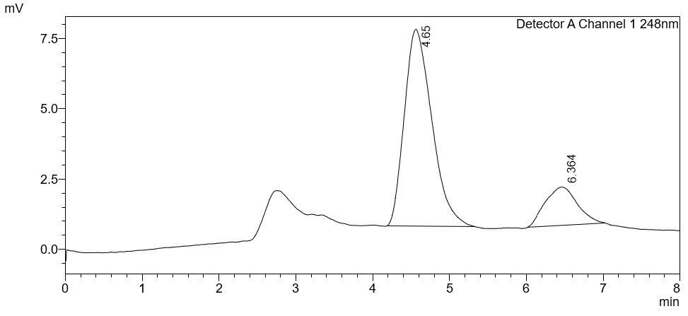
H

Fig. S1- Chromatogram of (E)- Blank Milk, (F)- both Amoxicillin and Gentamicin Milk Sample with 50% Spik, (G)- both Amoxicillin and Gentamicin with 100% Spik, (H)- both Amoxicillin and Gentamicin with 150% Spik, with the retention time of 4.65 min and 6.35 min, respectively.

Validation of the Developed Method as per ICH Guidelines

    - System suitability
Table S1- System suitability data of gentamicin and amoxicillin
SI. No | Retention Time |  | Theoretical Plate Count |  | Peak Area |  | Tailing Factor
SI. No | AMX | GNT | AMX | GNT | AMX | GNT | AMX | GNT
01 | 4.666 | 6.34 | 2093 | 2049 | 69514 | 30757 | 1.301 | 1.220
02 | 4.606 | 6.349 | 2089 | 2413 | 68945 | 30024 | 1.330 | 1.264
03 | 4.599 | 6.322 | 2103 | 2298 | 69317 | 29906 | 1.243 | 1.306
04 | 4.633 | 6.331 | 2064 | 2456 | 69595 | 30530 | 1.305 | 1.305
05 | 4.621 | 6.35 | 2081 | 2054 | 69523 | 30810 | 1.272 | 1.303
06 | 4.648 | 6.329 | 2092 | 2029 | 69167 | 30241 | 1.326 | 1.335
Mean | 4.6288 | 6.33683 | 2087 | 2049.83 | 69343.5 | 30378 | 1.29616 | 1.28883
SD | 0.0254 | 0.01137 | 13.3116 | 529.257 | 251.077 | 379.536 | 0.03330 | 0.04060
%RSD | 0.54984 | 0.1794894 | 1.2246 | 1.61182 | 0.3620 | 1.2493 | 0.25696 | 0.31503

    - LOD and LOQ

      - LOD and LOQ of Amoxicillin
For amoxicillin, the residual standard deviation of the Y-intercept, t value, and slope were determined to be 5648, 3.182, and 3880.5, respectively.
LOD = t×S /σ
= 3.182×5648/3880.5 = 4.63 ng/ml
LOQ = LOD × 3
= 4.63 × 3 = 13.89 ng/ml
      - LOD and LOQ of Gentamicin
For gentamicin, the residual standard deviation of the Y-intercept, t value, and slope were determined to be 667.6, 2.776, and 40.898, respectively.
LOD = t× S /σ
= 2.776×667.6 /40.898 = 45.40 ng/ml
LOQ = LOD× 3
= 45.40×3 = 136.2 ng/ml
    - Accuracy
Table S2- Accuracy data of Gentamicin and Amoxicillin
Drug | % of drug | Amt of Std. added (ng/ml) | Amt of test added (ng/ml) | Total amt of drug (ng/ml) | Total amt of drug found (ng/ml) | % Recovery | SD | %RSD
AMX | 50% | 20 | 20 | 40 | 40.57 | 101.425 | 0.05 | 0.0492
AMX | 100% | 20 | 40 | 60 | 58.851 | 98.081 | 0.0480 | 0.0490
AMX | 150% | 20 | 60 | 80 | 80.571 | 100.71 | 0.0180 | 0.0178
GNT | 50% | 200 | 200 | 400 | 396.75 | 99.243 | 0.063 | 0.0638
GNT | 100% | 200 | 400 | 600 | 606.481 | 101.00 | 0.080 | 0.0800
GNT | 150% | 200 | 600 | 800 | 796.751 | 99.621 | 0.03207 | 0.0322

    - Precision
Table S3-Results of intraday precision
Drug | Conc (ng/mL) | Area | Mean | SD | %RSD
AMX | 20 | 69209 | 69143.33 | 66.5156 | 0.0961
AMX | 20 | 69076 | 69143.33 | 66.5156 | 0.0961
AMX | 20 | 69145 | 69143.33 | 66.5156 | 0.0961
AMX | 40 | 153552 | 153114 | 402.962 | 0.2631
AMX | 40 | 152759 | 153114 | 402.962 | 0.2631
AMX | 40 | 153031 | 153114 | 402.962 | 0.2631
AMX | 60 | 235003 | 233089.66 | 1669.62 | 0.7163
AMX | 60 | 231928 | 233089.66 | 1669.62 | 0.7163
AMX | 60 | 232338 | 233089.66 | 1669.62 | 0.7163
GNT | 200 | 30757 | 30699 | 148.738 | 0.4845
GNT | 200 | 30530 | 30699 | 148.738 | 0.4845
GNT | 200 | 30810 | 30699 | 148.738 | 0.4845
GNT | 400 | 38500 | 38463.66 | 54.5007 | 0.1416
GNT | 400 | 38401 | 38463.66 | 54.5007 | 0.1416
GNT | 400 | 38490 | 38463.66 | 54.5007 | 0.1416
GNT | 600 | 47268 | 47175.66 | 85.582 | 0.1814
GNT | 600 | 47099 | 47175.66 | 85.582 | 0.1814
GNT | 600 | 47160 | 47175.66 | 85.582 | 0.1814

Table S4-Results of interday precision
Drug | Conc (ng/mL) | Area | Mean | SD | %RSD
AMX | 20 | 69595 | 69428.33 | 229.166 | 0.33007
AMX | 20 | 69523 | 69428.33 | 229.166 | 0.33007
AMX | 20 | 69167 | 69428.33 | 229.166 | 0.33007
AMX | 40 | 152009 | 151670 | 541.914 | 0.35729
AMX | 40 | 151045 | 151670 | 541.914 | 0.35729
AMX | 40 | 151956 | 151670 | 541.914 | 0.35729
AMX | 60 | 232010 | 231590 | 375.932 | 0.1623
AMX | 60 | 231285 | 231590 | 375.932 | 0.1623
AMX | 60 | 231475 | 231590 | 375.932 | 0.1623
GNT | 200 | 30024 | 30057 | 169.920 | 0.56532
GNT | 200 | 29906 | 30057 | 169.920 | 0.56532
GNT | 200 | 30241 | 30057 | 169.920 | 0.56532
GNT | 400 | 38500 | 38462.6667 | 61.231 | 0.15919
GNT | 400 | 38496 | 38462.6667 | 61.231 | 0.15919
GNT | 400 | 38392 | 38462.6667 | 61.231 | 0.15919
GNT | 600 | 47268 | 47249.3333 | 82.5974 | 0.17481
GNT | 600 | 47321 | 47249.3333 | 82.5974 | 0.17481
GNT | 600 | 47159 | 47249.3333 | 82.5974 | 0.17481
    - Robustness
Table S5-Robustness data
Analyte | Parameter | Variation | Retention Time | Theoretical Plates | Tailing factor
AMX | Acetonitrile ratio in the mobile phase (15%±2) | 13% | 4.698 | 2986 | 1.384
AMX | Acetonitrile ratio in the mobile phase (15%±2) | 17% | 4.600 | 2982 | 1.315
AMX | Flow rate (1ml/min±0.1ml/min) | 0.9ml/min | 4.994 | 2005 | 1.354
AMX | Flow rate (1ml/min±0.1ml/min) | 1.1ml/min | 4.165 | 2012 | 1.339
AMX | Wavelength (248nm ±2nm) | 246nm | 4.642 | 2989 | 1.345
AMX | Wavelength (248nm ±2nm) | 250nm | 4.683 | 2969 | 1.357
AMX | column oven temperature (30ºC±2°C) | 28ºC | 4.647 | 2003 | 1.308
AMX | column oven temperature (30ºC±2°C) | 32ºC | 4.634 | 2986 | 1.296
AMX | Mean |  | 4.59802 | 2616.5 | 1.337
AMX | SD |  | 0.244498 | 505.031 | 0.0292
AMX | %RSD |  | 0.53164 | 1.9301 | 0.2184
GNT | Acetonitrile ratio in the mobile phase (15%±2) | 13% | 6.369 | 2091 | 1.36
GNT | Acetonitrile ratio in the mobile phase (15%±2) | 17% | 6.352 | 2006 | 1.32
GNT | Flow rate (1ml/min±0.1ml/min) | 0.9ml/min | 6.66 | 2054 | 1.31
GNT | Flow rate (1ml/min±0.1ml/min) | 1.1ml/min | 6.175 | 2078 | 1.37
GNT | Wavelength (248nm ±2nm) | 246nm | 6.295 | 2087 | 1.39
GNT | Wavelength (248nm ±2nm) | 250nm | 6.392 | 2001 | 1.351
GNT | column oven temperature (30ºC±2°C) | 28ºC | 6.291 | 2096 | 1.302
GNT | column oven temperature (30ºC±2°C) | 32ºC | 6.361 | 2088 | 1.38
GNT | Mean |  | 6.3683 | 2175.125 | 1.347
GNT | SD |  | 0.15734 | 330.1724 | 0.0333
GNT | %RSD |  | 0.24830 | 1.5179 | 0.2471

