Supplementary Materials
Early Pregnancy Biomarkers for Predicting GDM and Its Impact on Pregnancy Outcomes
Wang et al. | BMC Endocrine Disorders | 2026

Contents of Supplementary Materials:
Supplementary Table S1. Variable Pre-screening Criteria and Decisions (n=46 variables)
Supplementary Table S2. Univariate Analysis: Factors Associated with Cesarean Section in GDM Group
Supplementary Table S3. Ethnicity Sensitivity Analysis Results
Supplementary Figure S1. Ethnicity Distribution and GDM Rates by Ethnic Group
Supplementary Figure S2. Sensitivity Analysis: OR Comparison With and Without Ethnicity Adjustment

Supplementary Table S1. Variable Pre-screening Criteria and Decisions
All 46 collected variables were systematically evaluated against four pre-specified exclusion criteria before LASSO modelling. Variables retained for modelling are indicated in bold.
Variable | Category | Missing% | Spearman r | Decision & Reason | Status
Age | Demographic | 1.1% | — | Retained: demographic predictor | ✓
Pre-pregnancy BMI | Demographic | 3.5% | — | Retained: established GDM risk factor | ✓
SBP | Demographic | 0% | — | Excluded: high collinearity with MAP (r=0.96) | ✗
DBP | Demographic | 0% | — | Excluded: high collinearity with MAP (r=0.95) | ✗
MAP | Demographic | 0% | — | Excluded: P=0.033, borderline; MAP=2DBP/3+SBP/3 (derived) | ✗
Gravidity | Demographic | 0% | — | Retained | ✓
Parity | Demographic | 0% | — | Retained | ✓
Ethnicity | Demographic | 0% | — | Excluded: 11 categories, sparse cells, EPV risk | Sensitivity
Occupation | Demographic | 0% | — | Excluded: sparse categories, no clear GDM mechanism | ✗
TSH | Thyroid | 2.4% | — | Retained | ✓
FT3 | Thyroid | 0% | — | Retained | ✓
FT4 | Thyroid | 0% | — | Retained | ✓
FT3/FT4 ratio | Thyroid | 0% | FT3 r=0.87 | Excluded: derived from FT3+FT4 (collinear) | ✗
TT3 | Thyroid | 0% | — | Retained: biological significance (active T3) | ✓
TT4 | Thyroid | 0% | TT3 r=0.72 | Excluded: P=0.408; collinear with TT3 | ✗
TPOAb | Thyroid | 0% | — | Excluded: P=0.916 univariate; not significant | ✗
TGAb | Thyroid | 0% | — | Excluded: P=0.210 univariate; not significant | ✗
WBC | CBC | 0.5% | — | Retained | ✓
NEUT# | CBC | 0.5% | NEUT% r=0.98 | Excluded: collinear with NEUT% (r=0.98) | ✗
NEUT% | CBC | 0.5% | — | Retained: better standardized than absolute count | ✓
LYMPH# | CBC | 0.5% | NLR r=0.89 | Excluded: collinear with NLR; NLR also excluded | ✗
NLR | CBC | 0.5% | NEUT% r=0.96 | Excluded: collinear with NEUT% (r=0.961) | ✗
RBC | CBC | 0.5% | HGB r=0.65 | Excluded: collinear with HGB (r=0.645) | ✗
HGB | CBC | 0.5% | — | Retained | ✓
PTA | Coagulation | 31.6% | — | Excluded: missing rate >30% | ✗
PT | Coagulation | 31.6% | — | Excluded: missing rate >30% | ✗
INR | Coagulation | 31.6% | — | Excluded: missing rate >30% | ✗
PTR | Coagulation | 31.6% | — | Excluded: missing rate >30% | ✗
APTT | Coagulation | 31.6% | — | Excluded: missing rate >30% | ✗
TT (coag) | Coagulation | 31.6% | — | Excluded: missing rate >30% | ✗
FIB | Coagulation | 31.6% | — | Excluded: missing rate >30% | ✗
TBIL | Liver | 1.9% | DBIL r=0.82 | Excluded: collinear with DBIL/IBIL; P=0.404 | ✗
DBIL | Liver | 2.0% | TBIL r=0.82 | Excluded: collinear with TBIL; P=0.481 | ✗
IBIL | Liver | 2.0% | TBIL r=0.79 | Excluded: derived (IBIL=TBIL−DBIL) | ✗
ALT | Liver | 1.9% | — | Retained | ✓
AST | Liver | 1.9% | ALT r=0.69 | Excluded: collinear with ALT (r=0.690) | ✗
ALP | Liver | 2.0% | — | Retained | ✓
GGT | Liver | 2.0% | — | Retained | ✓
BUN | Renal | 2.4% | — | Excluded: P=0.368; physiologically suppressed in pregnancy | ✗
Cr | Renal | 2.4% | — | Excluded: P=0.541; physiologically reduced in pregnancy | ✗
UA | Renal | 2.8% | — | Excluded: P=0.125; high variability | ✗
FPG | Glucose | 2.6% | — | Retained: direct GDM-related biomarker | ✓
TG | Lipids | 37.0% | — | Excluded: missing rate >37% | §
TC | Lipids | 35.5% | — | Excluded: missing rate >35.5% | §
HDL-C | Lipids | 37.0% | — | Excluded: missing rate >37% | §
LDL-C | Lipids | 37.0% | — | Excluded: missing rate >37% | §
ApoA1 | Lipids | 37.0% | — | Excluded: missing rate >37% | §
ApoB | Lipids | 37.0% | — | Excluded: missing rate >37% | §
TyG index | Lipids | 37.5% | — | Excluded: missing rate >37.5%; derived variable | §
non-HDL-C | Lipids | 37.0% | — | Excluded: missing rate >37%; derived (TC−HDL-C) | §
Urine ketone | Urinalysis | 1.7% | — | Excluded: P=0.352; qualitative; rare positive (13%) | ✗
Urine glucose | Urinalysis | 1.7% | — | Excluded: P=1.000; 1.0% positive rate (extreme imbalance) | ✗
✓ Retained for LASSO modelling (15 variables). ✗ Excluded. § Excluded due to missing rate >30%; shown descriptively in Table 1. "Sensitivity" = included only in sensitivity analysis. Bold green rows: variables retained for final model. Yellow rows: lipid variables (high missing rate). CBC, complete blood count; TBIL/DBIL/IBIL, total/direct/indirect bilirubin; BUN, blood urea nitrogen; Cr, creatinine; UA, uric acid; FPG, fasting plasma glucose; TyG, triglyceride-glucose index; PTA, prothrombin time activity; FIB, fibrinogen; NLR, neutrophil-to-lymphocyte ratio.

Supplementary Table S2. Univariate Analysis: Factors Associated with Cesarean Section in GDM Patients (n=257)
Variable | Cesarean (n=169)  Median (Q1,Q3) | Vaginal (n=88)  Median (Q1,Q3) | P-value | Entered multivariate
TSH (uIU/mL) | 1.08 (0.72, 1.93) | 1.65 (0.83, 2.56) | 0.013 | Yes
FT3 (pg/mL) | 2.90 (2.69, 3.07) | 2.90 (2.65, 3.22) | 0.488 | No
FT4 (ng/dL) | 1.13 (1.01, 1.27) | 1.19 (1.02, 1.30) | 0.267 | No
TT3 (ng/mL) | 1.54 (1.33, 1.81) | 1.50 (1.35, 1.81) | 0.908 | No
WBC (×10⁹/L) | 8.35 (7.07, 9.44) | 8.61 (7.33, 9.82) | 0.254 | No
HGB (g/L) | 140 (133, 145) | 143 (137, 147) | 0.013 | Yes
NEUT% (%) | 68.75 (63.60, 73.35) | 69.40 (65.10, 72.95) | 0.651 | No
ALT (U/L) | 15.0 (11.0, 23.0) | 17.0 (13.0, 29.0) | 0.033 | Yes
ALP (U/L) | 53.0 (44.0, 62.0) | 53.0 (44.0, 61.0) | 0.976 | No
GGT (U/L) | 20.0 (14.0, 27.3) | 19.0 (13.0, 29.0) | 0.934 | No
FPG (mmol/L) | 4.55 (4.21, 4.93) | 4.69 (4.12, 5.00) | 0.643 | No
OGTT 0h (mmol/L) | 4.53 (4.17, 5.15) | 5.30 (4.92, 5.52) | <0.001 | Yes
OGTT 1h (mmol/L) | 7.54 (6.01, 9.17) | 8.96 (7.54, 10.69) | <0.001 | Yes
OGTT 2h (mmol/L) | 6.46 (5.35, 7.72) | 7.51 (6.36, 8.91) | <0.001 | Yes
HbA1c (%) | 4.60 (4.35, 5.31) | 5.30 (4.70, 5.79) | 0.160 | No
Mann-Whitney U test. Bold variables: P<0.05 in univariate analysis; entered into multivariate logistic regression. OGTT, oral glucose tolerance test; HbA1c, glycated hemoglobin.

Supplementary Table S3. Ethnicity Sensitivity Analysis
Comparison of GDM incidence by ethnicity and effect of ethnicity adjustment on primary model predictors.
Ethnicity | Total n | GDM n | GDM Rate | OR vs Han (95%CI) | P-value
Han (汉族) | 287 | 76 | 26.5% | Reference | —
Naxi (纳西族) | 307 | 99 | 32.2% | 1.484 (1.218–1.808) | <0.001
Yi (彝族) | 86 | 24 | 27.9% | 1.076 (0.636–1.820) | 0.785
Bai (白族) | 73 | 29 | 39.7% | 1.821 (1.073–3.091) | 0.027
Lisu (傈僳族) | 32 | 13 | 40.6% | 1.884 (0.901–3.937) | 0.092
Pumi (普米族) | 24 | 7 | 29.2% | 1.128 (0.454–2.800) | 0.795
Tibetan (藏族) | 11 | 3 | 27.3% | 1.043 (0.270–4.022) | 0.951
Others | 27 | 6 | 22.2% | 0.810 (0.320–2.050) | 0.653
All minorities (combined) | 560 | 181 | 32.3% | 1.621 (1.317–1.995) | <0.001

Effect of Ethnicity Adjustment on Primary Predictor OR Estimates
Variable | OR (main model) | 95%CI | P (main) | OR (with ethnicity) | P (adj.) & Change
TT3 | 1.429 | 1.136–1.796 | 0.002 | 1.435 (1.140–1.803) | 0.002 (+0.4%)
HGB | 1.344 | 1.076–1.679 | 0.009 | 1.346 (1.078–1.682) | 0.009 (+0.1%)
FPG | 1.273 | 1.043–1.553 | 0.018 | 1.255 (1.027–1.533) | 0.021 (−1.4%)
FT3 | 0.737 | 0.563–0.965 | 0.026 | 0.742 (0.567–0.970) | 0.028 (+0.7%)
All OR changes <2%, confirming that ethnicity does not materially confound the identified associations. Model AUC: main model 0.658; with ethnicity adjustment 0.662 (change +0.4%). Han ethnicity used as reference category.

Supplementary Figures
Supplementary Figure S1. Ethnicity Distribution and GDM Incidence Rates
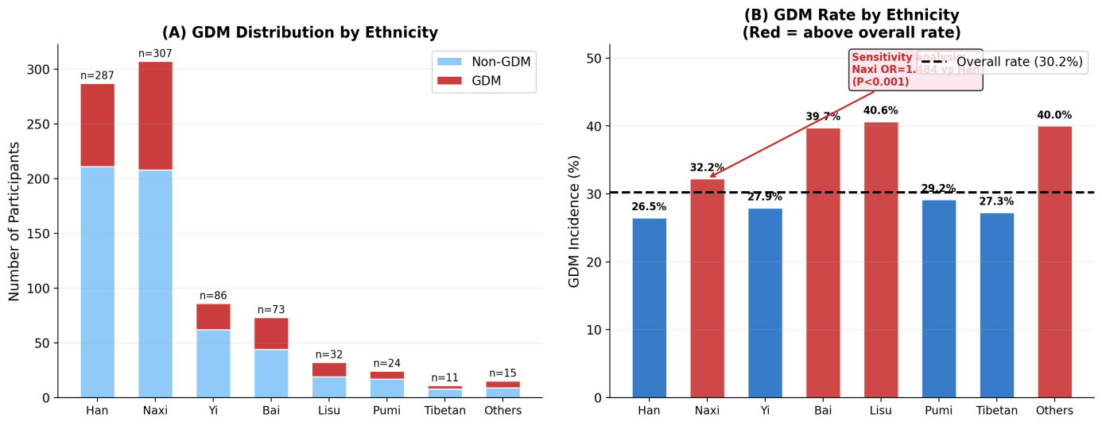
Supplementary Figure S1. (A) Stacked bar chart showing the distribution of Non-GDM and GDM participants across 8 ethnic groups. (B) GDM incidence rate by ethnicity, with the dashed horizontal line indicating the overall cohort rate (30.2%). Red bars indicate rates above the overall rate. Naxi and minority women show higher GDM rates than Han women (Naxi OR=1.484, P<0.001; Other minorities OR=1.621, P<0.001, adjusted for clinical covariates).
Supplementary Figure S2. Sensitivity Analysis: OR Comparison With and Without Ethnicity Adjustment
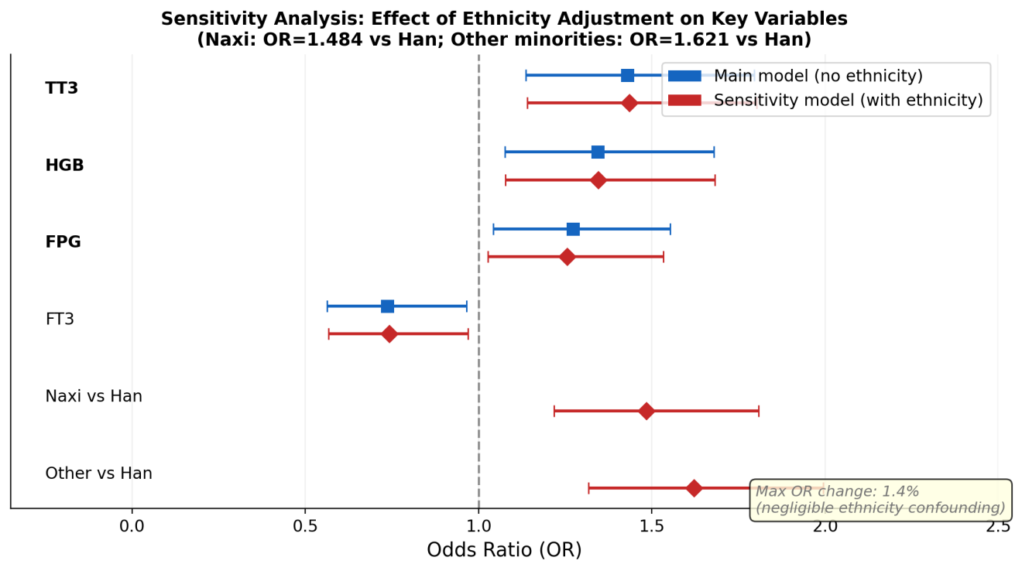
Supplementary Figure S2. Forest plot comparing odds ratio (OR) estimates for primary GDM predictors and ethnicity variables between the main model (blue squares, without ethnicity) and the sensitivity model (red diamonds, with ethnicity adjustment). Maximum OR change for any primary predictor was 1.4% (FPG), confirming robustness against ethnic confounding. Naxi women (OR=1.484) and other minority women (OR=1.621) had significantly higher GDM risk than Han women (both P<0.001).

