Supplementary Figure 1. Forest Plots summarizing network meta-analysis comparing whole gland ablation and focal therapy with radical prostatectomy.
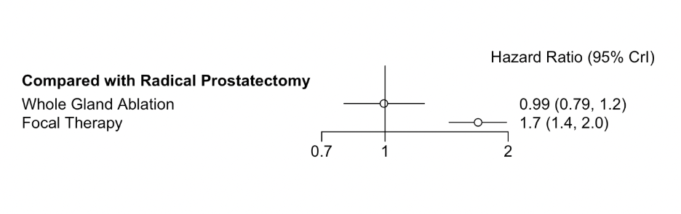
Supplementary Figure 2. Forest Plots summarizing functional outcomes comparing focal therapy with robotic assisted radical prostatectomy. A) Erectile function, stratified by follow-up periods. B) Continence, stratified by follow-up period
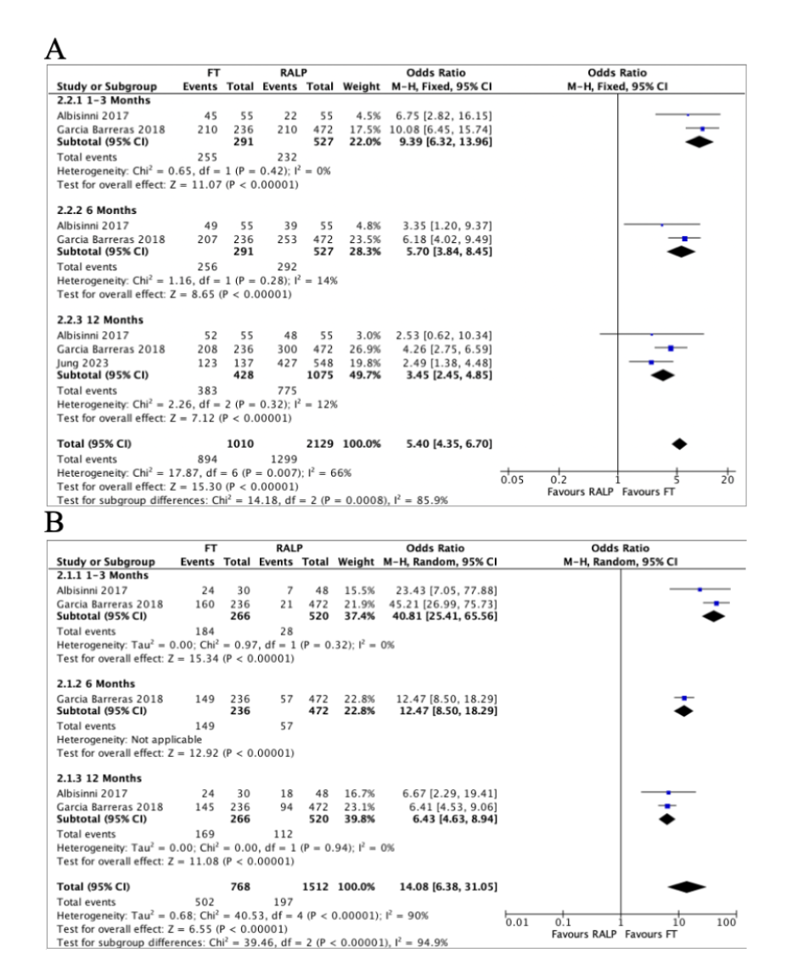
Supplementary Figure 3. Forest Plots summarizing complications. A) Overall complications. B) Minor complications. C) Major complications.
