Supplementary Figure Captions
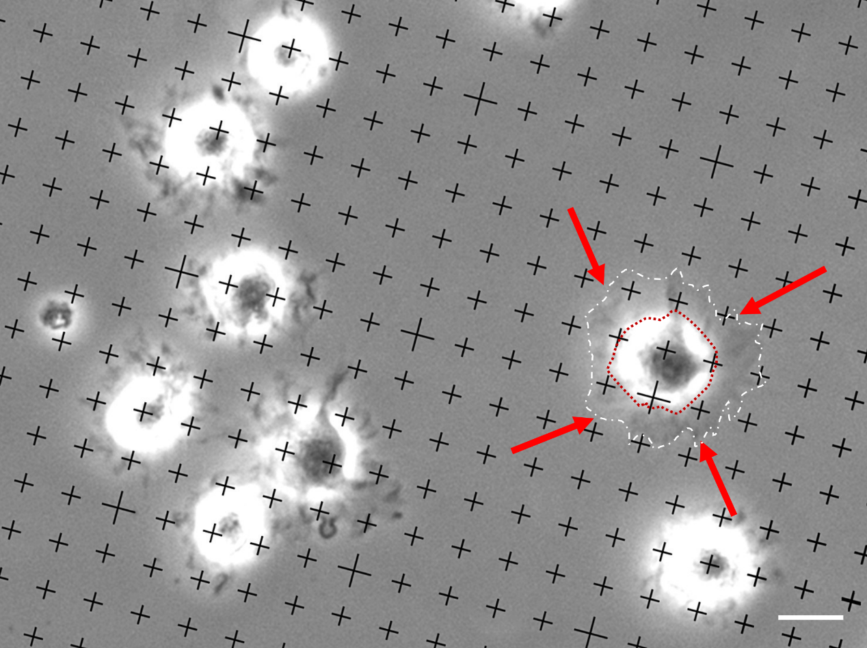
Supplementary Figure 1
Supplementary Figure 1 Graph depicting a point-counting method to measure the surface area of cell spreading. The grid was randomly put on the light micrographs of cells during spreading for the point-counting method. The filopodia and lamellipodia (red arrow, range of white dashed line) were included for calculating the cell spreading area, with the exclusion of the relatively constant peri-nuclear area (within red dot circle). Bar = 50 μm

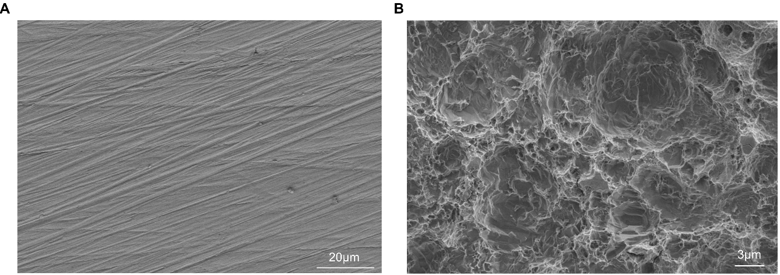
Supplementary Figure 2
Supplementary Figure 2 Representative SEM images of the titanium SLA surface after sandblasting and acid etching. (A) Magnification ×1,000; scale bar = 20 μm. (B) Magnification ×3,000; scale bar = 3 μm

