Table 1 Geographical, climatic and vegetation for the grassland sites under undegraded and degraded states
Site | Latitude  (°N) | Longitude  (°E) | Elevation(m) | MAP  (mm) | MAT  (℃) | Height  (cm) | Coverage  (%) | Species richness
EQM-UD | 100.4627 | 38.0456 | 2980 | 303.3 | -0.12 | 17.6±0.9ª | 97.5±0.9^{b} | 9.6±0.5ª
EQM-D | 100.9240 | 37.9492 | 3315 | 400 | -0.5 | 4.0±0.1^{d} | 95.4±0.2^{c} | 8.3±0.3^{b}
DS-UD | 98.9452 | 38.8395 | 3738 | 373.9 | -3.89 | 12.9±1.0^{b} | 99.0±0.4ª | 7.4±0.7^{c}
DS-D | 98.9452 | 38.8395 | 3738 | 373.9 | -3.89 | 3.5±0.3e | 72.2±5.2^{d} | 7.6±0.4^{c}
CL-UD | 81.4990 | 36.8707 | 1434 | 35.1 | 11.9 | 3.6±0.1e | 67.2±3.3^{d} | 6.4±0.2^{c}
CL-D | 81.4990 | 36.8707 | 1434 | 35.1 | 11.9 | 5.2±0.3^{c} | 59.4±5.2^{d} | 3.8±0.4^{d}

The classification of undegraded (UD) and degraded (D) plots at each site was based on objective, measurable declines in key vegetation and soil properties (Table 1). At the Eastern Qilian Mountains (EQM) alpine meadow site, plots were categorized as degraded primarily based on pronounced reductions in vegetation structure and soil nitrogen availability. Compared to UD plots, D plots exhibited a 72% decrease in mean vegetation height (from 17.6 cm to 4.0 cm) and a 64% reduction in soil NO₃⁻–N concentration (from 44.8 mg·kg⁻¹ to 15.9 mg·kg⁻¹). Plant cover remained high (~97%) in both states. At the Dashalong (DS) marsh meadow site, degradation classification was strongly supported by changes in vegetation structure. Degraded plots showed a 73% reduction in mean height (from 12.9 cm to 3.5 cm) and a 27% decrease in plant cover (from 99% to 72%). In contrast, species richness and soil nitrogen concentrations exhibited no consistent directional change between UD and D plots. At the Cele (CL) mountain steppe site, degradation was characterized by the most comprehensive set of indicators, including: (i) a complete shift in dominant species composition, (ii) a 41% reduction in species richness (from 6.4 to 3.8), (iii) reduced plant cover, and (iv) significant declines in both NH₄⁺–N (39% decrease) and NO₃⁻–N (42% decrease). Collectively, these criteria ensured that the UD/D classification was robustly underpinned by quantifiable, site-specific deterioration in core ecosystem attributes, thereby providing a reliable basis for subsequent comparative analyses.
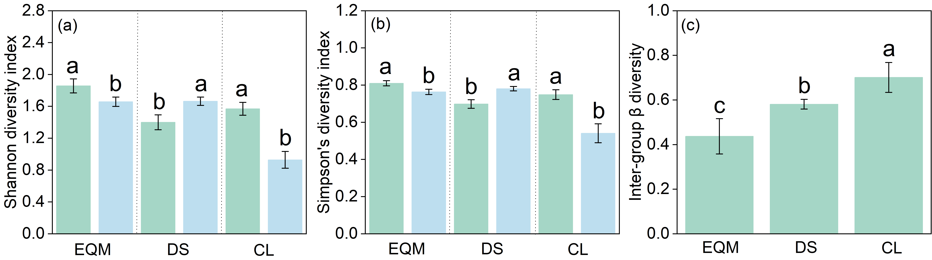
Fig. S1 Differential effects of grassland degradation on plant community α- and β-diversity across an aridity gradient. (a) Shannon diversity index, (b) Simpson's diversity index, and (c) Inter-group β-diversity (Bray-Curtis dissimilarity) between undegraded (UD) and degraded (D) states at the three study sites (EQM, DS, CL). Values are means ± SE.
Plant Community Composition and Diversity
Plant community surveys were conducted concurrently with biomass sampling. Within each of the five 50 cm × 50 cm quadrats per plot, all vascular plant species were identified, and their percent cover was visually cross-estimated by two researchers. From the species cover data, α-diversity including species richness (S), Shannon-Wiener index (H' = -Σpᵢ ln pᵢ); and Simpson's Index (D = 1 - Σpᵢ²) were computed. Where pᵢ is the relative cover of species i. The mean value of the five quadrats was used for the plot-level analysis. β-diversity was calculated to quantify and test the overall differences in plant community composition between the UD and D states, based on Bray-Curti’s dissimilarity matrix.

