Supplementary Material

GHOST ROADS AS HIDDEN DRIVERS OF LANDSCAPE CONNECTIVITY LOSS IN THE COLOMBIAN ANDES–AMAZON CORRIDOR
Jairo Andrés Sánchez Camacho ª, Paulo J. Murillo-Sandoval^{b}, Camilo Andrés Correa-Ayram ^{c, *}
a. Maestría en Gestión Ambiental, Facultad de Estudios Ambientales y Rurales, Universidad Javeriana, Bogotá, Colombia.
b. Departamento de Ecología y Territorio, Facultad de Estudios Ambientales y Rurales, Universidad Javeriana, Bogotá, Colombia.
c. Departamento de Ecología y Territorio, Facultad de Estudios Ambientales y Rurales, Universidad Javeriana, Bogotá, Colombia.
*Author to correspondence should be addressed.
E-mail: correa.c@javeriana.edu.co

Graphical definitions for habitat loss, habitat, and connected habitat including the effect of ghost roads
A conceptual illustration of landscape elements used to evaluate connectivity change in the AATB. In panel A, Habitat lost (light yellow) represents areas transformed from original forest, Habitat (dark green) corresponds to remaining non-transformed patches that may occur as isolated units. Connected habitat is defined as the subset of these patches that remain functionally connected given a species-specific dispersal distance (d), here illustrated as 1000 m.
In panel B, the incorporation of both officially mapped roads and ghost roads—unmapped or informal road networks—introduces additional fragmentation across the landscape. These linear features disrupt movement pathways and reduce the functional connectivity among habitat patches, even when the total amount of isolated habitat appears unchanged.

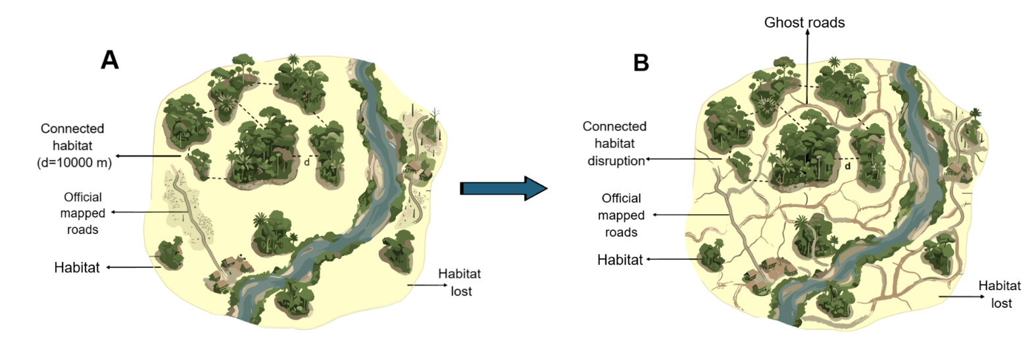

Fig 1. SD. A hypothetical landscape (A, B) illustrating the concepts of lost habitat, habitat and connected habitat under a defined dispersal distance (d=10000 m). Panel A represents baseline conditions, while panel B incorporates the presence of officially mapped roads and ghost roads, which increase fragmentation and disrupt connectivity pathways, leading to a reduction in connected habitat despite similar total habitat extent.

weighing the roads according to their influence on the landscape
The roads mapped in this study were assigned a weighting matrix based on their width, road type, and potential influence on changes in landscape structure and connectivity (Table 1). Accordingly, each road type was assigned a weight corresponding to its degree of landscape impact; wider roads that connect hamlets and urban centers received higher weights. Road network expansion affects biodiversity by altering land use and intensifying anthropogenic pressures on the territory (Kati et al., 2020; Selva et al., 2015). Likewise, roads in forested areas increase natural resource extraction and wildlife hunting (Clements et al., 2018), while generating edge effects (Barber et al., 2014; Kunert et al., 2015; Maynard et al., 2016) that, in the event of fire, wind, or tree mortality, can penetrate several kilometers into the Amazon rainforest (Broadbent et al., 2008).

Road Type | Description | Road Weight | Buffer Weight (1km)
Type 1 Road | Paved road for vehicular traffic (including heavy vehicles), animals, or people, with width >5 m. These roads connect urban centers and have year-round vehicular flow. | 10 | 5
Urban Center Road | Road located within a municipal urban center. | 10 | 5
Hamlet Road | Road located within a municipal hamlet. | 9 | 4.5
Type 2 Road | Unpaved road for vehicular, animal, or pedestrian traffic, with width ≥5 m. Connects municipal headquarters with their veredas or veredas among themselves. | 9 | 4.5
Type 3 Road | Unpaved road for vehicular, animal, or pedestrian traffic. Connects municipal headquarters with their veredas or veredas among themselves. | 7 | 3.5
Trail, Path | Rural path for pedestrian and animal traffic. | 4 | 2.0
Table 1. SD. Weight assignments for road categories based on their potential influence on changes in landscape structure and connectivity, considering road width and capacity to connect different human settlements.

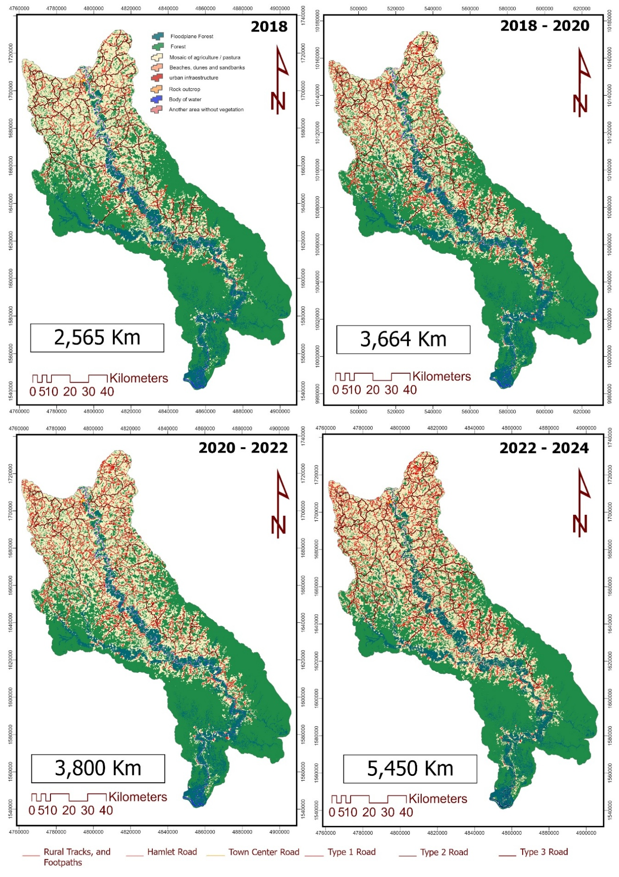Fig 2. SD. Map of road infrastructure growth in the study area during the period 2018-2024
Weighing of impacts on landscape connectivity
Mapped road datasets from this study (2018 and 2024) and dECA_grid results were used to analyze spatiotemporal relationships between road infrastructure and landscape connectivity changes. Each road segment received an influence weight (Table 1), while connectivity hexagons were assigned importance values, with higher scores for areas of greater connectivity impact (Table 2). This enabled application of a generic equation (Equation 1) integrating road influence, habitat loss, and connected habitat.

$MLCLR = (R_{t1}+R_{t2}+A_{iat1}+A_{iat2})*I$ (Equation 1. SD.)

$MLCLR$ represents the landscape connectivity loss model associated with road presence; $R_{t1}$ = roads for 2018, $R_{t2}$ = roads for 2024; $A_{iat1}$ = 1 km influence area of roads for 2018, $A_{iat2}$ = 1 km influence area of 2024 roads; and finally, $I$ = importance of connectivity impact on the landscape.

The R package Makurhini (Godínez-Gómez et al., 2025) quantified connectivity states and changes in 2 km² hexagons using graph theory. Hexagons with habitat loss or connected habitat gains/losses received impact scores (0–50), where low values indicate conserved/gained connectivity (positive impacts) and high values signal negative impacts, considering dispersion thresholds. Isolated habitat loss has minimal effects, but disruption of connecting nodes causes significant negative alterations (Saura et al., 2011; Saura & Pascual-Hortal, 2007).

Zone | Importance of Impact | Ponderación | Justificación
dECA = dA = 0 | Low or null | 0 | Low scores are assigned as these are areas of stable natural forest
dECA or dA gain | Low or null | 1 | Low or null importance values are assigned, as these areas experienced recovery in connectivity functioning.
dA< dECA<0 | Medium | 22 | A medium impact value was assigned, as habitat loss occurred but did not affect connectivity in functional terms.
dECA<dA<0 | High | 42 | It is given a higher value of importance with respect to habitat loss, since in these areas there was habitat loss that functioned as a connector with other nodes.
dECA<dA=0 | Very High | 50 | It is given a higher value of importance with respect to habitat loss, since in these areas there was habitat loss that functioned as a connector with other nodes.
Table 2. SD. Weighting the importance of the impacts on landscape connectivity

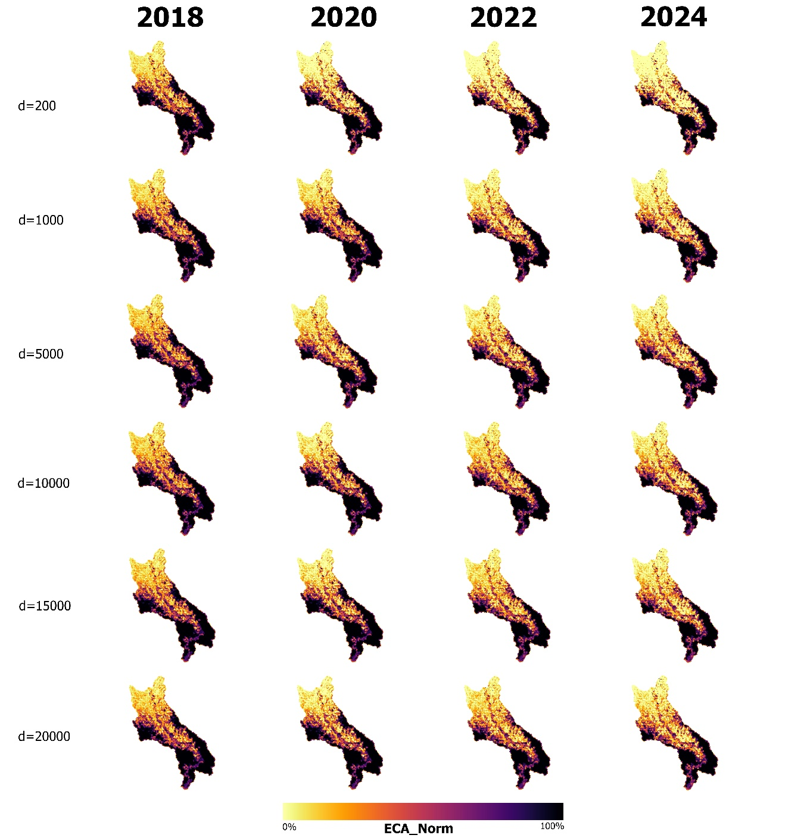
Fig 3. SD. normalized ECA result for dispersal thresholds of 200 m, 1000 m, 5000 m, 10000 m, 15000 m and 20000 m

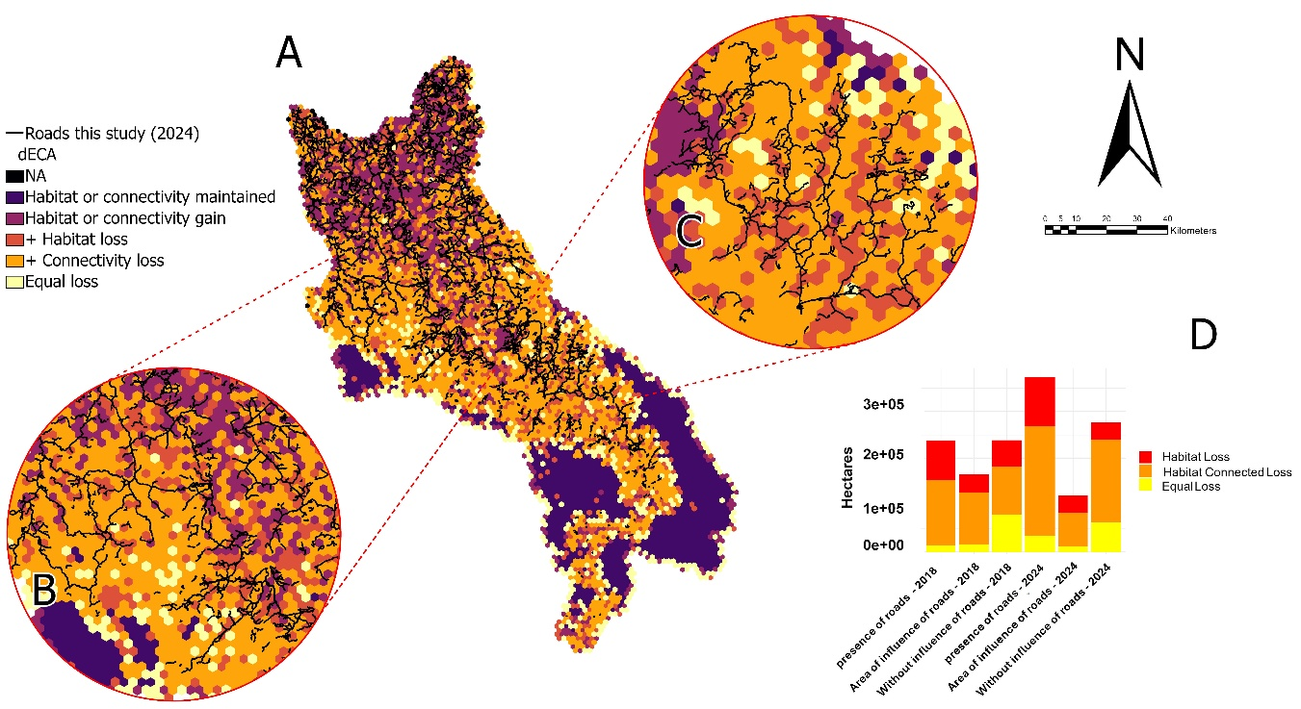
Fig 4. SD. A) Map of habitat loss, connected habitat loss, and road presence; B) hotspot located in the Caguán–Sunsiya region; C) hotspot located in the mid-Caguán–Chiribiquete region; D) graph of areas with habitat loss and connected habitat loss associated with road presence. The analysis considered areas with habitat loss, connected habitat loss, and those exhibiting simultaneous loss of both elements in the landscape, using a 10,000 m dispersal threshold. The graph relates the zones where roads are present and where losses occur, as well as the area with losses but no road presence.

Spatial Human Footprint Index
Four HFI maps were generated using different road datasets to evaluate results: 1) OSM roads, 2) DNP roads, 3) IGAC roads, and 4) roads mapped in this 2024 study. Data sources included analyzed road databases, study-mapped roads, land cover, human settlements, constructions, and equipment (Table 3. SD.).
Calculations processed six covariables linking anthropogenic pressures to updated databases (Table 3), scored 0–5 (0 = low/null; 5 = high pressure). Equation 3 yielded Human Pressure Index values (0–100; higher = greater impact) via ArcGIS Pro Raster Calculator (Esri, 2022), producing 577 m pixel maps.

$( \frac{CV+DV+CAH+DI+IF+TCN}{25} )*100$ (Ecuación 3 SD)

Covariables: $PR$ = proximity to roads, $RD$ = road density, $HS$ = proximity to human settlements, $ID$ = infrastructure density, $FI$ = fragmentation index, $NC$ = natural cover.

Variable | Fuente de los datos
Distance to Human Settlements | Geographic layer of urban centers and districts of the IGAC (Agustín Codazzi Geographic Institute (IGAC), 2017)
landscape fragmentation Index | Calculation of the Fragmentation Index using the R package Makurhini (Godínez-Gómez et al., 2025b)
Building density | Identification of constructions through the repository and documentation of the Open Buildings v3 dataset (Google Research - Open Buildings, 2023).
Distance to Facilities | Using the base cartography of the IGAC, the georeferencing of the facilities was obtained (IGAC, 2018).
Landscape transformation | Land cover maps were generated using data from the MapBiomas Colombia Project – Collection 3.0 of annual land cover and land use maps, which can be accessed in October 2025 through the link: https://colombia.mapbiomas.org
Road density present study | Density of the roads mapped in the present study.
IGAC road density | IGAC road density (Agustín Codazzi Geographic Institute (IGAC), 2017).
OSM road density | OSM road density (Open Street Maps (OSM), 2024).
DNP road density | DNP road density (Departamento Nacional de Planeación (DNP) et al., 2021).
Category of roads this study | Categorization of roads based on their impacts on the landscape (Table 1).
IGAC road category | Default categorization of roads according to the typology assigned in the database.
OSM road category | Default categorization of roads according to the typology assigned in the database.
DNP road category | Categorization taking into account its spatial location and the width of the road.
Table 3 SD. Covariables and data sources considered for calculating the HFI using road information from the different databases analyzed in this study.

BIBLIOGRAPHY
Broadbent EN, Asner GP, Keller M et al. (2008) Forest fragmentation and edge effects from deforestation and selective logging in the Brazilian Amazon. Biological Conservation, 141(7), 1745–1757. https://doi.org/10.1016/j.biocon.2008.04.024
Clements GR, Aziz SA, Bulan R et al. (2018) Not everyone wants roads: Assessing Indigenous people's support for roads in a globally important tiger conservation landscape. Human Ecology, 46(6), 909–915. https://doi.org/10.1007/s10745-018-0029-4
Esri (2022) Calculadora ráster. ArcMap | Documentación. https://desktop.arcgis.com/es/arcmap/latest/tools/spatial-analyst-toolbox/raster-calculator.htm
Godínez-Gómez O, Correa-Ayram CA, Goicolea T and Saura S (2026) Makurhini: An R package for comprehensive analysis of landscape fragmentation and connectivity. Environmental Modelling and Software, 201, 106981. https://doi.org/10.1016/j.envsoft.2026.106981
Kati V, Kassara C, Psaralexi M, Tzortzakaki O et al. (2020) Conservation policy under a roadless perspective: Minimizing fragmentation in Greece. Biological Conservation, 252, Article 108828. https://doi.org/10.1016/j.biocon.2020.108828
Kunert N, Aparecido LM, Higuchi N et al. (2015) Higher tree transpiration due to road-associated edge effects in a tropical moist lowland forest. Agricultural and Forest Meteorology, 213, 183–192. https://doi.org/10.1016/j.agrformet.2015.06.009
Maynard RJ, Aall NC, Saenz D et al. (2016) Road-edge effects on herpetofauna in a lowland Amazonian rainforest. Tropical Conservation Science, 9(1), 1–17. https://doi.org/10.1177/1940082915627026
Saura S and & Pascual-Hortal L (2007) A new habitat availability index to integrate connectivity in landscape conservation planning: Comparison with existing indices and application to a case study. Landscape and Urban Planning, 83(2–3), 91–103. https://doi.org/10.1016/j.landurbplan.2007.03.005
Saura S, Estreguil C, Mouton C and Rodríguez-Freire M (2011) Network analysis to assess landscape connectivity trends: Application to European forests (1990-2000). Ecological Indicators, 11(2), 407-416. https://doi.org/10.1016/j.ecolind.2010.06.011
Selva N, Switalski A, Kreft S and Ibisch PL (2015) Why keep areas road-free? The importance of roadless areas. In R. E. van der Ree, D. J. S. Grilo, & C. R. Dickman (Eds.), Handbook of road ecology (pp. 16–26). Wiley Blackwell. https://doi.org/10.1002/9781118568170.ch3

