Enhancing plant establishment via rhizosphere signaling and hormonal regulation through biopolymer-mediated soil pore restructuring

Kaniz Fatema¹, Aaron Sloutski^{1, *}, Yiwei Fang¹, Xiaoyang Liu², Jay G. Gao³, Marcia Simon³, Eyal Zussman⁴, Vitaly Citovsky⁵, Miriam Rafailovich^{1, *}
¹Department of Materials Science and Chemical Engineering, State University of New York at Stony Brook, Stony Brook, New York 11794, USA.
²Advanced Photon Source, Argonne National Laboratory, Lemont, Illinois 60439, USA.
³Department of Oral Biology and Pathology, School of Dental Medicine, Stony Brook University, Stony Brook, NY, 11794, USA.
⁴Faculty of Mechanical Engineering, Technion-Israel Institute of Technology, Haifa.
⁵Department of Biochemistry and Cell Biology, State University of New York at Stony Brook, Stony Brook, New York 11794, USA.
*Corresponding author.

S1. Methodology

Preparation of ethanol-precipitable material (EPM)
For the preparation of ethanol-precipitable material (EPM) from Rhizobium tropici (RT), a single RT colony from peptone-yeast extract (PYE) agar was inoculated into 10 mL PYE broth (0.3% yeast extract, 0.5% casein peptone, and 10 mM CaCl₂), and grown for 24 h at 30 °C with shaking (300 rpm). The culture was then transferred into 250 mL liquid minimal medium (LMM; 2 g L⁻¹ NH₄Cl, MgSO₄·7H₂O, 0.15 g L⁻¹ CaCl₂·2H₂O, 10 mg L⁻¹ FeCl₃, 50 mM potassium phosphate buffer, pH 6.9) supplemented with 55 mM glucose, and incubated for an additional 48 h at 30 °C (300 rpm). Cells were removed by centrifugation, and the clarified supernatant was mixed with three volumes of ethanol and incubated overnight at 4 °C to precipitate extracellular material. The precipitate was collected by centrifugation, washed with ethanol, and dried rapidly in a SpeedVac concentrator to minimize caramelization. Dried EPM was dissolved in tap water overnight at room temperature with gentle stirring to obtain a 1 mg mL⁻¹ stock solution for subsequent experiments.

Soil compaction and unconfined compression testing
Cylindrical sand specimens were prepared to quantify the mechanical effects of biopolymer amendments. We compared xanthan gum (XG), a microbial polysaccharide commonly used for soil stabilization, with ethanol-precipitable material (EPM), an extracellular polymeric fraction derived from R. tropici previously linked to particle aggregation and rhizosphere-related functions ²⁷.
Dry sand (120 g per specimen) was homogenized, then mixed with aqueous biopolymer solutions at 125 or 500 mg L⁻¹ (corresponding to ~0.01–0.05wt% relative to dry sand, depending on added volume). Mixing was performed using a planetary mixer (Thinky ARE-250; 2000 rpm, 30 s) to promote uniform dispersion and minimize agglomeration. Additional deionized water was added as needed to obtain a moldable paste, followed by a second mixing step.
The material was cast into cylindrical molds (68 mm height × 34 mm diameter), lightly compacted to a smooth surface, demolded, and cured at room temperature (25 ± 5 °C) for 1-3 days; this curing window was chosen to approximate typical irrigation intervals in plant experiments (watering every ~1-3 days after partial drying). Moisture loss was tracked gravimetrically to ensure comparable drying across conditions.
Unconfined compressive strength (UCS) tests were performed using a GeoJac Digital Load Actuator at a constant displacement rate of 1 mm min⁻¹. Peak strength and stress-strain responses were extracted for each condition. Standardized preparation (mixing, moisture adjustment, and compaction) was used to minimize variability unrelated to polymer treatment. Figure S1 shows the images of the sand block making process and the failure modes of the blocks.
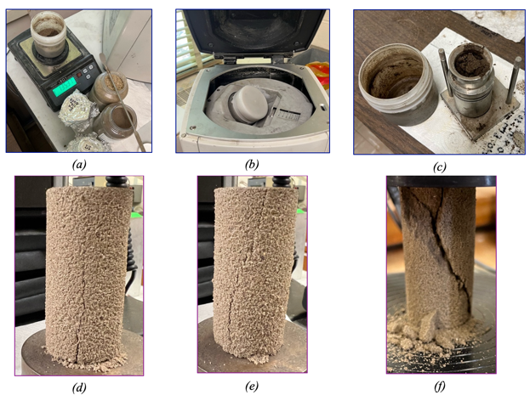
Figure S1| Sand blocks for compressive strength test.
(a) weighing raw materials (b) mixing of raw materials (c) mold for block making
Failure mode of sand blocks having 500 mg/L biopolymers and 1-day curing.
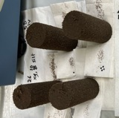
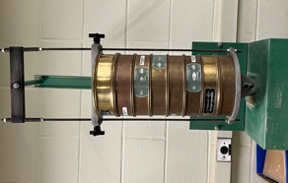
(d) XG (e) EPM (f) Control

Bermuda grass growth and analysis
Bermuda grass was grown in the Stony Brook University Life Sciences greenhouse under long-day conditions (16 h light/8 h dark) at 25 °C for 2 months. Prior to seeding, sand was premixed with XG and EPM working solutions to yield final concentration of 125 mg L⁻¹. For 1 gram of sand, 1 ml of biopolymer solution was added to each pot. At harvest, sand was washed from roots, shoots and roots were collected for gravimetric measurements, and root morphology was imaged using a Keyence VHX-7000 digital microscope. Figure S2 shows a few pots of barmuda grass where plants were grown in sand without and with biopolymers.

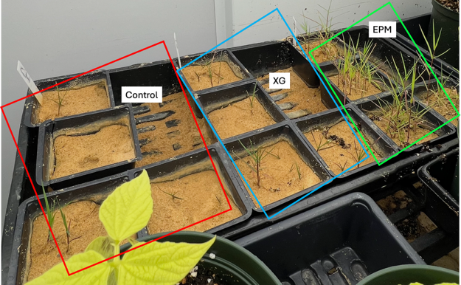
Figure S2| A few pots of control, XG, and EPM pots of barmuda grass in the greenhouse chamber.

Bush beans in garden soil
Bush bean seeds were sown in garden soil that had been homogenized and amended with EPM prior to planting. Soil was premixed with EPM working solutions to achieve final concentrations of 0, 12.5, 50, or 125 mg L⁻¹, with 1 mL of solution applied per gram of soil in each pot to ensure uniform distribution. Plants were maintained under controlled greenhouse conditions. At harvest, roots were carefully washed free of soil, and shoot and root tissues were collected separately for gravimetric biomass determination. Root morphology was subsequently documented using a Keyence VHX-7000 digital microscope. Bush beans in chamber are shown in Figure S3.
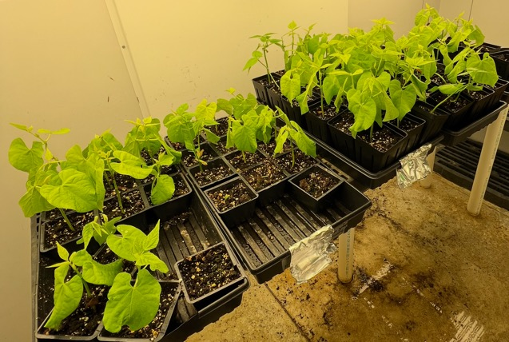
Figure S3| Bush beans in chamber with different concentrations of EPM.

Arabidopsis thaliana growth and root analysis
Arabidopsis thaliana plants were grown under long-day conditions (16 h light/8 h dark) at 21 °C in the Stony Brook University greenhouse. Seeds were germinated in soil for 3 weeks and then transplanted into sand. Both the germination soil and the transplant sand were premixed with EPM working solutions to achieve final concentrations of 0 or 125 mg L⁻¹. Plants were grown in sand for ~3 weeks until maturity. Roots were then recovered by washing away sand and imaged using a Keyence VHX-7000 digital microscope. Figure S4 shows a few pots of A. thaliana just before harvesting for biomass analysis.
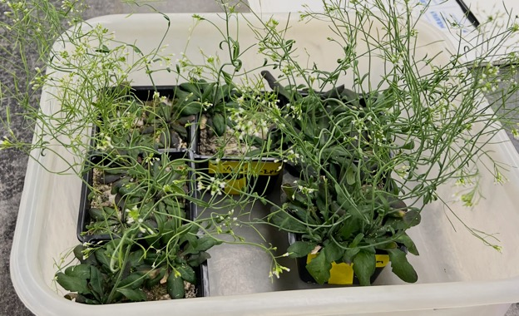
Figure S4| Matured Arabidopsis thaliana in sand before harvesting.

Root sampling for RNA analysis
For gene-expression assays, roots were harvested directly from sand-grown plants of different ages. Samples were rinsed rapidly, roots were excised, wrapped in aluminum foil, flash-frozen in liquid nitrogen, and stored at -80 °C until extraction.

RNA extraction
Total RNA was extracted from ~100 mg frozen root tissue using the RNeasy Plant Mini Kit (Qiagen), following the manufacturer’s protocol. Tissue was ground to a fine powder in liquid nitrogen, lysed in 450 µL RLT buffer supplemented with β-mercaptoethanol (4.5 µL), and clarified by centrifugation. The lysate was mixed with 0.5 volumes of 96-100% ethanol and applied to the RNeasy spin column. Columns were washed with RW1 and RPE buffers (including two RPE washes), and RNA was eluted in 30 µL RNase-free water. RNA concentration and purity were measured using a NanoDrop One spectrophotometer, and RNA was stored at -20 °C until cDNA synthesis.

cDNA synthesis and qPCR
First-strand cDNA was synthesized from purified RNA using the ProtoScript First Strand cDNA Synthesis Kit (New England Biolabs) with an oligo(dT) primer (d(T)23VN), following the manufacturer’s instructions. Briefly, RNA and primer were incubated at 70 °C for 5 min and cooled on ice, followed by reverse transcription at 42 °C for 1 h and enzyme inactivation at 80 °C for 5 min. cDNA was stored at -20 °C and used for downstream amplification (≤10% of total PCR reaction volume). Quantitative PCR was performed at the Stony Brook University Hospital Genomics Core Facility.

S2. Interpretation of compressive strength behavior
Unconfined compressive strength measurements (Figure S5 a-b) demonstrate polymer-specific and concentration-dependent modifications to sand load transfer. Untreated controls (0 mg L⁻¹) exhibit nearly invariant strength with curing (~0.21-0.22 MPa), confirming negligible intrinsic cementation and providing a stable mechanical baseline.
At 125 mg L⁻¹, EPM induces only a modest increase in compressive strength, even after 3 days of curing, indicating enhancement of interparticle adhesion without significant pore collapse or dense particle rearrangement. The low variability at longer curing times suggests formation of a homogeneous, weakly bonded contact network, consistent with a thin, compliant polymer coating that stabilizes grain contacts while preserving deformability. In contrast, xanthan gum (XG) produces a stronger, curing-dependent increase in strength at the same concentration, reflecting its higher molecular rigidity and viscosity, which promote particle bridging and partial pore filling.
At 500 mg L⁻¹, both biopolymers substantially increase compressive strength; however, XG exhibits a markedly larger response, particularly after extended curing. The pronounced strength gain and elevated variability indicate the development of stiff, heterogeneous polymer-rich domains, likely associated with gel-like bridging that restricts particle mobility and reduces pore connectivity. EPM-treated sand, by comparison, displays a more moderate and controlled strengthening, implying distributed, compliant binding rather than excessive densification.
Untreated sand exhibits a porosity of ~42.6%, consistent with a loosely packed granular framework (Figure S5 c-d). Addition of both EPM and xanthan gum reduces porosity across all concentrations, confirming that polymer incorporation promotes particle rearrangement and partial pore filling. At 125 mg L⁻¹, EPM induces a modest porosity loss (~2.6% relative to control), whereas xanthan gum produces a slightly larger reduction (~3.2%). This trend persists at 500 mg L⁻¹, with XG exhibiting the greatest porosity loss (~3.5%), exceeding that of EPM (~3.1%). These differences indicate that xanthan gum more effectively collapses pore space, consistent with its higher viscosity and propensity for gel-like bridging between grains.
Importantly, the relatively small porosity reduction induced by EPM, even at higher concentration, supports the mechanical observations, demonstrating that EPM enhances strength without excessive densification. In contrast, the stronger porosity loss associated with xanthan gum aligns with its pronounced compressive strengthening and increased heterogeneity, indicative of over-consolidation. Together, the porosity and strength data establish a mechanistic link between polymer chemistry, pore-scale restructuring, and macroscopic mechanical response.
Representative two-dimensional micro-CT slices provide qualitative insight into the pore-scale origin of the observed porosity trends. Untreated sand exhibits a highly open pore network dominated by large, well-connected voids and minimal fine material between grains. In contrast, both EPM- and xanthan gum-amended samples show the appearance of finer material occupying intergranular regions, consistent with partial pore filling and particle rearrangement. Notably, EPM-treated sand retains visibly connected pore pathways, whereas xanthan gum produces more compact and spatially dense regions, particularly at higher concentration. These microstructural differences corroborate the quantitative porosity analysis and explain the distinct mechanical responses observed for the two biopolymers.
(a)
(b)
(c)
(d) | 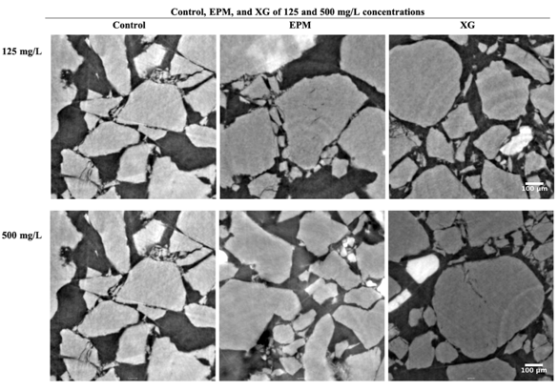
Figure S5 | Effect of biopolymers on sand compression and pore-scale restructuring.
(a) Unconfined compressive strength of sand amended with EPM at 0 (control), 125, and 500 mg L⁻¹ after 1, 2, and 3 days of curing (silt = 0%). Bars represent mean values and error bars denote standard deviation. EPM produces a moderate, curing-dependent increase in strength, with limited densification at intermediate concentration.
(b) Unconfined compressive strength of sand amended with xanthan gum at 0, 125, and 500 mg L⁻¹ after 1, 2, and 3 days of curing (silt = 0%). Xanthan gum induces a stronger, concentration-dependent increase in strength compared to EPM, particularly at high concentration and longer curing times, consistent with enhanced particle bridging and matrix stiffening.
(c) Total porosity of untreated sand and sand amended with EPM or xanthan gum at 125 and 500 mg L⁻¹ (silt = 0%), calculated from three-dimensional X-ray micro–computed tomography reconstructions.
(d) Representative two-dimensional micro-CT slices illustrating pore-scale morphology for control sand (column 1), EPM-amended sand (column 2), and xanthan gum–amended sand (column 3), at 125 mg L⁻¹ (row 1) and 500 mg L⁻¹ (row 2). Control samples exhibit a highly porous framework dominated by coarse sand grains, whereas biopolymer-amended samples show increased presence of fine material between grains, with xanthan gum producing denser and less connected pore structures than EPM.

S3. Growth of Barmuda grass with biopolymers in sand
To facilitate comparison across plant traits, biomass values were normalized to the control mean (Table S1). EPM-treated plants exhibited a 4.5-fold increase in total biomass, driven by a 3.9-fold increase in root mass and a 5.5-fold increase in shoot mass, while XG-treated plants remained comparable to the control across all metrics. Despite substantial increases in absolute biomass, the shoot-to-root mass ratio remained close to unity under EPM treatment, indicating proportional enhancement of above- and below-ground growth rather than a shift in biomass allocation. The relatively large standard deviations reflect biological variability in individual plant growth, consistent with the broad distributions observed in the raw data.
Table S1 | Relative growth metrics of Bermuda grass in biopolymer-amended sand (125 mg L⁻¹ ). Values represent fold change relative to the control mean (mean ± s.d.).
Metric | Control | EPM (relative to control) | XG (relative to control)
Plant mass | 1.00 ± 1.33 | 4.55 ± 1.80 | 1.01 ± 1.01
Root mass | 1.00 ± 1.36 | 3.89 ± 1.91 | 0.98 ± 0.91
Shoot mass | 1.00 ± 1.30 | 5.55 ± 2.30 | 1.07 ± 1.23
Shoot:root ratio | 1.00 ± 0.71 | 1.18 ± 0.40 | 0.95 ± 0.75

S4. Growth of beans with biopolymers in garden soil
XRF analysis of bean pods revealed that EPM application was associated with increased accumulation of several nutritionally important mineral elements (Figure S6). Calcium concentrations increased with EPM addition, reaching a maximum at 100 mg L⁻¹ and remaining elevated at 500 mg L⁻¹ . Potassium exhibited a similar response, with substantially higher concentrations at 50 and 100 mg L⁻¹ relative to the control, followed by a slight decrease at the highest EPM level. Phosphorus content increased sharply between 0 and 50 mg L⁻¹ EPM and then remained comparatively constant at 100 and 500 mg L⁻¹ , indicating diminishing gains with further EPM addition. In contrast, sulphur concentrations increased progressively across the full range of EPM treatments, with the highest values observed at 500 mg L⁻¹ .
Collectively, these results indicate that EPM treatments associated with enhanced plant growth were also accompanied by improved mineral nutrient concentrations in bean pods, suggesting a potential enhancement of pod nutritional quality.
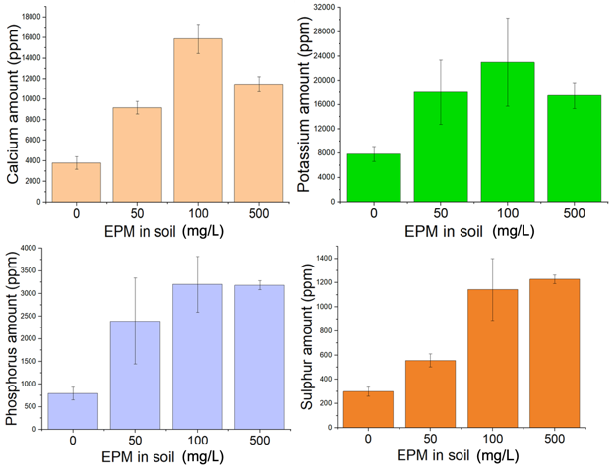
Figure S6 | Elemental composition of bean pods determined by XRF
XRF-derived concentrations of nutritionally important elements in bean pods grown under different EPM treatments. Calcium (a), potassium (b), phosphorus (c), and sulphur (d) show enrichment in response to EPM application. Calcium and potassium concentrations peak at 100 mg L⁻¹ EPM, while phosphorus increases sharply at low EPM doses and plateaus thereafter. Sulphur concentrations increase monotonically across the full EPM concentration range. These trends indicate that EPM application enhances the mineral nutrient content of bean pods, particularly at low to intermediate doses.

XRF analysis of bean roots grown in soils amended with increasing concentrations of EPM revealed a non-linear, concentration-dependent pattern of elemental accumulation across essential nutrients, beneficial elements, and lithogenic tracers (Figure S7).
Essential macronutrients (P, S, K, Ca and Cl; Figure S7a) showed pronounced enrichment in roots grown in soils treated with 50 and 500 mg L⁻¹ EPM relative to the control. In contrast, roots from plants grown at 100 mg L⁻¹ EPM consistently exhibited macronutrient concentrations comparable to, or only marginally higher than, untreated controls.
A similar trend was observed for essential micronutrients (Fe, Cu and Zn; Figure S7b). Roots from the 50 and 500 mg L⁻¹ treatments accumulated markedly higher concentrations of these elements, whereas roots grown at 100 mg L⁻¹ EPM showed micronutrient levels close to control values. In contrast, Mo concentrations remained relatively constant across all treatments, indicating element-specific responses to EPM amendment.
Beneficial and analog elements (Si, Sr and Rb; Figure S7c) followed the same non-monotonic trend. Silicon accumulation was strongly enhanced at 50 and 500 mg L⁻¹ EPM, while roots grown at 100 mg L⁻¹ contained intermediate Si levels. Strontium and rubidium also increased with EPM addition but were consistently lower at 100 mg L⁻¹ than at 50 or 500 mg L⁻¹.
In contrast, potentially toxic trace elements (e.g., Cr, Cd and U; Figure S7d) showed relatively minor variation across treatments. Concentrations remained comparable among control and EPM-amended soils, suggesting that EPM addition did not substantially enhance the uptake of toxic elements within the tested concentration range.
Finally, geochemically inert or lithogenic tracers (Sc, Ti, Nb, Zr, W and Pd; Figure S7e) exhibited enrichment patterns similar to those of macronutrients and micronutrients. Roots grown in 50 and 500 mg L⁻¹ EPM-amended soils generally contained higher concentrations of these elements, whereas roots from the 100 mg L⁻¹ treatment clustered closely with control samples.
Taken together, these results indicate that EPM concentration strongly influences elemental retention within the root system. Lower (50 mg L⁻¹) and higher (500 mg L⁻¹) EPM additions promote accumulation of a broad range of elements in roots, whereas at 100 mg L⁻¹ EPM, roots retain fewer nutrients despite improved shoot growth and superior pod development. This apparent decoupling between root elemental accumulation and fruit nutrient content suggests that, at intermediate EPM concentrations, nutrient translocation from roots to reproductive tissues is more efficient. In contrast, excessive or insufficient EPM may favor nutrient sequestration within the root system without proportional transfer to aboveground organs, consistent with the reduced pod yield observed at 500 mg L⁻¹.
(a)
(b)
(c)
(d)
(e)
Figure S7 | Elemental concentrations in bean roots grown in EPM-amended soil
XRF-determined elemental concentrations (ppm) in bean roots exposed to different EPM concentrations.
(a) Essential macronutrients (Mg, P, Ca, K) are elevated in roots from 50 and 500 mg L⁻¹ EPM treatments, whereas roots from the 100 mg L⁻¹ treatment show concentrations comparable to the control.
(b) Essential micronutrients (Mn, Fe, Cu, Zn, Mo, Ni) follow a similar trend.
(c) Beneficial elements (Si, Co, Se, Sr, Rb) are lower in the 100 mg L⁻¹ treatment relative to 50 and 500 mg L⁻¹.
(d) Potentially toxic elements (Cr, Cd, U) show no systematic variation across treatments.
(e) Lithogenic tracers (Sc, Ti, W) display trends comparable to macronutrients.
These results indicate enhanced elemental accumulation in roots at low and high EPM concentrations, while moderate EPM application maintains elemental levels similar to the control.

The PCA biplot of root elemental composition reveals a strong treatment-dependent structuring of elemental uptake and accumulation (Figure S8). PC1 (61.6%) represents the dominant gradient in root geochemistry and clearly separates the control and low-to-moderate EPM treatments from the higher EPM concentration. Elements loading positively on PC1, most notably U, Sc, Mo, and Zr, align with the control and 100 mg L⁻¹ EPM samples, indicating a root elemental signature characterized by relatively conservative uptake of these elements under lower amendment levels.
In contrast, the majority of elements, including V, Cd, Nb, Rb, Sr, Cu, Fe, Cl, W, Cr, K, Ca, Si, S, P, Ag, Zn, and Ti, load negatively along PC1 and are associated with higher EPM concentrations. This pattern indicates that increasing EPM dosage promotes enhanced accumulation of a broad suite of macro-, micro-, and potentially toxic elements in roots, consistent with increased ion retention, complexation, or facilitated transport at the root-soil interface.
PC2 (28.7%) captures a secondary but substantial gradient dominated by V and Sc, with contributions from Pd and U, reflecting element-specific uptake pathways and physiological regulation rather than bulk nutrient accumulation. The separation of samples along PC2 suggests differential sensitivity of certain trace elements to EPM-mediated changes in rhizosphere chemistry, potentially involving redox behavior, ligand binding, or transporter-level controls.
Overall, the biplot demonstrates that EPM concentration is the primary driver of root elemental composition (PC1), while PC2 reflects selective and element-specific uptake responses. Notably, the 100 mg L⁻¹ EPM treatment clusters close to the control, indicating that moderate amendment maintains a root elemental profile comparable to unamended conditions, whereas higher EPM levels induce broad-scale elemental enrichment in root tissues.
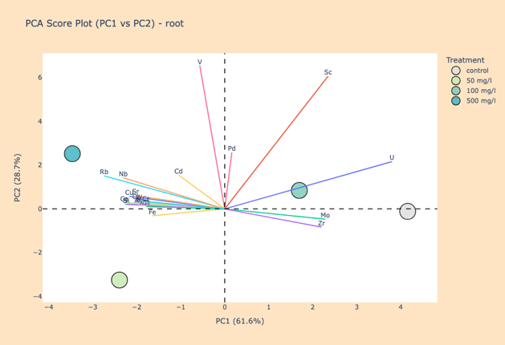
Figure S8 | PCA loading plot of elemental contributions in bean roots.
PCA loading plot illustrating the contribution of individual elements to sample separation across EPM treatments. Elements such as Pd, Sc, U, Mo, and Zr load on the same side of PC1 as the control and 100 mg L⁻¹ EPM samples, whereas elements including V, Cd, Nb, Rb, Sr, Cu, Fe, Cl, W, Cr, K, Ca, Si, S, P, Ag, Zn, and Ti load oppositely. This distribution indicates that increased EPM concentrations promote greater accumulation of most macro-, micro-, and potentially toxic elements in roots, while the 100 mg L⁻¹ treatment maintains an elemental profile similar to the control.

S5. Biological relevance of activated genes under EPM treatment
To gain mechanistic insight into the biological processes underlying the growth-promoting effects of EPM, experiments were extended to Arabidopsis thaliana, a genetically well-characterized model organism that enables downstream analysis of gene-level regulation associated with plant growth and development. Digital root imaging revealed clear morphological differences between water-treated control plants and those exposed to EPM (Figure S9). In control Arabidopsis roots (Figure S9 a,b), the root system consisted of relatively thin primary roots with limited development of lateral and fine roots. In contrast, plants treated with 125 mg/L soil EPM (Figure S9 c,d) exhibited visibly thicker roots and a markedly denser network of fine roots, resulting in a more compact and structurally complex root architecture. Root surfaces in the EPM-treated samples also appeared less uniform, with increased local bundling and aggregation of root strands compared to controls. These observations indicate that the root growth responses induced by EPM extend to Arabidopsis thaliana, supporting the use of this model system for probing EPM-mediated regulation of plant growth at the molecular level.
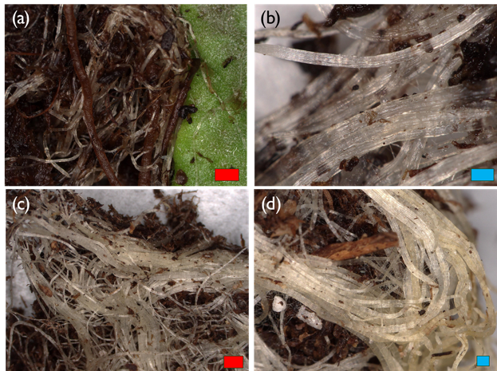
Figure S9 | Roots digital imaging obtained from water treated Arabidopsis (a, b) and Arabidopsis treated with 125 mg/L soil of EPM (c, d). (Red scale bar – 1000 μm; blue scale bar – 250 μm).
Activated genes under EPM treatment reveal a coordinated molecular response supporting root adaptation to altered soil conditions (Figure S10). Strong induction of small heat shock proteins (HSP22.0 and HSP18.1/HSP18.2) suggests enhanced molecular chaperone activity to stabilize proteins and cellular structures under mechanical and environmental stress imposed by EPM-amended soil. Upregulation of GPT2 indicates increased metabolite exchange between the cytosol and chloroplasts, supporting elevated energy and carbon demands during stress-responsive growth. Elevated expression of APX2 reflects strengthened antioxidant capacity and redox homeostasis, consistent with controlled ROS signaling during root adjustment. Activation of the transcription factor SPL5 implies broader transcriptional reprogramming linked to developmental and stress-adaptive pathways. Increased EXT17 expression further indicates active cell wall remodeling and reinforcement, suggesting structural modification of roots to accommodate changes in soil physical properties. Moderately activated genes reinforce this response, showing coordinated upregulation of ROS-scavenging enzymes (PEROX, APX1, APX3), additional small heat shock proteins (HSP17, HSP20, HSP21), transcription factors (MYB, NAC, SPL3), and metabolic regulators, collectively supporting cellular protection, hormonal balance, and structural integrity during root growth in EPM-treated soil. Figure S10 presents these responses as three bar plots depicting strongly (a), moderately (b), and lightly (c) activated genes.
(a)
(b)
(c)
Figure S10 | Gene activation for Arabidopsis thaliana with EPM over control (RNA-seq). Bar plots showing gene activation in Arabidopsis roots under EPM-amended soil. Panel (a) depicts strongly activated genes, panel (b) shows moderately activated genes, and panel (c) presents lightly activated genes, highlighting coordinated responses in stress protection, antioxidant activity, transcriptional regulation, and cell wall remodeling supporting root adaptation to altered soil conditions.

