Supplementary Figure 1. Calculation of apparent feed conversion ratio (a-FCR) of locusts. Data presented are Mean ± SD. Tomato leaves were subjected to four handling treatments: FL (fresh leaves), LS (leaves stored at 8 °C for 3 days), LSD (leaves stored at 8 °C for 6 days and used daily, starting with fresh leaves on day 1), and LCM (leaf-cutting method, with leaves replaced by newly treated leaves on day 4).

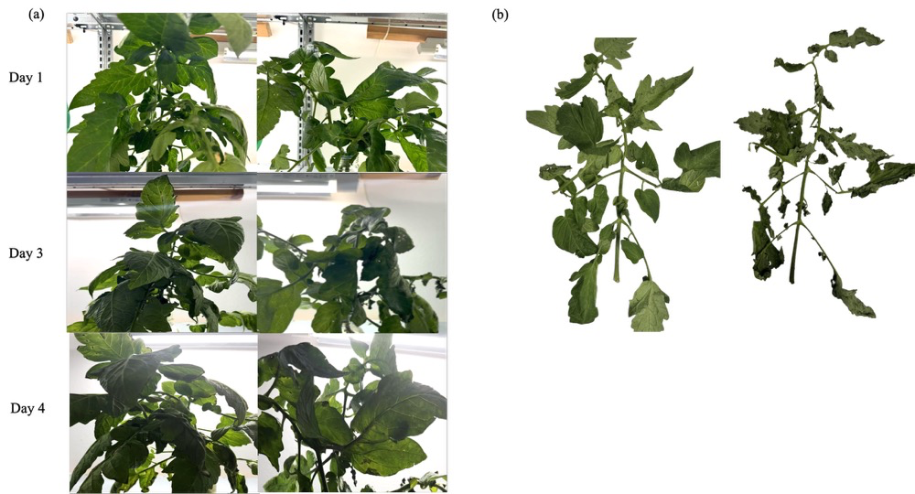
Supplementary Figure S2. Visual changes in tomato leaves during the simulation experiment. (a) Tomato leaves under the LCM on day 1, day 2, and day 4 during storage in the cages. (b) Tomato leaves under the FL treatment after 24 h exposure in the cage.

Supplementary Table 1. Effects of leaf-cutting on the elemental composition of tomato leaves after 3 and 7 days through a simulation experiment.
Tomato Leaves | Al | B | Ca | Zn | S | Cu | Fe | K | Mg
Tomato Leaves | mg/kg | mg/kg | g/kg | mg/kg | g/kg | mg/kg | mg/kg | g/kg | g/kg
FL | 16.12±8.99 | 124.71±25.74 | 52.95±13.1 | 23.22±1.21ª | 26.87±1.36 | 14.35±4.07ª | 101.19±6.19ª | 49.40±1.10ª | 6.76±0.72^{ab}
LCM (3 days) | 16.42±1.39 | 104.93±1.26 | 68.18±0.43 | 15.49±0.35^{c} | 27.90±0.09 | 9.19±0.64^{ab} | 98.22±0.93ª | 42.67±0.71^{b} | 7.19±0.05ª
LCM (7 days) | 19.66±3.05 | 89.88±0.82 | 70.36±0.43 | 18.64±1.04^{b} | 29.23±0.96 | 6.97±0.62^{b} | 89.85±1.10^{b} | 44.82±1.05^{b} | 6.08±0.07^{b}
Tomato Leaves | Mn | Mo | Na | P | Ni | Cr | Pb | Cd | CP
Tomato Leaves | mg/kg | mg/kg | g/kg | g/kg | mg/kg | mg/kg | mg/kg | mg/kg | %
FL | 750.36±30.48^{b} | 5.62±0.25^{b} | 2.18±0.03ª | 5.05±0.14^{b} | 1.64±2.06 | 0.82±0.10ª | 0.33±0.11 | 0.07±0.03 | 24.37±0.23ª
LCM (3 days) | 691.42±6.68^{b} | 6.41±0.02ª | 1.11±0.02^{c} | 5.42±0.02^{b} | 0.27±0.18 | 0.50±0.01^{c} | 0.24±0.05 | 0.03±0.01 | 23.35±0.12^{b}
LCM (7 days) | 968.09±45.27ª | 6.68±0.32ª | 1.44±0.09^{b} | 6.05±0.29ª | 0.26±0.14 | 0.66±0.02^{b} | 0.29±0.04 | 0.03±0.01 | 23.14±0.28^{b}
Note: Data are presented as Mean ± SD (n = 3). Vertical comparison was performed across tomato leaves, and different letters above the columns indicate significant differences (P < 0.05). FL (fresh leaves), LCM (leaf-cutting method, with replacement on day 4)

Supplementary Table 2. Cadmium (Cd) and lead (Pb) concentrations in desert locusts compared with the maximum limits for feed materials established by EU legislation.
Element | Feed material max  limit [mg/kg] | Feed material max  limit [DW, mg/kg] |  | FL [mg/kg] | LS  [mg/kg] | LSD  [mg/kg] | LCM  [mg/kg]
Cd | 0.8 | 0.91 | 0.16 |  | 0.16 | 0.13 | 0.11
Pb | 10 | 11.36 | 0.01 |  | 0.02 | 0.06 | 0.08
Note: Maximum levels for undesirable substances in feed materials established by Directive 2002/32/EC and its subsequent amendments are expressed on a 12% moisture basis (88% dry matter). Since the present results are reported on a dry matter basis, regulatory values were converted accordingly.

