Supplementary Table S1.
GLCM Texture Feature Interpretation and Directionality
Feature No. | Feature name | Interpretation | Preferred direction | Biological meaning
T1 | Uniformity / Energy / Angular Second Moment | Global homogeneity, uniform gray-level distribution | Higher = better | More regular and homogeneous tissue organization
T2 | Entropy | Randomness / disorder | Lower = better | Less heterogeneous, more organized tissue
T3 | Dissimilarity | Local intensity variation | Lower = better | Smoother local texture, reduced microstructural irregularity
T4 | Contrast / Inertia | Edge strength, high-frequency variation | Lower = better | Reduced sharp transitions, greater structural smoothness
T5 | Inverse Difference | Local similarity | Higher = better | Greater similarity between neighboring voxels
T6 | Correlation | Linear dependency between neighboring voxels | Higher = better | Greater structural coherence
T7 | Homogeneity / Inverse Difference Moment | Weighting toward similar gray levels | Higher = better | More homogeneous tissue texture
T8 | Autocorrelation | Repetition of texture patterns | Higher = better | Greater regularity of spatial structure
T9 | Cluster Shade | Skewness / asymmetry of texture distribution | Lower = better | Reduced asymmetry, more stable distribution
T10 | Cluster Prominence | Peakedness / outlier sensitivity | Lower = better | Reduced extreme texture values
T11 | Maximum Probability | Dominant texture pattern | Higher = better | Stronger dominant homogeneous pattern
T12 | Sum of Squares (Variance) | Overall gray-level variability | Lower = better | Reduced intensity dispersion
T13 | Sum Average | Mean gray-level magnitude | Context dependent | Reflects average signal intensity; interpretation depends on modality
T14 | Sum Variance | Global variance around mean | Lower = better | Reduced heterogeneity
T15 | Sum Entropy | Global disorder | Lower = better | More ordered tissue structure
T16 | Difference Variance | Local variance of differences | Lower = better | Reduced microstructural variability
T17 | Difference Entropy | Local disorder | Lower = better | More organized local texture
T18 | Information Measure of Correlation (IMC1) | Information shared between voxels | Higher = better | Greater spatial dependency and structure
T19 | Information Measure of Correlation (IMC2) | Nonlinear voxel dependency | Higher = better | Stronger complex structural relationships
T20 | Maximal Correlation Coefficient | Maximal nonlinear correlation | Higher = better | Richer and more organized texture structure
T21 | Inverse Difference Normalized (IDN) | Normalized local homogeneity | Higher = better | Increased normalized similarity
T22 | Inverse Difference Moment Normalized (IDMN) | Normalized homogeneity measure | Higher = better | Greater normalized tissue regularity

Note. This table summarizes the biological interpretation and preferred directionality of gray-level co-occurrence matrix (GLCM) texture features used in the present study. Directionality reflects widely adopted conventions in neuroimaging and radiomics literature, in which higher values of features indexing homogeneity, similarity, and spatial dependency are generally interpreted as reflecting greater tissue regularity, whereas higher values of features indexing entropy, contrast, and variance are interpreted as reflecting greater disorder or heterogeneity (Haralick et al., 1973; Castellano et al., 2004; Thibault et al., 2014; Parekh & Jacobs, 2016). For context-dependent features, biological interpretation may vary depending on image contrast, acquisition parameters, and preprocessing.
Supplementary Figure S1.
Flow Diagram of Randomized Trial
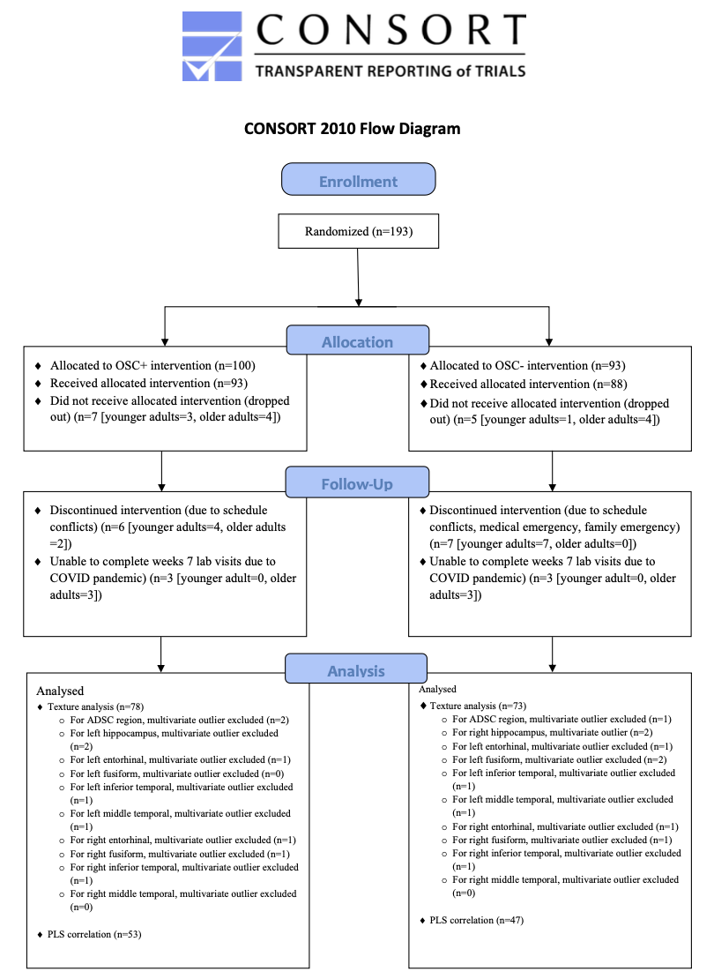
Supplementary References
Castellano, G., Bonilha, L., Li, L. M., & Cendes, F. (2004). Texture analysis of medical images. Clinical Radiology, 59(12), 1061–1069. https://doi.org/10.1016/j.crad.2004.04.008
Haralick, R. M., Shanmugam, K., & Dinstein, I. (1973). Textural features for image classification. IEEE Transactions on Systems, Man, and Cybernetics, SMC-3(6), 610–621. https://doi.org/10.1109/TSMC.1973.4309314
Parekh, V. S., & Jacobs, M. A. (2016). Radiomics: A new application from established techniques. Expert Review of Precision Medicine and Drug Development, 1(2), 207–226. https://doi.org/10.1080/23808993.2016.1164013
Thibault, G., Angulo, J., & Meyer, F. (2014). Advanced statistical matrices for texture characterization: Application to cell classification. IEEE Transactions on Biomedical Engineering, 61(3), 630–637. https://doi.org/10.1109/TBME.2013.2284610

