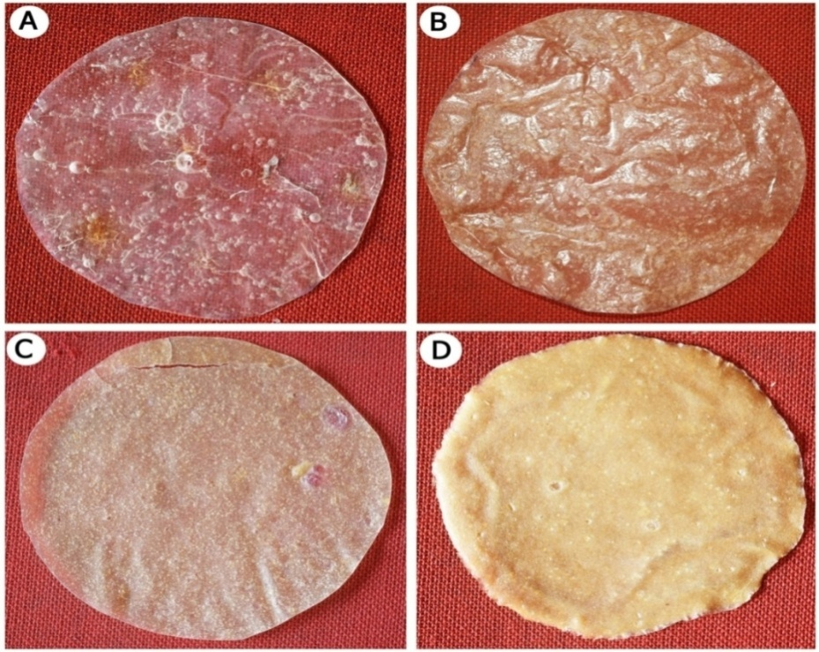
Supplementary figure.1. Bioplastic film at different concentrations of Corn starch and Fish scale. A. CS, B. CSFS1,C. CSFS2, D. FS

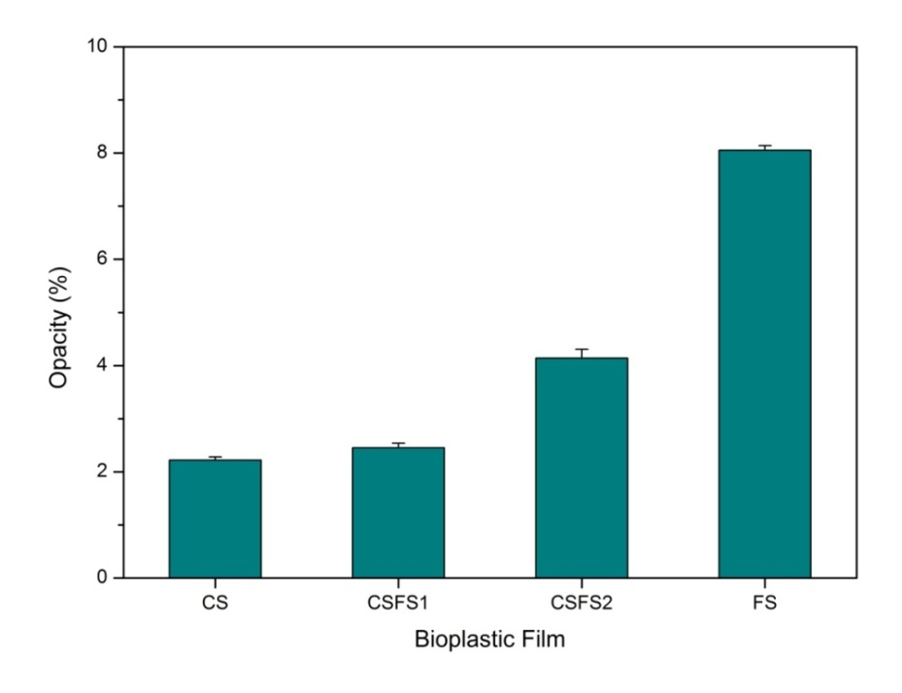
Supplementary figure. 2. Opacity of different bioplastic films
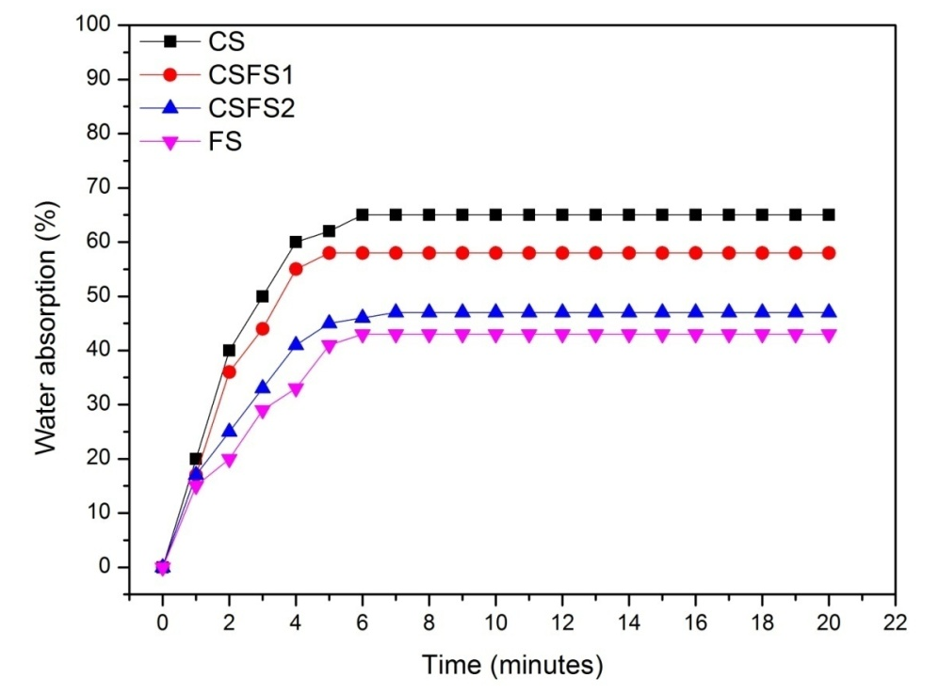
Supplementary figure. 3. Water absorption Kinetics of different bioplastic films

Supplementary figure. 4. TGA of different bioplastic films

