Brain MR Elastography Metrics Associated with Alterations in Learning and Memory in People with HIV
Supplementary Information

Supplementary Tables

Table 1: Cognitive Domain Assessment
This table shows the corrected p-values, effect sizes (Cohen's d), and interpretation for various cognitive domains. A p-value less than 0.01 was considered significant.
Cognitive Domain | HIV+ Mean (Std) | HC Mean (Std) | Corrected P-Value (q) | Cohen's d
Learning | 0.1090 (0.927) | 1.3178(1.102) | 0.0002 | -1.18
Memory | 0.0611 (0.945) | 1.0287(1.171) | 0.006 | -0.9
Language | 0.3690(0.825) | 1.102(0.974) | 0.026 | -0.81
Total Score | -0.38901(3.901) | 3.4733(4.554) | 0.001 | -0.91
Motor Skills | -0.5759(1.075) | -0.0533(0.907) | 0.369 | -0.53
Speed of Processing | -0.2490(0.866) | 0.0986(0.856) | 0.966 | -0.4
Attention | -0.3074(0.595) | -0.2022(0.578) | 1 | -0.18
Executive Function | 0.2037(0.925) | 0.1816(1.048) | 1 | 0.02

The following tables detail the interaction p-values from various analyses, including Magnetic Resonance Elastography (MRE), advanced diffusion imaging (NODDI and DTI), and biomarker data.

MRE vs Cognitive Scores: Group Interaction Results

Table 2: Correlation (r) per group and Interaction p-value (FDR Corrected) for Viscosity (ϕ) ~ Cognition * Group

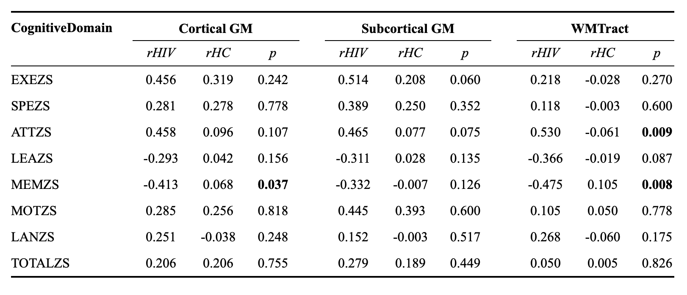

Table 3: Correlation (r) per group and Interaction p-value (FDR Corrected) for G: Stiffness (G) ~ Cognition * Group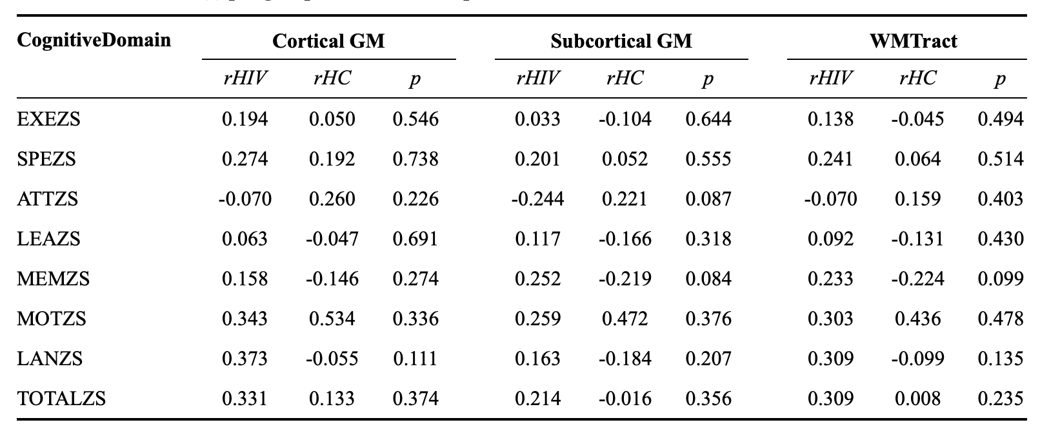

Table 4: Correlation (r) per group and Interaction p-value (FDR Corrected) for Strain ~ Cognition * Group

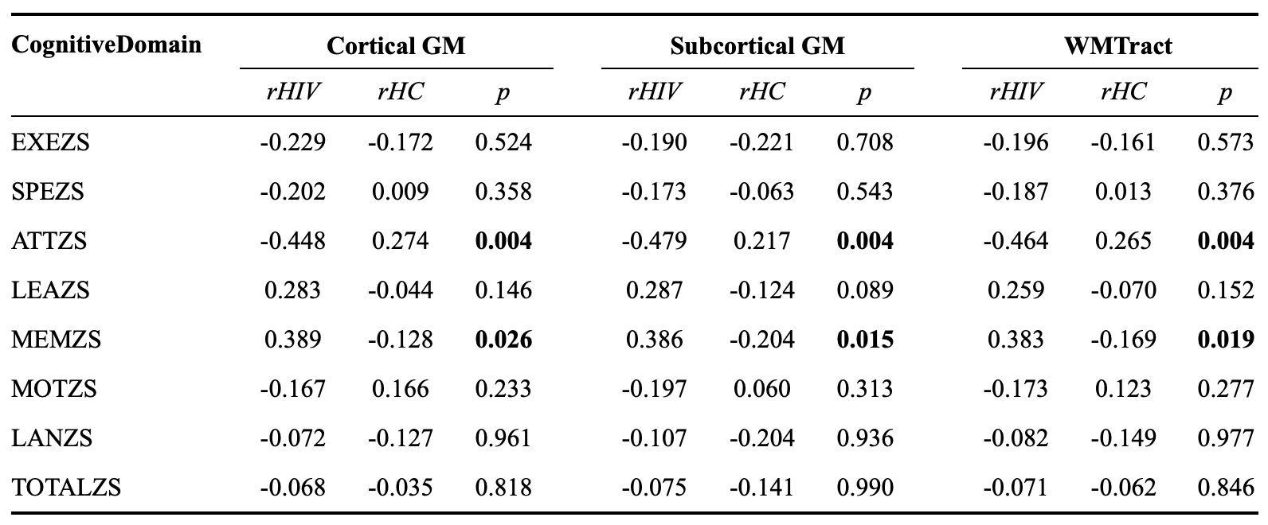

Diffusion Based Features (NODDI and DTI) vs Cognitive Scores: Group Interaction Results

Table 5: Correlation (r) per group and Interaction p-value (FDR Corrected) for fISO ~ Cognition * Group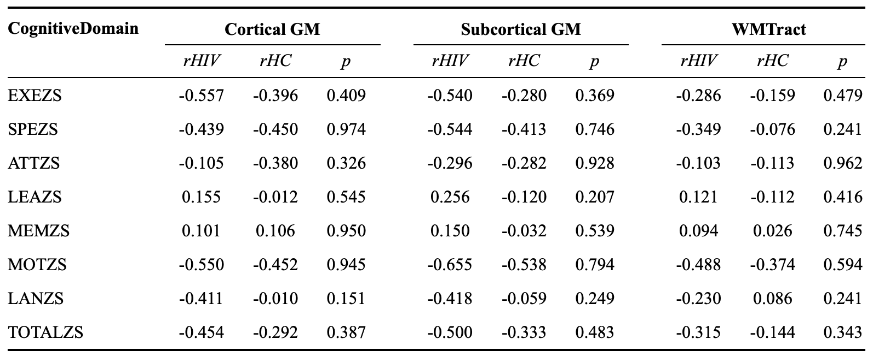

Table 6: Correlation (r) per group and Interaction p-value (FDR Corrected) for NDI ~ Cognition * Group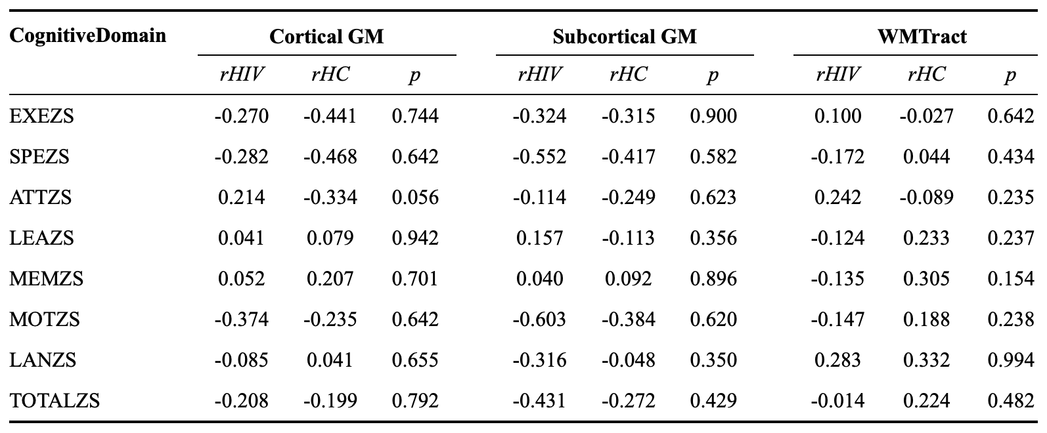

Table 7: Correlation (r) per group and Interaction p-value (FDR Corrected) for ODI ~ Cognition * Group

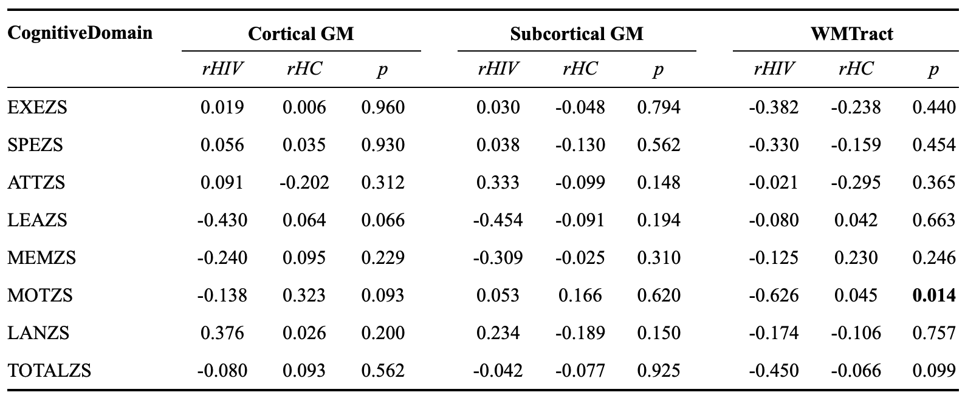

Table 8: Correlation (r) per group and Interaction p-value (FDR Corrected) for FA (DTI) ~ Cognition * Group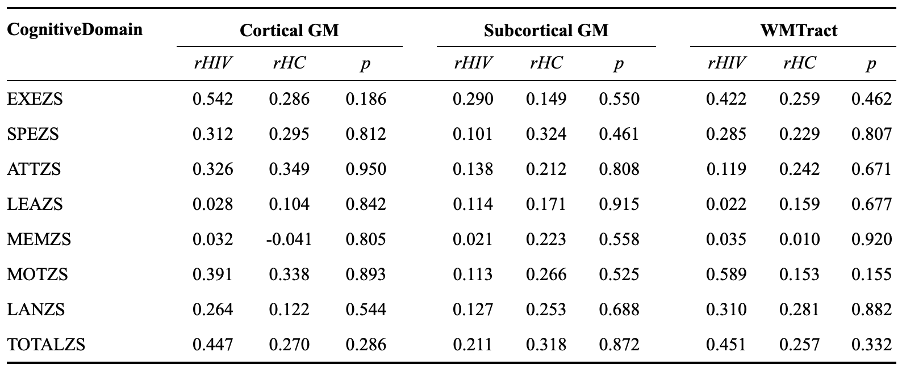

Table 9: Correlation (r) per group and Interaction p-value (FDR Corrected) for MD (DTI) ~ Cognition * Group

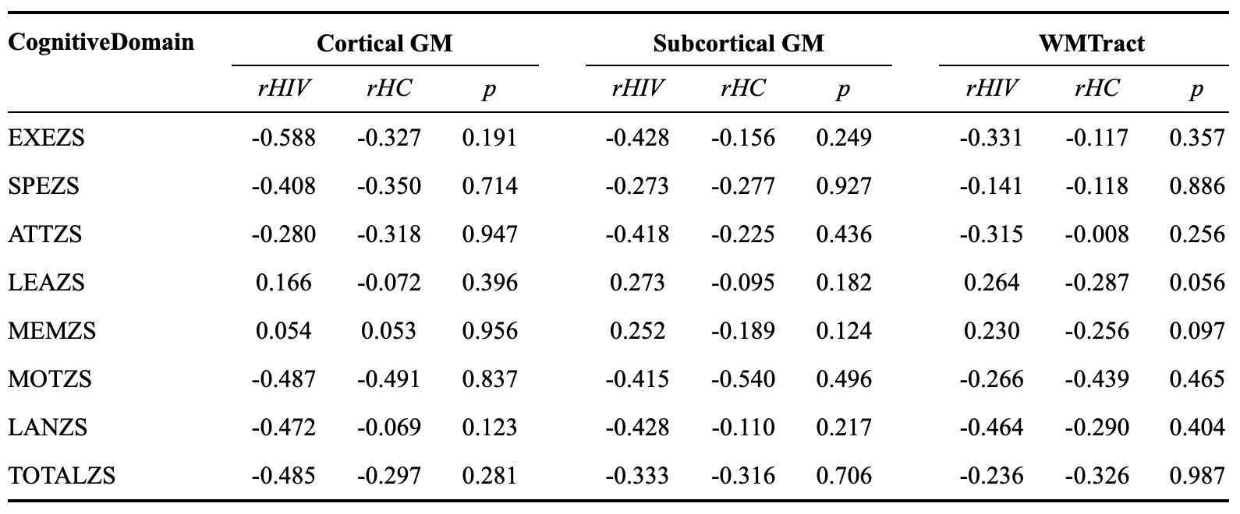

Peripheral Marker of Brain Injury vs Cognitive Scores: Group Interaction Results

Table 10: Group Interaction P-Values (FDR Corrected) and correlation coefficients for
NFL ~ Cognition * Group

Cognitive Domain | r (HIV+) | r (HC) | Interaction p-value
EXEZS | -0.418 | -0.357 | 0.241
SPEZS | -0.443 | -0.354 | 0.181
ATTZS | -0.419 | -0.211 | 0.200
LEAZS | 0.211 | -0.374 | 0.081
MEMZS | 0.223 | -0.411 | 0.061
MOTZS | -0.409 | -0.275 | 0.406
LANZS | -0.364 | -0.124 | 0.190
TOTALZS | -0.352 | -0.418 | 0.435
Note. r represents the Pearson correlation coefficient. Italicized p-values indicate a trending interaction (0.05 < p < 0.10). HC = Healthy Control.

Table 11: Group Interaction p-values (FDR Corrected) and correlation coefficients for
GFAP ~ Cognition * Group
Cognitive Domain | r (HIV+) | r (HC) | Interaction p-value
EXEZS | -0.359 | -0.267 | 0.388
SPEZS | -0.106 | -0.143 | 0.915
ATTZS | -0.271 | -0.124 | 0.497
LEAZS | -0.198 | -0.283 | 0.996
MEMZS | -0.063 | -0.365 | 0.488
MOTZS | 0.157 | -0.058 | 0.473
LANZS | -0.243 | 0.020 | 0.314
TOTALZS | -0.218 | -0.250 | 0.751
Note. r represents the Pearson correlation coefficient. GFAP = Glial Fibrillary Acidic Protein. HC = Healthy Control. All interaction p-values in this set were non-significant (p > 0.10).

Blood and Vascular Biomarkers vs Cognitive Scores: Group Interaction Results

Table 12: Group Interaction P-Values (FDR Corrected) for
Blood Biomarkers ~ Cognition * Group
Cognitive Score | CD163 (pg/ml) | ICAM (pg/ml)
EXEZS | 0.38461 | 0.80821
SPEZS | 0.93013 | 0.27136
ATTZS | 0.77051 | 0.98665
LEAZS | 0.71885 | 0.55351
MEMZS | 0.90342 | 0.64763
MOTZS | 0.19725 | 0.95078
LANZS | 0.72652 | 0.54293
TOTALZS | 0.45235 | 0.61067

Table 13: Group Interaction P-Values (FDR Corrected) for
Vascular Marker ~ Cognition * Group
Cognitive Domain | r (HIV+) | r (HC) | Interaction p-value
EXEZS | -0.437 | -0.297 | 0.913
SPEZS | -0.220 | -0.322 | 0.427
ATTZS | -0.287 | -0.134 | 0.838
LEAZS | -0.061 | -0.017 | 0.905
MEMZS | -0.097 | 0.057 | 0.610
MOTZS | -0.300 | -0.193 | 0.876
LANZS | -0.653 | -0.007 | 0.062
TOTALZS | -0.462 | -0.166 | 0.439

Supplementary Figures

Supplementary Figure 1
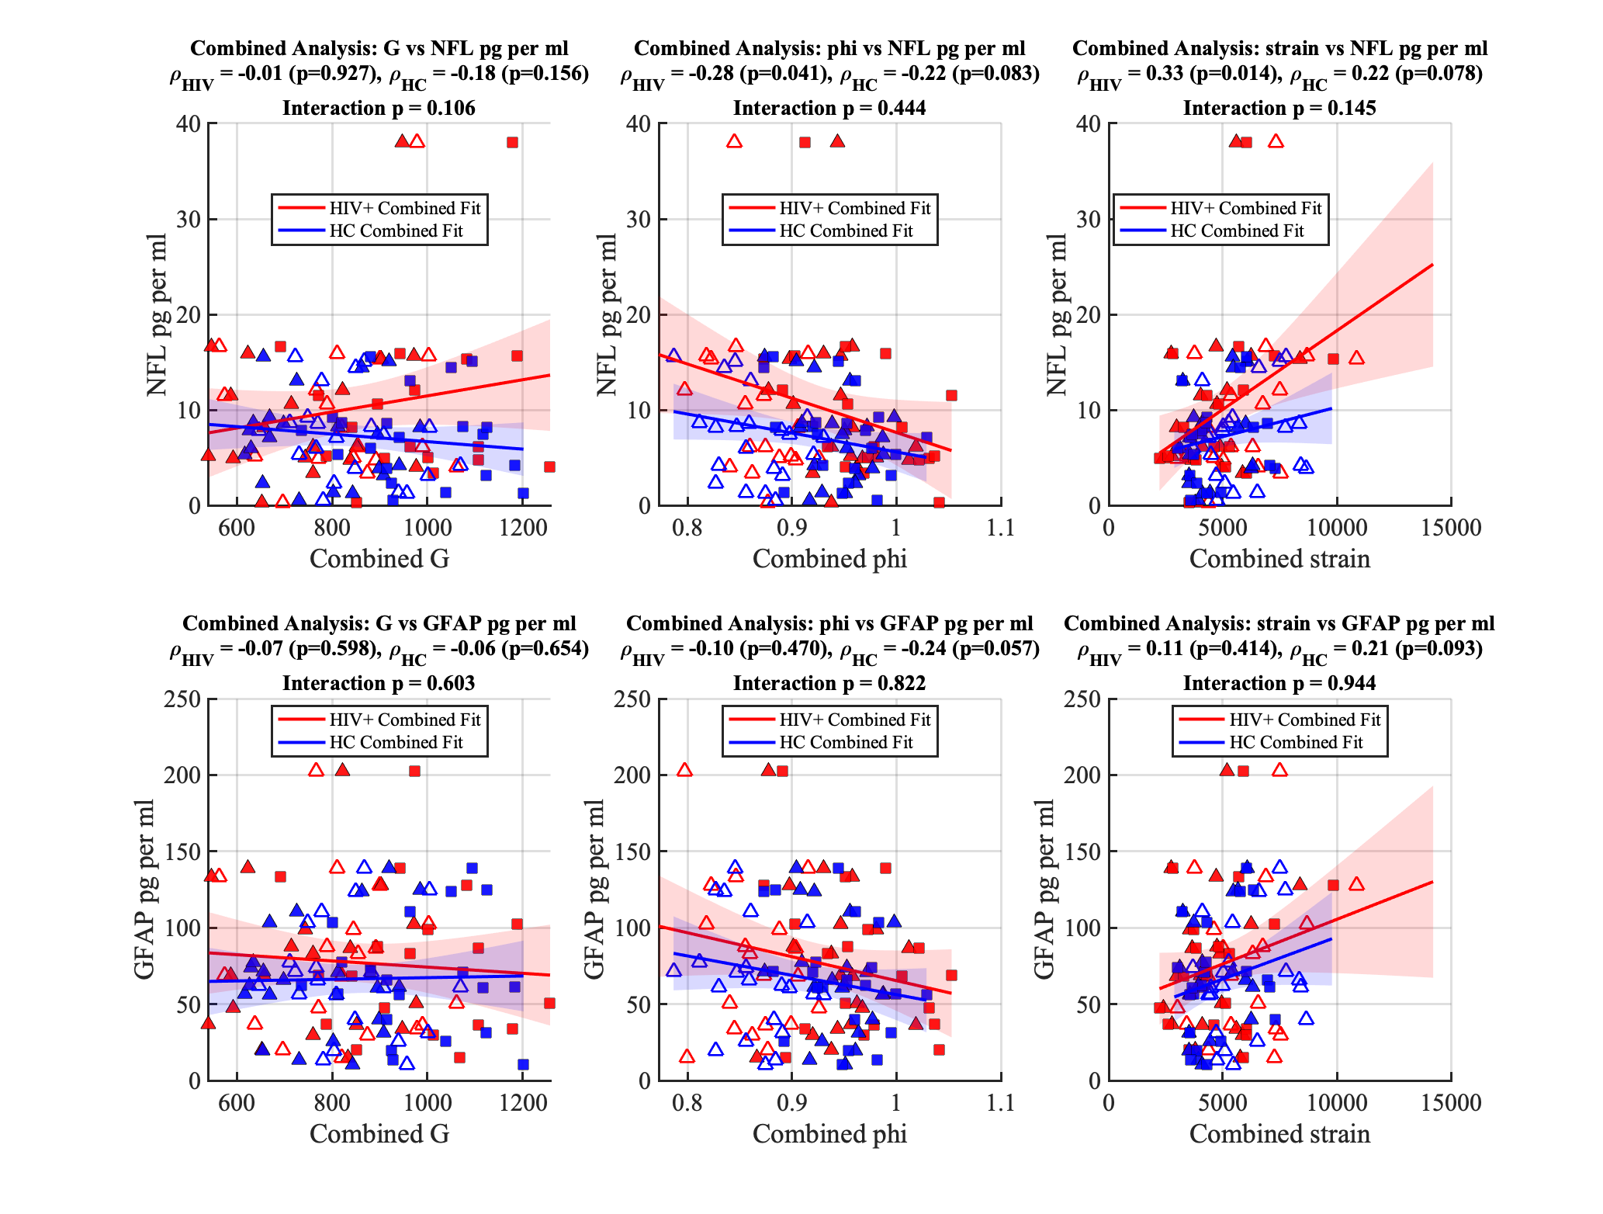
Supplementary Figure-1: Combined Brain ROI analysis (WM tracts, GM cortical and Sub-cortical regions) of group interaction for MRE metrics (G- stiffness, phi- viscosity and strain).

Supplementary Figure 2

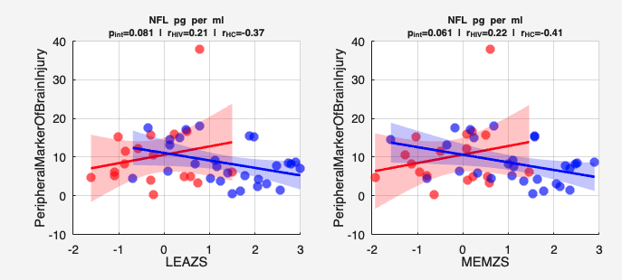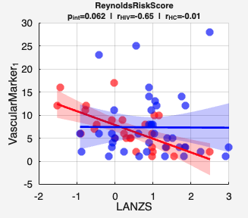
Supplementary Figure-2: Interaction of peripheral marker of brain injury (NFL) and Vascular Marker (Reynold’s Risk score) reported with the correlation coefficients of each group and interaction p-value. LEAZS, MEMZS, LANZS– indicates Z-Scores for Learning, Memory and Language Cognitive Tests respectively. HIV+ group indicated in red and HC in blue.

