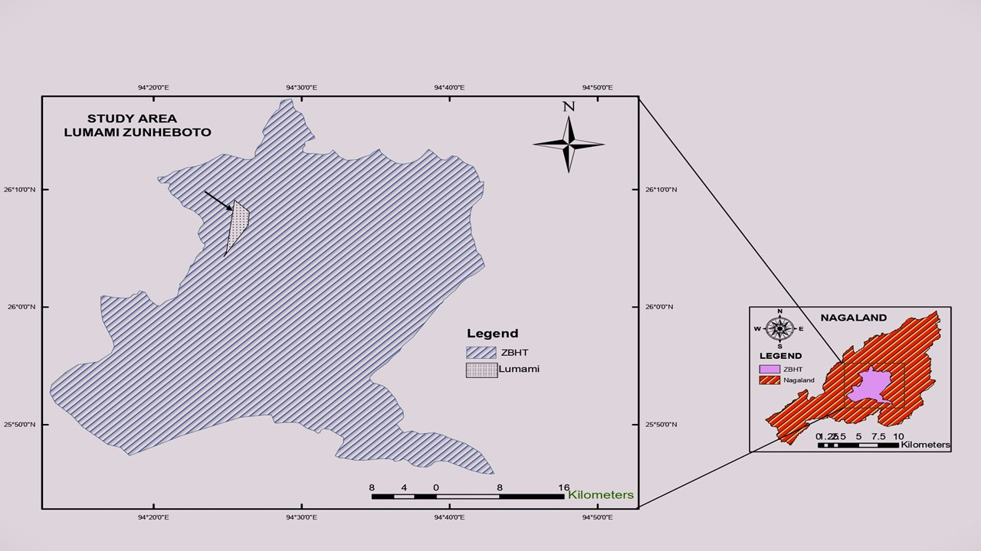
Plate 1. Map of Nagaland State showing the location of study site at Lumami
(shaded area pointed with arrow).

