Supplementary information

Impact attribution of climate and population change on compound flood impacts from tropical cyclone Idai in Mozambique
Doris M. Vertegaal*^{1,2}, Bart J. J. M. van den Hurk^{1,2}, Anaïs Couasnon^{1,2}, Dominik Paprotny^{3,4,5}, and Sanne Muis^{1,2}
¹Deltares, Delft, the Netherlands
²Institute for Environmental Studies (IVM), Vrije Universiteit Amsterdam, Amsterdam, the Netherlands
³Institute of Marine and Environmental Sciences, University of Szczecin, Poland
⁴Potsdam Institute for Climate Impact Research (PIK), Member of the Leibniz Association, Potsdam, Germany
⁵ Baltic Climate Centre, University of Szczecin, Poland

*Correspondence to: Doris M. Vertegaal (doris.vertegaal@deltares.nl)

S1. Climate change trend removal for climate counterfactual
Table S1: The adjustment of the moderate climate change counterfactual scenario of key flood drivers from preindustrial levels (as used in¹) to the counterfactual baseline year of 1975, as aligned with the population counterfactual.
Variable | Climate trend between preindustrial  and 2019 | Climate trend between 1975 and 2019 | Reference
Global average surface air warming | 1.1 °C | 0.9 °C | ²
Rain  (7%/°C) | 8 % | 6 % | Clausius–Clapeyron
Wind | 5 % | 4 % | ³
SLR | 10 cm | 7 cm | ⁴

S2. Validation of population data

S2.1 Validation of GHSL population rasters
The total population from the used Global Human Settlement Layer (GHSL)^{5,6} data for 2020 is compared to reported Census data⁷ administrative level 3 that touches our study domain (Table S1 and Fig. S1, panel a). Not all administrative level 3 regions are fully covering our case study domain, especially for regions Nhamatanda, Estaquinha and Sofala (shaded grey in Table S1). The total population within Mafambisse and Beira are underestimated, whereas the population in Tica is overestimated. These differences in total population can be due to multiple reasons, such as different district boundaries or differences in how total versus residential population is defined. In general, it is known that there is a large uncertainty in population data. When averaging over all districts, the difference between the reported and estimated total population within our case study area is small (-1 %), and therefore reasonable.
We also compare the estimated exposed population with the reported affected population from Mozambique’s National Institute for Disaster Management (INGC) & International Organisation for Migration Displacement Tracking Matrix (IOM DTM)⁸ (Table S2 and Fig. S1, panel b). Overall, our estimates tend to underestimate exposure when compared directly to the reported affected population. However, it is important to note that the reported numbers refer to people affected by shelter damage, which may result from multiple hazards beyond flooding, including, for example, the severe winds associated with Tropical Cyclone (TC) Idai.
Table S2: The reported⁷ and estimated total population for administrative level 3 region within our study domain. Districts partially included in the study region are presented in grey. Data is presented for the used year of 2020 and the year of TC Idai in 2019.
District | 2019 census | 2020 census | Census pop growth 2019 to 2020 | 2020 estimated | Difference reported and estimated 2020
 |  |  |  |  | # people | %
Beira | 648,124 | 666,674 | 3% | 583,788 | -82,886 | -12%
Buzi | 111,253 | 111,765 | 0% | 111,780 | 15 | 0%
Dondo | 110,427 | 113,750 | 3% | 113,231 | -519 | 0%
Tica | 93,705 | 95,474 | 2% | 108,483 | 13,009 | 14%
Mafambisse | 80,497 | 82,731 | 3% | 66,752 | -15,979 | -19%
Nhamatanda | 209,720 | 215,405 | 3% | 244,740 | 29,335 | 14%
Sofala | 30,028 | 30,039 | 0% | 31,149 | 1,110 | 4%
Estaquinha | 44,752 | 45,215 | 1% | 43,255 | -1,960 | -4%
Total | 1,328,506 | 1,361,053 | - | 1,303,178 | -57,025 | -
Average | - | - | 2% | - | - | -1%

Table S3: The reported affected population⁸ to TC Idai in 2019 and estimated exposed population based on GHSL^{5,6} population data for 2020. Districts partially included in the study region are presented in grey.
District | Modelled exposed Population (2020 Factual) | Reported affected population (2019) | Agreement %
Beira | 212,984 | 257,474 | 83%
Buzi | 22,923 | 86,550 | 26%
Dondo | 2,415 | 70,191 | 3%
Tica | 7,907 | 71,432 | 11%
Mafambisse | 2,365 | 59,017 | 4%
Nhamatanda | 227 | 127,890 | na
Sofala | 1,428 | 32,204 | na
Estaquinha | 169 | 25,722 | na
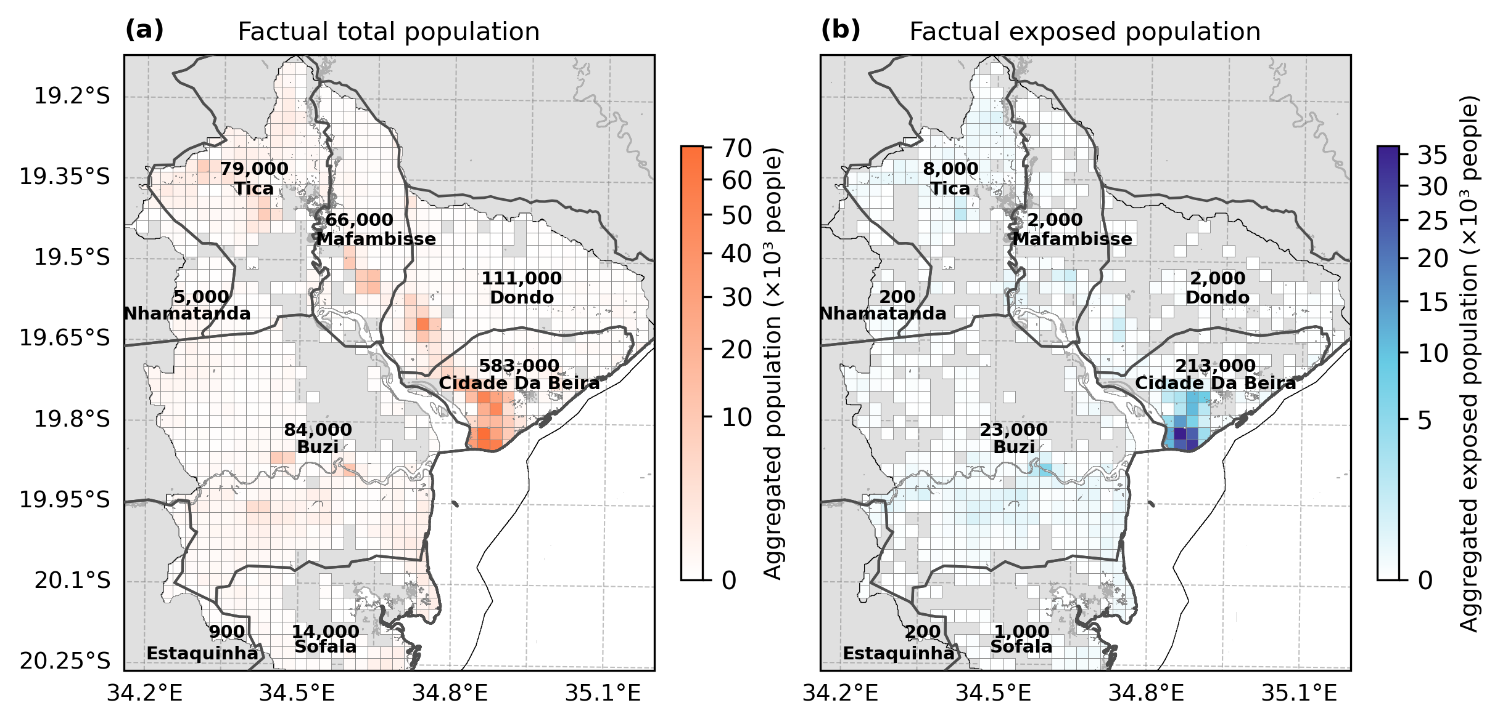
Figure S1: The estimated total and exposed population within the case study domain for the factual scenario per administrative level 3 region. Panel a shows the total residential population from GHSL data of 2020. Panel b shows the exposed population calculated by downscaling and overlaying the population data with the factual simulated flood extent. The population is aggregated to grid cells of 2.5 km for visualisation. The flood model domain is outlined in a thin black line and the administrative level 3 region in thicker black lines.

S2.2 Validation of GLOPOP-SG population raster
We compared the reported population data and its socio-economic characteristics from the 2017 Census for the Sofala province⁹ with the data from Ton et al.^{10,11}. First, the total population estimates for Sofala Province compare well, with a difference of approximately 6 %. This discrepancy can likely be explained by population growth between 2015 (the reference year used in Ton et al.) and 2017, which is estimated at around 6 %¹².
We further compared the socio-economic composition between rural and urban areas, as this appears to be a key determinant of differences in the attributable fraction of the exposed population. Overall, the modelled and reported datasets show reasonable agreement. In particular, the education-related variables, which are associated with some of the largest disproportionate impacts, compare well between the datasets.
However, the model may overestimate the proportion of younger and older people (< 5 and > 65 years old), although these demographic ratios may also differ locally within the case study region. As a result, the findings related to disproportionate impacts associated with age should be interpreted with somewhat greater caution. No reported data was available to compare the wealth of the population.
Table S4: Comparison of reported population data and its socio-economic characteristics with the data from Ton et al.^{10,11} (estimated) per rural and urban area within the Sofala province.
Socio-economic |  | Share within category in rural |  | Share within category in urban
 |  | Estimated | Reported | Estimated | Reported
Category | Group | [%] |  | [%]
Wealth | Poorest & Poorer | 42 | Na | 8 | Na
Wealth | Middle | 34 | Na | 10 | Na
Wealth | Richer & Richest | 25 | Na | 82 | Na
Education | < Primary & Primary | 87 | 83 | 57 | 54
Education | Incomplete secondary | 10 | 12 | 23 | 23
Education | Secondary & Higher | 2 | 5 | 20 | 22
Household size | 1 person | 1 | 9 | 1 | 10
Household size | 2+ people | 99 | 91 | 99 | 90
Sex | Male | 48 | 47 | 49 | 50
Sex | Female | 52 | 53 | 51 | 50
Age | Young (<5) & Elderly (65+) | 49 | 22 | 39 | 17
Age | 5-64 years | 52 | 78 | 61 | 83

S3. Factual and changes in flood and population conditions
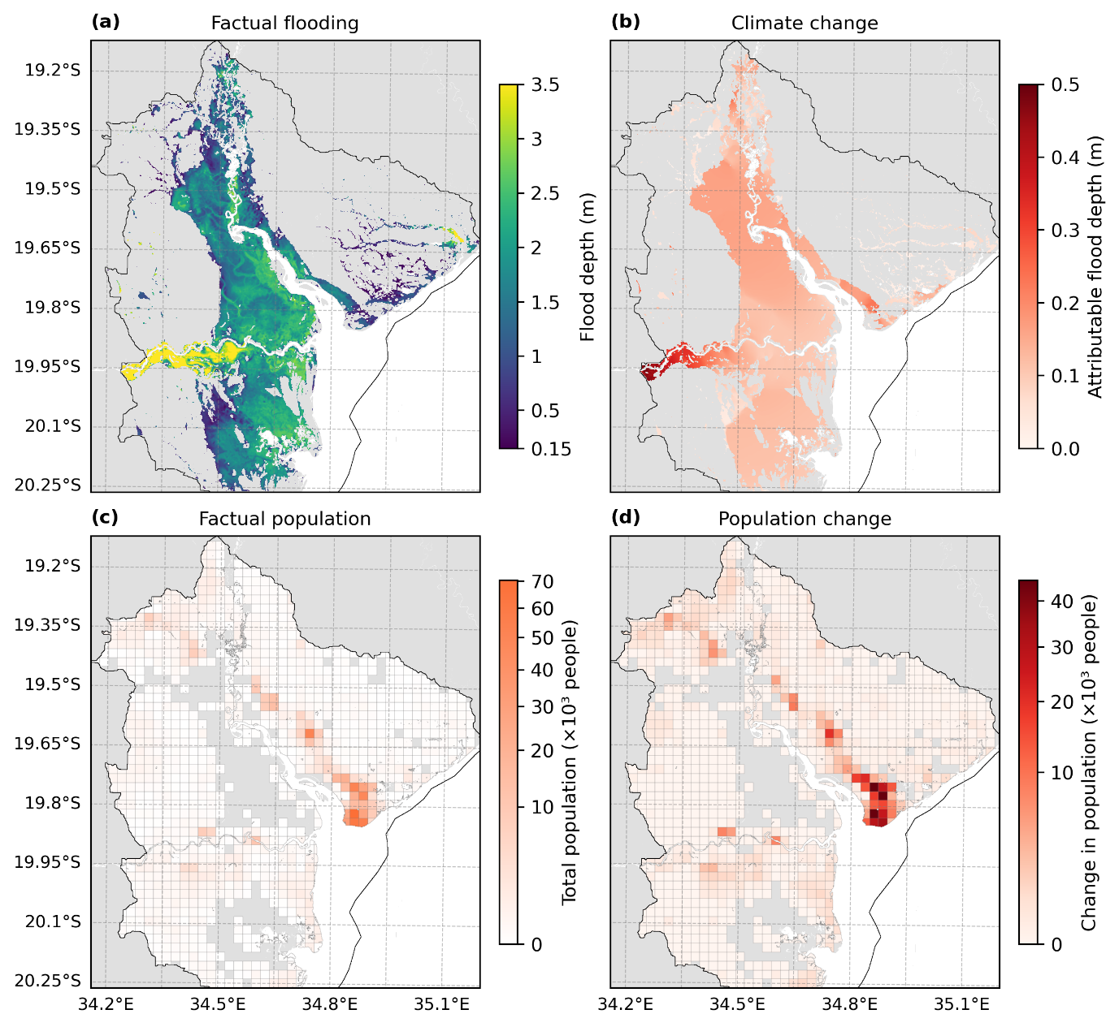
Figure S2: Factual and changed conditions relevant for the exposed population to compound flooding of TC Idai. Panel a shows the factual flood depth in meter from TC Idai, and panel b shows the attributable flood depth to climate change (factual - counterfactual). Panel c shows the factual population living in the case study area, and panel d shows the change in population living in the case study area since 1975 (factual - counterfactual). The compound flood modelling domain is shown in black.

S4. Disaggregated attribution assessments

S4.1 Disaggregation per flood depth category
Table S5: The exposed population per scenario and the attributable fraction to climate and/or population change per flood depth category. The change is expressed as the absolute exposed population, the absolute change in exposed population (factual - counterfactual scenario), and the attributable fraction of the exposed population (%) according to Eq. 1.
 | Aggregated across flood depths
 | Exposed population | Absolute change | Attributable exposed population
Scenario | [nr of people] | [nr of people] | [%]
Factual | 250,490 | - | -
Climate change | 228,599 | 21,891 | 9
Population change | 49,340 | 201,150 | 80
Climate and population change | 40,805 | 209,685 | 84
 | Low flood depth category (0.15 m - 0.5 m)
 | Exposed population | Absolute change | Attributable exposed population
Scenario | [nr of people] | [nr of people] | [%]
Factual | 117,464 | - | -
Climate change | 114,309 | 3,155 | 3
Population change | 30,622 | 86,842 | 74
Climate and population change | 25,370 | 92,094 | 78
 | Moderate-to-high flood depth category (0.5 m - 1.5 m)
 | Exposed population | Absolute change | Attributable exposed population
Scenario | [nr of people] | [nr of people] | [%]
Factual | 117,176 | - | -
Climate change | 102,298 | 14,878 | 13
Population change | 12,767 | 104,409 | 89
Climate and population change | 10,154 | 107,022 | 91
 | Very high flood depth category (> 1.5 m)
 | Exposed population | Absolute change | Attributable exposed population
Scenario | [nr of people] | [nr of people] | [%]
Factual | 15,850 | - | -
Climate change | 11,992 | 3,858 | 24
Population change | 5,951 | 9,899 | 62
Climate and population change | 5,281 | 10,569 | 67

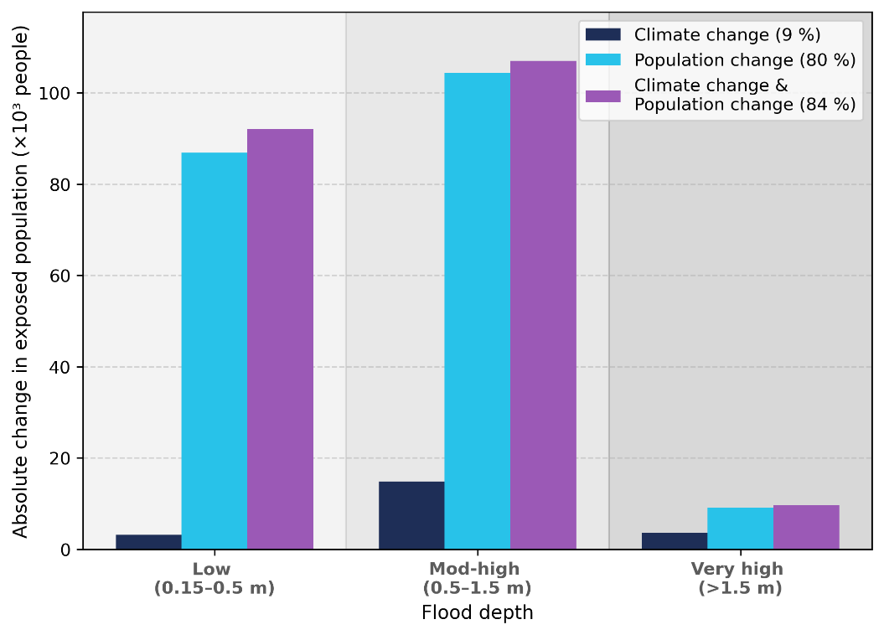
Figure S3: The absolute change (factual - counterfactual) in exposed population due to climate and population change per flood depth category. The dark blue bars show the absolute change in exposed population due to climate change. The light blue bars show the absolute change in exposed population due to population change. The purple bars show the absolute change in exposed population due to climate and population change combined. The attributable fraction per driver is annotated in the legend.
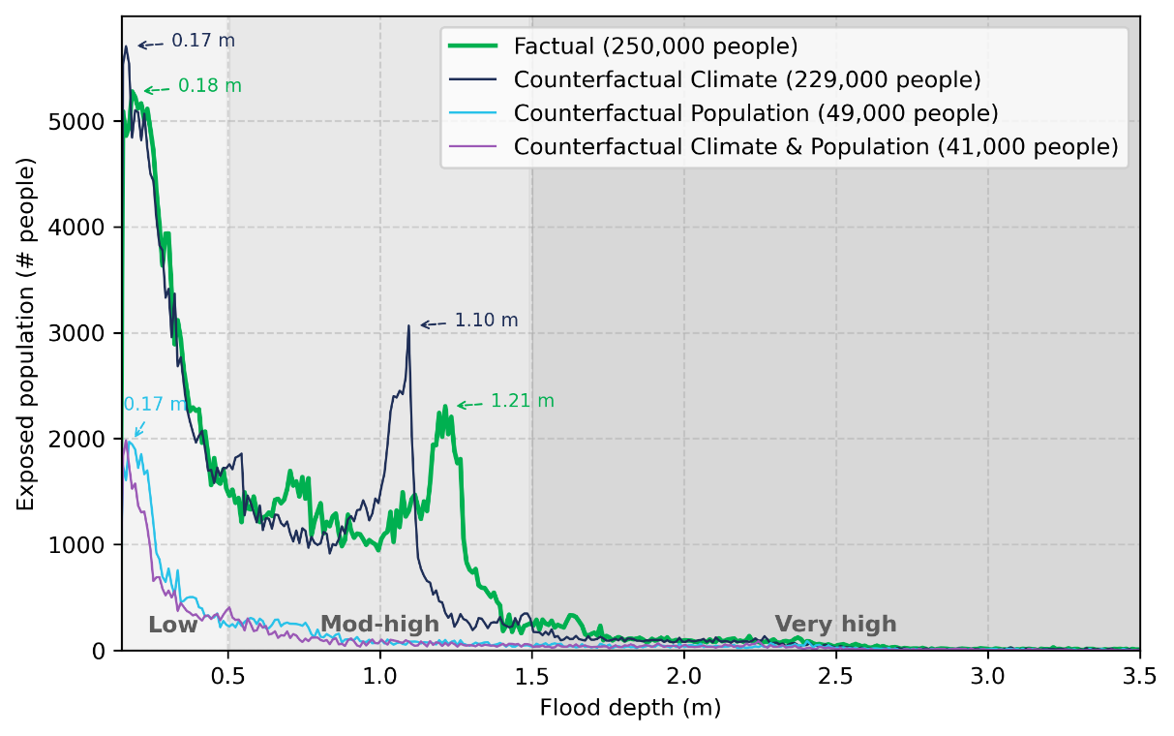
Figure S4: The exposed population per 1 cm flood depth bins for the factual (green) and counterfactual scenarios (dark blue – no climate change; light blue – no population change; purple – no climate and population change). We define 0.15 m – 0.5 m as low flood depth category, 0.5 m – 1.5 m as moderate-to-high flood depth category (abbreviated to Mod-High), and >1.5 m as very high flood depth category. The total exposed population in annotated in the legend per scenario.
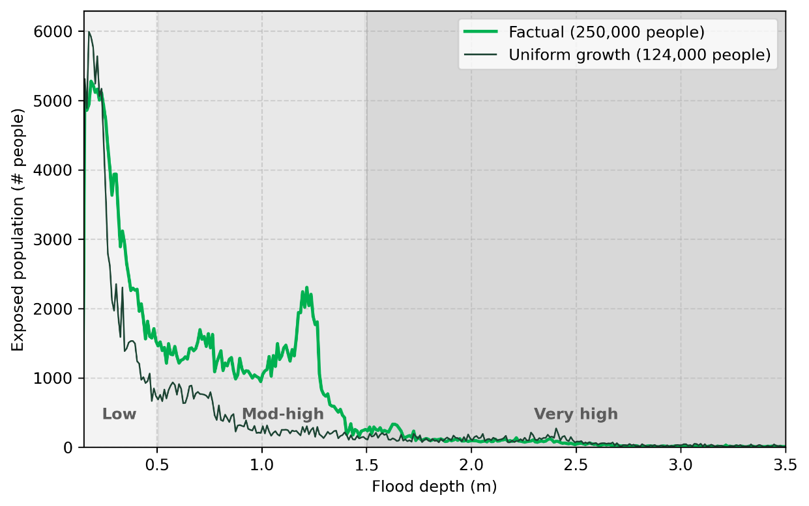
Figure S5: The exposed population per 1 cm flood depth bins for the factual (green) and uniform growth (dark green) scenarios. The total exposed population in annotated in the legend per scenario. We define 0.15 m – 0.5 m as low flood depth category, 0.5 m – 1.5 m as moderate-to-high flood depth category (abbreviated to Mod-High), and >1.5 m as very high flood depth category. We apply the aggregated growth rate between 1975 and 2020 to every cell of the 1975 population, resulting in a total population equal to 2020 but through uniform growth. If population growth would have been spatially uniform, 50 % less people would have been exposed to compound flooding from TC Idai. More people would have been exposed to low flood depths but much less to moderate-to-high flood depths.
Table S6: The change in flood depth category due to climate change among the exposed population in urban and rural areas.
Attributable exposed population
[nr of people]
Flood depth category change | Rural | Urban
No change | 27,141 | 178,862
None à Low | 1,901 | 19,988
None à Mod-high | 10 | -
None à Very high | - | -
Low à Mod-high | 1,363 | 17,364
Low à Very high | - | -
Mod-high à Very high | 907 | 2,952

S4.2 Disaggregation per socio-economic characteristics
Table S7: The population within every socio-economic group and their share per settlement type (rural vs. urban) within the case study area.
Socio-economic |  | Total population | Share within category in rural | Share within category in urban
Category | Group | [nr of people] | [%] | [%]
Wealth | Poorest & Poorer | 72,158 | 36 | 4
Wealth | Middle | 82,412 | 32 | 6
Wealth | Richer & Richest | 704,644 | 32 | 91
Education | < Primary & Primary | 485,993 | 85 | 52
Education | Incomplete secondary | 196,001 | 12 | 25
Education | Secondary & Higher | 177,220 | 3 | 24
Household size | 1 person | 7,744 | 1 | 1
Household size | 2+ people | 851,470 | 99 | 99
Sex | Male | 427,579 | 50 | 50
Sex | Female | 431,635 | 50 | 50
Age | Young (<5) & Elderly (65+) | 127,165 | 18 | 14
Age | 5-64 years | 732,049 | 82 | 86

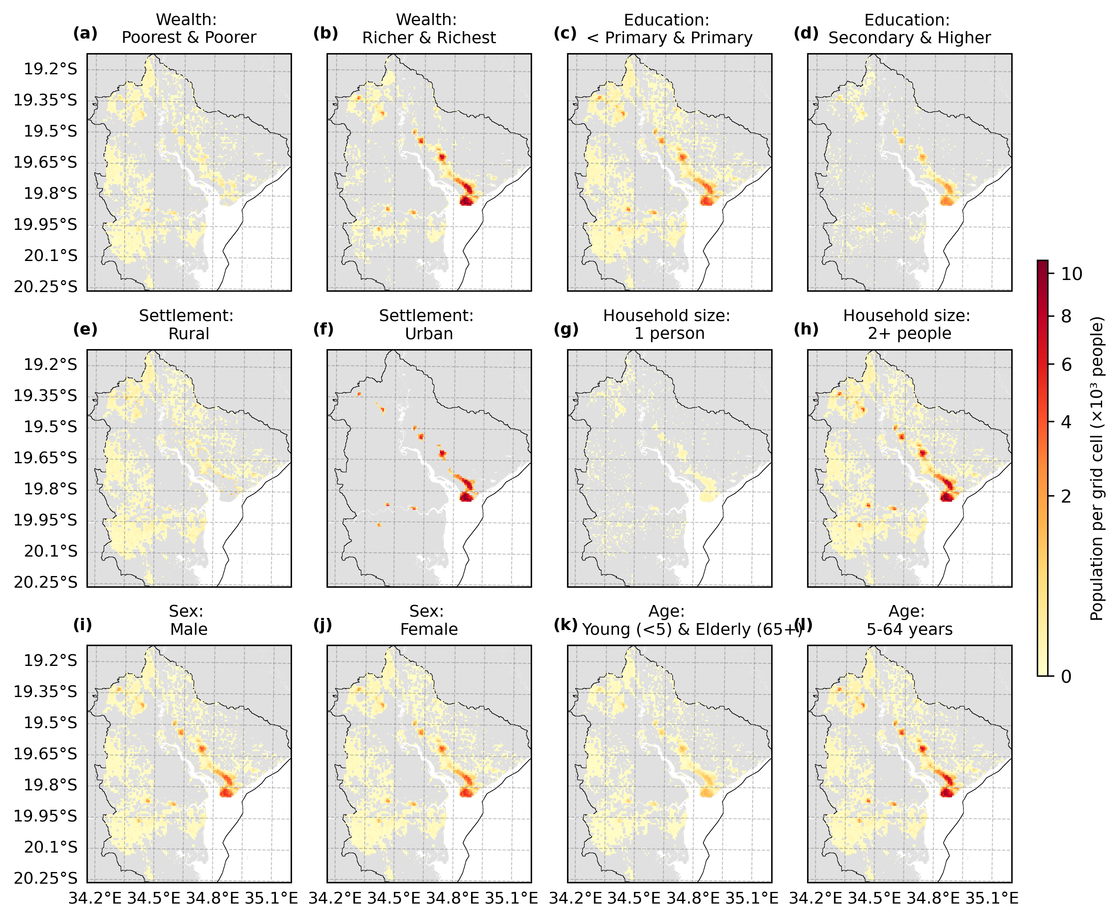Figure S6: The spatial distribution of the socio-economic characteristics of the population grouped for more and less vulnerable groups, based on data from GLOPOP-SG^{10,11}. The resolution of the data is 1 km and the compound flood model region is shown in black.

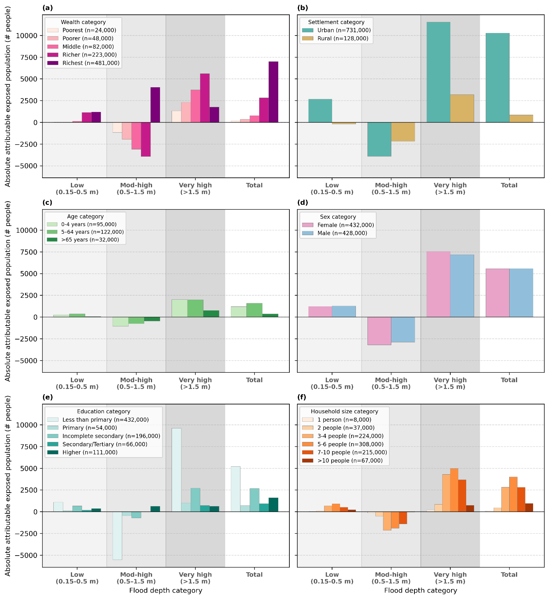
Figure S7: The absolute number of people exposed that is attributed to climate change per socio-economic characteristic and flood depth. The “Total” flood depth category aggregates the attributable fraction over all flood depths and is therefore a binary impact classification. Panel a, b, c, d, e, and f show the attributable fraction per flood depth category and regardless of flood depth (Total) for wealth, settlement type, age, sex, education, and household size, respectively. The total number of people per socio-economic category is annotated in the legend. Low, moderate-to-high (abbreviated to “Mod-high”) and very high flood depths consider 0.15 m – 0.5 m, 0.5 m – 1.5 m, and > 1.5 m, respectively.

References
1. Vertegaal, D. M. et al. Climate and impact attribution of compound flooding induced by tropical cyclone Idai in Mozambique. Natural Hazards and Earth System Sciences 26, 1417–1433 (2026).
2. Copernicus Climate Change Service. Temperature. https://climate.copernicus.eu/climate-indicators/temperature.
3. Knutson, T. et al. Tropical Cyclones and Climate Change Assessment: Part II: Projected Response to Anthropogenic Warming. Bull. Am. Meteorol. Soc. 101, E303–E322 (2020).
4. Treu, S. et al. Reconstruction of hourly coastal water levels and counterfactuals without sea level rise for impact attribution. Earth Syst. Sci. Data 16, 1121–1136 (2024).
5. Pesaresi, M. et al. Advances on the global human settlement layer by joint assessment of earth observation and population survey data. Int. J. Digit. Earth 17, 2390454 (2024).
6. Schiavina M., F. S. , C. A. , M. K. GHS-POP R2023A - GHS population grid multitemporal (1975-2030). Preprint at https://doi.org/10.2905/2FF68A52-5B5B-4A22-8F40-C41DA8332CFE (2023).
7. U.S. Census Bureau. International Database (IDB). https://www.census.gov/data-tools/demo/idb/.
8. Mozambique’s National Institute for Disaster Management (INGC) & International Organisation for Migration Displacement Tracking Matrix (IOM DTM). Mozambique: Tropical Cyclone Idai Baseline Assessment - Sofala Province. ReliefWeb https://reliefweb.int/report/mozambique/mozambique-tropical-cyclone-idai-baseline-assessment-sofala-province-data (2019).
9. Instituto Nacional de Estatística (INE). Sofala - District statistics. https://www.ine.gov.mz/web/guest/d/07-sofala (2025).
10. Ton, M. J. et al. GLOPOP-SG. https://zenodo.org/records/17076088 (2025) doi:10.5281/ZENODO.17076088.
11. Ton, M. J. et al. Spatial 30 arc-second allocation of a global synthetic population using high resolution socio-economic data. Comput. Environ. Urban Syst.
12. World Population Prospects. https://population.un.org/wpp/.

