Supplement of

Assessing Future Water Security in the Upper Main Catchment: A Coupled SWAT+-WEAP Approach

Supplementary Information includes additional details on model calibration, validation, and demand projections: Sections S1 (Hydrological Model Calibration and Validation Details), S2 (Future Agricultural Irrigation Demand Projections), and S3 (Historical Hydrological Model Performance); Figures S1–S8 detailing historical model performance, water availability, supply distribution, and seasonal WEI+ dynamics; and Table S1 summarizing the calibrated model parameters.
SI Text
Section S1. Hydrological Model Calibration and Validation Details
Hydrological calibration and validation of the SWAT+ model were performed to ensure accurate representation of streamflow dynamics at the catchment scale. Calibration and validation were carried out using observed discharge data from the Kemmern gauge (LfU, 2026), which serves as the primary outlet of the modeled basin. The calibration was performed for the historical period of (2008-2014), followed by an independent validation over the time-period 2015-2019. Additionally, simulated evapotranspiration (ET) and mean annual recharge were evaluated against independent reference datasets, including ERA5 ET (Hersbach et al., 2023) and regional recharge estimates (Bayerischer Landtag, 2020), over the historical period 2008-2014. The simulated inflows in two channels to the reservoir were also calibrated at a monthly resolution in the isolated model.
Parameter selection for calibration was informed by a prior sensitivity analysis conducted using the Morris method in SPOTPY (Houska et al., 2015). Based on their influence on streamflow, a subset of hydrological parameters was selected for calibration, including parameters controlling surface runoff, snow, soil water processes and groundwater flow (Table S1).
Bayesian calibration was performed using the Differential Evolution Adaptive Metropolis (DREAM) algorithm implemented in the SPOTPY framework (Houska et al., 2015). DREAM is a multi-chain Markov Chain Monte Carlo (MCMC) algorithm that enables efficient exploration of the parameter space and estimation of posterior parameter distributions. Multiple chains were run to ensure robust convergence and to capture parameter uncertainty (Houska et al., 2015). The calibration process was further conducted manually and iteratively, with parameter ranges refined based on intermediate results, to improve model performance and ensure physically realistic parameter values. This refinement process allowed optimization of parameters and improved representation of key hydrological processes within the catchment.

Section S2. Future Agricultural Irrigation Demand Projections
Projected annual irrigation demand was obtained from Heilemann et al. (2025), which incorporates farmers’ adaptive land-use decisions. The demand data is a product of a hydro-economic multi-agent system (MAS) model, scenario-based price projections from the SSPs, and a machine learning crop yield model (Heilemann et al., 2025). A known limitation of utilizing this dataset in our framework is the use of SSP3-8.5 projection as a proxy for SSP3-7.0. Furthermore, the agricultural dataset simulates irrigation investment decisions at decadal time steps. Consequently, if a high share of land is equipped with irrigation infrastructure at the start of a decade, the demand exhibits sharp initial spikes. The monthly variations were assumed constant within defined time slices historical (2007–2019), near-future (2041–2060), and far-future (2081–2100). The variations were calculated using the basin-averaged potential evapotranspiration regime from the SWAT+ model. The agricultural consumption rate was determined using Irrigation efficiency rates of sprinkler (FAO, 1989), which aligns with the projection dataset used (Heilemann et al., 2025).

Section S3. Historical Hydrological Model Performance
The calibrated and validated SWAT+ model reproduced the observed discharge dynamics at the catchment outlet, namely the Kemmern Station, reasonably well and captured both the seasonal variability and the major flow peaks over the calibration period (Fig. S2a). The performance statistics indicate a good overall fit, with NSE of 0.65, logNSE of 0.74, KGE of 0.81, and PBIAS of -3.89% during the calibration period. Although some peak flows were over- or under-estimated and a few extreme events were not matched perfectly, the model was able to represent the general timing and magnitude of discharge fluctuations satisfactorily. Additional validation against independent datasets showed that simulated evapotranspiration reproduced the seasonal dynamics and overall magnitude of ERA5 evapotranspiration well (NSE = 0.85, KGE = 0.87, and PBIAS = 0.31; Fig. S3), while simulated multi-annual mean groundwater recharge was consistent with the available reference value. These additional evaluations complement the discharge-based calibration and indicate that the model not only captures streamflow behavior at the outlet but also represents important water balance components realistically. The WEAP model reproduced the SWAT-simulated discharge at Kemmern well (Fig. S2b), demonstrating a consistent transfer of hydrological information from SWAT+ to the water management model and confirming that the coupled SWAT+–WEAP framework is robust for assessing future water availability in the catchment.

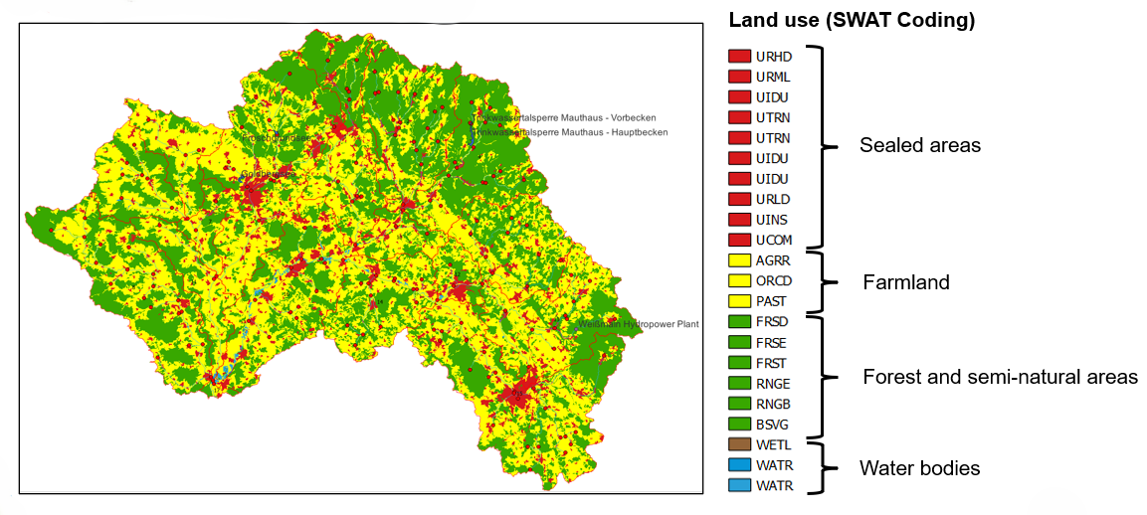
Fig. S1. Land Use Distribution from CORINE Land Cover 2018 (European Environment Agency, 2019) used for model delineation. The AGRR is further discretized to different crop types based on data from InVeKoS (Bayerisches Staatsministerium für Ernährung, Landwirtschaft und Forsten, 2024).
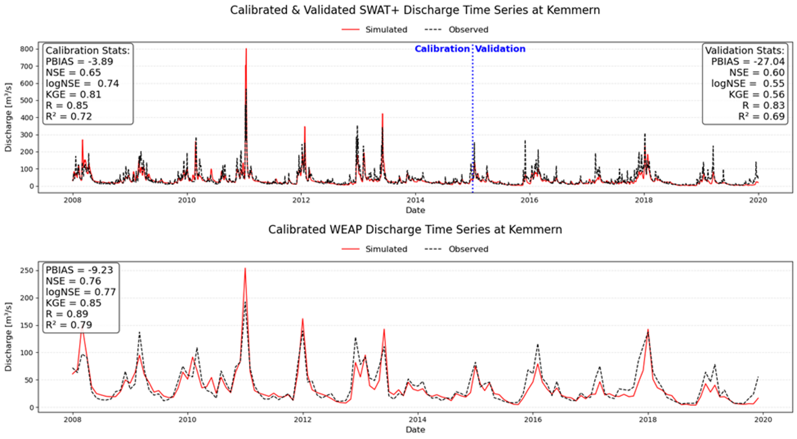
Fig. S2. Comparison of observed and simulated discharge time series at Kemmern for (a) the calibrated and validated SWAT+ model and (b) the WEAP allocation model.

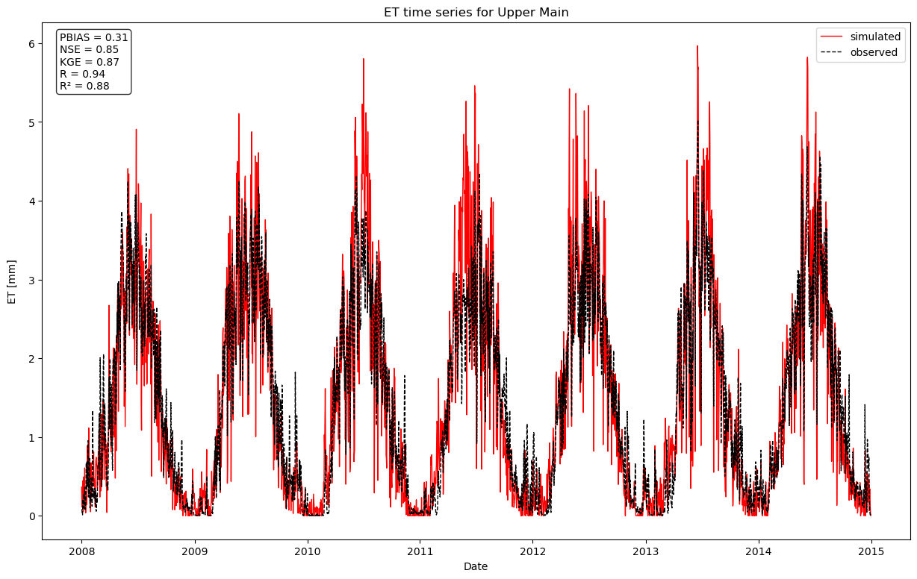
Fig. S3. Comparison of observed and simulated basin-averaged evapotranspiration time series for the calibrated SWAT+ model.
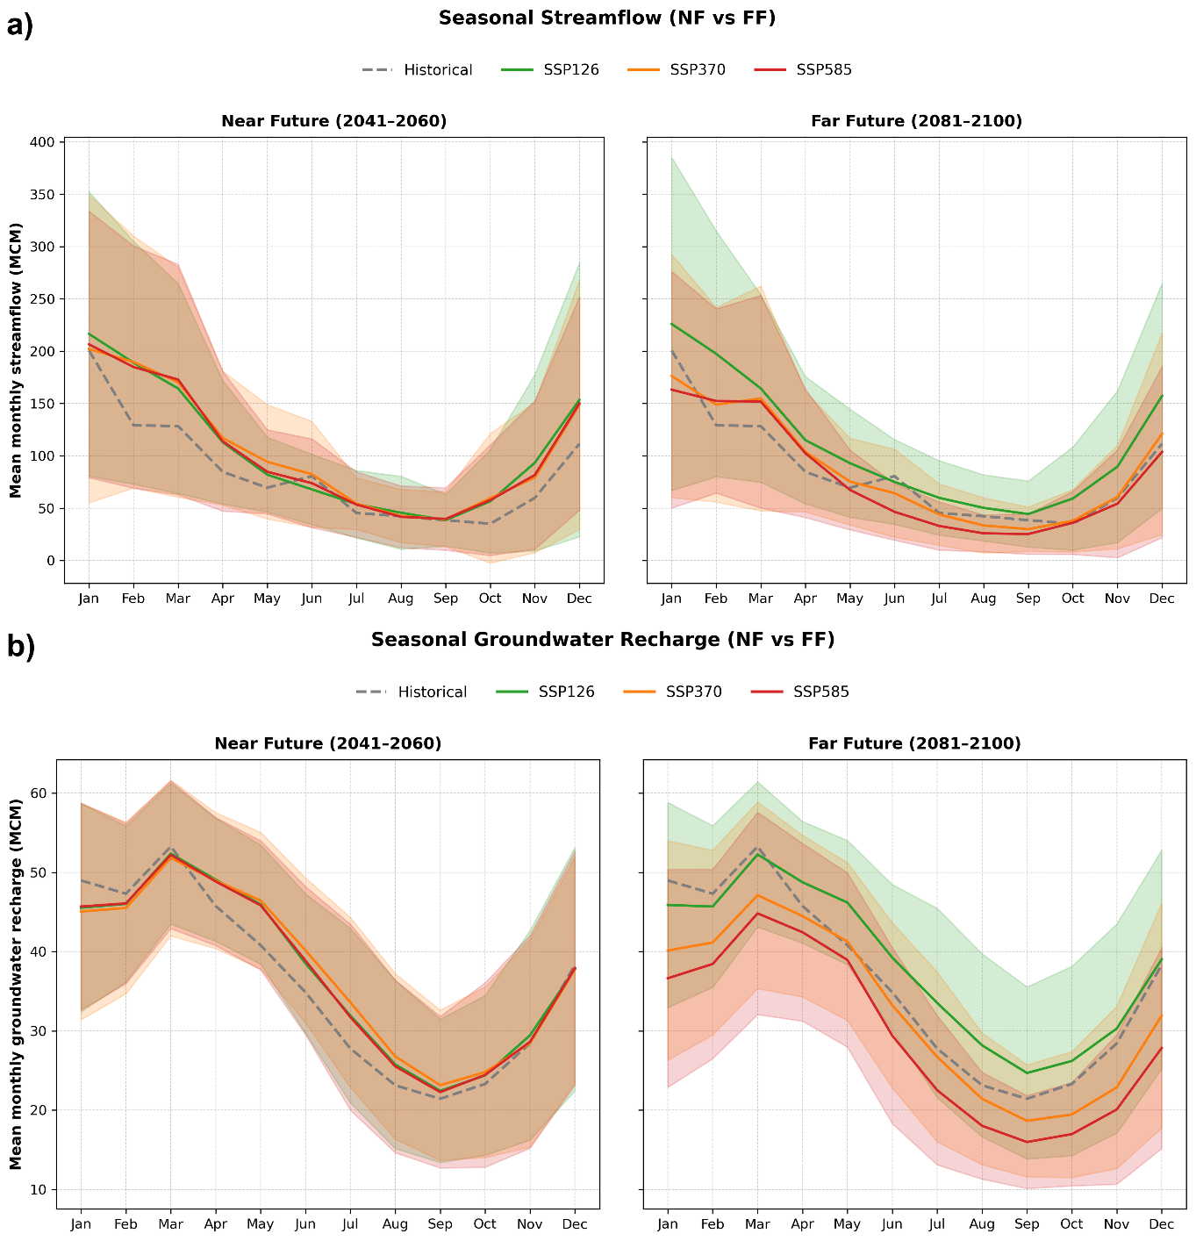
Fig. S4. Projected changes in streamflow and groundwater recharge in the Upper Main catchment. Seasonal patterns of (a) streamflow and (b) groundwater recharge are shown for the near future (2041–2060) and far future (2081–2100). Solid lines indicate scenario ensemble means, shaded areas indicate the scenario range, and the dashed grey line represents the historical reference period. Units are million m³.
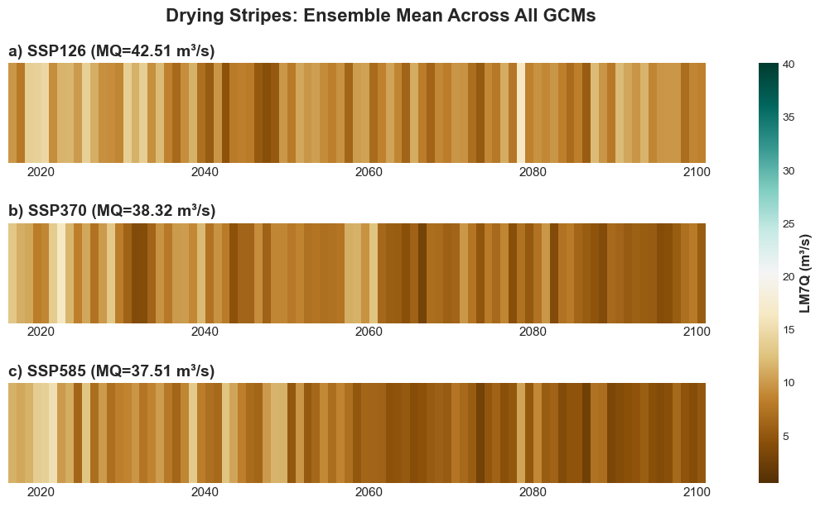
Fig. S5. Annual 7-day minimum discharge (LM7Q) averaged across the five climate model runs for SSP scenarios, represented as drying stripes.

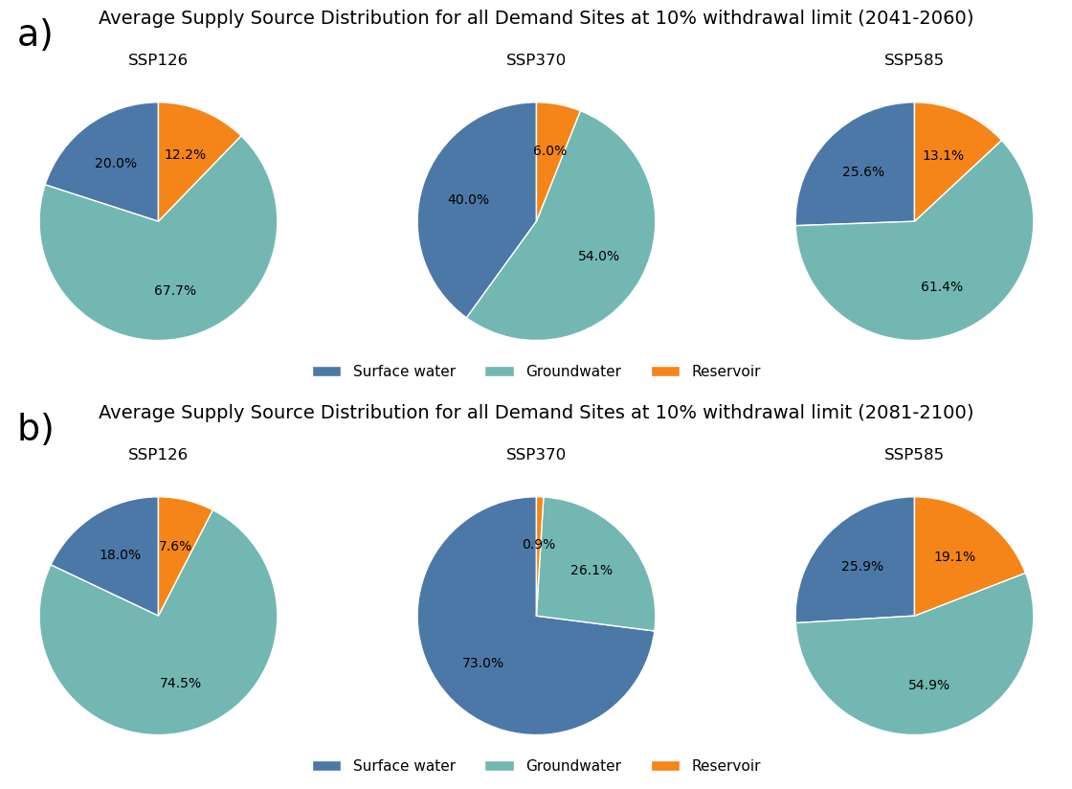
Fig. S6. Average supply source distribution under 10% groundwater withdrawal limit, showing share of total water supply sources under SSP1-2.6, SSP3-7.0, and SSP5-8.5 averaged across the five climate model runs.

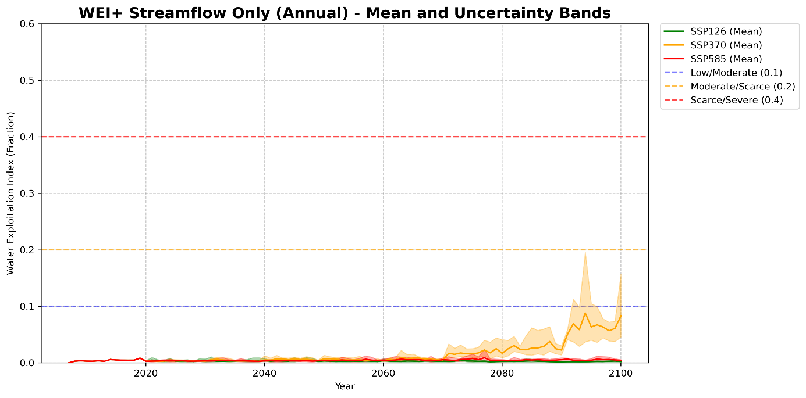
Fig. S7. Multi-model ensemble projections of annual Water Exploitation Index Plus (WEI+) under SSP1-2.6, SSP3-7.0, and SSP5-8.5 scenarios. Continuous annual time series (2007–2100) displaying ensemble means (solid lines) and min-max uncertainty ranges (shaded bands).

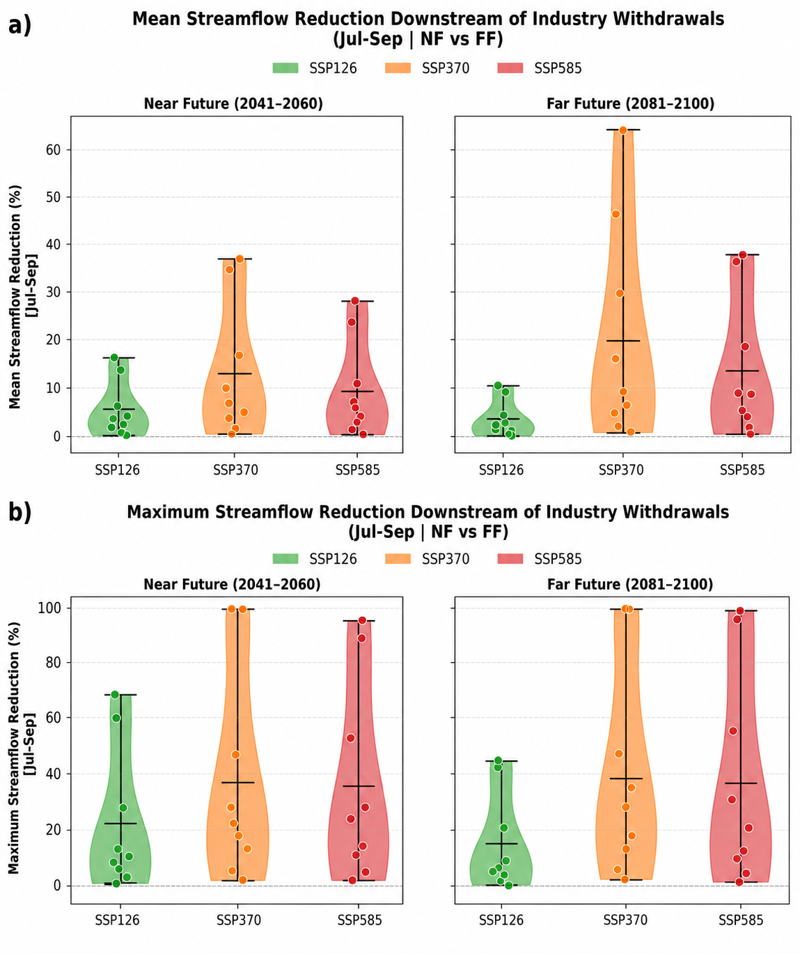
Fig. S8. Local streamflow reductions downstream of industrial withdrawals during July–September. Violin plots show the distribution of (a) mean and (b) maximum streamflow reduction downstream of selected industrial abstraction nodes for the near future (2041–2060) and far future (2081–2100) under SSP1-2.6, SSP3-7.0, and SSP5-8.5. Points indicate individual abstraction nodes, black horizontal lines indicate the mean across nodes, and whiskers indicate the range.

Table S1 Summary of streamflow calibration parameters, including parameter ranges, implemented change types in the SWAT+ model, and the final calibrated values or adjustments. “absval” denotes replacement by an absolute parameter value, whereas “abschg” denotes an absolute change added to the initial parameter value.
Parameter | Description | Minimum | Maximum | Change Type | Final Value/Adjustment
cn2 | Curve Number for Hydrological Soil Group A/B/C/D | 30 | 100 | abschg | 12.039
cn3_swf | Soil water adjustment factor for CN3 | 0 | 1 | absval | 0.842
epco | Plant uptake compensation factor | 0.01 | 1 | absval | 0.950
esco | Soil evaporation compensation factor | 0.01 | 1 | absval | 0.115
perco | Percolation coefficient | 0 | 1 | absval | 0.322
canmx | Maximum canopy storage | 0 | 100 | absval | 2.733
surlag | Surface runoff lag coefficient | 1 | 24 | absval | 8.973
awc | Available water capacity of the soil layer | 0.01 | 1 | abschg | 0.183
k | Saturated hydraulic conductivity of the soil layer | 0.0001 | 2000 | abschg | -2.342
bd | Moist bulk density of the soil layer | 0.9 | 2.5 | abschg | 0.455
alpha | Alpha factor for groundwater recession curve | 0 | 1 | absval | 0.360
flo_min | Threshold depth from surface to water table for groundwater flow to occur | 0 | 10 | absval | 5.489
snomelt_tmp | Snow melt base temperature | -5 | 5 | absval | -0.867
snofall_tmp | Snowfall temperature | -5 | 5 | absval | 2.655
snomelt_min | Melt factor for snow on December 21 | 0 | 10 | absval | 2.905
petco | Linear adjustment factor for PET equations | 0.8 | 1.2 | absval | 1.011
chk | Effective hydraulic conductivity of the channel alluvium | -0.01 | 500 | absval | 0.350

References
Bayerischer Landtag (2020) Grundwasserneubildung in Oberfranken.
Bayerisches Staatsministerium für Ernährung LuFS (2024) InVeKoS – Integriertes Verwaltungs- und Kontrollsystem.
European Environment Agency (2019) CORINE Land Cover 2018 (vector), Europe, 6-yearly - version 2020_20u1, May 2020. European Environment Agency.
Food and Agriculture Organization (1989) Irrigation Water Management: Irrigation Scheduling, https://www.fao.org/4/t7202e/t7202e00.htm.
Heilemann J, Nagpal M, Werner S et al. (2025) Scenario projections of future irrigation water demand for field crops in Germany considering farmers’ adaptive land use. Agricultural Water Management 318, DOI:10.1016/j.agwat.2025.109699.
Hersbach H, Bell B, Berrisford P et al. (2023) ERA5 hourly data on single levels from 1940 to present. in (C3S) CCCS (ed.). Climate Data Store (CDS), DOI:10.24381/cds.adbb2d47.
Houska T, Kraft P, Chamorro-Chavez A, Breuer L (2015) SPOTting Model Parameters Using a Ready-Made Python Package. PLoS One 10:e0145180, DOI:10.1371/journal.pone.0145180.
LfU Bayerische Landesamt für Umwelt (2026) Gewässerkundlicher Dienst Bayern: Pegel Kemmern (24010004), https://www.gkd.bayern.de/de/fluesse/abfluss/bayern/kemmern-24010004.

