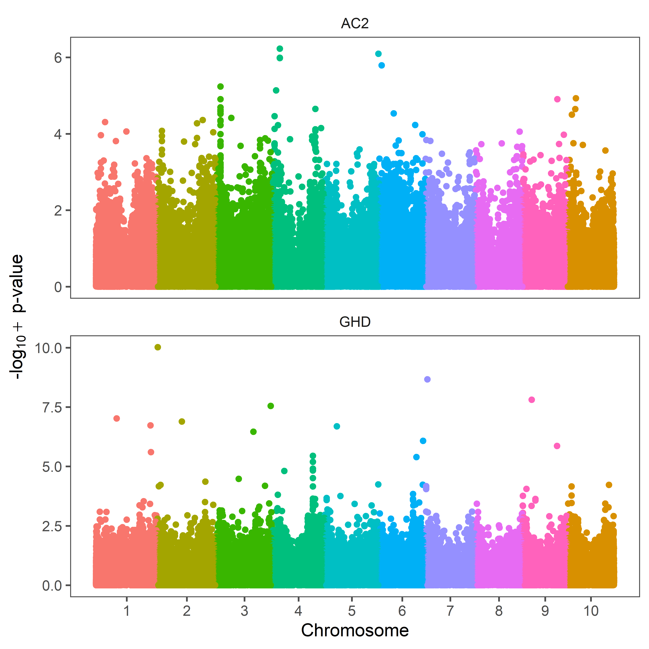

Supplementary Fig. S2. GWAS across 281 Sorghum Association Panel (SAP) accessions using 191,738 SNP markers. Manhattan plots showing significant false discovery rate (FDR) adjusted p-value ≤ 0.05 associated with AC2 Aphid count for second-rating dates and greenhouse damage (GHD) rating using single-run FarmCPU. Y-axis represents -log10 (raw) p-value and x-axis represents sorghum chromosome.

