Table 1: Evaluation of Deleteriousness and Pathogenicity of MCL-1 Missense Variants using SIFT, PolyPhen-2, PROVEAN, SNPs&GO, PANTHER
Mutations | Polyphen-2 | SIFT | PROVEAN | SNPs&GO | PANTHER
R215G | 0.989 | 0.013 | -5.09 | 0.535 | 0.677
R215G | DAMAGING | DAMAGING | DELETERIOUS | DISEASE | DISEASE
V216G | 0.996 | 0 | -5.38 | 0.468 | 0.685
V216G | DAMAGING | DAMAGING | DELETERIOUS | NEUTRAL | DISEASE
L235Q | 0.999 | 0 | -5.15 | 0.537 | 0.759
L235Q | DAMAGING | DAMAGING | DELETERIOUS | DISEASE | DISEASE
R263S | 1 | 0 | -5.94 | 0.821 | 0.735
R263S | DAMAGING | DAMAGING | DELETERIOUS | DISEASE | DISEASE
G271D | 0.991 | 0.001 | -4.53 | 0.698 | 0.739
G271D | DAMAGING | DAMAGING | DELETERIOUS | DISEASE | DISEASE
W305G | 1 | 0 | -12.08 | 0.82 | 0.832
W305G | DAMAGING | DAMAGING | DELETERIOUS | DISEASE | DISEASE
G311D | 0.991 | 0 | -4.91 | 0.579 | 0.47
G311D | DAMAGING | DAMAGING | DELETERIOUS | DISEASE | NEUTRAL

Table 2 Refinement and Validation of Protein Stability and Flexibility of MCL-1 Missense Variants
Mutations | I-mutant2.0 | MUpro | SAAFEC | iStable
R215G | -1.6 | -1 | -1.32 | 0.753
R215G | Decrease | Decrease | Destabilizing | Decrease
V216G | -3.54 | -0.867 | -1.95 | 0.756
V216G | Decrease | Decrease | Destabilizing | Decrease
L235Q | -2.16 | -1 | -1.23 | 0.74
L235Q | Decrease | Decrease | Destabilizing | Decrease
R263S | -2.98 | -1 | -1.29 | 0.726
R263S | Decrease | Decrease | Destabilizing | Decrease
G271D | -1.6 | 0.636 | -1.17 | 0.68
G271D | Decrease | Increase | Destabilizing | Decrease
W305G | -2.27 | -1 | -2.5 | 0.664
W305G | Decrease | Decrease | Destabilizing | Decrease
G311D | -1.65 | -0.004 | -1.63 | 0.751
G311D | Decrease | Decrease | Destabilizing | Decrease

Table 3: Assessment of Structure Based Stability of Seven Most Significant MCL-1 Missense Mutation using mCSM and DynaMut2.
Mutations | mCSM | DynaMut2
R215G | -0.763  Destabilizing | -1.15  Destabilizing
V216G | -2.35  Highly Destabilizing | -2.28  Destabilizing
L235Q | -1.513  Destabilizing | -1.6  Destabilizing
R263S | -1.832  Destabilizing | -1.59  Destabilizing
G271D | -1.681  Destabilizing | -1.68  Destabilizing
W305G | -2.818  Highly Destabilizing | -2.9  Destabilizing
G311D | -1.028  Destabilizing | -1.04  Destabilizing

Table 4: Prediction of Mutational Effects on MCL-1 Protein Structure With Meta RNN Score Using HOPE Server to Identify Pathogenic Variants
Variant | Mutation Size & Structure | MetaRNN score
R215G | 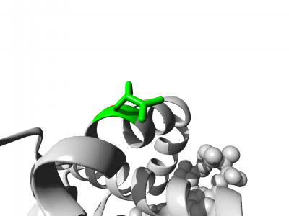  Smaller | 0.956  Pathogenic
V216G | 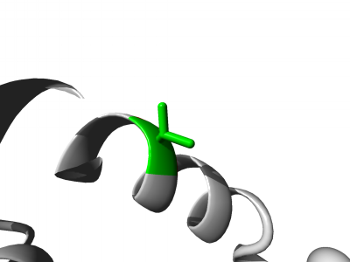  Smaller | 0.862  Pathogenic
L235Q | 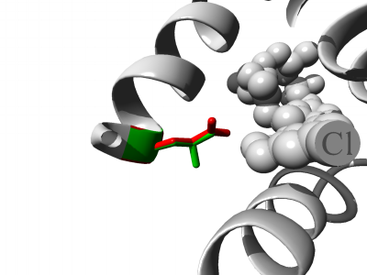  Larger | 0.948  Pathogenic
R263S | 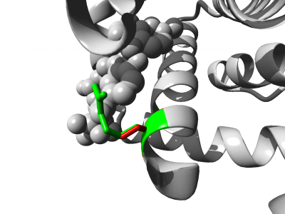  Smaller | 0.951  Pathogenic
G271D | 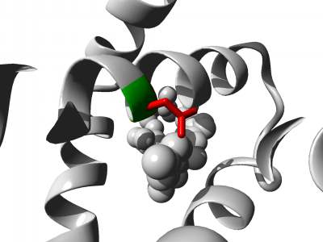  Larger | 0.941  Pathogenic
W305G | 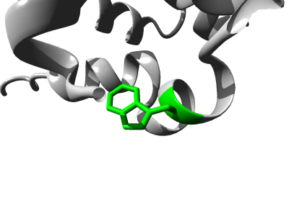  Smaller | 0.958  Pathogenic
G311D | 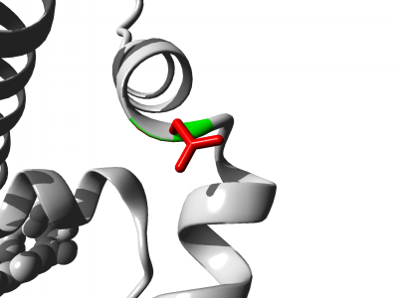  Larger | 0.982  Pathogenic

Table 5: Analysis of Docking Interaction Between Seven Identified High Risk Mutated MCL-1 and Wild type BAK in Comparison with Wild type MCL-1 and Wild type BAK
Docking  Tools → | HADDOCK  (Score) | HDOCK  (Negative  docking  score) | HDOCK  Ligand  RMSD (Å) | ClusPro  (Center Weighted  score) | PPA_PRED2  ΔG (binding  free energy) | PPA_PRED2  Kd(dissociation  constant) | PRODIGY  (ΔG)
Wild type  MCL-1 | 233.5 +/- 34.5 | -251.41 | 48.03 | -672.2 | -16.17  kcal/mol | 1.38e-12 M | -12.8
R215G | 288.1 +/- 14.0 | -267.93 | 34.82 | -769.2 | -16.18  kcal/mol | 1.36e-12 M | -13.6
V216G | 236.4 +/- 26.1 | -266.81 | 34.97 | -669.4 | -16.35  kcal/mol | 1.01e-12 M | -15.6
L235Q | 284.8 +/- 9.0 | -268.85 | 34.92 | -748.9 | -16.28  kcal/mol | 1.14e-12 M | -13.8
R263S | 278.0 +/- 9.6 | -268.59 | 34.89 | -689.9 | -16.23  kcal/mol | 1.26e-12 M | -14.9
G271D | 248.1 +/- 39.1 | -260.82 | 34.94 | -706.2 | -16.23  kcal/mol | 1.25e-12 M | -14.2
W305G | 210.5 +/- 11.9 | -264.82 | 34.89 | -651.8 | -16.22  kcal/mol | 1.27e-12 M | -11.4
G311D | 211.4 +/- 7.1 | -267.53 | 34.92 | -639.2 | -16.23  kcal/mol | 1.25e-12 M | -11.5

