Supplementary Information

Efficient ethylene purification by a robust ethane-trapping porous organic cage
Kongzhao Su^{1,2,4}, Wenjing Wang^{1,4}, Shunfu Du^{1,3}, Chunqing Ji^{1,2} & Daqiang Yuan^{1,2,*}
¹State Key Laboratory of Structure Chemistry, Fujian Institute of Research on the Structure of Matter, Chinese Academy of Sciences, Fuzhou, 350002 Fujian, China
²University of the Chinese Academy of Sciences, Beijing, 100049, China
³College of Chemistry, Fuzhou University, Fuzhou, 350116, China
⁴These authors contributed equally
Corresponding author. E-mail address: ydq@fjirsm.ac.cn (D.Q. Yuan).

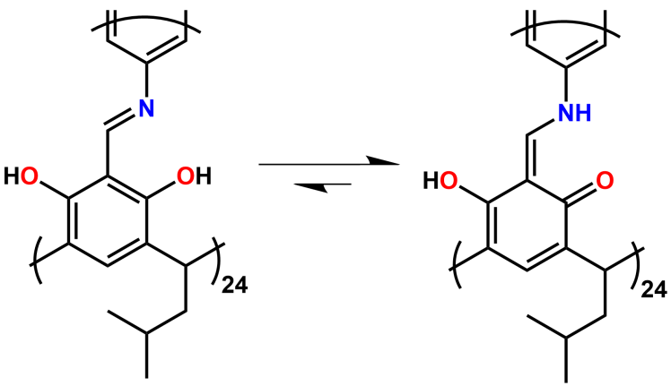
Supplementary Fig. 1 Keto–enol tautomerization within CPOC-1.

Supplementary Fig. 2 ¹HNMR of CPOC-1 (CDCl₃, 400 MHz, 298 K).

Supplementary Fig. 3 FT-IR spectra of CPOC-1.

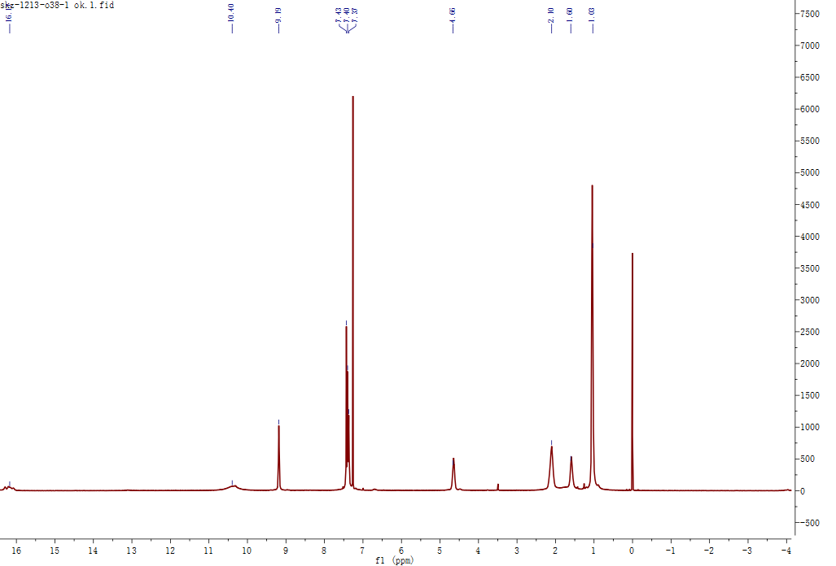
Supplementary Fig. 4 ¹HNMR of CPOC-1 after storing in air for half a year (CDCl₃, 400 MHz, 298 K).
Supplementary Fig. 5 TGA curve of CPOC-1.

Supplementary Fig. 6 PXRD pattern of CPOC-1.
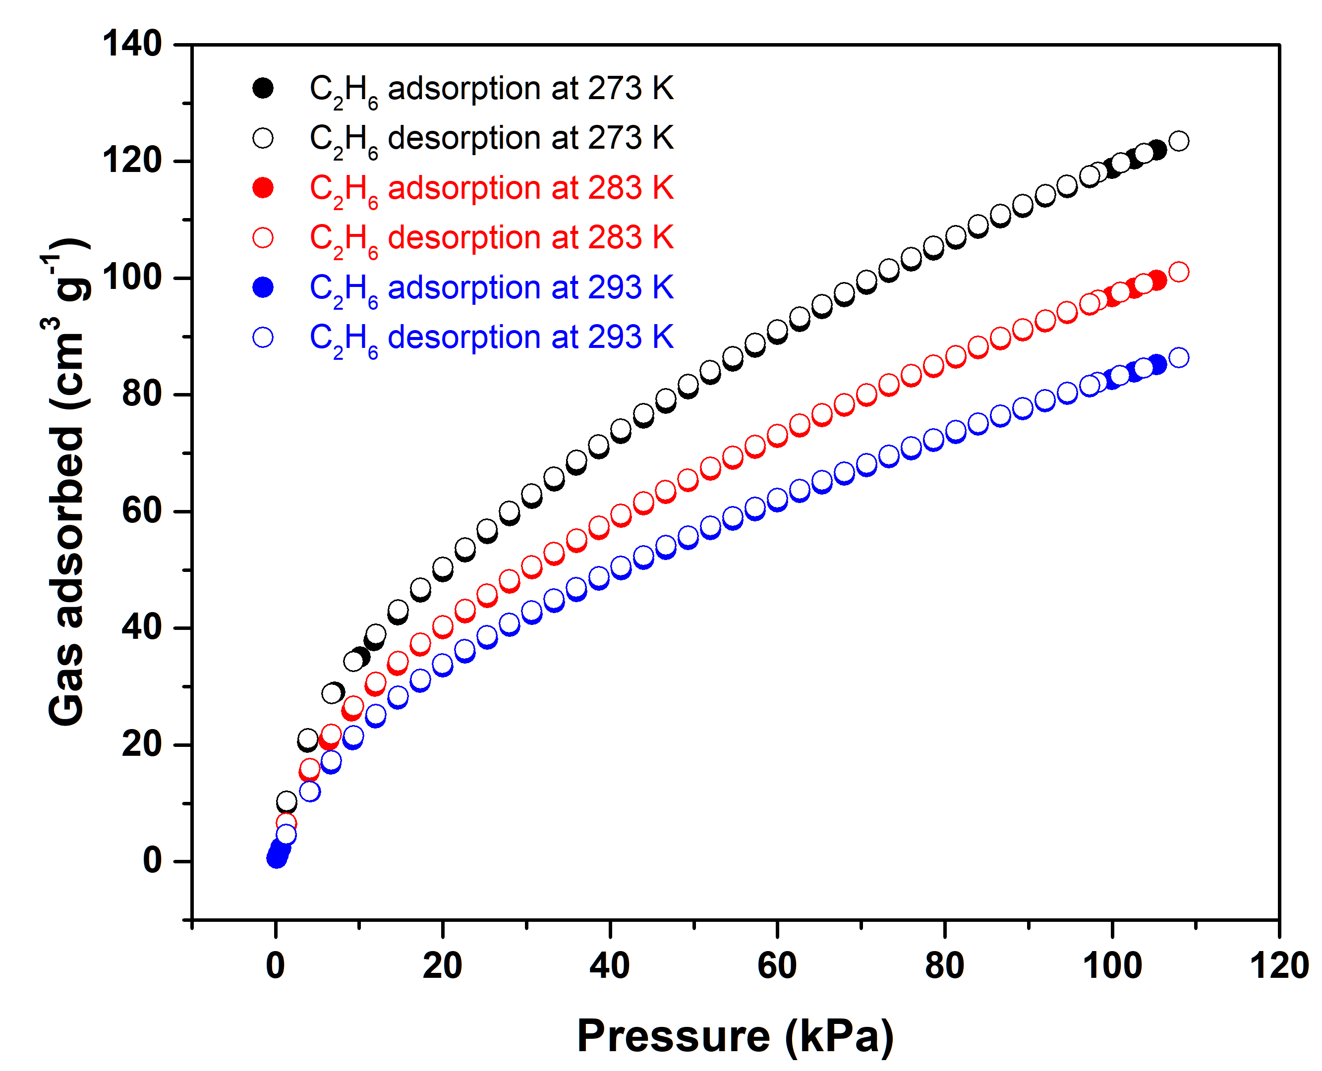
Supplementary Fig. 7 C₂H₆ adsorption/desorption isotherm of CPOC-301 at 273, 283 and 293 K.
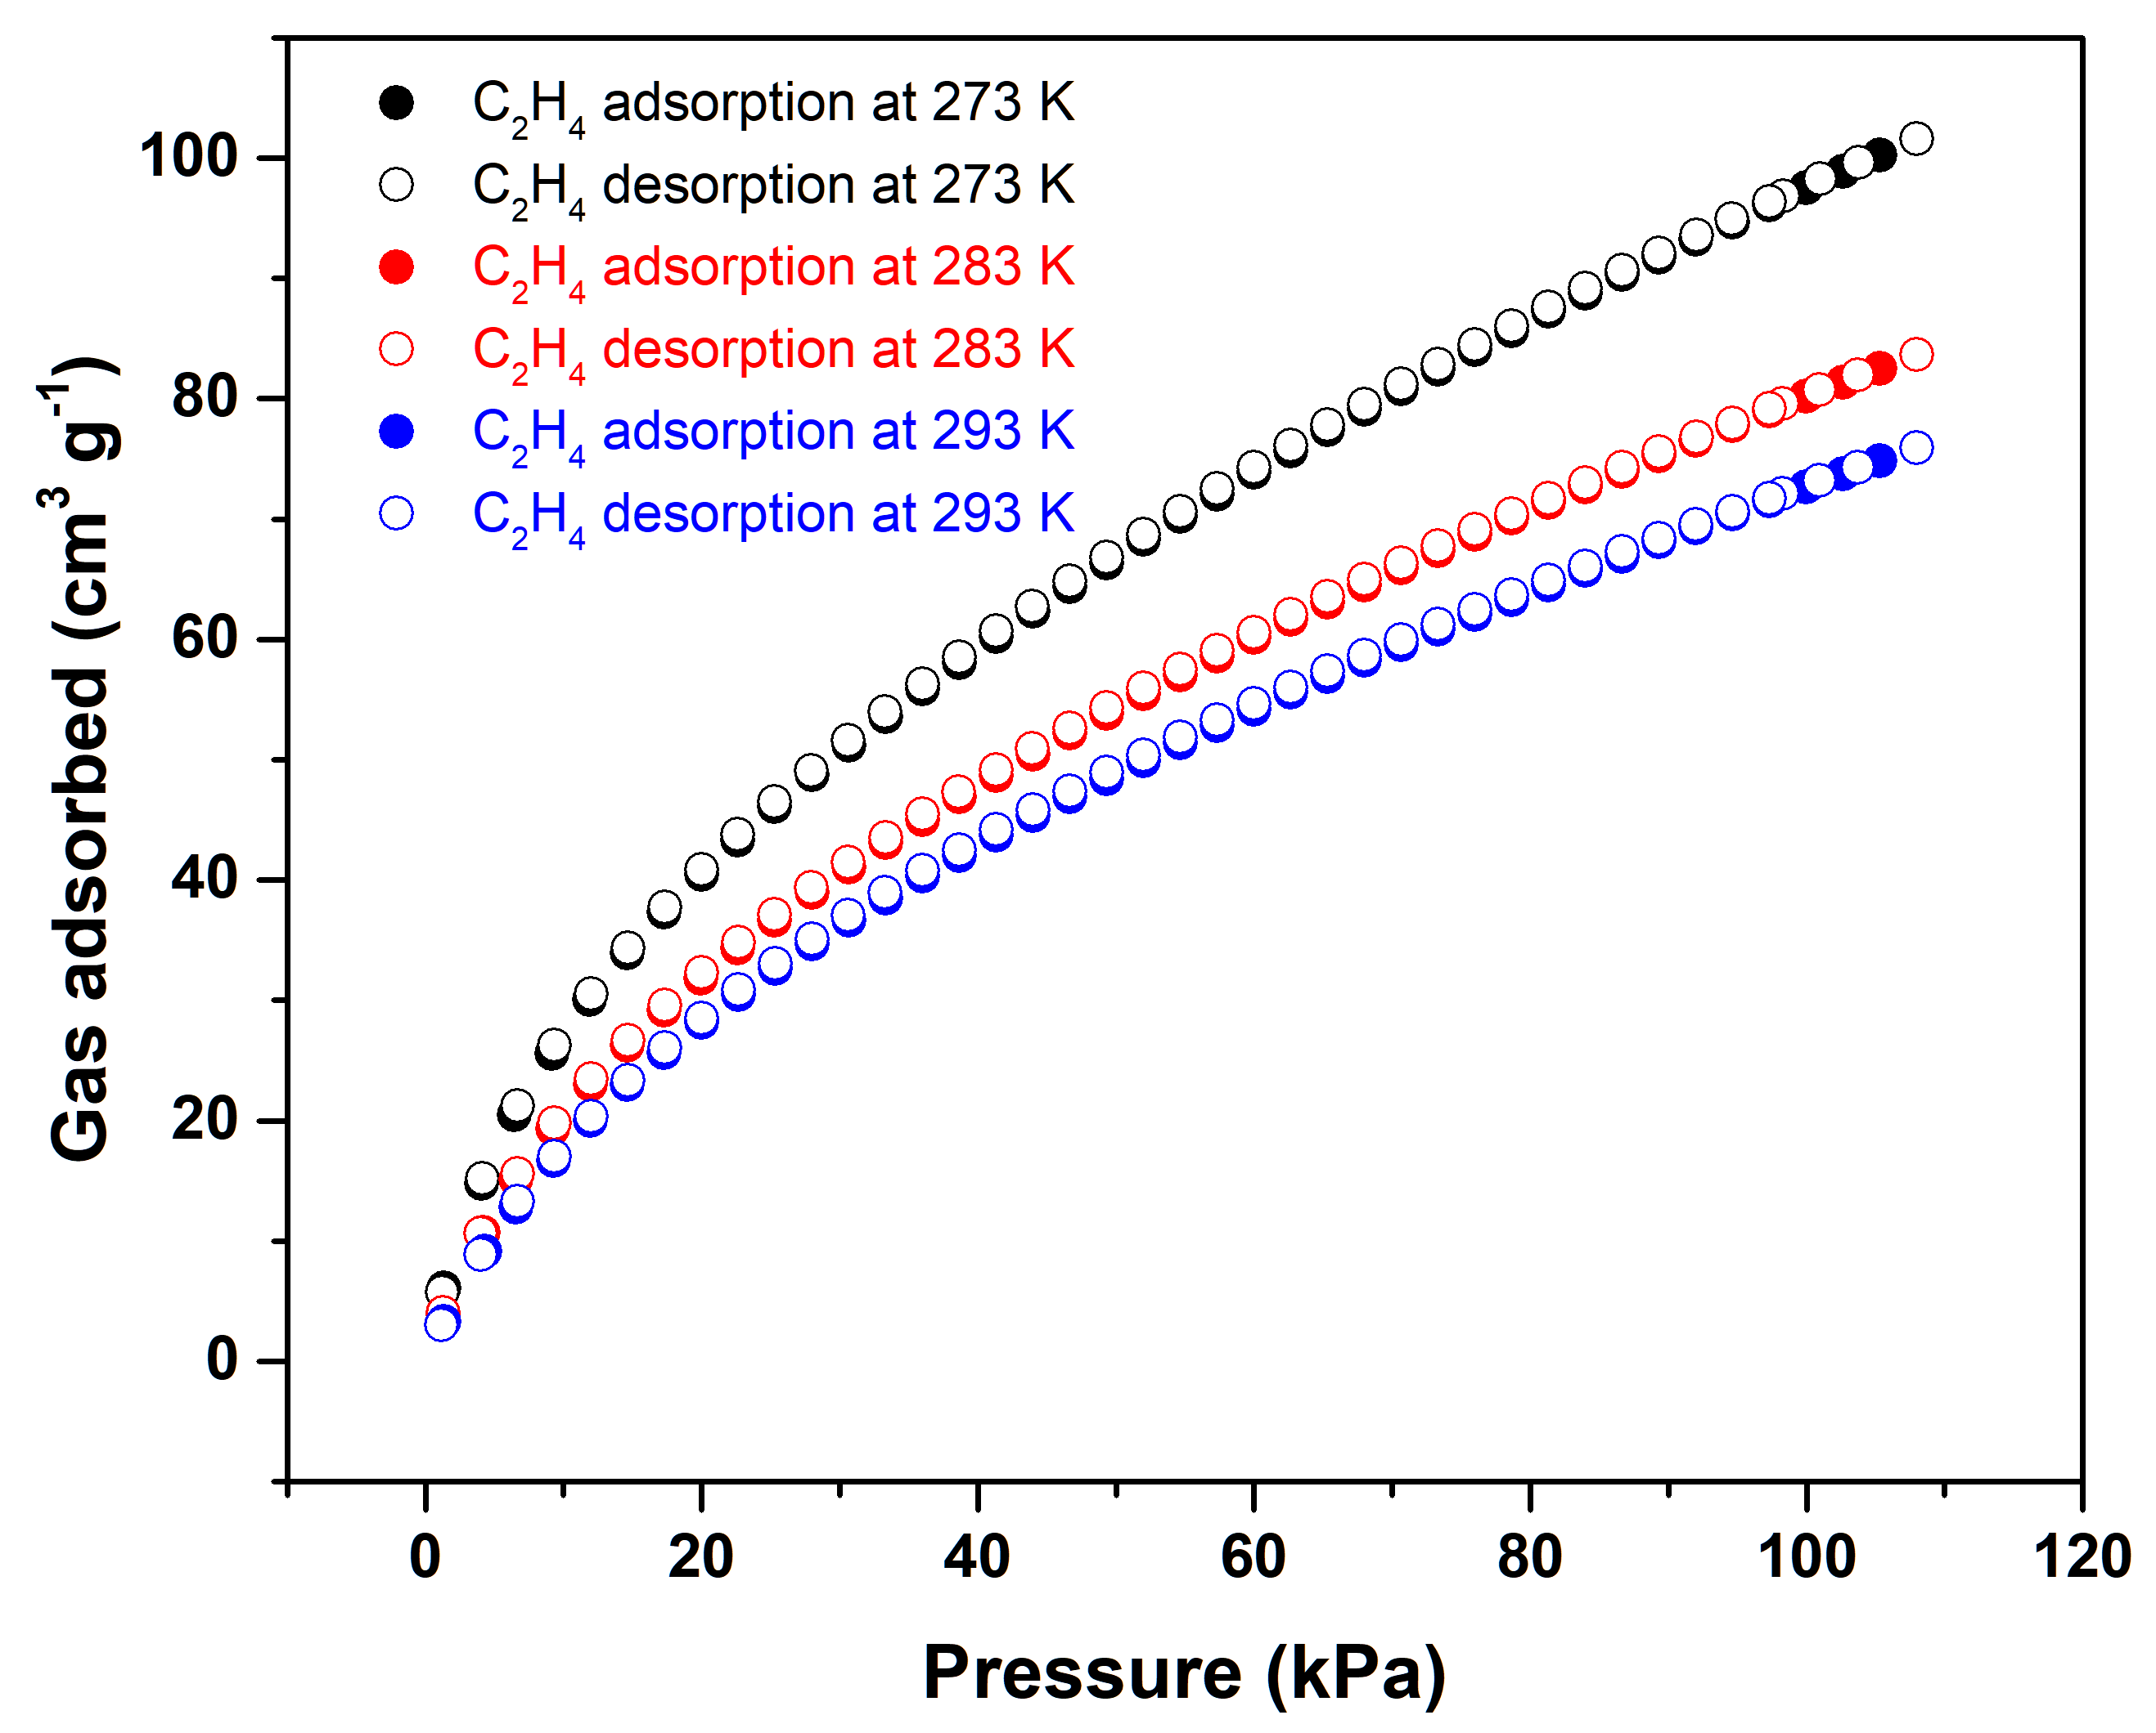
Supplementary Fig. 8 C₂H₄ adsorption/desorption isotherm of CPOC-301 at 273, 283 and 293 K.

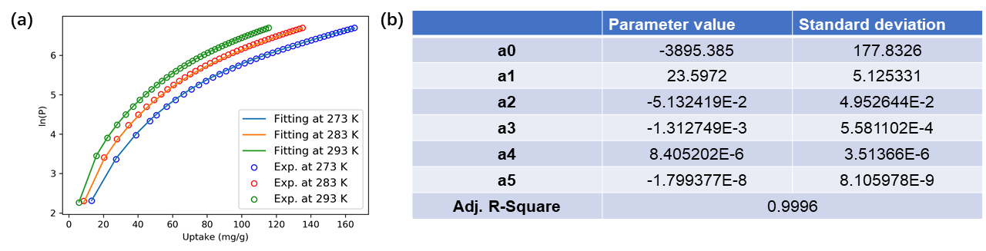
Supplementary Fig. 9 (a) Virial equation fitting of the C₂H₆ adsorption isotherm of CPOC-301 at 273, 283 and 293 K. (b) Relevant fitting parameters for C₂H₆.

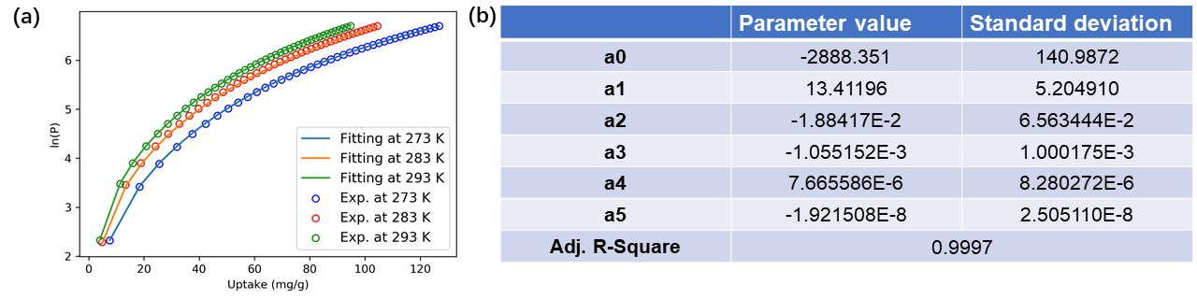
Supplementary Fig. 10 (a) Virial equation fitting of the C₂H₄ adsorption isotherm of CPOC-301 at 273, 283 and 293 K. (b) Relevant fitting parameters for C₂H₄.

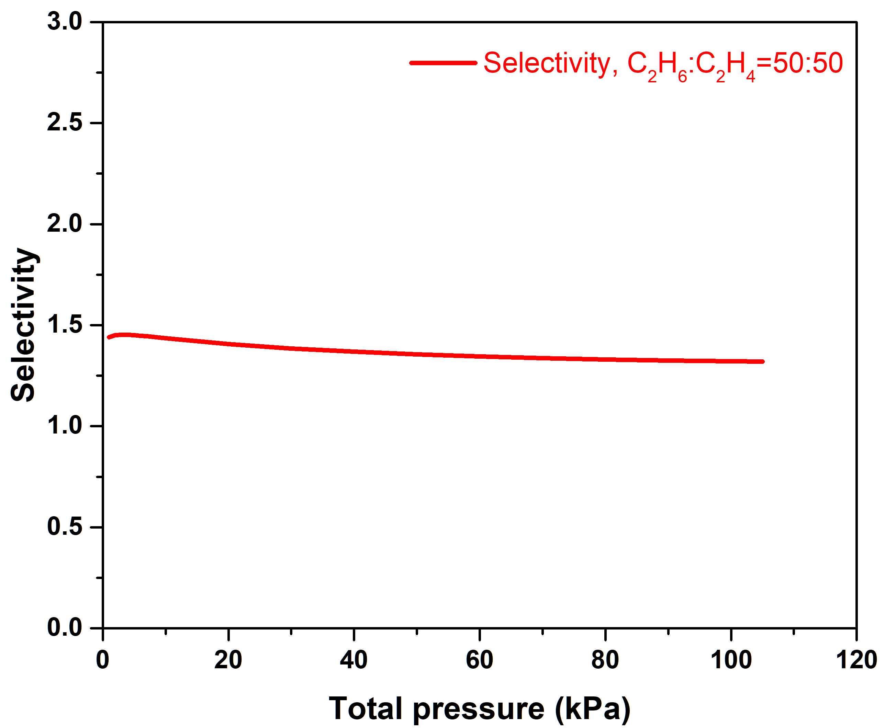
Supplementary Fig. 11 Selectivity of CPOC-301 predicted by the IAST method for an equimolar C₂H₆/C₂H₄ mixture at 293 K.

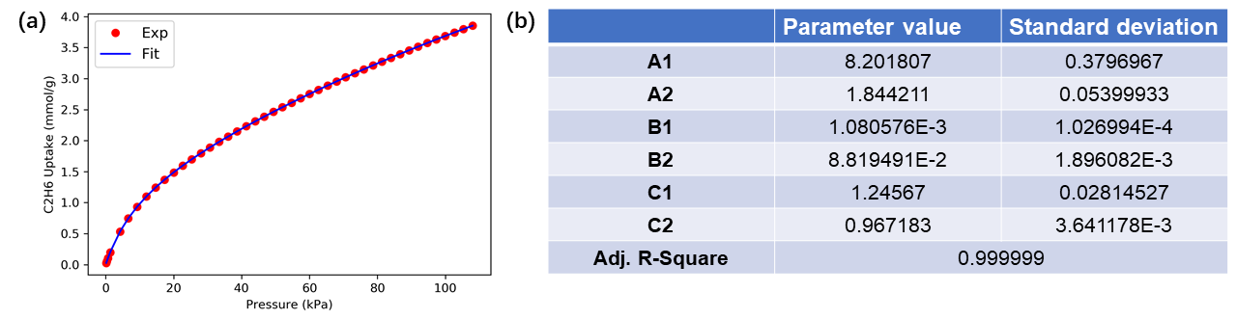
Supplementary Fig. 12 Dual-site Langmuir-Freundlich fitting of the C₂H₆ adsorption isotherm of CPOC-301 at 293 K. (b) Relevant fitting parameters for C₂H₆.

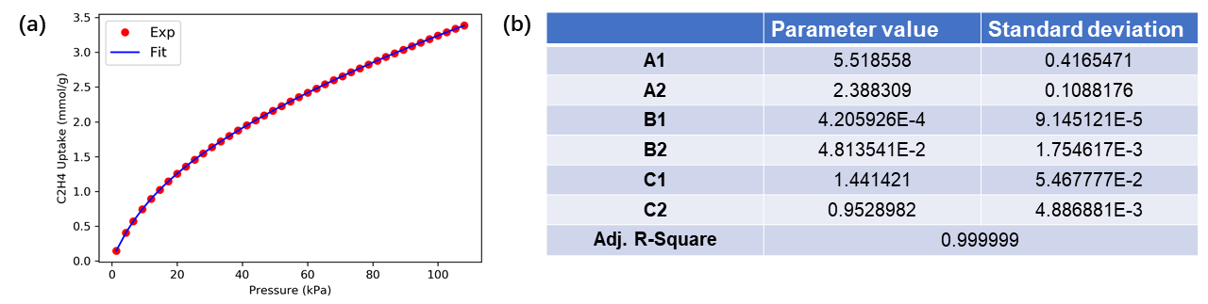
Supplementary Fig. 13 Dual-site Langmuir-Freundlich fitting of the C₂H₄ adsorption isotherm of CPOC-301 at 293 K. (b) Relevant fitting parameters for C₂H₄.

Supplementary Fig. 14 ¹HNMR of CPOC-301 after breakthrough experiments (CDCl₃, 400 MHz, 298 K).
Supplementary Fig. 15 PXRD of CPOC-301 after breakthrough experiments.

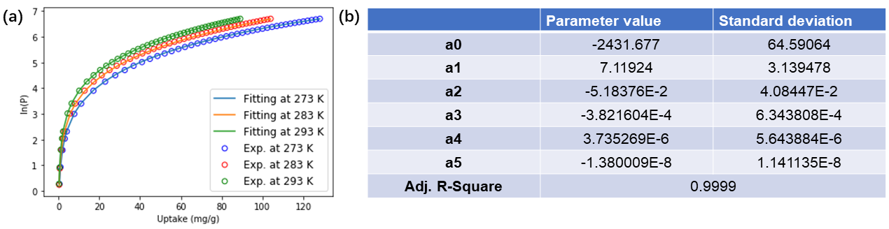
Supplementary Fig. 16 (a) Virial equation fitting of the C₂H₂ adsorption isotherm of CPOC-301 at 273, 283 and 293 K. (b) Relevant fitting parameters for C₂H₂.

