Supplemental Figure 1 Nonlinear Relationship Between Lower-Limb Squat Strength and Agility, Jump, and Sprint in Beach Volleyball Players
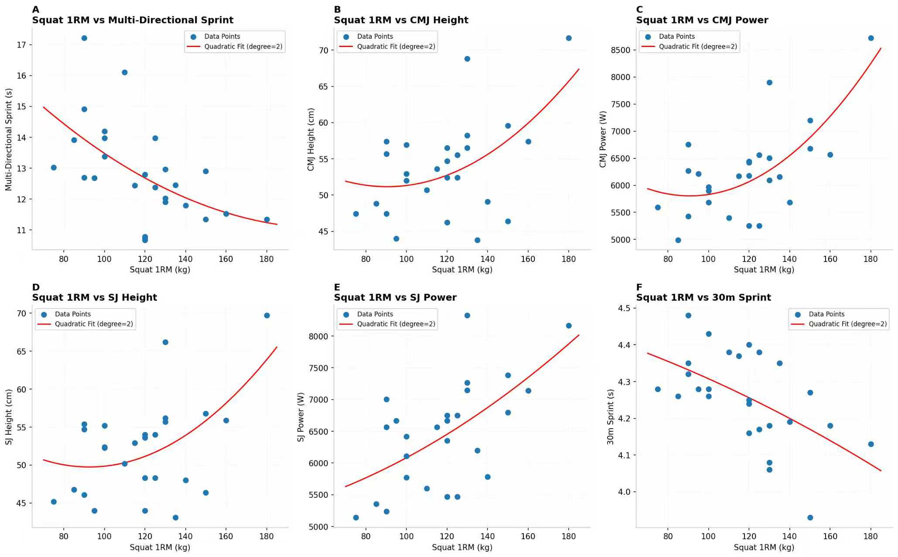
Supplemental Figure 1 Nonlinear Relationship Between Lower-Limb Squat Strength and Agility, Jump, and Sprint in Beach Volleyball Players
(A) Squat 1RM Strength VS. Multi-Directional sprint time; (B) Squat 1RM Strength VS. Countermovement jump vertical height; (C) Squat 1RM Strength VS. Countermovement jump vertical peak power; (D) Squat 1RM Strength VS. Squat jump vertical height; (E) Squat 1RM Strength VS. Squat jump vertical peak power; (F) Squat 1RM Strength VS. 30-meter sprint.

Supplemental Figure 2. Nonlinear Relationship Between Lower-Limb Deadlift 1RM Strength and Agility, Jump, and Sprint in Beach Volleyball Players
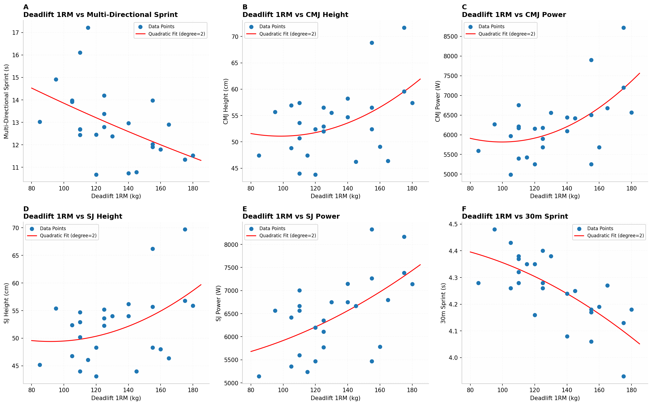
Figure 2. Nonlinear Relationship Between Lower-Limb Deadlift 1RM Strength and Agility, Jump, and Sprint in Beach Volleyball Players (A) Squat 1RM Strength VS. Multi-Directional sprint time; (B) Squat 1RM Strength VS. Countermovement jump vertical height; (C) Squat 1RM Strength VS. Countermovement jump vertical peak power; (D) Squat 1RM Strength VS. Squat jump vertical height; (E) Squat 1RM Strength VS. Squat jump vertical peak power; (F) Squat 1RM Strength VS. 30-meter sprint.

