Smaller than a needle! Assessing technological behaviour and contextual integrity through lithic refittings at Cova Gran de Santa Linya (SE Pyrenees)
Javier Sánchez-Martínez^{1,2,3} * Jorge Martínez-Moreno³, Alfonso Benito-Calvo⁴
¹ IPHES-CERCA, Institut Català de Paleoecologia Humana i Evolució Social, Zona Educacional 4, Campus Sescelades URV (Edifici W3), 43007, Tarragona, Spain.
² ICArEHB, Interdisciplinary Centre for Archaeology and the Evolution of Human Behaviour, University of Algarve, Faro, Portugal.
³ CEPAP-UAB, Centre d’Estudis del Patrimoni Arqueològic, Universitat Autònoma de Barcelona. Facultat de Filosofia
⁴ CENIEH, Centro Nacional de Investigación sobre la Evolución Humana. Paseo Sierra de Atapuerca 3, 09002 Burgos, Spain.

* Corresponding author: jsanchez@iphes.cat

ORCID
JSM: 0000-0001-8819-4177
JMM: 0000-0002-6326-7058
ABC: 0000-0002-6363-1753

This supplement includes:
- Supporting information of technological analysis, raw materials and refittings
- Technical information of hearth 7P E1
- Statistical analysis of linear and circular metric variables from refits

1. Supporting information of technological analysis, refittings and raw materials
Here we provide data of interest of the archaeological record of level 7P (Table s1), as well as some specific technological and procurement data of lithic artefacts.

Category | N | %
Lithic | 3043 | 73,6
Bone | 964 | 23,3
Charcoal | 63 | 1,5
Malacofauna | 6 | 0,1
Shell beads | 17 | 0,4
Mineral | 5 | 0,1
Samples | 34 | 0,2
Total general | 4132 | 100

Table s1: Artefacts recovered from the level 7P by general categories.

Level 7P encompasses 4132 remains. We have not included in this count the microdebris and small bone fragments daily recovered from the site during fieldwork. Lithic debris smaller than 10 mm account for 3728 while bone fragments smaller than 20 mm account for 13687 remains. Bones with identifiable patterns below this metric range were coordinated. Among this assemblage, there are also 830 remains associated to small game (e.g leporids and birds). Together with these remains, 12 mineral fragments were also recovered.
Lithic microremains were analysed to recover small bladelet fragments for this study. Some of them, were successfully refitted, indicating the relevance of precise and meticulous recovery techniques for high-resolution studies. The high fragmentation of the assemblage is associated to the laminar characteristics of the assemblage. However, as occurs in most of Upper Palaeolithic assemblages, flakes and flake fragments are most abundant (table s2)
Category | N | %
Flake | 539 | 17,7
Fragments | 1099 | 36,1
Elongated flake | 74 | 2,4
Blade | 13 | 0,4
Blade fragments | 204 | 6,7
Bladelet | 346 | 11,4
Bladelet fragments | 760 | 25,0
Other | 8 | 0,3
Total | 3043 | 100

Table s2: Main blanks identified in the lithic assemblage.

Flakes and bladelets have played a central role in this work, because they are the blanks and the production goals of on edge reduction methods. Reduction on the lateral edges of flakes generates characteristic artefacts typologically named burin spalls because of its association with burins. Regardless the epistemological approach stablished (technological or typological) for the analysis of burins, burin spalls have been widely considered central elements for the characterisation of Upper Palaeolithic technocomplexes, especially in the LGM. From a functional perspective, burin spalls are considered by-products obtained from the resharpening of burin facets (Cattin, 2006) after long use and dullness of the sharp edges. From a technological perspective, these elements are considered part of the lithic production of microblades obtained through on edge reduction methods (Le Brun-Ricalens and Brou 2003, Leplongeon and Gorin-Morris, 2018), which have a wide variety of by-products associated (Table s3). We support this option as the most plausible explanation for the obtention of these pieces, regardless of whether after their detachment, burin spalls, or even on edge cores, are used for specialised activities. Since, to us burins spalls should be considered by default as bladelets (Sánchez-Martínez et al. 2024) and only after carrying out functional studies pieces in the sphere of on edge technology might be associated to tools

Category | N | %
Burin spall | 310 | 63,92
1st order crested bladelet | 54 | 11,13
2nd order crested bladelet | 38 | 7,84
Burin tablet | 25 | 5,15
Crest | 3 | 0,62
Semi-crest | 19 | 3,92
Tablet | 3 | 0,62
Semi-tablet | 6 | 1,24
Core-side | 25 | 5,15
Overshoot | 2 | 0,41
Total | 485 | 100

Table s3: Main lithic products, by-products and core maintenance artefacts from on edge reduction methods.

Crested bladelets are characterised for a retouched edge located in the central ridge of the dorsal face and helps at opening on edge knapping surfaces. Although these pieces registered an edge modification compatible with retouch, they are not typologically considered tools, as the modification is part of the maintenance and preparation actions required for creating and keeping the distal convexity of on edge cores.

Refittings
Up to 139 refit sets were identified in the level 7P as part of a specific refitting programme conducted at Universitat Autònoma de Barcelona (Table s4)
Artefacts | N | Σ
2 | 112 | 80,6
3 | 16 | 11,5
4 | 9 | 6,5
+5 | 2 | 1,4
Total | 139 | 100

Table s4: Absolute and relative data of the pieces involved by refit set.
Refits encompassing 2 artefacts are the most abundant ones. This occurs in assemblages with high fragmentation of the operational chain, but it could be also associated in that case to the high proportion of transversal fractures, that generally divide an artefact in two halves.
Raw materials
As indicated in previous works, evaporitic chert in the central-southern Pyrenees is characterised by its macroscopic variability (Sánchez de la Torre, 2014; Roy-Sunyer, 2016), limiting the identification of single knapped nodules (named Raw Material Units) within the assemblages. For that reason, chert varieties were grouped following RMG (Table s5 and table s6) to reduce inter-nodule macroscopic variability. In the following tables we have only included the raw material varieties and groups that have recorded refits.

RM | N | Σ
RMG-A | 61 | 18,0
RMG-G | 31 | 9,1
RMG-M | 81 | 23,9
RMG-Lacustrine | 80 | 23,6
NC | 47 | 13,9
Bone | 25 | 7,4
Not analysed | 14 | 4,1
Total | 339 | 100

Table s5: Refits by RMG and other raw materials. NC = Not catalogued because of surface macroscopic alterations

Table s6
RM | N | Σ
a--001 | 2
a--201 | 51
a--216 | 7
a--nc | 1
RMG-A | 61 | 18,0
g--001 | 1
g--206 | 3
g--207 | 8
g--208 | 3
g--210 | 2
g--211 | 9
RMG-G | 31 | 9,1
m--2109 | 18
m--220 | 47
m--nc | 16
RMG-M | 81 | 23,9
sll--1 | 7
sll--3 | 37
sll--4 | 36
RMG-Lacustrine | 80 | 23,6
nc | 46
nc--c | 1
NC | 47 | 13,9
Bone | 25 | 7,4
Not analysed | 14 | 4,1

Table s6: List of the refits sets by chert varieties and RMG groups. RMG A, G and M refers to evaporitic chert, while RMG – Lacustrine comprise mostly lacustrine sources linked with Catelltallat Formation. NC = Not catalogued because of surface macroscopic alterations.

We did not identify any preferred pattern in the use of evaporitic or lacustrine chert for knapping goals, as they are both used for the configuration of semi-circumferential and on edge cores (Sánchez-Martínez et al. 2022). Generally, lacustrine chert recorded a highest artefact refitting ratio as the available raw material in the landscape is also found in smaller formats than the evaporitic chert varieties, and then fragmentation tend to be smaller. Refittings on diverse RMG indicate lithic resources from several source areas were knapped indistinctly, exhibiting the diversity of cherts varieties in the landscape.

2. Technical information of hearth 7P E1
7P–E1 is a pit-hearth identified near the eastern profile of level 7P (grid coordinates X = 238700 / Y = 529000) and represent the unique combustion structure found so far. The hearth is characterised by an ashy-coloured sediment and by the presence of basal rubefaction. Part of the structure had been previously exposed during the initial Platform test trench.
The hearth covers an area of 0.97 m² (118 × 105 cm), with a perimeter of 3.5 m and a maximum thickness of approximately 10 cm. Topographic points have allowed reconstructing the general morphology of the hearth (Figure s1).
Microstratigraphic observation distinguished three internal layers from top to base:
- an upper ashy sandy layer containing dispersed charcoal;
- a fine sandy matrix with small clasts displaying ashy coloration, including lithic and faunal remains, with thermally altered clasts
- a basal layer with rubefaction. Beneath this, darker sediments with varying degrees of thermal alteration were also identified and the substrate upon which the hearth was established.
The assemblage within the hearth is dominated by faunal remains, particularly lagomorph bones, several of which exhibit thermal alteration. Lithic and larger faunal remains are comparatively scarce. Sediment and anthracological samples were reovered from the hearth for the identification of the fuel, IR signals and the preservation of phytoliths.
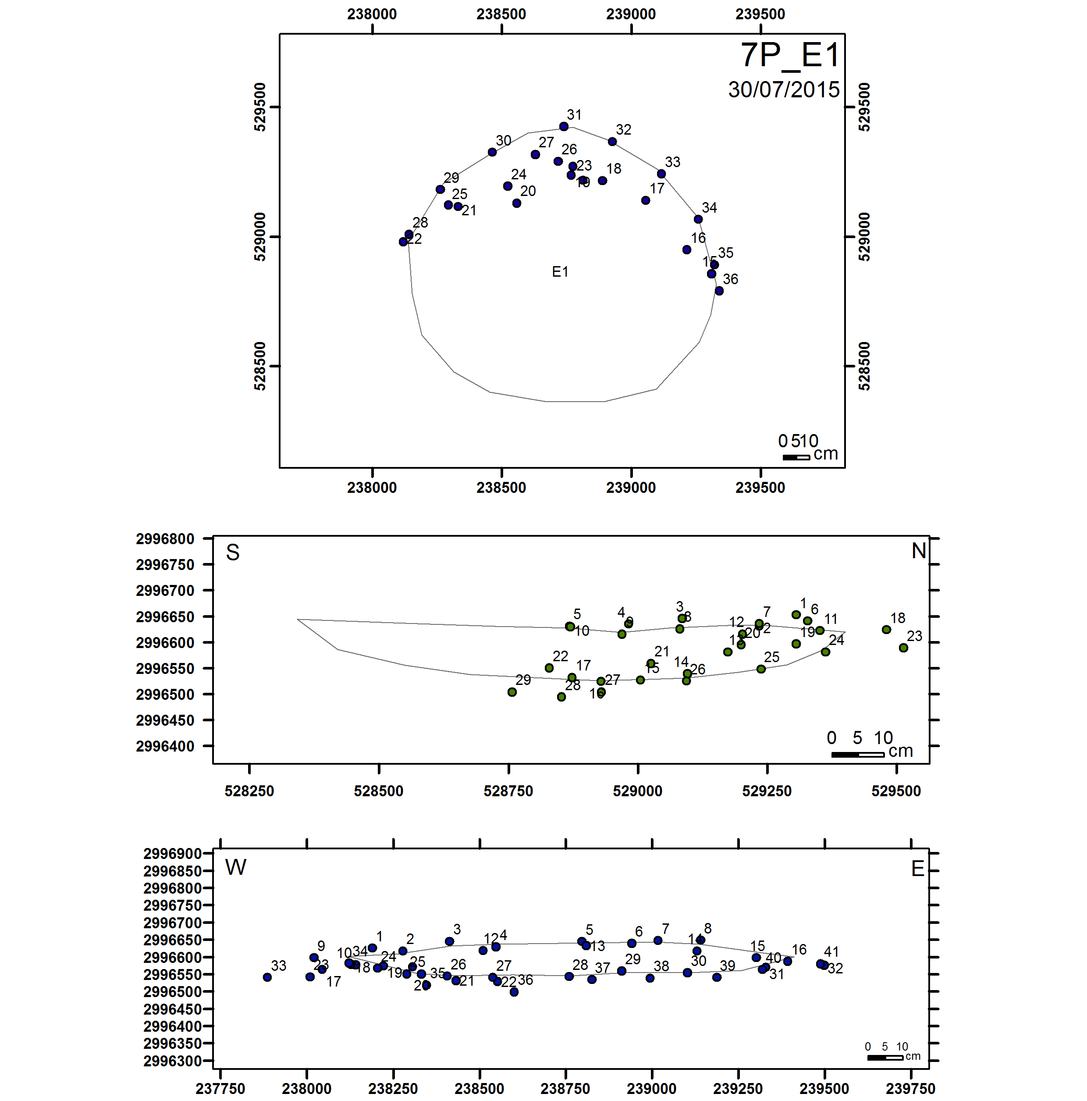
Figure s1: Plant view of the hearth including perimeter and topographic points, N-S cross-section and E-W cross-section.

3. Statistical analysis of linear and circular metric variables from refits
We have included 4 main metric variables for the contextual characterisation of lithic refits: Horizontal distance (horintal_dist), vertical distance (vertical_dist), inclination and azimuth.
As SUGAR software allows stablishing hierarchy between pieces within the reduction sequence, when possible, we have determined the original piece (e.g. core) and the destination piece (e.g bladelet connecting with the core).
- Horizontal_dist refers to the distance on the X axis between the original piece and the destination piece. It is calculated in millimetres.
- Vertical_dist refers to the distance on the Y axis between the original piece and the destination piece. It is calculated in millimetres.
- Inclination refers to the slope of the connection line between the original and the destination piece. Inclination values are set on a flat X axis. Negative inclination indicates a higher position of destination piece, while positive inclination refers to lower destination pieces. It is calculated in degrees.
- Azimuth refers to the orientation of the connection line between original and destination piece. It is calculated in degrees.
The statistical analysis is available in the Rscript “CG_JASr_7P_refittings.R”. All the analysis can be reproduced using Rstudio (R version 4.5.2) and the "CG_7P_Ref.xlsx" file within the supplementary materials.
Statistical analysis and normality test of refit variables
Shapiro–Wilk tests on horizontal distance, vertical distance and inclination data indicated significant deviations from normality (p-value > 0.001) (Table s7). Thus, linear variables do not show normal distribution.
Variable | W | p-value
Horizontal_dist | 0.95 | 3.30 x 10⁻⁶
Vertical_dist | 0.86 | 1.09 x 10⁻¹²
Inclination | 0.77 | 2.2 x 10⁻¹⁶
Table s7: Results of the Shapiro-Wilk normality test of all linear metric variables.

Quantile–Quantile (Q–Q) plots were used to visually assess whether the linear variables (horizontal distance, vertical distance and inclination) follow a normal distribution. They indicate systematic deviations from normality across all linear variables, supporting the results of the Shapiro–Wilk tests, particularly in inclination and vertical distance where heavy-tailed distributions are evident (Figure s2).
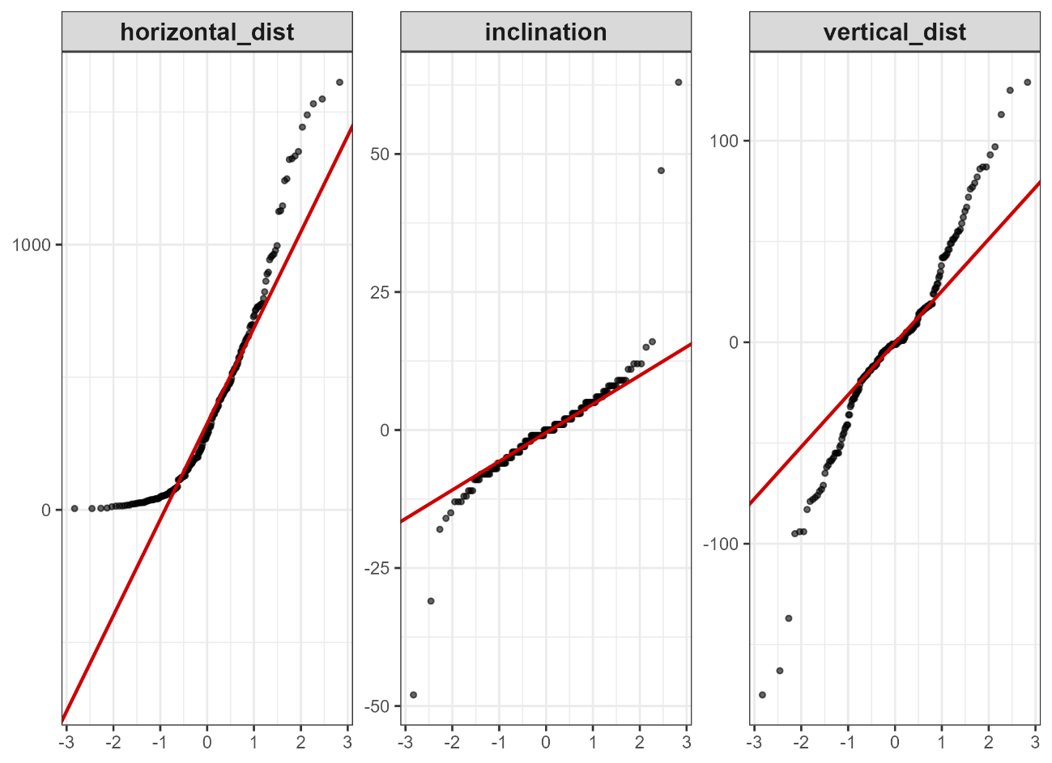
Figure s2: QQ plots for all linear metric variables.

Circular statistical tests were performed to evaluate the uniformity of azimuth values. The Rayleigh test revealed a significant deviation from uniformity (p < 2.2 × 10⁻¹⁶), indicating the presence of a preferred directional component. The Kuiper test also rejected the null hypothesis of uniform distribution (p < 0.01), confirming that the orientation of refitting connection lines is not randomly distributed. Together, these results indicate a structured angular pattern rather than isotropic dispersion.

Non-parametric tests
Non-parametric Kruskal–Wallis tests were performed to evaluate potential differences in horizontal distance, vertical distance, and inclination across the most abundant refitting connections (REF 1, REF 2 and REF 4). In all cases, results were not statistically significant (p > 0.05).
These results suggest that the refitting connections exhibit comparable central tendencies and dispersion patterns for the variables considered. Consequently, the refitting categories were analysed as a single group. The Watson two-sample tests did not reveal significant differences in azimuth distributions between refitting connections (p > 0.05), supporting their statistical comparability.

References
Cattin, M. I. (2006). Parcours de burins, de la fabrication au rejet: Exemples issues des sites magdaléniens de Champréveyres et Monruz (Suisse). Burins préhistoriques : formes, fonctionnements, fonctions. M. de Araujo Igreja, J. P. Bracco and F. Le Brun-Ricalens, Musée National d'Histoire et d'Art (Luxembourg): 241-252.
Le Brun-Ricalens, F. and L. Brou (2003). Burins carénés-nucléus à lamelles: identification d'une chaîne opératoire particulière à Thèmes (Yonne) et implications. Bulletin de la Société Préhistorique Française 1000(1): 67-83.
Leplongeon, A. and A. N. Goring-Morris (2018). Terminal Pleistocene lithic variability in the Western Negev (Israel): Is there any evidence for contacts with the Nile Valley? Journal of Lithic Studies 5(1): 1-39. https://doi.org/10.2218/jls.2614
Roy-Sunyer, M., A. Tarriño Vinagre, A. Benito-Calvo, R. Mora and J. Martínez-Moreno (2013). Aprovisionamiento de sílex en el Prepirineo Oriental durante el Paleolítico Superior: el nivel arqueológico 497C de Cova Gran (Santa Linya, Lleida). Trabajos de Prehistoria 71(1): 1-22. https://doi.org/10.3989/tp.2013.12100
Sánchez de la Torre, M. (2014). Las sociedades cazadoras-recolectoras del Paleolítico Superior final pirenaico: territorios económicos y sociales, Universidad de Barcelona.
Sánchez-Martínez, J., et al. (2022). Beyond Shapes. Core Reduction Strategies in the Magdalenian of Cova Gran de Santa Linya. Journal of Paleolithic Archaeology, 5, Article 7. (Page range/DOI not retrievable from provided PDFs snippet.)
Sánchez-Martínez, J., X. Roda-Gilabert and J. Martínez-Moreno (2024). Unravelling the burin-core dichotomy: Historiographic and technological data to develop a new analytical framework for the study of on-edge artefacts. Journal of Lithic Studies 11(2): 30.

