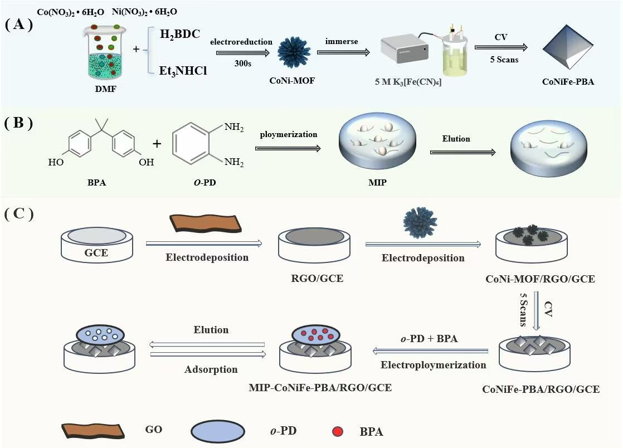
Scheme 1. Schematic illustration of (A) CoNiFe-PBA synthesis, (B) molecularly imprinted polymer (MIP) preparation, and (C) stepwise fabrication of the MIP/CoNiFe-PBA/RGO/GCE sensor

