Supplementary Information for:

Selective Electroreduction of CO₂ to C₂₊ Biofuels by Graphitic Frustrated Lewis Pair Catalyst

Hyun-Tak Kim^{1,3,4†}, Jaehyun Park^{2,4†}, Jinhong Mun^{1,4†}, HyeonOh Shin^{1,4}, Deok-Ho Roh^{1,4}, Junhyeok Kwon^{1,4}, Sungtae Kim^{1,4}, Geunsik Lee^{1,4*}, Seok Ju Kang^{2,4}*, and Tae-Hyuk Kwon^{1,4}*

¹Department of Chemistry, School of Natural Science, Ulsan National Institute of Science and Technology (UNIST), Ulsan 44919, Republic of Korea
²Department of Energy Engineering, School of Energy and Chemical Engineering, Ulsan National Institute of Science and Technology (UNIST), Ulsan 44919, Republic of Korea
³Center for Environment & Sustainable Resources, Korea Research Institute of Chemical Technology (KRICT), Daejeon 34114, Republic of Korea
⁴Center for Wave Energy Materials, Ulsan National Institute of Science and Technology (UNIST), Ulsan 44919, Republic of Korea
† These authors contributed equally to this work.
* E-mail: gslee@unist.ac.kr, sjkang@unist.ac.kr, kwon90@unist.ac.kr
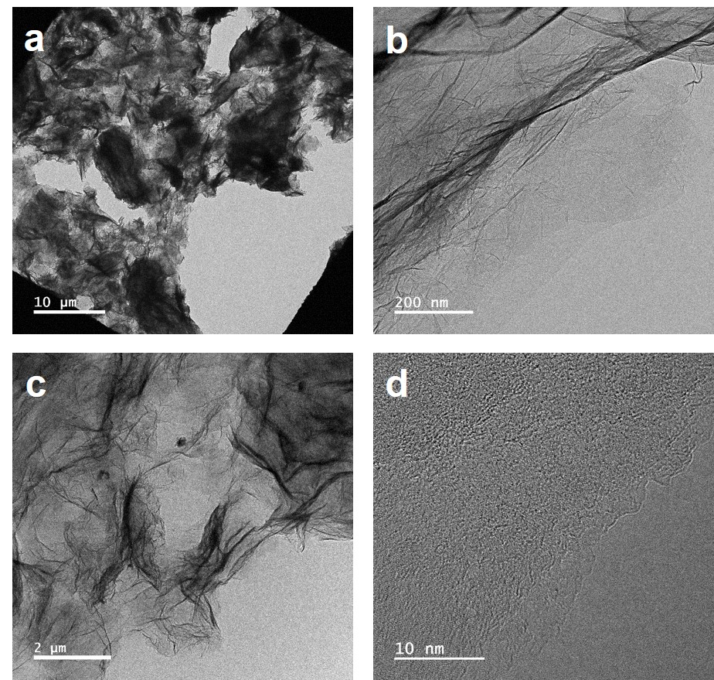
Supplementary Fig. 1┃High resolution transmission electron microscopy (HR-TEM) characterization of synthesized BN-GFLP with different magnification.
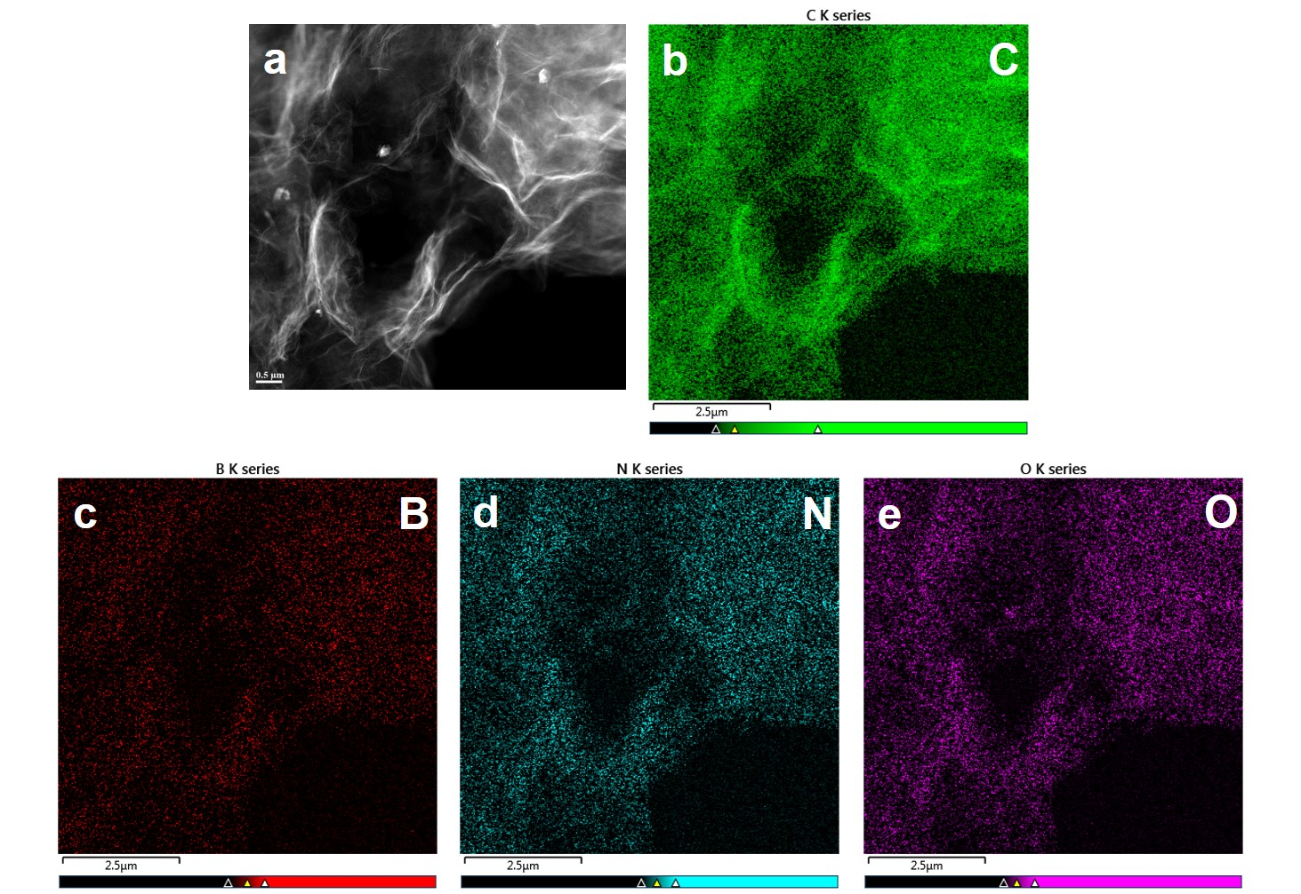
Supplementary Fig. 2┃Energy dispersive X-ray spectroscopy (EDS) elemental mappings of BN-GFLP. (a) HR-TEM of standard BN-GFLP, and EDS mapping of (b) carbon, (c) boron, (d) nitrogen, and (e) oxygen in BN-GFLP.

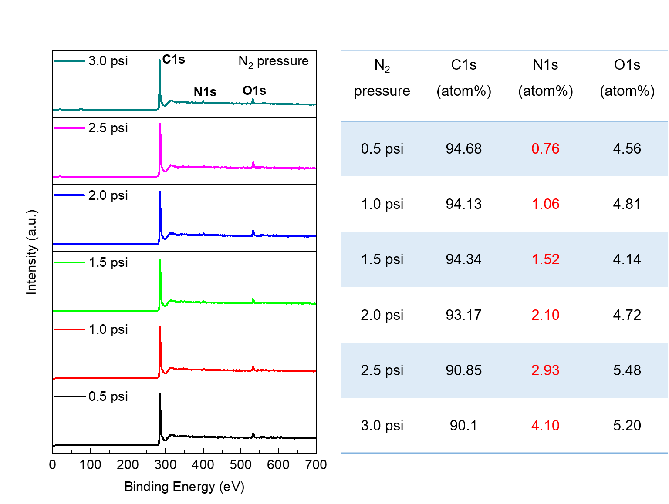
Supplementary Fig. 3┃Nitrogen (N) doping contents control in graphene nanopowder (GN). According to a pressure of the impact N₂ carrier gas in SNS, N doping contents in GN could be precisely controlled from 0.76 atom% (0.5 psi) to 4.10 atom% (3.0 psi) in X-ray photoelectron spectroscopy (XPS) analysis. Other experimental conditions were same with described SNS process in Materials and Method, but pressure of N₂ gas is only variable in the range of minimum pressure (0.5 psi) to maximum pressure (3.0 psi).

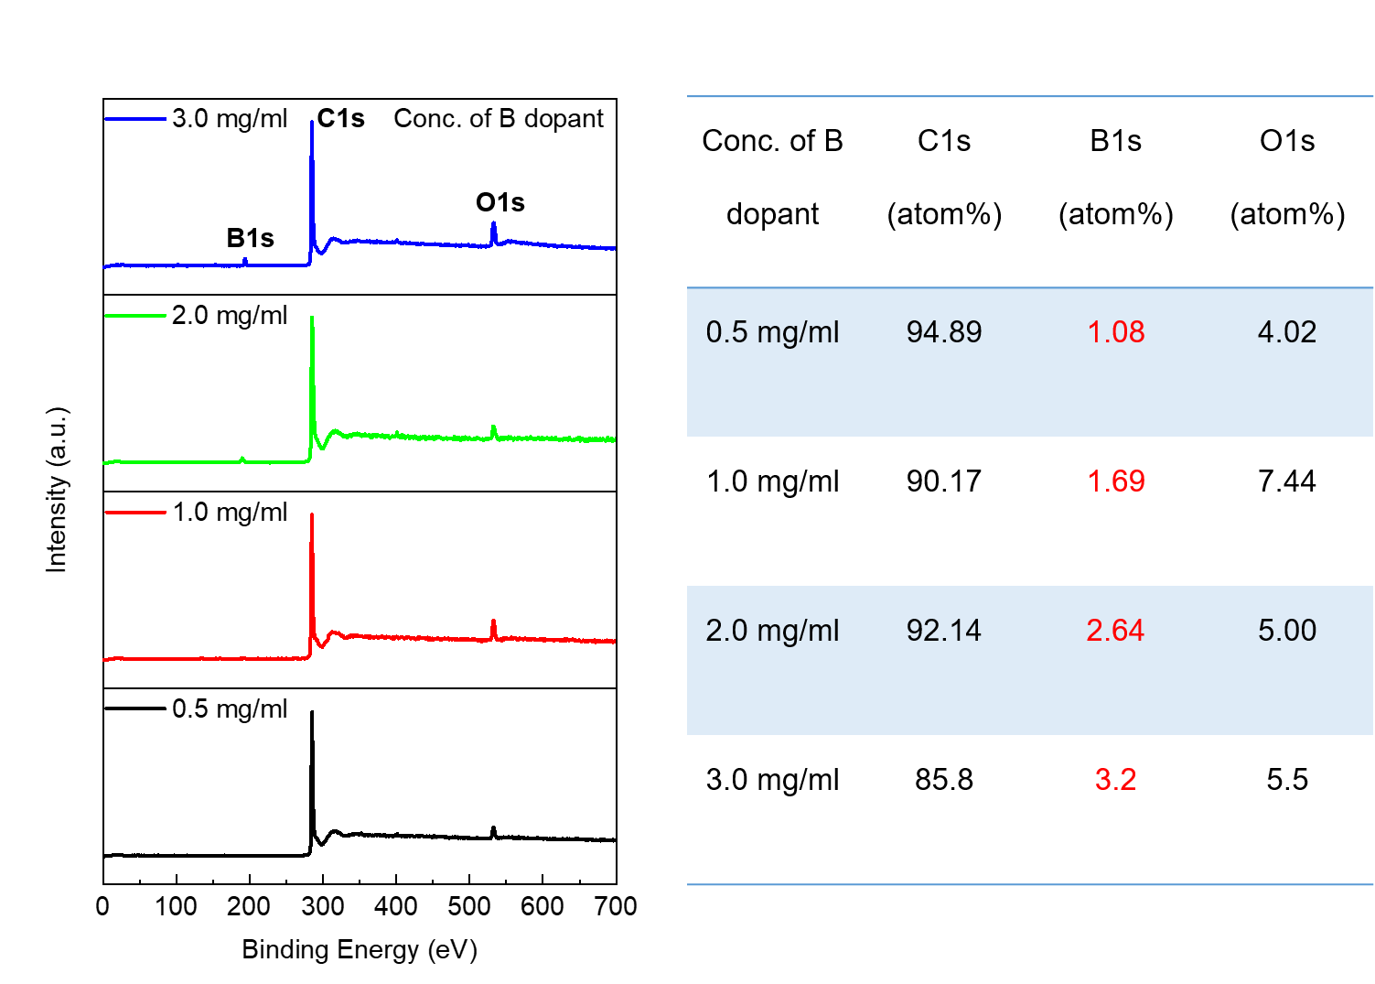
Supplementary Fig. 4┃Boron (B) doping contents control in GN. To control the B doping contents in GN, we optimized concentration of B dopant solution from 0.5 to 3.0 mg/ml in SNS process, and thereby achieving linearly increased doped B contents from 1.08 atom% to 3.20 atom%. In higher B dopant concentration than 3.0 mg/ml, undesirable borate functional groups were increased in B-GN due to the unreacted B dopant (bis(pinacolato)diboron). Please note that the higher B contents (6.8 atom%) in BN-GFLP could be derived by B-N bond formation in the presence of both of the B and N dopants in SNS process.

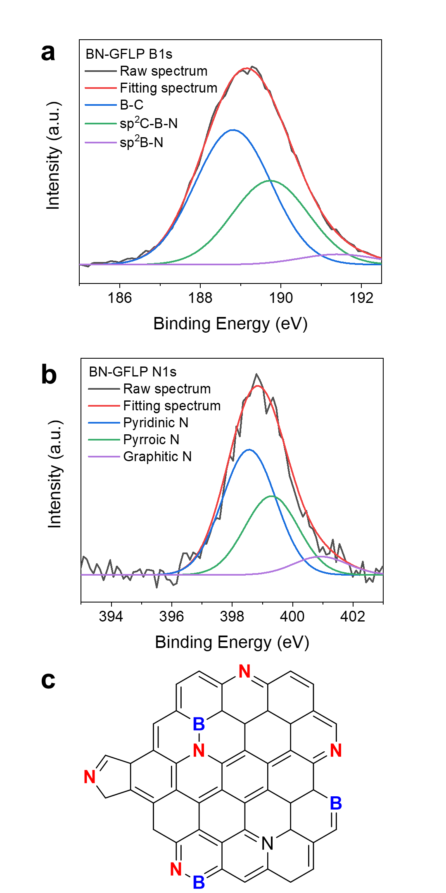
Supplementary Fig. 5┃High resolution X-ray photoelectron spectroscopy (XPS). Deconvoluted (a) N1s and (b) B1s XPS spectra, and (c) possible heteroatom configurations in BN-GFLP

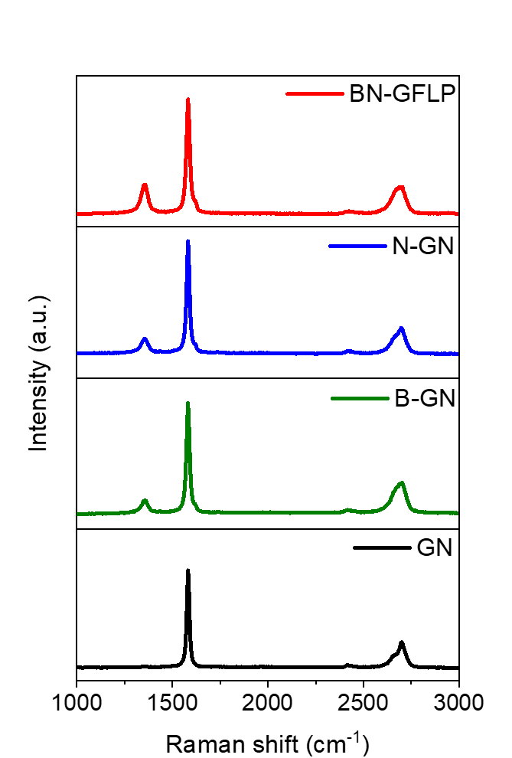
Supplementary Fig. 6┃Raman spectroscopy. Raman spectra of heteroatom doped GN materials, and their D band and G band appeared in 1358.2 cm⁻¹ and 1582.2 cm⁻¹, respectively. The heteroatom doped GN materials showed higher I_{D}/I_{G} ratios, 0.627 of BN-GFLP, 0.522 of N-GN, and 0.538 of B-GN, compared to control 0.504 of GN. This increase of I_{D}/I_{G} ratios of heteroatom doped GNs came from i) inserted heteroatom defects and ii) diminution of sp² hybridized graphitic framework by collision of ultrasonic energy in SNS process.

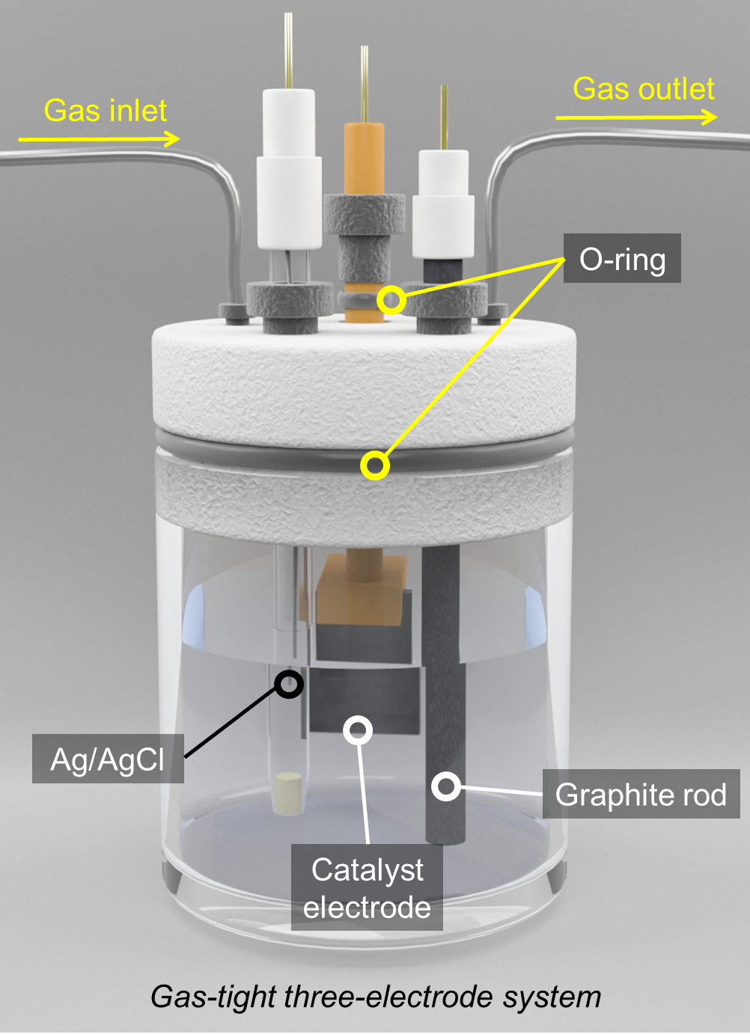
Supplementary Fig. 7┃Gas-tight three-electrode beaker cell system. Schematic of gas-tight three-electrode beaker cell with catalyst contained electrode.

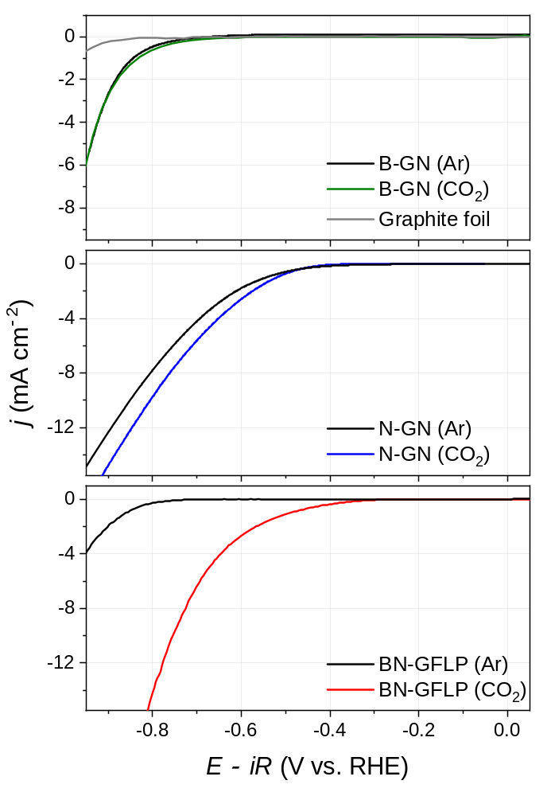
Supplementary Fig. 8┃Linear sweep voltammetry curves. LSV of (top) B-GN (Ar), B-GN (CO₂) and graphite foil, (middle) N-GN (Ar) and N-GN (CO₂), and (bottom) BN-GFLP (Ar) and BN-GFLP (CO₂).

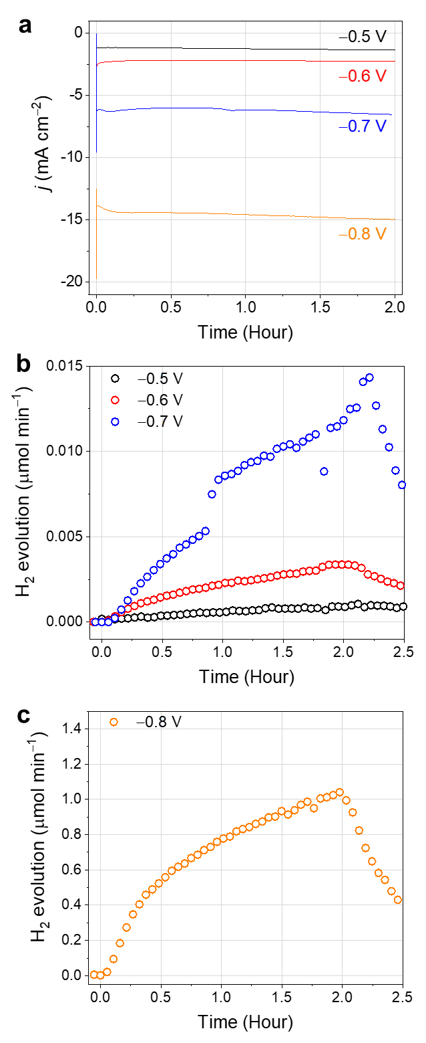
Supplementary Fig. 9┃Chronoamperometry of BN-GFLP. (a) Plot of current density versus time at constant voltages of -0.5, -0.6, -0.7, and -0.8 V. Corresponding DEMS results of the constant voltages of (b) -0.5, -0.6, -0.7, and (c) -0.8 V in (a).

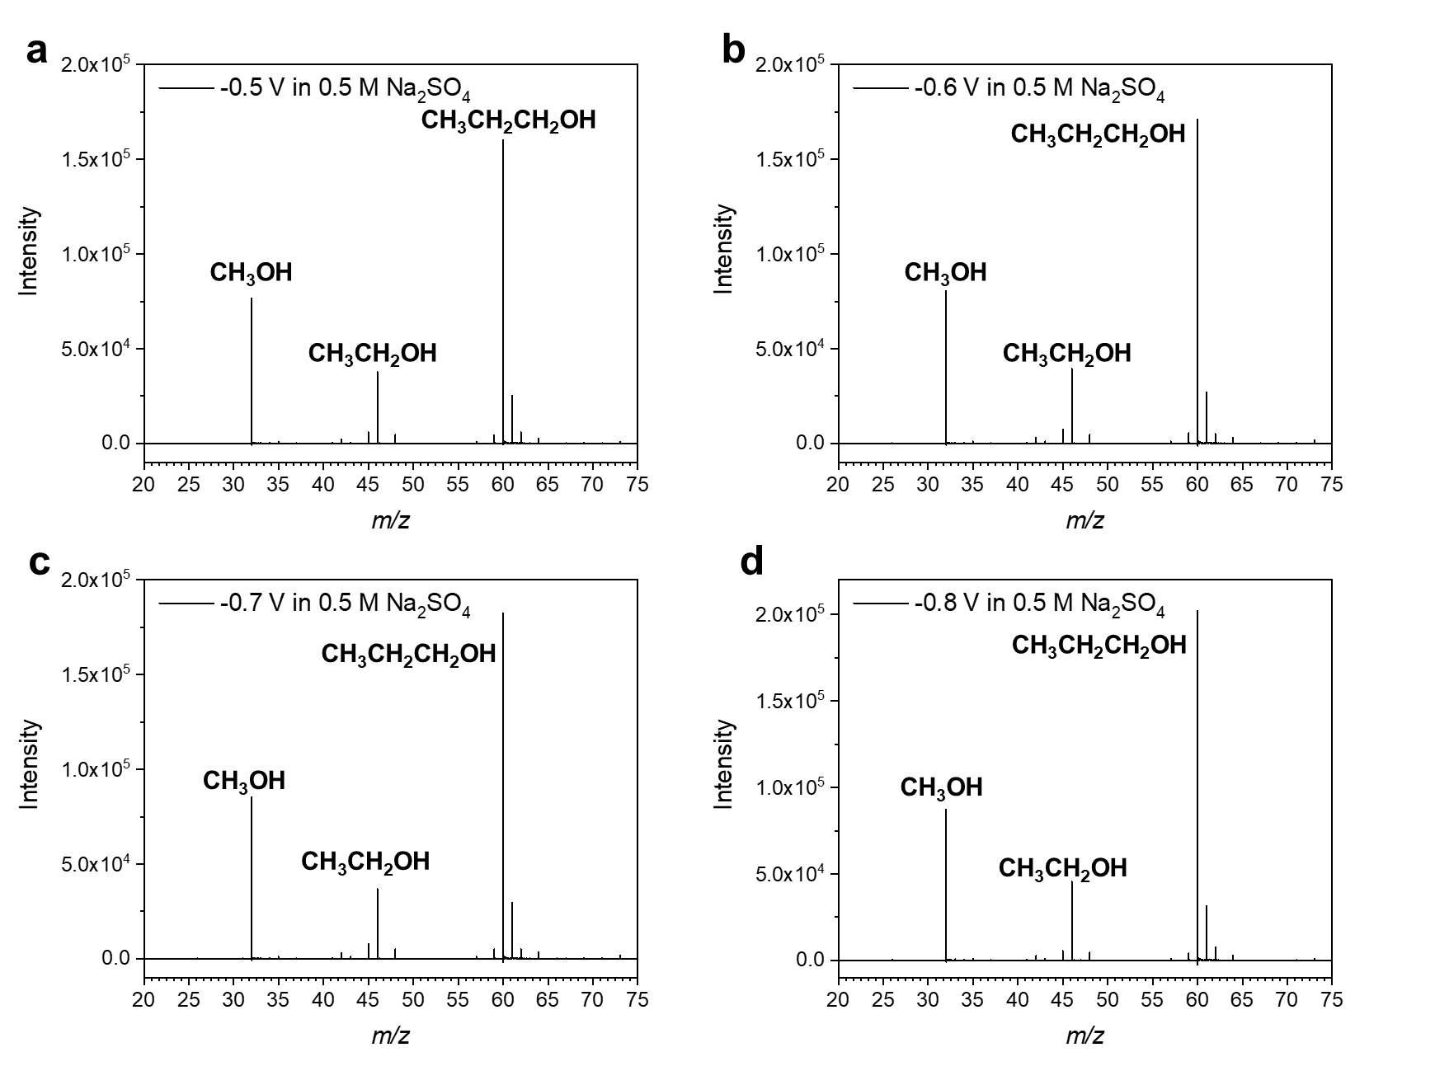
Supplementary Fig. 10┃ESI-MS spectra. CO₂R products of BN-GFLP after electrolysis applying various potentials ranging from (a) –0.50, (b) –0.60, (c) –0.70, and (d) –0.80 V (vs. RHE) for 2 hours.

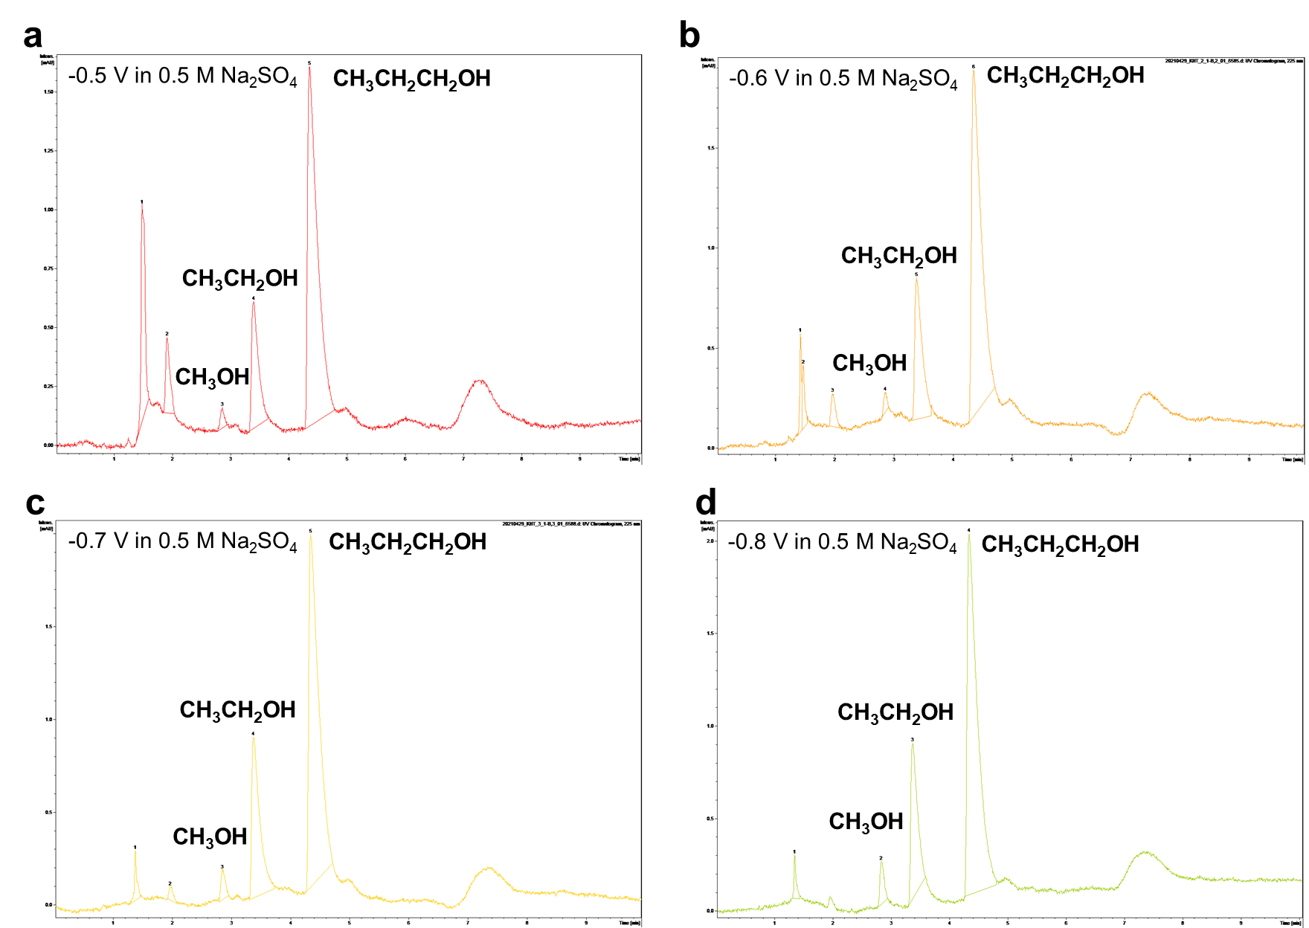
Supplementary Fig. 11┃HPLC spectra. CO₂R products of BN-GFLP after electrolysis applying various potentials ranging from (a) –0.50, (b) –0.60, (c) –0.70, and (d) –0.80 V (vs. RHE) for 2 hours.

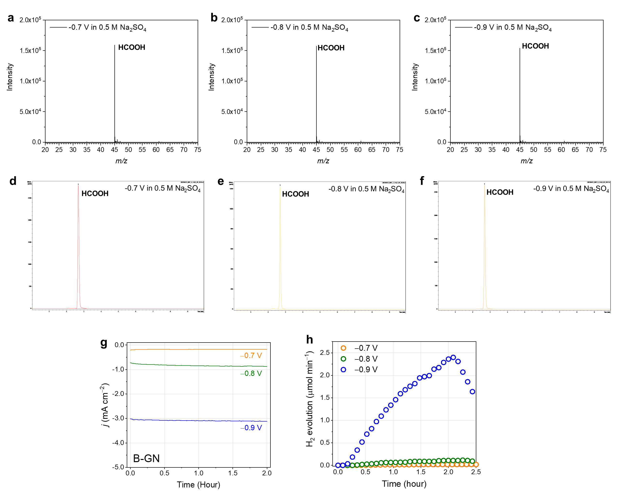
Supplementary Fig. 12┃CO₂R performance of B-GN. CO₂R products of B-GN confirmed by (a-c) ESI-MS and (d-f) HPLC, after electrolysis applying various potentials ranging from –0.70 to –0.90 V (vs. RHE) for 2 hours. (g) Chronoamperometry test of B-GN and (h) corresponding DEMS results.

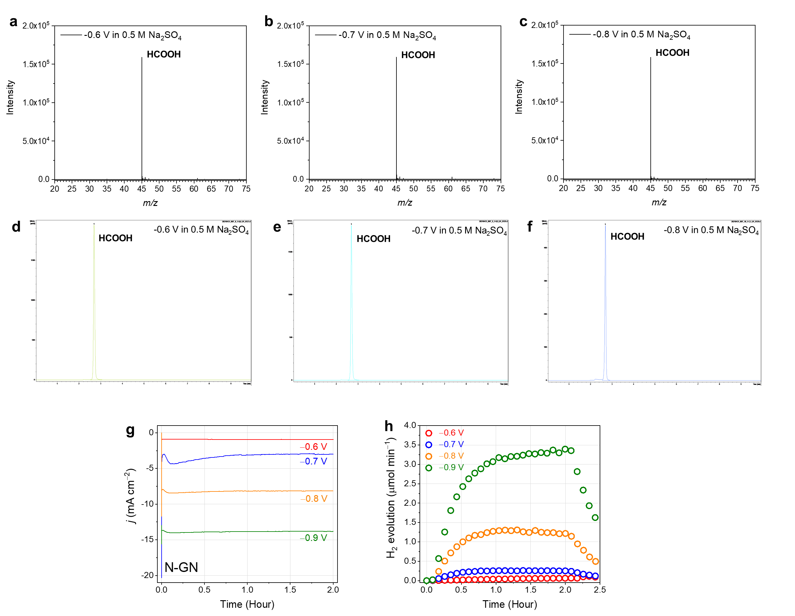
Supplementary Fig. 13┃ CO₂R performance of N-GN. CO₂R products of N-GN confirmed by (a-c) ESI-MS and (d-f) HPLC, after electrolysis applying various potentials ranging from –0.60 to –0.80 V (vs. RHE) for 2 hours. (g) Chronoamperometry test of N-GN and (h) corresponding DEMS results.

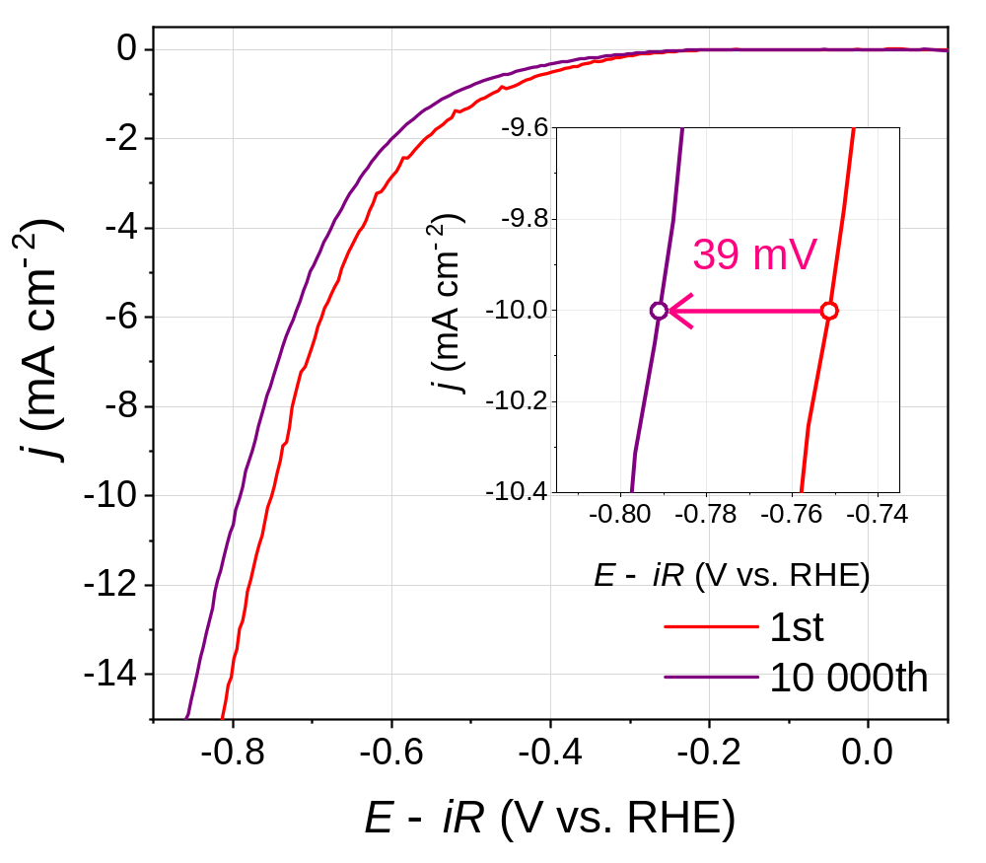
Supplementary Fig. 14┃Long-term stability of BN-GFLP after 10,000 cycles of cyclic voltammetry.

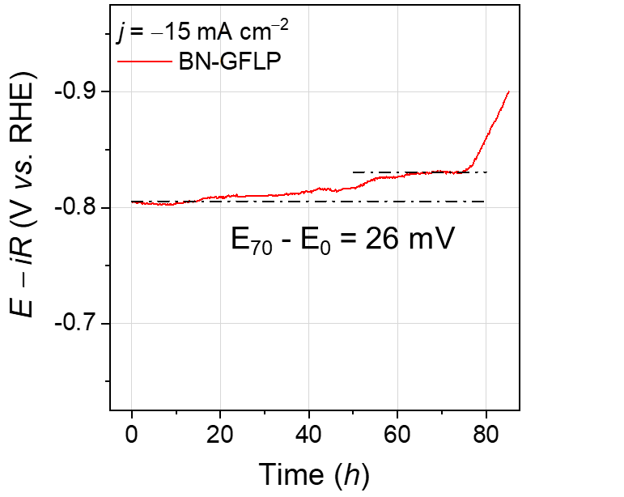
Supplementary Fig. 15┃Potential versus time plot of BN-GFLP at a constant current density of -15 mA cm⁻².

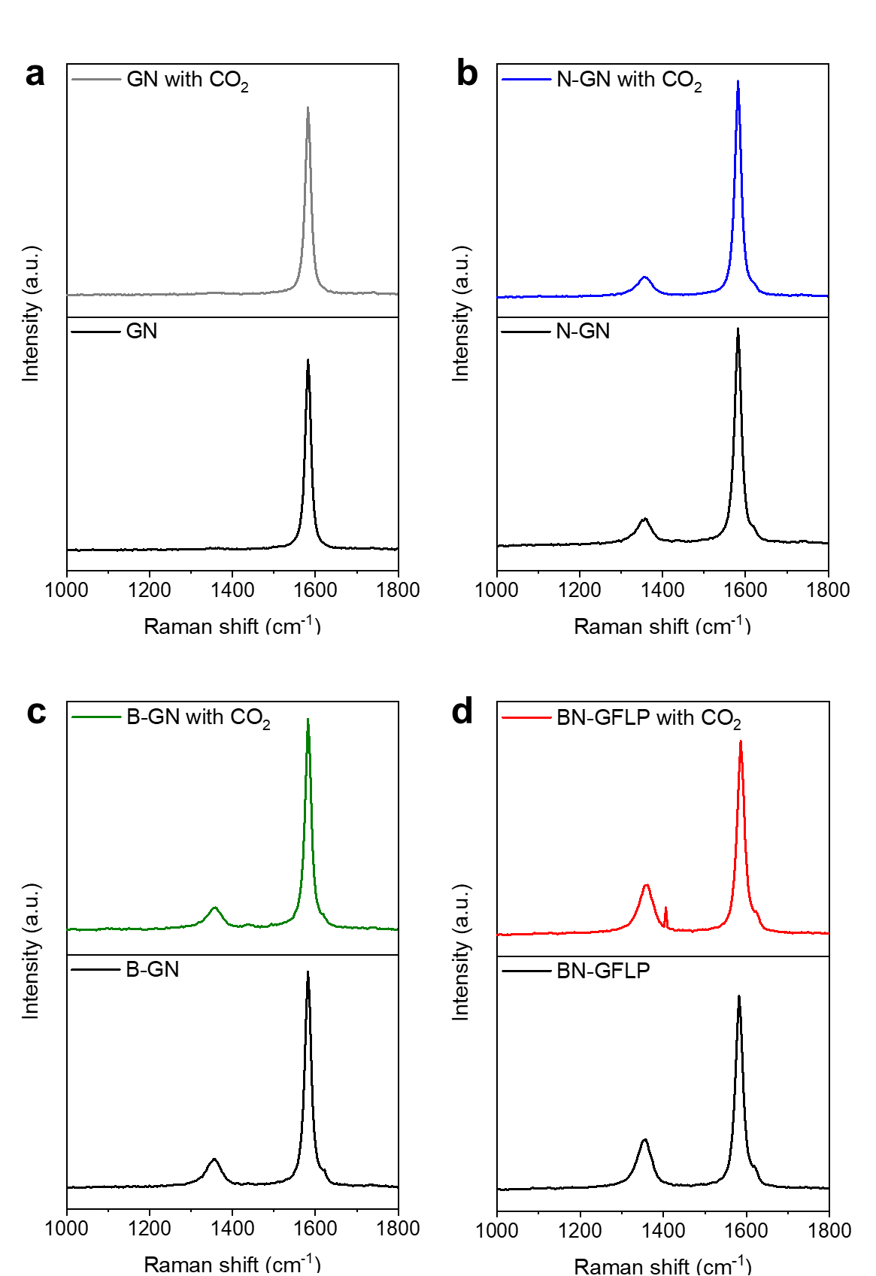
Supplementary Fig. 16┃Raman spectroscopy with and without CO₂ stimuli. Raman spectra of (a) GN, (b) N-GN, (c) B-GN, and (d) BN-GFLP samples with and without CO₂ stimuli. To promote fully saturated CO₂ environment, we used quantitative CO₂ aeration system during 1 hour as described in Materials and Methods section. In addition, we added 0.5 g of dry ice to each samples for prevention of radical self-quenching in heteroatom doped carbon materials. As a result, only BN-GFLP sample with CO₂ stimuli showed additional symmetric stretch peak of CO₂ at 1366.2 cm⁻¹ due to the FLP binding sites for CO₂, but there were no differences in other GN materials after CO₂ stimuli.

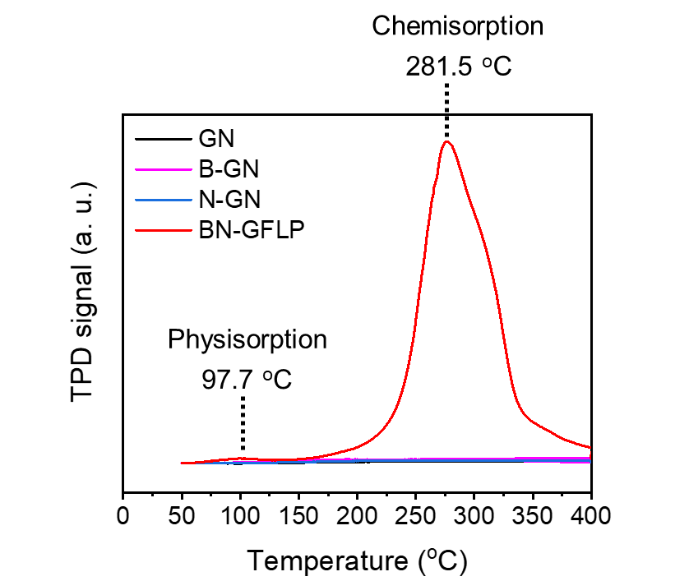
Supplementary Fig. 17┃Temperature programmed desorption with CO₂. As the chemisorption of CO₂ is the initial step towards CO₂R, the CO₂ chemisorption ability of the catalysts was measured by temperature-programmed desorption (TPD). The results indicate that GN, B-GN, and N-GN has weak CO₂ chemisorption. On the other hand, the BN-GFLP catalyst exhibited substantial enhancement in the chemisorption of CO₂. Owing to the electronic interaction of dual binding site, the TPD peaks of BN-GFLP showed high temperatures (281.5 °C), indicating the superior chemical adsorption ability in the BN-GFLP.

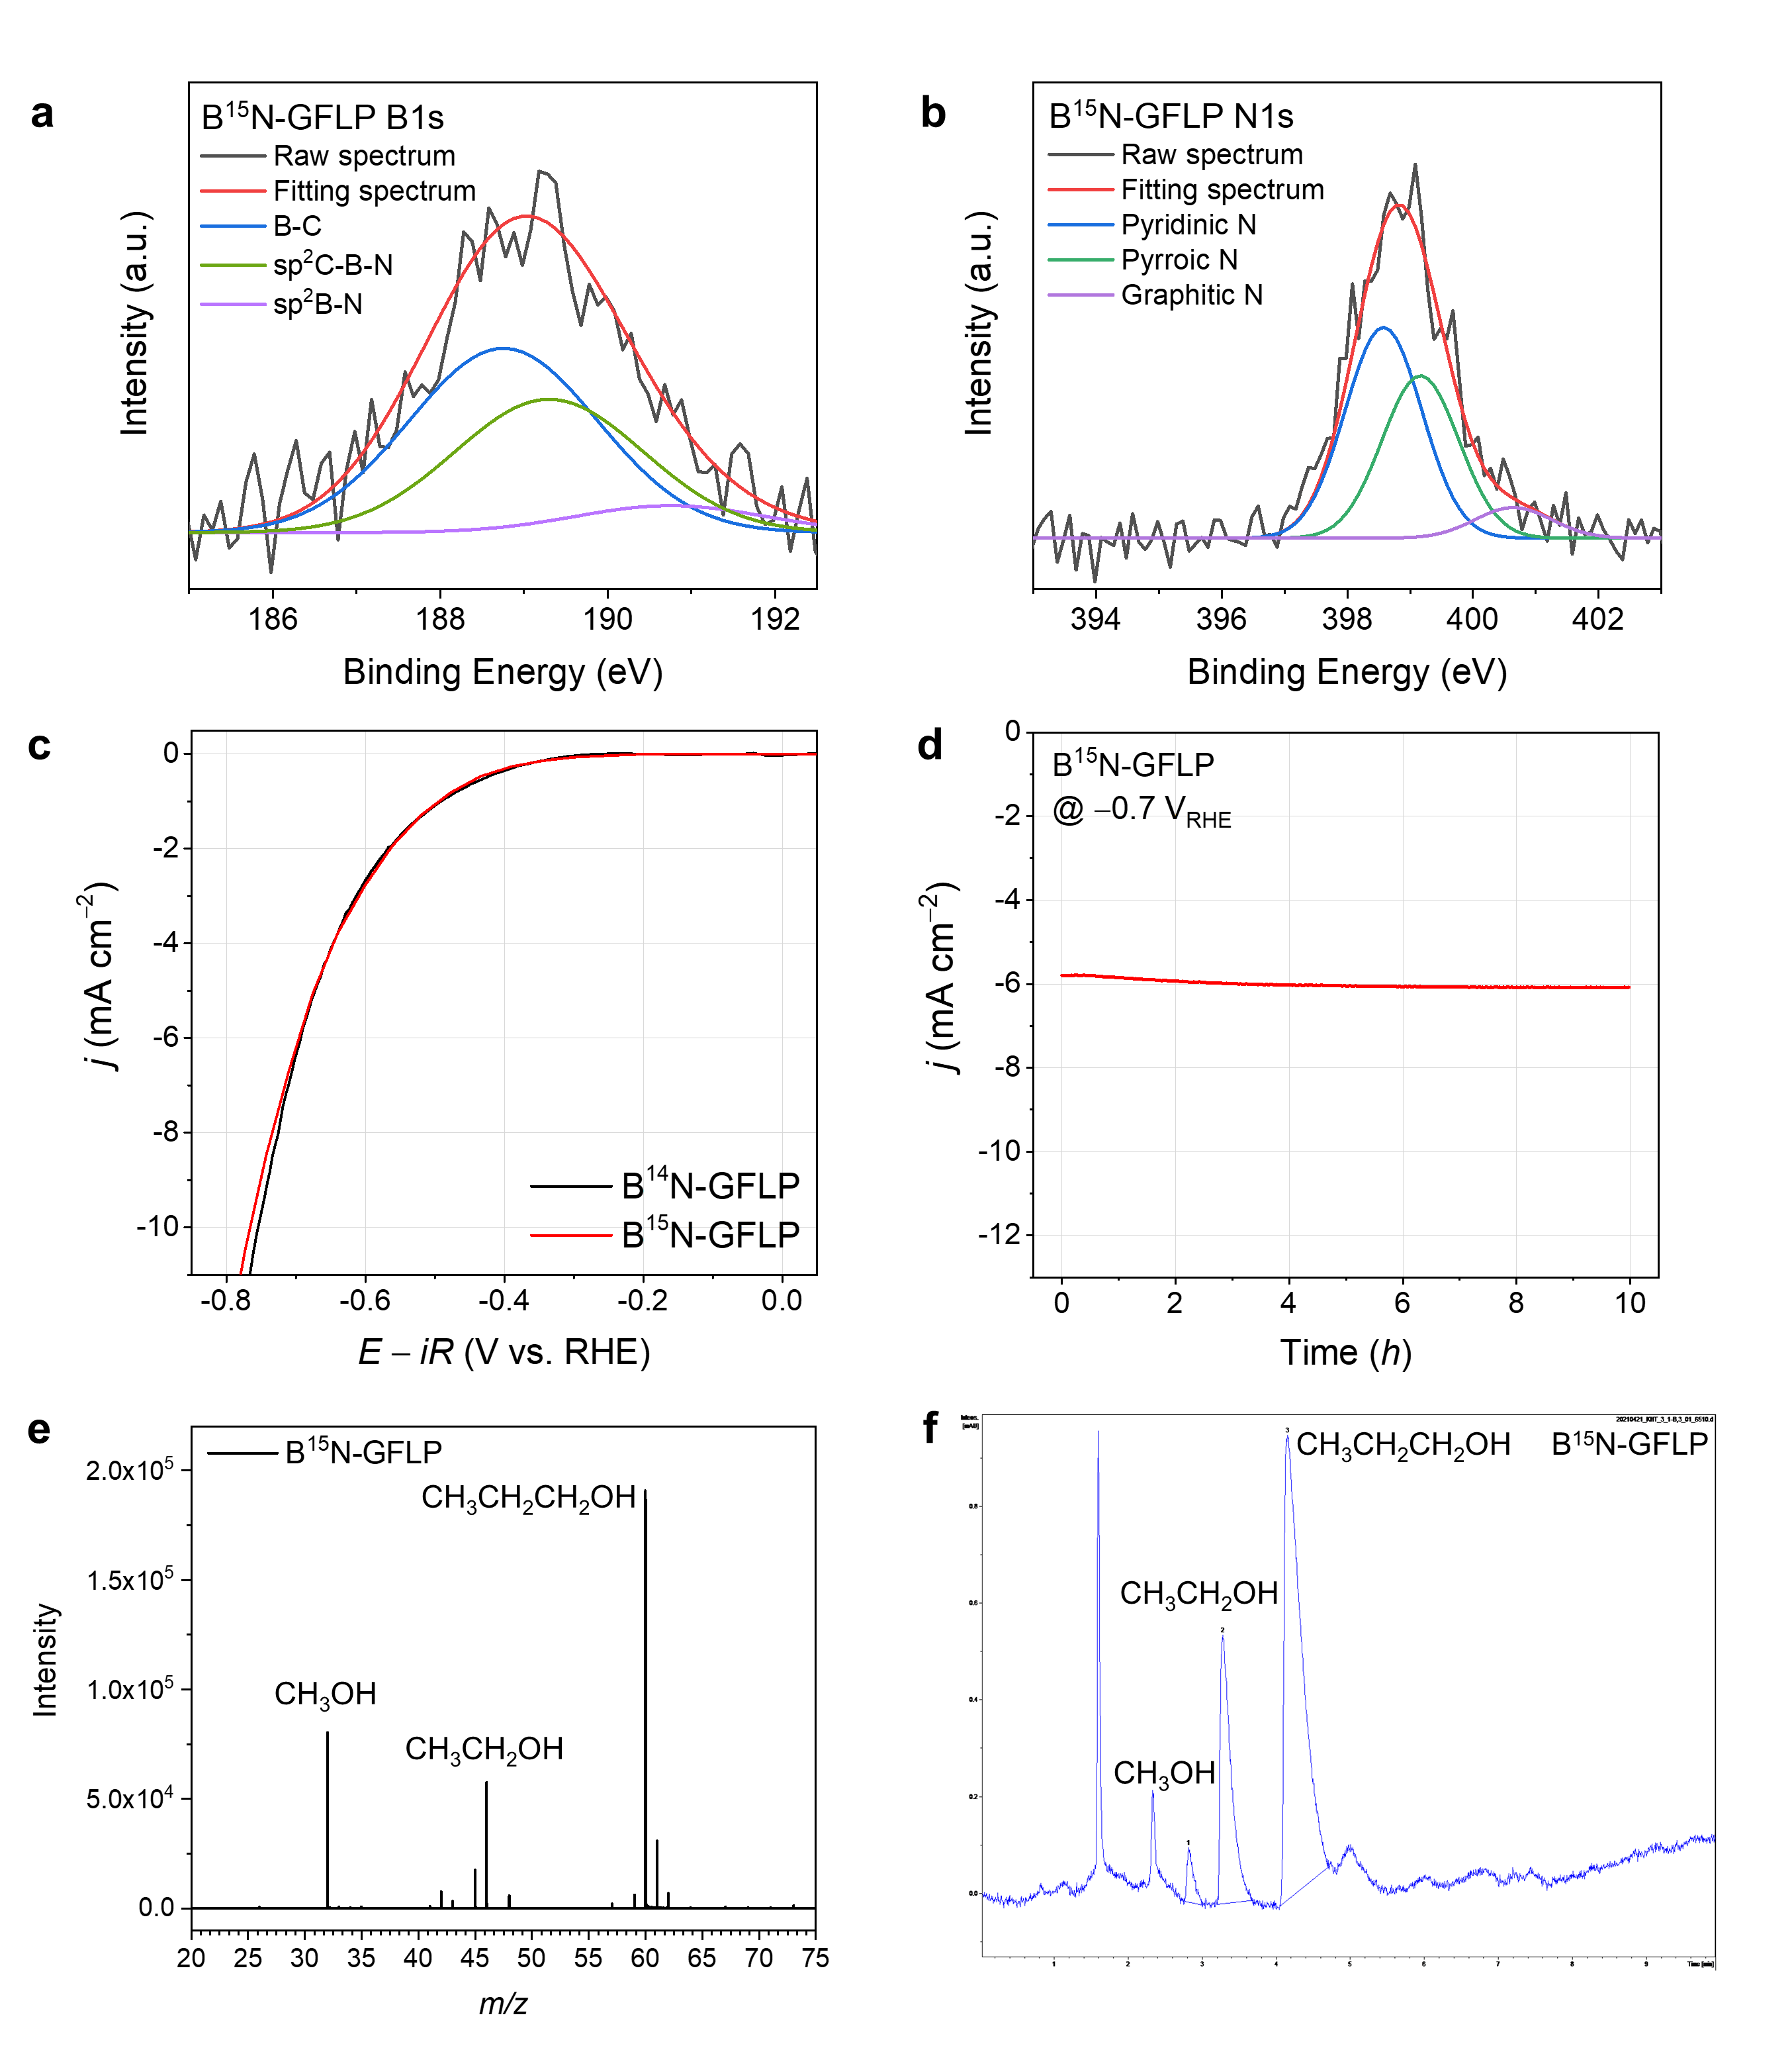
Supplementary Fig. 18┃CO₂R performance and products of B¹⁵N-GFLP. Deconvoluted (a) B1s and (b) N1s XPS spectra in B¹⁵N-GFLP. (c) LSV of B¹⁴N-GFLP and B¹⁵N-GFLP. (d) Plot of current density versus time of B¹⁵N-GFLP at constant voltages of -0.7 V_{RHE}. (e) ESI-MS and (f) HPLC spectra of CO₂R products of B¹⁵N-GFLP catalyst after 10 hr electrolysis at -0.7 V.
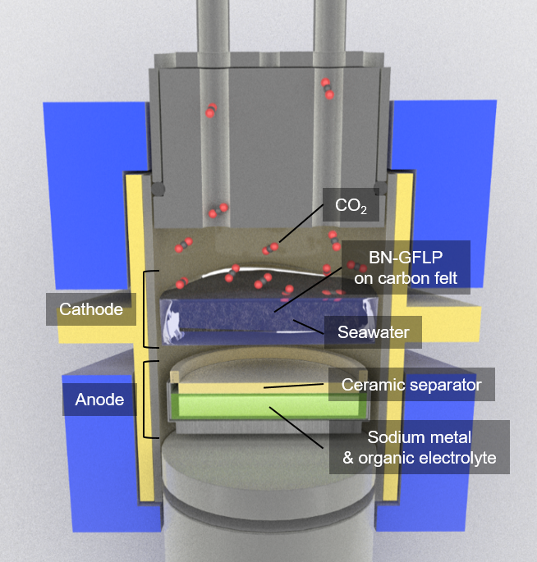
Supplementary Fig. 19┃The schematic illustration of home-built Swagelok type seawater battery cell. Schematic architecture of home-built Swagelok type seawater battery consisting of Na-metal anode, ceramic separator, seawater catholyte, and BN-GFLP contained carbon cathode.

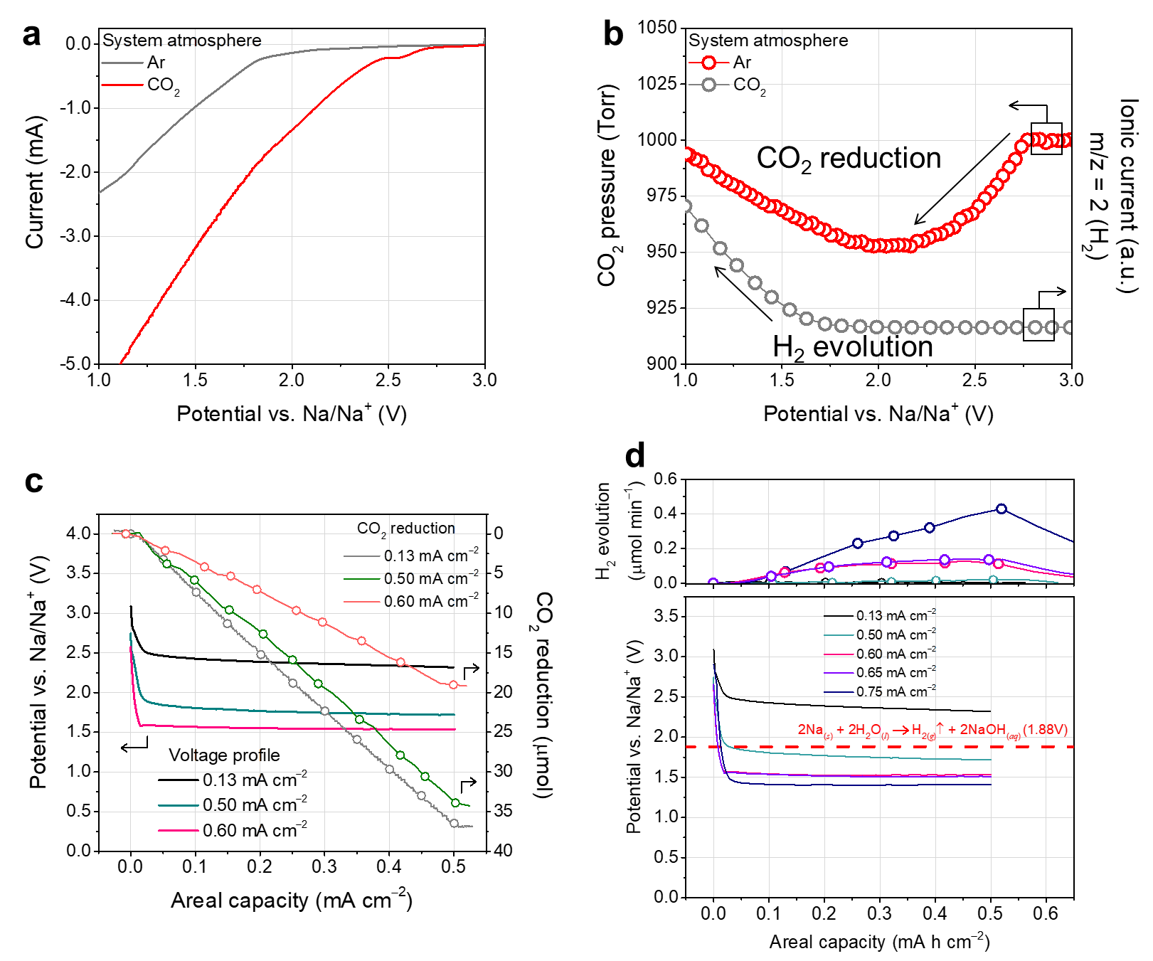
Supplementary Fig. 20┃CO₂R selectivity of BN-GFLP from HER in CBS system. (a) LSV profiles of BN-GFLP catalyst at different system atmosphere with voltage window of 3.0 V–1.0 V vs Na/Na⁺ and voltage sweep speed of 0.1 mV s^{–1}. (b) The corresponding inner pressure decay (red color) and complementary DEMS (grey color) result. (c) Galvanostatic discharge voltage profiles of CBS system with various catalysts at fixed current density of 0.13, 0.50, and 0.60, mA cm^{–2} and the corresponding quantitative CO₂ gas consumption plot during galvanostatic discharge process. (d) Galvanostatic discharge voltage profiles at various current densities at 0.13, 0.50, 0.60, 0.65 and 0.75 mA cm⁻² and corresponding DEMS results.
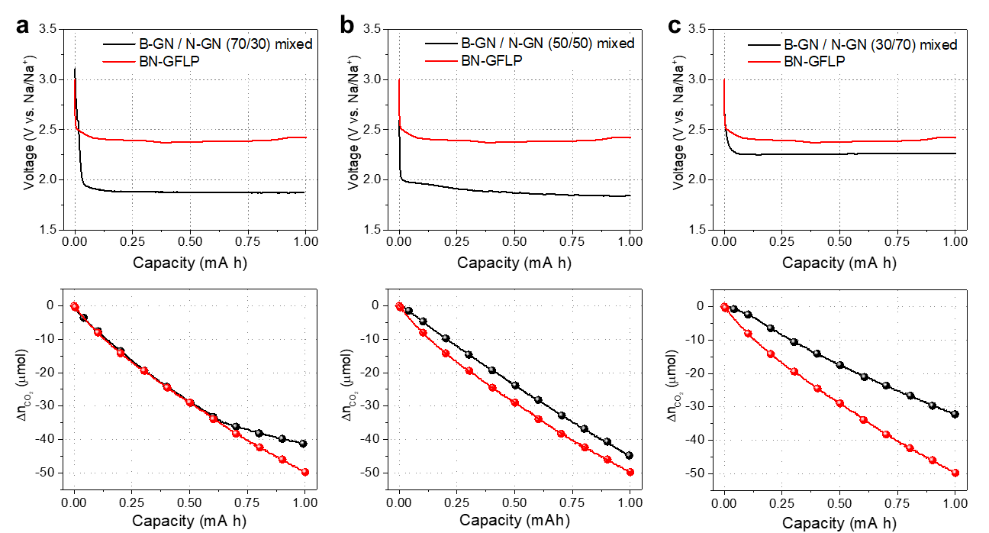
Supplementary Fig. 21┃ CO₂R performance of physically mixed B-GN and N-GN cathode in CBS system. To demonstrate the effect of BN-GFLP structure for CO₂R, we prepared physically mixed B-GN and N-GN electrode with different component ratios (B-GN / N-GN), (a) 70 / 30, (b) 50 / 50, and (c) 30 / 70. First row is Galvanostatic discharge voltage profiles, and second row is the quantitative CO₂ gas consumption plot during galvanostatic discharge process. In the excess of B-GN (a), CO₂ reduction performance was corresponding to BN-GFLP due to the catalytic effect of Lewis acid (LA), but discharging potential was lower about Δ0.5 V than that of BN-GFLP. In contrast, the excess of N-GN (c) sample showed similar discharging potential of BN-GFLP due to the enhanced reaction rate by Lewis base (LB), but its CO₂ reduction performance was lower than that of the BN-GFLP. Furthermore, half mixed ratio (b) sample showed poor discharging potential and CO₂ reduction compared to BN-GFLP because of Lewis acid-base adduct formation and π-π restacking of mixed B-GN and N-GN by Van der Waals interaction. BN-GFLP (red line) showed synergetic effect of LA (enhanced catalytic activity) and LB (increase of reaction rate), thereby lowered CO₂ reduction overpotential and also significantly enhanced CO₂ reduction performance. From these physically mixed experiment, co-anchoring LA and LB on the graphitic framework was the key design strategy for catalytic cathode of CBS system.

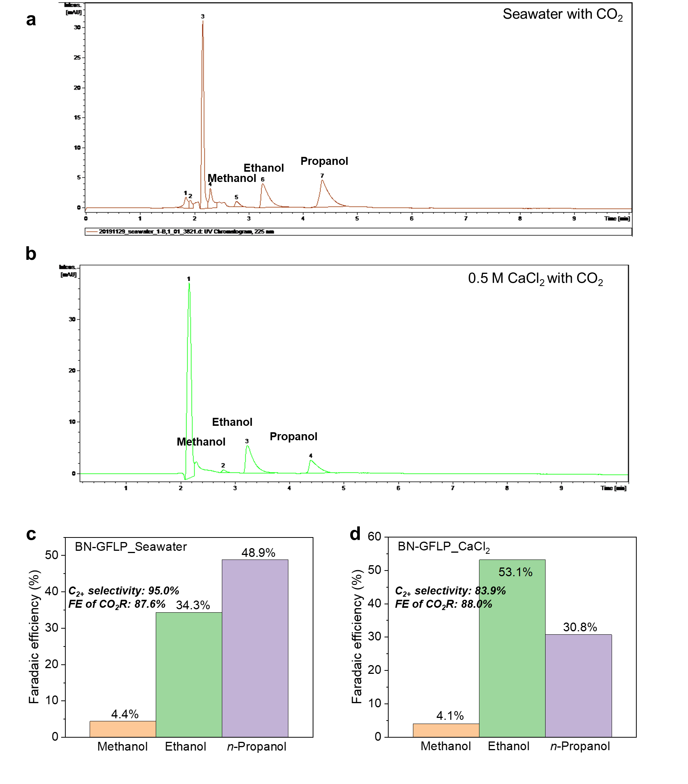
Supplementary Fig. 22┃ Product analysis. High performance liquid chromatography (HPLC) spectra of CO₂R products of BN-GFLP in (a) seawater and (b) 0.5 M CaCl₂ saline electrolytes after 10 h electrolysis. Faradaic efficiency (FE) values of C₁₋₃ products on BN-GFLP in different electrolytes, (c) seawater with CO₂ and (d) 0.5 M CaCl₂ saline electrolyte with CO₂ saturation after 10 h electrolysis.

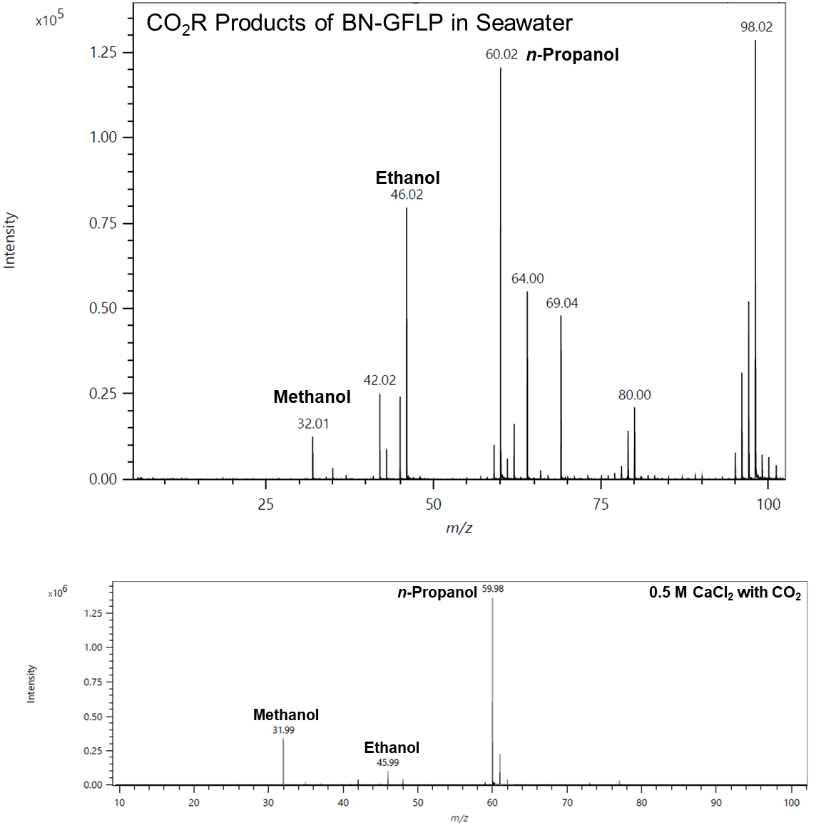
Supplementary Fig. 23┃Electrospray ionization mass spectroscopy (ESI-MS). CO₂R products of BN-GFLP in seawater and 0.5 M CaCl₂ saline electrolyte after 10 h electrolysis.

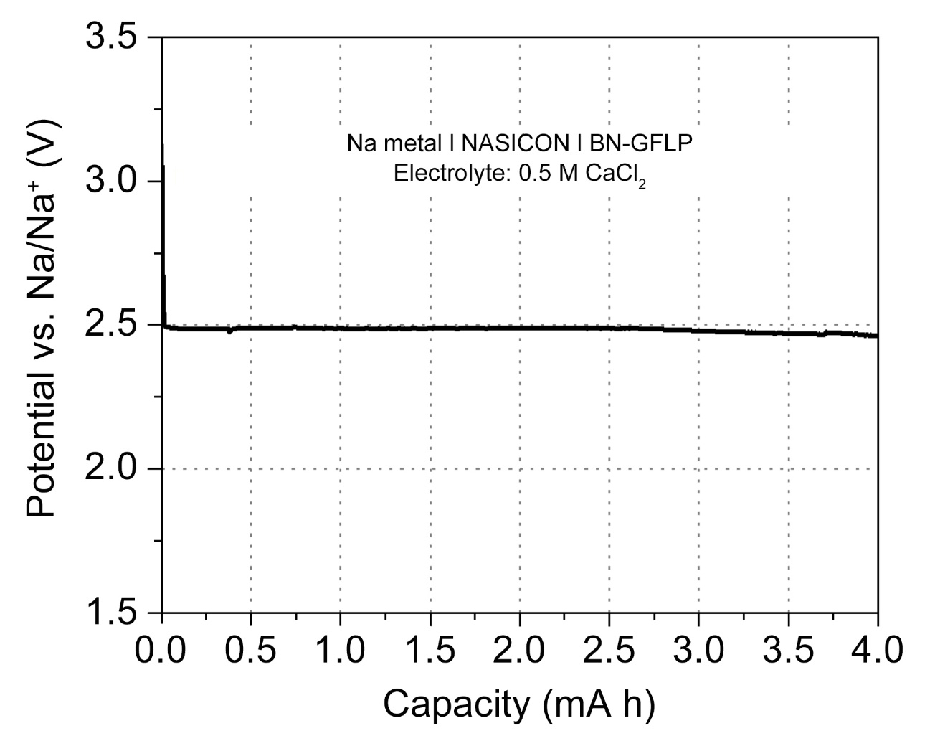
Supplementary Fig. 24┃ Galvanostatic discharge voltage profiles. BN-GFLP based CBS system in 0.5 M CaCl₂ saline electrolyte with CO₂ saturation at fixed current density of 0.13 mA cm^{–2}.

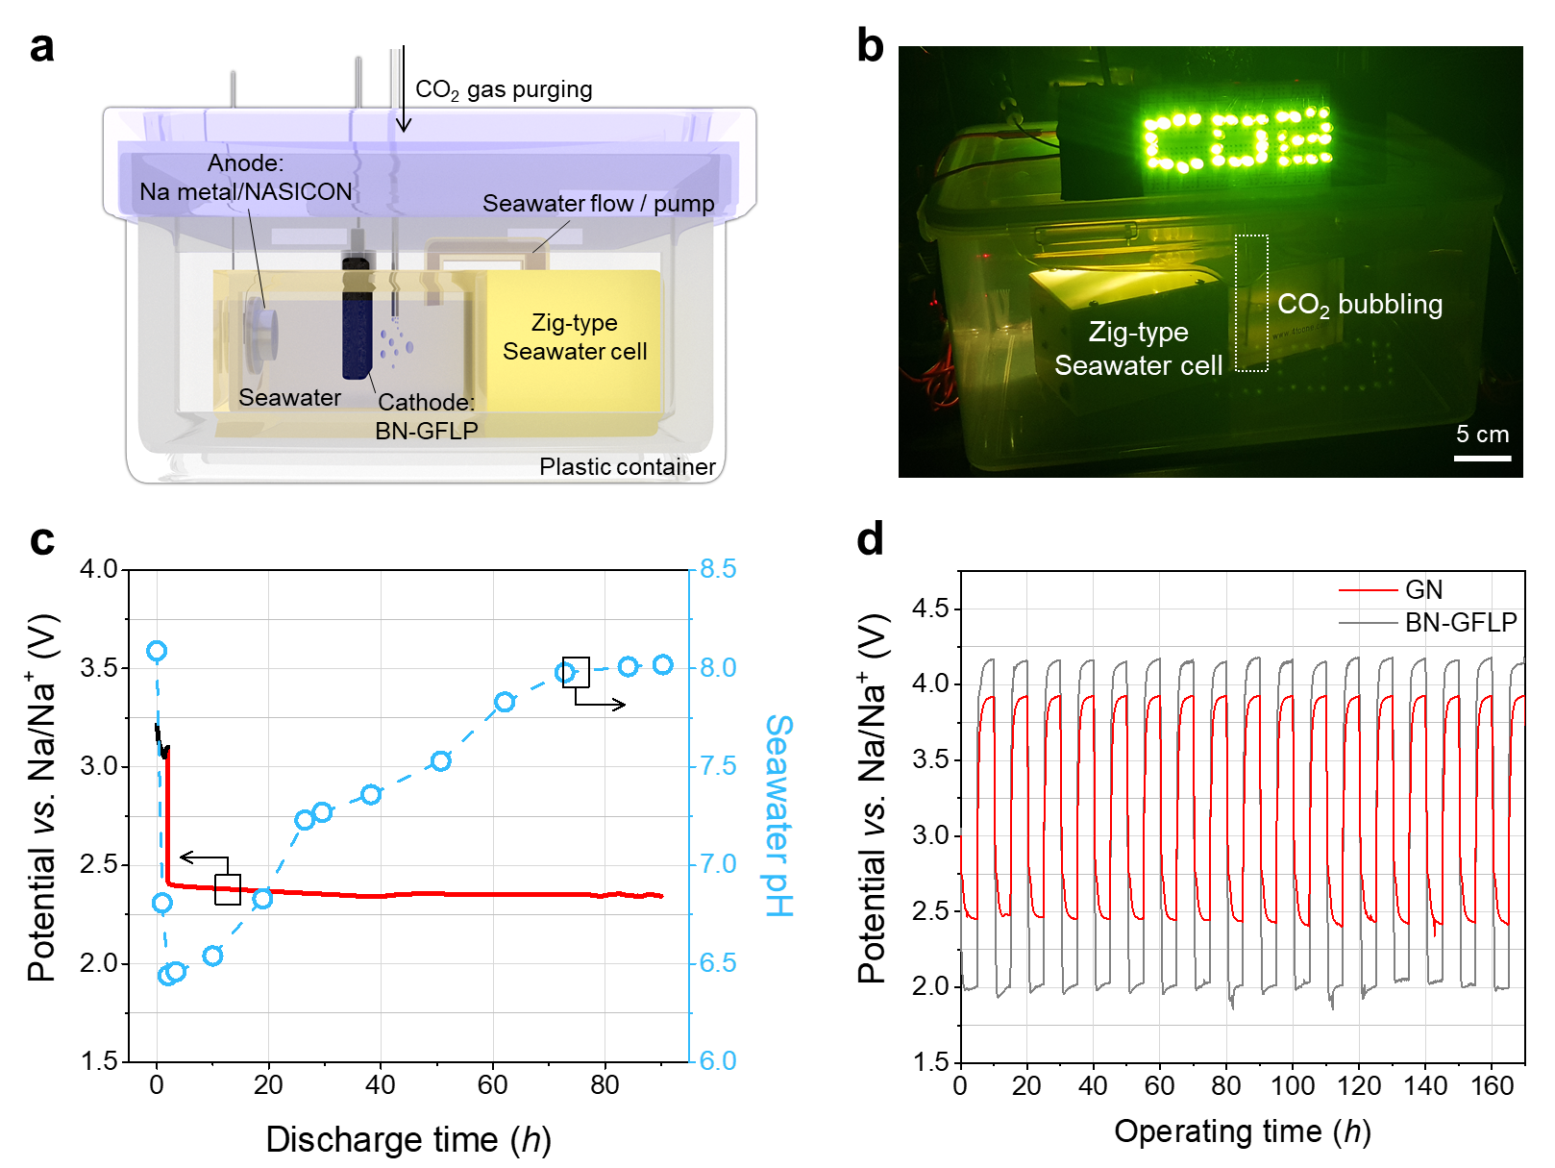
Supplementary Fig. 25┃ Rechargeable CO₂ electrolysis system and stability of the CBS cell with the BN-GFLP cathode during CO₂R. (a) Schematic of the zig-type CBS system. (b) Digital photograph of 36 LEDs powered by the CBS system. (c) Seawater pH as a function of time during CO₂R with a fixed current density of 0.13 mA cm^{–2}. The pH was controlled by bubbling CO₂ into the seawater. (d) Galvanostatic charge–discharge voltage plots of zig-type CBS cells with BN-GFLP (red) and control GN (grey) cathodes.

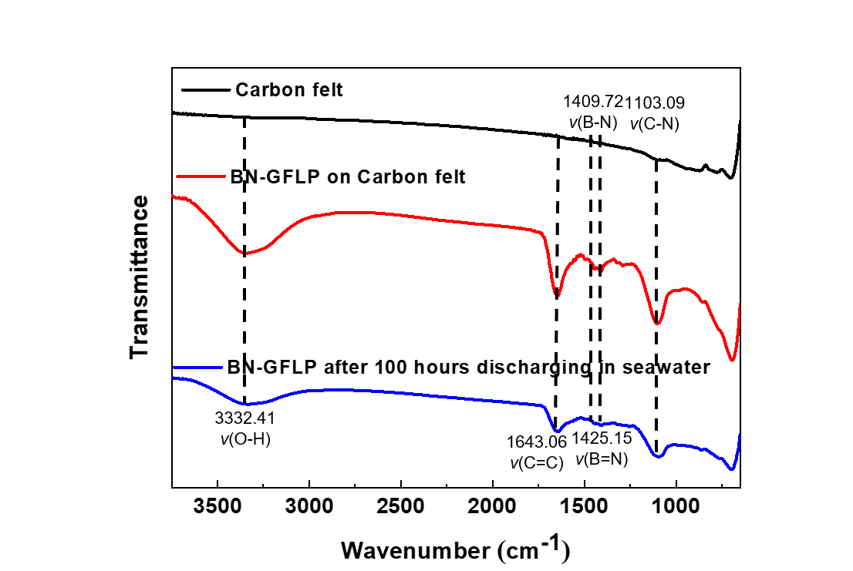
Supplementary Fig. 26┃FT-IR spectroscopy of BN-GFLP cathode. After 100 hours of discharging in CBS system, BN-GFLP cathode was well retained chemical structure, and there were no calcification phenomena on the surface of BN-GFLP cathode.
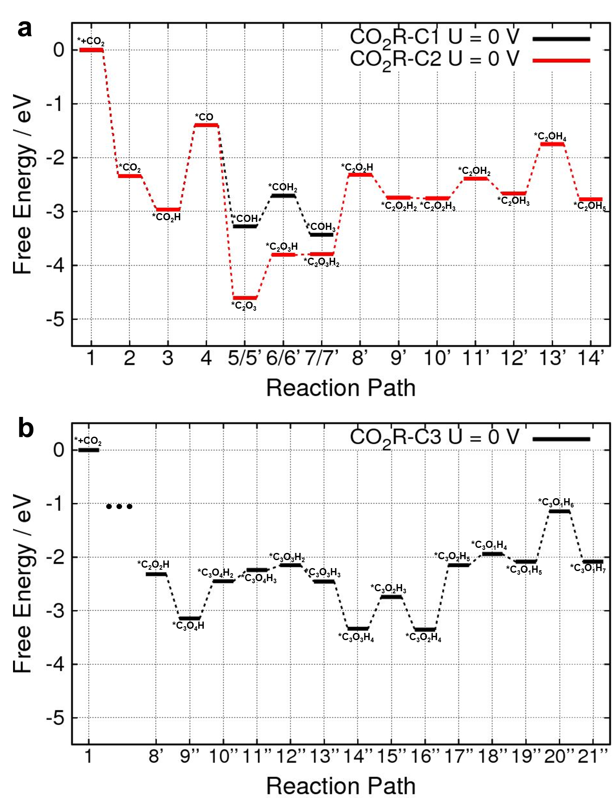
Supplementary Fig. 27┃Full Gibbs free energy plots for (a) C₁ and C₂ production (b) C₃ production.

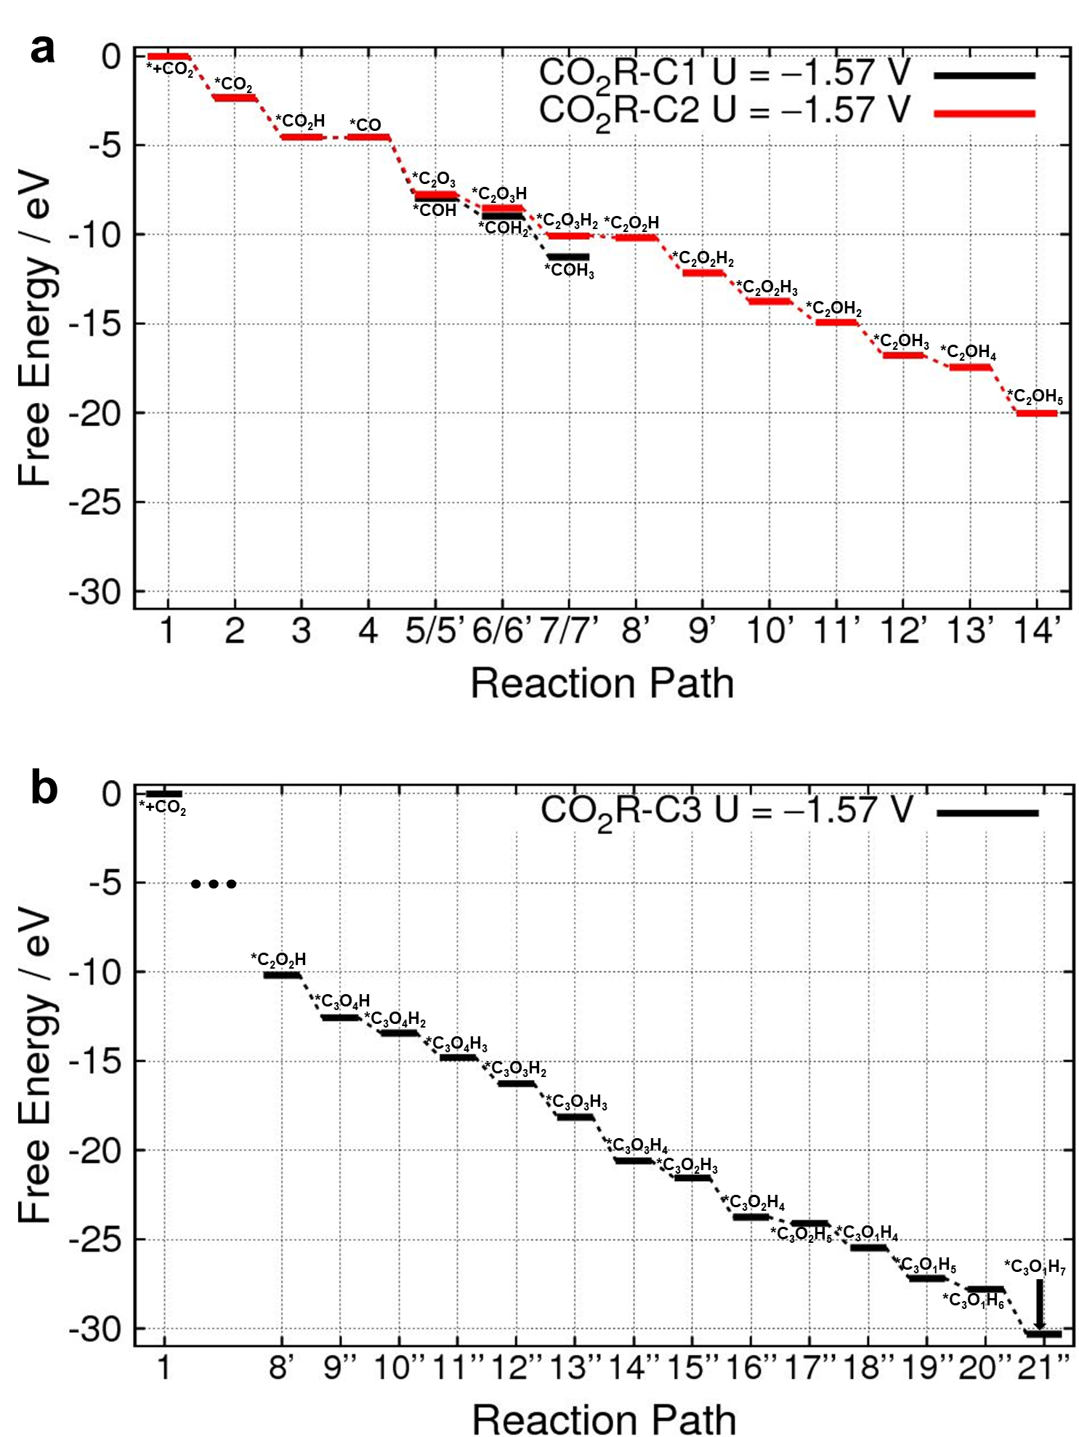
Supplementary Fig. 28┃Full Gibbs free energy plots in U = -1.57 V for (a) C₁ and C₂ production (b) C₃ production.

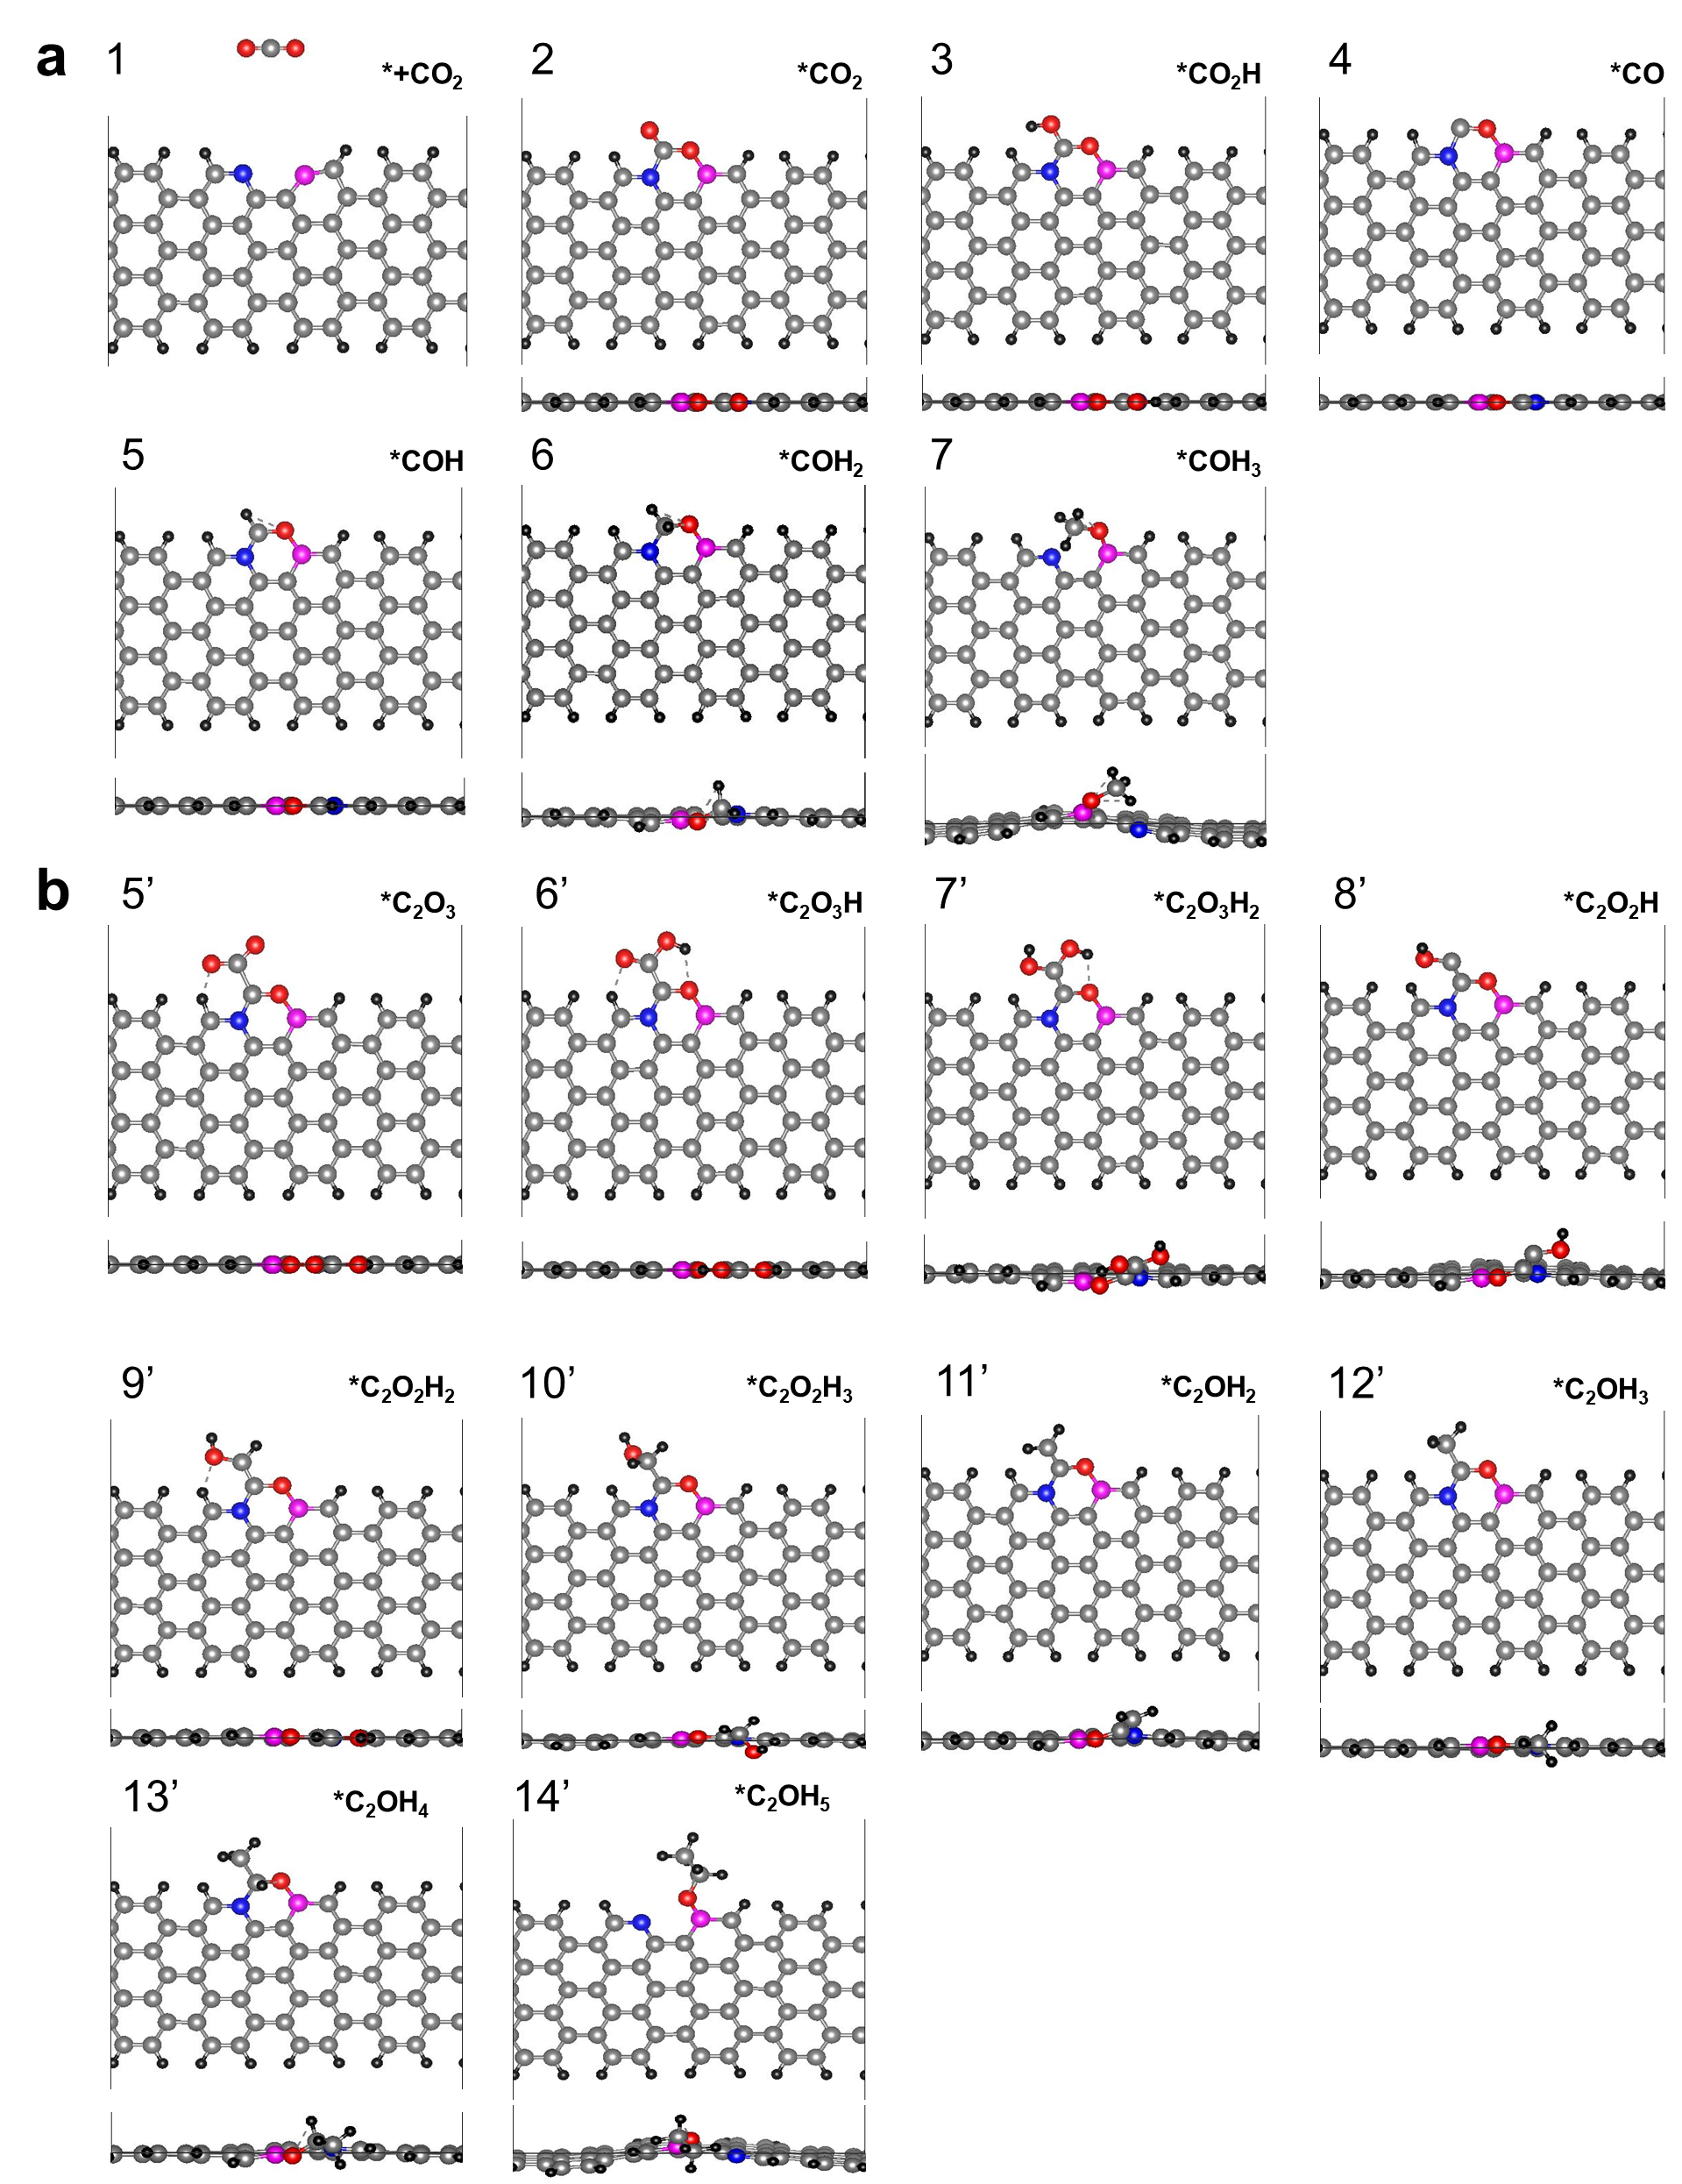
Supplementary Fig. 29┃Optimized structures of each intermediates in (a) C₁ product (b) C₂ product. Each number denotes the corresponding steps in Gibbs free energy plot, Supplementary Fig. 27a. The color of the corresponding atom: hydrogen (black), nitrogen (blue), boron (purple), carbon (grey), and oxygen (red).

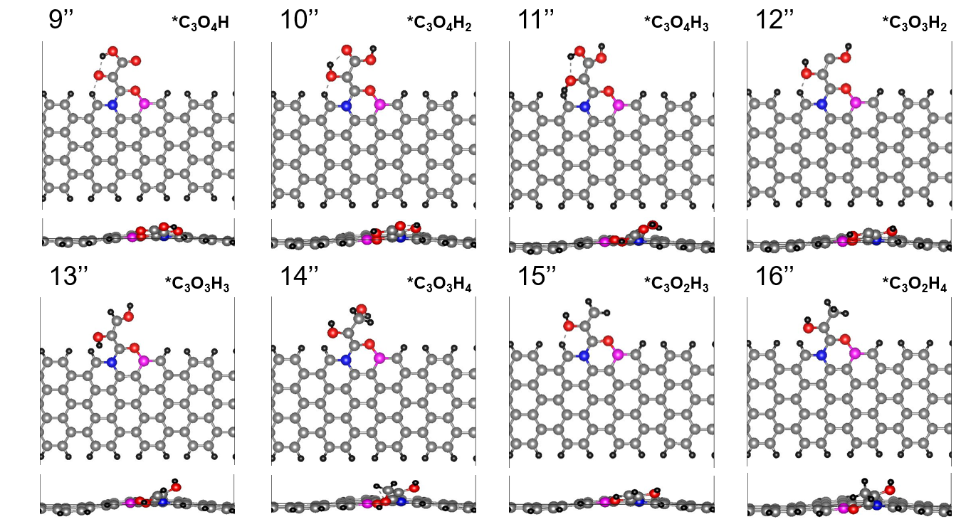
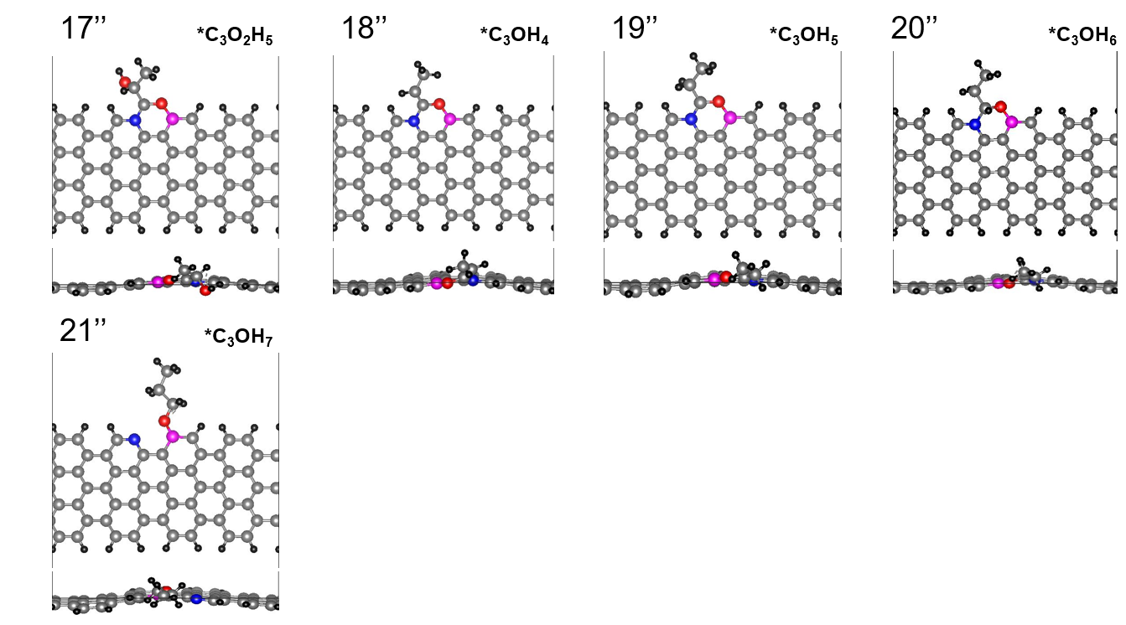
Supplementary Fig. 30┃Optimized structures of each intermediates in C₃ product. Each number denotes the corresponding steps in Gibbs free energy plot, Supplementary Fig. 27b. 1st step to 8th step structures are same as C₂ process structure, Supplementary Fig. 27a. The color of the corresponding atom: hydrogen (black), nitrogen (blue), boron (purple), carbon (grey), and oxygen (red).

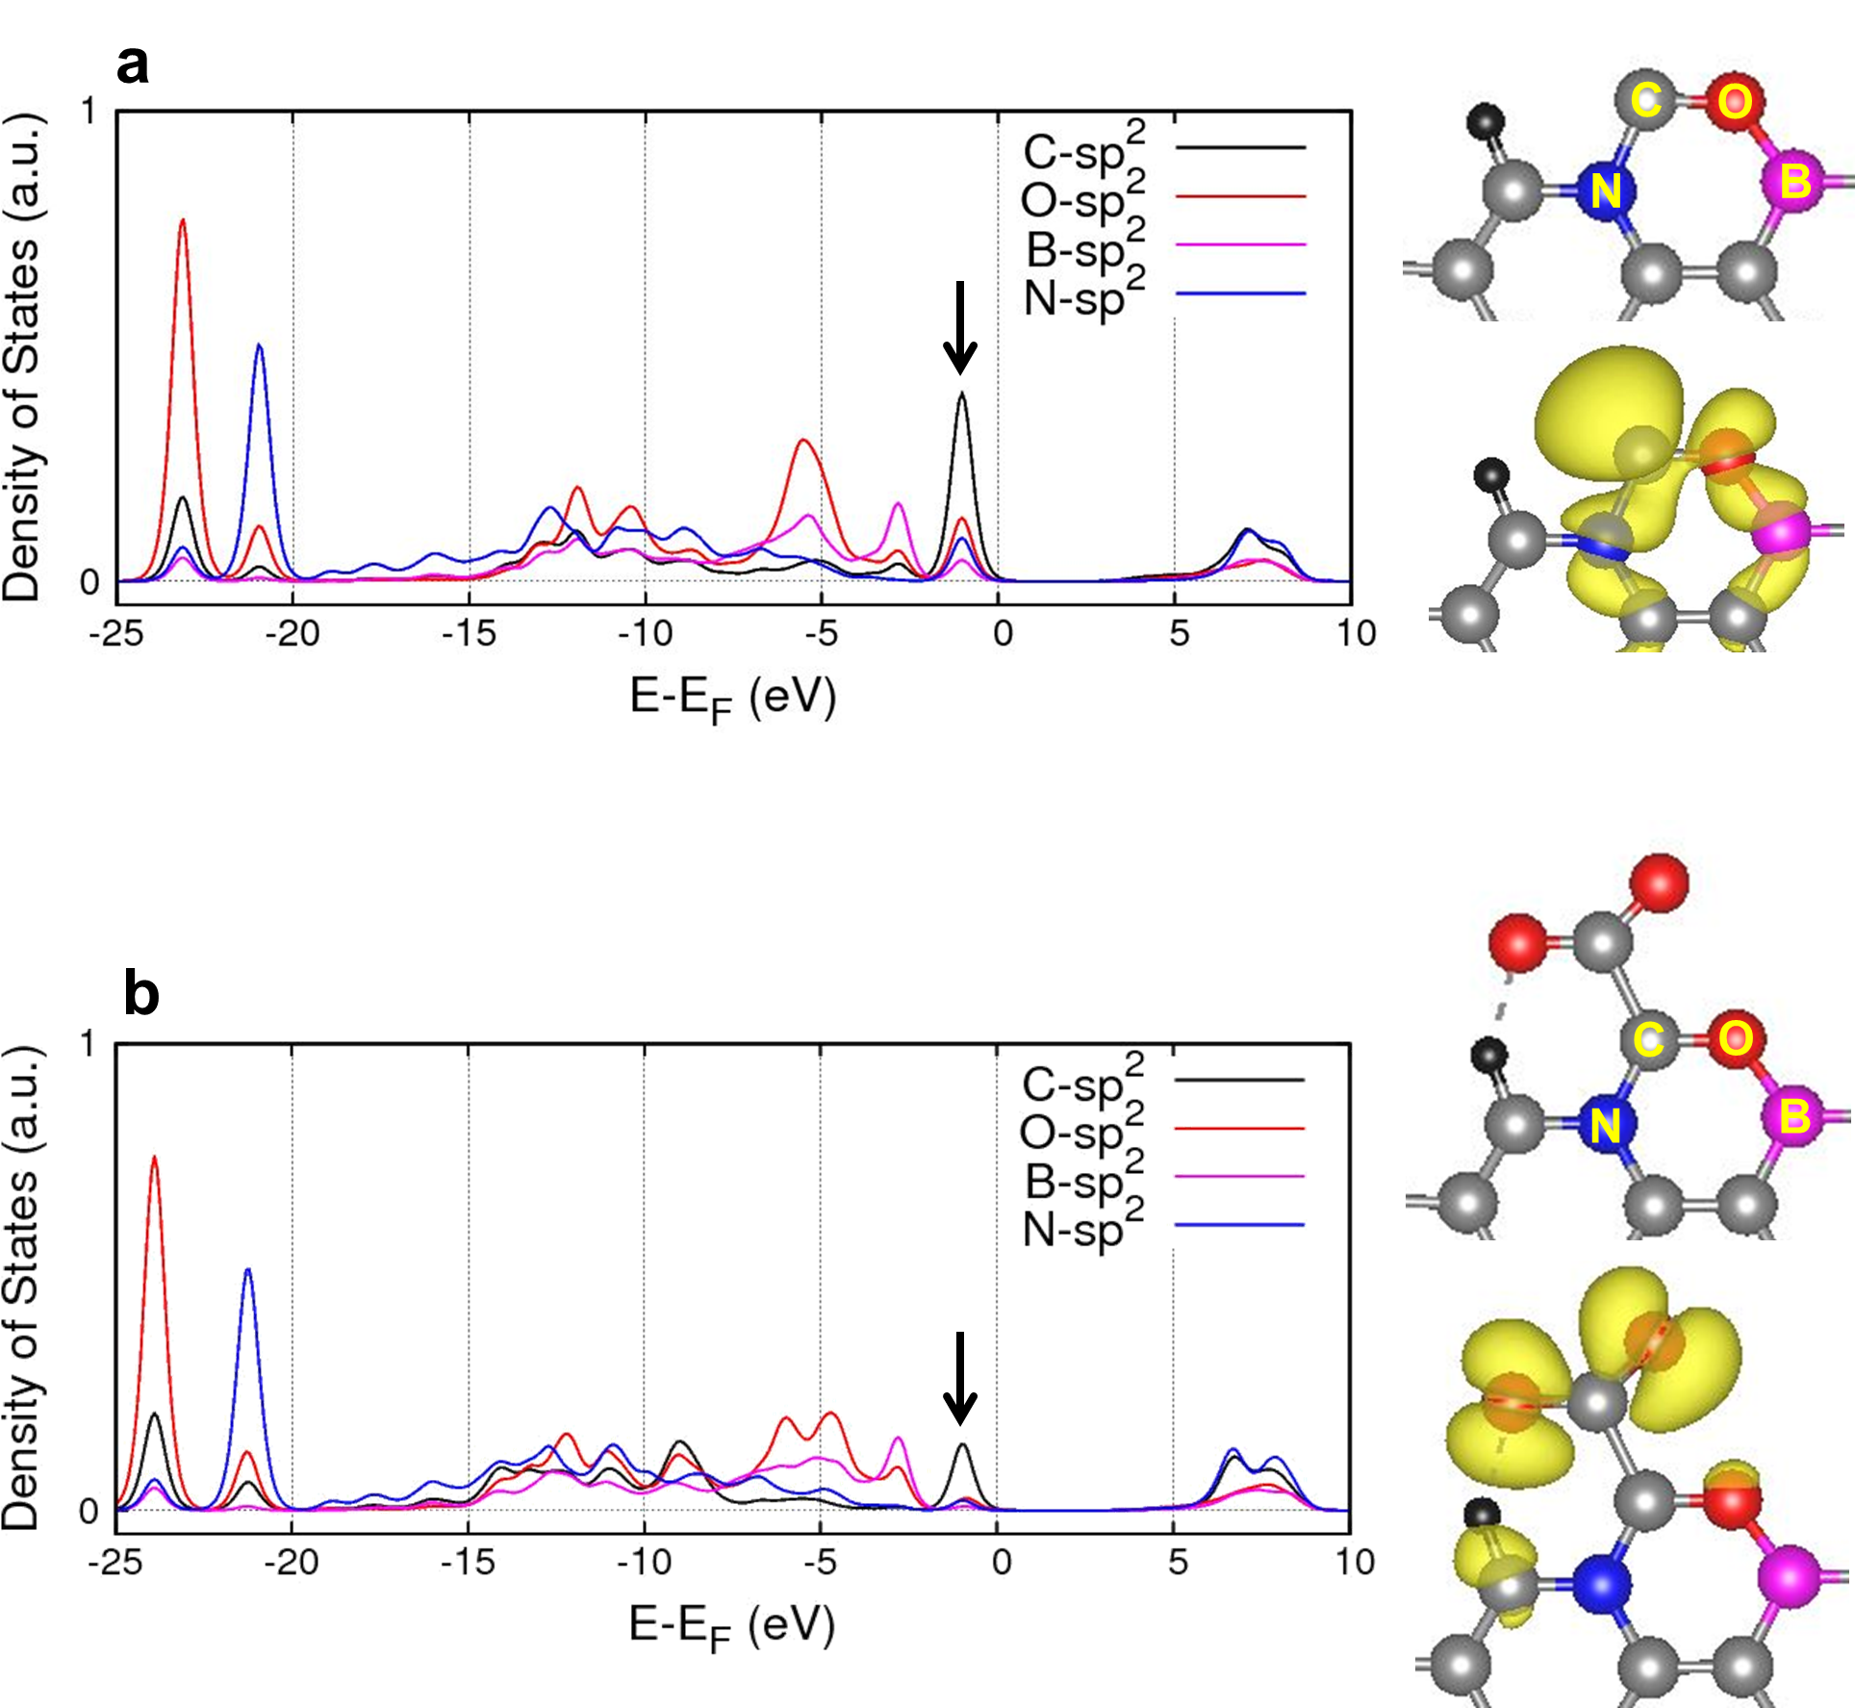
Supplementary Fig. 31┃Computed sp² density of states (PDOS) of CO adsorbed structure (a) and C₂O₃ adsorbed structure (b). Searched atoms are indicated in yellow text on right structure. The MO shape of each structure indicates the DOS peak in green arrow.

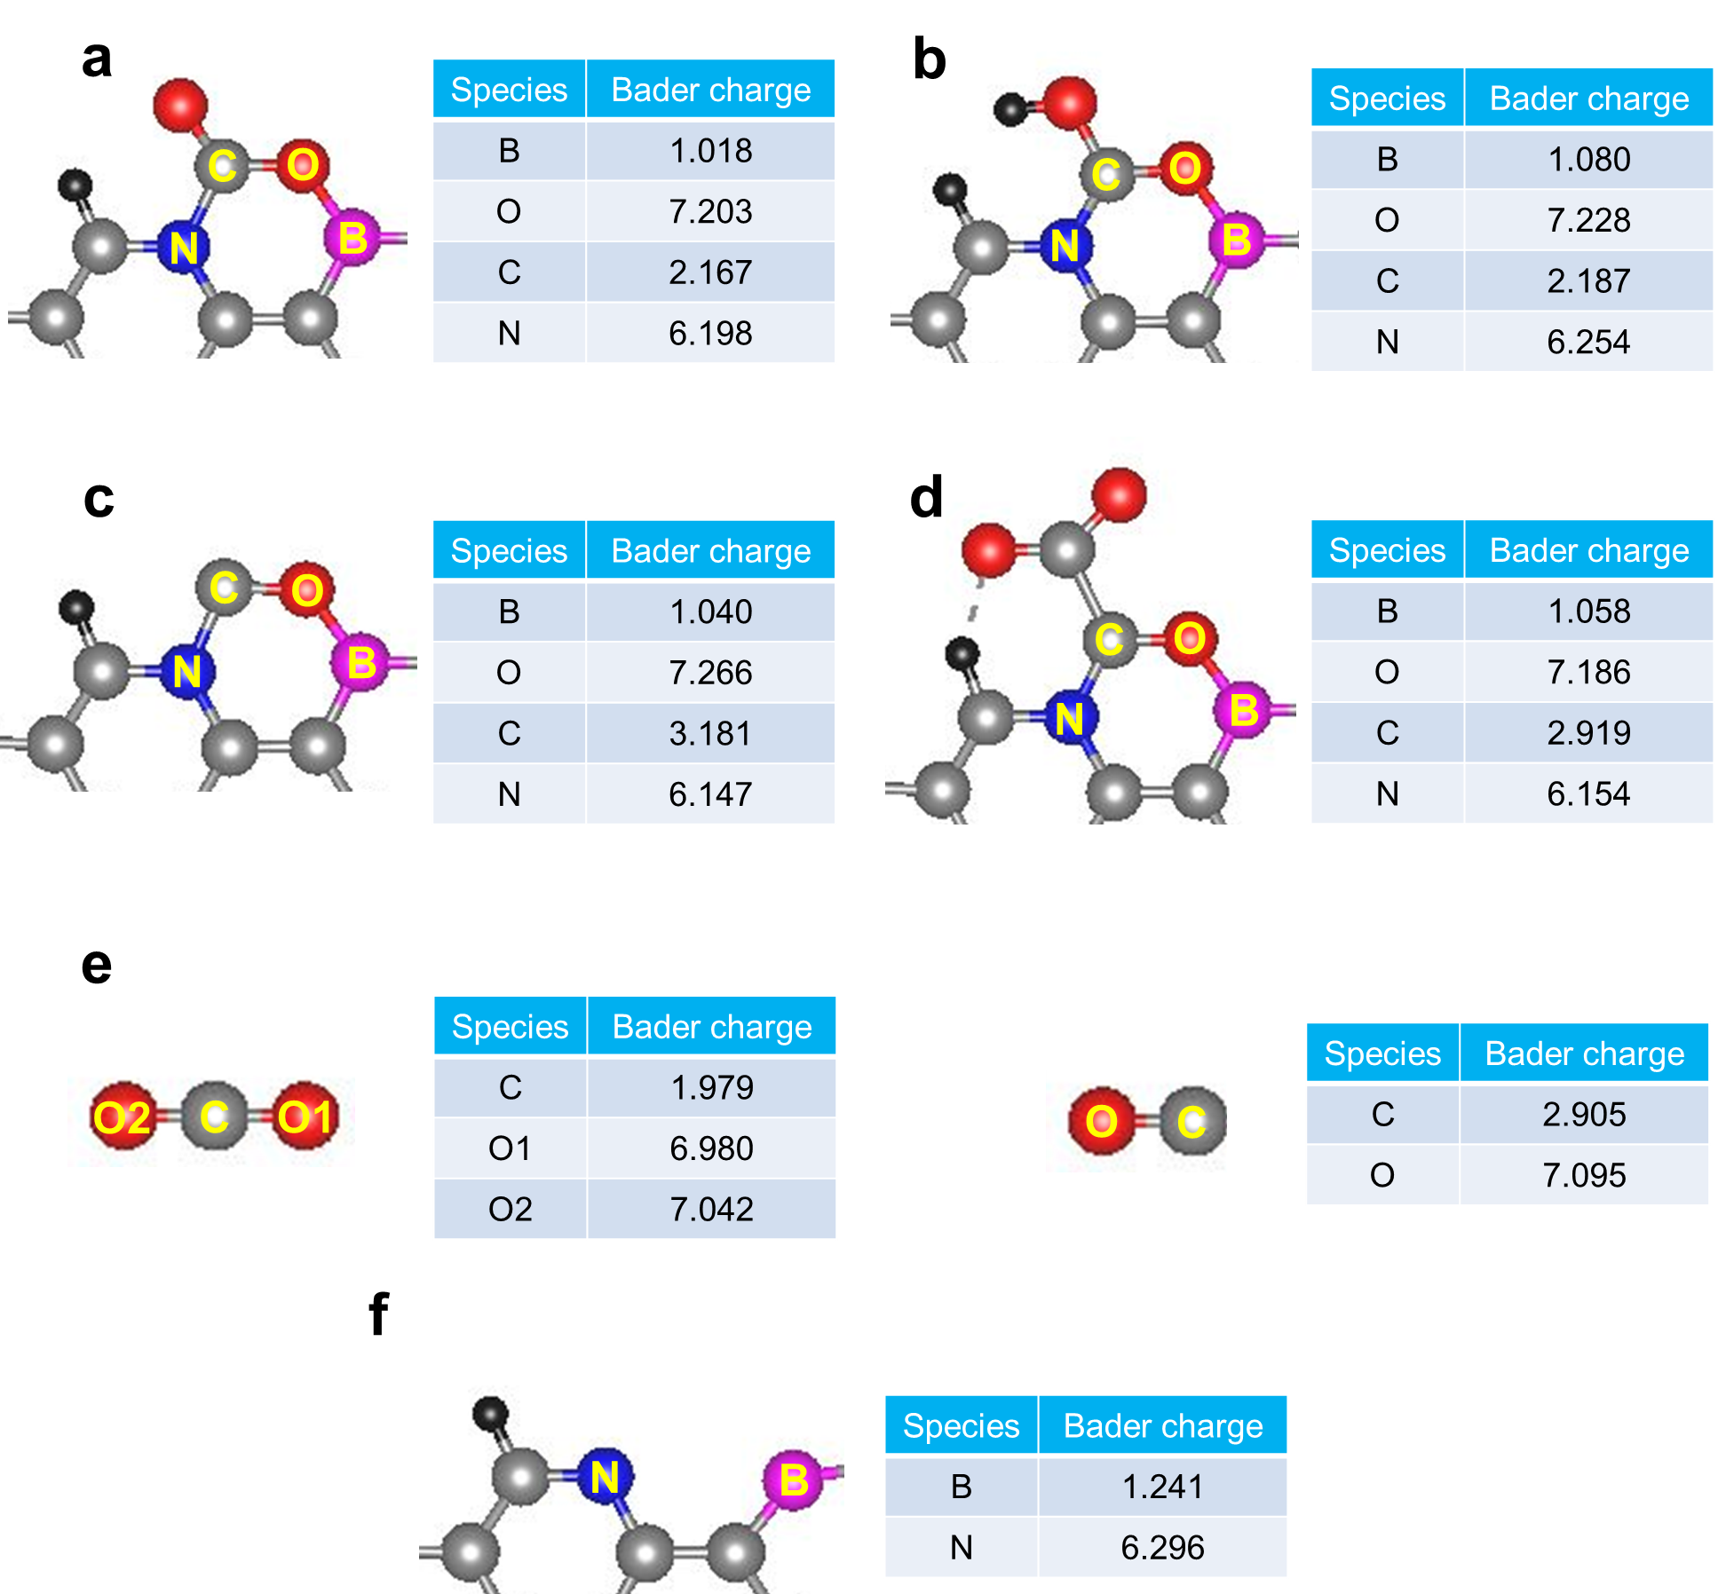
Supplementary Fig. 32┃Computed Bader Charge Analysis of CO₂ adsorbed structure (a) CO₂ adsorbed structure (b) CO₂H adsorbed structure (c) CO adsorbed structure (d) C₂O₃ adsorbed structure (e) CO₂ and CO molecules (f) pristine BN structure in BN-GFLP. Searched atoms are indicated in yellow text on left structure.

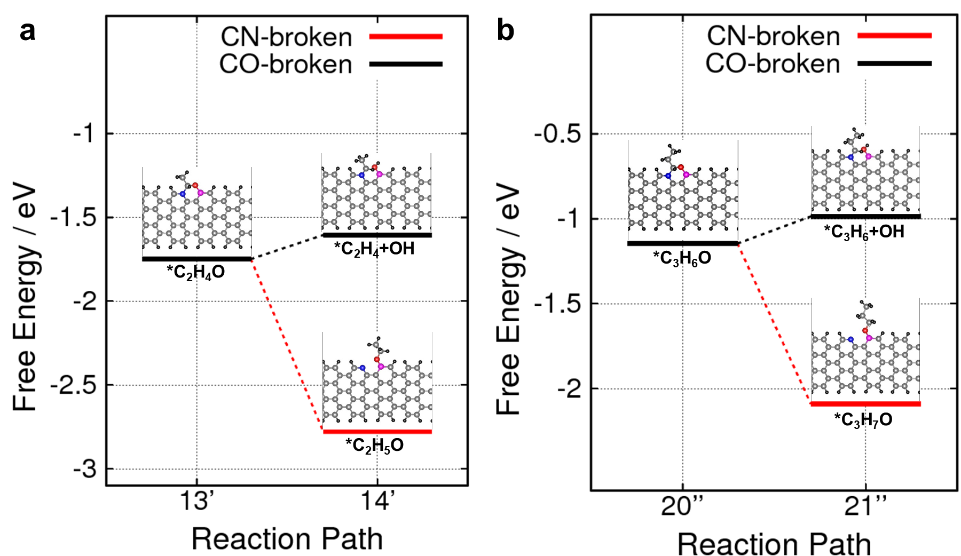

Supplementary Fig. 33┃Gibbs free energy comparison of C-O bond breakage and C-N bond breakage in applied potential U = 0 V, for (a) ethanol production and (b) n-propanol production. Optimized structures for each step are shown in upward of Gibbs free energy graph.

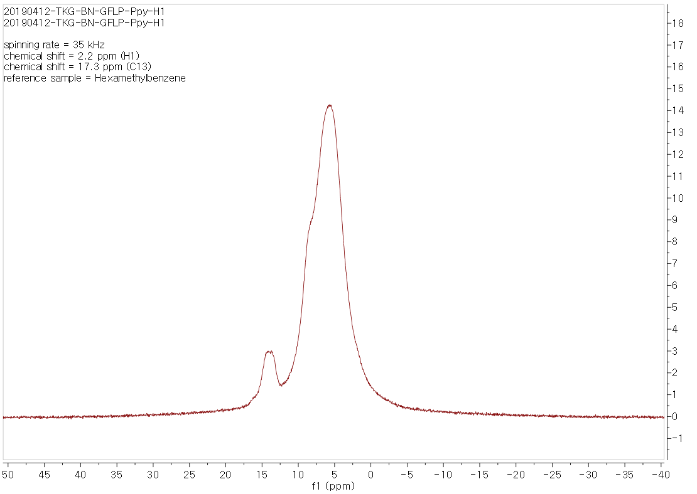
Supplementary Fig. 34┃¹H magic angle spinning nuclear magnetic resonance spectrum of pyrrole adsorbed on BN-GFLP.

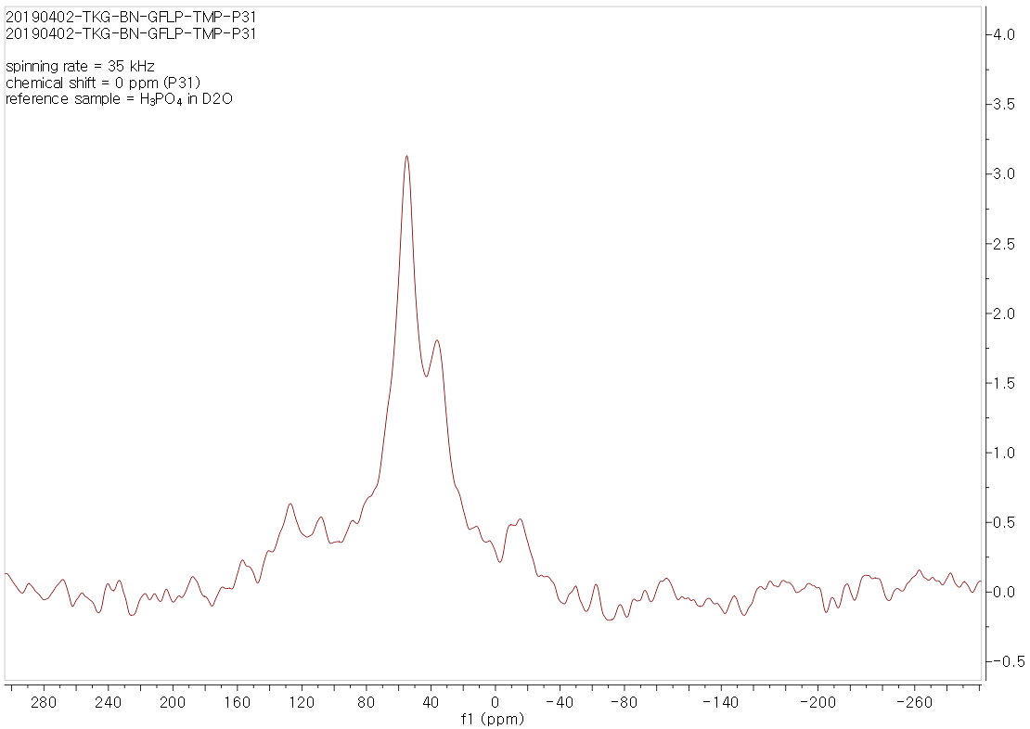
Supplementary Fig. 35┃³¹P magic angle spinning nuclear magnetic resonance spectrum of TMP adsorbed on BN-GFLP.
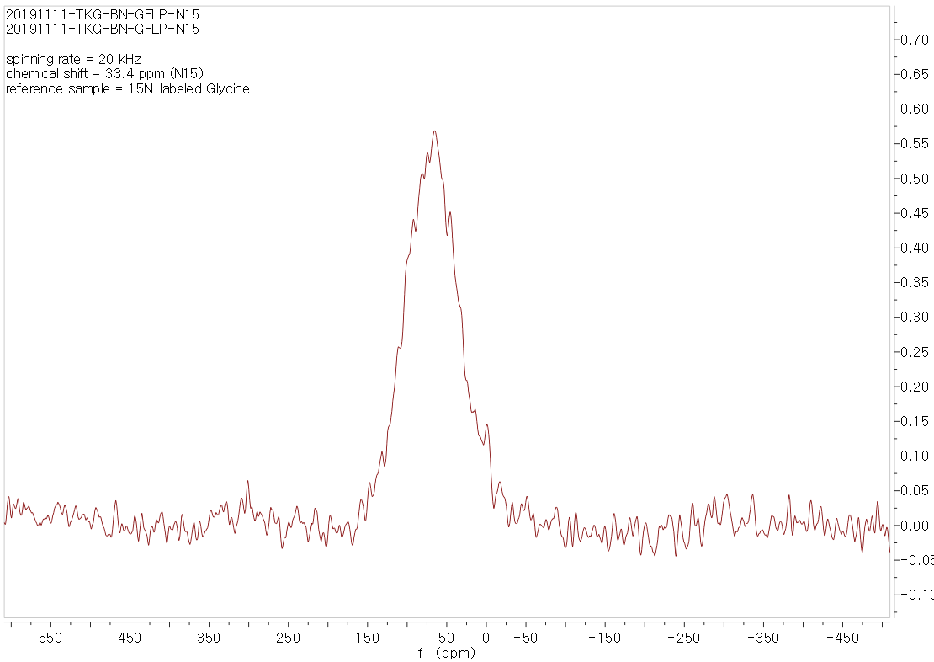
Supplementary Fig. 36┃¹⁵N magic angle spinning nuclear magnetic resonance spectrum of ¹⁵N urea doped BN-GFLP.
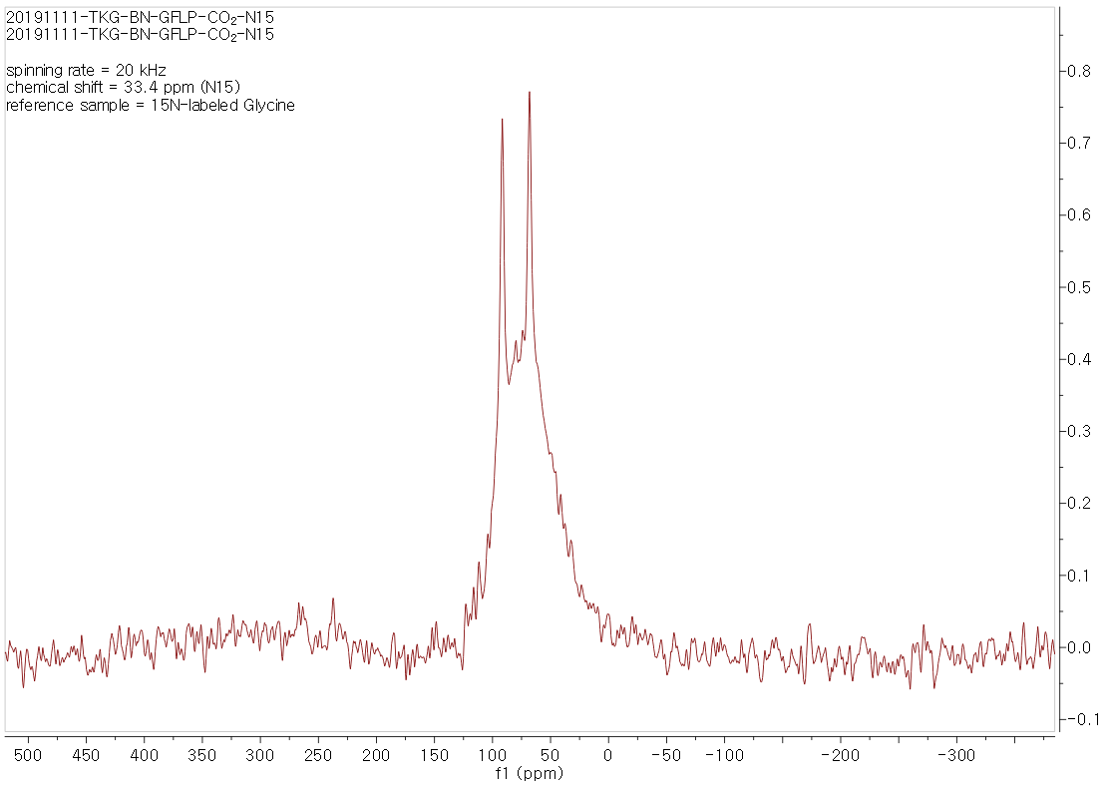
Supplementary Fig. 37┃¹⁵N magic angle spinning nuclear magnetic resonance spectrum of ¹⁵N urea doped BN-GFLP with CO₂ stimulus.
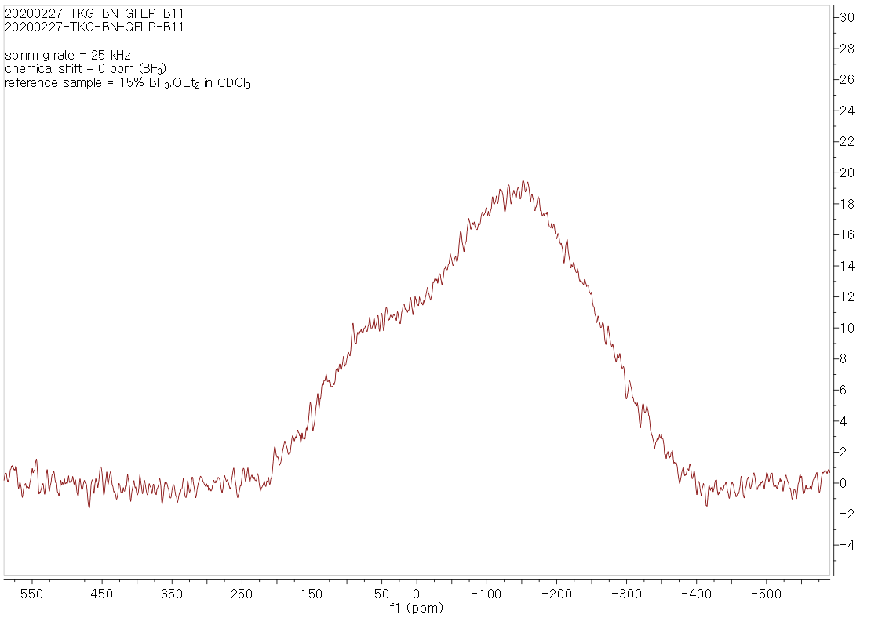
Supplementary Fig. 38┃¹¹B magic angle spinning nuclear magnetic resonance spectrum of BN-GFLP.
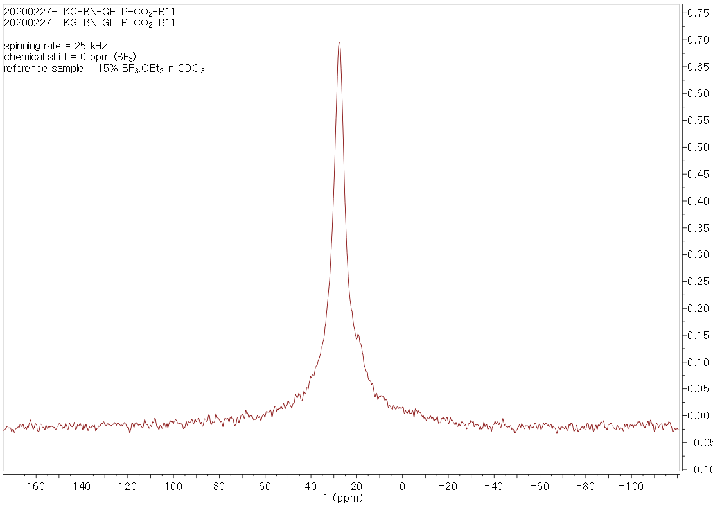
Supplementary Fig. 39┃¹¹B magic angle spinning nuclear magnetic resonance spectrum of BN-GFLP with CO₂ stimulus.

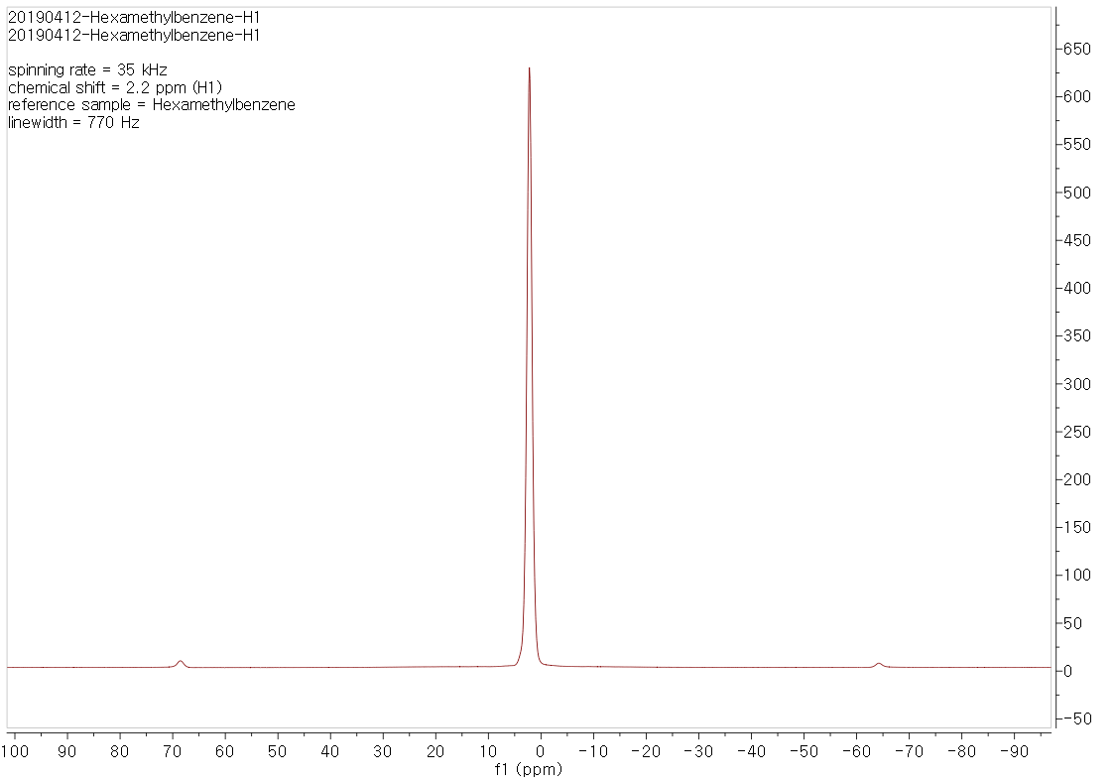
Supplementary Fig. 40┃¹H magic angle spinning nuclear magnetic resonance spectrum of hexamethylbenzene as reference.
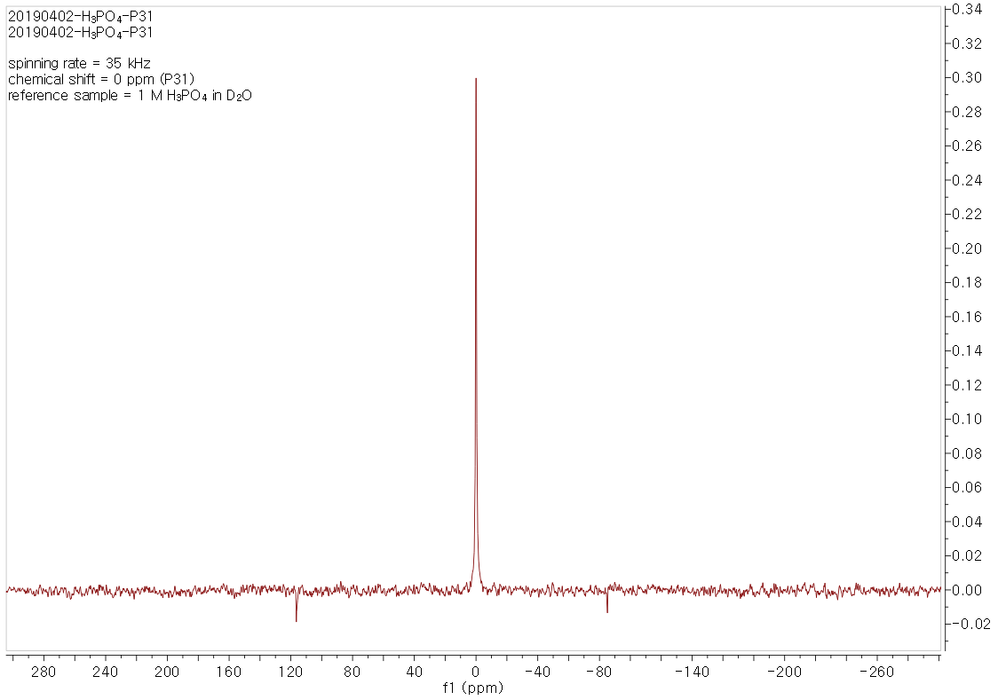
Supplementary Fig. 41┃³¹P magic angle spinning nuclear magnetic resonance spectrum of 1 M H₃PO₄ in D₂O as reference.
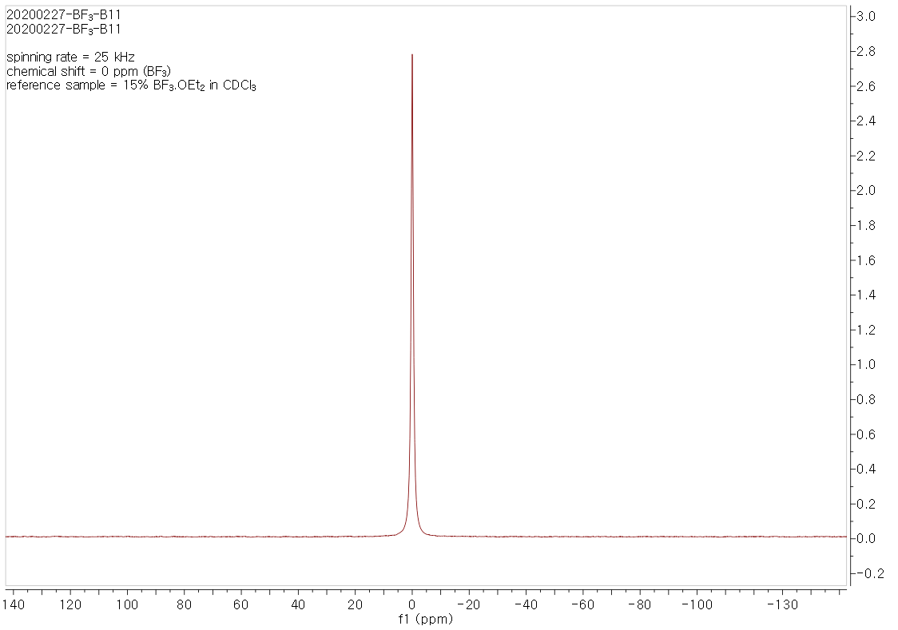
Supplementary Fig. 42┃¹¹B magic angle spinning nuclear magnetic resonance spectrum of 15% BF₃·O(C₂H₅)₂ in CDCl₃ as reference.

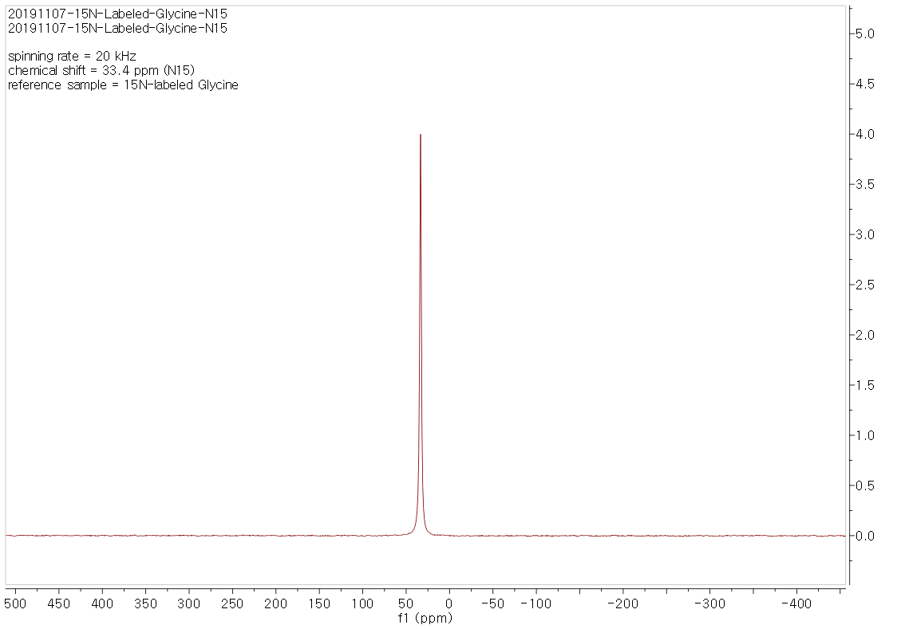
Supplementary Fig. 43┃¹⁵N magic angle spinning nuclear magnetic resonance spectrum of ¹⁵N labeled glycine as reference.

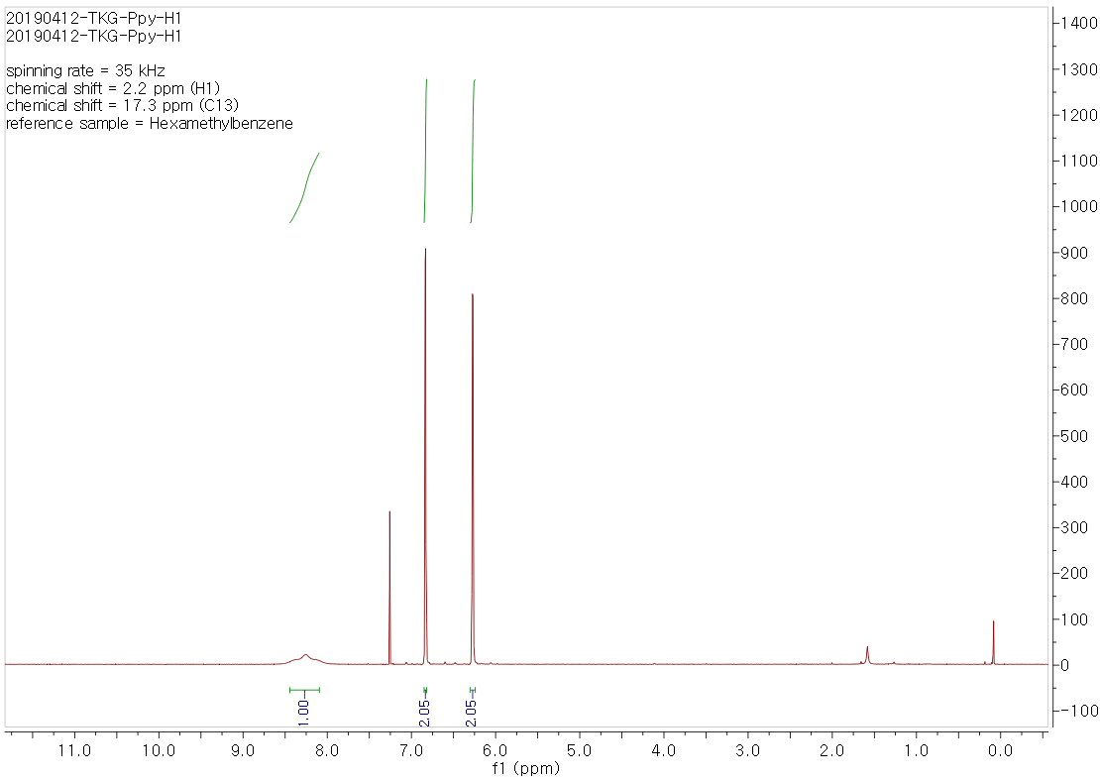
Supplementary Fig. 44┃¹H nuclear magnetic resonance spectrum of pyrrole.
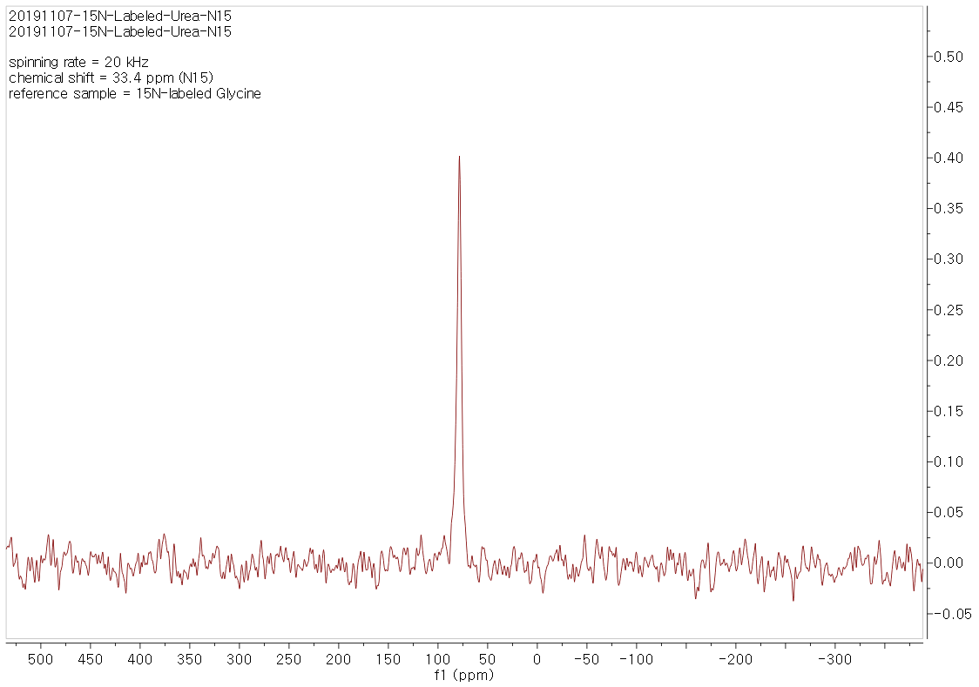
Supplementary Fig. 45┃¹⁵N magic angle spinning nuclear magnetic resonance spectrum of ¹⁵N urea.

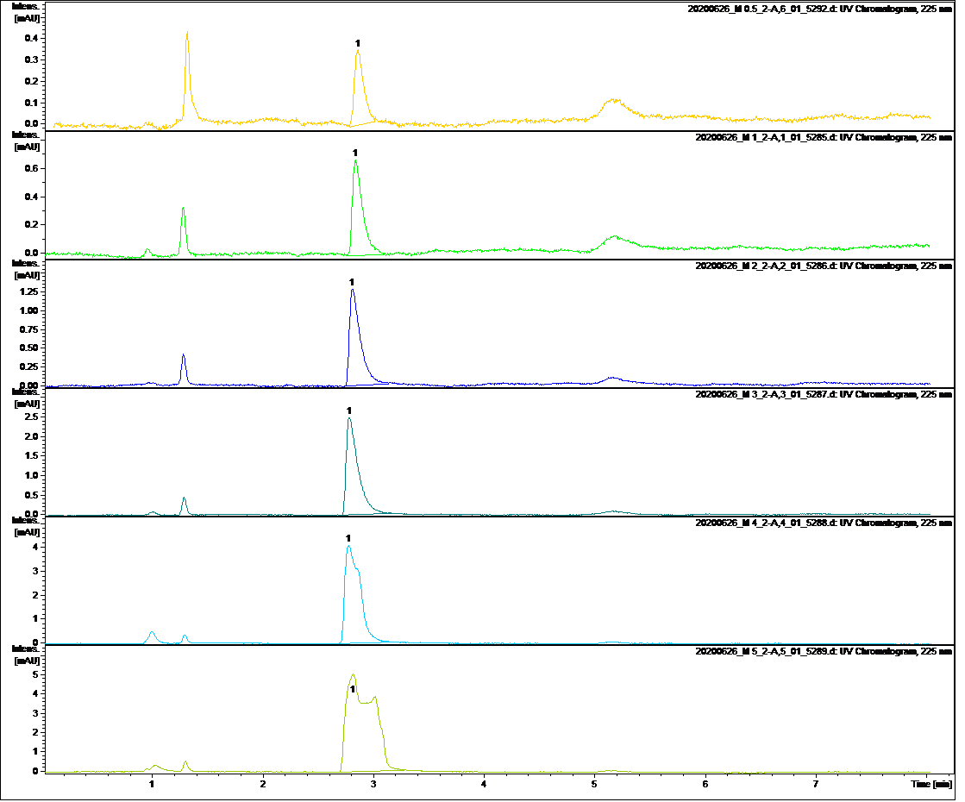
Supplementary Fig. 46┃HPLC spectra of methanol for internal standard method.

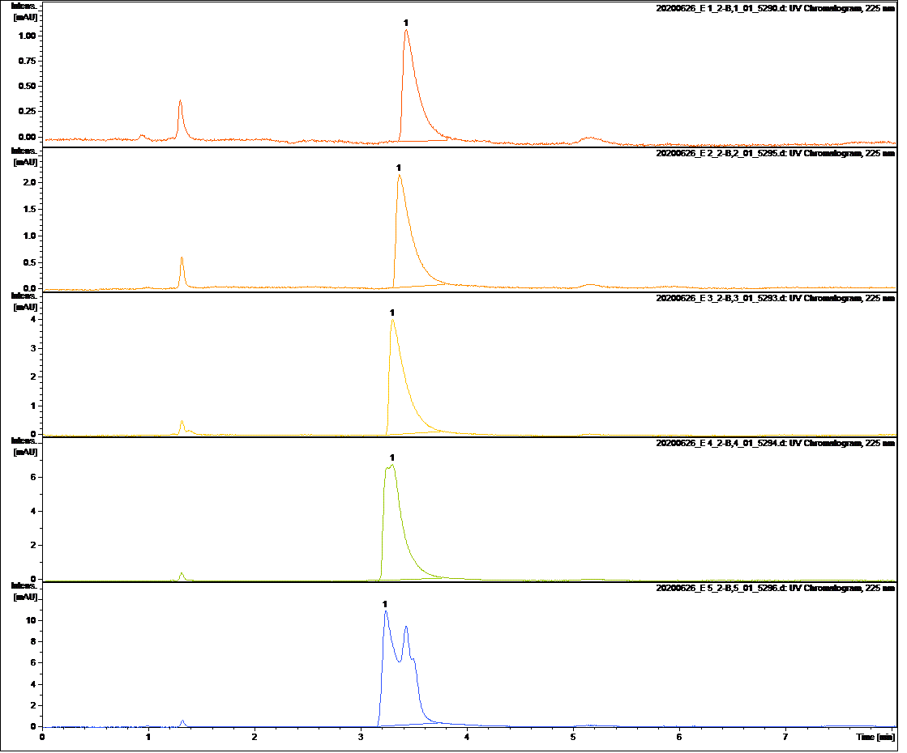
Supplementary Fig. 47┃HPLC spectra of ethanol for internal standard method.

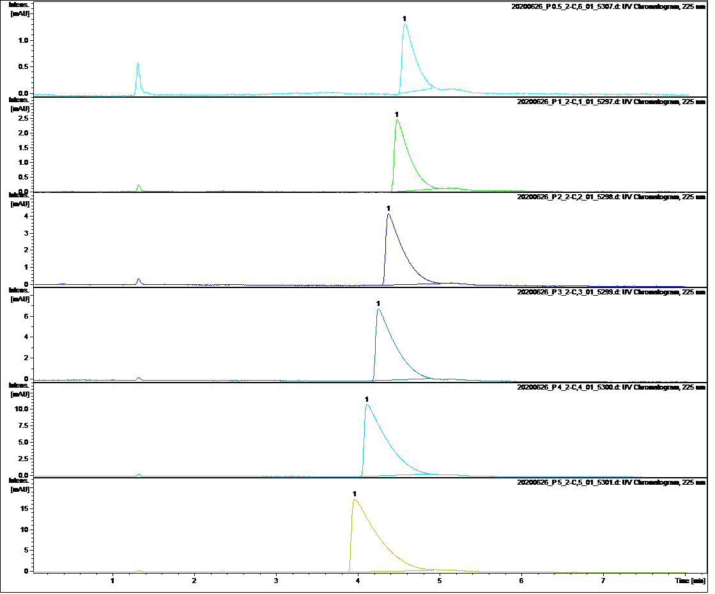
Supplementary Fig. 48┃HPLC spectra of n-propanol for internal standard method.

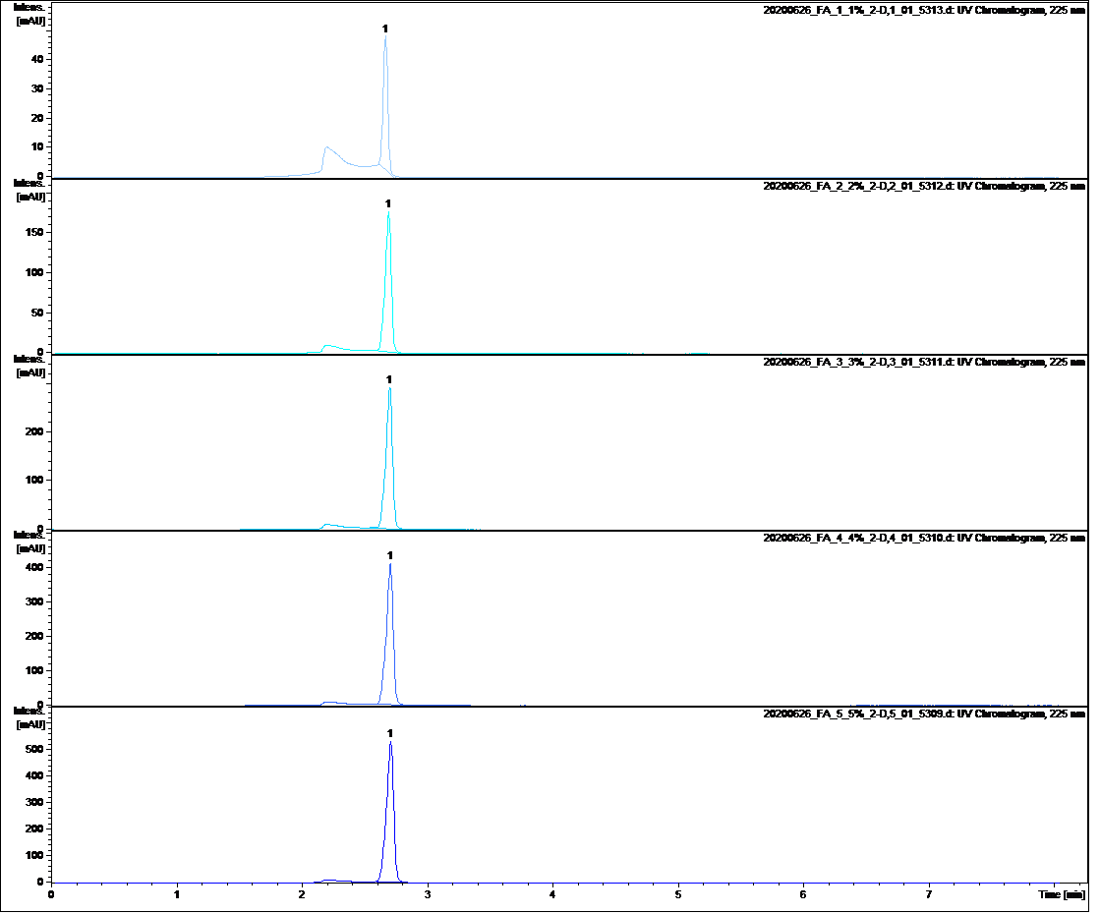
Supplementary Fig. 49┃HPLC spectra of formic acid for internal standard method.

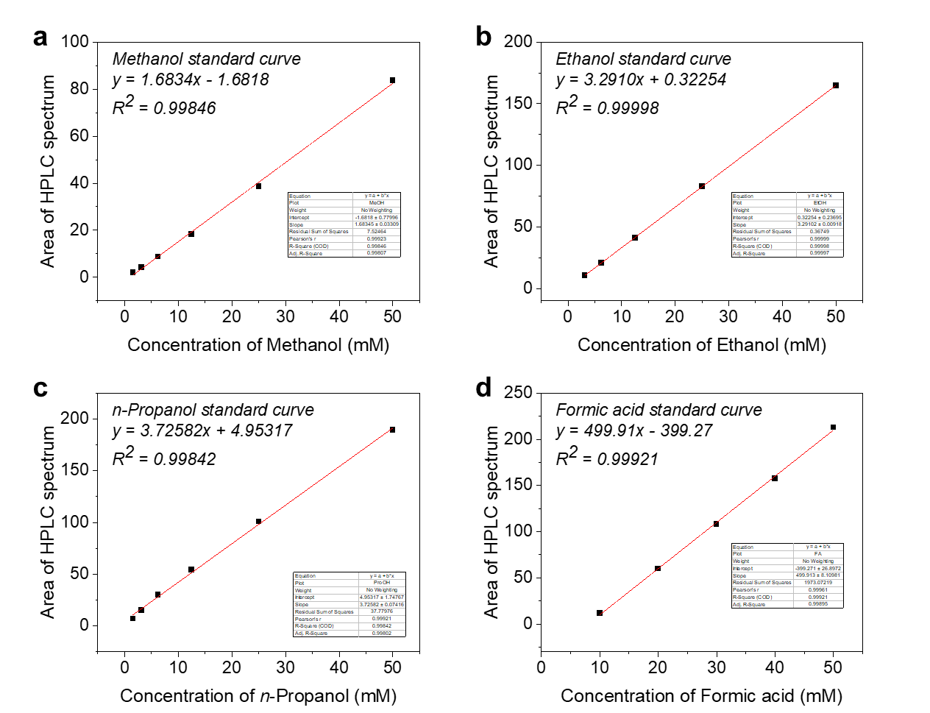
Supplementary Fig. 50┃Internal standard curves of HPLC area based on Supplementary Fig. 46 to 49.

Supplementary Table 1. Comparison of CO₂R to multi-carbon performance with state-of-the-art metal-free catalysts.

Catalyst | J_{max}/C₂₊  (mA cm⁻²) | FE_{max}/C₂₊  (%) | C₂₊ selectivity (%) | C₂₊ product | Reference
BN-GFLP | 10.6 | 87.9 | 90.2 | ethanol, propanol | This work
Cu-SA/NPC | 1.42 | 36.7 | 45.9 | acetone | Nat Commun. 2020, 11, 2455
GO-VB₆-4 | 0.74 | 45.3 | 59.4 | ethanol, acetone | Electrochimica Acta, 2018, 282, 694
BND | 1.00 | 93.2 | 94.9 | ethanol | Angew. Chem. Int. Ed. 2017, 56, 15607
Fe₂P₂S₆ | 0.40 | 23.1 | 29.0 | ethanol | ACS Catal. 2019, 9, 9721
c-NC | 0.25 | 77.0 | 100 | ethanol | Angew. Chem. Int. Ed. 2017, 56, 10840
CuN₄ | 12.0 | 80.0 | 84.1 | ethanol, ethylene | Angew. Chem. Int. Ed. 2019, 58, 15098
CTF-Cu-4.8% | 6.74 | 68.4 | 84.6 | ethylene, acetate | ACS Catal. 2020, 10, 4534
Cu-PANI | 3.82 | 80.0 | 84.2 | ethylene | ACS Catal. 2020, 10, 4103
Fe/N-C | 0.36 | 61.0 | 62.6 | acetic acid | Nat Commun. 2018, 9, 935

