Supplementary Material

Microbial Strains and Culture Conditions
The bacterial strain Shewanella oneidensis MR-1 was a generous donation from Prof. Moh El-Naggar, University of Southern California, USA. The fungal strain Ustilago maydis FB1 was kindly provided by Saravanan Matheswaran, Indian Institute of Technology Kanpur, India. Both organisms were used as model systems to evaluate microbial growth dynamics under laboratory conditions and within the MAEx payload system. Traditionally, S. oneidensis is cultured in Luria Broth (LB) medium, whereas U. maydis is routinely grown in Yeast Extract Peptone Dextrose (YPD) medium. To simplify inoculation and maintain a common nutrient environment within the payload biochamber, YPD was selected as a shared rich medium for both organisms (Supplementary Figure 3). YPD medium was prepared using yeast extract (10 g/L), peptone (20 g/L), and dextrose (20 g/L) dissolved in Milli-Q water, followed by sterilization by autoclaving at 121 °C for 20 min. Starter cultures were initiated from glycerol stocks stored at -80ºC and grown overnight under aerobic conditions. Both cultures were incubated statically at 30°C without shaking. Overnight cultures were subsequently diluted into fresh sterile YPD medium to an initial optical density (OD₆₀₀​) of approximately 0.1 prior to loading into either 24-well plates or payload biochambers.

Preparation of Protein Aggregates
For in vitro aggregation experiments, purified human γD crystallin (HγD-Crys) was diluted to a final concentration of 50 μM in phosphate buffer maintained at low pH conditions (pH 3.5). The acidic environment was used to induce gradual protein aggregation under controlled conditions. Samples were incubated statically at 25°C and monitored over a period of up to 35 days.

Spectrofluorometric analysis
For microbial growth measurements, 24-well plates were prepared with 0.5 mL of YPD agar per well, followed by inoculation with 100 μL of diluted microbial culture. Wells in the top row containing 100 μL sterile Milli-Q water served as negative controls. Triplicate plates were incubated at 25°C throughout the experiment. Microbial growth dynamics were monitored using the SpectraMax M3 Multi-Mode Microplate Reader through absorbance measurements at 600 nm (OD₆₀₀​) and fluorescence-based detection of intracellular NADH using excitation/emission wavelengths of 340/460 nm. Measurements were acquired once daily to evaluate temporal changes in microbial biomass and metabolic activity.
For protein aggregation experiments, 200 μL of purified human γD-crystallin solution was loaded into individual wells of a 96-well microplate. Control samples consisting of γD-crystallin maintained in a phosphate buffer at pH 7 under non-aggregating conditions were prepared and measured in parallel. All measurements were performed in triplicate. Protein aggregation was monitored using a PerkinElmer Multimode Plate Reader equipped with a 365 nm excitation source. Transmitted light intensity measurements were recorded once every day throughout the incubation period and expressed as optical density at 365 nm.

Electrochemical analysis
Two independent 200 mL experimental bottles containing sediment slurry were prepared for comparative electrochemical analysis. The biotic positive control consisted of sediment slurry supplemented with 5 mL of an actively growing Shewanella oneidensis culture (resuspended in 1X PBS). In contrast, the abiotic negative control consisted of sterilized sediment slurry (autoclaving at 121 °C for 30 min).
Each experimental bottle was configured as a three-electrode electrochemical cell connected to a single-channel t potentiostat (MedPStat, MTXLabs, India). The electrochemical setup consisted of a carbon cloth working electrode, an Ag/AgCl (1 M KCl) reference electrode, and a platinum wire counter electrode. The exposed surface area of the working electrode was 1.0 cm² for the biotic condition and 9 cm² for the abiotic condition. Chronoamperometric measurements were performed by poising the working electrode at +0.2 V versus Ag/AgCl throughout the experiment. Anodic current was recorded every 10 min during the initial 2 h, followed by measurements acquired every 1 h over the subsequent 3 days to monitor temporal changes in electron transfer activity.

Payload-Integrated Imaging Analysis
Aliquots of diluted cultures were aseptically transferred into sterile sample chambers integrated within the MAEx payload. Each chamber contained 0.5 mL of YPD agar supplemented with 100 μL of microbial culture and was sealed to minimize contamination and evaporation during payload operation. Control chambers containing sterile YPD agar with 100 μμL of Milli-Q water were included for baseline signal correction. Images of the payload biochambers were acquired at 10 min intervals throughout the experiment. For downstream analysis, all images were processed using a custom in-house Python-based image analysis pipeline developed for automated temporal monitoring of microbial growth.

Payload-Integrated Spectrofluorometric Analysis
Protein samples were prepared as described earlier for in vitro aggregation experiments. For payload integration experiments, the final working volume in each biochamber was adjusted to 400 μL, consisting of 200 μL Milli-Q water and 200 μL protein solution. A small volume of acid was added to maintain acidic pH conditions required for induction of γD-crystallin aggregation. Control chambers containing only Milli-Q water were included for baseline correction.
Protein aggregation within the payload biochambers was monitored through transmitted light measurements using the onboard spectrofluorometric sensing module equipped with a 365 nm LED illumination source. Transmitted light intensity measurements were recorded in repeated acquisition cycles consisting of 10 measurements collected at 1 min intervals throughout the experiment. Optical signals transmitted through the sample chamber were detected using photodiode-based sensors coupled to analog signal acquisition electronics.
The detector output voltage (V_{out}​) was used as a proxy for changes in optical attenuation associated with protein aggregate formation inside the chamber. Relative absorbance changes were estimated using the Beer-Lambert relationship:
$$A = -log_{10 }[\frac{I}{I_{0}}] = αl$$
where,
A is the absorbance,
I₀ is the incident light intensity,
I is the transmitted intensity measured by the photodetector,
Α is the absorption coefficient
ｌ is the optical path length
The input intensity (I₀) and detector response (measured I) will be proportional to the input and output voltage, intensity ratios were calculated from the corresponding voltage measurements i.e; $A = -log_{10 }[\frac{V_{out}}{V_{in}}] = αl$.

Payload-Integrated Electrochemical Analysis
Prior to biological experiments, the performance and stability of the payload-integrated potentiostat electronics were validated using a standard redox system consisting of 10 mM potassium ferricyanide [K₃Fe(CN)₆] prepared in 1 M KNO₃. Electrochemical measurements were performed using the onboard three-electrode configuration to confirm proper signal acquisition, electrode connectivity, and potentiostat operation under payload conditions. Stable and reproducible current responses obtained from the ferricyanide redox couple were used to verify the functionality of the electrochemical sensing module prior to sediment slurry experiments.
Payload-integrated electrochemical experiments will be performed using Shewanella oneidensis inoculated in LB agar to evaluate biological electron transfer activity in oxic solid agar based media.

Thermal Simulation
The STK-SEET thermal model estimates the mean steady-state temperature of a spacecraft using simplified thermal balance equations while approximating the vehicle as a single isothermal node with user-defined bulk thermal properties. The simulations incorporated three primary external heat sources: direct solar radiation, Earth-reflected solar radiation (albedo), and terrestrial infrared radiation emitted by the Earth. During sunlit orbital phases, all three heat sources contribute to the thermal balance, whereas during eclipse conditions the terrestrial infrared component remains the dominant external heat source. Representative spacecraft thermal parameters used in the simulation included an Earth albedo value of 0.34, material emissivity of 0.924, material absorptivity of 0.14, and a vehicle cross-sectional area of 0.0185 m². Internal power dissipation was assumed to be 0 W for the preliminary environmental estimation. The thermal model geometry was approximated using a plate-based representation aligned relative to the Sun vector within the STK-SEET framework.

Supplementary Table

Supplementary Table 1: The table summarizes the primary hardware components integrated into the MAEx payload, including control and computing systems, environmental monitoring sensors, thermal regulation modules, imaging and spectroscopic components, electrochemical circuitry, and supporting electronic elements. Listed information includes subsystem category, component type, model number, manufacturer details, and functional description relevant to payload operation and autonomous biological monitoring.

Category | Sub-category | Component | Model | Manufacturer Part Number | Make | Description
Main Payload | Control and Computing | Microprocessor | Raspberry Pi 3 Model B+ |  | Raspberry Pi Foundation | Central onboard computer for payload control, scheduling, and data handling
Main Payload | Environmental Monitoring | Temperature and Pressure Sensor | BMP280 | BMP280 | Bosch | Integrated temperature, pressure sensor
Main Payload | Thermal Regulation | Thermoelectric Cooler (TEC) | TEC1-12706 | TEC1-12706 | Generic | Thermoelectric module for active temperature regulation
Main Payload | Power Distribution | DC-DC Buck Converter | LM2596 Module | LM2596S | Texas Instruments | Step-down voltage regulator for 12 V and 5 V rails
Main Payload | Real-Time Clock | RTC Module | DS3231 | DS3231 | Analog Devices | Precision real-time clock for timestamp synchronization
Analytical Module | Imaging | Camera | Raspberry Pi Camera Module 3 Wide |  | Raspberry Pi Foundation | Wide-angle imaging module for microbial growth monitoring
Analytical Module | Imaging | White LEDs | Generic White LED |  | Generic | Illumination source for imaging
Analytical Module | Imaging | Diffuser Board | Acrylic Diffuser |  | Generic | Optical diffuser for uniform illumination
Analytical Module | Spectroscopy | Red LED | Generic Red LED | 630 nm | Generic | Generic red LED with 630 nm wavelength
Analytical Module | Spectroscopy | UV LED | MT3650W3-UV | MT3650W3-UV | Marktech Optoelectronics | Ultraviolet emitter, 365 nm, 3.5 V, 15 mA
Analytical Module | Spectroscopy | Optical Photodiode | OPT101P | OPT101P | Texas Instruments | Ambient optical sensor with integrated transimpedance amplifier
Analytical Module | Spectroscopy | UV Photodiode | MICROFJ-30035-TSV-TR | MICROFJ-30035-TSV-TR | ON Semiconductor | UV-sensitive photodiode for fluorescence detection
Analytical Module | Spectroscopy | ADC | ADS1115 | ADS1115 | Texas Instruments | 16-bit analog-to-digital converter with I²C interface
Analytical Module | Electrochemical | Capacitors | Ceramic Capacitor | 1 µF capacitor | Generic | 1 µF capacitor
Analytical Module | Electrochemical | Capacitors | Ceramic Capacitor | 1000 pF capacitor | Generic | 1000 pF capacitor
Analytical Module | Electrochemical | Capacitors | Electrolytic Capacitor | 10 µF capacitor | Generic | 10 µF capacitor
Analytical Module | Electrochemical | Capacitors | Ceramic Capacitor | 100 pF capacitor | Generic | 100 pF capacitor
Analytical Module | Electrochemical | Resistors | Carbon Film Resistor | 1 kΩ resistor | Generic | 1 kΩ resistor
Analytical Module | Electrochemical | Resistors | Carbon Film Resistor | 10 kΩ resistor | Generic | 10 kΩ resistor
Analytical Module | Electrochemical | Resistors | Carbon Film Resistor | 4.7 kΩ resistor | Generic | 4.7 kΩ resistor
Analytical Module | Electrochemical | Resistors | Carbon Film Resistor | 100 kΩ resistor | Generic | 100 kΩ resistor
Analytical Module | Electrochemical | Resistors | Carbon Film Resistor | 68 Ω resistor | Generic | 68 Ω resistor
Analytical Module | Electrochemical | Resistor (Jumper) | Carbon Film Resistor | 220 Ω jumper resistor | Generic | 220 Ω jumper resistor
Analytical Module | Electrochemical | Operational Amplifier |  |  | Texas Instruments | Precision CMOS operational amplifier
Analytical Module | Electrochemical | Reference Electrode | Ag/AgCl Electrode |  | Generic | Miniaturized Ag/AgCl reference electrode
Analytical Module | Electrochemical | Working Electrode | Carbon Cloth Electrode |  | Generic | Carbon cloth electrode for microbial electron transfer
Analytical Module | Electrochemical | Counter Electrode | Platinum Mesh Electrode |  | Generic | Platinum mesh counter electrode
Analytical Module | Electrochemical | Analog Connector | PIC-Snap Lock Connector |  | Generic | Analog electrical interface connector
Biochamber | Structural Material | Polycarbonate Sheet | Optical Grade PC |  | Generic | Machined substrate for biochamber fabrication
Biochamber | Optical Layer | Zeonor Film | Zeonor 1060R |  | Zeon Corporation | Transparent low-autofluorescence optical layer
Biochamber | Adhesive Layer | Pressure Sensitive Adhesive | PSA Film |  | Generic | Precision-cut sealing adhesive
Miscellaneous | Fasteners | Bolts and Nuts | Stainless Steel Fasteners |  | Generic | Structural fastening hardware
Miscellaneous | Wiring | Jumper Wires and Connectors | JST Connector Set |  | Generic | Internal electrical routing and subsystem connections
Miscellaneous | Structural Shielding | Aluminum Enclosure Panels (1.5 - 3 mm thickness) |  | Al 6061 or Al 7075 |  | Primary shielding against charged particles and secondary radiation
Miscellaneous | Thermal + Radiation Blanket | Multi-Layer Insulation (MLI) with (MLI)  Kapton + Mylar + Aluminum coating |  |  |  | Thermal insulation with partial radiation attenuation

Supplementary Figure 1: Biochamber configurations used in the MAEx payload. (A) Biochamber designed for the imaging and spectroscopy analytical modules. (B) Electrochemical biochamber incorporating the working, counter, and reference electrodes for three-electrode electrochemical measurements.

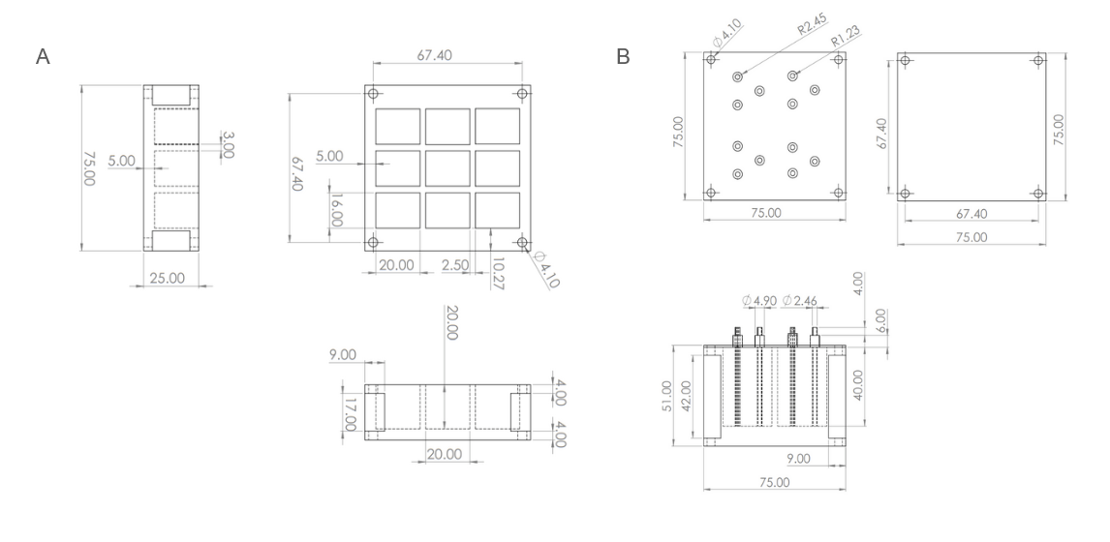

Supplementary Figure 2. The figure illustrates the field of view of the Raspberry Pi Camera Module 3 Wide at a working distance of 70 mm (red outline) relative to the dimensions of the biochamber (black dashed outline). The shaded region indicates the effective imaging area captured by the camera, demonstrating coverage of the central biochamber region used for microbial growth monitoring.

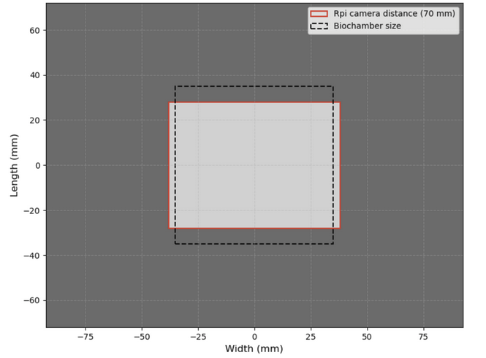

Supplementary Figure 3: Emission Spectra of UV (violet line) and Red (red line) LEDs characterized in the lab using. The black dashed-dotted line is the spectrum of the UV LED provided by the manufacturer.

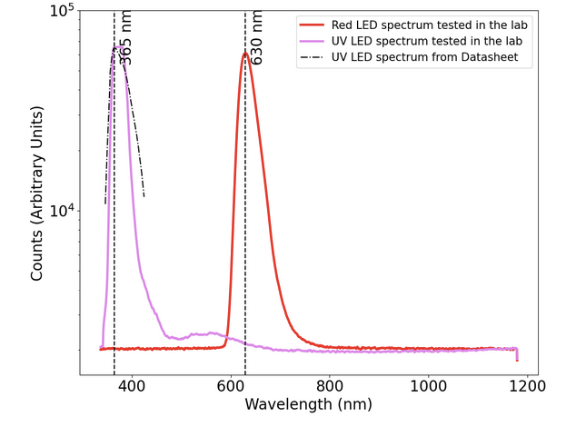

Supplementary Figure 4: Distribution of the normalized output voltage in small temperature bins (bin width ~ 1.5ºC). Since the temperature range is small in each bin, the variation in the output voltage is not due to temperature but intrinsic.

