Supplementary Table 1 Procurement volumes (in DDDs) of 19 rare disease drugs before and after policy implementation
Drug | Time of inclusion  in the NRDN | Procurement volumes (in DDDs)
Drug | Time of inclusion  in the NRDN | Before policy implementation (patient-day) | After policy implementation (patient-day) | Rate of change (%)
Eptacog Alfa (Activated) | 2017 | 10,490 | 32,086 | 205.9
Octreotide | 2018 | 32,643 | 135,712 | 315.7
Deferasirox | 2019 | 6,654 | 138,386 | 1979.9
Bosentan | 2019 | 26,647 | 41,949 | 57.4
Riociguat | 2019 | 62 | 45,862 | 73607.2
Macitentan | 2019 | 5 | 100,519 | 2010280.0
Teriflunomide | 2019 | 30 | 15,951 | 52484.6
Ruxolitinib | 2019 | 949 | 111,231 | 11618.8
Nintedanib | 2020 | 223 | 89,543 | 40108.2
Fingolimod | 2020 | 58 | 2,662 | 4463.1
Siponimod | 2020 | 16 | 20,677 | 132820.7
Agalsidase Alfa | 2021 | 122 | 7,761 | 6281.0
Nusinersen | 2021 | 2,280 | 110,937 | 4765.6
Luspatercept | 2022 | 134 | 9,922 | 7310.8
Ripretinib | 2022 | 453 | 11,054 | 2338.4
Treprostinil | 2022 | 1,063 | 7,955 | 648.2
Ofatumumab | 2022 | 343 | 29,029 | 8356.1
Dimethyl Fumarate | 2022 | 17 | 6,086 | 35269.4
Risdiplam | 2022 | 135 | 13,330 | 9773.9

Supplementary Table 2 Procurement amounts of 19 rare disease drugs before and after policy implementation
Drug | Time of inclusion  in the NRDN | Procurement amounts
Drug | Time of inclusion  in the NRDN | Before policy implementation (1000 USD) | After policy implementation (1000 USD) | Rate of change (%)
Eptacog Alfa (Activated) | 2017 | 924.3 | 2113.6 | 128.7
Octreotide | 2018 | 1270.8 | 3288.4 | 158.8
Deferasirox | 2019 | 205.6 | 1227.1 | 496.8
Bosentan | 2019 | 521.2 | 568.9 | 9.2
Riociguat | 2019 | 1.8 | 633.0 | 35315.9
Macitentan | 2019 | 0.7 | 1915.6 | 272915.8
Teriflunomide | 2019 | 1.8 | 631.5 | 35126.3
Ruxolitinib | 2019 | 100.7 | 5092.2 | 4957.2
Nintedanib | 2020 | 28.3 | 3241.1 | 11362.7
Fingolimod | 2020 | 3.1 | 85.2 | 2674.1
Siponimod | 2020 | 0.6 | 533.3 | 86711.7
Agalsidase Alfa | 2021 | 33.1 | 965.2 | 2819.3
Nusinersen | 2021 | 1190.6 | 4313.0 | 262.3
Luspatercept | 2022 | 12.0 | 446.8 | 3608.1
Ripretinib | 2022 | 96.6 | 802.3 | 730.8
Treprostinil | 2022 | 315.0 | 922.9 | 192.9
Ofatumumab | 2022 | 17.0 | 925.1 | 5355.9
Dimethyl Fumarate | 2022 | 0.6 | 104.5 | 16651.0
Risdiplam | 2022 | 35.0 | 589.6 | 1583.6

Supplementary Table 3 Daily costs (in DDDc) of 19 rare disease drugs before and after policy implementation
Drug | Time of inclusion  in the NRDN | Daily costs (in DDDc)
Drug | Time of inclusion  in the NRDN | Before policy implementation (USD/patient-day) | After policy implementation (USD/patient-day) | Rate of change (%)
Eptacog Alfa (Activated) | 2017 | 88.32 | 70.07 | -20.7
Octreotide | 2018 | 38.77 | 24.92 | -35.7
Deferasirox | 2019 | 30.89 | 8.91 | -71.1
Bosentan | 2019 | 19.55 | 14.13 | -27.8
Riociguat | 2019 | 35.57 | 13.75 | -61.3
Macitentan | 2019 | 140.33 | 19.20 | -86.3
Teriflunomide | 2019 | 59.10 | 39.59 | -33.0
Ruxolitinib | 2019 | 105.86 | 46.51 | -56.1
Nintedanib | 2020 | 127.53 | 39.50 | -69.0
Fingolimod | 2020 | 52.66 | 32.01 | -39.2
Siponimod | 2020 | 39.49 | 25.82 | -34.6
Agalsidase Alfa | 2021 | 338.71 | 124.37 | -63.3
Nusinersen | 2021 | 575.50 | 38.89 | -93.2
Luspatercept | 2022 | 90.07 | 45.03 | -50.0
Ripretinib | 2022 | 271.90 | 72.58 | -73.3
Treprostinil | 2022 | 296.31 | 117.07 | -60.5
Ofatumumab | 2022 | 49.39 | 31.85 | -35.5
Dimethyl Fumarate | 2022 | 36.33 | 17.18 | -52.7
Risdiplam | 2022 | 379.44 | 44.23 | -88.3

Supplementary Table 4 Affordability ratios of 19 rare disease drugs before and after policy implementation
Drug | Time of inclusion  in the NRDN | Affordability ratio (OOP/per capita disposable income of households)
Drug | Time of inclusion  in the NRDN | Before policy implementation (%) | After policy implementation (%) | Rate of change (%)
Eptacog Alfa (Activated) | 2017 | 106.1% | 84.1% | -20.7
Octreotide | 2018 | 46.5% | 29.9% | -35.7
Deferasirox | 2019 | 37.1% | 10.7% | -71.1
Bosentan | 2019 | 23.5% | 17.0% | -27.8
Riociguat | 2019 | 42.7% | 16.5% | -61.3
Macitentan | 2019 | 168.5% | 23.1% | -86.3
Teriflunomide | 2019 | 71.0% | 47.5% | -33.0
Ruxolitinib | 2019 | 127.1% | 55.8% | -56.1
Nintedanib | 2020 | 153.1% | 47.4% | -69.0
Fingolimod | 2020 | 63.2% | 38.4% | -39.2
Siponimod | 2020 | 47.4% | 31.0% | -34.6
Agalsidase Alfa | 2021 | 406.7% | 149.3% | -63.3
Nusinersen | 2021 | 691.0% | 46.7% | -93.2
Luspatercept | 2022 | 108.2% | 54.1% | -50.0
Ripretinib | 2022 | 326.5% | 87.2% | -73.3
Treprostinil | 2022 | 355.8% | 140.6% | -60.5
Ofatumumab | 2022 | 59.3% | 38.2% | -35.5
Dimethyl Fumarate | 2022 | 43.6% | 20.6% | -52.7
Risdiplam | 2022 | 455.6% | 53.1% | -88.3

Supplementary Figure 1.
Observed and predicted procurement volumes of 19 rare disease drugs
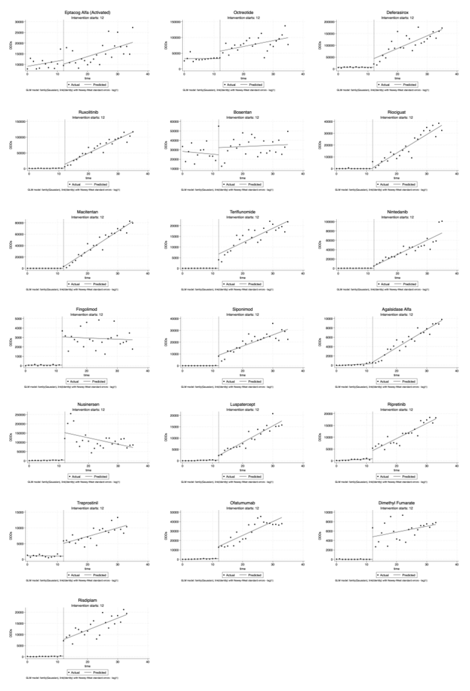

Supplementary Figure 2.
Observed and predicted procurement amounts of 19 rare disease drugs
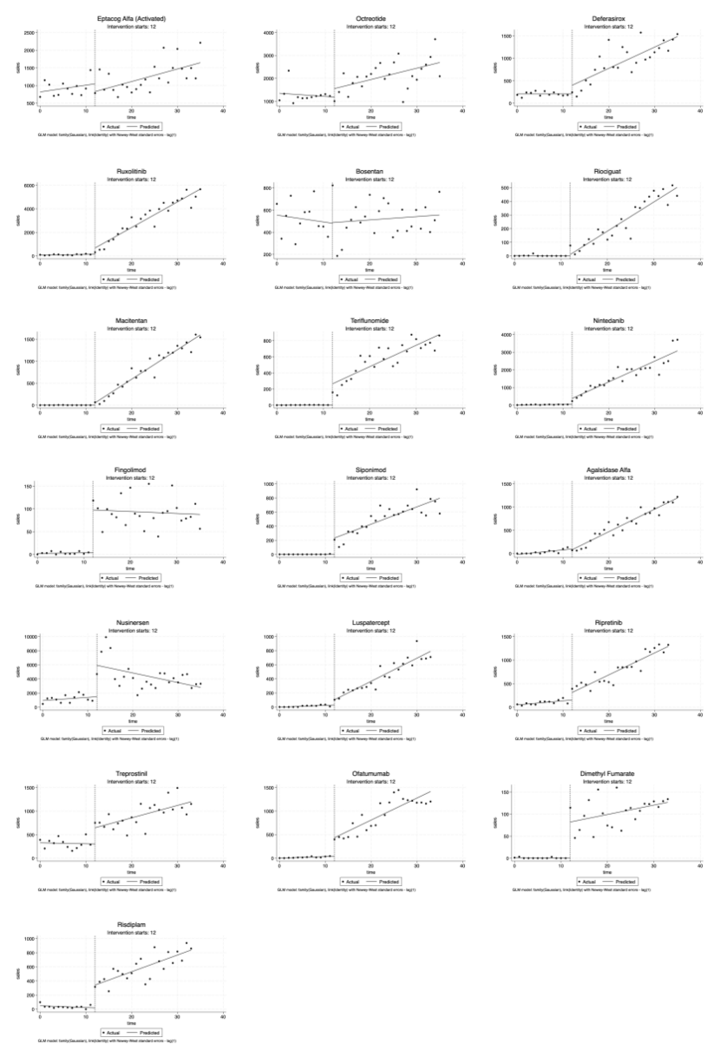

Supplementary Figure 3.
Observed and predicted daily costs of 19 rare disease drugs
