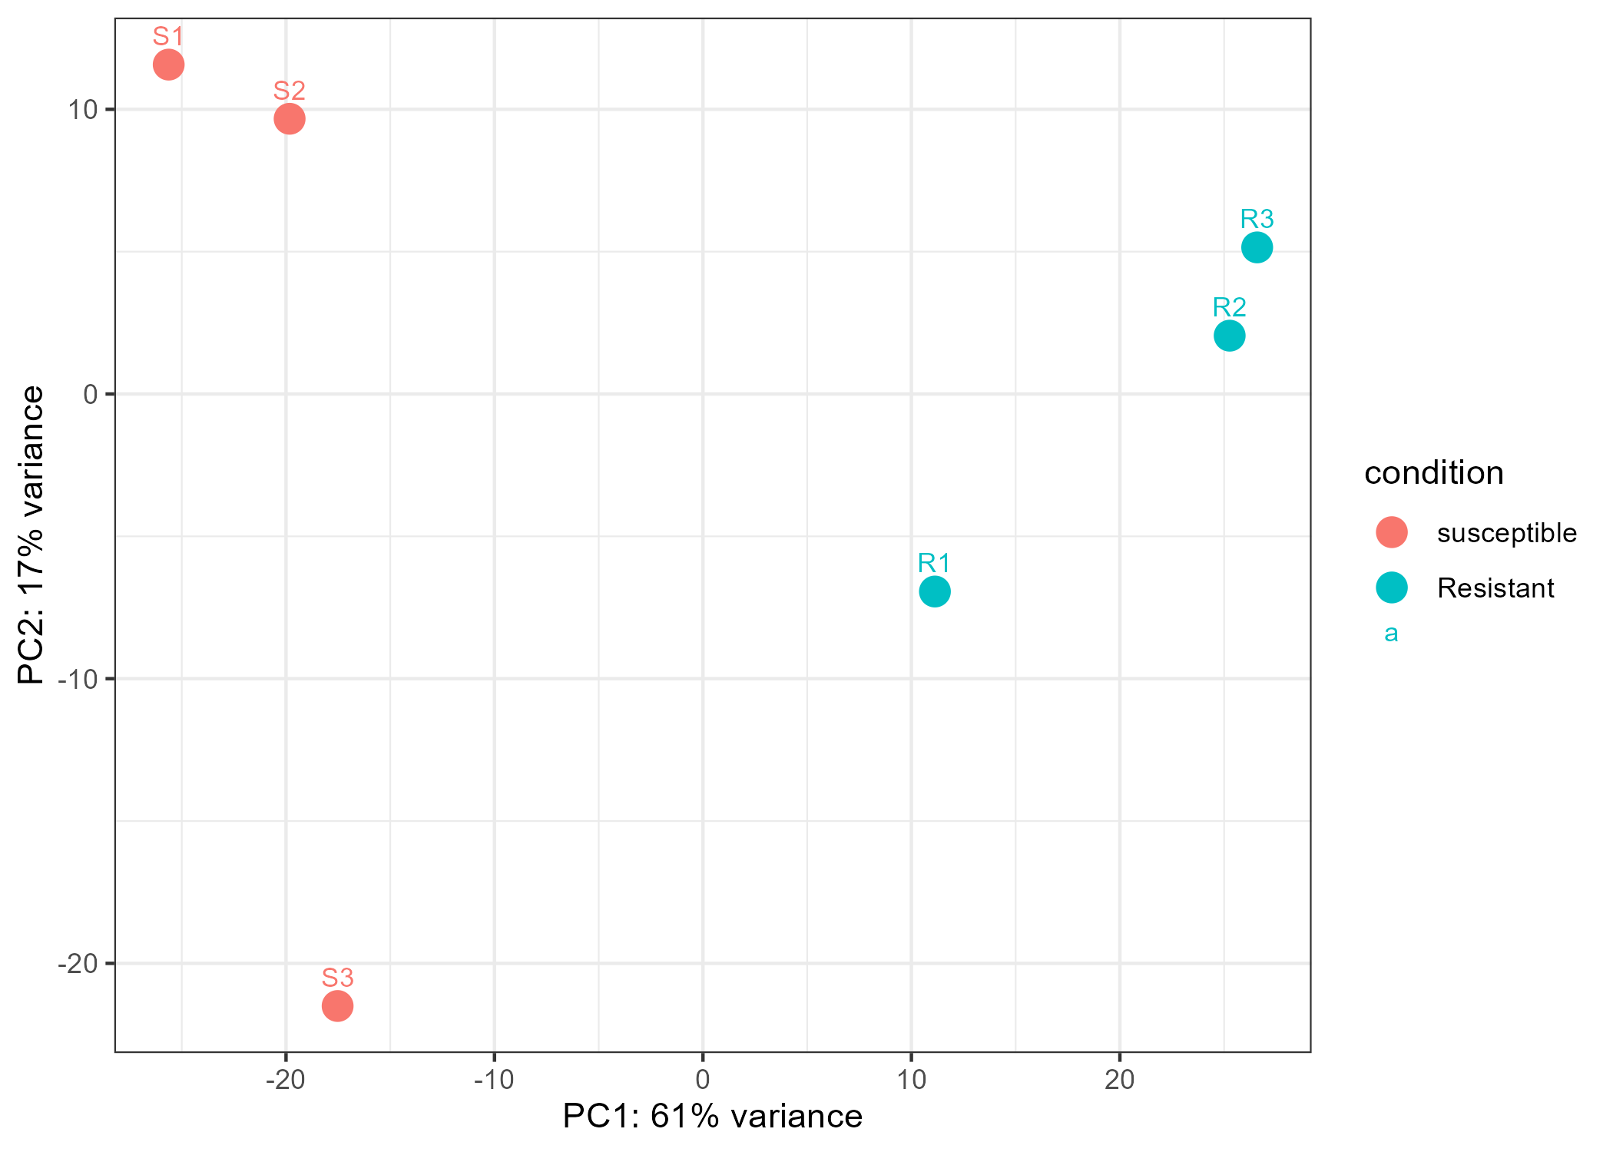
Supplementary Figure 1. PCA plot of RNA-seq samples (R=common scab resistant potato variety, S=common scab resistant potato variety).

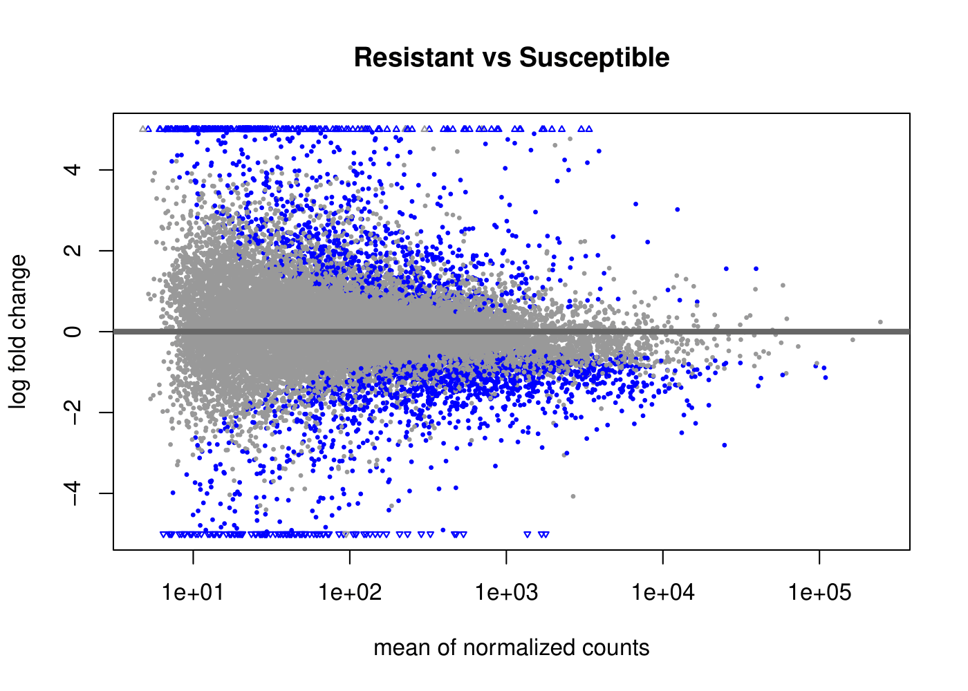
Supplementary Figure 2. MA plot of DEGs.

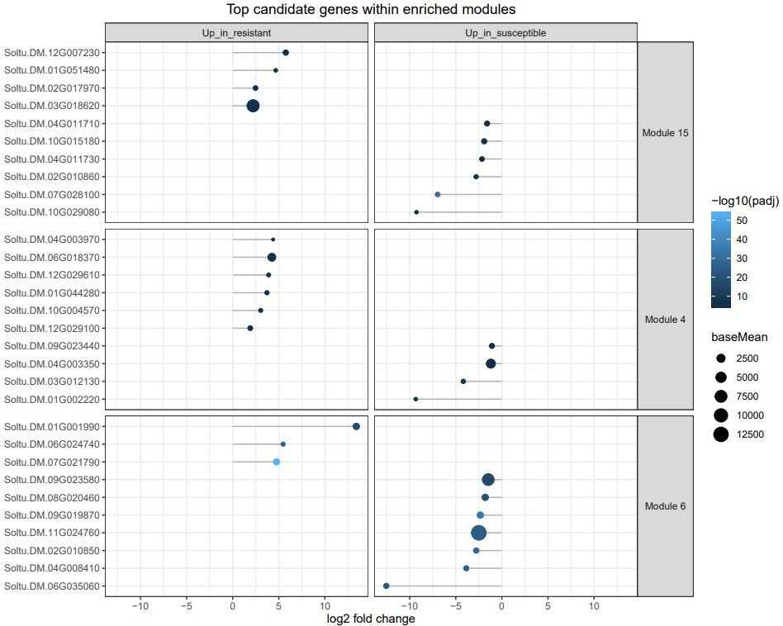
Supplementary Figure 3. Top candidate genes enriched in SpudDB co-expression modules.

