Supplementary figures
- Fig1 (Photographs of birds and their nesting habitats taken during the sampling period)
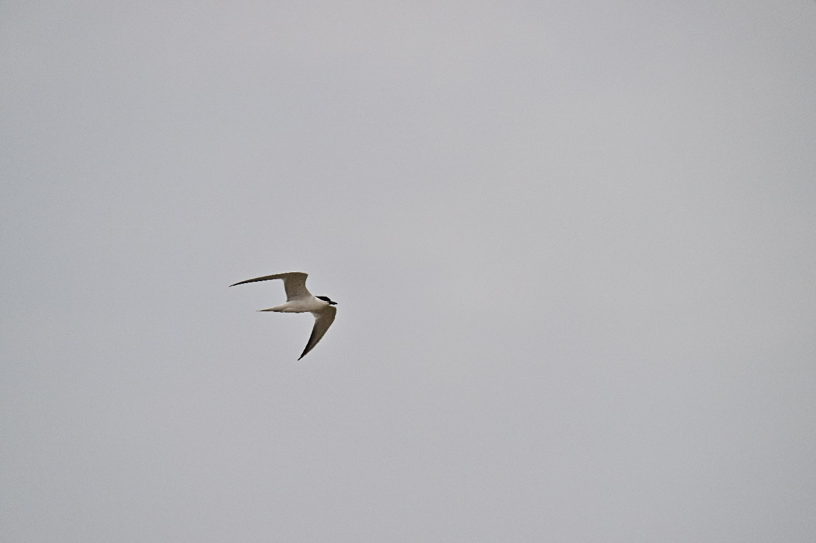
- Fig2 (Photographs of birds and their nesting habitats taken during the sampling period)

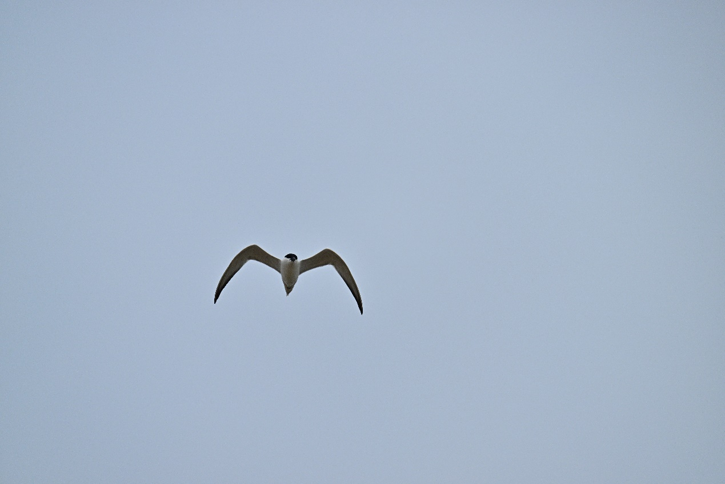
- Fig3 (Photographs of birds and their nesting habitats taken during the sampling period)

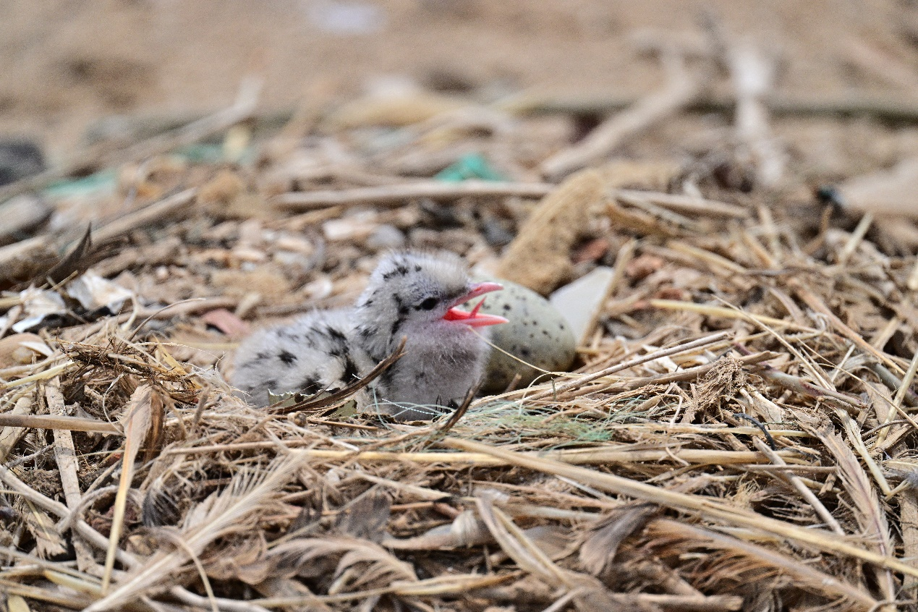
- Fig4 (Photographs of birds and their nesting habitats taken during the sampling period)

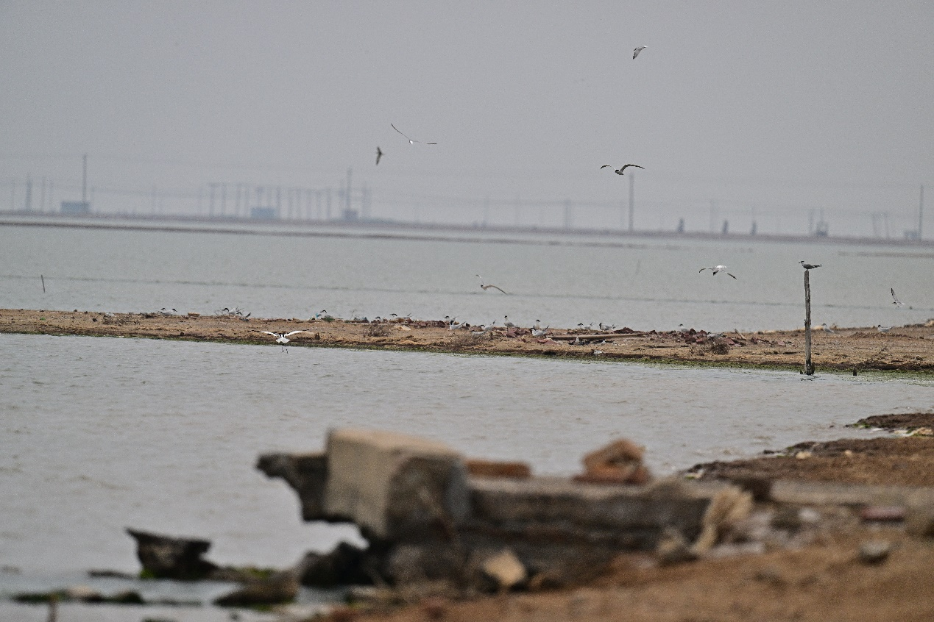
- Fig5 (Photographs of birds and their nesting habitats taken during the sampling period)
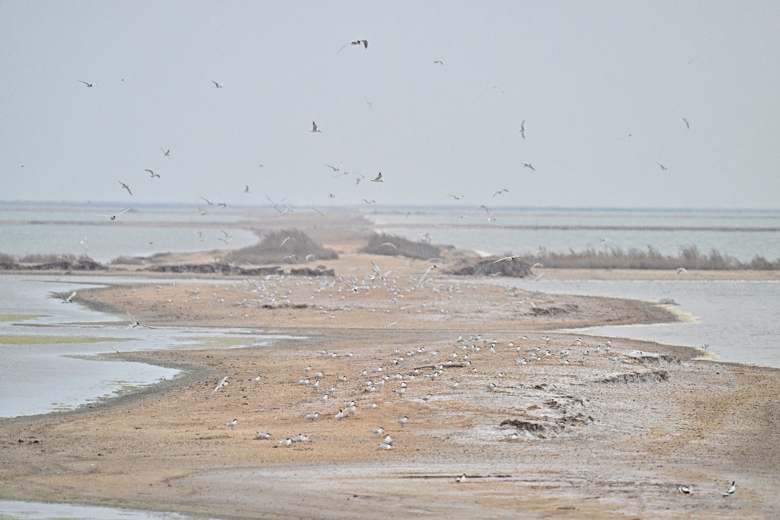
- Fig6 (Photographs of birds and their nesting habitats taken during the sampling period)

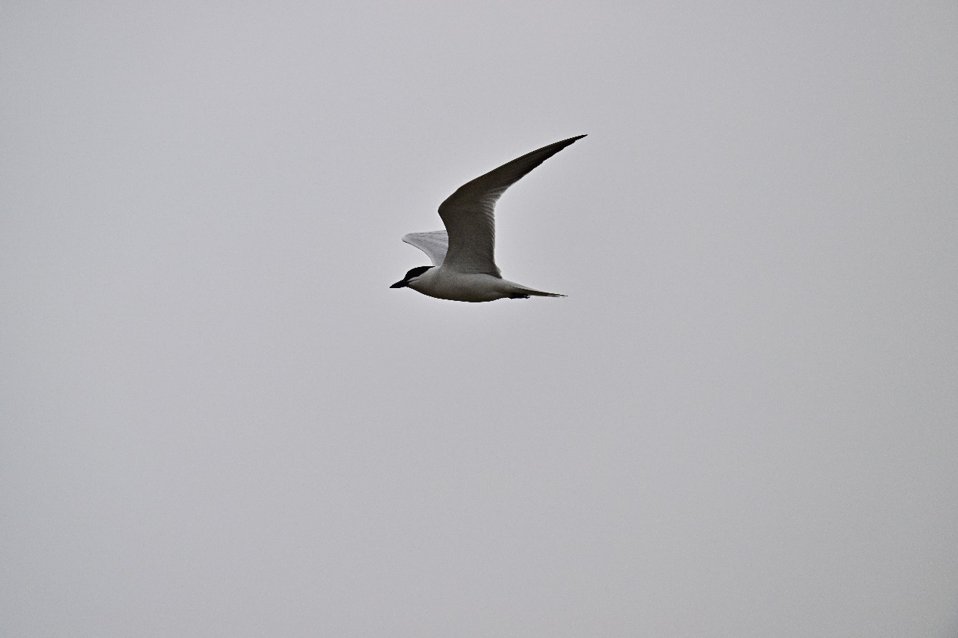

- Fig7 (Photographs of birds and their nesting habitats taken during the sampling period)

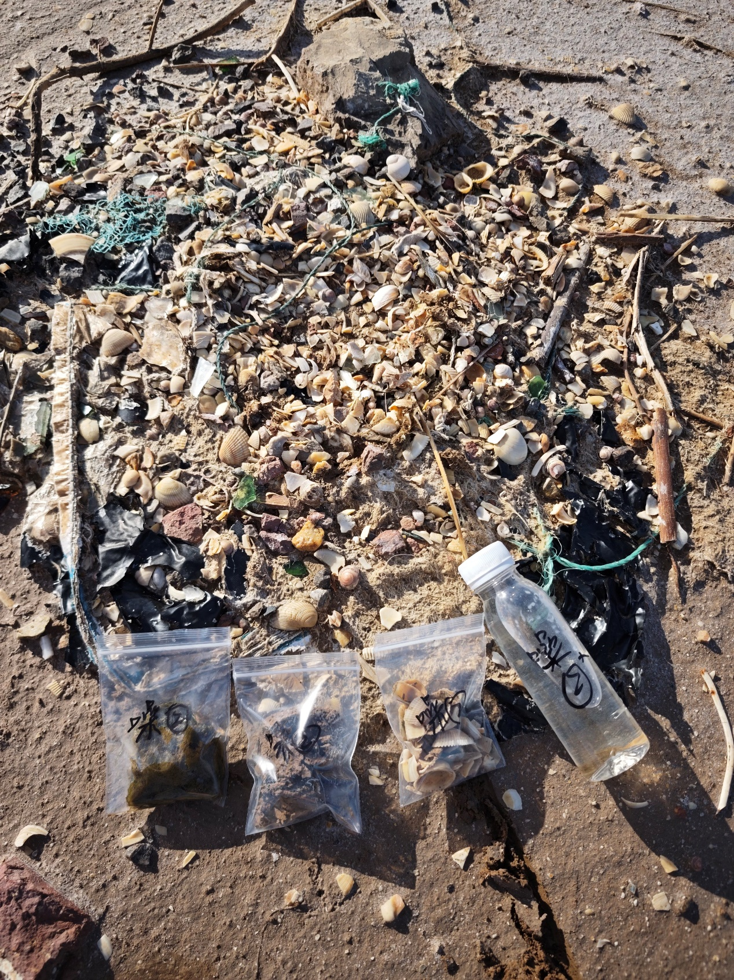

- Fig8 (Photographs of birds and their nesting habitats taken during the sampling period)
