Supporting Information for
A Dual-Emission Probe Based on Silicon Nanoparticles and Rhodamine B for Ratiometric Fluorescence/Colorimetric Dual-Mode Detection of Methyl Parathion
Mengxin Li ª, Congjie Pan ^{a,b,*}, Liu Wang, Qiujuan Ma ^{a,b,*}
ª School of Pharmacy, Henan University of Chinese Medicine, Zhengzhou, 450046, China
^{b} Henan Engineering Research Center of Modern Chinese Medicine Research, Development and Application, Zhengzhou, 450046, China

Corresponding author at: School of Pharmacy, Henan University of Chinese Medicine, Zhengzhou, 450046, China
E-mail addresses: pancongjie@hactcm.edu.cn (C.J. Pan); maqiujuan104@126.com (Q. J. Ma).
Experimental sections
Reagents and materials
(3-aminopropyl)triethoxysilane (APTES) was obtained from Energy Chemical Co. Ltd. L-cysteine (L-Cys), L-histidine (L-His), L-lysine (L-Lys), L-tryptophan (L-Trp), L-serine (L-Ser), L-tyrosine (L-Tyr), L-arginine (L-Arg), L-glutamic acid (L-Glu), L-alanine (L-Ala), L-glycine (Gly), L-valine (L-Val), L-isoleucine (L-Ile), thiram, glyphosate, and phoxim were purchased from Aladdin Chemical Co. Ltd. Methyl parathion was purchased from Shanghai Titan Technology Co. Ltd. NaH₂PO₄·2H₂O and Na₂HPO₄·12H₂O were received from Tianjin Fuchen Chemical Reagent Factory. Anhydrous ethanol was obtained from Tianjin Fuyu Fine Chemical Co. Ltd. Sodium chloride (NaCl), aluminium nitrate (Al(NO₃)₃), ferric chloride (FeCl₃), potassium chloride (KCl), magnesium sulfate (MgSO₄), manganese chloride (MnCl₂), and zinc nitrate (Zn(NO₃)₂) were purchased from Tianjin Kemiou Reagent Co. Ltd. All reagents were analytical grade and used without further purification. Ultrapure water was used throughout the experiment.
Apparatus and characterization
Fluorescence measurements were carried out using an F-7000 spectrofluorophotometer with both excitation and emission slits set at 5 nm. The excitation wavelength was 383 nm. Ultraviolet-visible (UV-Vis) absorption spectra were recorded by an EVOLUTION 260 BIO UV-Vis spectrophotometer. Absorption and emission measurements were conducted in 1 cm × 1 cm quartz cuvettes. X-ray photoelectron spectroscopy (XPS) measurement was performed using a Thermo Scientific K-Alpha photoelectron spectrometer. Fourier transform infrared spectrum (FT-IR) was conducted on a Thermo Fisher Scientific Nicolet is20 spectrometer using KBr pellets. Transmission electron microscopy (TEM) image of SiNPs were obtained using a JEOL JEM-F 200 instrument. A drop of SiNPs solution was placed on a copper grid coated with a thin layer of amorphous carbon film and dried at room temperature for the TEM analysis. The fluorescence lifetime and quantum yield of SiNPs were measured by Edinburgh FLS1000 steady/transient fluorescence spectrometer.
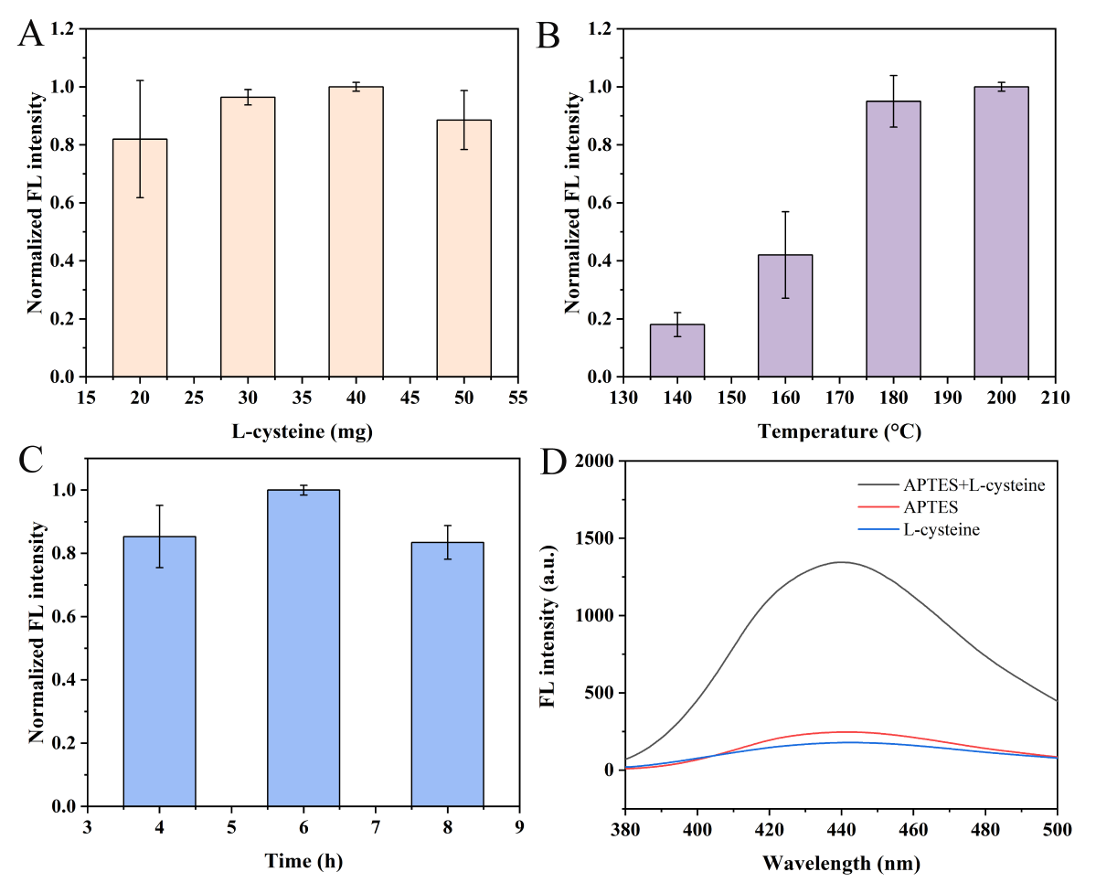
Fig. S1 Normalized fluorescence intensity of SiNPs synthesized with different L-cysteine dosages (A), different reaction temperatures (B) and different reaction times (C); (D) The fluorescence emission spectra of APTES, L-cysteine, and the mixture of APTES and L-cysteine.
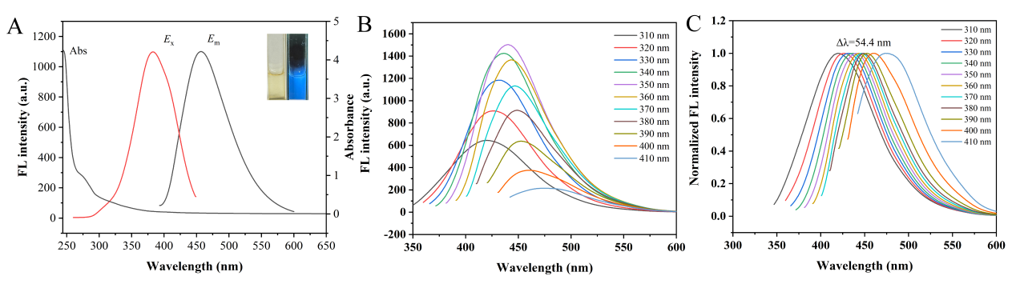
Fig. S2 (A) Fluorescence excitation, emission and UV-Vis absorption spectra of SiNPs (the inset was the SiNPs solutions under sunlight (left) and 365 nm ultraviolet light (right)); (B) Fluorescence emission spectra of SiNPs under different excitation wavelengths; (C) Normalized fluorescence emission spectra of SiNPs under different excitation wavelengths.
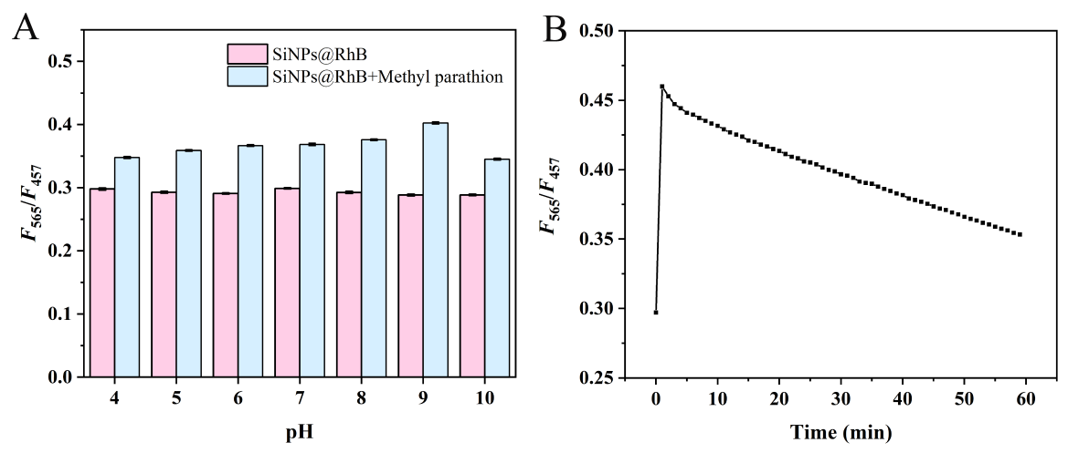
Fig. S3 F₅₆₅/F₄₅₇ value of the SiNPs@RhB probe under 10 mmol/L PBS buffer at different pH (pH 4.0~10.0) before and after the addition of methyl parathion; (B) F₅₆₅/F₄₅₇ value of the SiNPs@RhB probe after addition of methyl parathion for different incubation time (0-60 min).
Table S1 Effects of different concentrations of methyl parathion on the fluorescence lifetime of the SiNPs@RhB probe.
Concentration of methyl parathion (μmol/L) | τ₁  (ns, E_{m}=457 nm) | τ₂  (ns, E_{m}=565 nm)
0 | 6.57 | 6.62
10 | 6.61 | 6.54
50 | 6.70 | 6.59
100 | 6.50 | 6.92

