Supplementary figures and tables
The following items should be supplied as Supplementary Figures
Fig. S1, pre-fertilisation sensitivity analysis excluding Karabinus 2014
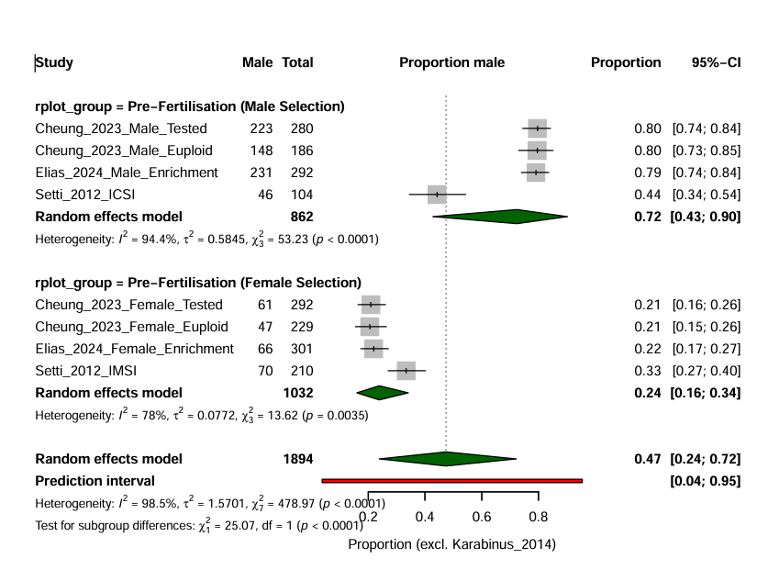
Fig. S2, blastulation-day comparison
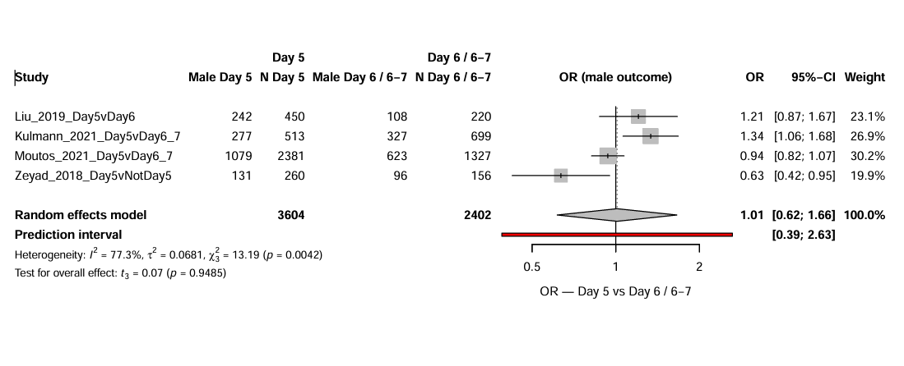
Fig. S3, TE-grade comparison
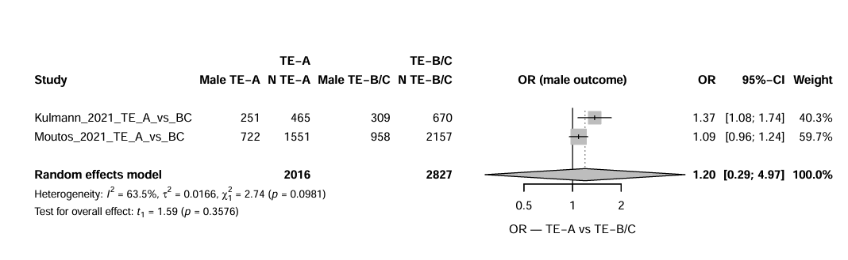

Fig. S4, ICM-grade comparison
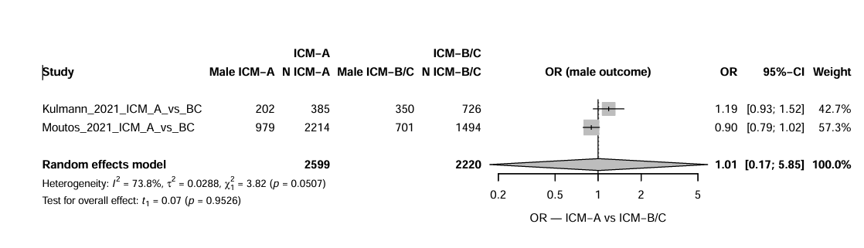
Fig. S5, fertilisation-method comparison
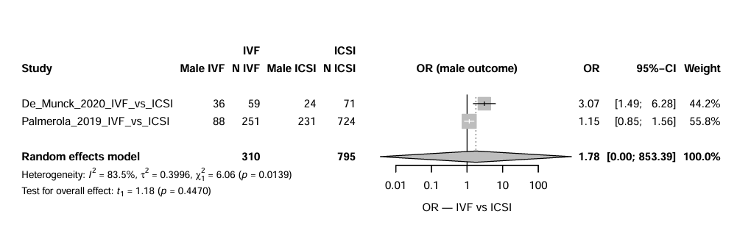
Fig. S6, primary contour-enhanced funnel plot
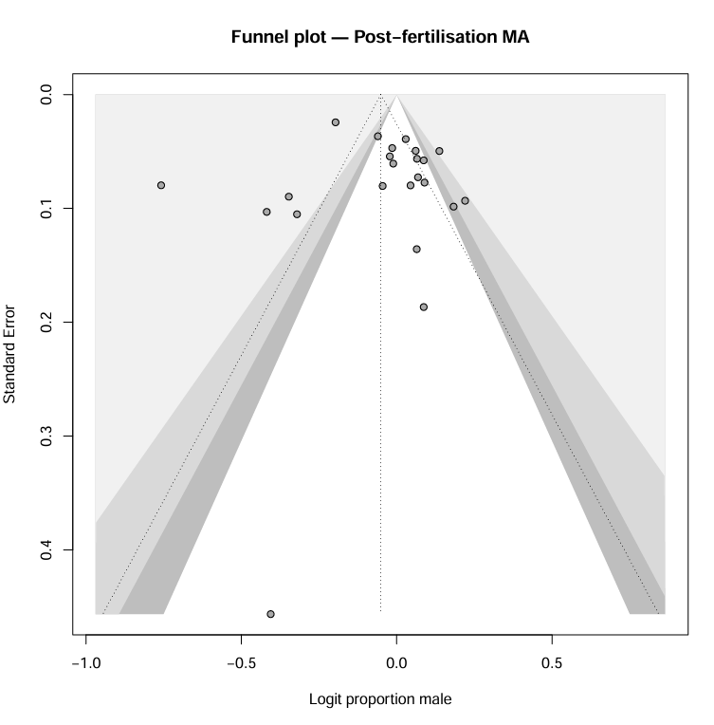

Fig. S7, primary sensitivity analysis
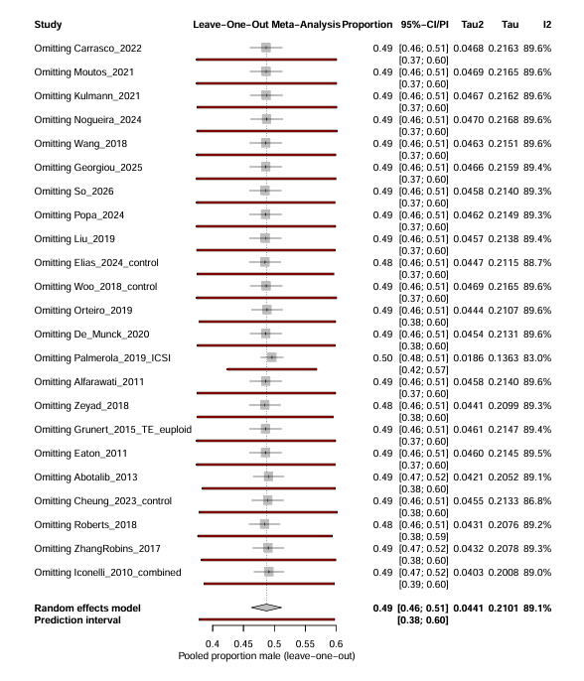
Fig. S8, secondary contour-enhanced funnel plot
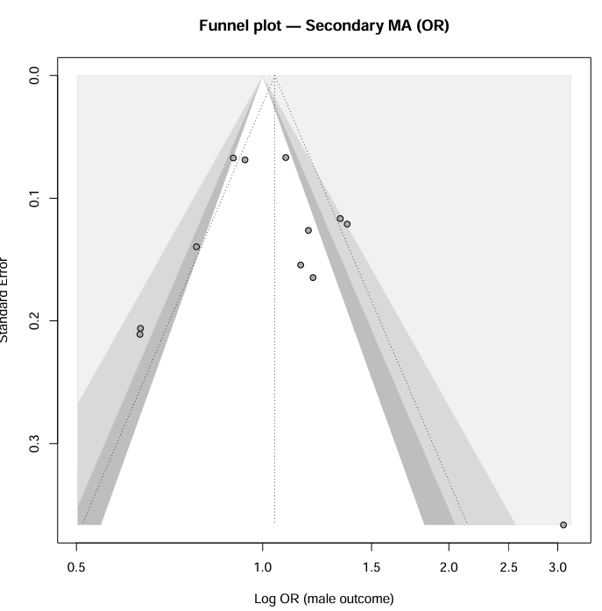
Fig. S9, secondary sensitivity analysis
