Figure 1. Spatial transcriptomics of human adenomyosis.
- Spatial scatter plot of total UMI count of sample A1, A7 and A12.
- Spatial scatter plot showing the cell type annotation of stRNA-seq data by using cell2location software. Colors indicate cell types.
- Heat map of marker genes for cell annotation of stRNA-seq data.
- Bar plot showing each cell ratio, Colors indicate samples.
- Spatial scatter plot showing the spatial distribution of Unciliated Epithelial cells, Ciliated Epithelial cells, Smooth muscle cells and Fibroblasts.
- Spatial visualization of the expression levels of gene EPCAM, WFDC2, ACTG2 and COL3A1.

Figure S1. Spatial transcriptomics of human adenomyosis.
- UMAP plot of single-cell transcriptome profiles of the adenomyosis scRNA-seq data including SRR12791871(AM_EC), SRR12791872(AM_EM), and SRR12791873(AM_CTRL) that were obtained from the Sequence Read Archive (SRA) of the National Center for Biotechnology Information (NCBI). Colors indicate groups，seurat_clusters and cell types.
- Dot plot of marker genes for cell annotation of scRNA-seq data.
- Bar plot showing each cell ratio of scRNA-seq data.
- Heat map plot showing the most enrichment GO biological process terms of marker genes in each cell type of scRNA-seq data. Top 3 terms were selected for each cell type and heat map shows the enrichment q-value of these terms (scaled by column).
- Heat map plot showing the most enrichment KEGG pathways of marker genes in each cell type of scRNA-seq data. Top 3 pathways were selected for each cell type and heat map shows the enrichment q-value of these terms (scaled by column).
- Estimated cell abundances of FB, SMC, Pericytes, Ciliated_Epi cell and Unciliated_Epi cell of stRNA-seq data by using cell2location software(color intensity) .

Figure 2. Differentially expression analysis of all cell types of invasion and normal regions.
- Regions selection of the invasive lesions and normal tissues by using the lasso tool of StereoMap software. Yellow indicate invasion regions, and Lightblue indicate normal regions.
- Bar plot showing each cell ratio of invasion and normal regions in the sample A1(left), A7(middle) and A12(right).
- Gene ontology enrichment analysis of biological processes of up-regulated differentially expressed genes(DEGs) between invasion and normal regions. Top 3 terms were selected for each cell type and Dot plot showing the gene ratio and adjusted P-value of these terms.
- Gene ontology enrichment analysis of biological processes of down-regulated DEGs between invasion and normal regions. Top 3 terms were selected for each cell type and Dot plot showing the gene ratio and adjusted P-value of these terms.
- KEGG pathway enrichment analysis of up-regulated DEGs between invasion and normal regions. Top 3 pathways were selected for each cell type and Dot plot showing the gene ratio and adjusted P-value of these pathways.
- KEGG pathway enrichment analysis of down-regulated DEGs between invasion and normal regions. Top 3 pathways were selected for each cell type and Dot plot showing the gene ratio and adjusted P-value of these pathways.

Figure S2. Spatial transcriptomics of human adenomyosis.
- Spatial scatter plot showing the spatial distribution of Endothelial cell, Vascular progenitor cell, MYH11+ perivascular cell, Pericytes, NK cell, T cell, Monocyte or Macrophages and Mast.
- Spatial visualization of the expression levels of gene PECAM1, TFF3, SORBS2, RGS5, NKG7, CD3D, CD74 and CPA3.

Figure 3. differentially expression analysis of the Epithelial cells of invasion and normal regions.
(A) Bubble plots showing KEGG pathway enrichment of upregulated DEGs in epithelial cells from invasive regions compared with non-invasive regions (left, ciliated epithelial cells; right, unciliated epithelial cells).
(B) Bubble plots showing KEGG pathway enrichment of downregulated DEGs in epithelial cells from invasive regions compared with non-invasive regions (left, ciliated epithelial cells; right, unciliated epithelial cells).

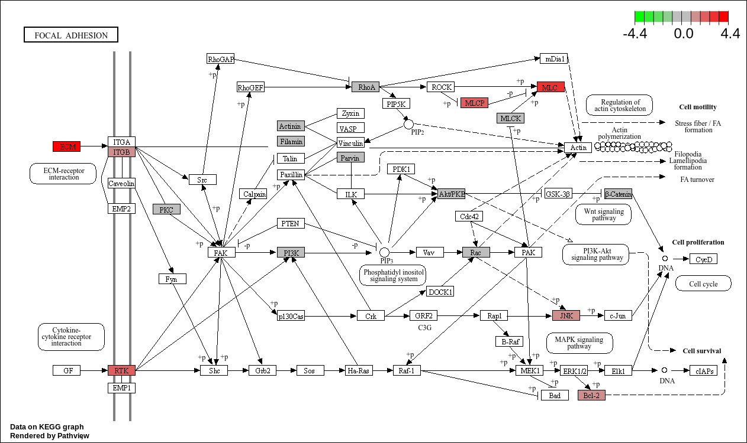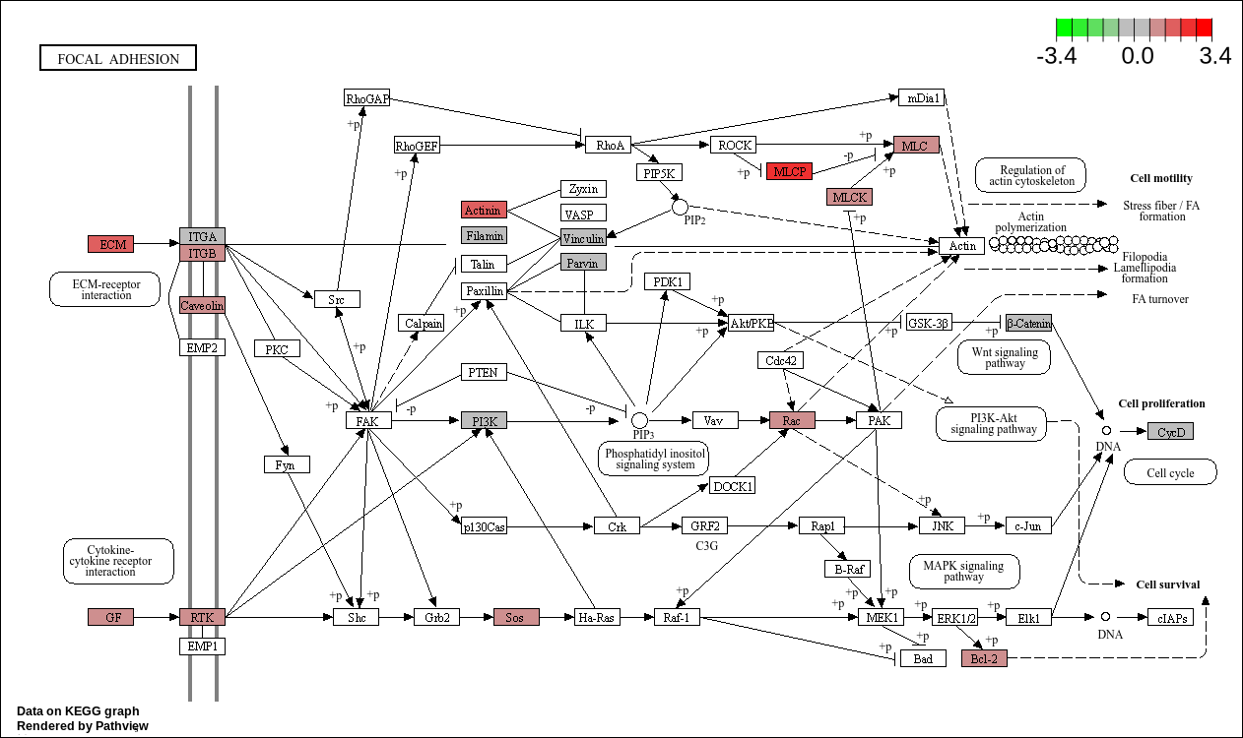
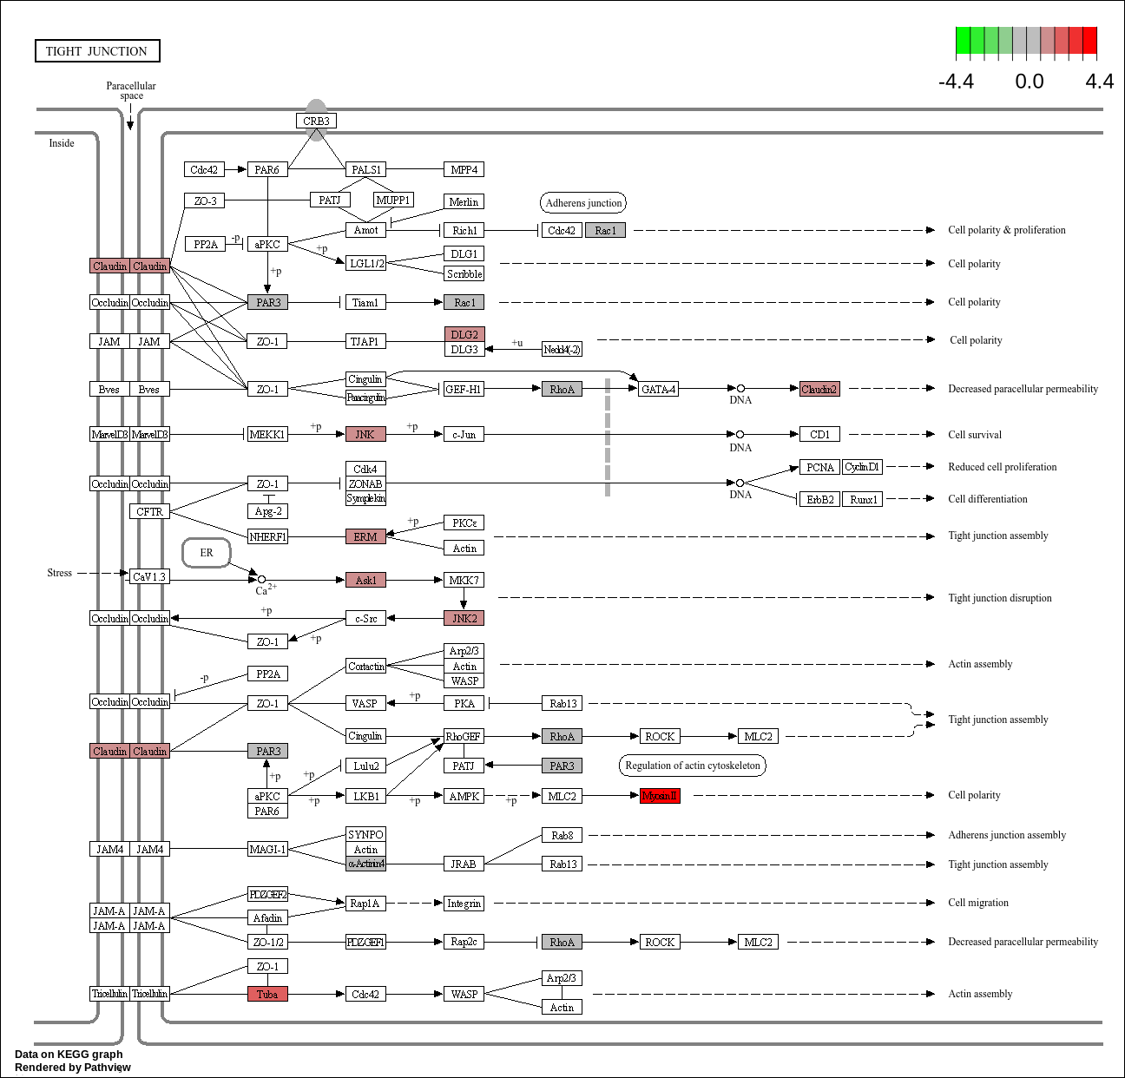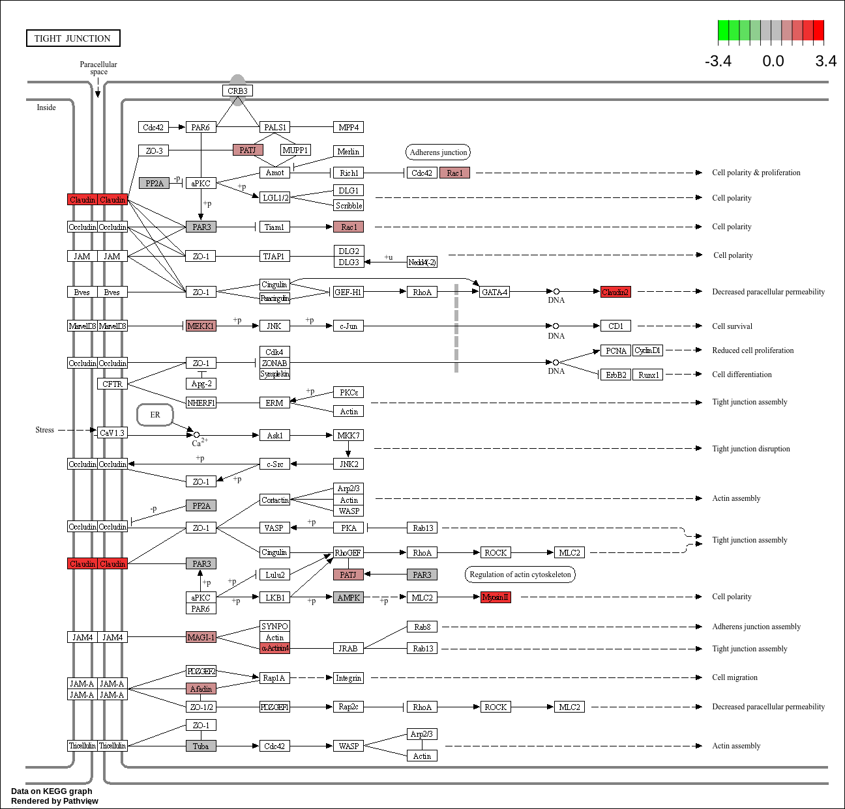
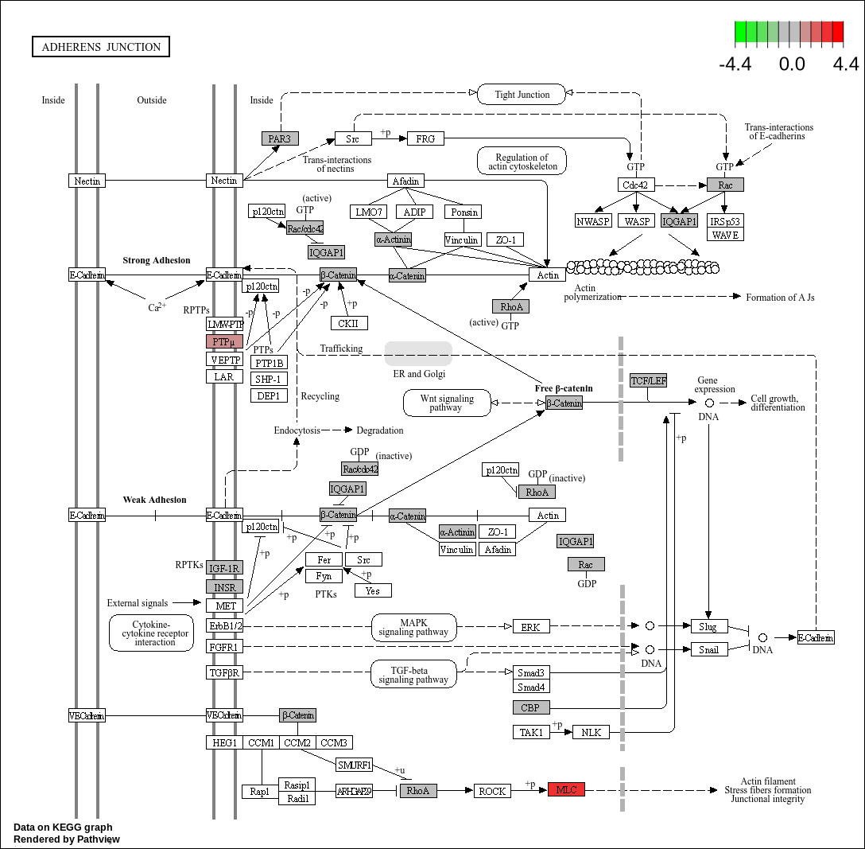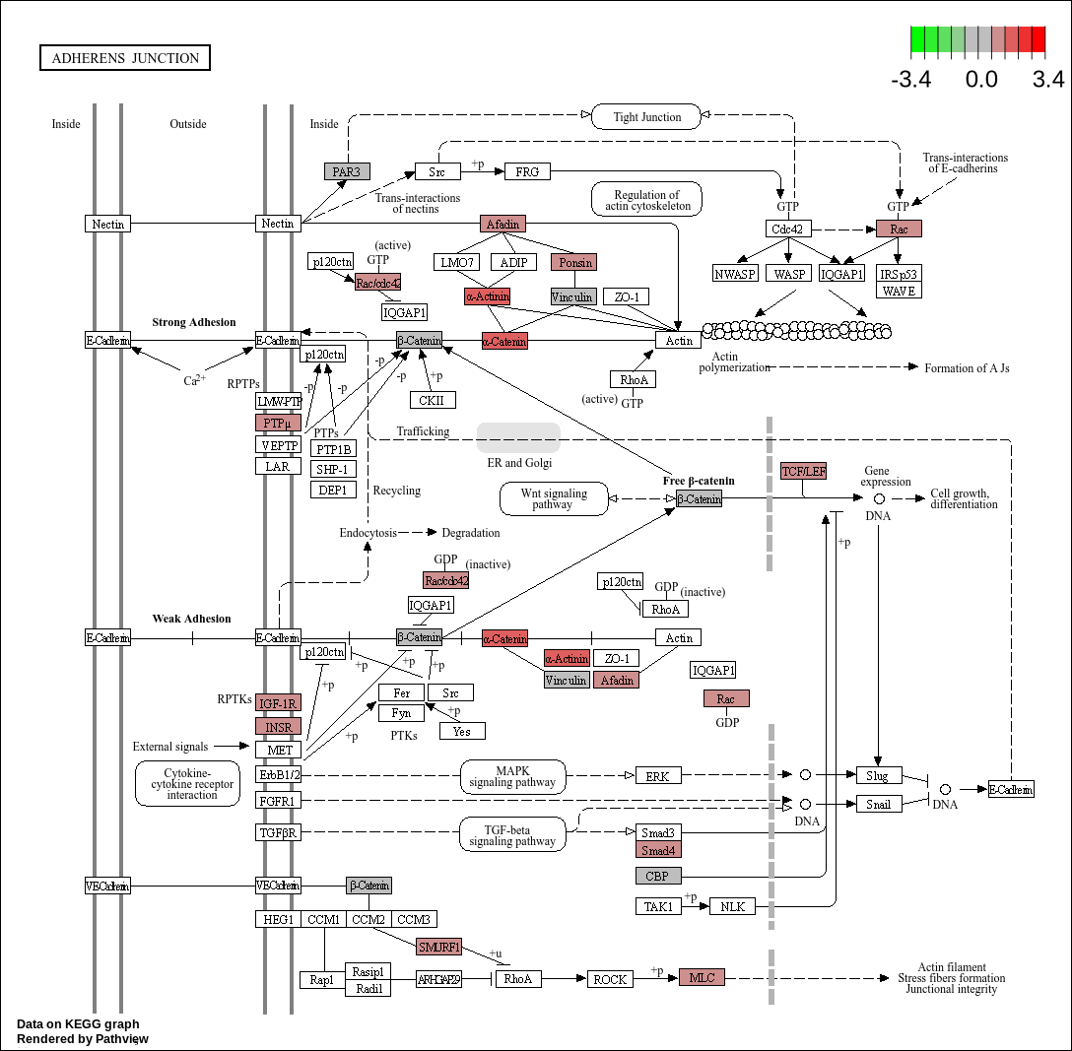

- Bubble plot showing the most enrichment KEGG pathways of the up-regulated DEGs in the Epithelial cells of invasion regions compare to the normal regions(left,Ciliated_Epi; right, Unciliated_Epi).
- Bubble plot showing the most enrichment KEGG pathways of the down-regulated DEGs in the Epithelial cells of invasion regions compare to the normal regions(left,Ciliated_Epi; right, Unciliated_Epi).
- Enrichment of highly expressed genes in the epithelial cell focal adhesion signaling pathway(left,Ciliated_Epi; right, Unciliated_Epi).
- Enrichment of highly expressed genes in the epithelial cell tight junction (left,Ciliated_Epi; right, Unciliated_Epi).
- Enrichment of highly expressed genes in the epithelial cell adherens junction(left,Ciliated_Epi; right, Unciliated_Epi).

Figure S3. differentially expression analysis of the Epithelial cells of invasion and normal regions.
- Bubble plot showing the most enrichment GO biological process terms of the up-regulated DEGs in the Epithelial cells of invasion regions compare to the normal regions(left,Ciliated_Epi; right, Unciliated_Epi).
- Bubble plot showing the most enrichment GO biological process terms of the down-regulated DEGs in the Epithelial cells of invasion regions compare to the normal regions(left,Ciliated_Epi; right, Unciliated_Epi).

Figure4. The chemokine receptor-ligand cell interaction analysis.
- Heat map showing the centrality scores/importance of each cell type as senders, receivers, mediators and influencers in CXCL signaling pathway network in sample A1(left); Spatial plot showing the inferred communication network of CXCL signaling pathway in sample A1(middle); Bar plot showing the contribution of each ligand-receptor pair in the overall CXCL signaling pathway in sample A1(right).
- Heat map showing the centrality scores/importance of each cell type as senders, receivers, mediators and influencers in CXCL signaling pathway network in sample A7(left); Spatial plot showing the inferred communication network of CXCL signaling pathway in sample A7(middle); Bar plot showing the contribution of each ligand-receptor pair in the overall CXCL signaling pathway in sample A7(right).
- Heat map showing the centrality scores/importance of each cell type as senders, receivers, mediators and influencers in CXCL signaling pathway network in sample A12(left); Spatial plot showing the inferred communication network of CXCL signaling pathway in sample A12(middle); Bar plot showing the contribution of each ligand-receptor pair in the overall CXCL signaling pathway in sample A12(right).

FigureS4. The chemokine receptor-ligand cell interaction analysis.
- Heatmap showing the number and strength of interactions in sample A1.
- Heatmap showing the number and strength of interactions in sample A7.
- Heatmap showing the number and strength of interactions in sample A12.
- Heat map showing the centrality scores/importance of each cell type as senders, receivers, mediators and influencers in CX3C signaling pathway network in sample A1(left); Spatial plot showing the inferred communication network of CX3C signaling pathway in sample A1(middle); Bar plot showing the contribution of each ligand-receptor pair in the overall CX3C signaling pathway in sample A1(right).

Figure5. The growth factor receptor-ligand cell interaction analysis.
- Heat map showing the centrality scores/importance of each cell type as senders, receivers, mediators and influencers in PDGF signaling pathway network in sample A1(left); Spatial plot showing the inferred communication network of PDGF signaling pathway in sample A1(middle); Bar plot showing the contribution of each ligand-receptor pair in the overall PDGF signaling pathway in sample A1(right).
- Heat map showing the centrality scores/importance of each cell type as senders, receivers, mediators and influencers in PDGF signaling pathway network in sample A7(left); Spatial plot showing the inferred communication network of PDGF signaling pathway in sample A7(middle); Bar plot showing the contribution of each ligand-receptor pair in the overall PDGF signaling pathway in sample A7(right).
- Heat map showing the centrality scores/importance of each cell type as senders, receivers, mediators and influencers in PDGF signaling pathway network in sample A12(left); Spatial plot showing the inferred communication network of PDGF signaling pathway in sample A12(middle); Bar plot showing the contribution of each ligand-receptor pair in the overall PDGF signaling pathway in sample A12(right).
- Heat map showing the centrality scores/importance of each cell type as senders, receivers, mediators and influencers in IGF signaling pathway network in sample A1(left); Spatial plot showing the inferred communication network of IGF signaling pathway in sample A1(middle); Bar plot showing the contribution of each ligand-receptor pair in the overall IGF signaling pathway in sample A1(right).
- Heat map showing the centrality scores/importance of each cell type as senders, receivers, mediators and influencers in IGF signaling pathway network in sample A7(left); Spatial plot showing the inferred communication network of IGF signaling pathway in sample A7(middle); Bar plot showing the contribution of each ligand-receptor pair in the overall IGF signaling pathway in sample A7(right).
- Heat map showing the centrality scores/importance of each cell type as senders, receivers, mediators and influencers in IGF signaling pathway network in sample A12(left); Spatial plot showing the inferred communication network of IGF signaling pathway in sample A12(middle); Bar plot showing the contribution of each ligand-receptor pair in the overall IGF signaling pathway in sample A12(right).

FigureS5. The growth factor receptor-ligand cell interaction analysis.
- Heat map showing the centrality scores/importance of each cell type as senders, receivers, mediators and influencers in FGF signaling pathway network in sample A1(left); Spatial plot showing the inferred communication network of FGF signaling pathway in sample A1(middle); Bar plot showing the contribution of each ligand-receptor pair in the overall FGF signaling pathway in sample A1(right).
- Heat map showing the centrality scores/importance of each cell type as senders, receivers, mediators and influencers in FGF signaling pathway network in sample A7(left); Spatial plot showing the inferred communication network of FGF signaling pathway in sample A7(middle); Bar plot showing the contribution of each ligand-receptor pair in the overall FGF signaling pathway in sample A7(right).
- Heat map showing the centrality scores/importance of each cell type as senders, receivers, mediators and influencers in FGF signaling pathway network in sample A12(left); Spatial plot showing the inferred communication network of FGF signaling pathway in sample A12(middle); Bar plot showing the contribution of each ligand-receptor pair in the overall FGF signaling pathway in sample A12(right).
- Heat map showing the centrality scores/importance of each cell type as senders, receivers, mediators and influencers in TGFb signaling pathway network in sample A1(left); Spatial plot showing the inferred communication network of TGFb signaling pathway in sample A1(middle); Bar plot showing the contribution of each ligand-receptor pair in the overall TGFb signaling pathway in sample A1(right).
- Heat map showing the centrality scores/importance of each cell type as senders, receivers, mediators and influencers in TGFb signaling pathway network in sample A7(left); Spatial plot showing the inferred communication network of TGFb signaling pathway in sample A7(middle); Bar plot showing the contribution of each ligand-receptor pair in the overall TGFb signaling pathway in sample A7(right).
- Heat map showing the centrality scores/importance of each cell type as senders, receivers, mediators and influencers in TGFb signaling pathway network in sample A12(left); Spatial plot showing the inferred communication network of TGFb signaling pathway in sample A12(middle); Bar plot showing the contribution of each ligand-receptor pair in the overall TGFb signaling pathway in sample A12(right).

