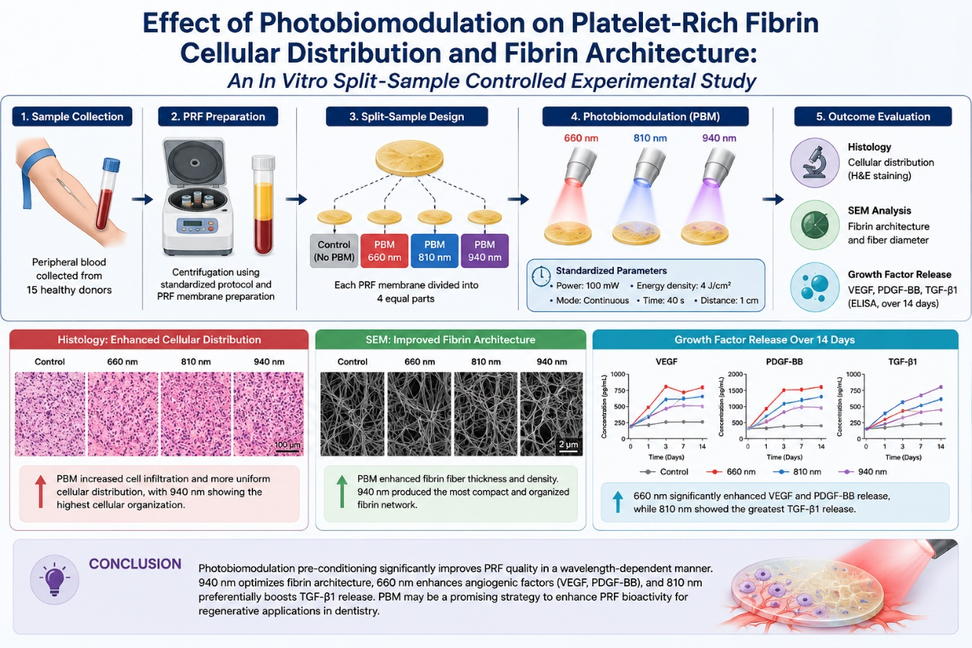
Figure S1:
Graphical Abstract: Wavelength-Dependent Effects of Photobiomodulation on Platelet-Rich Fibrin Structure and Growth-Factor Release
Figure Legend :
This graphical abstract illustrates the experimental design and principal findings of the present study evaluating the effects of photobiomodulation (PBM) on platelet-rich fibrin (PRF). PRF membranes were exposed to 660 nm, 810 nm, and 940 nm diode laser irradiation and compared with non-irradiated controls. Histologic and SEM analyses demonstrated improved cellular distribution, fibrin organisation, and scaffold density following PBM exposure. Growth-factor analysis showed wavelength-dependent biologic responses, with 660 nm producing the greatest VEGF and PDGF-BB release, 810 nm showing the highest TGF-β1 release, and 940 nm generating the most compact and organised fibrin architecture. These findings suggest that PBM may serve as a biologic preconditioning strategy for optimising PRF regenerative performance.
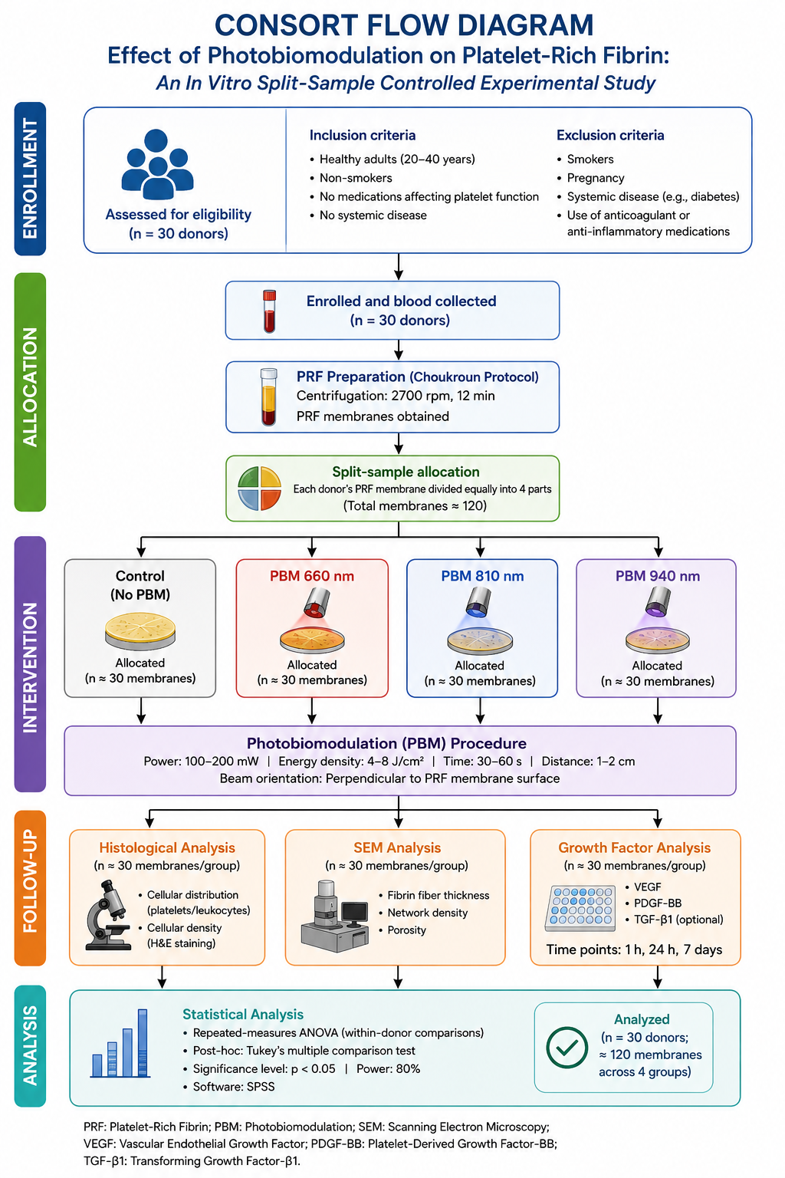
Figure S2
CONSORT Flow Diagram of the Experimental Design and Photobiomodulation Protocol
Figure Legend :
This CONSORT-style flow diagram illustrates the study workflow used to evaluate the effects of photobiomodulation (PBM) on platelet-rich fibrin (PRF) membranes in an in vitro split-sample controlled experimental design. Following donor enrollment and PRF preparation, each membrane was equally divided into four groups: control, PBM 660 nm, PBM 810 nm, and PBM 940 nm. Samples subsequently underwent histologic analysis, scanning electron microscopy (SEM) assessment, and growth-factor release evaluation at multiple time points. Statistical comparisons were performed to determine wavelength-dependent effects on PRF cellular distribution, fibrin architecture, and biologic activity.

Supplementary Statistical Analysis
Table S1: P-values for pairwise comparisons between PBM groups and Control
Outcome | Comparison | T-statistic | P-value | Significance
Platelet distribution | PBM 660 nm vs Control | 6.051 | < 0.001 | ***
Platelet distribution | PBM 810 nm vs Control | 10.324 | < 0.001 | ***
Platelet distribution | PBM 940 nm vs Control | 12.291 | < 0.001 | ***
Leukocyte distribution | PBM 660 nm vs Control | 6.821 | < 0.001 | ***
Leukocyte distribution | PBM 810 nm vs Control | 9.765 | < 0.001 | ***
Leukocyte distribution | PBM 940 nm vs Control | 14.408 | < 0.001 | ***
Cellular density | PBM 660 nm vs Control | 6.211 | < 0.001 | ***
Cellular density | PBM 810 nm vs Control | 8.673 | < 0.001 | ***
Cellular density | PBM 940 nm vs Control | 13.512 | < 0.001 | ***
Fibrin fiber thickness | PBM 660 nm vs Control | 6.555 | < 0.001 | ***
Fibrin fiber thickness | PBM 810 nm vs Control | 13.167 | < 0.001 | ***
Fibrin fiber thickness | PBM 940 nm vs Control | 18.21 | < 0.001 | ***
Network density | PBM 660 nm vs Control | 7.359 | < 0.001 | ***
Network density | PBM 810 nm vs Control | 13.238 | < 0.001 | ***
Network density | PBM 940 nm vs Control | 17.966 | < 0.001 | ***
Porosity | PBM 660 nm vs Control | -7.126 | < 0.001 | ***
Porosity | PBM 810 nm vs Control | -10.6 | < 0.001 | ***
Porosity | PBM 940 nm vs Control | -17.552 | < 0.001 | ***
Table S1 presents the p-values resulting from independent t-tests comparing each photobiomodulation (PBM) group to the non-irradiated control group across primary structural and cellular outcomes. The analysis reveals that all tested wavelengths (660 nm, 810 nm, and 940 nm) produced highly significant changes (p < 0.001) in platelet distribution, leukocyte distribution, cellular density, fibrin fiber thickness, network density, and porosity when compared to the control group. The magnitude of the t-statistics suggests a wavelength-dependent response, with the 940 nm group consistently demonstrating the most pronounced differences from the control across all structural parameters.

Table S2: Effect sizes (Cohen's d) for differences between PBM groups and Control
Outcome | Comparison | Cohen's d | Magnitude
Platelet distribution | PBM 660 nm vs Control | 1.562 | Large
Platelet distribution | PBM 810 nm vs Control | 2.666 | Large
Platelet distribution | PBM 940 nm vs Control | 3.174 | Large
Leukocyte distribution | PBM 660 nm vs Control | 1.761 | Large
Leukocyte distribution | PBM 810 nm vs Control | 2.521 | Large
Leukocyte distribution | PBM 940 nm vs Control | 3.72 | Large
Cellular density | PBM 660 nm vs Control | 1.604 | Large
Cellular density | PBM 810 nm vs Control | 2.239 | Large
Cellular density | PBM 940 nm vs Control | 3.489 | Large
Fibrin fiber thickness | PBM 660 nm vs Control | 1.693 | Large
Fibrin fiber thickness | PBM 810 nm vs Control | 3.4 | Large
Fibrin fiber thickness | PBM 940 nm vs Control | 4.702 | Large
Network density | PBM 660 nm vs Control | 1.9 | Large
Network density | PBM 810 nm vs Control | 3.418 | Large
Network density | PBM 940 nm vs Control | 4.639 | Large
Porosity | PBM 660 nm vs Control | -1.84 | Large
Porosity | PBM 810 nm vs Control | -2.737 | Large
Porosity | PBM 940 nm vs Control | -4.532 | Large
VEGF 24h | PBM 660 nm vs Control | 4.898 | Large
VEGF 24h | PBM 810 nm vs Control | 3.109 | Large
VEGF 24h | PBM 940 nm vs Control | 2.069 | Large
Table S2 illustrates the effect sizes (Cohen's d) for the differences between each PBM group and the control group. All interventions yielded "Large" effect sizes (d > 0.8) across the measured parameters, indicating substantial biological and structural modifications induced by laser irradiation. Notably, the 940 nm wavelength produced the most massive effect sizes for structural parameters such as fibrin fiber thickness (d = 4.702) and network density (d = 4.639). Conversely, the 660 nm wavelength generated the largest effect size for VEGF release at 24 hours (d = 4.898), further supporting the wavelength-specific modulation of PRF characteristics.

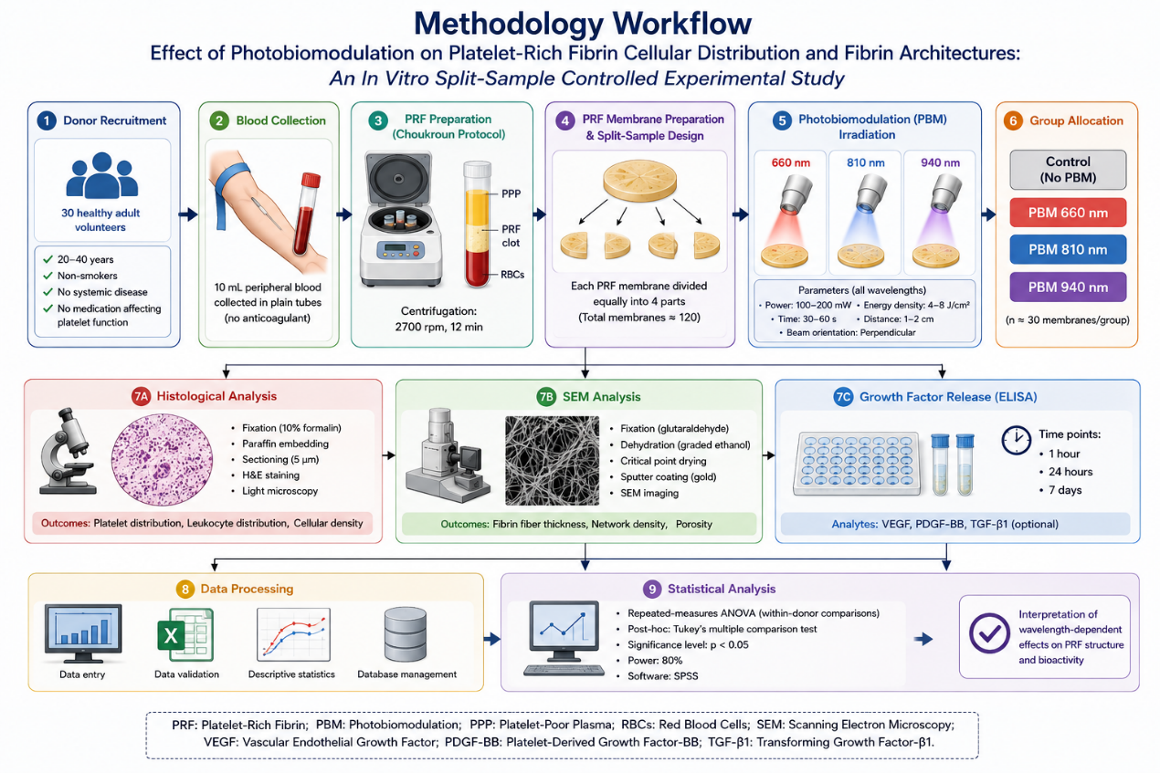
Figure S3:
Methodology Workflow of the In Vitro Split-Sample Experimental Study
Figure Legend / Caption:
This methodology workflow illustrates the experimental procedures used to evaluate the effects of photobiomodulation (PBM) on platelet-rich fibrin (PRF) membranes. Following donor recruitment and peripheral blood collection, PRF membranes were prepared using the Choukroun centrifugation protocol and divided into four groups: control, PBM 660 nm, PBM 810 nm, and PBM 940 nm. Samples subsequently underwent histological evaluation, scanning electron microscopy (SEM) analysis, and ELISA-based growth-factor assessment at different time intervals. Statistical analyses were then performed to determine wavelength-dependent effects on PRF cellular distribution, fibrin microarchitecture, and biologic activity.

