Supplementary Figures
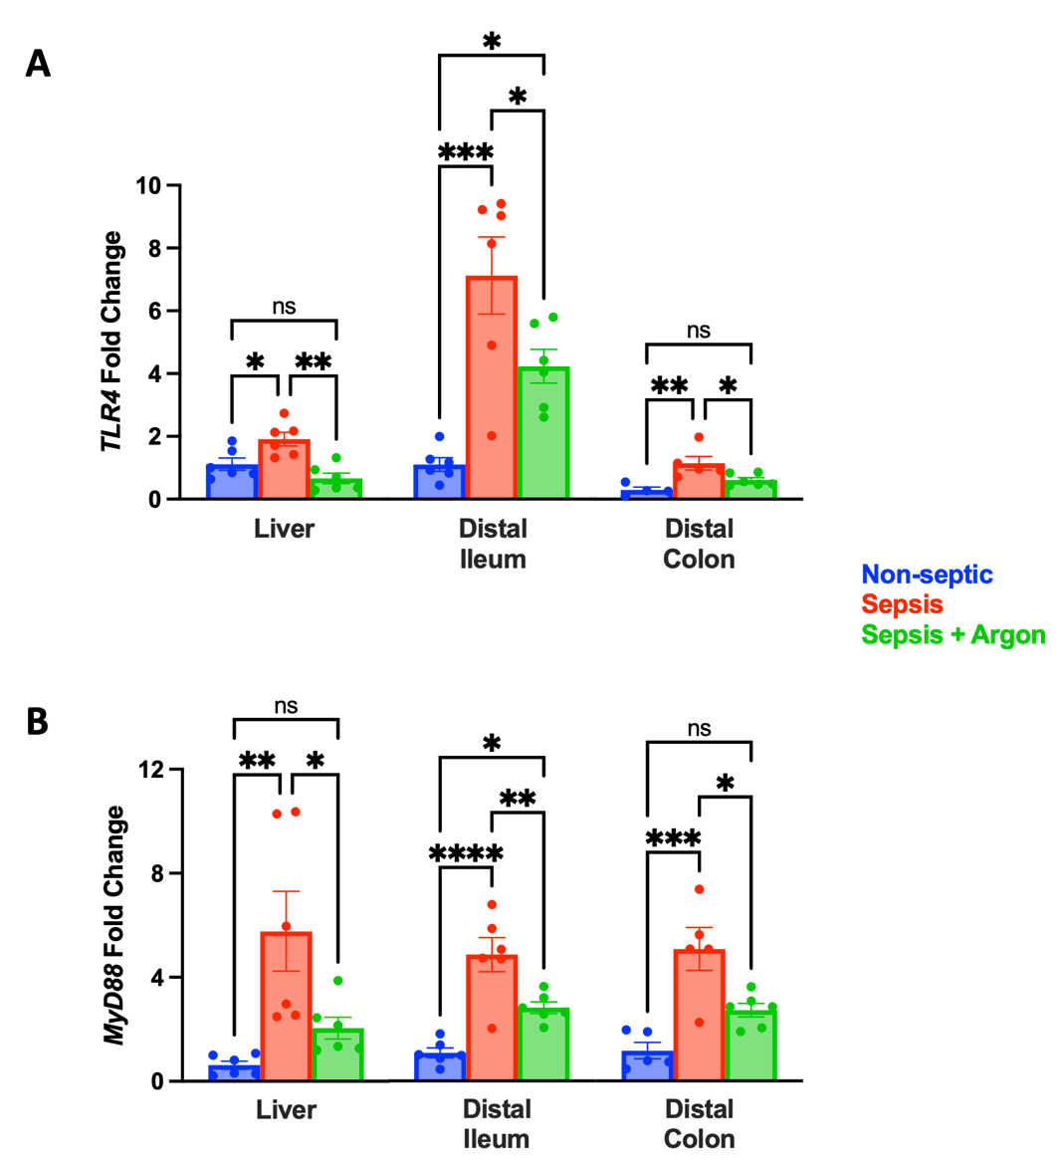

Supplementary Figure 1. Argon modulates mRNA expression of the TLR4 MyD88-dependent pathway. mRNA expression levels of (A) TLR4 and (B) its downstream mediator MyD88 in liver, distal ileum and distal colon tissue lysates were measured and compared between all experimental groups. N=6 per group. Data are presented as mean $±$ SEM and compared using one-way ANOVA with post-hoc Tukey test (*p<0.05, **p<0.01, ***p<0.001, ****p<0.0001).

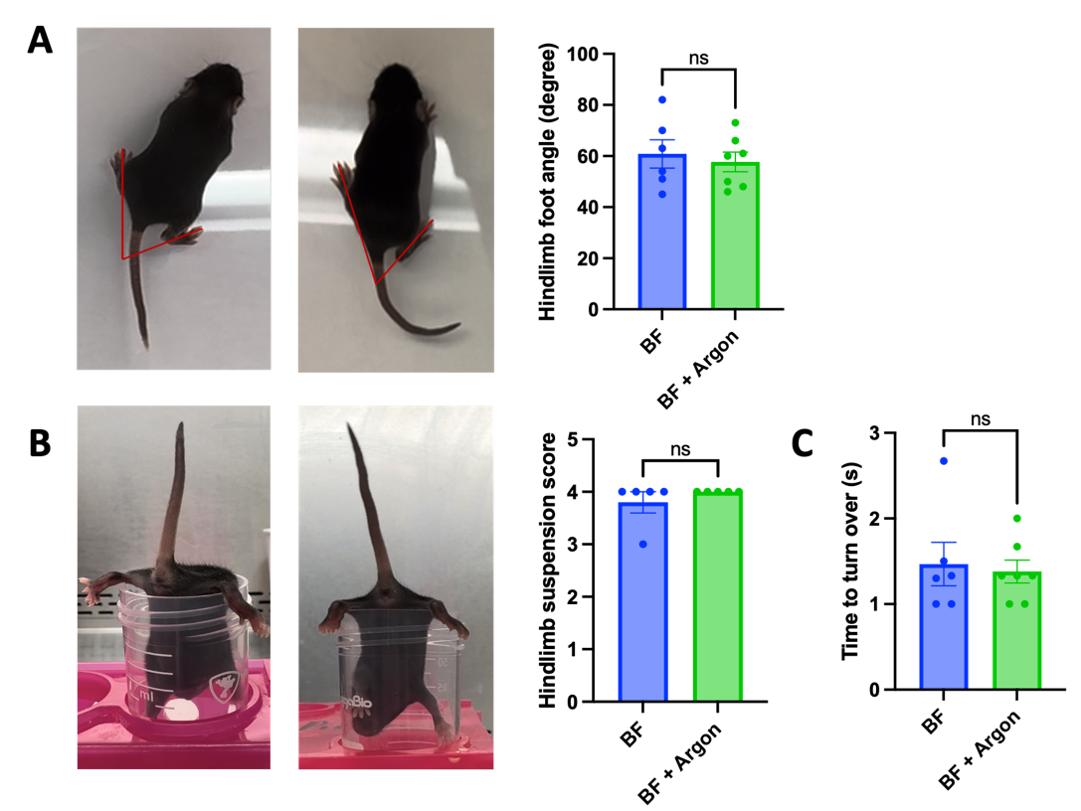
Supplementary Figure 2. Argon showed no overt signs of toxicity in neonatal mice. Argon inhalation is safe to administer and does not produce any deficit in cognitive motor function for breastfed (BF) control P9 pups (n=6-7 per group). (A) The hindlimb foot angle test was performed by measuring the food angle using a line drawn from the mid-heel through the middle (longest) toe. Argon inhalation did not alter the hindlimb foot angle in breastfed control pups. (B) The hindlimb suspension test was performed to evaluate right/left limb strength and neuromuscular function. Argon inhalation did not alter the hindlimb suspension score in breastfed control pups. (C) The surface righting test was performed to assess the motor ability of pups to turn over onto their feet from the supine position. Argon inhalation did not alter the time to turn over in breastfed control pups. Data was compared using Student’s t-test or Kolmogorov–Smirnov nonparametric test and presented as mean $±$ SEM.

