Supplementary Information

Wuxing Hua^{1,2†}, Huan Li^{3†}, Chun Pei^{2†}, Jingyi Xia¹, Yafei Sun², Chen Zhang⁴, Wei Lv⁵, Ying Tao¹, Yan Jiao³, Bingsen Zhang⁶, Shi-Zhang Qiao³, Ying Wan²* and Quan-Hong Yang¹*

¹Nanoyang Group, State Key Laboratory of Chemical Engineering, School of Chemical Engineering and Technology, Tianjin University, Tianjin 300350, China;
²Key Laboratory of Resource Chemistry of Ministry of Education, Shanghai Key Laboratory of Rare Earth Functional Materials, Department of Chemistry, Shanghai Normal University, Shanghai 200234, China;
³School of Chemical Engineering and Advanced Materials, The University of Adelaide, Adelaide, SA 5005, Australia;
⁴School of Marine Science and Technology, Tianjin University, Tianjin 300072, China;
⁵Shenzhen Key Laboratory for Graphene-based Materials and Engineering Laboratory for Functionalized Carbon Materials, Graduate School at Shenzhen, Tsinghua University, Shenzhen 518055, China;
⁶Shenyang National Laboratory for Materials Science, Institute of Metal Research, Chinese Academy of Sciences, Shenyang 110016, China.
†These authors are equal main contributors.
Corresponding E-mails: ywan@shnu.edu.cn; qhyangcn@tju.edu.cn.

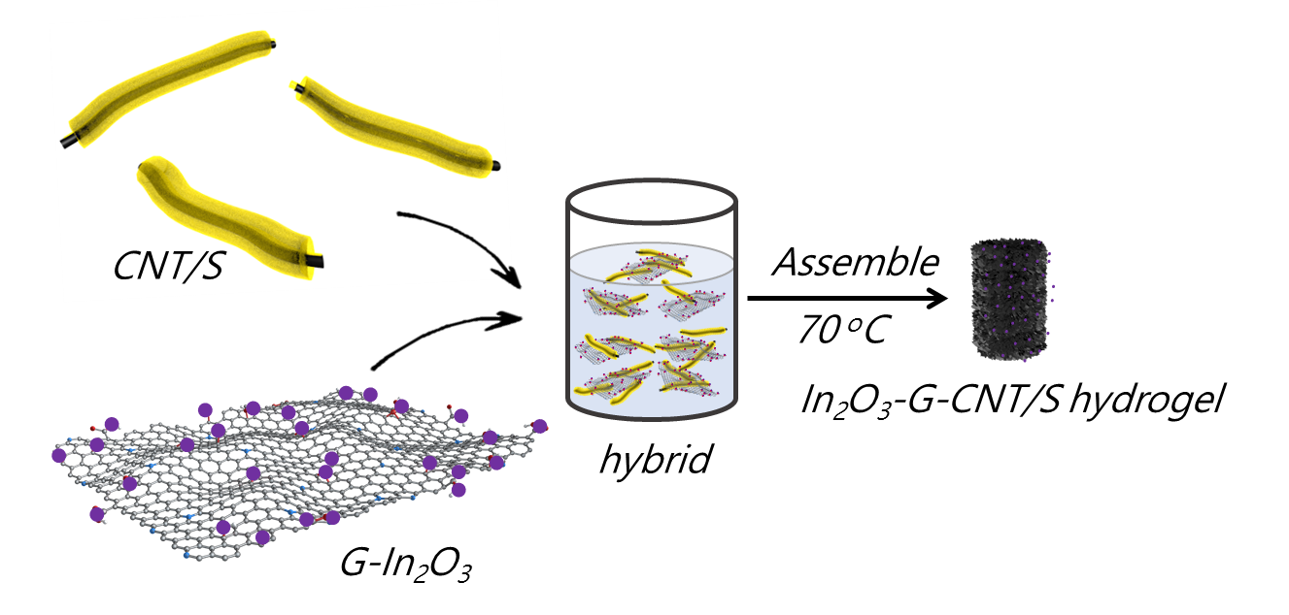
Supplementary Figure 1. The detail fabrication process of In₂O₃-G-CNT/S hydrogel.

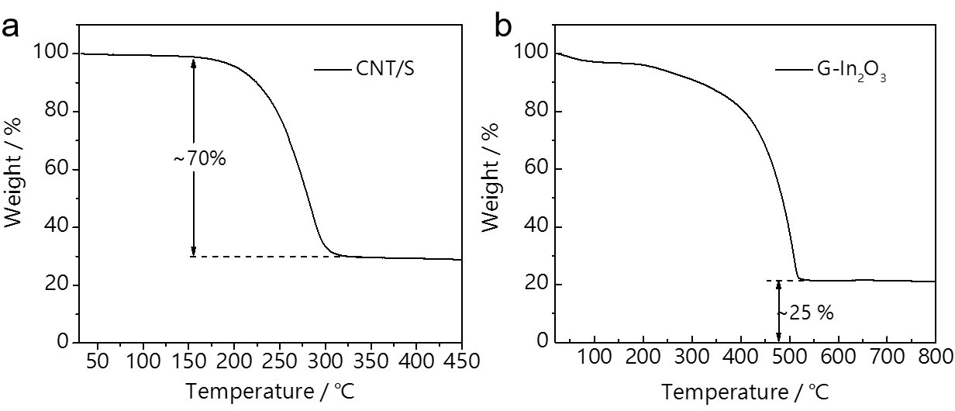
Supplementary Figure 2. TGA curves of the (a) CNT/S and (b) G-In₂O₃ hybrids.

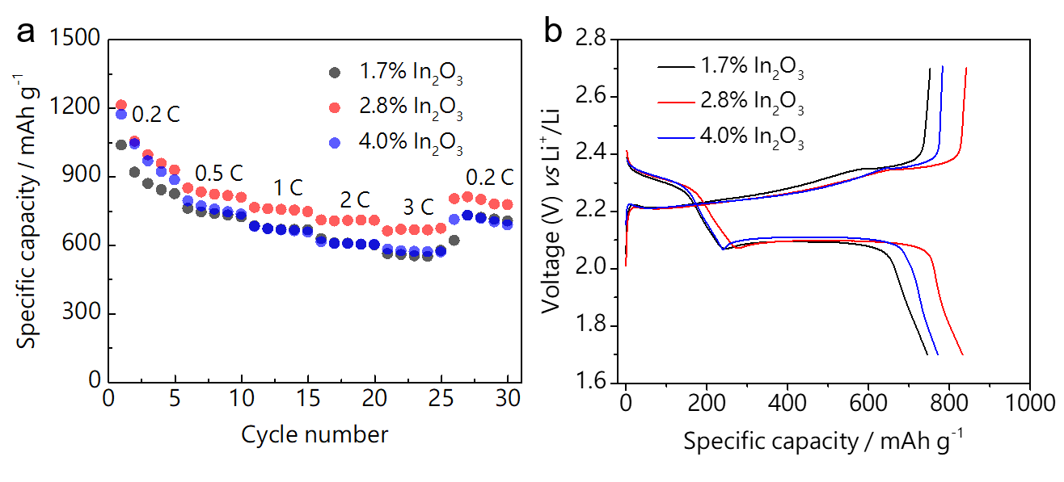
Supplementary Figure 3. (a) The rate performance of In₂O₃-catalyzed batteries after introducing different content of In₂O₃ in the In₂O₃-based cathode and (b) their charge and discharge profiles at 0.5 C.
The In₂O₃-based cathodes are prepared by mixing In₂O₃-G-CNT/S powder (95 wt%) and poly (vinylidene fluoride) (5 wt%), and the total mass of the cathode is ~ 1.2 mg. Therefore, the mass of the In₂O₃-G-CNT/S powder in the cathode is ~ 1.14 mg (1.2*0.95). The ratio of CNT/S and In₂O₃-G in the In₂O₃-G-CNT/S powder is 9:1, and the contents of In₂O₃ in the G-In₂O₃ hybrids are 15, 25 and 35 wt%. Therefore, the contents of In₂O₃ in the In₂O₃-based cathodes are ~1.7 % (1.14*0.1*0.15*100%), 2.8 % (1.14*0.1*0.25*100%) and 4.0 % (1.14*0.1*0.35*100%).
The mass fraction of In₂O₃ catalyst in cathode were optimized in order to study the performance of catalyst-based battery in comparison to that free of catalyst. With only 2.8 % In₂O₃ in the cathode, the battery gives the highest capacity at various rates (Supplementary Fig. 3a). The cathode with 4.0 % In₂O₃ shows the lowest overpotential among the three batteries (Supplementary Fig. 3b), which is attributed to the enhanced redox of the Li₂S_{n}. Considering that additional In₂O₃ could lead to a drop of the capacity and energy density, the 2.8 wt% In₂O₃ in the cathode was used in this work.

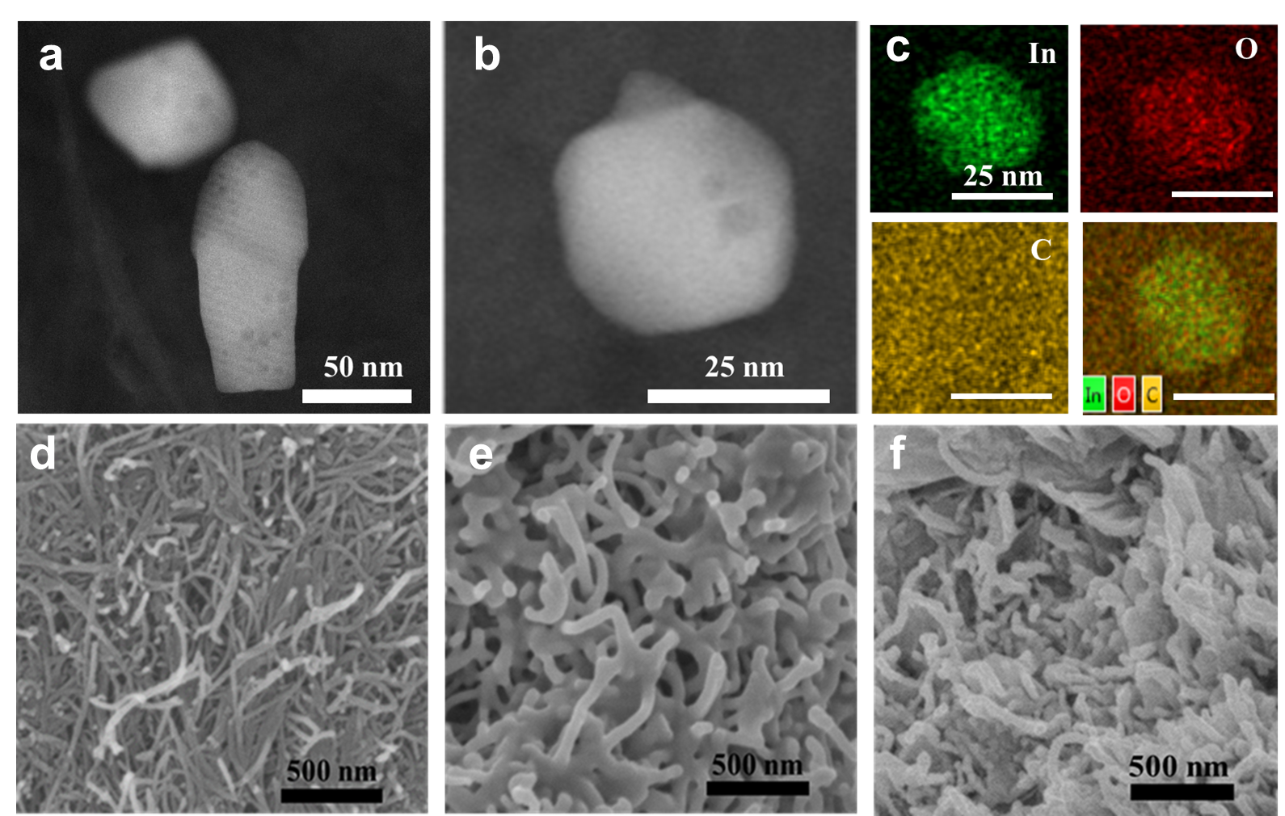
Supplementary Figure 4. ADF-STEM images of (a) G-In₂O₃ hybrids; (b) ADF-STEM images and (c) the corresponding EDX elemental mapping images of G-In₂O₃ hybrids; SEM images of (d) pure CNT; (e) CNT/S and (f) In₂O₃-G-CNT/S hybrids.

Supplementary Figre 5. XRD patterns of Pure sulfur, CNT and CNT/S hybrids.

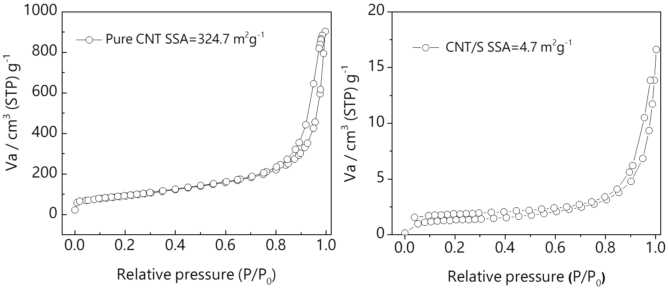
Supplementary Figure 6. Nitrogen adsoption-desorption isotherms of (a) Pure CNT, (b) CNT/S hybrids.

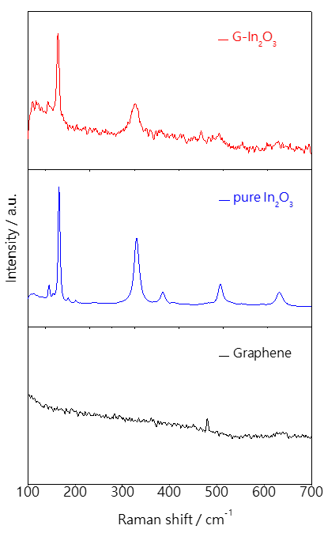
Supplementary Figure 7. Raman spectra of Graphene, pure In₂O₃ and G-In₂O₃ hybrid.

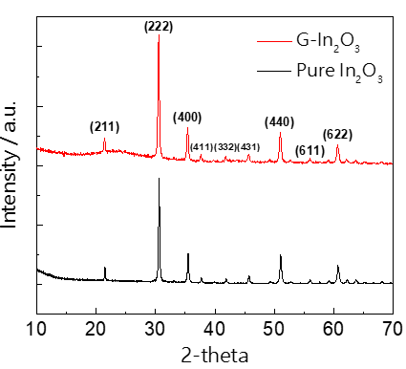
Supplementary Figre 8. XRD patterns of pure In₂O₃ and G-In₂O₃.

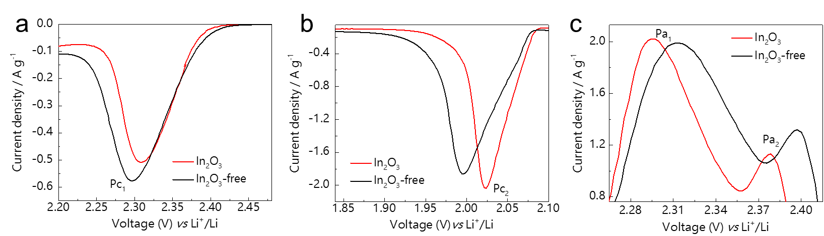
Supplementary Figure 9. Magnification of the (a, b) cathodic and (c) oxidation peaks of the two batteries.

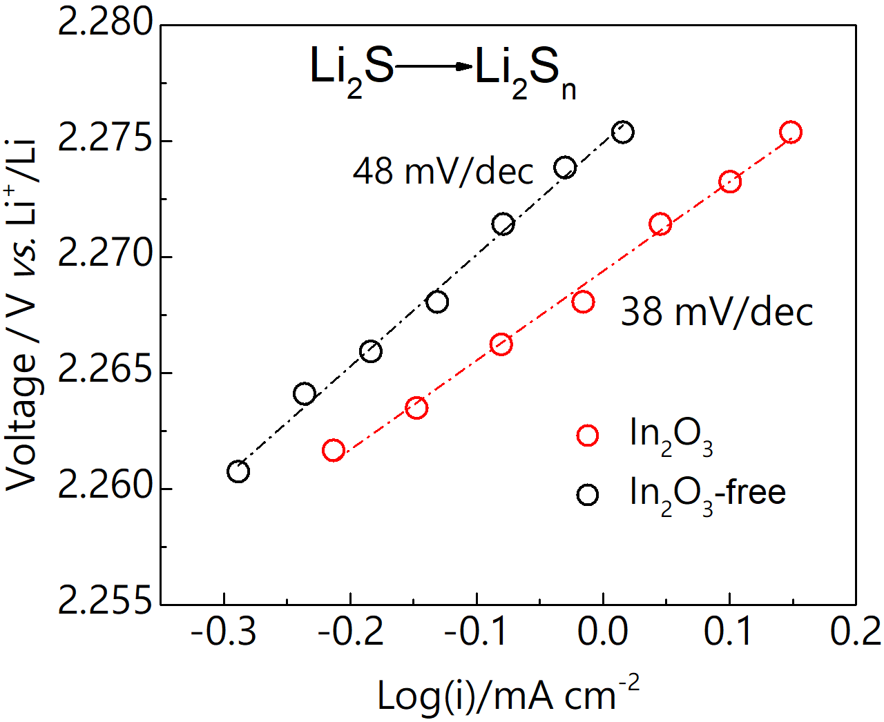
Supplementary Figure 10. Tafel plots corresponding to the oxidation of Li₂S to the Li₂S_{n}.

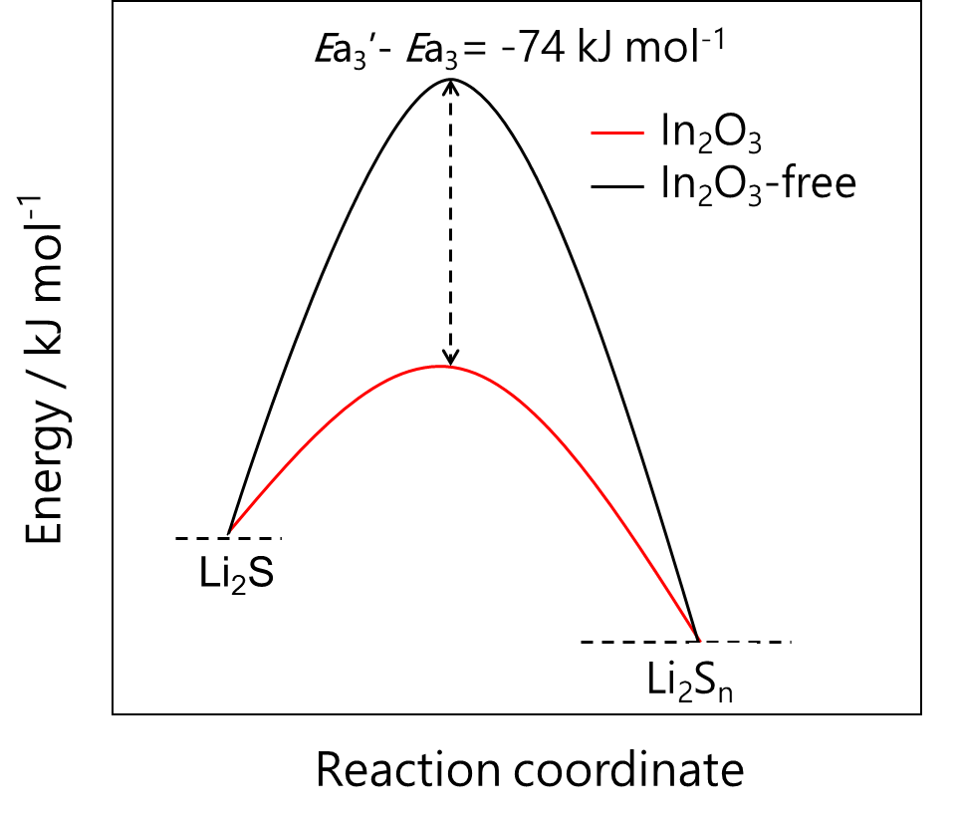
Supplementary Figure 11. The difference in activation energy between two cathodes: the In₂O₃-catalyzed cathode shows lower energy barrier for the conversion from Li₂S to Li₂S_{n}.

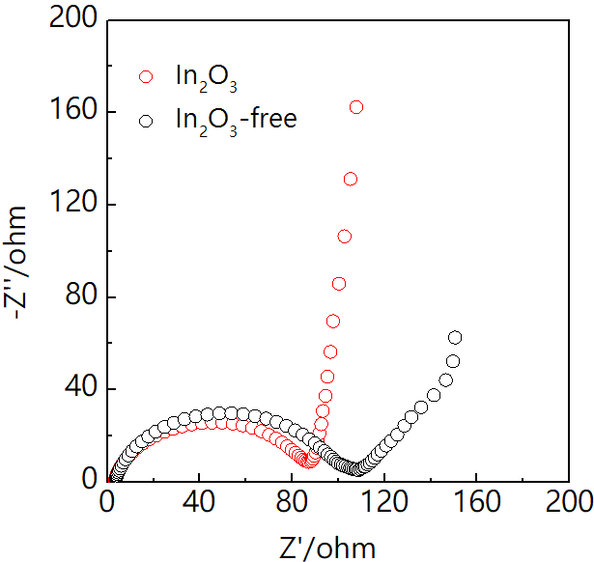
Supplementary Figure 12. Electrochemical impedance spectroscopy (EIS) of the two batteries.

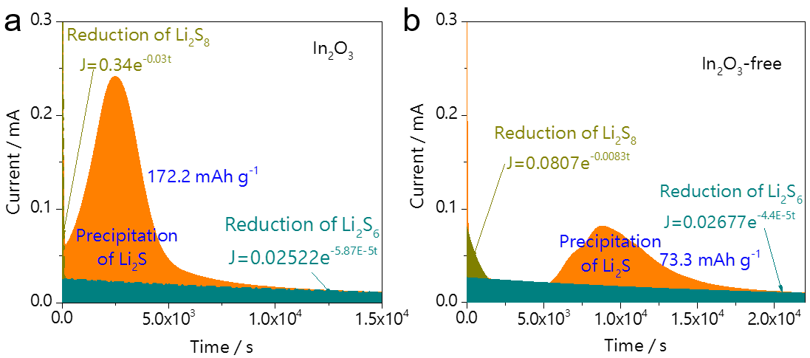
Supplementary Figure 13. Potentiostatic discharge curves of a Li₂S₈/tetraglyme solution at 2.05 V on (a) G-In₂O₃ and (b) Graphene surfaces.

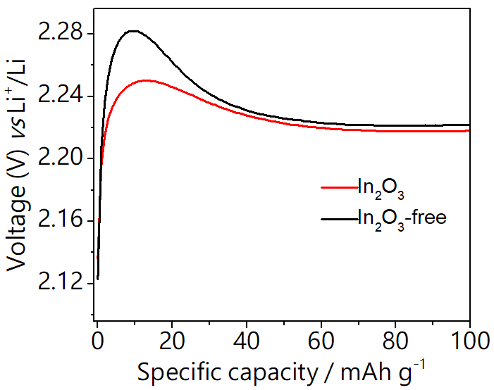
Supplementary Figure 14. Magnification of the charge voltage profiles of the In₂O₃-catalyzed and In₂O₃-free batteries.

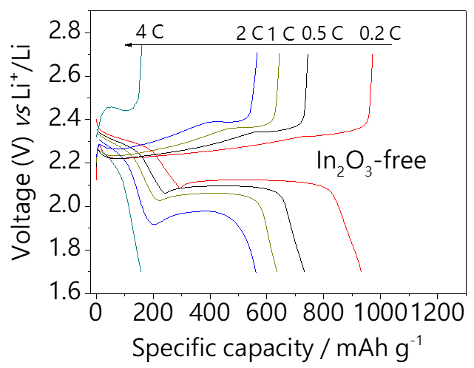
Supplementary Figure 15. Galvanostatic charge-discharge profiles of the In₂O₃-free battery at various current rates.

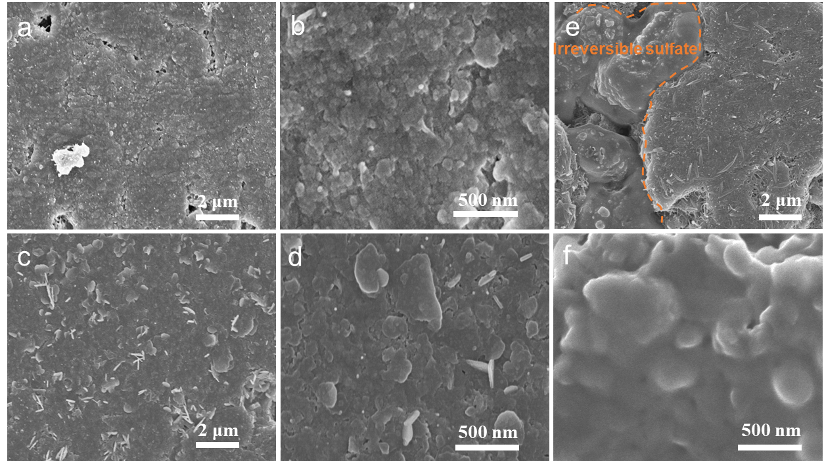
Supplementary Figure 16. SEM images of (a), (b) In₂O₃-free and (c), (d) In₂O₃-based cathodes after 100 cycles at 0.5 C; (e, f) SEM images of In₂O₃-based cathodes after 1000 cycles with irreversible sulfates on the surface.

Supplementary Figure 17. Cycling performance of In₂O₃-catalyzed battery with a high sulfur loading and a low electrolyte/sulfur ratio (8 μL mg⁻¹).

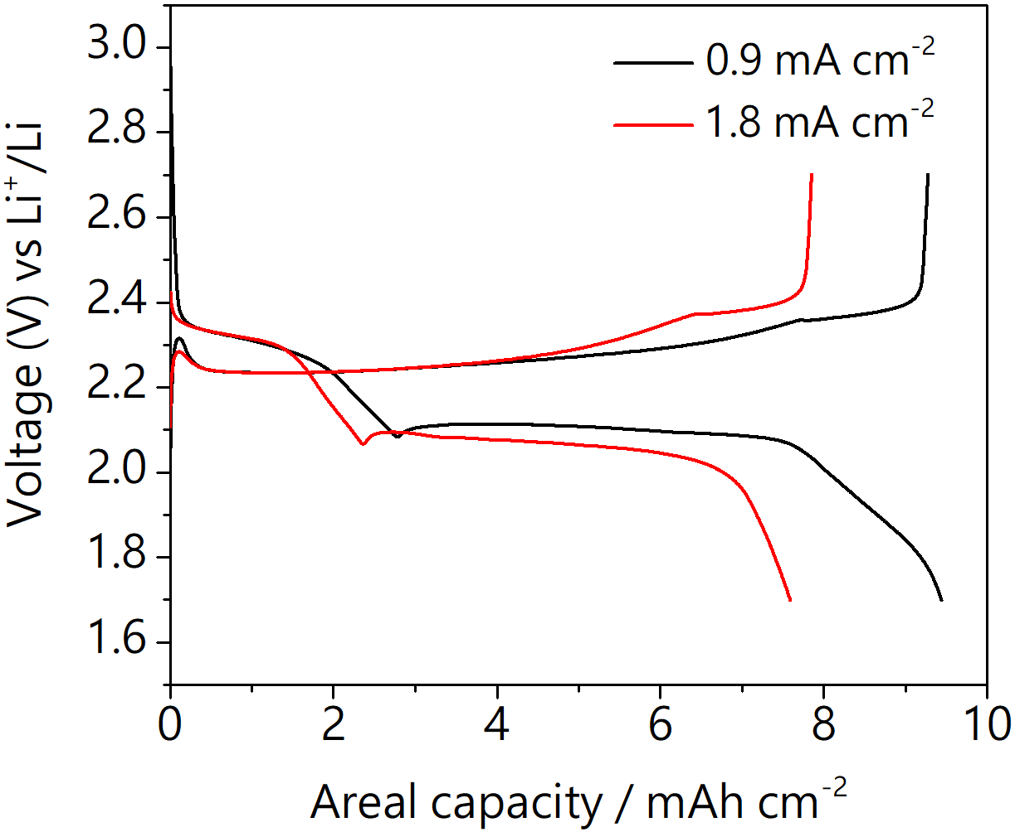
Supplementary Figure 18.Typical galvanostatic charge-discharge profiles of the In₂O₃-catalyzed battery with a high sulfur loading of 9.0 mg cm⁻² and a low electrolyte/sulfur ratio (8 μL mg⁻¹).

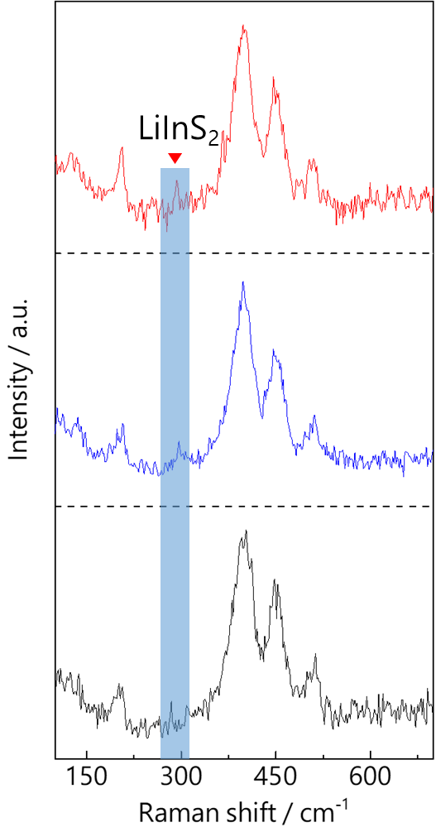
Supplementary Figure 19. In-situ Raman measurements of a In₂O₃-catalyzed electrode in different regions at 1.70 V.
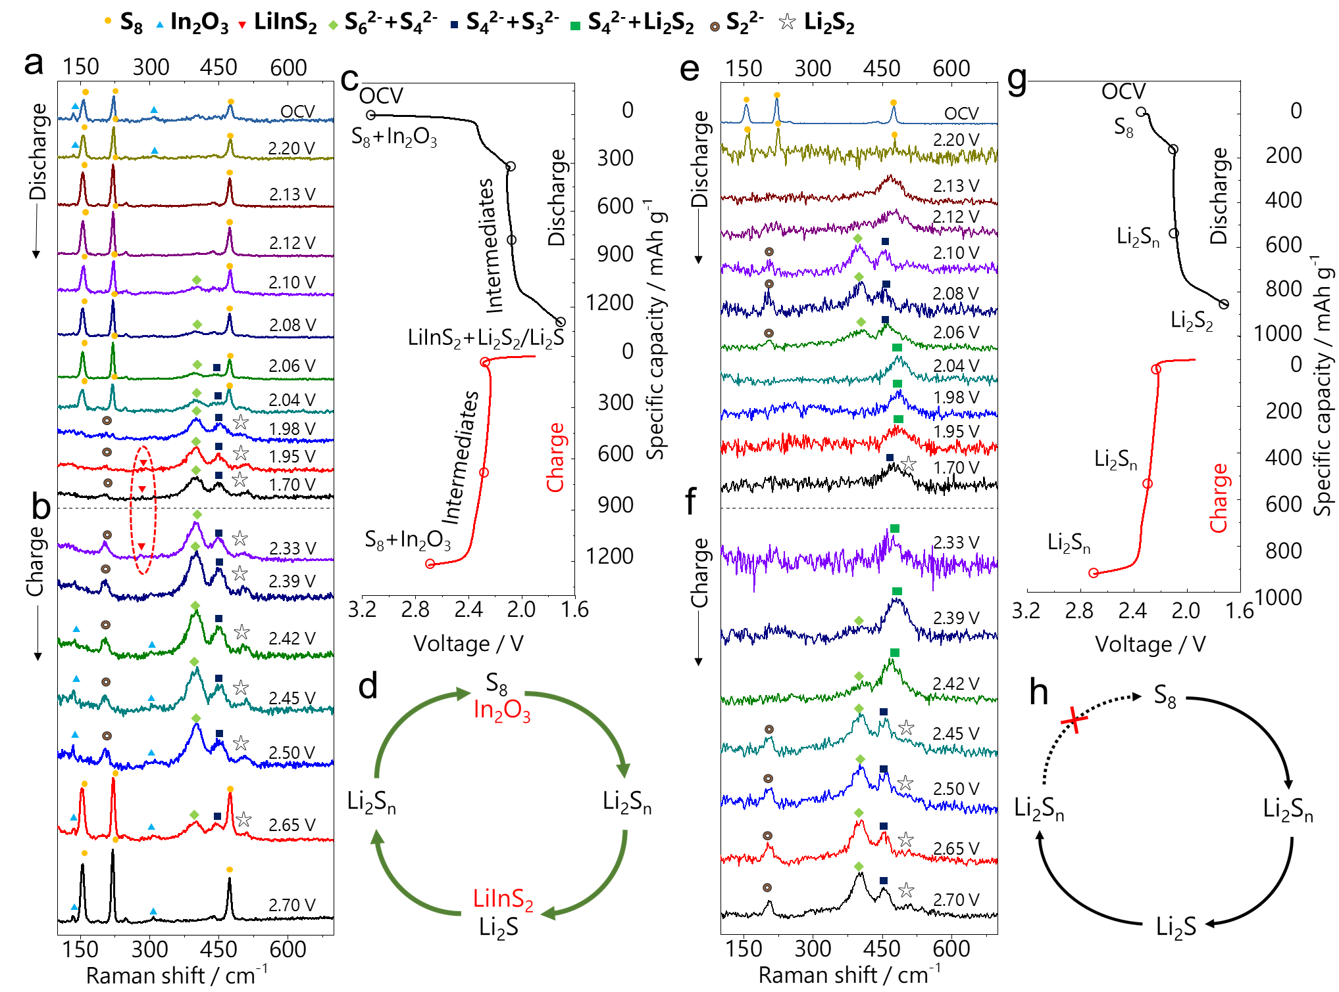Supplementary Figure 20. (a, b) Detailed In-situ Raman Results of an In₂O₃-catalyzed battery and (c) the corresponding charge-discharge potentials of the detected substances; (d) A complete cycle of the sulfur redox with In₂O₃ catalyst; (e, f) In-situ Raman measurements of an In₂O₃-free battery and (g) the corresponding charge-discharge profile; (h) An incomplete cycle of the sulfur redox free of In₂O₃ catalyst.

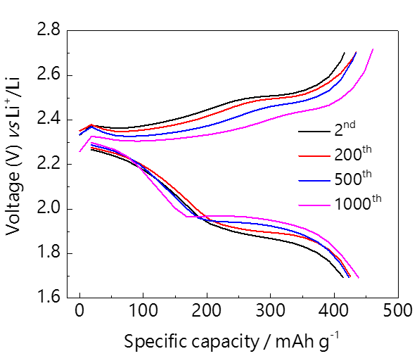
Supplementary Figure 21.Typical galvanostatic charge-discharge profiles of the In₂O₃-catalyzed battery at 4.0 C.

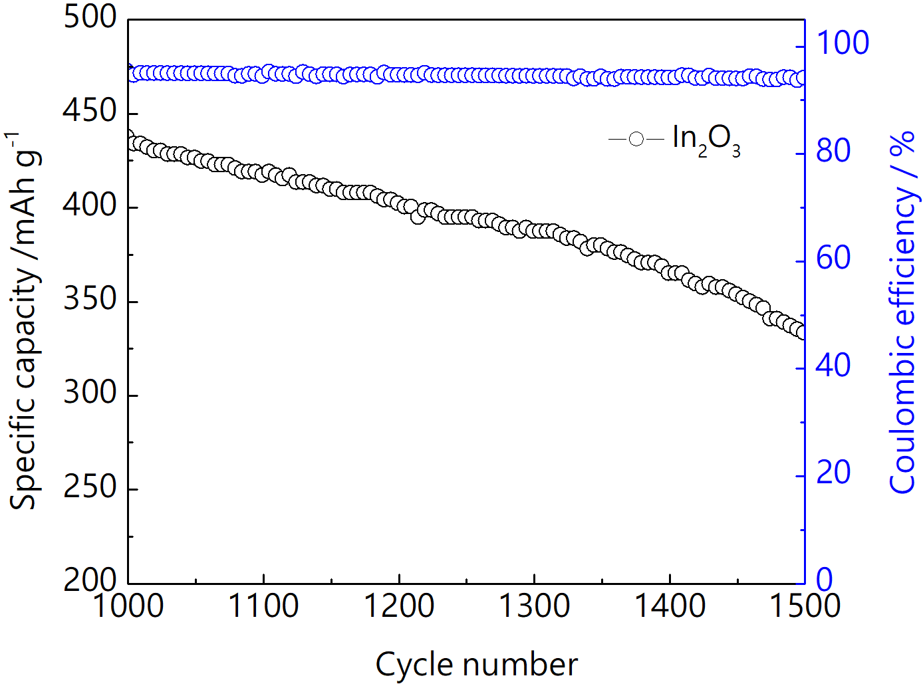
Supplementary Figure 22.The cycling performance for the In₂O₃-catalyzed battery at 4.0 C after 1000 cycles.

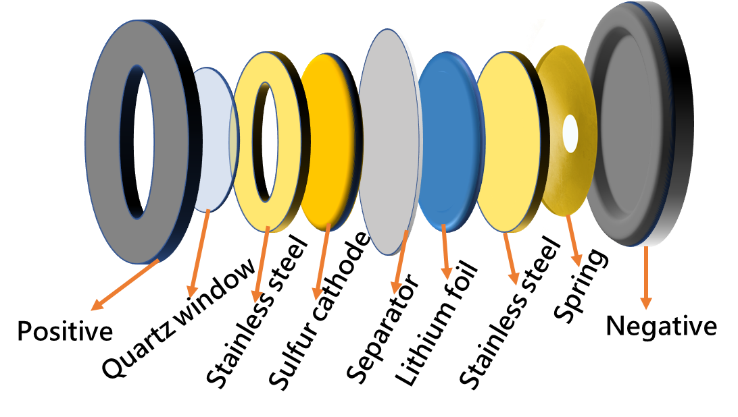
Supplementary Figure 23. The cell configuration with a quartz window for in-situ Raman analysis.

Table 1. Catalytic parameters for In₂O₃-catalyzed and In₂O₃-free cells are derived from CV plots.
Electrode | E1_{pa}, E2_{pa} (V) | E1_{pc}, E2_{pc} (V) | Peak separation  (E1pa ~E2pc) | Exchange current density (mA cm⁻²)
In₂O₃ | 2.295, 2.378 | 2.309, 2.024 | 0.271 | 6.02 (cathodic, E2pc)  0.20 (anodic, E1pa)
In₂O₃-free | 2.314, 2.395 | 2.296, 1.996 | 0.318 | 3.29 (cathodic, E2pc)  0.16 (anodic, E1pa)

Table 2. Comparison of areal capacity of recent publications in Li–S batteries with high sulfur loadings with electrolyte/sulfur ratios ≤ 8 μL/mg.
Materials | Sulfur loading (mg cm⁻²) |  |  |  | E/S  (μL/mg) |  | Areal capacity  (mAh cm⁻²) |  | SR.
In₂O₃ |  | 9.0 |  |  | 8.0 | 9.4 (Initial @0.9 mA cm⁻²)  5.3 (100 cycles @1.8 mA cm⁻²) |  | This work
C/TiO₂-TiN/S |  |  | 8.0 |  | 6.8 | 5.12 ( 400 cycles @2.68 mA cm⁻²) |  | 1
S@3VO₂-1VN/G |  |  | 13.2 |  | 7.5 | 5.7 (20 cycles @1.1 mA cm⁻²) |  | 2
a-Ta₂O_{5-x}/MCN/S |  |  | 5.6 |  | 3.6 | 4.0 (200 cycles @1.87 mA cm⁻²) |  | 3
Co@N-C |  |  |  | 7.5 | 7.5 | 7.75 (Initial @0.63 mA cm⁻²)  3.0 (300 cycles @12.56 mA cm⁻²) |  | 4
A-Nb₂O_{5-x}@MCS |  |  |  | 5.8 | 4.5 | 5.48 (200 cycles @0.97 mA cm⁻²) |  | 5
Mo₆S₈ |  |  |  | 6.2 | 2.4 | 7.8 (Initial @0.5 mA cm⁻²) |  | 6
CC@CS@HPP/S |  |  |  | 8.1 | 7.0 | 8.1 (Initial @ 0.135 mA cm⁻²) |  | 7
MoP-CNT-10-S |  |  |  | 6.0 | 4.0 | 4.0 (50 cycles @0.8 mA cm⁻²) |  | 8

Supplementary Note 1. Materials characterization of In₂O₃, G, CNT, CNT/S, G-In₂O₃, and In₂O₃-G-CNT/S composite.
ADF-STEM images and the corresponding EDX elemental maps showed that the In₂O₃ NPs are laid flat on the graphene support film as shown in Supplementary Fig.4a-c. The morphology and microstructures of the pure CNT and CNT/S are shown in Supplementary Figs. 4d, e, which show that there are no bulk sulfur particles on the surface of the CNT after loading with 70 wt% sulfur. Moreover,the voids in CNT/S are filled with G-In₂O₃ sheets, significantly improving the electrode conductivity (Supplementary Fig. 4f). The XRD results also showed that the intensity of sulfur peaks was much weaker in the CNT, indicating the excellent physical confinement of sulfur inside the CNT (Supplementary Fig. 5). Furthermore, the CNT are found to have a high specific surface area (SSA) of 324.7 m² g⁻¹, which is reduced to 4.7 m² g⁻¹ after incorporating the sulfur, indicating that sulfur filled most of the pores (Supplementary Fig. 6). The Raman spectra (Supplementary Fig. 7) together with the diffraction peaks of the XRD patterns (Supplementary Fig. 8) suggested that the In₂O₃ NPs and Graphene were uniformly composited after the hydrothermal reduction.

Supplementary Note 2. The detail calculation scheme of relative activation energy.
CV tests were performed under a scan rate (0.1 mV S⁻¹) at 298 K as shown in Figure 1a. Correspondingly, the relationship between electrode potential and activation energy over the In₂O₃-free and In₂O₃-catalyzed batteries could be calculated according to the equation (1):
$E_{a}=E_{a}^{0}+αzFφ_{cathode}{\left(Ox\text{│}Red\right)}_{IR}$ (1)
where $E_{a}$ is the activation energy of reduction process, $E_{a}^{0}$ is the intrinsic activation energy, $α$ is the symmetry coefficient, $Z$ is the number of charge transfer, F is the Faraday’s constant, $φ_{cathode}{\left(Ox\text{│}Red\right)}_{IR}$ is the irreversible potential during cycling.
The Tafel curve calculation formula (2):
$η_{cathode}=\frac{RT}{αzF}lnj_{0}-\frac{RT}{αzF}lnj_{cathode}$ (2)
Where $η_{cathode}$ is the overpotential of the cathode, $j_{0}$ is the exchange current density, $j_{cathode}$ is the current of the cathode. The equation can be written in a more concise form:
$η_{cathode}=a+blnj_{cathode}$ (3)
b =$-\frac{RT}{αZF}$ (4)
Where a is the intercept of Tafel curve, b is the slop of Tafel curve. Therefore, the equation (1) can be written in a more concise form:
$E_{a}=E_{a}^{0}-\frac{RT}{b}φ_{cathode}{\left(Ox\text{│}Red\right)}_{IR}$ (5)
Based on the intercept and slop of the Tafel curve as shown in Figures 1b, c and Supplementary Fig. 9, the activation energy during the discharge and charge process can be calculated.
The activation energy corresponding to the reduction of S₈ to the long-chain Li₂S_{n}:
In₂O₃-free cathode: Ea₁ = Ea₁⁰–121 kJ mol⁻¹
In₂O₃-based cathode: Ea₁’ = Ea₁⁰–111 kJ mol⁻¹
The difference in activation energy could be calculated by subtracting the activation energy of In₂O₃-free electrode from that of In₂O₃-based electrode.
Ea₁’- Ea₁ = (Ea₁⁰–111) kJ mol⁻¹– (Ea₁⁰–121) kJ mol⁻¹= 10 kJ mol⁻¹

The activation energy of long-chain Li₂S_{n} to Li₂S:
In₂O₃-free cathode: Ea₂ = Ea₂⁰–157 kJ mol⁻¹
In₂O₃-based cathode: Ea₂’ = Ea₂⁰–176 kJ mol⁻¹
Ea₂’- Ea₂ = (Ea₂⁰–176) kJ mol⁻¹– (Ea₂⁰–157) k J mol⁻¹= -19 kJ mol⁻¹

The activation energy of Li₂S to long-chain Li₂S_{n}:
In₂O₃-free cathode: Ea₃ = Ea₃⁰–282 kJ mol⁻¹
In₂O₃-based cathode: Ea₃’ = Ea₃⁰–356 kJ mol⁻¹
Ea₃’- Ea₃ = (Ea₃⁰ –356) kJ mol⁻¹– (Ea₃⁰–282) kJ mol⁻¹= -74 kJ mol⁻¹

Supplementary References
- Xu Z-L, et al. Visualization of regulated nucleation and growth of lithium sulfides for high energy lithium sulfur batteries. Energy & Environmental Science 12, 3144-3155 (2019).
2. Song Y, et al. Synchronous immobilization and conversion of polysulfides on a VO₂–VN binary host targeting high sulfur load Li–S batteries. Energy & Environmental Science 11, 2620-2630 (2018).
3. Zhang Z, et al. Tantalum-Based Electrocatalyst for Polysulfide Catalysis and Retention for High-Performance Lithium-Sulfur Batteries. Matter 3, 1-15 (2020).
4. Li Y, et al. A Honeycomb-like Co@N-C Composite for Ultrahigh Sulfur Loading Li-S Batteries. ACS Nano 11, 11417-11424 (2017).
5. Luo D, et al. Revealing the Rapid Electrocatalytic Behavior of Ultrafine Amorphous Defective Nb₂O_{5-x} Nanocluster toward Superior Li-S Performance. ACS Nano 14, 4849-4860 (2020).
6. Xue W, et al. Intercalation-conversion hybrid cathodes enabling Li–S full-cell architectures with jointly superior gravimetric and volumetric energy densities. Nature Energy 4, 374-382 (2019).
7. Ye Z, Jiang Y, Li L, Wu F, Chen R. A High-Efficiency CoSe Electrocatalyst with Hierarchical Porous Polyhedron Nanoarchitecture for Accelerating Polysulfides Conversion in Li-S Batteries. Advanced Materials, 2002168 (2020).
8. Yang Y, et. al. Electrocatalysis in Lithium Sulfur Batteries under Lean Electrolyte Conditions. Angewandte Chemie International Edition 57, 15549-15552 (2018).

