Supplementary

Supplementary Methods
The present manuscript reports previously unpublished autonomic and gut microbiome outcomes from a prespecified laboratory substudy. Biological sampling was conducted only in the intervention and active control groups. Exploratory analyses included HRV, α-diversity, β-diversity, taxonomic abundance, and predicted microbial functional pathways (Supplementary Figure 1).

Participants
The parent trial enrolled women aged ≥18 years living with at least one child and teleworking at least one day per week, criteria chosen pragmatically and based on evidence linking telework to burnout risk (Griffith, 2022; Mendonça et al., 2022). There were no restrictions on concurrent treatments. Exclusion criteria included severe depression, substance use disorder, or psychosis. Recruitment was conducted online with electronic informed consent. The laboratory subsample was drawn from this cohort and additionally required attendance at study visits, absence of gastrointestinal disease, no recent antibiotic use or diarrhea, and no medical conditions likely to substantially affect microbiota.

Randomization and Blinding
Participants in the primary trial were randomized by an independent researcher using a computer-generated sequence (1:1 ratio) to either the IBAP-BP intervention or the active control condition until 125 participants were allocated per arm. Allocation was stratified by parental burnout severity (PBA ≥84), without blocking, and concealed until assignment. Due to scheduling logistics, the first 250 randomized participants selected session times without knowledge of group allocation; those unable to attend were replaced from the waitlist, resulting in slight imbalance across groups and an overall sample size exceeding preregistration. Allocation was concealed until group assignment, after which research assistants provided instructions.
For the biological extension, up to 17 participants per group were randomly selected from the IBAP-BP and active control arms. Blinding of participants and instructors was not feasible; however, statistical analysts remained blinded to group allocation. Detailed randomization and replacement procedures are reported elsewhere (Author & Author, 2025).

Procedures

Intervention
The IBAP-BP intervention comprised eight online group sessions (two hours weekly) led by trained instructors, with 20–30 minutes of daily practice (e.g., meditation or reflective writing). The active control practiced daily Jacobson’s progressive muscle relaxation combined with journaling. Both groups received weekly reminders, psychoeducational materials, and access to an online peer-support group. The waitlist control group was offered IBAP-BP after the nine-month follow-up.
Intervention delivery was organized in cohorts of 25 participants. Content was adapted from a validated program (Author 2022; Author et al., 2023; Author, 2023) and focused on reducing parental burnout by targeting risk factors such as perfectionism, limited emotional regulation, and lack of social support, while promoting self-compassion and effective parenting strategies (Mikolajczak & Roskam, 2018).

Instructors
Instructors (two psychologists, two psychiatrists, and one physician) were supported by an assistant who managed the online platform. Most had previous mindfulness training; one underwent a six-month preparation using the MBI-TAC framework (Crane et al., 2013). All facilitators completed eight two-hour training sessions specific to IBAP-BP, and standardized manuals and materials were provided to ensure fidelity across cohorts.

Data Collection and Follow-Up
Participants completed online assessments at baseline (T0), post-intervention (T1, 3 months), 6 months (T2), and 9 months (T3). Surveys included demographics (age, gender, education, occupation, income, workplace role, marital status, and number/gender of children) as well as primary and secondary outcomes.
In the biological substudy, fecal samples, lifestyle measures, and ECG recordings were collected at T0, T1, and T2 in the intervention and active control groups only. Because fecal sample availability and usable ECG recordings varied across time points, sample sizes are reported separately for each biological outcome. Mixed-effects models included all available observations for each outcome.
To maximize retention, independent assistants sent email reminders and conducted telephone check-ins.

Stool sampling and ECG recording
At baseline, each participant was invited to the laboratory to provide a fecal sample and undergo resting electrocardiogram (ECG) measurements. We used a Zephyr BioPatch HP device (Zephyr Technology/Medtronic) device with two electrodes placed in the second intercostal space on the right side of the sternum and on the left shoulder, with a sampling frequency of 250 Hz.
Participants rested for 10 minutes before measurement. For each specific moment, the assistant marked an event by pressing a button. After starting the recording, the first event indicated that the participant should stand up for 20 seconds and then sit down. The second event marked the beginning of a 1-minute rest measurement. After this, a third event was marked, and the recording stopped. Following stool sample collection, a second ECG measurement was taken following the same sequence, yielding up to two recordings per participant.
Fecal samples were collected in the laboratory and stored at –80 °C until processing.
DNA Extraction and Sequencing
Microbiome sequencing was performed by SeqCenter using 16S rRNA gene amplicon sequencing targeting the V3/V4 region. Samples were prepared with Zymo Research’s Quick-16S kit using phased primers directed against the V3/V4 regions of the 16S gene; the primer sequences reported by the provider were 341f (CCTACGGGDGGCWGCAG / CCTAYGGGGYGCWGCAG) and 806r (GACTACNVGGGTMTCTAATCC). According to SeqCenter’s standard protocol, DNA extraction follows the ZymoBIOMICS DNA Miniprep Kit workflow. For solid samples, including fecal material, samples are processed according to the kit guidelines, transferred to ZR BashingBead Lysis Tubes, and mechanically lysed using the MP FastPrep-24 lysis system with 1 minute of lysis at maximum speed followed by 5 minutes of rest for 5 cycles. After centrifugation, the supernatant is passed through a Zymo-Spin III-F Filter, combined with ZymoBIOMICS DNA Binding Buffer, loaded onto a Zymo-Spin IICR Column, washed with ZymoBIOMICS DNA Wash Buffer 1 and Wash Buffer 2, eluted in 75 µl ZymoBIOMICS DNase/RNase Free Water, further purified through a Zymo-Spin III-HRC Filter, and quantified by Qubit. Following cleanup and normalization, libraries were sequenced on a P1 600cyc NextSeq2000 Flowcell to generate 2 × 301 bp paired-end reads, with a target sequencing depth of 100,000 16S reads per sample for the Illumina Microbiome Analysis service. Quality control and adapter trimming were performed using bcl-convert (v4.2.4).

Data Processing and Bioinformatic Workflow

Sequence Processing and Denoising
Bioinformatics analysis was conducted using the QIIME 2 (version 2024.10) ecosystem (Bolyen et al., 2019). Raw paired-end sequences were imported via the PairedEndFastqManifestPhred33V2 format based on a manifest file containing sample metadata. Adapter and primer sequences (Forward: CCTAYGGGNBGCWGCAG; Reverse: GACTACNVGGGTMTCTAATCC) were identified and removed using the cutadapt plugin (Martin, 2011).
Sequence denoising, including the filtering of low-quality reads, dereplication, and the identification of chimeric sequences, was performed using the DADA2 pipeline (Callahan et al., 2016). Specifically, the forward and reverse reads were maintained at their original lengths (--p-trunc-len 0), a maximum expected error threshold of 5 was permitted for both reads, and a minimum overlap of 9 nucleotides was required for successful merging. This process resulted in the generation of high-resolution Amplicon Sequence Variants (ASVs).

Taxonomic Classification
Taxonomic assignment of the representative ASV sequences was performed using the consensus VSEARCH classifier (Rognes et al., 2016). Sequences were aligned against the SILVA 138 (99% identity) reference database (Quast et al., 2013). For taxonomic composition analysis, the feature table was collapsed at the species level (taxonomic level 7). Feature tables were exported into both BIOM and Tab-Separated Value (TSV) formats to facilitate downstream relative abundance analysis.

Diversity and Phylogenetic Analysis
Alpha diversity metrics, including Shannon entropy and Observed Features (richness), were calculated to assess within-sample diversity. Quality control metrics were tracked across the pipeline (input, filtered, denoised, merged, and non-chimeric) using a custom summary script to calculate the percentage of reads retained per sample.
Phylogenetic reconstruction was performed by aligning representative sequences with MAFFT (Katoh & Standley, 2013) ,followed by the construction of a rooted maximum-likelihood tree using FastTree 2 (Price et al., 2010). To further characterize community complexity, phylogenetic entropy was calculated for each sample using the rooted Newick tree and ASV abundance data (Allen et al., 2009). This metric provides an abundance-weighted measure of the evolutionary distances present within the microbial assembly.

Functional Prediction
The functional potential of the microbial communities was predicted using the PICRUSt2 pipeline (version 2.5.2) (Douglas et al., 2020). ASV sequences were placed into a reference phylogenetic tree, and gene family abundances were predicted based on hidden-state transitions. Pathway abundances were subsequently calculated using the KEGG (Kyoto Encyclopedia of Genes and Genomes) database to generate an unstratified profile of functional metabolic potential across the dataset.

ECG processing workflow
Raw ECG data were extracted from ACQ files using Python 3.9 and the bioread package. Signal preprocessing and window selection were performed using scipy.signal (Bioread, n.d.; Signal Processing (Scipy.Signal) — SciPy v1.16.1 Manual, n.d.). We implemented an algorithm to identify 1-minute ECG segments near the 2nd and 3rd events, fulfilling the following quality criteria: heart rate between 40–150 bpm, maximum RR interval of 2 s, maximum NaN ratio ≤ 0.01, minimum standard deviation ≥ 0.02, and spike Z-score ≤ 9. Candidate segments were then visually inspected using matplotlib.pyplot (Pyplot Tutorial — Matplotlib 3.10.5 Documentation, n.d.).
ECG recordings were first screened according to predefined quality criteria. When two valid recordings were available for the same participant and time point, the first valid recording was retained to ensure one observation per participant per wave. When only one recording met quality criteria, that recording was used. Recordings failing quality criteria were excluded prior to HRV estimation and statistical modeling.
QRS detection was performed on signals bandpass-filtered with a 4th-order Butterworth filter (5–15 Hz) (Pan & Tompkins, 1985), and RR intervals outside the physiological range of 0.4–1.5 s (40–150 bpm) were excluded as artifacts. RR intervals were cubic-spline interpolated to 4 Hz for spectral analysis. Frequency-domain HRV indices were computed for the low-frequency (LF, 0.04–0.15 Hz) and high-frequency (HF, 0.15–0.40 Hz) bands (Electrophysiology, 1996).

Measurements
The parent RCT prespecified parental burnout at nine months (T3), assessed using the Chilean-validated Parental Burnout Assessment (PBA), as its primary clinical outcome; these results have been reported elsewhere (Author, 2025). The current manuscript focuses on prespecified exploratory biological outcomes in the laboratory subsample, including gut microbiome diversity, composition and short-term vagally mediated HRV indexed by lnRMSSD. Parental burnout trajectories from T0 to T2 were also examined to contextualize biological changes. In addition, we conducted exploratory analyses of parental burnout subdimensions, the Five Facet Mindfulness Questionnaire, and for microbiome: Shannon diversity, observed richness, β-diversity, taxonomic composition at multiple levels (phylum, class, order, family, genus), and predicted metabolic functions.

Psychological variables
Parental burnout was assessed using the 23-item Parental Burnout Assessment (PBA), which evaluates emotional exhaustion, loss of pleasure in the parental role, emotional distancing, and negative parental self-perception (range 0–138; mean 0–6). Mean scores were used to avoid imputing missing items as zero (Manrique-Millones et al., 2022). Trait mindfulness was assessed using the 15-item Five Facet Mindfulness Questionnaire (FFMQ-15), which measures five dimensions: observing, describing, acting with awareness, nonjudging of inner experience, and nonreactivity to inner experience (Author., 2023). Quality of life was evaluated using the EuroQol Five-Dimension instrument (EQ-5D), a five-item measure assessing mobility, self-care, usual activities, pain/discomfort, and anxiety/depression. Lower scores indicate better health-related quality of life (Balestroni & Bertolotti, 2012).

Lifestyle variables
A self-reported questionnaire assessed diet, physical activity, and sleep. Because lifestyle factors substantially influence gut microbial composition, prespecified healthy and unhealthy lifestyle indices derived from food-frequency, physical activity, and sleep measures were included as covariates in microbiome models.
Dietary intake was recorded using standardized frequency categories (<1 to ≥6 portions/week) and was classified a priori into healthy food groups (fruits, vegetables, legumes, nuts/seeds, whole grains, omega-3 sources, fermented foods) and unhealthy food groups (red and processed meats, sweets, sugary drinks, high-sodium foods, and trans- and saturated-fat–rich products). Physical activity was evaluated by weekly frequency (1 to ≥5 days), duration (<15 to >60 minutes), and intensity (very low to very high), and sleep by average nightly duration (<4 to >8 hours) and subjective quality (very poor to very good).
For analysis, composite indices were constructed by summing standardized recoded variables: the healthy behaviors index combined healthy food groups, physical activity, and sleep, whereas the unhealthy behaviors index included unhealthy food groups only. Higher scores reflected greater frequency. The theoretical ranges were 18–153 for healthy behaviors and 3.5–42 for unhealthy behaviors.

Microbiome variables
Primary exploratory biological outcome was α-diversity, operationalized as phylogenetic entropy computed from an ultrametric phylogeny (construction method and database specified elsewhere) (Cassol et al., 2025). As secondary measures, we considered Shannon diversity (non-phylogenetic) and observed richness. For β-diversity, we used the Bray–Curtis dissimilarity index (Turku, n.d.). In addition, we analyzed relative abundances at the phylum, class, order, family, and genus levels. For KEGG metabolic pathways, functional profiles were inferred using PICRUSt2 (Richter et al., 2017).

Heart rate variability variables
To analyze a proxy measure of short-term vagally mediated cardiac variability, we followed the recommendations of Laborde et al. (2017) for heart rate variability (HRV) measurements (Laborde et al., 2017). Given the 1-minute resting ECG segment recording duration, we selected the natural logarithm of the root mean square of successive differences (lnRMSSD) as the primary variable (Laborde et al., 2017). Additional measures included the percentage of high-quality RR intervals, the RMSSD/lnRMSSD ratio, variation of the normalized RMSSD coefficient by mean RR, high-frequency power, and respiratory rate.

Statistic
Data were first analyzed at baseline. Normality was tested using the Shapiro–Wilk test, revealing non-normal distributions. Group differences at baseline were assessed with the Kruskal–Wallis test, with no significant differences detected.

Missing data
Given the high rate of loss to follow-up, we conducted a missing data analysis. First, we examined patterns of missingness across groups and time points, finding comparable proportions. Next, we tested whether baseline characteristics differed between participants who dropped out and those who completed the study; no significant differences were observed (all p > 0.05). The Missing Completely at Random (MCAR) assumption was evaluated with the Hawkins test (p = 0.16), supporting an MCAR mechanism (Jamshidian et al., 2014). Furthermore, no baseline variables (age, parental burnout, EQ subscales, FFMQ total, extraversion, neuroticism, diet indices, phylogenetic entropy, lnRMSSD) predicted dropout in the linear mixed-effects models (LMM).
Given the limited sample size and statistical power, data were treated as Missing at Random (MAR) by including baseline covariates in the analyses (baseline outcome, age and parental burnout). To assess robustness, we performed sensitivity analyses using (1) complete-case data and (2) joint multiple imputation with Bayesian methods with pooled estimates and standard error using Rubin’s rules.

Multiple comparison correction
For multiple comparisons, Holm–Bonferroni correction was applied to main outcomes (lnRMSSD, phylogenetic Shannon diversity, and parental burnout) with p < 0.05 as the threshold. For exploratory secondary outcomes, the Benjamini–Hochberg procedure was used to control the false discovery rate (Ranganathan et al., 2016). FDR correction was applied separately within prespecified families of exploratory analyses, including α-diversity metrics, β-diversity post hoc contrasts, genus-level differential abundance analyses, and predicted functional pathway analyses. All tests were two-sided with α=0.05 unless otherwise specified.

Analysis
No formal power calculation was conducted for the biological substudy. Sample size was constrained by laboratory feasibility and should therefore be considered exploratory and hypothesis-generating.
Longitudinal outcomes were analyzed using linear mixed-effects models (LMMs) with fixed effects for group, time, and the group × time interaction, and a random intercept for participant. Models adjusted for z-standardized baseline covariates, including baseline outcome values, baseline parental burnout, age, extraversion, and neuroticism when applicable. Longitudinal analyses used all available observations according to randomized group assignment rather than complete-case data only. Primary longitudinal analyses were conducted using a modified intention-to-treat approach including participants with at least one post-baseline assessment (N = 324). The general model structure was:
Outcome ~ group + time + group × time + baseline outcome + baseline parental burnout + age + covariates + (1 | participant)

Group contrasts at each time point were estimated using estimated marginal means. Standardized mean differences (Cohen’s d) were calculated using the model residual standard deviation, with 95% confidence intervals estimated using Wald methods.

Microbiota analysis
Alpha diversity was primarily assessed using phylogenetic entropy, with additional reporting of Shannon entropy and observed richness. Beta diversity was evaluated using Bray–Curtis dissimilarity, and group differences were tested using PERMANOVA with 9,999 permutations including group, time, and the group × time interaction, with participant-level stratification for repeated samples. Post hoc pairwise contrasts were adjusted using the Benjamini–Hochberg (BH) procedure.
To quantify within-subject microbial change over time, Bray–Curtis distances between baseline (T0) and follow-up assessments (T1/T2) were analyzed using linear mixed-effects models (LMMs) adjusted for baseline covariates and healthy/unhealthy lifestyle indices:
Delta ~ group + time + group × time + baseline covariates + healthy/unhealthy lifestyle indices + (1 | participant)
For taxonomic features at the phylum, class, order, family, and genus levels, relative abundances were logit-transformed. For each feature, we fit an LMM of the form:
logit(abundance) ~ group + time + group × time + baseline abundance + baseline parental burnout + age + healthy/unhealthy lifestyle indices + (1 | participant)

Predicted microbial functional pathways inferred using PICRUSt2 were analyzed using the same framework, applying a logit transformation with an ε-stabilizer prior to model estimation.

Additional exploratory analysis
Exploratory baseline associations were assessed using Spearman’s ρ with Benjamini–Hochberg correction for multiple testing. Analyses examined associations among parental burnout, lnRMSSD, phylogenetic entropy, mindfulness, and quality of life outcomes, as well as associations between these outcomes and microbial taxa or predicted functional pathways.
Exploratory temporal analyses used LMMs with lag-1 predictors and random intercepts for participant. Variables at time t−1 included parental burnout, lnRMSSD, and phylogenetic entropy; all variables were z-standardized, and models adjusted for baseline levels of the dependent variable. The following exploratory models were specified:
- lnRMSSD_t ~ time + parental_burnout_{t−1} + (1 | participant)
- phylogenetic_entropy_t ~ time + parental_burnout_{t−1} + (1 | participant)
- parental_burnout_t ~ time + lnRMSSD_{t−1} + (1 | participant)
- parental_burnout_t ~ time + phylogenetic_entropy_{t−1} + (1 | participant)
Additional exploratory screening analyses examined lag-1 microbial taxa and predicted functional pathways as predictors of subsequent parental burnout using analogous LMMs with BH correction across features:
parental_burnout_t ~ time + feature_{t−1} + (1 | participant)
Because of the limited size of the biological substudy, lagged analyses were considered exploratory and hypothesis-generating. These analyses should not be interpreted as formal cross-lagged panel models.
All analyses were conducted in R (version 4.5.1) with packages: tidyverse, rstatix, lme4, lmerTest, emmeans, broom, logistf, vegan (Supplementary Table 1).

Ethics
Ethical approval was granted by the Anonymous author University Research Ethics Committee on October 27, 2022 (Code: 38-2022), amended on December 20, 2022, and further extended on January 31, 2023 for the microbiome and HRV subsample (Code: 06-2023). The protocol is registered at ClinicalTrials.gov (NCT-anonymous) and adheres to CONSORT reporting guidelines.

Supplementary figure 1. Study design and assessment timeline
Participants from the initial cohort were randomized to intervention (IBAP), active control (AC), or waiting list (WL). Outcomes were measured at baseline, 3 months (post-intervention), 6 months, and 9 months. Subsamples underwent additional assessments, including fecal microbiota and electrocardiogram at baseline 3 and 6 months. After the randomized phase, WL and AC groups crossed over to receive IBAP during the open phase, with extended follow-up at 12, 18, and 24 months. IBAP = mindfulness- and compassion-based inter-care program; AC = active control; WL = waiting list.
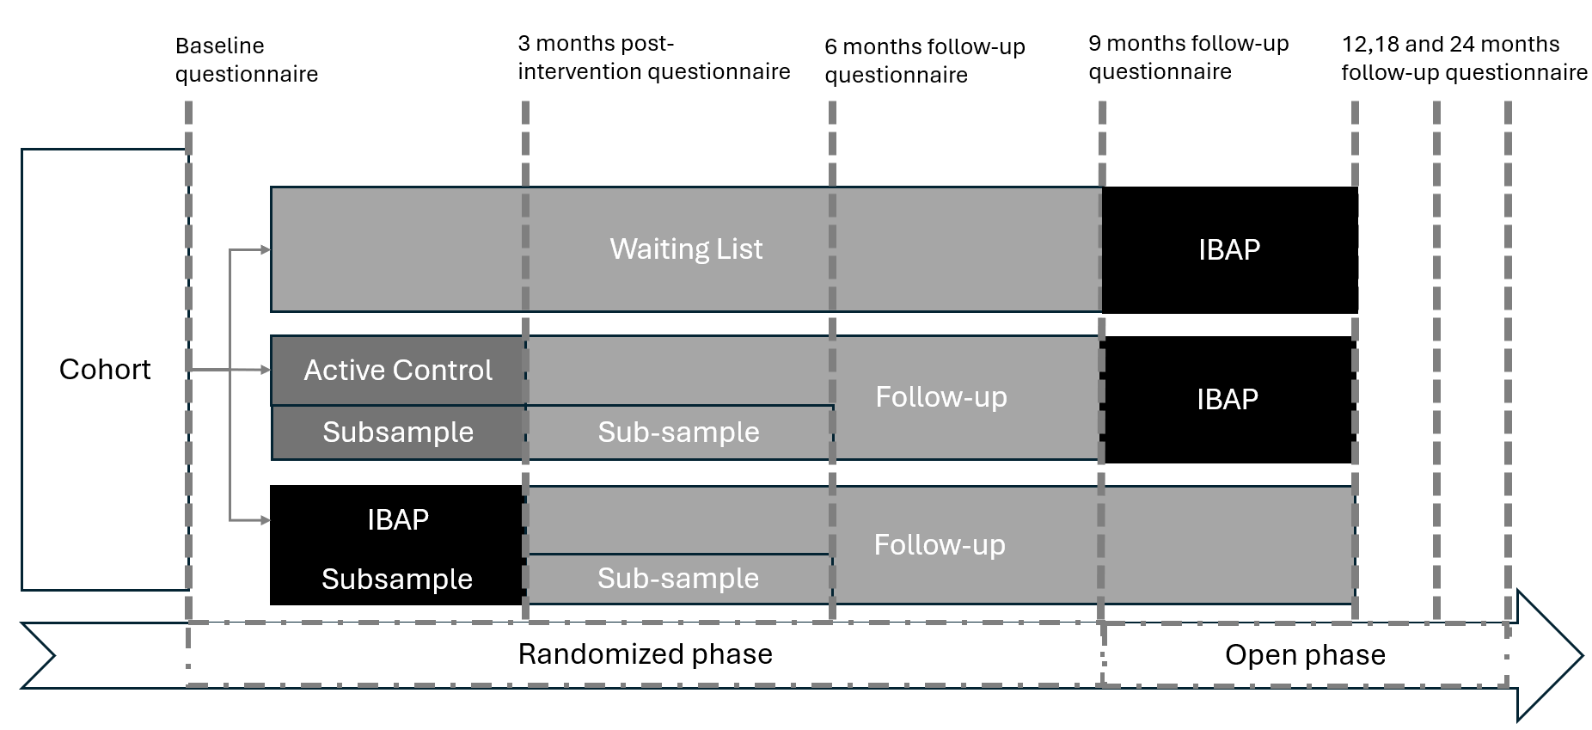

Supplementary table 1. Packages used in R for statistical analysis.
Package | Primary use
Data ingestion & wrangling
readxl | Import Excel files.
dplyr, tidyr | Data manipulation and reshaping (select, mutate, pivot).
stringr | String/text handling.
tibble | Modern data frames.
forcats | Factor (categorical) handling.
janitor | Data/table cleaning helpers.
purrr | Functional programming (map/iteration).
rlang | Tidyverse programming infrastructure.
Modeling & inference
lme4, lmerTest | Linear mixed-effects models and tests/p-values.
emmeans | Estimated marginal means and post-hoc contrasts.
lmtest, sandwich | Hypothesis tests and robust SEs.
logistf | Logistic regression with Firth correction (fallback).
broom, broom.mixed | Tidy model outputs (incl. mixed models).
rstatix | Nonparametric tests and effect sizes (Kruskal, Dunn, Wilcoxon).
DHARMa | Residual diagnostics for mixed models.
Missing data
MissMech | MCAR tests (Hawkins / TestMCARNormality).
naniar | Missingness exploration/visualization.
mice, miceadds | Multiple imputation by chained equations.
Microbiome & ecology
vegan | Diversity, Bray–Curtis, PERMANOVA (adonis2).
permute | Permutation schemes (support for vegan).
Visualization
ggplot2 | Core plotting.
ggthemes, ggsci, ggtext, scales | Themes, scientific palettes, rich text, scales.
gridExtra, patchwork | Figure layout/combination.
tidytext | Text utilities (used in reporting/labels).

Supplementary table 2. Availability of psychological, fecal microbiome, and ECG/HRV data across study waves
Values are n (% of randomized participants within each group). Psychological assessments included parental burnout, quality of life, and mindfulness measures collected in the parent trial sample. Fecal microbiome and ECG/HRV assessments were conducted only in the intervention (IBAP) and active control (AC) groups. ECG and fecal microbiome subsets partially overlapped, resulting in different sample sizes across biological outcomes. Longitudinal mixed-effects models used all available observations rather than complete-case data only. AC = active control; IBAP = mindfulness- and compassion-based intervention; WL = waitlist; ECG = electrocardiogram; HRV = heart rate variability.
Outcome / Wave | AC | IBAP | WL | Total
Psychological assessments

T0 | 23 (100.0%) | 24 (100.0%) | 277 (100.0%) | 324 (100.0%)
T1 | 20 (87.0%) | 18 (75.0%) | 110 (39.7%) | 148 (45.7%)
T2 | 17 (73.9%) | 14 (58.3%) | 74 (26.7%) | 105 (32.4%)
T3 | 17 (73.9%) | 13 (54.2%) | 64 (23.1%) | 94 (29.0%)
Fecal microbiome samples

T0 | 17 (73.9%) | 15 (62.5%) | — | 32 (9.9%)
T1 | 12 (52.2%) | 11 (45.8%) | — | 23 (7.1%)
T2 | 7 (30.4%) | 5 (20.8%) | — | 12 (3.7%)
Usable ECG/HRV recordings

T0 | 21 (91.3%) | 17 (70.8%) | — | 38 (11.7%)
T1 | 11 (47.8%) | 10 (41.7%) | — | 21 (6.5%)
T2 | 9 (39.1%) | 5 (20.8%) | — | 14 (4.3%)

Supplementary table 3. Baseline sociodemographic, psychological, microbiota, and heart rate variability characteristics of participants.
Values are mean (SD) for continuous variables and n (%) for categorical variables. Psychological variables are reported for the parent trial sample. Lifestyle, microbiome, and ECG/HRV variables are reported for the corresponding biological subsamples only; therefore, sample sizes differ across outcomes. ECG and fecal microbiome subsets partially overlapped. Lower EQ-5D scores indicate better health-related quality of life. IBAP = mindfulness- and compassion-based inter-care program; AC = active control; WL = waitlist; PBA = Parental Burnout Assessment; EQ-5D = EuroQol 5 Dimensions questionnaire; FFMQ = Five Facet Mindfulness Questionnaire; ECG = electrocardiogram; HRV = heart rate variability; HR = heart rate; RR = interval between consecutive R waves; RMSSD = root mean square of successive RR interval differences; lnRMSSD = natural logarithm of RMSSD; HF power, ms² = spectral power in the high-frequency band (0·15–0·40 Hz); LF power, ms² = spectral power in the low-frequency band (0·04–0·15 Hz); HF–HRV (%) = HF power expressed as a percentage of total spectral power (LF+HF); bpm = beats per minute; ms = milliseconds.
Variable | IBAP | AC | WL | Total
Sociodemographic variables, Mean (SD) | (n=24) | (n=23) | (n=277) | (N=324)
Age, years | 39.21 (8.02) | 38.27 (5.42) | 38.48 (5.16) | 38.52 (5.36)
Household size | 3.54 (1.06) | 3.22 (1.04) | 3.65 (1.03) | 3.61 (1.04)
Children in household | 1.75 (0.90) | 1.65 (0.71) | 1.62 (0.78) | 1.63 (0.78)
Household care, % | 81.58 (16.62) | 81.83 (17.42) | 78.21 (16.37) | 78.72 (16.46)
Work from home, days/week | 3.75 (1.45) | 3.39 (1.56) | 3.80 (1.39) | 3.77 (1.41)
Work, days/week | 4.92 (0.50) | 5.04 (0.47) | 5.00 (0.72) | 5.00 (0.69)
Sociodemographic variables, n (%) | (n=24) | (n=23) | (n=277) | (N=324)
Female | 24 (100.0%) | 23 (100.0%) | 274 (98.9%) | 321 (99.1%)
Complete school education | 1 (4.2%) | 1 (4.3%) | 7 (2.5%) | 9 (2.8%)
Professional education | 4 (16.7%) | 3 (13.0%) | 38 (13.7%) | 45 (13.9%)
Bachelor’s degree | 10 (41.7%) | 12 (52.2%) | 144 (52.0%) | 166 (51.2%)
Postgraduate degree | 9 (37.5%) | 7 (30.4%) | 87 (31.4%) | 103 (31.8%)
Married | 8 (33.3%) | 8 (34.8%) | 119 (43.0%) | 135 (41.7%)
In partnership, not married | 8 (33.3%) | 3 (13.0%) | 87 (31.4%) | 98 (30.2%)
Divorced | 1 (4.2%) | 1 (4.3%) | 20 (7.2%) | 22 (6.8%)
Single | 5 (20.8%) | 11 (47.8%) | 46 (16.6%) | 62 (19.1%)
Psychological variables, Mean (SD) | (n=24) | (n=23) | (n=277) | (N=324)
Parental burnout (PBA total) | 3.11 (1.38) | 3.62 (1.34) | 3.13 (1.26) | 3.17 (1.28)
PBA – exhaustion | 2.87 (1.66) | 3.37 (1.66) | 2.75 (1.44) | 2.80 (1.48)
PBA – emotional distancing | 4.07 (1.55) | 4.49 (1.27) | 4.19 (1.42) | 4.20 (1.42)
PBA – loss of parental pleasure | 2.92 (1.37) | 3.61 (1.55) | 2.90 (1.48) | 2.95 (1.48)
PBA – negative self-perception | 2.59 (1.37) | 3.02 (1.47) | 2.70 (1.33) | 2.71 (1.34)
Quality of Life (Total EQ-5D) | 1.38 (0.26) | 1.50 (0.27) | 1.34 (0.25) | 1.35 (0.26)
EQ-5D – activity | 1.33 (0.48) | 1.39 (0.50) | 1.22 (0.42) | 1.24 (0.43)
EQ-5D – anxiety/depression | 1.92 (0.58) | 2.04 (0.56) | 1.82 (0.59) | 1.84 (0.59)
EQ-5D – self-care | 1.00 (0.00) | 1.00 (0.00) | 1.01 (0.12) | 1.01 (0.11)
EQ-5D – discomfort | 1.58 (0.50) | 2.00 (0.52) | 1.57 (0.57) | 1.60 (0.57)
EQ-5D – mobility | 1.04 (0.20) | 1.09 (0.29) | 1.06 (0.25) | 1.06 (0.25)
Mindfulness (Total FFMQ) | 3.52 (0.30) | 3.53 (0.37) | 3.46 (0.43) | 3.47 (0.42)
FFMQ – observing | 3.75 (0.81) | 4.04 (0.66) | 3.75 (0.75) | 3.77 (0.75)
FFMQ – describing | 3.29 (0.91) | 3.15 (0.55) | 3.33 (0.74) | 3.31 (0.74)
FFMQ – acting with awareness | 3.93 (0.57) | 3.79 (0.63) | 3.70 (0.69) | 3.72 (0.68)
FFMQ – nonjudging | 3.49 (0.57) | 3.41 (0.66) | 3.39 (0.67) | 3.40 (0.66)
FFMQ – nonreactivity | 3.15 (0.90) | 3.26 (0.86) | 3.14 (0.94) | 3.15 (0.93)
Extraversion | 3.26 (0.41) | 3.18 (0.40) | 3.07 (0.42) | 3.09 (0.42)
Neuroticism | 3.42 (0.68) | 3.25 (0.39) | 3.23 (0.41) | 3.25 (0.43)
Lifestyle variables, Mean (SD) | (n=22) | (n=20) | — | (N=42)
Healthy lifestyle index | 70.59 (19.64) | 67.85 (26.37) | — | 69.29 (22.84)
Unhealthy lifestyle index | 11.00 (6.43) | 11.82 (7.27) | — | 11.39 (6.77)
Fecal microbiome variables, Mean (SD) | (n=15) | (n=17) | — | (N=32)
Observed features | 494.67 (131.02) | 501.18 (173.32) | — | 498.12 (152.54)
Shannon entropy | 6.01 (0.63) | 5.93 (0.82) | — | 5.97 (0.73)
Phylogenetic entropy | 1.18 (0.18) | 1.12 (0.17) | — | 1.15 (0.18)
ECG/HRV variables, Mean (SD) | (n=17) | (n=21) | — | (N=38)
Mean HR, bpm | 79.94 (11.38) | 83.49 (10.51) | — | 81.90 (10.91)
Mean RR, ms | 765.98 (116.04) | 729.82 (94.14) | — | 746.00 (104.62)
RMSSD, ms | 46.76 (18.29) | 47.45 (17.84) | — | 47.14 (17.80)
lnRMSSD | 3.77 (0.40) | 3.77 (0.47) | — | 3.77 (0.43)
HF power, ms² | 144.33 (109.18) | 140.89 (110.04) | — | 142.43 (108.18)
LF power, ms² | 319.56 (235.80) | 312.90 (245.90) | — | 315.88 (238.20)
RR quality, % | 92.62 (7.96) | 93.76 (6.50) | — | 93.25 (7.11)

Supplementary Table 4. Model-estimated contrasts for psychological, autonomic, and microbiome outcomes across time points
Values represent model-estimated marginal mean differences (β) derived from linear mixed-effects models with random intercepts. Estimates are reported with standard errors (SE), 95% confidence intervals (CI), adjusted p values, and standardized mean differences (Cohen’s d), calculated using the model residual standard deviation. Positive β values indicate higher scores in the first-listed group.
For parental burnout (PBA total score), Holm–Bonferroni correction was applied to adjust for multiple comparisons across time points. For heart rate variability (lnRMSSD), α-diversity indices, quality of life (EQ-5D), mindfulness (FFMQ total), parental burnout subscales, genus-level abundance, and KEGG pathways, p values were adjusted using the Benjamini–Hochberg false discovery rate procedure at the global level unless otherwise specified.
IBAP = mindfulness- and compassion-based intervention; AC = active control (audios); WL = waitlist; T0 = baseline; T1 = post-intervention (3 months); T2 = 6 months; T3 = 9 months; lnRMSSD = natural logarithm of the root mean square of successive differences; α-diversity = within-sample diversity; KEGG = Kyoto Encyclopedia of Genes and Genomes predicted metabolic pathways.
All tests were two-sided with α = .05.
Metric | Time | Contrast | β (SE) | 95% CI | p (Adj) | d
Parental Burnout (PBA)
 | T0 | IBAP vs WL | 0.10 (0.20) | [−0.35, 0.54] | 1.000 | 0.15
 | T0 | AC vs WL | 0.11 (0.19) | [−0.32, 0.54] | 1.000 | 0.17
 | T1 | IBAP vs WL | −0.50 (0.23) | [−1.01, 0.01] | .233 | −0.77
 | T1 | AC vs WL | −0.62 (0.22) | [−1.11, −0.13] | .052 | −0.95
 | T2 | IBAP vs WL | −0.80 (0.26) | [−1.38, −0.23] | .027 | −1.24
 | T2 | AC vs WL | −1.08 (0.25) | [−1.63, −0.54] | <.001 | −1.68
 | T3 | IBAP vs WL | −0.51 (0.27) | [−1.12, 0.10] | .347 | −0.79
 | T3 | AC vs WL | −0.73 (0.24) | [−1.27, −0.20] | .028 | −1.13
Heart rate variability (lnRMSSD)
 | T0 | IBAP vs AC | −0.01 (0.12) | [−0.25, 0.23] | .928 | −0.05
 | T1 | IBAP vs AC | 0.62 (0.16) | [0.30, 0.93] | <.001 | 2.58
 | T2 | IBAP vs AC | 0.35 (0.22) | [−0.08, 0.79] | .214 | 1.48
α-diversity
Phylogenetic entropy | T0 | IBAP vs AC | 0.02 (0.04) | [−0.06, 0.10] | .787 | 0.29
 | T1 | IBAP vs AC | −0.04 (0.05) | [−0.13, 0.05] | .787 | −0.57
 | T2 | IBAP vs AC | 0.17 (0.06) | [0.05, 0.29] | .019 | 2.43
Observed features | T2 | IBAP vs AC | −71.30 (32.09) | [−135.43, −7.16] | .101 | −1.76
Shannon entropy | T2 | IBAP vs AC | −0.44 (0.21) | [−0.86, −0.02] | .125 | −1.64
Quality of life (EQ-5D)
 | T0 | IBAP vs WL | 0.009 (0.042) | [−0.084, 0.102] | .980 | 0.07
 | T0 | AC vs WL | 0.024 (0.040) | [−0.065, 0.114] | .952 | 0.18
 | T1 | IBAP vs WL | −0.131 (0.049) | [−0.240, −0.023] | .056 | −0.96
 | T1 | AC vs WL | −0.171 (0.051) | [−0.283, −0.058] | .012 | −1.25
 | T2 | IBAP vs WL | −0.130 (0.057) | [−0.258, −0.003] | .125 | −0.95
 | T2 | AC vs WL | −0.160 (0.054) | [−0.281, −0.039] | .040 | −1.17
 | T3 | IBAP vs WL | −0.155 (0.058) | [−0.283, −0.026] | .056 | −1.13
 | T3 | AC vs WL | −0.105 (0.050) | [−0.218, 0.007] | .172 | −0.77
Mindfulness (FFMQ total)
 | T0 | IBAP vs WL | 0.039 (0.081) | [−0.141, 0.219] | .953 | 0.15
 | T0 | AC vs WL | 0.009 (0.078) | [−0.165, 0.183] | .984 | 0.03
 | T1 | IBAP vs WL | −0.087 (0.095) | [−0.298, 0.123] | .798 | −0.33
 | T1 | AC vs WL | 0.128 (0.098) | [−0.090, 0.345] | .588 | 0.49
 | T2 | IBAP vs WL | −0.079 (0.111) | [−0.325, 0.168] | .914 | −0.30
 | T2 | AC vs WL | 0.173 (0.105) | [−0.061, 0.407] | .389 | 0.66
 | T3 | IBAP vs WL | 0.043 (0.112) | [−0.205, 0.292] | .953 | 0.17
 | T3 | AC vs WL | 0.108 (0.098) | [−0.110, 0.326] | .759 | 0.41
Parental Burnout (PBA)
Negative self-perception
 | T0 | IBAP – WL | 0.092 (0.237) | [−0.436, 0.621] | .953 | 0.119
 | T0 | AC – WL | 0.165 (0.229) | [−0.346, 0.675] | .914 | 0.212
 | T1 | IBAP – WL | −0.797 (0.274) | [−1.409, −0.186] | .041 | −1.02
 | T1 | AC – WL | −0.684 (0.263) | [−1.271, −0.098] | .066 | −0.88
 | T2 | IBAP – WL | −1.104 (0.307) | [−1.787, −0.420] | .008 | −1.41
 | T2 | AC – WL | −1.202 (0.292) | [−1.854, −0.551] | .002 | −1.54
 | T3 | IBAP – WL | −0.892 (0.326) | [−1.619, −0.165] | .056 | −1.14
 | T3 | AC – WL | −0.806 (0.286) | [−1.442, −0.169] | .048 | −1.03
Emotional distancing
 | T0 | IBAP – WL | 0.174 (0.246) | [−0.374, 0.723] | .914 | 0.212
 | T0 | AC – WL | 0.244 (0.239) | [−0.288, 0.776] | .759 | 0.296
 | T1 | IBAP – WL | −0.300 (0.285) | [−0.935, 0.335] | .759 | −0.36
 | T1 | AC – WL | −1.088 (0.274) | [−1.698, −0.478] | .002 | −1.32
 | T2 | IBAP – WL | −0.291 (0.319) | [−1.002, 0.420] | .798 | −0.35
 | T2 | AC – WL | −1.580 (0.305) | [−2.259, −0.900] | <.001 | −1.91
 | T3 | IBAP – WL | −0.365 (0.340) | [−1.122, 0.392] | .759 | −0.44
 | T3 | AC – WL | −1.029 (0.298) | [−1.692, −0.366] | .011 | −1.25
Exhaustion
 | T0 | IBAP – WL | 0.090 (0.233) | [−0.428, 0.609] | .953 | 0.121
 | T0 | AC – WL | 0.050 (0.223) | [−0.448, 0.548] | .980 | 0.067
 | T1 | IBAP – WL | −0.497 (0.268) | [−1.095, 0.101] | .268 | −0.66
 | T1 | AC – WL | −0.246 (0.256) | [−0.817, 0.325] | .794 | −0.33
 | T2 | IBAP – WL | −1.210 (0.300) | [−1.879, −0.542] | .002 | −1.62
 | T2 | AC – WL | −0.911 (0.285) | [−1.545, −0.277] | .019 | −1.22
 | T3 | IBAP – WL | −0.184 (0.318) | [−0.893, 0.525] | .952 | −0.24
 | T3 | AC – WL | −0.651 (0.277) | [−1.269, −0.033] | .118 | −0.87
Loss of parental pleasure
 | T0 | IBAP – WL | 0.088 (0.217) | [−0.396, 0.572] | .953 | 0.125
 | T0 | AC – WL | 0.083 (0.209) | [−0.382, 0.547] | .953 | 0.117
 | T1 | IBAP – WL | −0.355 (0.251) | [−0.913, 0.204] | .549 | −0.50
 | T1 | AC – WL | −0.361 (0.239) | [−0.895, 0.172] | .485 | −0.51
 | T2 | IBAP – WL | −0.601 (0.280) | [−1.226, 0.023] | .158 | −0.85
 | T2 | AC – WL | −0.576 (0.266) | [−1.169, 0.017] | .158 | −0.81
 | T3 | IBAP – WL | −0.580 (0.298) | [−1.244, 0.083] | .227 | −0.82
 | T3 | AC – WL | −0.341 (0.259) | [−0.919, 0.238] | .588 | −0.48
Abundance, Genus
[Eubacterium] nodatum group | T2 | IBAP – AC | −2.469 (0.587) | [−3.643, −1.294] | .047 | −3.264
Lachnospiraceae FCS020 group | T2 | IBAP – AC | −2.825 (0.692) | [−4.210, −1.440] | .047 | −3.287
UCG-005 | T2 | IBAP – AC | −1.957 (0.492) | [−2.941, −0.973] | .047 | −3.070
Coprococcus | T2 | IBAP – AC | −2.314 (0.609) | [−3.532, −1.095] | .0647 | −2.934
Erysipelatoclostridium | T2 | IBAP – AC | 1.601 (0.451) | [0.698, 2.504] | .0776 | 2.735
Marvinbryantia | T2 | IBAP – AC | −2.132 (0.591) | [−3.314, −0.951] | .0776 | −2.839
Sutterella | T2 | IBAP – AC | 2.465 (0.689) | [1.086, 3.845] | .0776 | 2.780
UCG-010 | T2 | IBAP – AC | −1.938 (0.551) | [−3.041, −0.835] | .0776 | −2.939
Senegalimassilia | T2 | IBAP – AC | 1.704 (0.499) | [0.706, 2.701] | .0945 | 2.652
Lachnospira | T1 | IBAP – AC | 1.973 (0.621) | [0.731, 3.215] | .1470 | 1.882
KEGG, Pathway
TYRFUMCAT-PWY | T1 | IBAP – AC | −8.027 (1.920) | [−11.884, −4.171] | .0419 | −2.09
GLYCOLYSIS-E-D | T1 | IBAP – AC | −8.249 (2.414) | [−13.098, −3.401] | .2262 | −1.67
12DICHLORETHDEG-PWY | T0 | IBAP – AC | ~0 (4.33e−14) | [−1.15e−13, 6.38e−14] | .7972 | −0.32
12DICHLORETHDEG-PWY | T1 | IBAP – AC | ~0 (4.81e−14) | [−1.40e−13, 5.85e−14] | .7972 | −0.52
14DICHLORBENZDEG-PWY | T0 | IBAP – AC | 0.679 (1.306) | [−1.945, 3.303] | .7972 | 0.205
14DICHLORBENZDEG-PWY | T2 | IBAP – AC | −0.822 (2.162) | [−5.155, 3.511] | .7972 | −0.24
1CMET2-PWY | T0 | IBAP – AC | ~0 (4.39e−14) | [−5.38e−14, 1.24e−13] | .7972 | 0.428
1CMET2-PWY | T1 | IBAP – AC | ~0 (4.94e−14) | [−1.18e−13, 8.15e−14] | .7972 | −0.22
1CMET2-PWY | T2 | IBAP – AC | ~0 (6.34e−14) | [−1.01e−13, 1.53e−13] | .7972 | 0.314
3-HYDROXYPHENYLACETATE-DEGRADATION-PWY | T0 | IBAP – AC | 1.740 (1.471) | [−1.212, 4.691] | .7972 | 0.440

Supplementary Figure 3. Forest plot for secondary outcomes by group and time.
Forest plots show Cohen’s d with 95% CIs for group contrasts at baseline (T0), 3 months (T1), 6 months (T2), and 9 months (T3). Outcomes include parental burnout subscales (negative self-perception, emotional distancing, loss of parental pleasure, exhaustion), quality of life (EQ-5D total), mindfulness (FFMQ total score), and microbiota α-diversity (observed richness, Shannon index). Comparisons are shown for AC vs WL, IBAP vs WL, and IBAP vs AC. Positive d favors the first group named in the contrast; negative d favors the second. PBA = Parental Burnout Assessment, WL = waiting list; AC = active control; IBAP = mindfulness- and compassion-based inter-care program. * unadjusted p < 0.05; + Benjamini–Hochberg–adjusted p < 0.05.
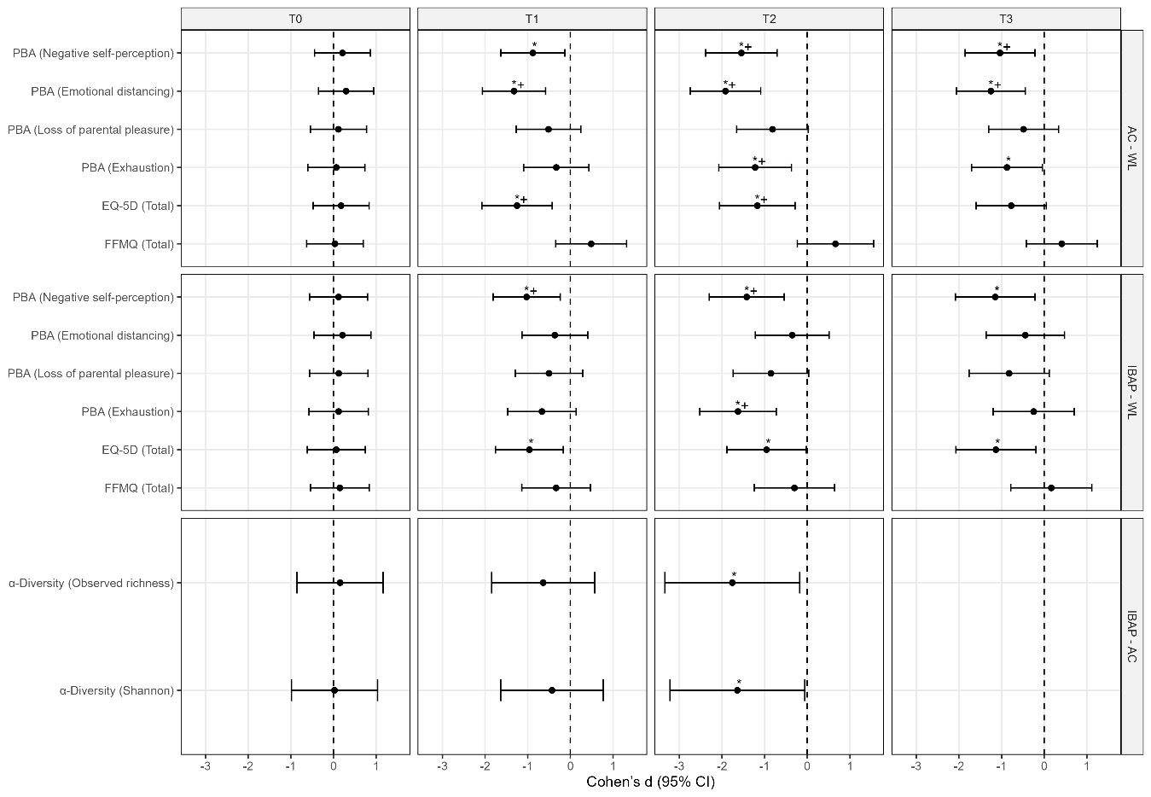

Supplementary figure 2. Sensitivity analyses of primary outcomes using complete-case and imputed data
Forest plots show Cohen’s d with 95% CIs for contrasts at baseline (T0), 3 months (T1), 6 months (T2), and 9 months (T3). Outcomes include α-diversity (phylogenetic entropy), heart rate variability (lnRMSSD), and parental burnout (PBA total). Results are displayed for IBAP vs AC, IBAP vs WL, and AC vs WL. Solid symbols represent complete-case analyses; dashed symbols represent multiply imputed models. WL = waiting list; AC = active control; IBAP = mindfulness- and compassion-based inter-care program.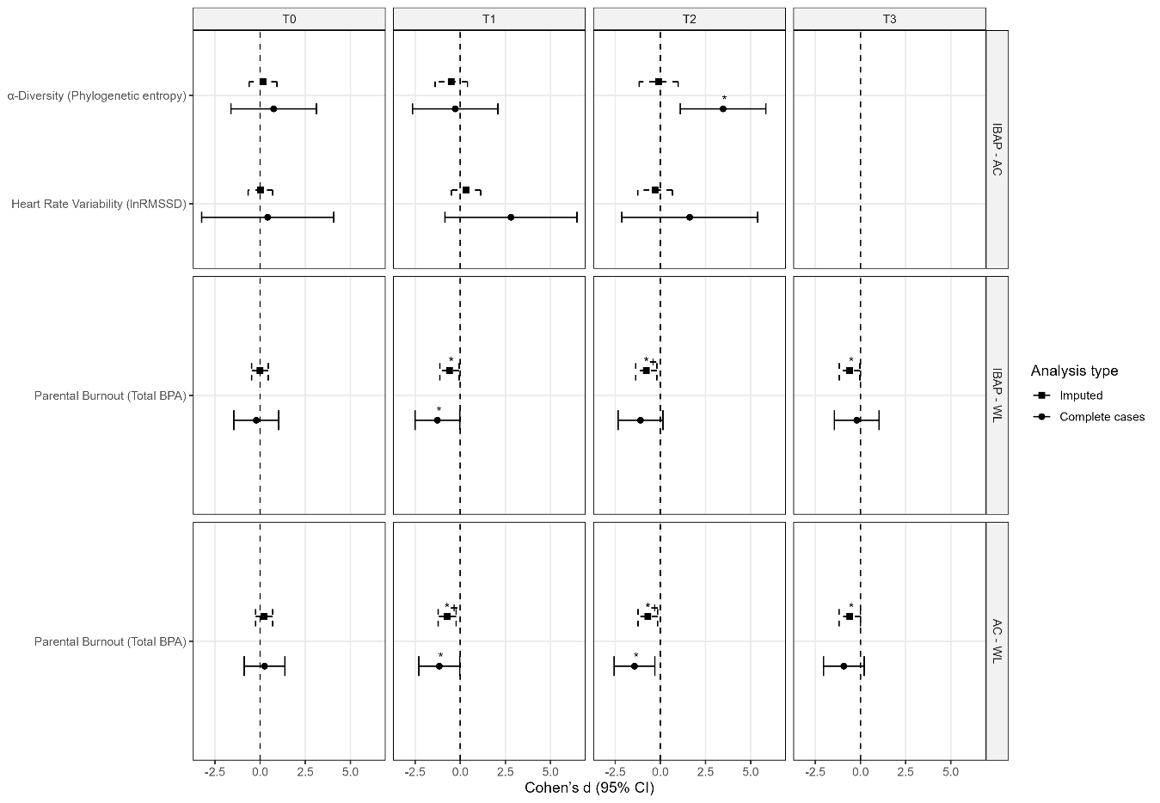

Supplementary figure 4. Principal coordinates analysis (PCoA) of gut microbiota β-diversity (Bray–Curtis distances) by group and time
Plots show PCoA of Bray–Curtis dissimilarities at baseline (T0), 3 months (T1), and 6 months (T2) for participants in the IBAP and AC groups. Each point represents one participant; ellipses indicate 95% confidence intervals of group distribution. Group differences were tested using PERMANOVA including group, time, and group×time, adjusted for baseline covariates. AC = active control; IBAP = mindfulness- and compassion-based inter-care program.
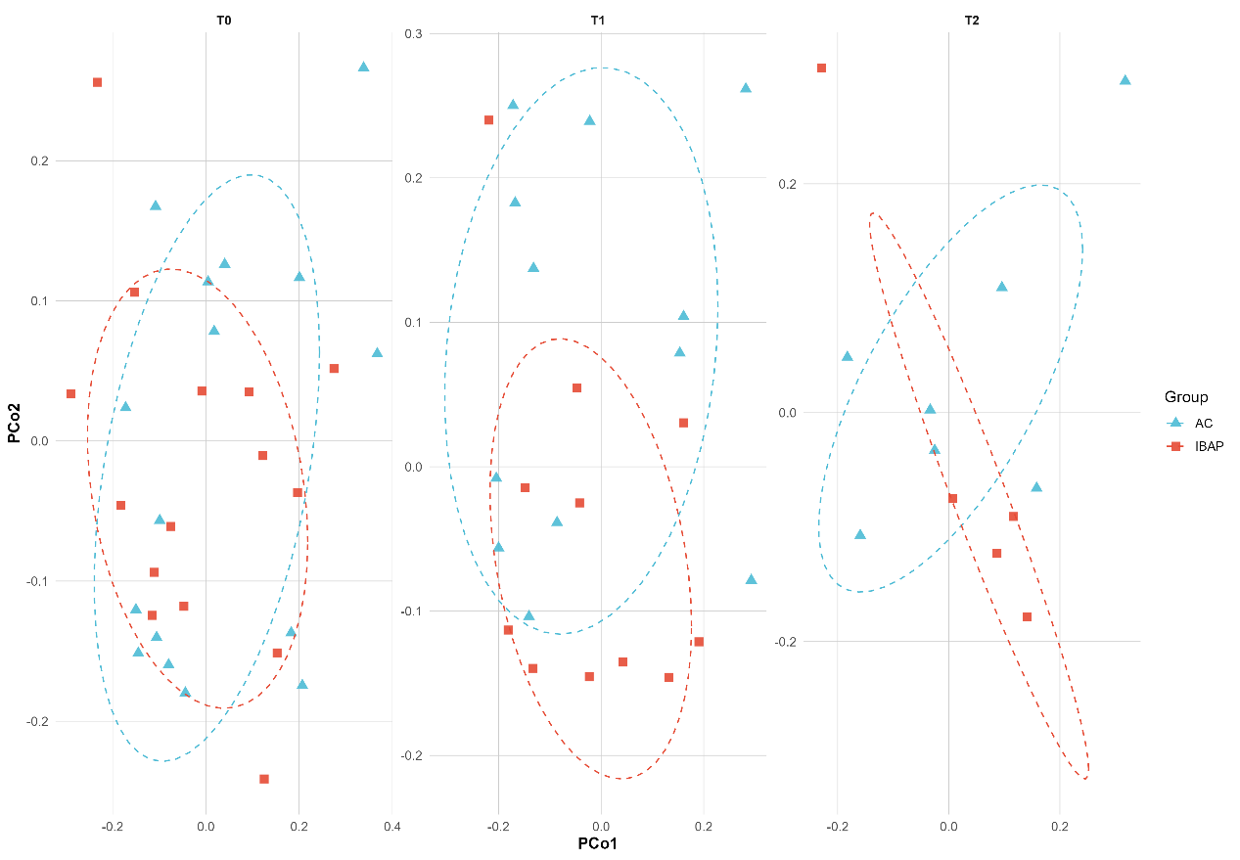

Supplementary figure 5. Change in gut microbiota β-diversity (Bray–Curtis distance from baseline) over time by group
Lines represent individual participants; larger symbols indicate estimated marginal means with 95% CIs at 3 months (T1) and 6 months (T2). Distances reflect within-subject change relative to baseline (T0). Analyses were conducted with linear mixed-effects models including group, time, and group×time. WL = waiting list; IBAP = mindfulness- and compassion-based inter-care program.

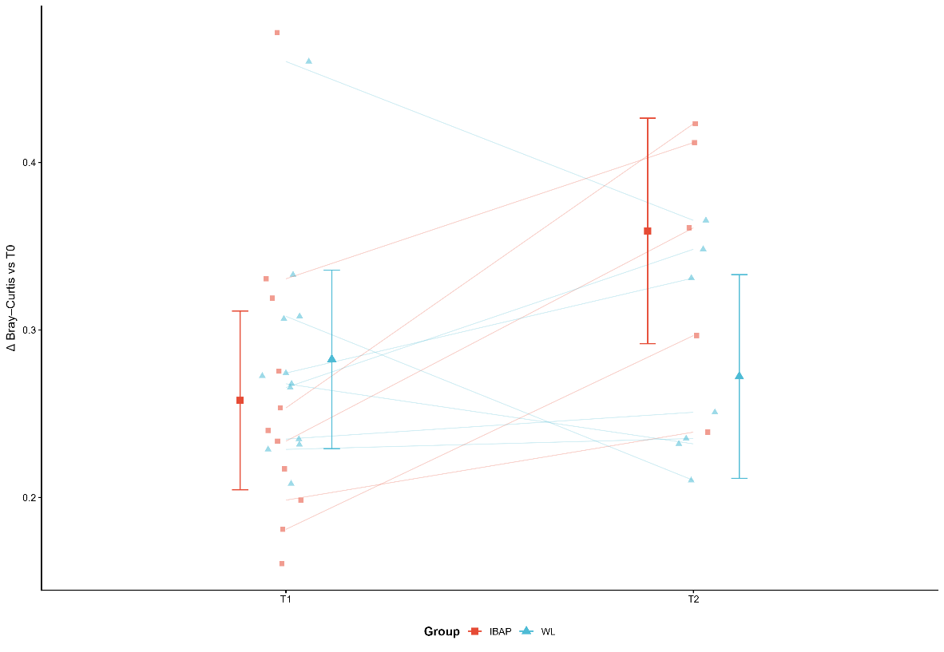

Supplementary figure 6. Relative abundance of gut microbiota by taxonomic level, group, and time
Stacked bar plots show mean relative abundance of bacterial taxa in AC and IBAP groups at baseline (T0), 3 months (T1), and 6 months (T2). Panels represent different taxonomic levels: (A) phylum, (B) class, (C) family, and (D) genus. Only the most prevalent taxa are displayed; all others are grouped as “Other.” AC = active control; IBAP = mindfulness- and compassion-based inter-care program.

A
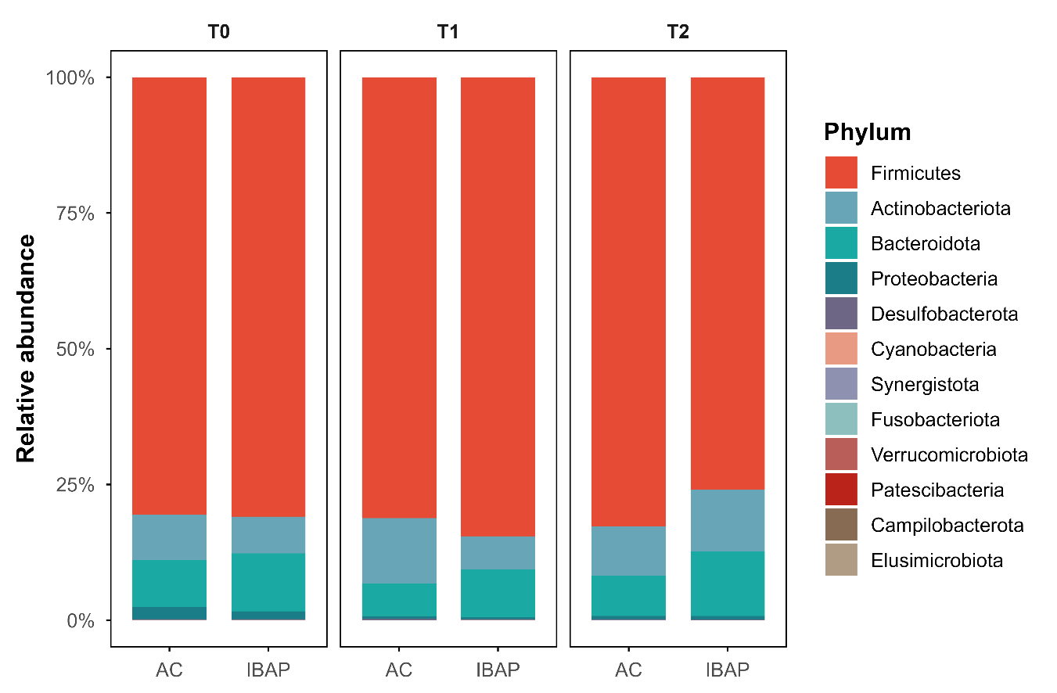

B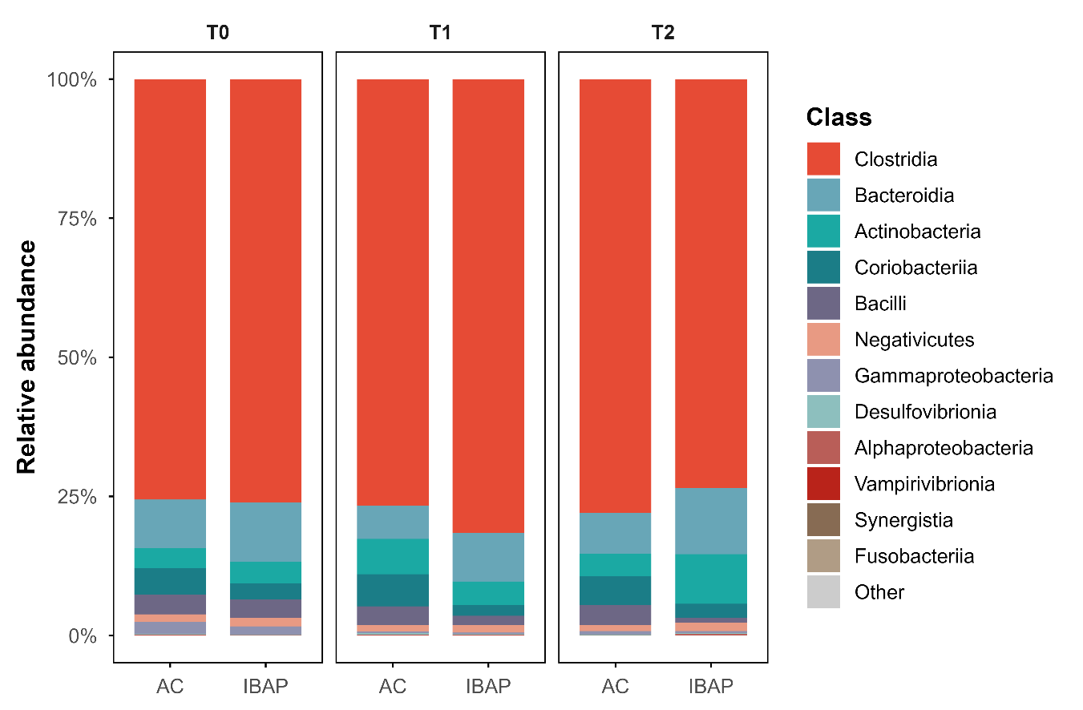

C
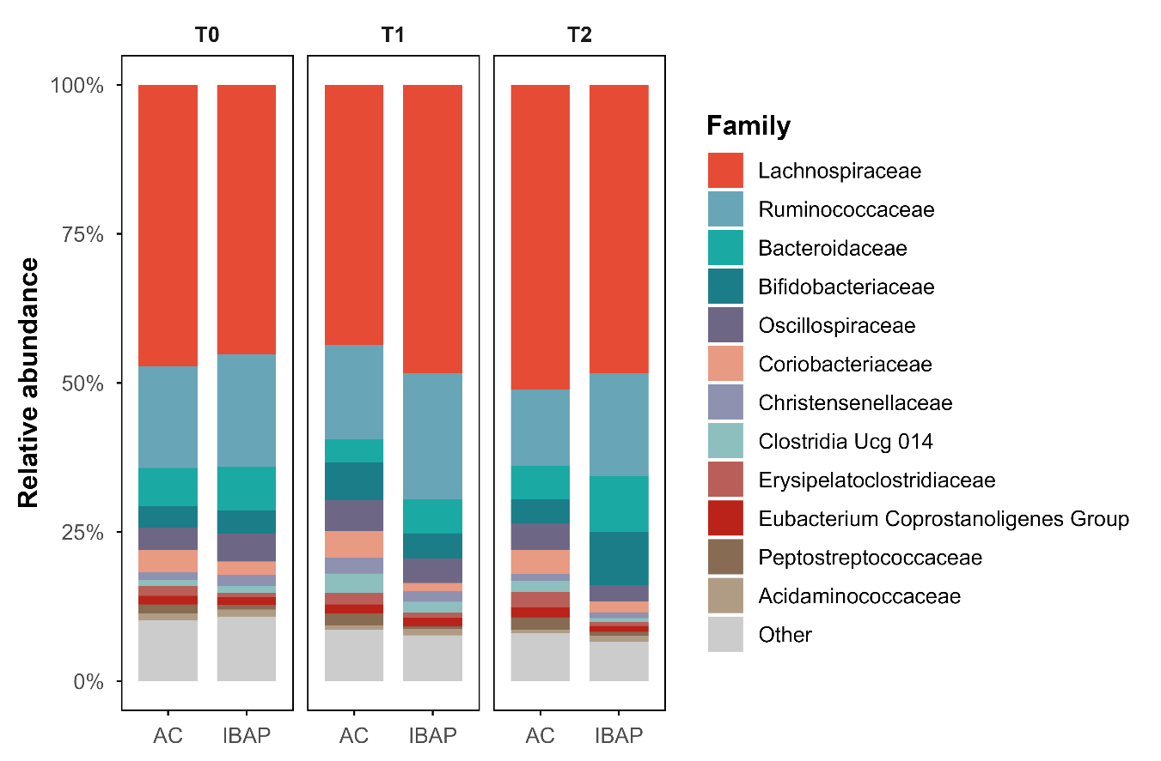

D
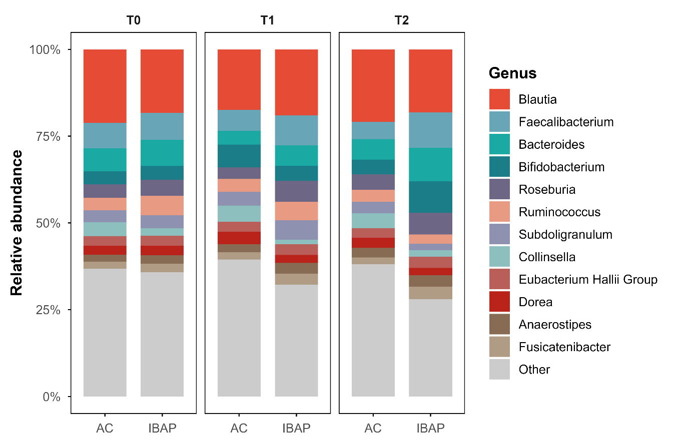

Supplementary figure 7. Differential abundance of gut microbiota across taxonomic levels by group and time
Forest plots show estimated contrasts (IBAP − AC) with 95% CIs for relative abundance of taxa at baseline (T0), 3 months (T1), and 6 months (T2). Panels include (A) phylum, (B) class, (C) order, (D) family, and (E) genus. Effect sizes are presented on the logit scale; positive values indicate higher abundance in IBAP. AC = active control; IBAP = mindfulness- and compassion-based inter-care program. * unadjusted p < 0.05; + Benjamini–Hochberg–adjusted p < 0.05.

A
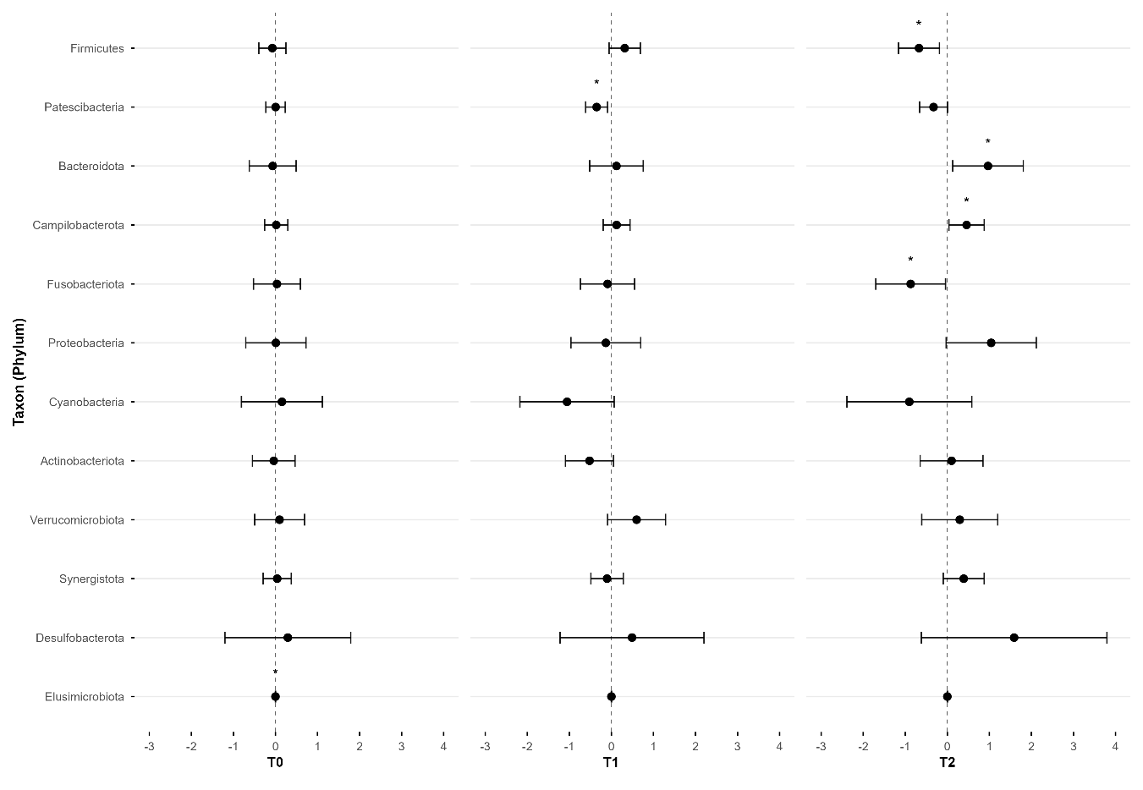

B
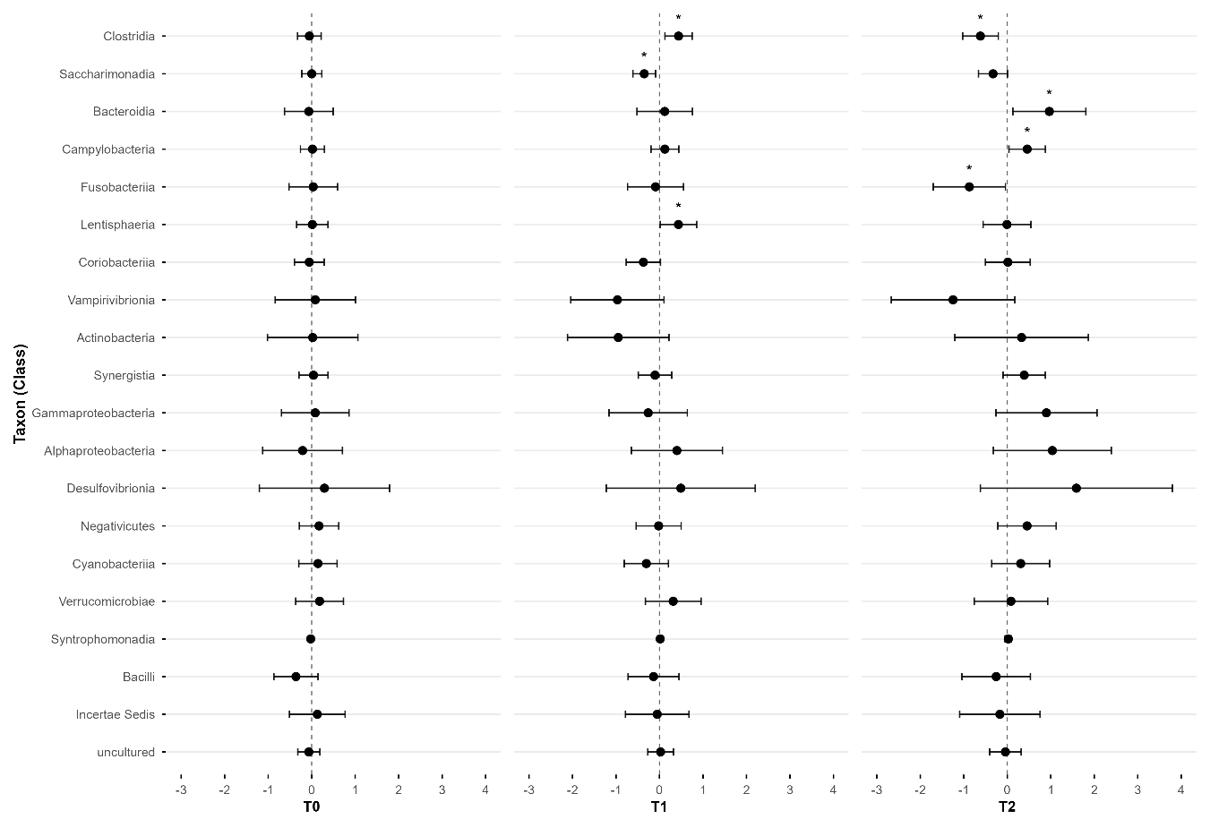

C

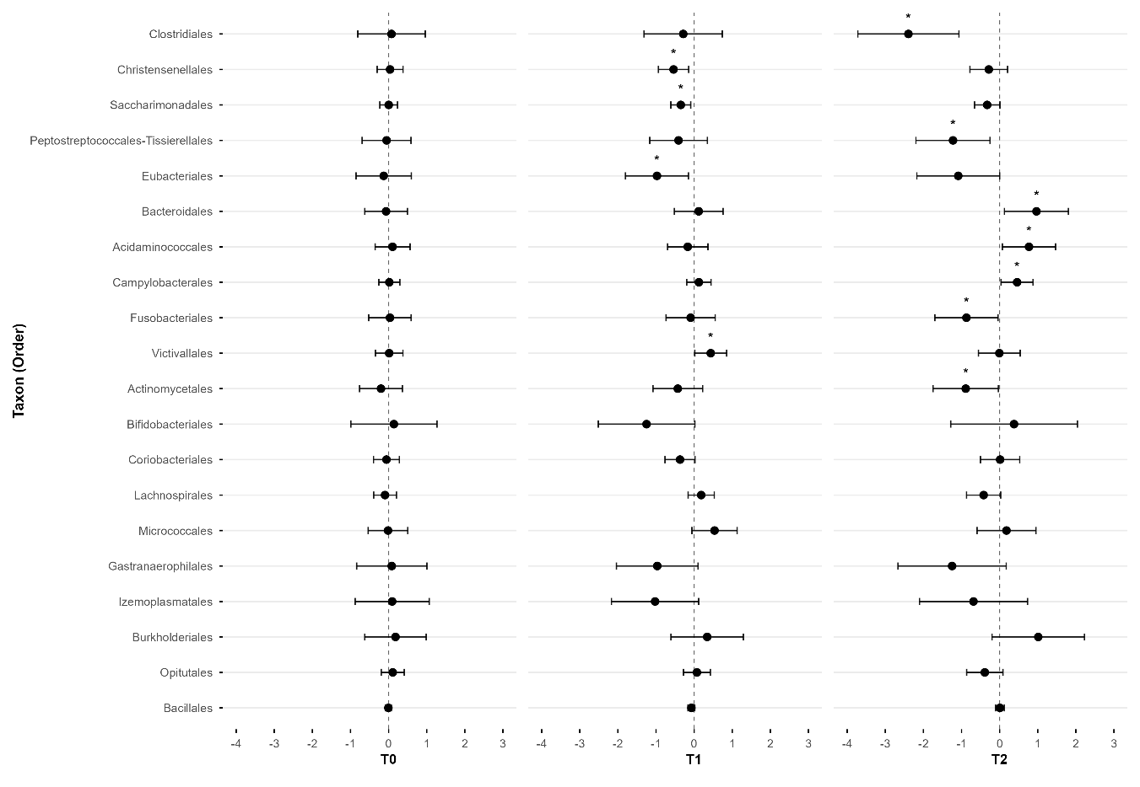

D
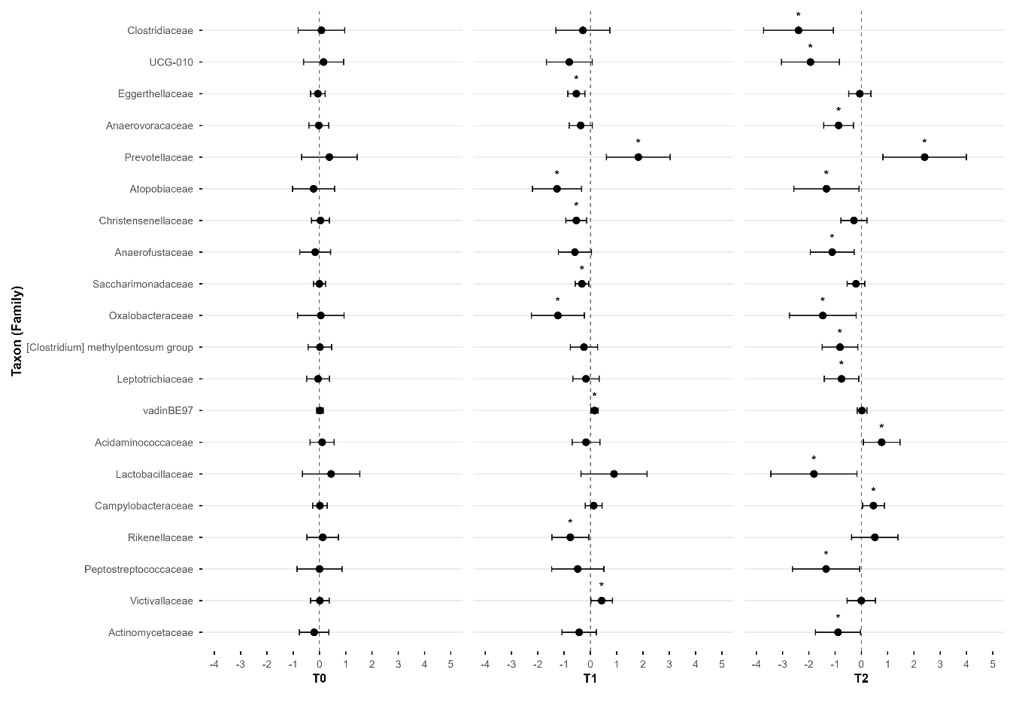

E
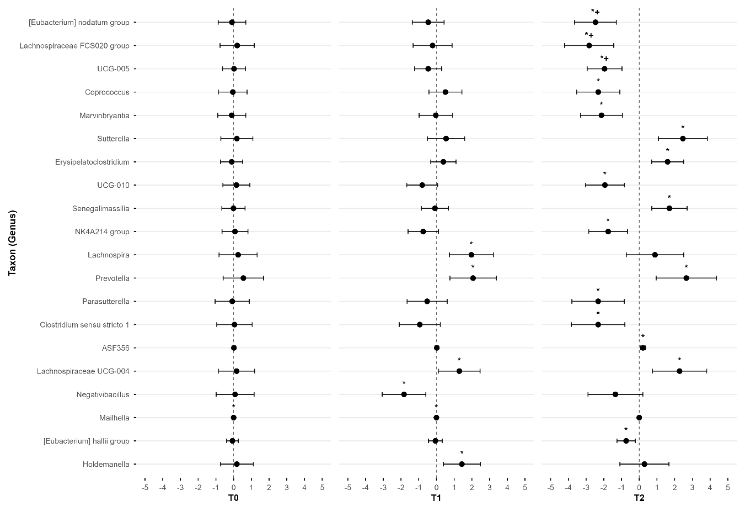

Supplementary figure 8. Spearman correlations between psychological, physiological, and microbiota variables
Heatmaps show Spearman’s ρ for associations among (A) psychological and physiological outcomes (PBA, lnRMSSD, phylogenetic entropy, EQ-5D, and FFMQ) and psychological/physiological outcomes with microbial features phylum (B), class (C), order (D), family (E), genus (F), and KEGG pathways (G). Color scale represents correlation coefficients (red = positive; blue = negative). Grey cells denote unavailable data. PBA = Parental Burnout Assessment; EQ-5D = EuroQol 5 dimensions; FFMQ = Five Facet Mindfulness Questionnaire; lnRMSSD = natural logarithm of the root mean square of successive differences. * unadjusted p < 0.05; + Benjamini–Hochberg–adjusted p < 0.05.

A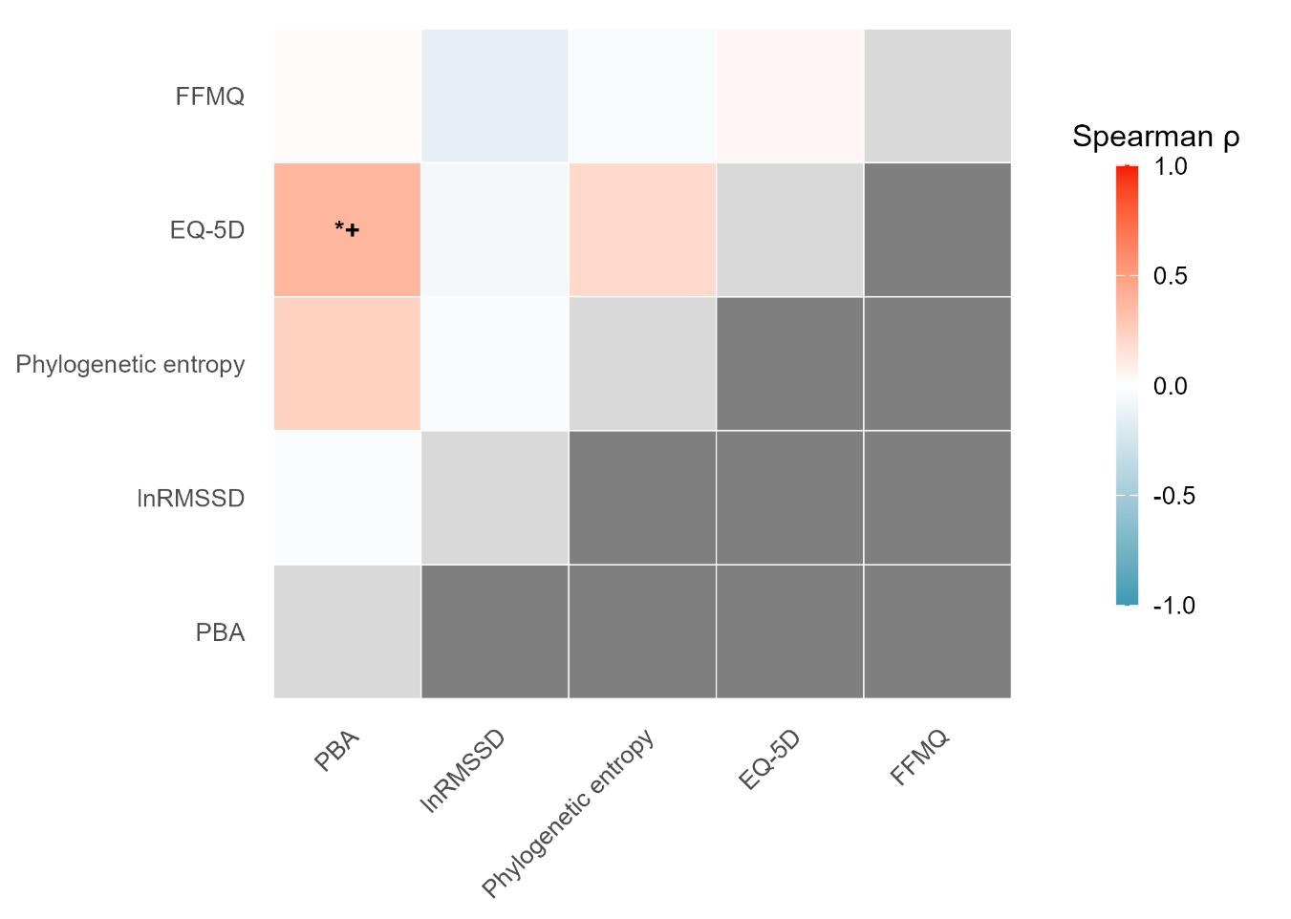

B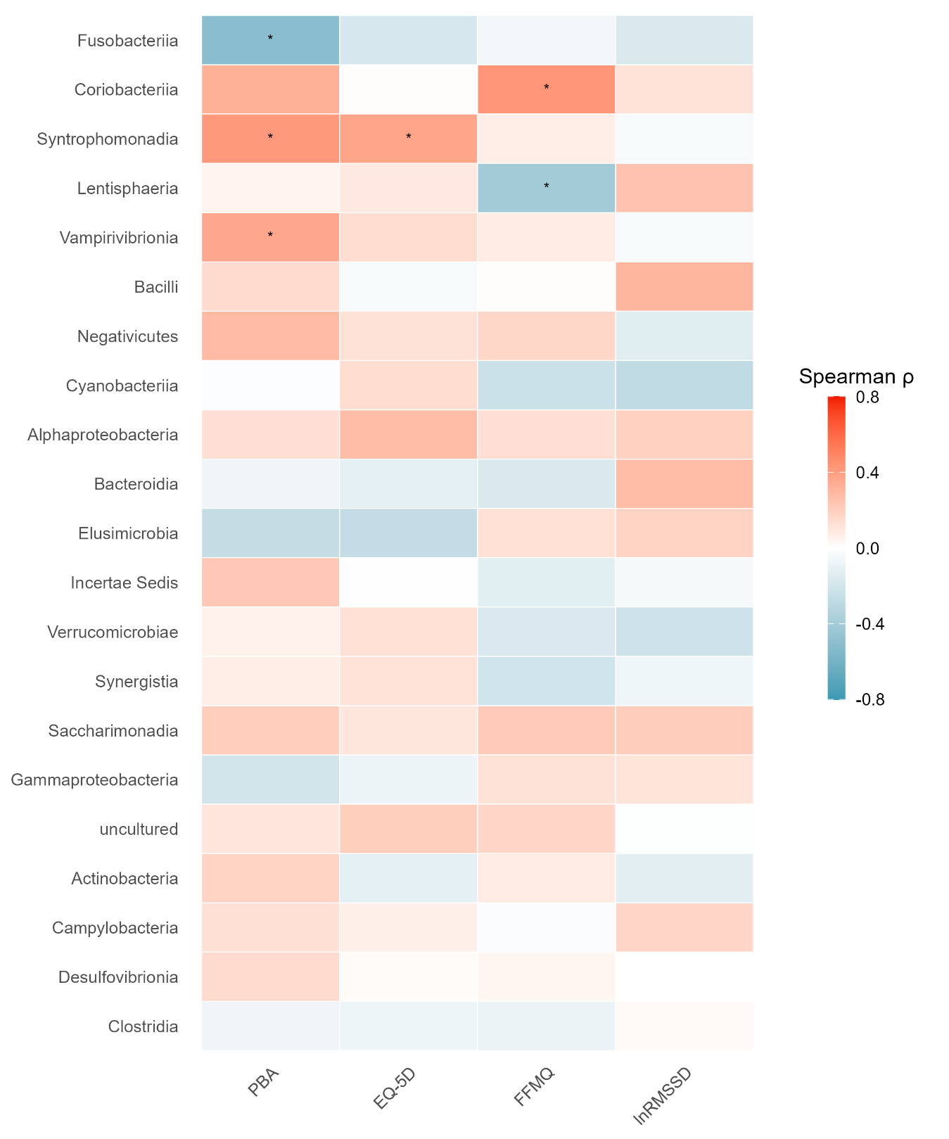

C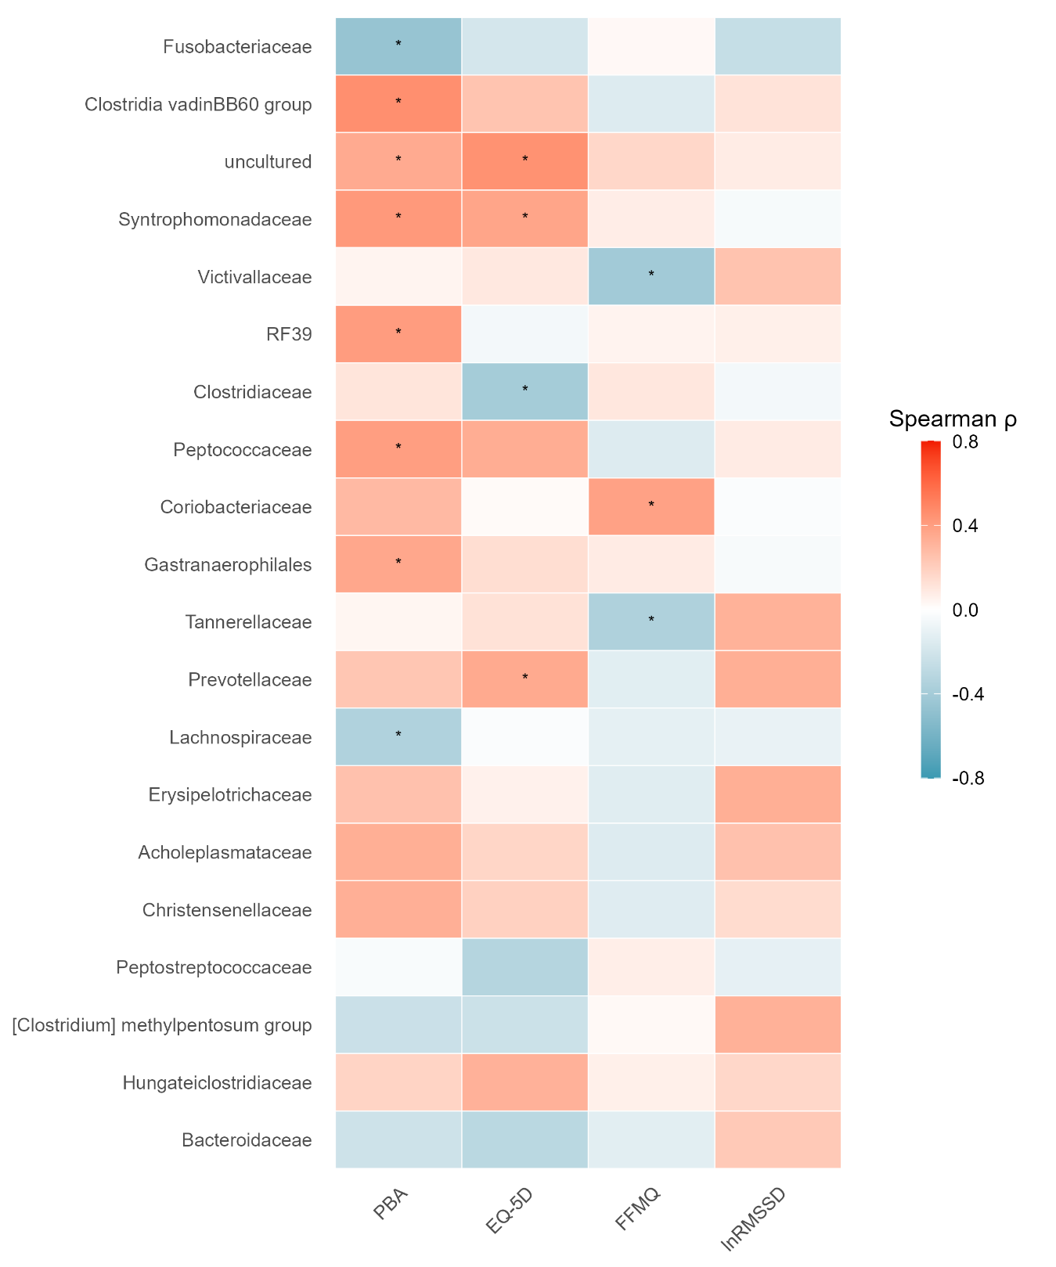

D
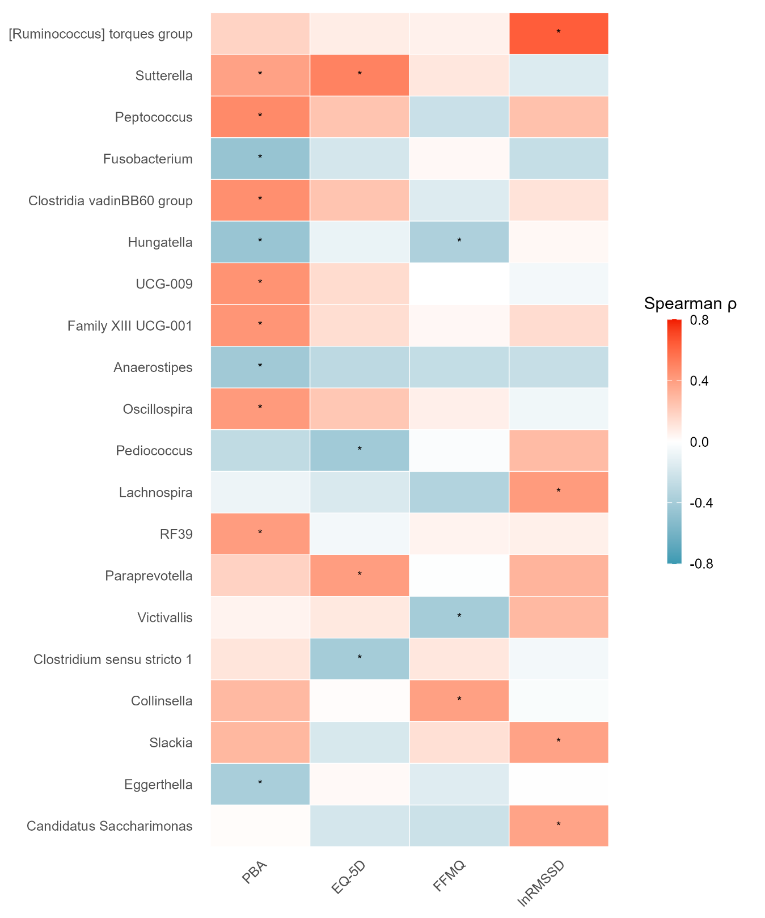

E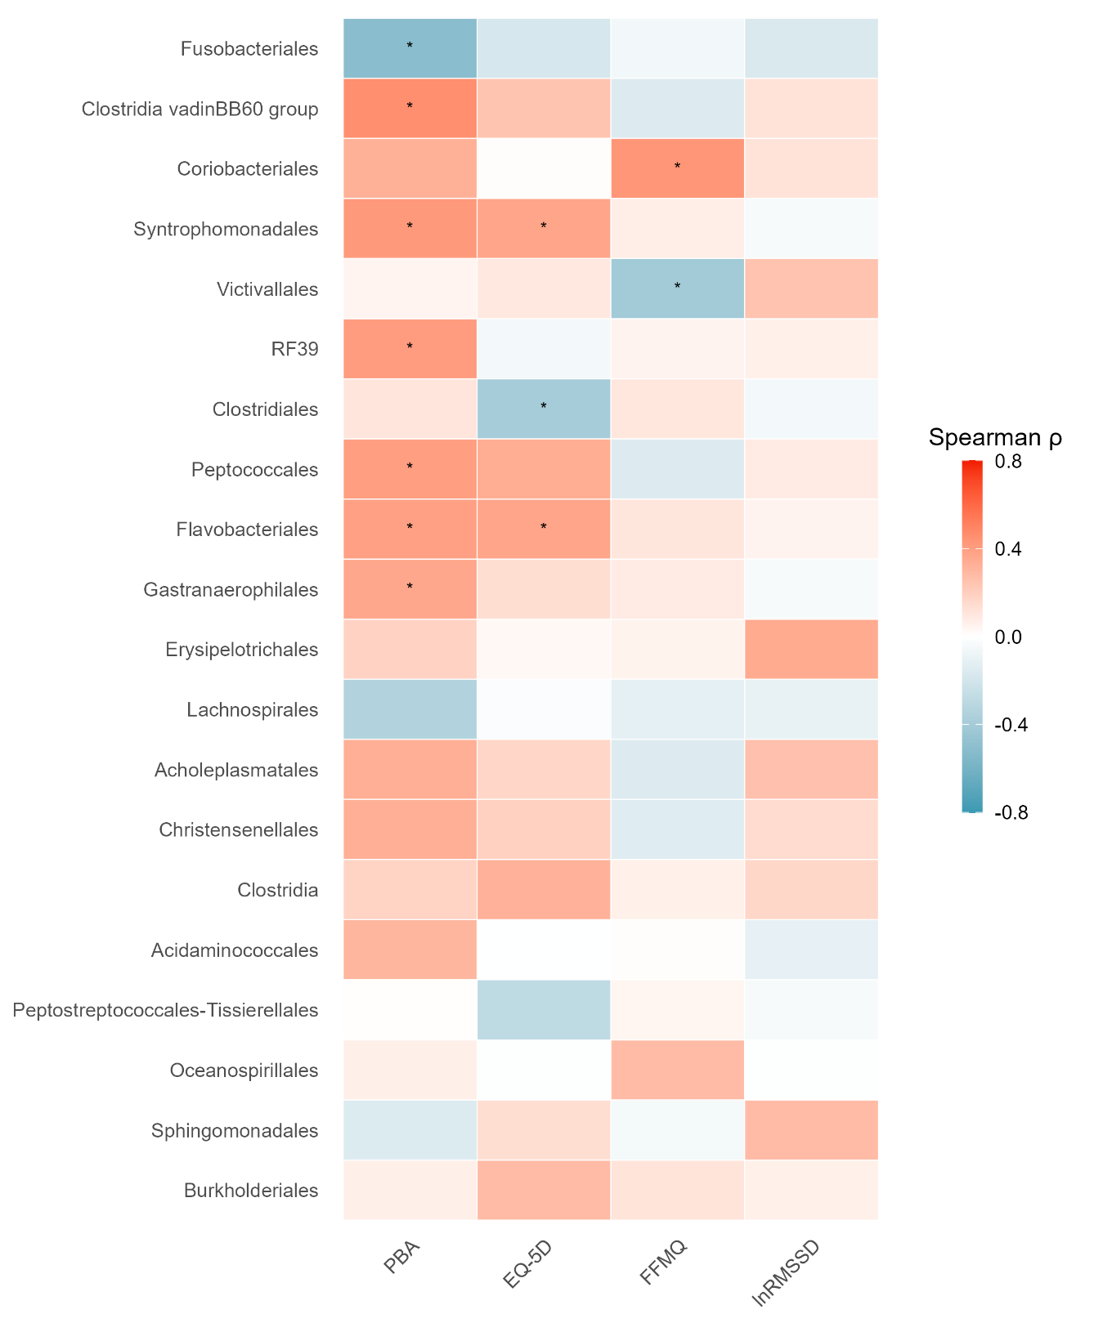

F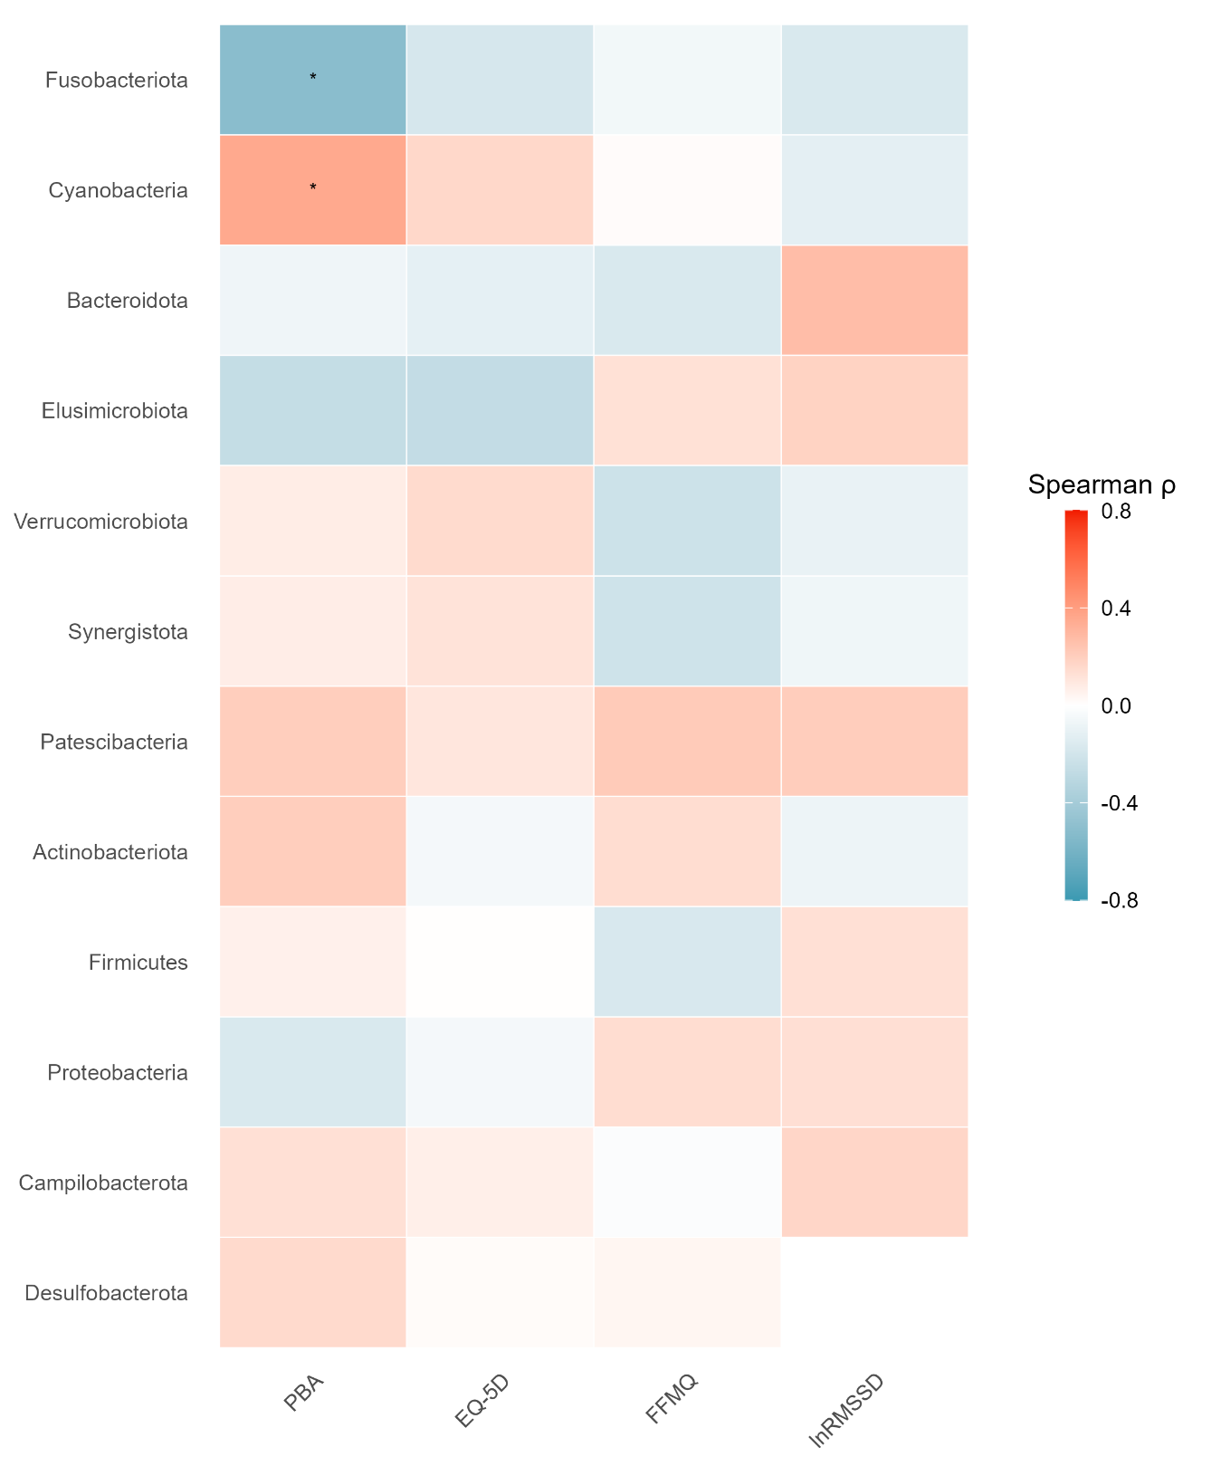

G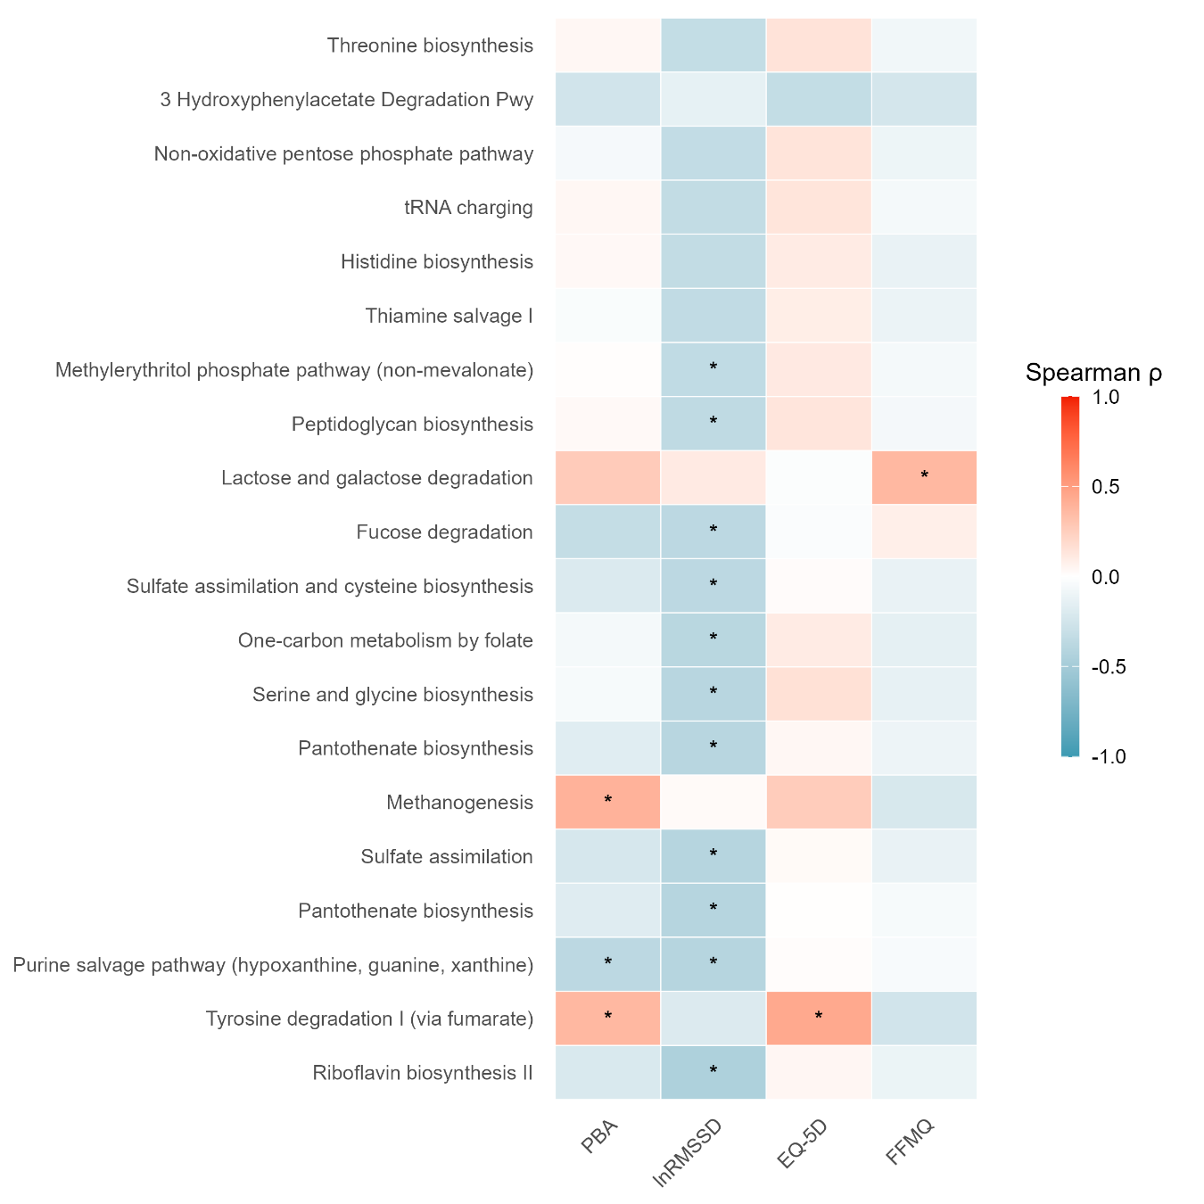

References
Allen, B., Kon, M., & Bar‐Yam, Y. (2009). A New Phylogenetic Diversity Measure Generalizing the Shannon Index and Its Application to Phyllostomid Bats. The American Naturalist, 174(2), 236–243. https://doi.org/10.1086/600101
Balestroni, G., & Bertolotti, G. (2012). [EuroQol-5D (EQ-5D): An instrument for measuring quality of life]. Monaldi Archives for Chest Disease = Archivio Monaldi Per Le Malattie Del Torace, 78(3), 155–159. https://doi.org/10.4081/monaldi.2012.121
bioread: Utilities to read BIOPAC AcqKnowledge files (Version 2025.5.2). (n.d.). [Computer software].
Bolyen, E., Rideout, J. R., Dillon, M. R., Bokulich, N. A., Abnet, C. C., Al-Ghalith, G. A., Alexander, H., Alm, E. J., Arumugam, M., Asnicar, F., Bai, Y., Bisanz, J. E., Bittinger, K., Brejnrod, A., Brislawn, C. J., Brown, C. T., Callahan, B. J., Caraballo-Rodríguez, A. M., Chase, J., … Caporaso, J. G. (2019). Reproducible, interactive, scalable and extensible microbiome data science using QIIME 2. Nature Biotechnology, 37(8), 852–857. https://doi.org/10.1038/s41587-019-0209-9
Callahan, B. J., McMurdie, P. J., Rosen, M. J., Han, A. W., Johnson, A. J. A., & Holmes, S. P. (2016). DADA2: High-resolution sample inference from Illumina amplicon data. Nature Methods, 13(7), 581–583. https://doi.org/10.1038/nmeth.3869
Cassol, I., Ibañez, M., & Bustamante, J. P. (2025). Key features and guidelines for the application of microbial alpha diversity metrics. Scientific Reports, 15(1), 622. https://doi.org/10.1038/s41598-024-77864-y
Crane, R. S., Eames, C., Kuyken, W., Hastings, R. P., Williams, J. M. G., Bartley, T., Evans, A., Silverton, S., Soulsby, J. G., & Surawy, C. (2013). Development and Validation of the Mindfulness-Based Interventions – Teaching Assessment Criteria (MBI:TAC). Assessment, 20(6), 681–688. https://doi.org/10.1177/1073191113490790
Douglas, G. M., Maffei, V. J., Zaneveld, J. R., Yurgel, S. N., Brown, J. R., Taylor, C. M., Huttenhower, C., & Langille, M. G. I. (2020). PICRUSt2 for prediction of metagenome functions. Nature Biotechnology, 38(6), 685–688. https://doi.org/10.1038/s41587-020-0548-6
Electrophysiology, T. F. of the E. S. of C. the N. A. S. of P. (1996). Heart Rate Variability. Circulation, 93(5), 1043–1065. https://doi.org/10.1161/01.CIR.93.5.1043
Griffith, A. K. (2022). Parental Burnout and Child Maltreatment During the COVID-19 Pandemic. Journal of Family Violence, 37(5), 725–731. https://doi.org/10.1007/s10896-020-00172-2
Jamshidian, M., Jalal, S., & Jansen, C. (2014). MissMech: An R Package for Testing Homoscedasticity, Multivariate Normality, and Missing Completely at Random (MCAR). Journal of Statistical Software, 56, 1–31. https://doi.org/10.18637/jss.v056.i06
Katoh, K., & Standley, D. M. (2013). MAFFT Multiple Sequence Alignment Software Version 7: Improvements in Performance and Usability. Molecular Biology and Evolution, 30(4), 772–780. https://doi.org/10.1093/molbev/mst010
Laborde, S., Mosley, E., & Thayer, J. F. (2017). Heart Rate Variability and Cardiac Vagal Tone in Psychophysiological Research – Recommendations for Experiment Planning, Data Analysis, and Data Reporting. Frontiers in Psychology, 8. https://doi.org/10.3389/fpsyg.2017.00213
Manrique-Millones, D., Vasin, G. M., Dominguez-Lara, S., Millones-Rivalles, R., Ricci, R. T., Abregu Rey, M., Escobar, M. J., Oyarce, D., Pérez-Díaz, P., Santelices, M. P., Pineda-Marín, C., Tapia, J., Artavia, M., Valdés Pacheco, M., Miranda, M. I., Sánchez Rodríguez, R., Morgades-Bamba, C. I., Peña-Sarrionandia, A., Salinas-Quiroz, F., … Roskam, I. (2022). Parental Burnout Assessment (PBA) in Different Hispanic Countries: An Exploratory Structural Equation Modeling Approach. Frontiers in Psychology, 13. https://www.frontiersin.org/articles/10.3389/fpsyg.2022.827014
Martin, M. (2011). Cutadapt removes adapter sequences from high-throughput sequencing reads. EMBnet.Journal, 17(1), 10–12. https://doi.org/10.14806/ej.17.1.200
Mendonça, I., Coelho, F., Ferrajão, P., & Abreu, A. M. (2022). Telework and Mental Health during COVID-19. International Journal of Environmental Research and Public Health, 19(5), 2602. https://doi.org/10.3390/ijerph19052602
Mikolajczak, M., & Roskam, I. (2018). A Theoretical and Clinical Framework for Parental Burnout: The Balance Between Risks and Resources (BR2). Frontiers in Psychology, 9, 886. https://doi.org/10.3389/fpsyg.2018.00886
Pan, J., & Tompkins, W. J. (1985). A Real-Time QRS Detection Algorithm. IEEE Transactions on Biomedical Engineering, BME-32(3), 230–236. https://doi.org/10.1109/TBME.1985.325532
Price, M. N., Dehal, P. S., & Arkin, A. P. (2010). FastTree 2 – Approximately Maximum-Likelihood Trees for Large Alignments. PLOS ONE, 5(3), e9490. https://doi.org/10.1371/journal.pone.0009490
Pyplot tutorial—Matplotlib 3.10.5 documentation. (n.d.). Retrieved 15 August 2025, from https://matplotlib.org/stable/tutorials/pyplot.html
Quast, C., Pruesse, E., Yilmaz, P., Gerken, J., Schweer, T., Yarza, P., Peplies, J., & Glöckner, F. O. (2013). The SILVA ribosomal RNA gene database project: Improved data processing and web-based tools. Nucleic Acids Research, 41(D1), D590–D596. https://doi.org/10.1093/nar/gks1219
Ranganathan, P., Pramesh, C. S., & Buyse, M. (2016). Common pitfalls in statistical analysis: The perils of multiple testing. Perspectives in Clinical Research, 7(2), 106–107. https://doi.org/10.4103/2229-3485.179436
Richter, C. G., Babo-Rebelo, M., Schwartz, D., & Tallon-Baudry, C. (2017). Phase-amplitude coupling at the organism level: The amplitude of spontaneous alpha rhythm fluctuations varies with the phase of the infra-slow gastric basal rhythm. NeuroImage, 146, 951–958. https://doi.org/10.1016/j.neuroimage.2016.08.043
Rognes, T., Flouri, T., Nichols, B., Quince, C., & Mahé, F. (2016). VSEARCH: A versatile open source tool for metagenomics. PeerJ, 4, e2584. https://doi.org/10.7717/peerj.2584
Signal processing (scipy.signal)—SciPy v1.16.1 Manual. (n.d.). Retrieved 15 August 2025, from https://docs.scipy.org/doc/scipy/reference/signal.html
Turku, U. of. (n.d.). Chapter 8 Beta diversity | Introduction to microbiome data science. Retrieved 11 September 2025, from https://microbiome.github.io/course_2021_radboud/beta-diversity.html
Author
Author
Author
Author
Author

