Supporting Information
Reducing Structural Ambiguity in Food Compound Identification via Computational Refinement: A Case Study of Catechins and Their Oxidation Products in Chinese Black Tea
Shanbo Zhangª, Zhi En Lowª, Kim-Huey Ee^{b}, Yunle Huang^{b}, Rui Min Vivian Goh^{b}, Lingyi Liª, Lionel Jublot^{b}, Chee Sian Gan^{c}, Shao Quan Liuª, Dachuan Zhangª*, and Bin Yu^{b}*
ª Department of Food Science and Technology, Faculty of Science, National University of Singapore, 2 Science Drive 2, 117542, Singapore
^{b} Mane SEA PTE LTD, 3 Biopolis Drive, #07-17/18/19 Synapse, 138623, Singapore
^{c} Agilent Technologies Singapore (Sales) PTE LTD, 1 Yishun Avenue 7, 768923,
Singapore
⁎ Corresponding authors e-mail address: gsgpbiy@gmail.com (B. Yu); dachuan.zhang@nus.edu.sg (D. Zhang)

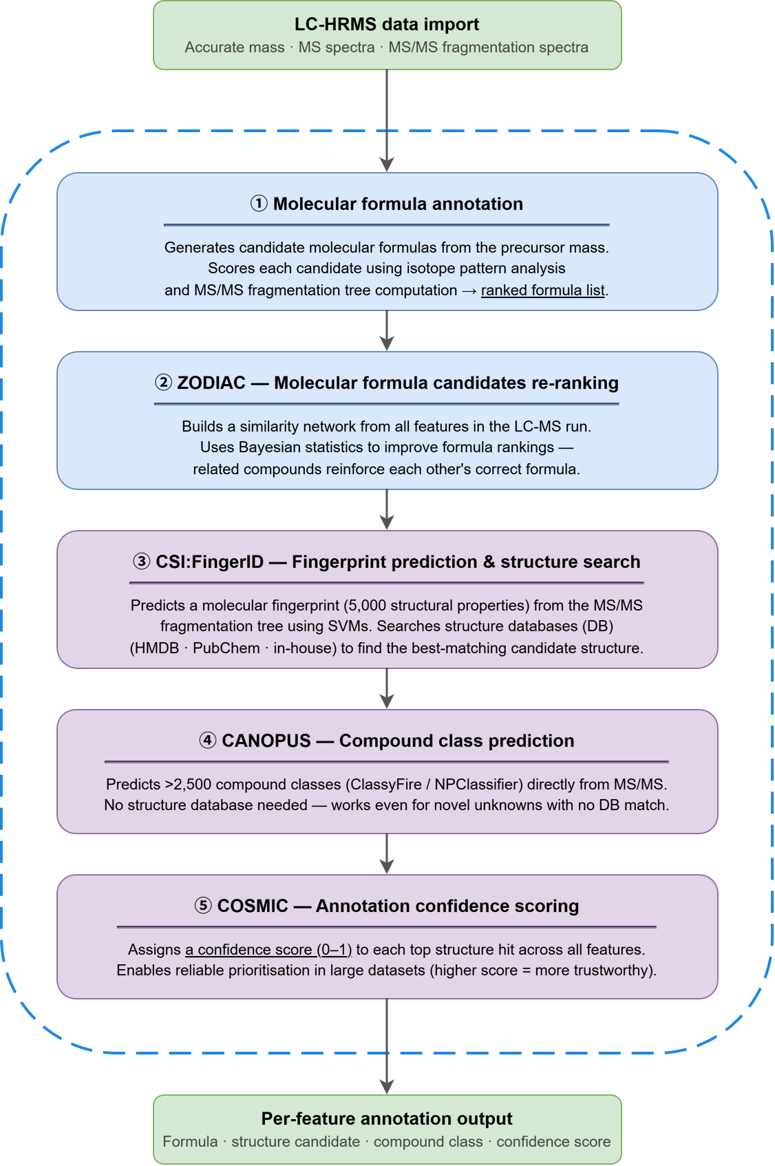

Figure S1. Schematic overview of the SIRIUS 6 annotation workflow applied in this study, comprising five sequential computational modules: (i) molecular formula annotation via isotope pattern analysis and fragmentation tree scoring; (ii) ZODIAC for network-based molecular formula re-ranking; (iii) CSI:FingerID for molecular fingerprint prediction and candidate structure search against public and in-house databases; (iv) CANOPUS for compound class prediction using the ClassyFire taxonomy; and (v) COSMIC for annotation confidence scoring.

Figure S2. Chromatographic and MS/MS-based discrimination of vitexin and isovitexin as representative C-glycoside positional isomers. Collision energy-dependent MS/MS spectra at CE = 0, 10, 20, and 40 eV are shown for each compound, alongside CSI:FingerID structure prediction results showing rank 1 assignment for vitexin and isovitexin, respectively.

Figure S3. Key MS/MS fragment ions of theaflavin and its cascade oxidative product (theaflavin with oxygen insertion at the benzotropolone moiety) generated under collision-induced dissociation. Proposed fragment structures and their corresponding m/z values are shown for each compound.

Figure S4. Demonstration of confidence level upgrading from Level 4 to Level 3 through the introduction of a computationally generated candidate list. (a) The same compound feature (Cpd Grp 1155, [M−H]⁻ m/z 775.114, RT 18.54 min) was subjected to CSI:FingerID structure annotation under two database configurations. When searched against PubChem alone, no structural candidate was returned ("No results found"), reflecting the complete absence of this compound class from public structural databases; under these conditions, only a molecular formula assignment is achievable, corresponding to MSI Level 4. (b) Upon activating the computationally generated candidate list alongside public databases, CSI:FingerID returned (-)-epigallocatechin gallate dimer_product_20 (C₃₇H₂₈O₁₉) as the top-ranked candidate (CSI:FingerID score: −122.887), with structural support derived exclusively from the large-scale generated candidate list. The availability of a chemically informed structural candidate consistent with the observed precursor mass and molecular formula elevates the annotation confidence to MSI Level 3 (tentative candidate).

No | Standards | Company
1 | Analytical standards (>98% purity) including myricetin 3-O-glucoside, myricetin 3-O-galactoside, quercetin 3-O-rutinoside, apigenin-8-C-glucoside, apigenin-6-C-glucoside, quercetin 3-O-glucoside, luteolin, luteolin-7-O-rhamnoside, kaempferol 3-O-rutinoside, myricetin, quercetin, naringenin, apigenin, kaempferol, gallic acid, and myricetin 3-O-rutinoside. | Chemface, Wuhan, China
2 | Analytical standards (>99% purity) including gallocatechin, procyanidin B1, epigallocatechin, catechin, procyanidin B2, epicatechin, epigallocatechin gallate, procyanidin C1, gallocatechin gallate, epicatechin gallate, catechin gallate, epiafzelechin-3-gallate, theaflavin-3-gallate, theaflavin, theaflavin-3'-gallate, theaflavin-3,3'-digallate, kaempferol 3-O-galacotoside, kaempferol 3-O-glucoside, vicenin-1, vicenin-3. | FineTech Industry Limited, Wuhan, China
Table S1. List of authentic reference standards used for in-house spectral library construction and Level 1 compound identification.

Table S2. MSI Level 1 confirmed compounds identified in Chinese black tea by UHPLC-QTOF, with retention times, molecular formulae, adduct ions, theoretical m/z values, and chemical classes.
Compound | RT (min) | CAS | Molecular formula | Adduct | Theoretical m/z | Chemical class
Gallic acid | 8.415 | 149-91-7 | C₇H₆O₅ | [M−H]⁻ | 169.0142 | Phenolic acid
Epigallocatechin | 12.003 | 970-74-1 | C₁₅H₁₄O₇ | [M−H]⁻ | 305.0667 | Flavan-3-ol
Procyanidin B1 | 18.750 | 20315-25-7 | C₃₀H₂₆O₁₂ | [M−H]⁻ | 577.1351 | Flavan-3-ol dimer
Gallocatechin | 18.933 | 970-73-0 | C₁₅H₁₄O₇ | [M−H]⁻ | 305.0667 | Flavan-3-ol
Catechin | 18.933 | 13392-26-2 | C₁₅H₁₄O₆ | [M−H]⁻ | 289.0718 | Flavan-3-ol
Myricetin 3-O-glucoside | 25.276 | 19833-12-6 | C₂₁H₂₀O₁₃ | [M-H]⁻ | 479.0831 | Flavonol glycoside
Procyanidin B2 | 22.175 | 29106-49-8 | C₃₀H₂₆O₁₂ | [M−H]⁻ | 577.1351 | Flavan-3-ol dimer
Epigallocatechin gallate | 25.241 | 989-51-5 | C₂₂H₁₈O₁₁ | [M−H]⁻ | 457.0776 | Flavan-3-ol
Epicatechin | 27.408 | 17334-50-8 | C₁₅H₁₄O₆ | [M−H]⁻ | 289.0718 | Flavan-3-ol
Kaempferol 3-O-rutinoside⁴ | 34.062 | 17650-84-9 | C₂₇H₃₀O₁₅ | [M-H]⁻ | 593.1512 | Flavonol glycoside
Epicatechin gallate | 34.276 | 1257-08-5 | C₂₂H₁₈O₁₀ | [M−H]⁻ | 441.0827 | Flavan-3-ol
Vicenin-3 | 34.343 | 35927-38-9 | C₂₆H₂₈O₁₄ | [M-H]⁻ | 563.1406 | Flavonol glycoside
Procyanidin C1 | 35.178 | 37064-30-5 | C₄₅H₃₈O₁₈ | [M−H]⁻ | 865.1985 | Flavan-3-ol trimer
Vicenin-1 | 36.263 | 35927-38-9 | C₂₆H₂₈O₁₄ | [M-H]⁻ | 563.1406 | Flavonol glycoside
Myricetin 3-O-galactoside | 37.516 | 15648-86-9 | C₂₁H₂₀O₁₃ | [M-H]⁻ | 479.0831 | Flavonol glycoside
Myricetin | 38.440 | 529-44-2 | C₁₅H₁₀O₈ | [M−H]⁻ | 317.0303 | Flavonol
Kaempferol 3-O-galactoside | 39.272 | 23627-87-4 | C₂₁H₂₀O₁₁ | [M-H]⁻ | 447.0933 | Flavonol glycoside
Apigenin-6-C-glucoside | 40.701 | 3681-93-4 | C₂₁H₂₀O₁₀ | [M-H]⁻ | 431.0984 | Flavonol glycoside
Apigenin-8-C-glucoside | 40.959 | 3681-93-4 | C₂₁H₂₀O₁₀ | [M-H]⁻ | 431.0984 | Flavonol glycoside
Kaempferol 3-O-glucoside | 41.171 | 480-10-4 | C₂₁H₂₀O₁₁ | [M-H]⁻ | 447.0933 | Flavonol glycoside
Theaflavin | 42.893 | 4670-05-7 | C₂₉H₂₄O₁₂ | [M−H]⁻ | 563.1195 | Theaflavin
Theaflavin-3,3'-digallate | 42.893 | 30462-35-2 | C₄₃H₃₂O₂₀ | [M−H]⁻ | 867.1414 | Theaflavin
Theaflavin-3-gallate | 43.023 | 30462-34-1 | C₃₆H₂₈O₁₆ | [M−H]⁻ | 715.1305 | Theaflavin
Theaflavin-3'-gallate | 43.023 | 28543-07-9 | C₃₆H₂₈O₁₆ | [M−H]⁻ | 715.1305 | Theaflavin
Luteolin | 43.381 | 491-70-3 | C₁₅H₁₀O₆ | [M−H]⁻ | 285.0405 | Flavone
Apigenin | 44.129 | 520-36-5 | C₁₅H₁₀O₅ | [M−H]⁻ | 269.0455 | Flavone
Quercetin | 44.646 | 117-39-5 | C₁₅H₁₀O₇ | [M−H]⁻ | 301.0354 | Flavonol

Table S3. MSI Level 2 putatively annotated catechin oxidation products in Chinese black tea by UHPLC-QTOF, with retention times, molecular formulae, adduct ions, theoretical m/z values, and chemical classes.
Compound | RT (min) | CAS | Molecular formula | Adduct | Theoretical m/z | Chemical class
Catechin-4-ol 3-O-beta-D-glycopyranoside | 10.030 | - | C₂₁H₂₄O₁₂ | [M−H]⁻ | 467.1195 | Catechin glycoside
Theasinensin B | 13.746 | 89064-32-4 | C₃₇H₃₀O₁₈ | [M−H]⁻ | 761.1359 | Catechin oxidative product
Epicatechin-(4beta->8)-epigallocatechin 3'-gallate | 15.390 | 126715-89-7 | C₃₇H₃₀O₁₇ | [M−H]⁻ | 745.1410 | Catechin oxidative product
Theacitrin A | 15.604 | 201998-49-4 | C₃₇H₂₈O₁₈ | [M−H]⁻ | 759.1203 | Catechin oxidative product
Theaflavic acid | 20.822 | 30407-93-3 | C₂₁H₁₆O₁₀ | [M−H]⁻ | 427.0671 | Catechin oxidative product
Theasinensin F | 22.201 | - | C₄₄H₃₄O₂₁ | [M−H]⁻ | 897.1520 | Catechin oxidative product
Oolongtheanin | 27.498 | 116310-05-5 | C₃₆H₂₈O₁₇ | [M−H]⁻ | 731.1254 | Catechin oxidative product
Theacitrin C | 27.792 | - | C₄₄H₃₂O₂₂ | [M−H]⁻ | 911.1312 | Catechin oxidative product
Procyanidin B2 3,3'-di-O-gallate | 32.480 | 79907-44-1 | C₄₄H₃₄O₂₀ | [M−H]⁻ | 881.1571 | Catechin oxidative product
Oolongtheanin 3'-gallate | 34.290 | 117058-42-1 | C₄₃H₃₂O₂₁ | [M−H]⁻ | 883.1363 | Catechin oxidative product
epigallocatechin-(4beta->8)-epigallocatechin-3-O-gallate | 36.740 | 86588-88-7 | C₃₇H₃₀O₁₈ | [M−H]⁻ | 761.1359 | Catechin oxidative product
Epigallocatechin-(4beta->8)-epicatechin 3,3'-digallate | 36.790 | - | C₄₄H₃₄O₂₁ | [M−H]⁻ | 897.1520 | Catechin oxidative product
Catechin 3,7,-di-O-gallate | 36.820 | - | C₂₉H₂₂O₁₄ | [M−H]⁻ | 593.0937 | Catechin oxidative product
Epicatechin 3-O-(3-O-methylgallate) | 36.970 | - | C₂₃H₂₀O₁₀ | [M−H]⁻ | 455.0984 | Catechin oxidative product
Epigallocatechin 3,4',-di-O-gallate | 40.382 | - | C₂₉H₂₂O₁₅ | [M−H]⁻ | 609.0886 | Catechin oxidative product
Epitheaflavic acid-3-gallate | 45.083 | 34218-97-8 | C₂₈H₂₀O₁₄ | [M−H]⁻ | 579.0780 | Catechin oxidative product

Table S4. Predictive pipeline filtering criteria and threshold selection for biotransformation and chemical transformation pipelines. Checkmark (ü) indicates that the filter was applied to the respective pipeline, while dash (-) indicates that the filter was not implemented. Rationale provides scientific justification for each constraint to ensure chemical relevance and reduce candidate search space.
Category | Filter Name | Parameter/ Descriptor | Biotransformation | Chemical transformation | Rationale
Templates | EC_filter | Enzyme Commission Class Filter | ü(1) | - | Filters biotransformation templates by Enzyme Commission class classification.  Retain reactions with oxidoreductases (EC Class 1)
Similarity | Mol_similarity | Tanimoto similarity | ü(0.1) | - | Ensure application of relevant reaction templates. Parent compound has to be at least similar to the reference substrate in the reaction template.
Composition | Allowed_atoms | Permissible atomic composition | - | ü(C, N, O, S, F, Cl, Br, H) | Restrict to elements common to polyphenol chemistry.
Composition | Split_disconnected_  products | Include fragmentation products | - | ü(True) | Allow products formed via fragmentation. Fragmentation is a common reaction in thermal processing.
Size/Mass | Atom_limit_ ratio | Product:parent atoms | ü(2) | ü(5) | Exclude unrealistically large products.  Ratio of 2 for Biotrans. keeps the products within structural footprint of the parent.  Ratio of 5 for Chem. Trans. provides flexibility for large molecules from polymerisation.
Size/Mass | Min_product_atoms | Minimum number of atoms | ü(6) | ü(2) | Exclude small fragments and byproducts.  Biotrans. typically involves adding functional groups to existing structure.  Minimum of 6 to capture biologically meaningful transformations  Chem. Trans. generates both small fragments and large products.  Minimum of 2 to include small fragments from breakdown of larger molecules.
Size/Mass | Max_product_mw | Maximum product MW | ü(2000 Da) | ü(2000 Da) | Prevent generation of unrealistic polymers.  2000 Da is a standard ceiling that covers majority of relevant polyphenols and their dimers/trimers.

Supplementary Note S1. Detailed pipeline architecture and filtering strategy.
The predictive pipeline generated candidates through two complementary branches: biotransformation, focusing on enzymatic modifications, and chemical transformation, based on thermal processing reactions with a list of 41 parent compounds and their Simplified Molecular Line Entry System (SMILES). For the biotransformation branch, SMILES Arbitrary Target Specification (SMARTS)-based reaction rules were retrieved from the Biochemical and Chemical Substructure (BCS) database and pre-filtered to include only oxidoreductases (EC Class 1). This restriction narrows the search space to oxidative products characteristic of tea processing. The chemical transformation branch utilizes a curated library of approximately 270 reaction rules extracted from 23 studies on thermal food processing. In both pipelines, reaction templates were applied via substructure matching, which requires that the reaction center and its local environment match those of the parent compound. Subsequent filtering was performed to exclude chemically irrelevant candidates, such as unrealistically large condensation products or invalid fragments. The specific parameters, thresholds, and rationale for these filters are presented in Supplementary Table S4. After filtering, 2,919 and 363 candidates were obtained from the biotransformation and chemical transformation branches, respectively. After merging and deduplication by canonical SMILES, a custom database of 3,272 candidates was finalized for subsequent SIRIUS matching.

Table S5. Physicochemical descriptors used to characterize the predicted metabolite chemical space.
Descriptor chosen | Full Name | Definition/Significance
fr_Ar_OH | Aromatic Hydroxyl Count | Count of phenolic groups
NumAromaticRings | Number of Aromatic Rings | Count of aromatic rings
NumAtomStereoCenters | Number of Atom Stereocenters | Number of atoms bonded to 4 different substituents
MolLogP | Calculated LogP | Measures lipophilicity
MolWt | Molecular weight | Measures the size/mass of the molecule
TPSA | Topological polar surface area | Captures total molecular polarity

