Supplementary Table S1. Variance inflation factor diagnostics for the final selected features
Feature | VIF | Interpretation
Running speed | 12.448 | Severe multicollinearity
Mean stride length | 11.186 | Severe multicollinearity
Mean hip adduction peak angle | 4.178 | Generally acceptable
Mean knee rotation peak angle | 3.625 | Generally acceptable
Mean knee adduction peak angle | 2.890 | Generally acceptable
Mean stance time | 2.252 | Generally acceptable
Mean knee flexion peak angle | 2.214 | Generally acceptable
Mean ankle eversion peak velocity | 2.172 | Generally acceptable
Mean hip extension peak angle | 1.879 | Generally acceptable
Mean ankle dorsiflexion peak angle | 1.752 | Generally acceptable
Mean knee rotation excursion | 1.657 | Generally acceptable
Mean step width | 1.588 | Generally acceptable
Pelvic drop excursion asymmetry | 1.562 | Generally acceptable
Age | 1.547 | Generally acceptable
Mean ankle rotation peak velocity | 1.519 | Generally acceptable
Mean hip rotation peak angle | 1.510 | Generally acceptable
Mean ankle eversion peak angle | 1.357 | Generally acceptable
Mean hip rotation excursion | 1.352 | Generally acceptable
Mean ankle rotation excursion | 1.312 | Generally acceptable
Recreational running level | 1.294 | Generally acceptable
Years of running experience | 1.213 | Generally acceptable
10-km race distance | 1.185 | Generally acceptable
Note: VIF, variance inflation factor. VIF values <5 were considered generally acceptable, values between 5 and 10 indicated moderate multicollinearity, and values ≥10 indicated severe multicollinearity.

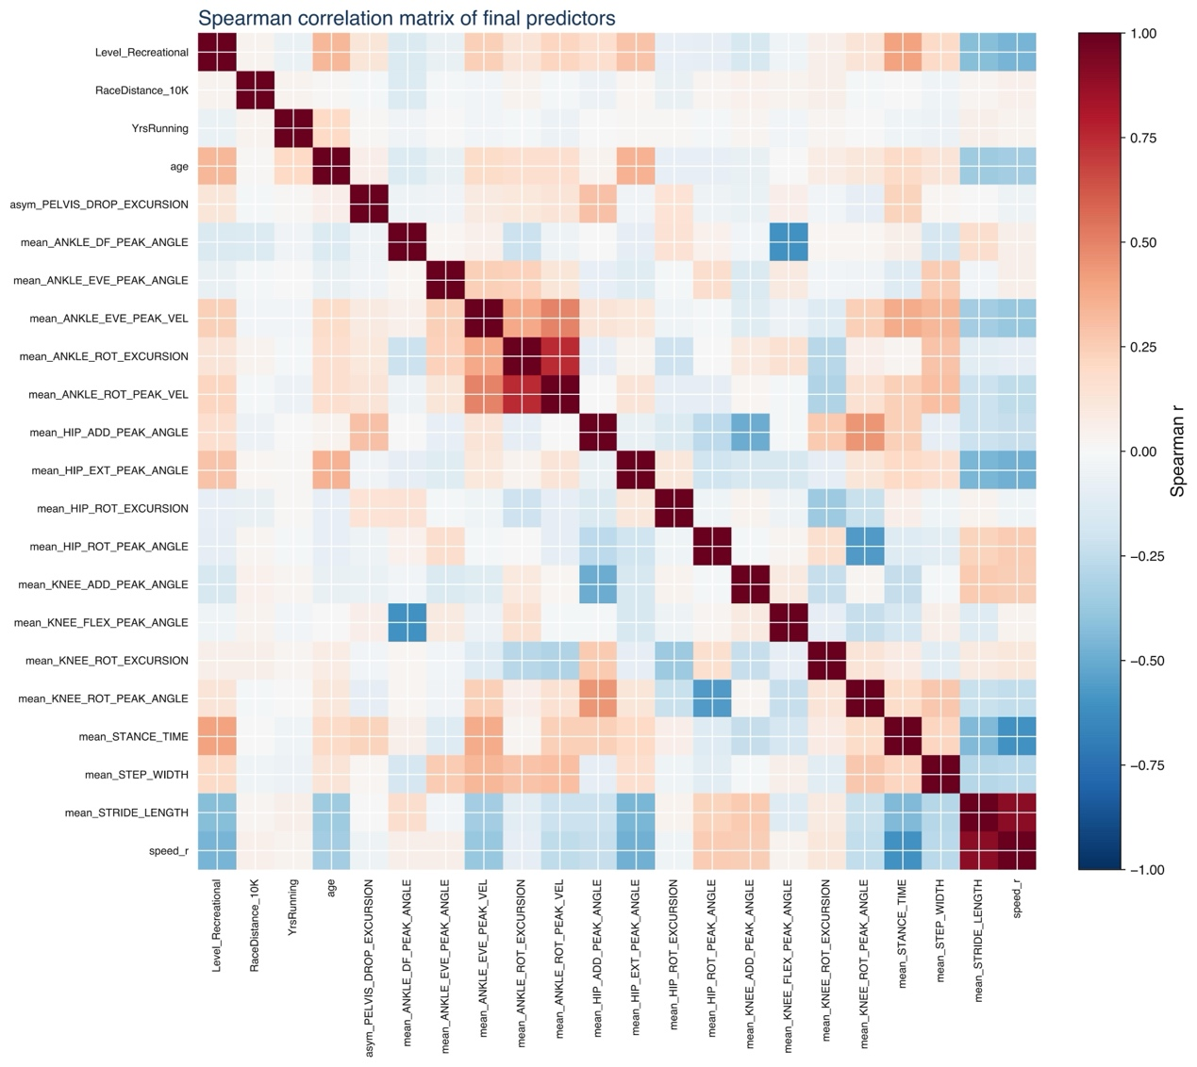
Supplementary Figure S1. Correlation plot of variance expansion factor diagnosis

Supplementary Table S2. Inter-group comparison of training and test sets
Variable | Training set  (n = 1220) | Test set  (n = 524) | FDR-adjusted P | Effect size
Recreational running level | 718/1220 (58.9%) | 319/524 (60.9%) | 0.860 | 0.018
10-km race distance | 174/1220 (14.3%) | 69/524 (13.2%) | 0.860 | 0.013
Years of running experience | 8.000 (3.000, 15.000) | 7.000 (3.000, 14.000) | 0.860 | 0.036
Age | 37.000 (27.000, 46.000) | 37.000 (28.000, 46.000) | 0.860 | 0.007
Running speed | 2.723 (2.485, 2.949) | 2.726 (2.483, 2.935) | 0.884 | 0.004
Pelvic drop excursion asymmetry | 9.351 (7.134, 11.813) | 9.328 (7.185, 11.961) | 0.860 | -0.007
Mean ankle dorsiflexion peak angle | 21.287 (18.843, 23.308) | 21.463 (19.120, 23.380) | 0.860 | -0.026
Mean ankle eversion peak angle | -6.763 (-8.655, -4.686) | -6.613 (-8.571, -4.492) | 0.860 | -0.036
Mean ankle eversion peak velocity | -223.230 (-283.044, -175.426) | -230.078 (-282.257, -179.322) | 0.860 | 0.017
Mean ankle rotation excursion | -9.198 (-11.175, -7.196) | -9.092 (-11.346, -7.097) | 0.860 | -0.007
Mean ankle rotation peak velocity | -154.466 (-187.391, -124.064) | -154.619 (-187.357, -122.543) | 0.860 | -0.010
Mean hip adduction peak angle | 8.240 (6.117, 10.842) | 8.727 (5.952, 11.031) | 0.860 | -0.026
Mean hip extension peak angle | -11.996 (-16.328, -8.202) | -12.115 (-16.349, -8.223) | 0.860 | 0.011
Mean hip rotation excursion | 0.744 (0.008, 2.139) | 0.835 (0.031, 2.105) | 0.860 | -0.017
Mean hip rotation peak angle | 15.566 (11.758, 19.810) | 14.784 (10.993, 19.478) | 0.699 | 0.056
Mean knee adduction peak angle | -4.112 (-6.454, -1.723) | -4.539 (-6.845, -2.252) | 0.699 | 0.061
Mean knee flexion peak angle | -42.816 (-46.461, -39.171) | -43.023 (-46.995, -39.478) | 0.860 | 0.029
Mean knee rotation excursion | 14.569 (11.884, 17.458) | 14.082 (11.559, 17.175) | 0.699 | 0.050
Mean knee rotation peak angle | -11.226 (-15.998, -6.016) | -11.152 (-16.280, -6.444) | 0.860 | 0.013
Mean stance time | 0.297 (0.275, 0.315) | 0.295 (0.273, 0.315) | 0.860 | 0.015
Mean step width | 0.058 (0.036, 0.079) | 0.059 (0.038, 0.077) | 0.860 | -0.010
Mean stride length | 1.989 (1.797, 2.154) | 1.981 (1.773, 2.159) | 0.860 | 0.007
Note: Continuous variables were compared using the Mann–Whitney U test, and categorical variables were compared using the chi-square test.

Supplementary Table S3. Comparison between the full-feature and biomechanics-only random forest models
Model | Feature set | Accuracy | ROC-AUC | AUPRC | Sensitivity | Specificity | F1-score
RF | Full feature set | 0.761 (0.725–0.798) | 0.790 (0.747–0.831) | 0.800 (0.751–0.857) | 0.905 (0.874–0.934) | 0.523 (0.453–0.593) | 0.826 (0.795–0.854)
RF | Biomechanics only | 0.729 (0.693–0.767) | 0.729 (0.683–0.775) | 0.764 (0.713–0.822) | 0.875 (0.838–0.910) | 0.487 (0.419–0.552) | 0.801 (0.769–0.833)
Note: ROC-AUC, area under the receiver operating characteristic curve; AUPRC, area under the precision–recall curve; RF, random forest.

