Journal Natural Hazard (Springer)
Supporting Information for
Spatiotemporal Changes of Extreme Rainfall Events and Associated Human Fatalities across Indian States (1970–2019)

Contents of this file: Supplementary Figure and Table
Figure S1: The Long Term (1970-2019) number of extreme rainfall according to IMD criteria for the intensity of rainfall, (a) Heavy rainfall (HR), (b) Very Heavy Rainfall (VHR), and (C) Extremely Heavy Rainfall (EHR) over India River basins.
Table S1: Human fatalities caused by extreme rainfall events across the Indian River basins.

Figure S1: The Long Term (1970-2019) number of extreme rainfalls according to IMD criteria for the intensity of rainfall, (a) Heavy rainfall (HR), (b) Very Heavy Rainfall (VHR), and (c) Extremely Heavy Rainfall (EHR).

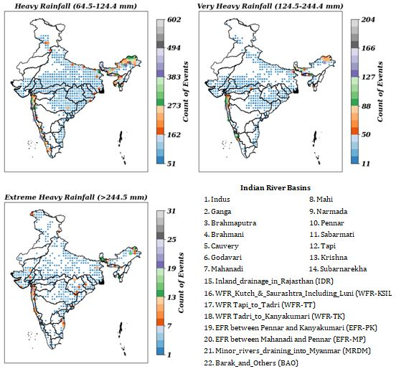

Table S1: Human fatalities caused by extreme rainfall events across the Indian River basins.
Sr.  No. | Indian River Basins (IBRs) | 50 years spatial sum of number of the rainfall extreme events |  |  | Human  Loss
Sr.  No. | Indian River Basins (IBRs) | HR  (64.5-124.4) | VHR  (124.5-244.4) | EHR  >= 244.5 | Human  Loss
1. | Indus | 4686 | 600 | 80 | 524
2. | Ganga | 23622 | 3703 | 318 | 3637
3. | Brahmaputra | 11919 | 1904 | 193 | 1769
4. | Brahmani | 1655 | 252 | 26 | 40
5. | Cauvery | 1171 | 124 | 14 | 5
6. | Godavari | 8630 | 1456 | 153 | 1502
7. | Mahanadi | 4877 | 832 | 78 | 352
8. | Mahi | 1129 | 282 | 24 | -
9. | Narmada | 3021 | 636 | 42 | 408
10. | Pennar | 698 | 110 | 9 | -
11. | Sabarmati | 817 | 184 | 23 | 200
12. | Tapi | 1209 | 195 | 16 | 652
13. | Krishna | 3169 | 370 | 36 | 275
14. | Subarnarekha | 945 | 181 | 20 | 15
15. | Inland_drainage_in_Rajasthan (IDR) | 701 | 83 | 12 | 89
16. | WFR_Kutch_&_Saurashtra_Including_Luni (WFR-KSIL) | 3228 | 828 | 160 | -
17. | WFR Tapi_to_Tadri (WFR-TT) | 8516 | 2348 | 259 | 30
18. | WFR Tadri_to_Kanyakumari (WFR-TK) | 4976 | 760 | 54 | 35
19. | EFR between Pennar and Kanyakumari (EFR-PK) | 2180 | 320 | 49 | -
20. | EFR between Mahanadi and Pennar (EFR-MP) | 2069 | 400 | 44 | -
21. | Minor_rivers_draining_into_Myanmar (MRDM) | 782 | 93 | 16 | -
22. | Barak_and_Others (BAO) | 3814 | 935 | 268 | 9

